ASSIGNMENT -1

1. Create a blog or website using BlogSpot and WordPress. customise the theme design and post new article with 500 words.

Blogspot url: <https://www.blogger.com/u/1/blog/post/edit/8436697430376488147/2939371067632311942>

WordPress url: <https://wordpress.com/post/delightdwellings.wordpress.com/17>

1. Create a new Facebook Business page and post one social media poster for your brand.

<https://m.facebook.com/story.php?story_fbid=pfbid0oWqvXgy298BD4oNPcYjvRT2CzqgLLTJY9vVB261Px2gjaNW6PaeRNBA2UmegWcUfl&id=61552645902906&sfnsn=wiwspwa&mibextid=RUbZ1f>

1. Create and design a social media advertisement poster using canva.

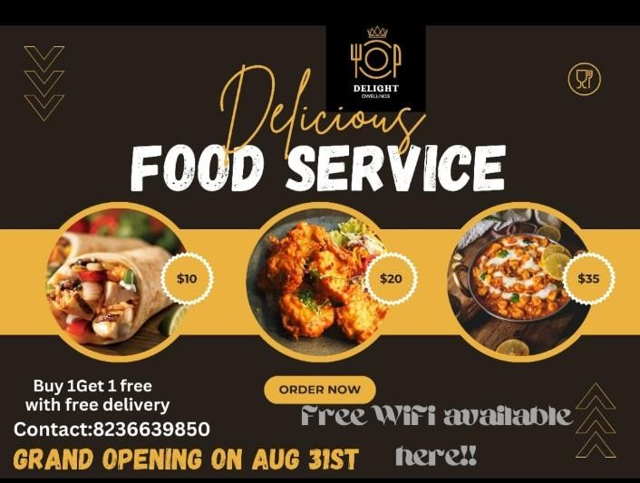

1. Create email newsletter design using MailChimp or Canva tool.

