WEEK 5

DEEP LEARNING APPLICATION IN DATA SCIENCE

Objective:
The task will involve creating a neural network model using a popular deep learning framework such as TensorFlow or PyTorch on a publicly available dataset.

Dataset Used: Fashion Mnist
Dataset Overview
- Total Images: 70,000 grayscale images
- Image Size: 28 × 28 pixels
- Splits: 60,000 training images and 10,000 testing images
- Purpose: Designed as a direct, more challenging drop-in replacement for the classic handwritten digits MNIST dataset
Labels
Each training and test example is assigned to one of the following labels:
- 0 T-shirt/top
- 1 Trouser
- 2 Pullover
- 3 Dress
- 4 Coat
- 5 Sandal
- 6 Shirt
- 7 Sneaker
- 8 Bag
- 9 Ankle boot
Software and Libraries:
Python is used as the programming language. TensorFlow/Keras provides dataset loading, neural-network layers, optimization, and callbacks. NumPy supports numerical operations; Pandas stores comparison results; Matplotlib and Seaborn create plots; and Scikit-learn provides train-validation splitting and classification metrics.
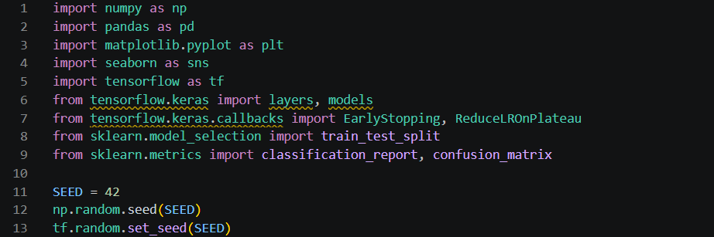
Loading,splitting and visualising the dataset:
- We are splitting the dataset into training set(51000) , test set(10000) and validation set(9000).
- We are also scaling the data from(0-1) and displaying the 1st 15 images

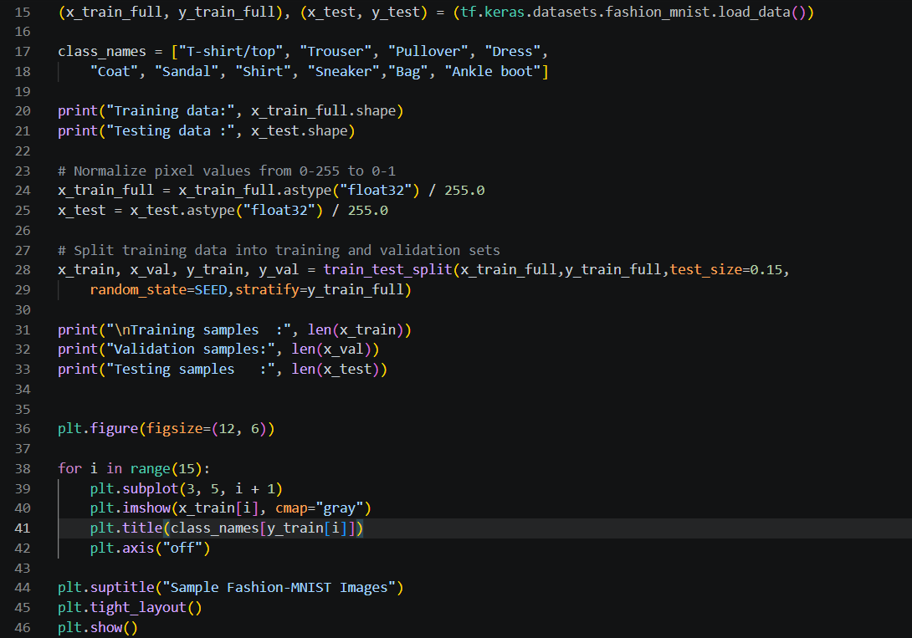
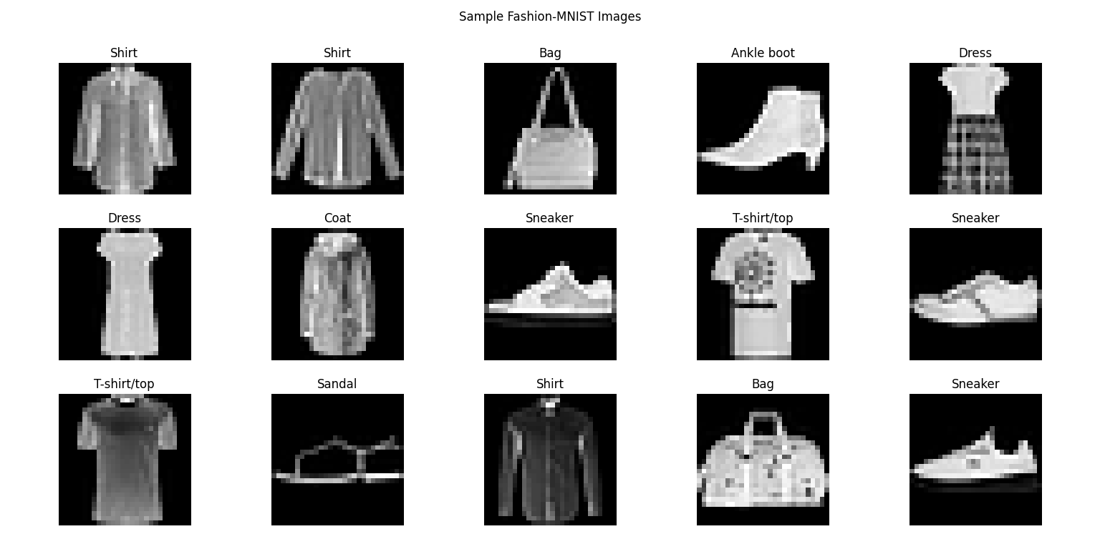
Callbacks:
Two callbacks are used:
- Early Stopping: Stops training if validation loss does not improve for four consecutive epochs and restores the weights from the best observed validation-loss epoch.
- ReduceLROnPlateau: Reduces the learning rate by half when validation loss stops improving for two consecutive epochs, subject to a minimum learning rate of 10^-6
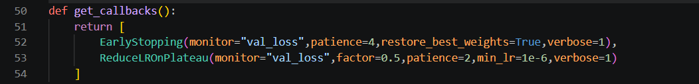

Model 1: Basic Artificial Neural Network
- The first model establishes a baseline for the classification task .
- The Flatten layer converts each 28 × 28 image into a one-dimensional vector containing 784 pixel values. The hidden Dense layer uses 128 neurons with ReLU activation to learn nonlinear relationships.
- The output layer contains ten neurons, one for each fashion category. Softmax converts the output scores into a probability distribution over the ten classes.
- The model uses SGD as its optimizer and sparse categorical cross-entropy as its loss function. SGD provides a simple baseline for comparison with the adaptive Adam optimizer used in later models.
- Limitation: The model has limited learning capacity and may not capture complex relationships between clothing features. Flattening also removes the explicit spatial arrangement of pixels.
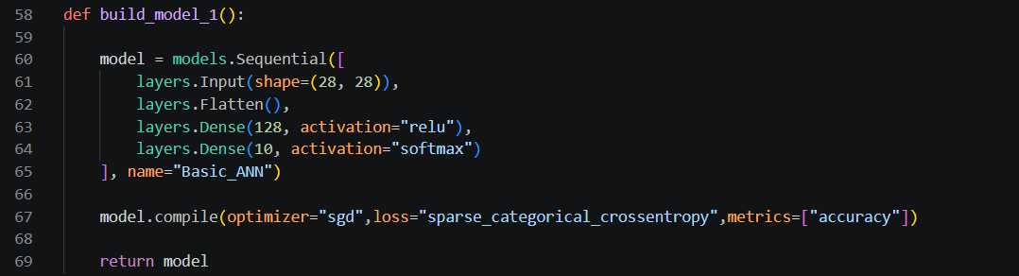

Model 2: Deeper ANN with Adam Optimizer
- The second model introduces additional hidden layers to increase the network's learning capacity.
- The deeper ANN contains three hidden Dense layers with 256, 128, and 64 neurons. ReLU activation is applied to each hidden layer, enabling the network to learn increasingly complex combinations of input features.
- The Adam optimizer replaces SGD. Adam adapts parameter-specific learning rates using estimates of gradient averages and squared gradients, often allowing faster and more stable convergence.
- The model uses the same loss function and evaluation metrics as Model 1, enabling a meaningful comparison of the architectures and optimizers.
- Limitation: Increasing the number of layers and neurons increases computational cost and the risk of overfitting. A deeper network is not guaranteed to achieve better test accuracy
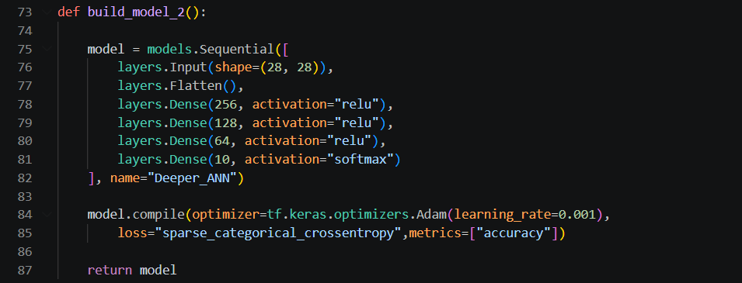

Model 3: ANN with Batch Normalization and Dropout
- The third model introduces regularization and training-stability techniques to address potential overfitting.
- Batch Normalization is applied after the first two Dense layers to normalize intermediate activations during training. This can help stabilize optimization.
- Dropout randomly disables a proportion of neurons during training. The model uses dropout rates of 30% and 25% after the first two hidden layers, respectively. This discourages excessive dependence on particular neurons and can improve generalization.
- The third hidden layer contains 64 neurons, followed by a ten-neuron Softmax output layer. Adam is used as the optimizer.
- Limitation: Batch Normalization and Dropout add complexity and may slow or restrict learning if their settings are unsuitable. Excessive dropout can cause underfitting, while Batch Normalization may not always improve a relatively small network

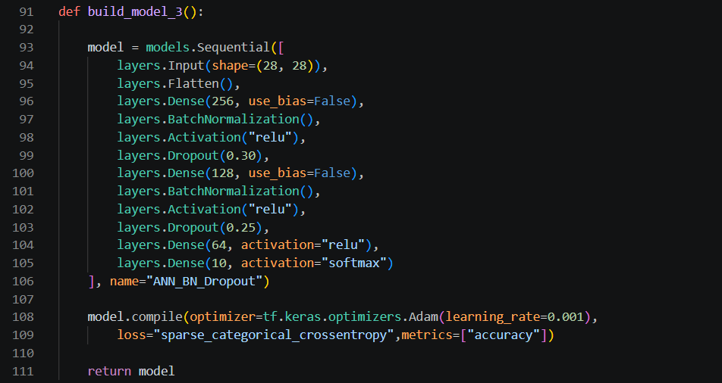

Training and evaluating the three models:
- The models are trained for a maximum of 25 epochs with a batch size of 128. During training, the dataset is processed in batches, and the network parameters are updated to minimize the classification loss.
- The models are trained using the fit method.After training, each model is evaluated using the held-out test dataset.
- The evaluate() function calculates the test loss and accuracy. The predict() function produces class probabilities, and np.argmax() selects the class with the highest predicted probability.
- The project stores each model's performance in a Pandas DataFrame and compares the results using a bar chart.
- The training histories are also used to plot validation accuracy and validation loss across epochs. These visualizations help identify whether a model is learning effectively or showing signs of overfitting.

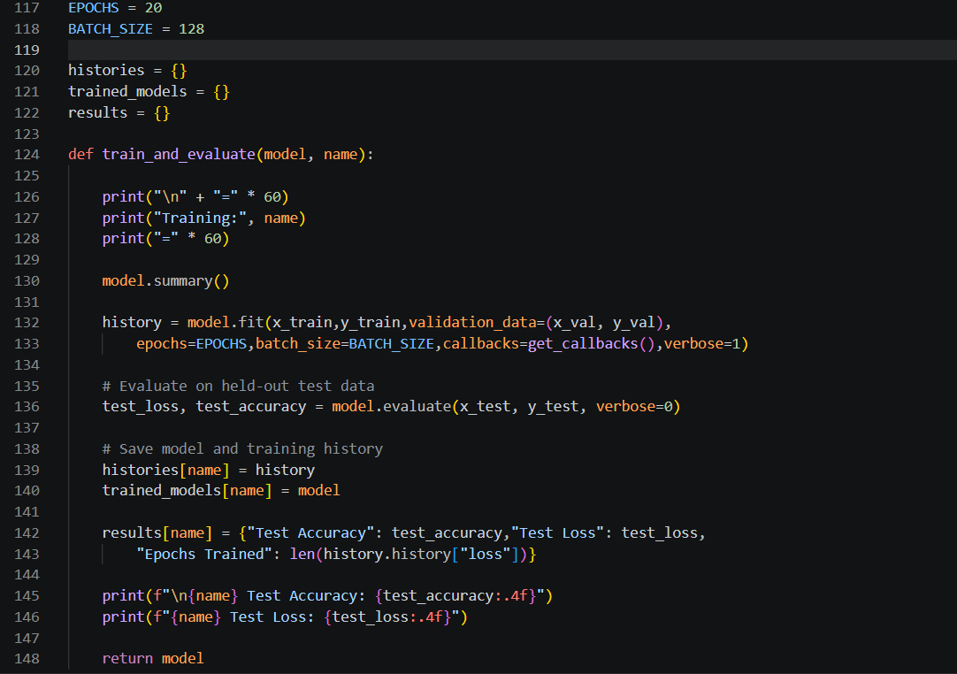
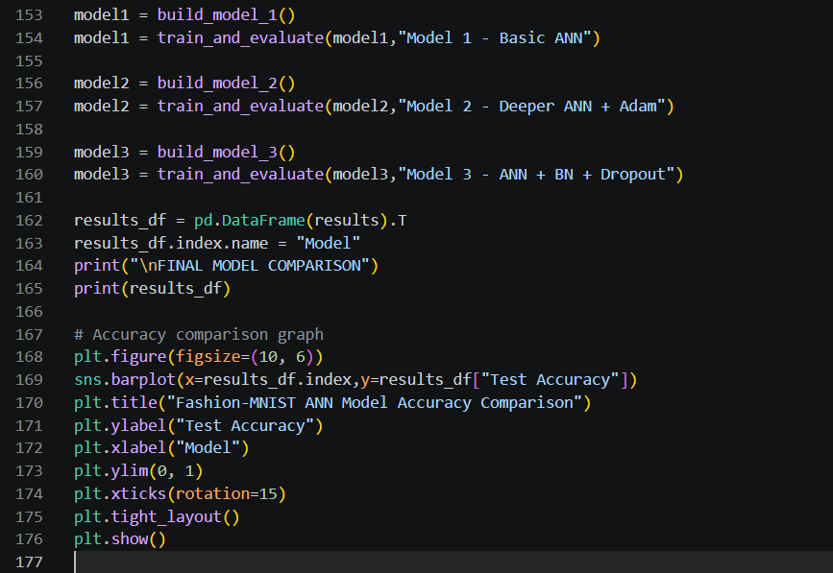
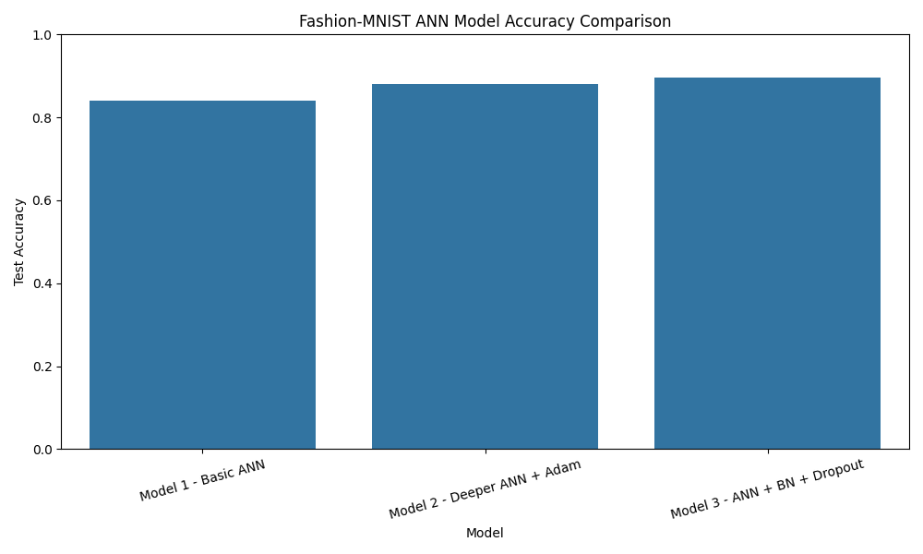
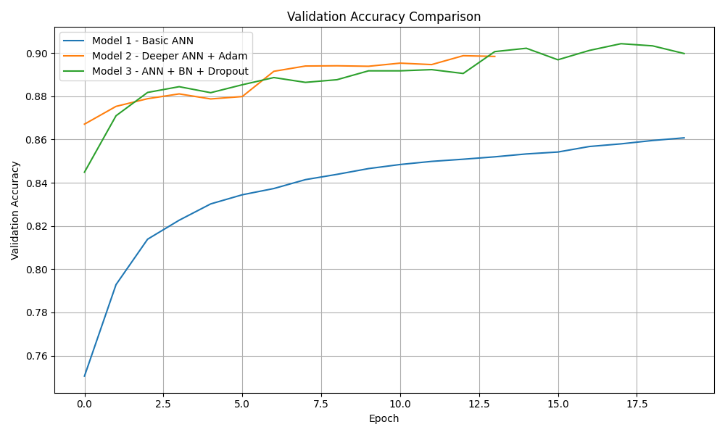

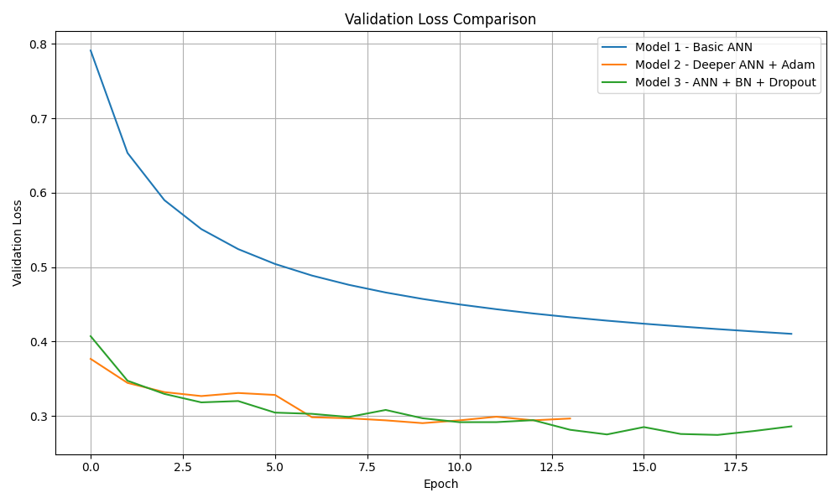
Selecting the best model:
- The best model is selected based on the validation accuracy.
- Then it is evaluated on the test set.
- After which the classification report is displayed.
- The project uses several evaluation metrics to analyze model performance.
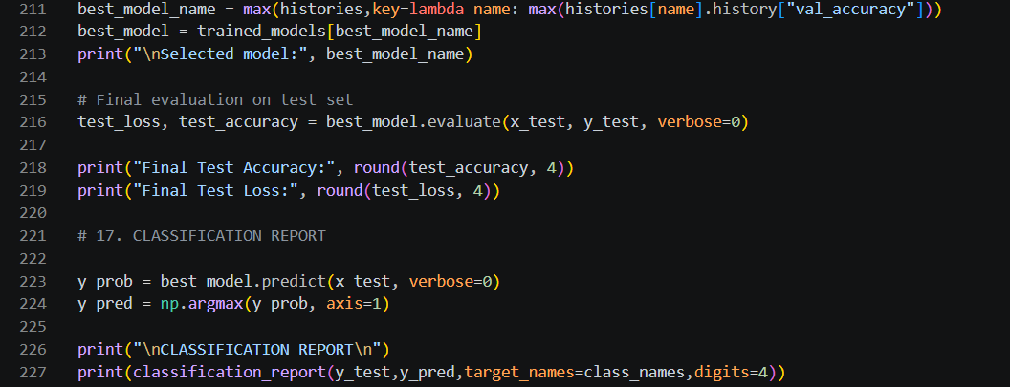

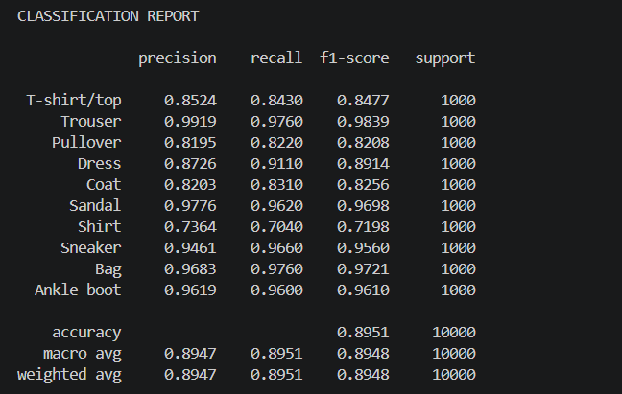
Metric | Explanation
Accuracy | Proportion of all test images classified correctly
Precision | Proportion of positive predictions for a class that are correct
Recall | Proportion of actual samples of a class correctly identified
F1-score | Harmonic mean of precision and recall
Confusion matrix | Shows correct and incorrect predictions for each class

The classification_report() function calculates precision, recall, F1-score, and support for each category. The confusion matrix helps identify classes that are frequently misclassified, such as visually similar clothing categories.

Confusion Matrix and misclassified Images:
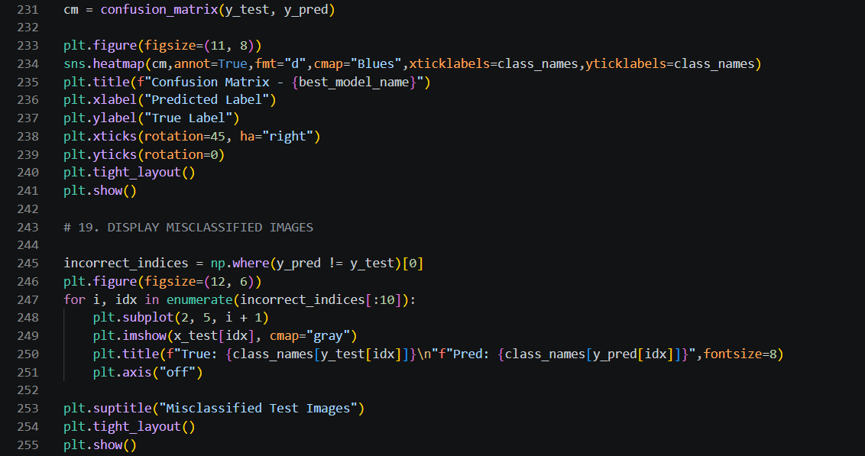
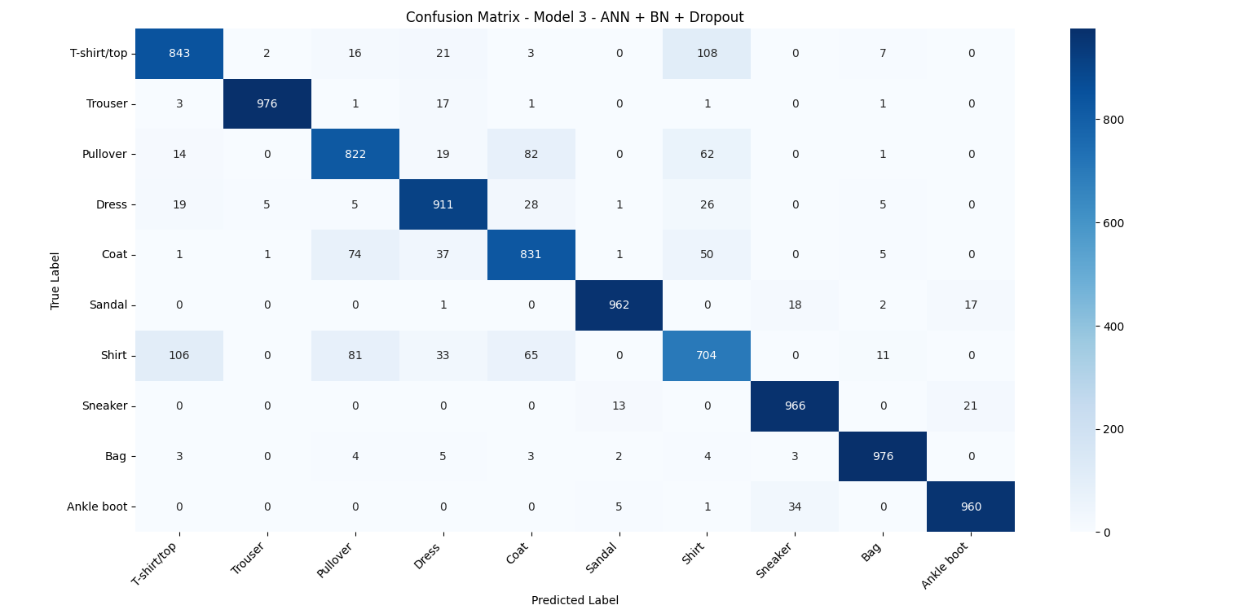
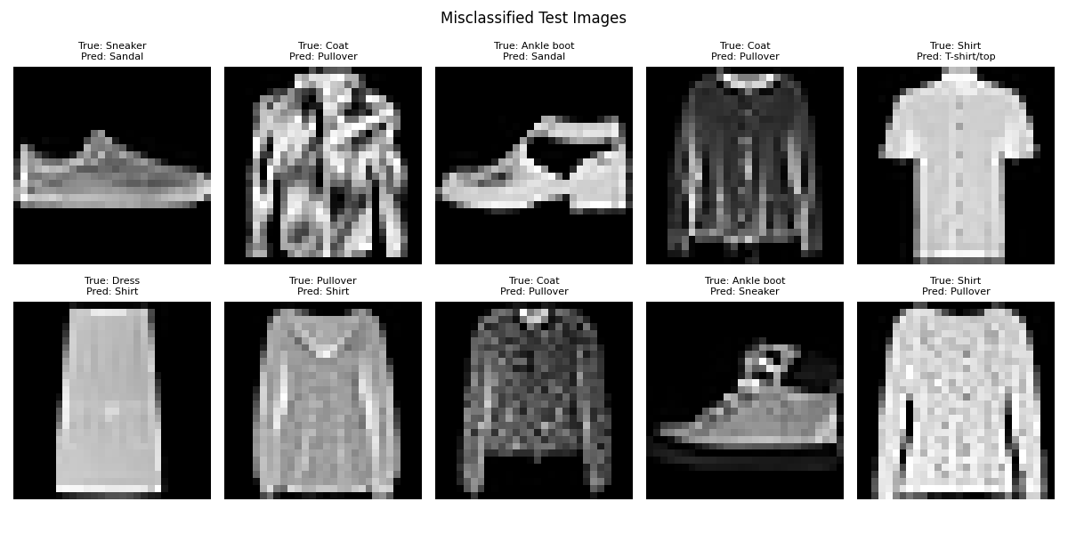
Result and test analysis:
The final test accuracy and loss are obtained by running the three models. Since the results depend on actual training, they should be recorded from the program output rather than assumed in advance.
Results Table
Model | Test Accuracy | Test loss
Model 1- Basic ANN | 0.8411 | 0.455116
Model 2 - Deeper ANN + Adam | 0.8809 | 0.333207
Model 3 - ANN+BN+Droupout | 0.8951 | 0.310717

Analysis of expected behavior
- Model 1 provides a baseline and may struggle to learn complex visual patterns because of its limited architecture.
- Model 2 has greater representational capacity and may benefit from the Adam optimizer's adaptive updates.
- Model 3 introduces regularization and training stabilization, which may reduce the gap between training and validation performance.
- A higher training accuracy does not necessarily indicate better generalization. The validation curves and final test metrics must be considered together.
- Important evaluation consideration: The supplied program compares test accuracy across models, then selects the model using validation accuracy for the detailed classification report. For a strict experimental procedure, use validation performance for model selection and reserve the test set for a single final evaluation after all design decisions have been made.
Limitations of the Implemented Models :
Although the three ANN models provide a useful progression in deep learning complexity, they have several limitations.

1. Loss of Spatial Information
The Flatten layer converts each image into a one-dimensional vector. This removes the explicit two-dimensional structure of the image, making it difficult for the network to exploit local relationships between neighboring pixels.

2. Limited Feature Extraction
Fully connected layers learn relationships between pixel values, but they do not inherently recognize spatial features such as edges, shapes, and textures. Consequently, the models may struggle to distinguish visually similar clothing categories.

3. Overfitting in Deeper Networks
Models with more hidden layers and neurons have more trainable parameters. They may learn specific patterns in the training data without generalizing equally well to unseen images.
Dropout and Early Stopping help address this issue, but they cannot eliminate overfitting completely.

4. Hyperparameter Sensitivity
Performance depends on the learning rate, number of neurons, batch size, dropout rates, optimizer, and number of epochs. The current implementation uses a limited set of manually selected values and does not systematically explore all possible configurations.

5. Computational Cost
Although Fashion-MNIST is relatively small, deeper ANNs require more operations and memory than simpler models. Training multiple models also increases total execution time, particularly on systems without GPU acceleration.

6. Limited Dataset Complexity
Fashion-MNIST consists of small, grayscale, low-resolution images with relatively simple backgrounds. Good performance on this dataset does not guarantee similar performance on real-world clothing images with complex backgrounds, varying lighting, and different orientations.

7. No Formal Statistical Comparison
The models are trained with a fixed random seed and a single train-validation split. Small differences in accuracy may arise from random initialization or data variation. Repeated runs and statistical comparisons would provide stronger evidence of consistent improvements.

Potential Improvements:
Several improvements can be explored to increase model accuracy, improve generalization, and strengthen the experimental evaluation.
Improvement | Description | Expected benefit
Hyperparameter tuning | Experiment with learning rates, batch sizes, and neuron counts | Identify more effective configurations
L2 regularization | Penalize large network weights | Reduce overfitting
Leaky ReLU | Allow a small gradient for negative inputs | Help address inactive ReLU neurons
Learning-rate tuning | Compare different initial learning rates | Improve convergence
Repeated experiments | Train models using multiple random seeds | Assess performance stability
Class-wise error analysis | Investigate frequently confused classes | Identify weaknesses in classification
More systematic validation | Compare models using consistent validation criteria | Improve reliability of model selection

1 Hyperparameter Tuning
Instead of manually selecting the number of neurons, learning rate, dropout rate, and batch size, a systematic search can be performed using KerasTuner or manual experiments.
For example, the learning rate could be compared across values such as 0.01, 0.001, and 0.0001. The best configuration should be selected using validation performance rather than test accuracy.

2 L2 Regularization
L2 regularization can be added to Dense layers to penalize large weights. This may help control model complexity and improve generalization, especially in deeper ANNs.

3 Improved Regularization Strategy
The dropout rates can be adjusted through experiments. A lower dropout rate may help when the model is underfitting, while stronger regularization may be useful if training accuracy is much higher than validation accuracy.

4 Repeated Experiments
Training each architecture with multiple random seeds and comparing mean accuracy and standard deviation would help determine whether improvements are consistent or due to random variation.

5 Advanced Image Classification Architectures
A future extension could explore architectures designed specifically for image data, such as Convolutional Neural Networks (CNNs). CNNs preserve spatial relationships and use convolutional filters to learn local visual features.

Applications:
The concepts demonstrated in this project are relevant to several practical applications:
- Automated clothing categorization in e-commerce platforms.
- Fashion product organization and image-based search.
- Automated tagging of product images.
- Educational demonstrations of neural network training and evaluation.
- Benchmarking optimization and regularization techniques in deep learning.
The current models are experimental classifiers trained on Fashion-MNIST and should not be considered production-ready clothing recognition systems without testing on representative real-world data.

Conclusion:
This project demonstrates the development and evaluation of three Artificial Neural Network models for Fashion-MNIST image classification using TensorFlow and Keras. Starting with a basic ANN, the project progressively introduces deeper network architecture, the Adam optimizer, Batch Normalization, and Dropout to investigate their effects on classification performance.
The training and evaluation process provides practical experience with data preprocessing, model compilation, optimization, regularization, validation, and performance visualization. Accuracy, loss, classification reports, and confusion matrices help analyze model behavior and identify common classification errors.
The project also highlights the limitations of fully connected neural networks, particularly their inability to explicitly preserve spatial relationships in images. Overall, it establishes a foundation for understanding deep learning model development and provides several opportunities for future improvement through hyperparameter tuning, regularization, and more advanced architectures.

References:
1. Xiao, H., Rasul, K., & Vollgraf, R. (2017). Fashion-MNIST: A Novel Image Dataset for Benchmarking Machine Learning Algorithms. arXiv:1708.07747. https://arxiv.org/abs/1708.07747
2. TensorFlow Documentation. Fashion-MNIST Dataset. https://www.tensorflow.org/api_docs/python/tf/keras/datasets/fashion_mnist
3. TensorFlow Documentation. Sequential Model. https://www.tensorflow.org/guide/keras/sequential_model
4. TensorFlow Documentation. Keras Callbacks. https://www.tensorflow.org/api_docs/python/tf/keras/callbacks
5. Scikit-learn Documentation. Classification Report and Confusion Matrix. https://scikit-learn.org/stable/modules/model_evaluation.html

