Exploratory Data Analysis Report
Titanic Passenger Survival Insights

Introduction

This report documents a comprehensive Exploratory Data Analysis (EDA) of the Titanic dataset. The objective is to understand the underlying structure of the data, identify missing values, perform necessary data cleaning, engineer useful features, and uncover key patterns related to passenger survival. Python's pandas, matplotlib, and seaborn libraries were utilized for
data manipulation and visualization.

Data Loading & Initial Inspection

The analysis begins by loading the dataset and performing a preliminary inspection to understand its dimensionality and data types.

import pandas as pd import numpy as np
import matplotlib.pyplot as plt import seaborn as sns

# Load dataset
df = sns.load_dataset("titanic") print("Dataset loaded. Shape:", df.shape)
The dataset contains information on 891 passengers, with features including age, sex, passenger class, fare paid, and survival status.

Data Cleaning and Imputation

Handling missing data is a crucial step. A significant number of missing values were observed in the age, deck, and embarked columns.

Page 1 of 10

# Missing values summary
missing = df.isnull().sum().sort_values(ascending=False)

# Fill missing Age with median
data["age_filled_median"] = data["age"].fillna(data["age"].median())

# Fill Embarked with mode
data["embarked_filled"] = data["embarked"].fillna(data["embarked"].mode()[0])

# Flag missing Deck values
data["deck_known"] = data["deck"].notna().astype(int)
Age was imputed using the median to avoid the influence of outliers. A binary flag was created for the 'deck' feature since its high proportion of missing values suggests that the knowledge of a passenger's deck might itself be informative.

Feature Engineering

New features were created to capture potential familial relationships which might have influenced survival.

# Calculate total family size
data["family_size"] = data["sibsp"].fillna(0) + data["parch"].fillna(0) + 1

# Flag if traveling alone
data["is_alone"] = (data["family_size"] == 1).astype(int)

# Create age groups
age_bins = [0, 12, 18, 35, 60, 100]
age_labels = ["Child","Teen","YoungAdult","Adult","Senior"]
data["age_group"] = pd.cut(data["age_filled_median"], bins=age_bins, labels=age_labels, include_lowest=True)

Features like family_size and is_alone help in analyzing if traveling with relatives improved the chances of survival. Categorizing age into discrete groups simplifies the analysis of age demographics.

Univariate Analysis

Understanding the distribution of individual variables provides foundational insights.

Page 2 of 10

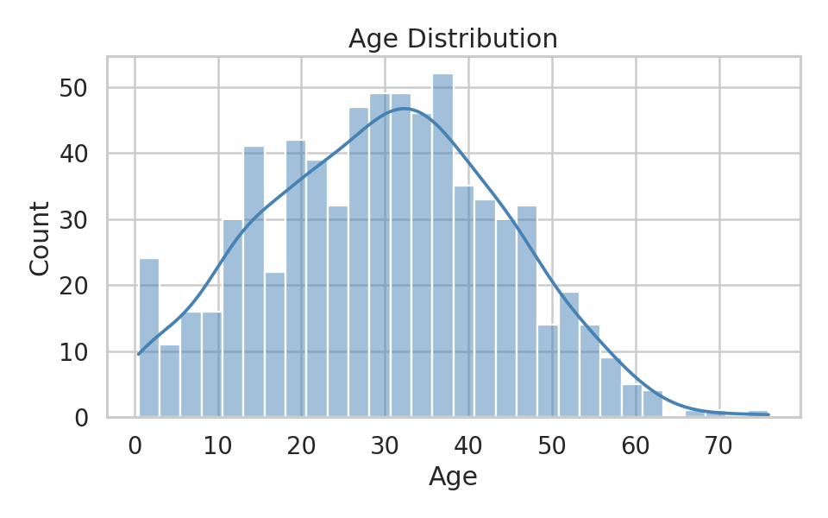

Figure 1: Distribution of passenger ages. The distribution is slightly right-skewed, indicating a younger demographic on board.

Page 3 of 10

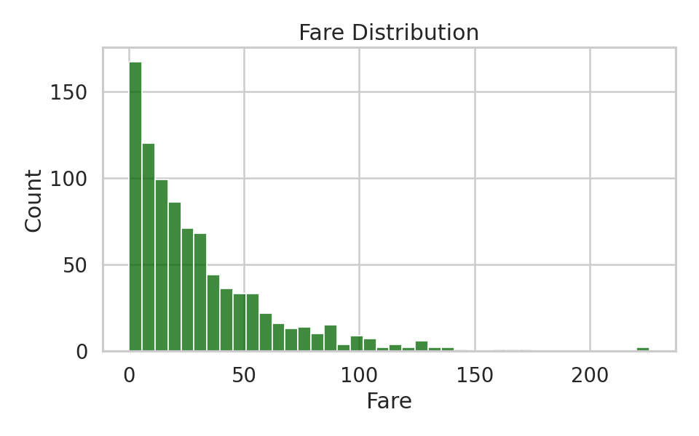

Figure 2: Distribution of fares paid. The long tail indicates a small number of passengers paid significantly higher fares, typical of first-class accommodations.

Bivariate & Multivariate Analysis

We then explore the relationships between features, particularly how they correlate with the target variable, survived.

Page 4 of 10

Age and Passenger Class
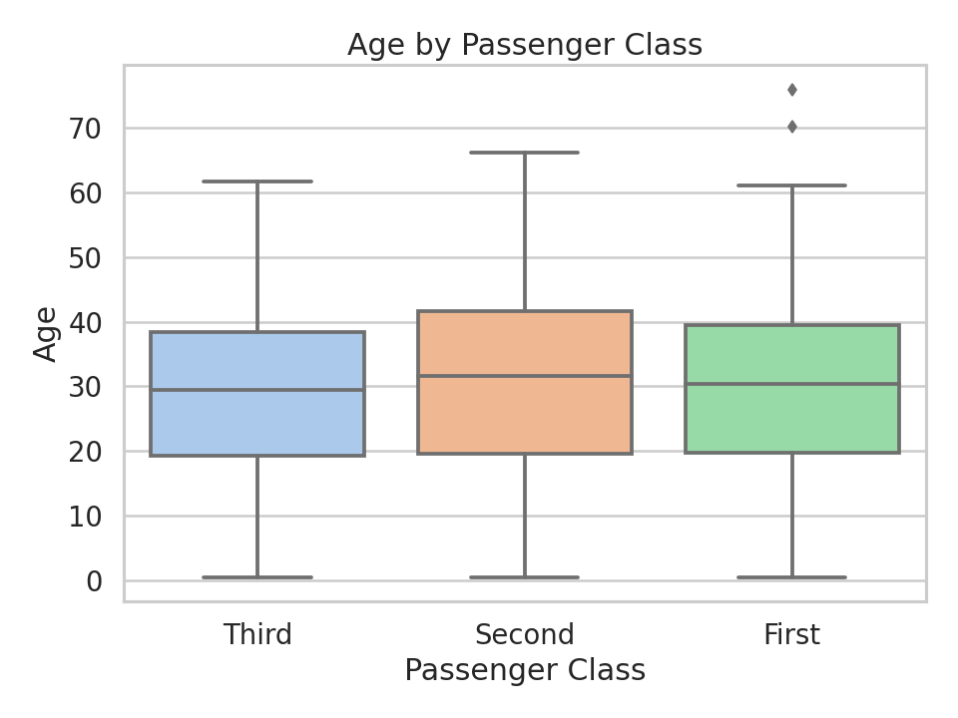

Figure 3: Age distribution across passenger classes. First-class passengers tend to be older, which aligns with the financial capacity required for higher-class tickets.

Page 5 of 10

Survival by Demographics (Sex and Class)
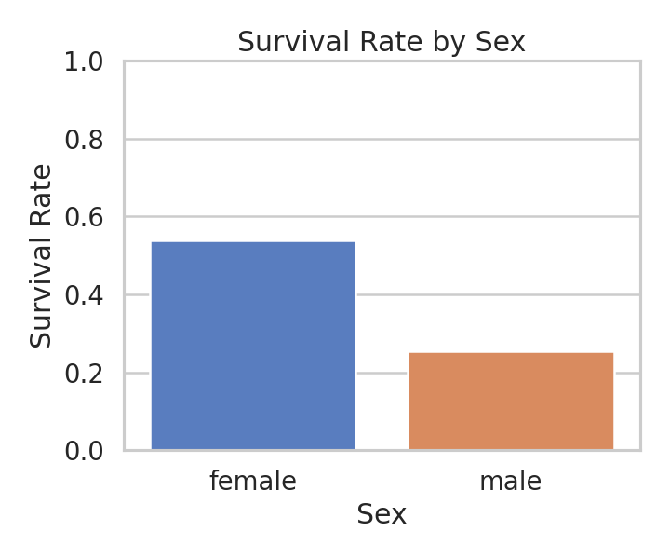

Figure 4: Survival rate comparing male and female passengers. The data clearly shows the 'women and children first' protocol was largely followed.

Page 6 of 10

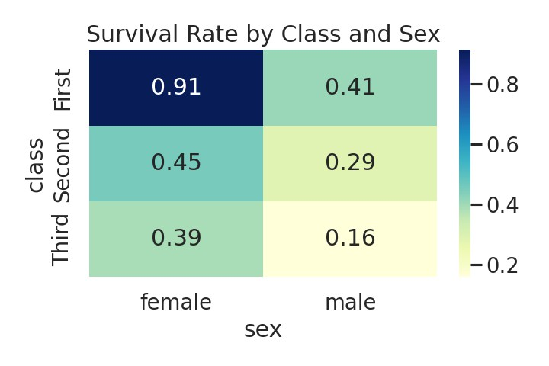

Figure 5: Heatmap showing the combined effect of class and sex on survival. First-class females had the highest survival rates, while third-class males had the lowest.

Page 7 of 10

Survival by Age Group
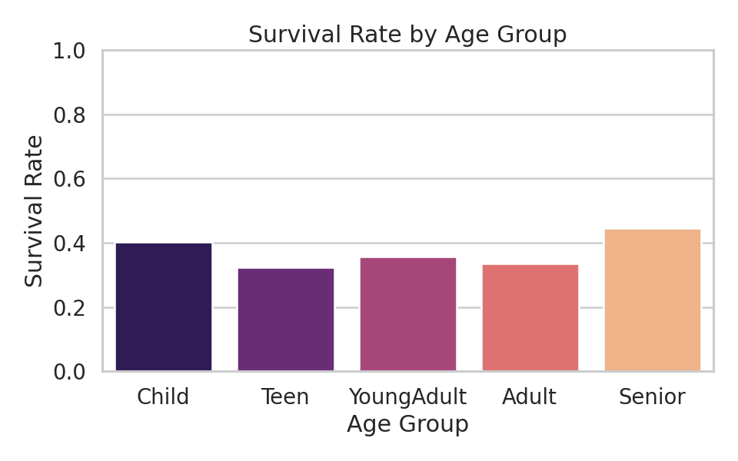

Figure 6: Survival rate across different age demographics. Children show a higher survival rate compared to other age brackets.

Correlation Analysis

To quantify the linear relationships between numeric variables, a correlation matrix was computed.

Page 8 of 10

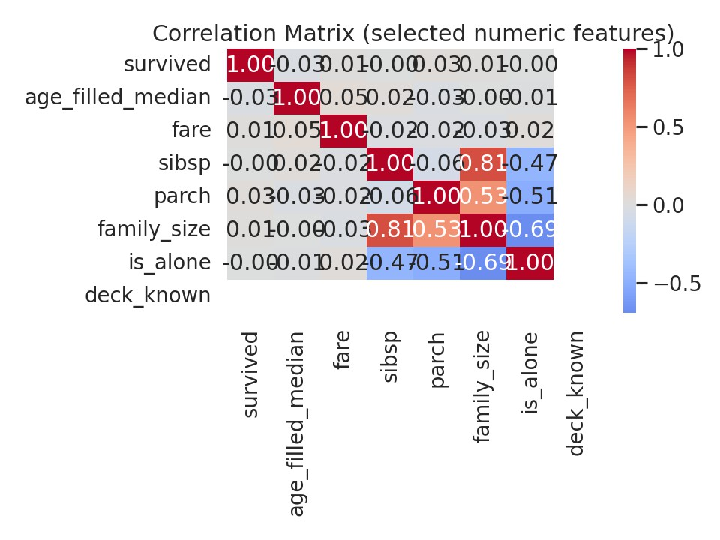
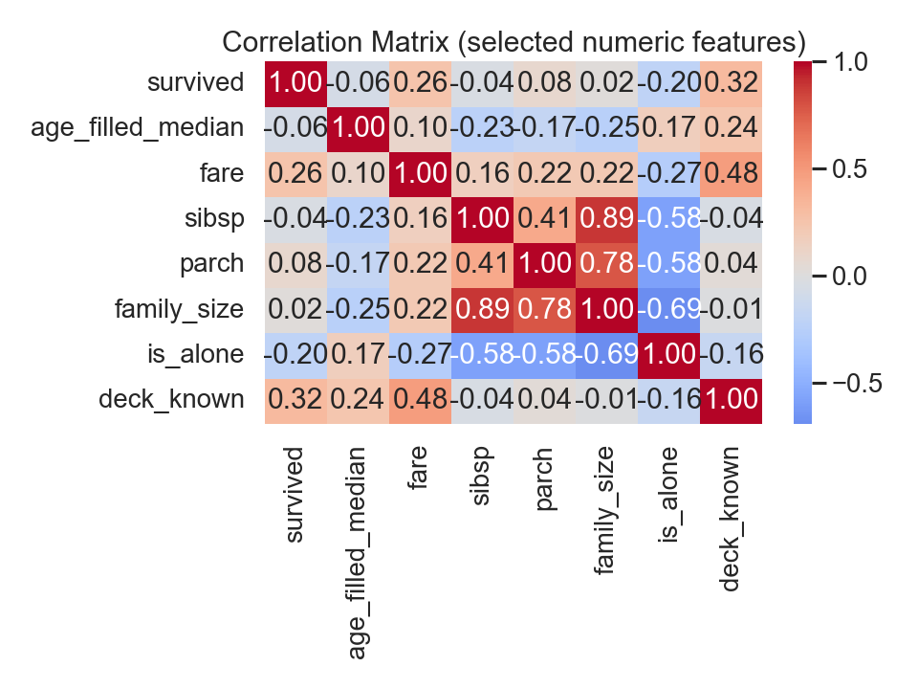

Figure 7: Correlation matrix of selected numeric features. A strong negative correlation is observed between 'is_alone' and 'family_size'. 'Fare' and 'survived' show a positive correlation.

Conclusion

The Exploratory Data Analysis of the Titanic dataset reveals several key findings:

- Socioeconomic Status Matters: Passengers in higher classes (First Class) who paid higher fares had significantly better survival chances.
- Gender Disparity: Female passengers had a markedly higher survival rate than male passengers.
- Age Factor: Children were prioritized during the evacuation, resulting in higher survival rates for the youngest demographic.
- Family Dynamics: Features engineered to capture family size indicate that traveling with a moderate family size might have offered an advantage over traveling alone, though very large families faced challenges.

Page 9 of 10

This preliminary analysis provides a strong foundation for building predictive models, highlighting sex, class, and age as pivotal features.

Page 10 of 10

