WEEK 6

Integrative Capstone Project And Evaluation

1. Problem Statement:
- Educational institutions collect information about students’ study habits, family and school background, attendance, previous academic experiences, and final results. Analyzing these attributes can reveal patterns associated with academic performance and can support data-informed educational planning.
- The problem addressed in this project is to determine whether demographic, social, school-related, and study-related variables can be used to estimate a student’s final academic grade and classify the student as Pass or Fail. The goal is not to replace teacher judgment or label students permanently, but to demonstrate how a complete Data Science pipeline can transform structured educational data into predictive and interpretable outputs.
- A major modeling decision is to exclude G1 and G2 from the predictors. The code explicitly identifies these variables as earlier-period grades and explains that using them to predict G3 would make the task easier but less useful for an early-support scenario. Therefore, the project focuses on information available independently of those earlier grades.
2. Objectives:
- Acquire a publicly available educational dataset using the ucimlrepo Python package.
- Inspect the dataset structure, data types, missing values, and descriptive statistics.
- Prepare numerical and categorical variables for machine learning.
- Remove G1 and G2 to create a more practically meaningful prediction task.
- Cap extreme numerical values using the IQR method.
- Convert categorical variables into machine-readable one-hot encoded features.
- Perform exploratory data analysis using distributions, correlations, boxplots, and scatter plots.
- Build regression models for predicting final grade G3.
- Build classification models for predicting Pass/Fail status.
- Evaluate models using appropriate quantitative metrics.
- Interpret feature importance and identify useful patterns.
- Discuss challenges, limitations, ethical considerations, and future improvements.
3. Dataset Collection and Description:
The project uses the UCI Student Performance dataset. The dataset is loaded programmatically using fetch_ucirepo(id=320), which makes the workflow reproducible without manually downloading and moving a CSV file.
The feature matrix contains 29 demographic, social, and school-related features, while the target data contain G1, G2, and G3. G1 and G2 represent earlier period grades, while G3 is the final grade on a 0–20 scale. The code combines the feature and target tables into a single Pandas DataFrame before analysis.
The program prints the exact shape, first rows, data types, total missing values, and numerical descriptive statistics.

Important Variables
Variable / Group | Role in the project | Interpretation
G3 | Regression target | Final grade on a 0–20 scale
Result | Classification target | Pass if G3 ≥ 10; otherwise Fail
G1, G2 | Excluded predictors | Earlier-period grades; removed for practical usefulness
studytime | Predictor | Weekly study-time category
failures | Predictor | Number of previous class failures
higher | Predictor | Whether the student intends to pursue higher education
absences | Predictor | Number of recorded absences
Demographic/social/school variables | Predictors | Background and educational context variables

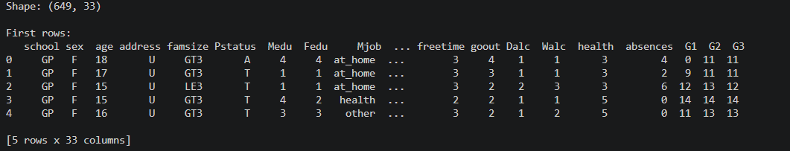
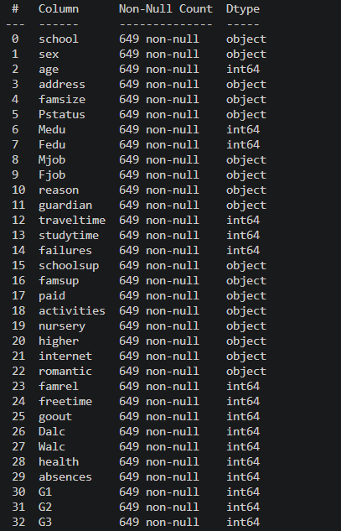
4. Methodological Approach:
The project follows a structured Data Science pipeline. Each stage has a defined purpose and contributes to the final predictive analysis.
- Data acquisition: retrieve the UCI dataset using ucimlrepo.
- Initial inspection: examine shape, records, data types, missing values, and descriptive statistics.
- Preprocessing: handle missing values if present, remove G1/G2, cap numerical outliers, and one-hot encode categorical variables.
- Target construction: create a Pass/Fail variable from G3 using a threshold of 10.
- Exploratory analysis: visualize G3 distribution, correlations, categorical relationships, and absences versus grade.
- Train/test preparation: split the data using an 80/20 split and stratify by the classification target.
- Feature scaling: fit StandardScaler on the training set and transform both training and test features.
- Regression: compare Linear Regression and Random Forest Regressor using RMSE, MAE, and R².
- Classification: compare Logistic Regression and Random Forest Classifier using accuracy, precision, recall, and F1-score, followed by ROC-AUC for the selected Random Forest model.
- Interpretation: examine Random Forest feature importance and identify practical insights.
- Reflection: assess limitations, potential leakage, model selection, and future improvements.
5 Data Cleaning and Preprocessing :

5.1 Missing Values
The program checks numeric and categorical columns separately. If a numerical column contains missing values, its missing entries are replaced with the column median. If a categorical column contains missing values, the mode is used. The current dataset is expected to have no missing values according to the program's inspection output, but the handling logic makes the workflow more robust.

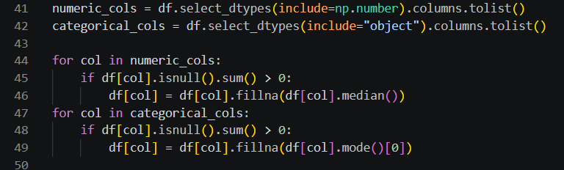

5.2 Removal of G1 and G2
G1 and G2 are deliberately removed before model training. Since these variables are previous-period grades, including them would make the final-grade prediction strongly dependent on information that is already very close to the target. Removing them creates a more meaningful experiment based on demographic, social, school, attendance, and study-related attributes.

5.3 Outlier Capping
The code uses the Interquartile Range (IQR) method. For each remaining numerical feature, Q1 and Q3 are calculated, the IQR is Q3 − Q1, and values below Q1 − 1.5×IQR or above Q3 + 1.5×IQR are clipped to the corresponding boundary. This reduces the influence of extreme observations without deleting entire records.

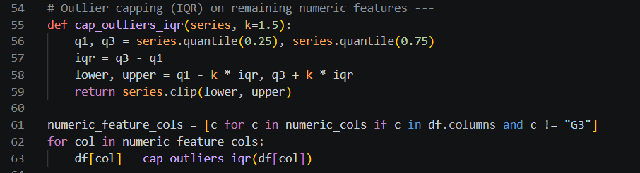

5.4 Categorical Encoding
Categorical variables are transformed using Pandas get_dummies() with drop_first=True. One-hot encoding converts categories into binary indicator columns that can be processed by the machine learning algorithms

5.5 Target Construction
For classification, the code creates a Result column using G3 ≥ 10 as Pass and G3 < 10 as Fail. The threshold is explicitly defined in the submitted program and is used consistently throughout the classification experiment.

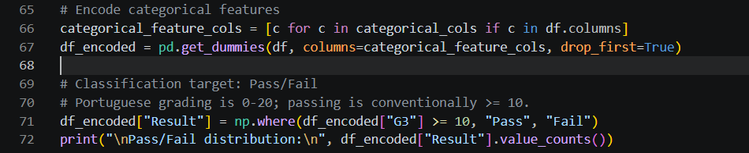

6. Exploratory Data Analysis:
EDA is used to understand the distribution of the target and the relationships between academic performance and selected explanatory variables before interpreting model results.

6.1 Final Grade Distribution
The code creates a histogram with a density curve for G3 and marks the Pass threshold at 10. This visualization helps determine how grades are distributed and whether a large concentration of observations lies close to the classification boundary.
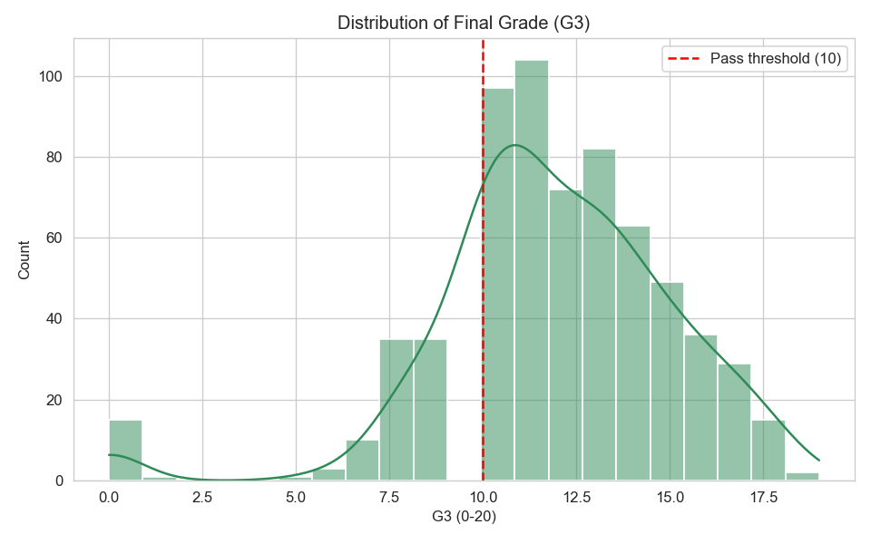
6.2 Correlation Heatmap
The correlation heatmap examines relationships among the remaining numerical features and G3. Stronger positive or negative correlations can indicate variables that deserve further investigation, although correlation alone does not establish causation.
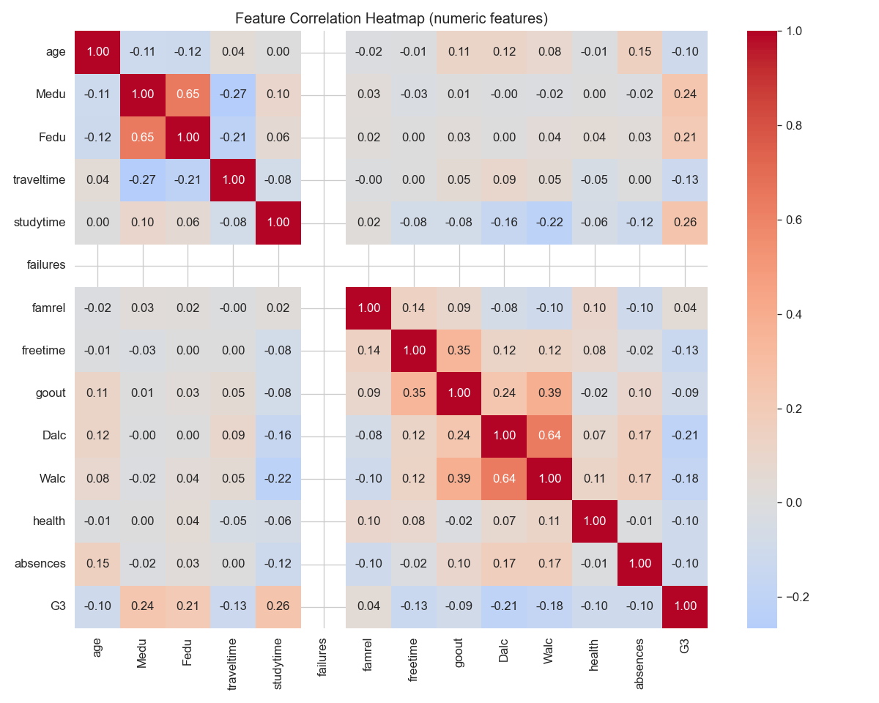
6.3 Study Time, Previous Failures, and Higher-Education Intention
The boxplots compare G3 across study-time categories, previous-failure counts, and higher-education intention. These plots can reveal differences in grade distributions between groups. Any observed difference should be described as an association rather than as proof that a particular behavior directly causes higher or lower grades.
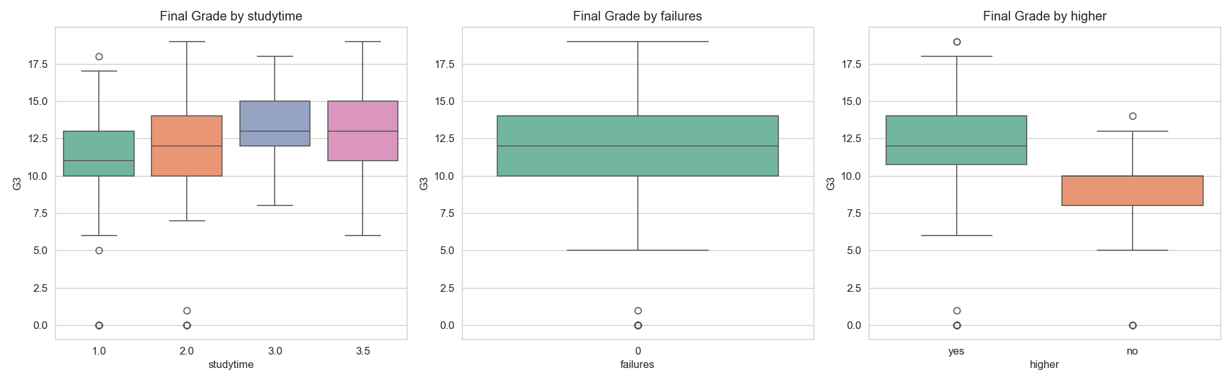

6.4 Absences versus Final Grade
The scatter plot compares absences with G3 and colors observations according to Pass/Fail status. This provides a visual check for possible relationships between attendance and final academic performance and can also reveal unusual observations
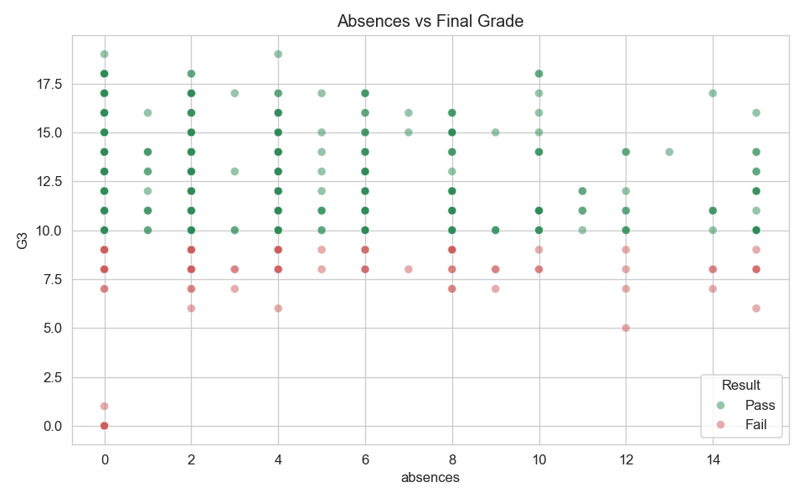
6.5 EDA Insights to Report After Execution
- Describe whether the final-grade distribution is concentrated around a particular range.
- Identify numerical variables with visibly stronger relationships with G3 in the heatmap.
- Compare the central tendency and spread of G3 across study-time groups.
- Describe how the number of previous failures relates to the observed grade distributions.
- Comment on whether higher-education intention groups show visibly different grade
distributions.
- Describe the overall pattern between absences and G3, while avoiding causal language.
- Identify visually unusual observations that may influence model performance.

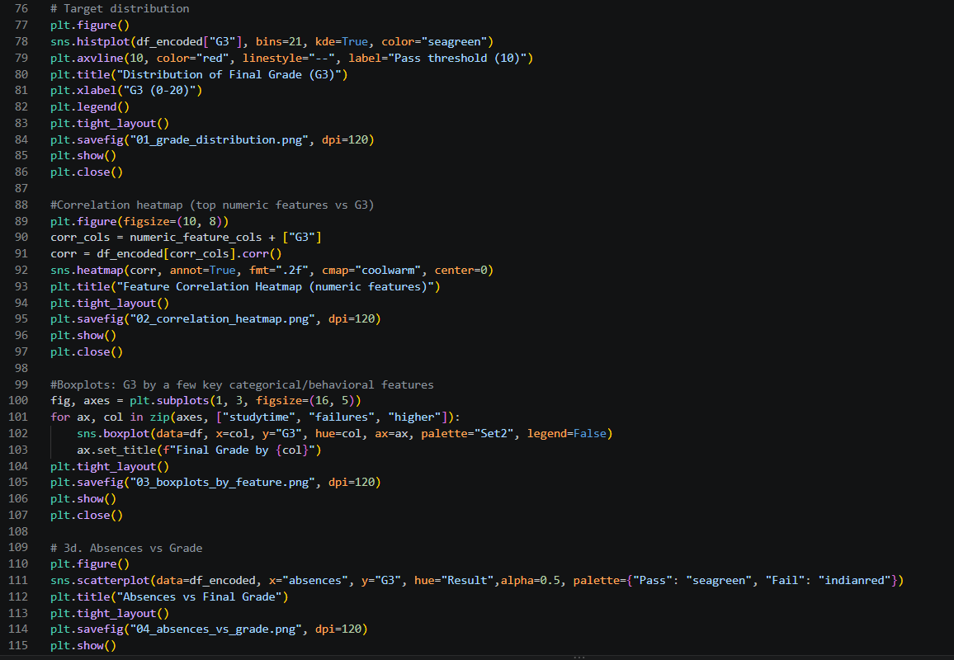
7. Model Development:

7.1 Train/Test Split
The code uses an 80/20 train/test split with random_state=42. Stratification is based on the Pass/Fail target so that the class distribution is approximately preserved between the training and testing sets. The same feature matrix is used for both regression and classification.

7.2 Standardization
StandardScaler is fitted on X_train and then used to transform X_train and X_test. This prevents information from the test set from being used to estimate the scaling parameters. Scaling is particularly relevant for Linear Regression and Logistic Regression. It is not required by Random Forest models, but the code implementation applies the same scaled feature matrix to all models for consistency.

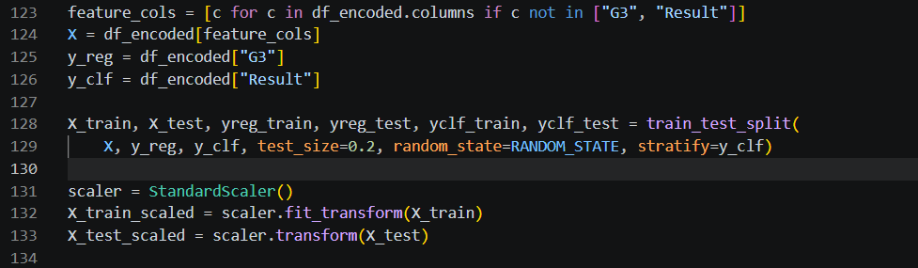

7.3 Regression Models

Model | Purpose | Key characteristics
Linear Regression | Baseline regression | Models G3 as a linear combination of the available predictors.
Random Forest Regressor | Nonlinear regression | Combines many decision trees and can model nonlinear interactions among features.
The regression models are evaluated using RMSE, MAE, and R². Lower RMSE and MAE indicate smaller prediction errors, while a higher R² indicates that the model explains more variance relative to a mean-based baseline.

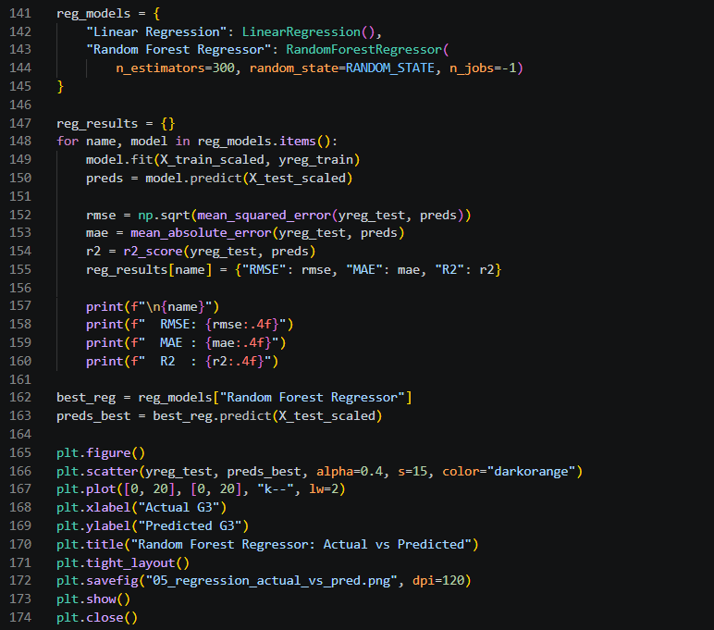
7.4 Classification Models

Model | Purpose | Key characteristics
Logistic Regression | Linear classification baseline | Estimates class probabilities using a logistic function.
Random Forest Classifier | Nonlinear classification | Combines many decision trees to capture nonlinear decision boundaries and interactions.
The classification models are evaluated using Accuracy, Precision, Recall, and F1-score. The code also calculates ROC-AUC for the Random Forest Classifier. Because the project contains two classes, these metrics provide complementary information about overall correctness and class-specific prediction quality.

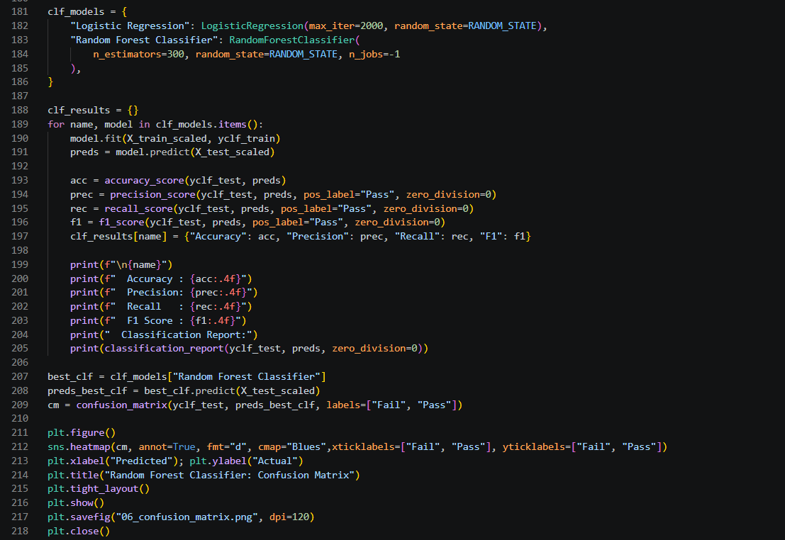

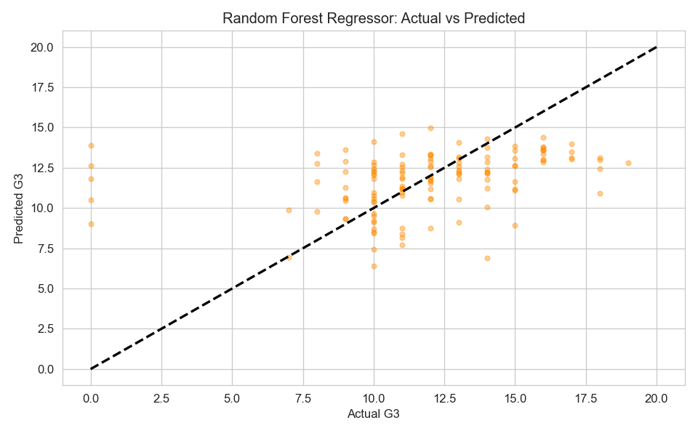

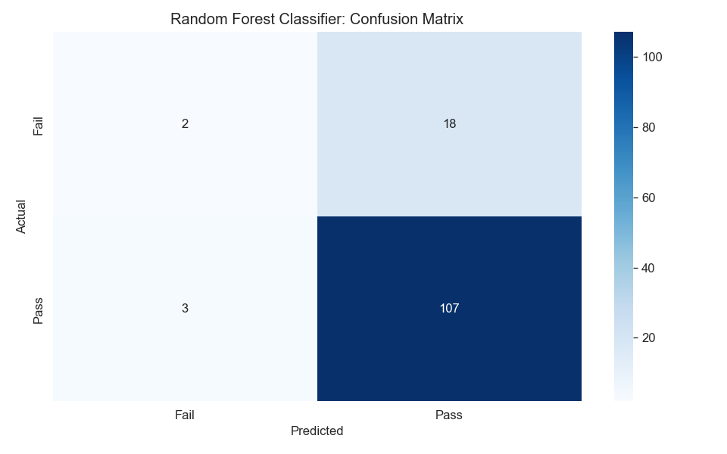
7.5 Feature Importance
The project extracts feature_importances_ from the Random Forest Regressor and Random Forest Classifier and displays the top 15 features. These importance values are useful for identifying which variables the fitted tree ensembles relied on most heavily. They should be interpreted as model-specific associations, not causal effects.
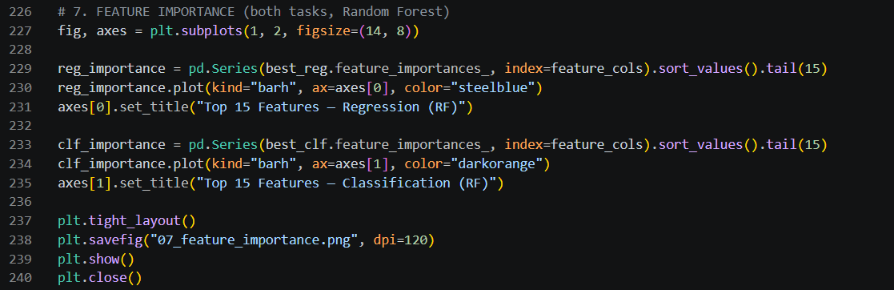
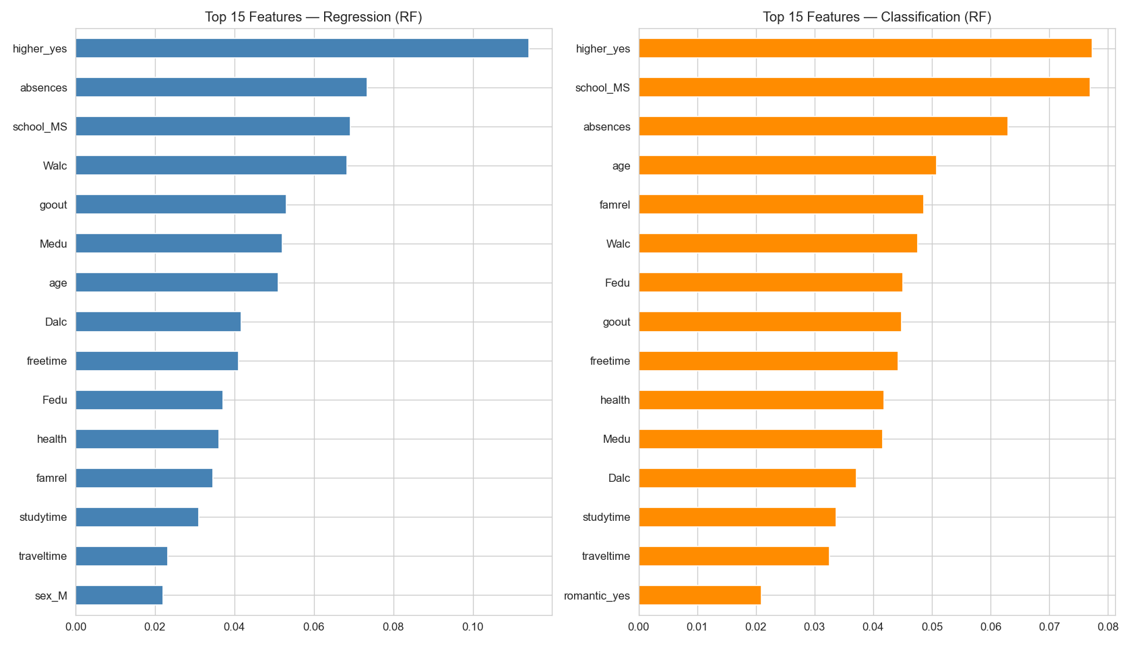

8. Model Evaluation and Results:
The submitted code prints the evaluation metrics directly after training. Because the uploaded code does not include the final console output, the numerical result fields below are intentionally left blank for insertion from the actual run. This keeps the report evidence-based and prevents unsupported performance claims.
8.1 Regression Results
Model | RMSE | MAE | R²
Linear Regression | 3.424425 | 2.461759 | 0.056016
Random Forest Regressor | 3.400600 | 2.393564 | 0.069105

8.2 Classification Results
Model | Accuracy | Precision | Recall | F1-score
Logistic Regression | 0.769231 | 0.857143 | 0.872727 | 0.864865
Random Forest Classifier | 0.838462 | 0.856000 | 0.972727 | 0.910638

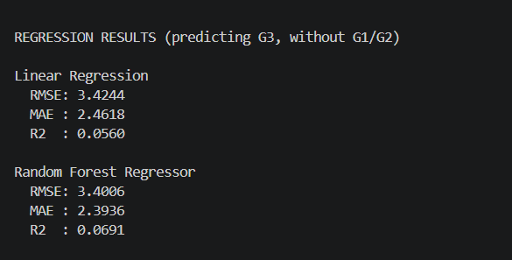
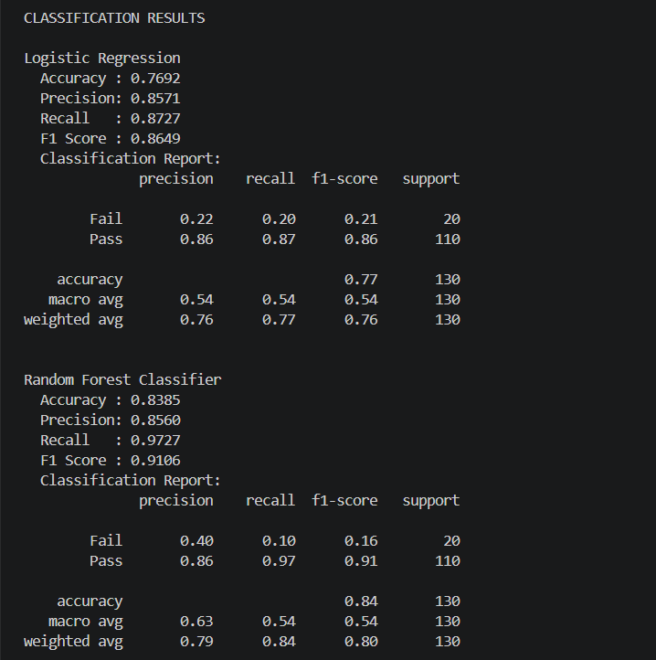

9. Results Interpretation and Key Insights:
The final interpretation should combine the EDA findings, numerical metrics, confusion matrix, and feature-importance plots. The following insights are designed to guide the final discussion while leaving the actual dataset-specific observations to the generated outputs.
9.1 Academic Performance Patterns
The project is designed to investigate whether study habits, attendance, previous failures, and other student characteristics contain useful information about final performance. If the EDA shows clear group differences, these should be reported as patterns in the observed data rather than as causal relationships.
9.2 Value of Removing G1 and G2
Removing G1 and G2 makes the problem more demanding but also more meaningful for an early-support interpretation. A model that performs reasonably without previous grades demonstrates that other student attributes contain predictive information, although the strength of that information must be established from the actual metrics.
9.3 Linear versus Nonlinear Modeling
The comparison between Linear Regression and Random Forest Regressor provides a useful test of whether nonlinear relationships and feature interactions improve grade prediction. Similarly, Logistic Regression provides a simple classification baseline, while Random Forest can represent more complex boundaries.
9.4 Feature Importance
The feature-importance chart can be used to identify variables that the Random Forest models rely on most heavily. These variables can guide further analysis, but importance should not be interpreted as evidence that changing a feature will necessarily change academic performance.
9.5 Practical Interpretation
If the models show useful predictive performance, they could be considered as analytical support tools for identifying broad patterns or prioritizing further review. Any real deployment would require validation on new student cohorts, fairness checks, careful privacy controls, and human oversight.

10. Challenges and Reflection:
One of the central challenges in this project was designing a prediction task that was not artificially easy. The submitted code explicitly recognizes that G1 and G2 are highly related to G3 and removes them. This is an important modeling decision because a technically accurate model can still be practically weak if it relies on information that becomes available too late.
Another challenge is preprocessing. Numerical and categorical variables require different treatment, and the final feature matrix must be consistent across the models. The project also demonstrates why multiple evaluation metrics are needed. A single accuracy value cannot describe the complete behavior of a classifier, while a single regression metric does not show every aspect of prediction error.
The project successfully integrates the main stages of a Data Science workflow: acquisition, inspection, preprocessing, EDA, supervised learning, evaluation, visualization, and interpretation. It also provides experience in comparing a simple statistical model with ensemble methods.
A further improvement would be to move preprocessing operations such as outlier-bound estimation and imputation inside a Scikit-learn Pipeline fitted only on the training data. In the code, these operations are performed before the train/test split. Although this may have limited impact on a small educational dataset, a stricter experimental design should prevent test-set information from influencing preprocessing decisions.
11. Limitations:
- The dataset represents a particular educational context and may not generalize to all institutions or student populations.
- The code uses a single 80/20 train/test split, so the reported performance can vary with the split.
- Outlier capping and missing-value handling occur before the train/test split in the submitted implementation; this can introduce mild preprocessing leakage.
- Random Forest does not require feature scaling, so scaling it is unnecessary although not inherently harmful to the fitted predictions.
- The code defines best_reg and best_clf directly as the Random Forest models rather than programmatically selecting the model with the best metric.
- Feature importance from Random Forest is model-specific and should not be interpreted as causal importance.
- The Pass threshold of 10 is a project assumption and should be confirmed against the grading policy relevant to the intended application.
- The project does not perform systematic hyperparameter tuning or repeated cross-validation.
- No fairness or subgroup error analysis is implemented in the current version.
- The model should not be treated as production-ready without external validation and appropriate governance.
12. Future Scope:
- Use cross-validation to obtain more stable estimates of model performance.
- Build preprocessing pipelines so that all learned transformations are fitted only on training data.
- Use GridSearchCV or RandomizedSearchCV for systematic hyperparameter tuning.
- Compare additional algorithms such as Gradient Boosting, Support Vector Regression, or Support Vector Classification.
- Perform permutation importance or SHAP-based interpretation for more detailed model analysis.
- Evaluate performance separately across demographic and contextual subgroups.
- Use repeated train/test experiments with different random seeds to estimate performance variability.
- Develop an early-warning version using only information available at the beginning of the academic period.
- Create a simple Streamlit dashboard for exploratory analysis and model demonstration.
- Validate the approach on an independent dataset before considering real-world use.

13. Applications:
- Educational data analysis and academic-performance research.
- Exploratory identification of factors associated with student outcomes.
- Demonstration of regression and classification techniques in education.
- Prototype dashboards for academic analytics.
- Teaching and learning applications for end-to-end machine learning workflows.

14. Conclusion:
This project demonstrates a complete Data Science pipeline for student exam score prediction and Pass/Fail classification using Python. The workflow begins with public data acquisition through ucimlrepo and continues through data inspection, preprocessing, exploratory analysis, model development, evaluation, visualization, and interpretation.
The project deliberately removes G1 and G2 from the feature set so that the models attempt to predict final performance using demographic, social, school, attendance, and study-related information. Linear Regression and Random Forest Regressor are used for continuous grade prediction, while Logistic Regression and Random Forest Classifier are used for Pass/Fail classification. Feature-importance analysis adds an interpretable layer to the machine learning results.
The project also highlights an important Data Science principle: strong model performance alone is not sufficient. The quality of preprocessing, validity of the evaluation procedure, practical availability of predictors, generalization to new data, and responsible interpretation all matter. With cross-validation, leakage-safe preprocessing, systematic tuning, subgroup evaluation, and external validation, the project could be extended into a more robust educational analytics system.

