As per your request added login for the farmer

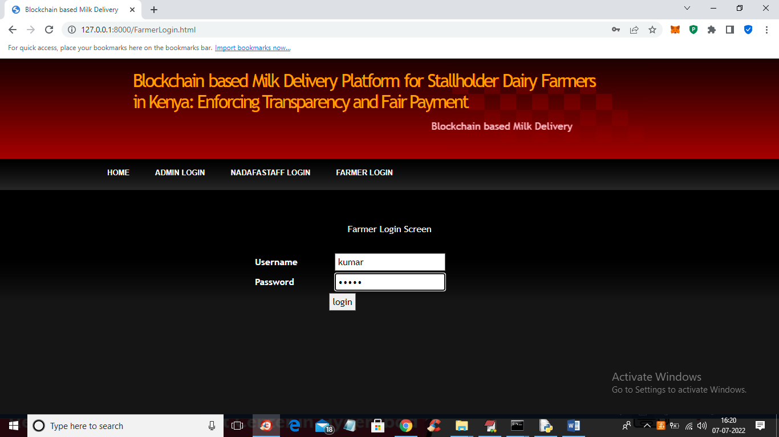

In above screen farmer is login and this username and password will be provided by ‘admin’ and after login will get below screen

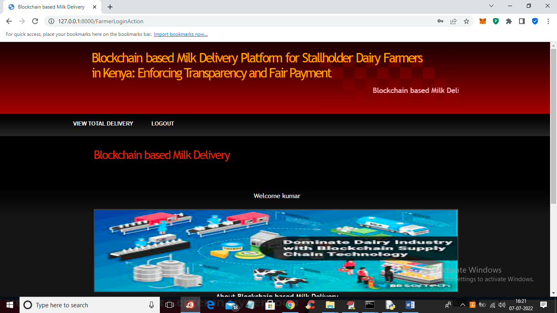

In above screen farmer can click on ‘View Total Delivery’ link to view all deliveries did by him

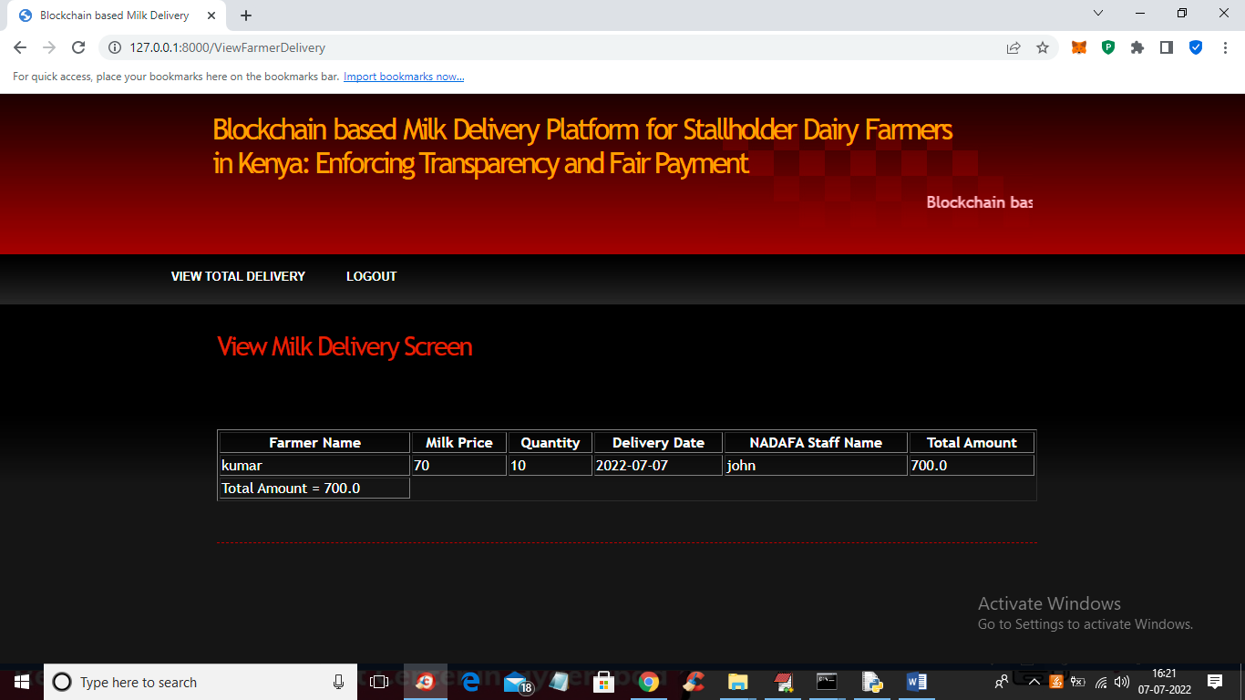

In above screen farmer can view all his milk deliveries with quantity and date wise. This details will be added by NADAF staff. Similarly you can add any number of farmer and staff and run code.