Blockchain based Milk Delivery Platform for Stallholder Dairy Farmers in Kenya: Enforcing Transparency and Fair Payment

In propose paper author is describing about milk production of Kenya country from its farmer. All farmers will sold their milk to 3rd part brokers or NADAF staff members and they will record each farmer milk delivery in a manual inventory report or in computer excel or centralized server. All framers may be no or less educated so brokers may alter farmer milk deliver records and make less payment to farmers and steal money.

To overcome from above issue author of this paper suggesting to migrate such inventory to Blockchain based server where data storage is immutable which means data cannot be alter in any manner after storage. Blockchain is a decentralized network which store data in multiple nodes and if one node is down then it can retrieve data from other working nodes. Blockchain store each record as block or transaction and associate each block with hash code and before storing any new block then it will verify hash code of each old blocks and if all records verified successfully then only it will store new records. So data alteration is impossible in Blockchain.

So by using Blockchain we can save farmers money stealing by brokers.

To implement this project we have designed following modules

1. Admin: admin can login to application by using username as admin and password as admin and then can add new farmer details who supply milk and add new NADAFA staff members. Admin can view all staff and farmer details
2. NADAFA Staff Login: staff can login to application by using username and password given by admin and then record all milk deliveries done by farmer and all this delivery details will be saved in Blockchain

To store record in Blockchain we need to design SOLIDITY Smart Contract code and this code contains all functions to store farmer and staff details and then this contract will be deployed on Blockchain Ethereum tool. After deployment we can call this contract to read and store data by using PYTHON WEB3 package.

Below screen showing solidity code

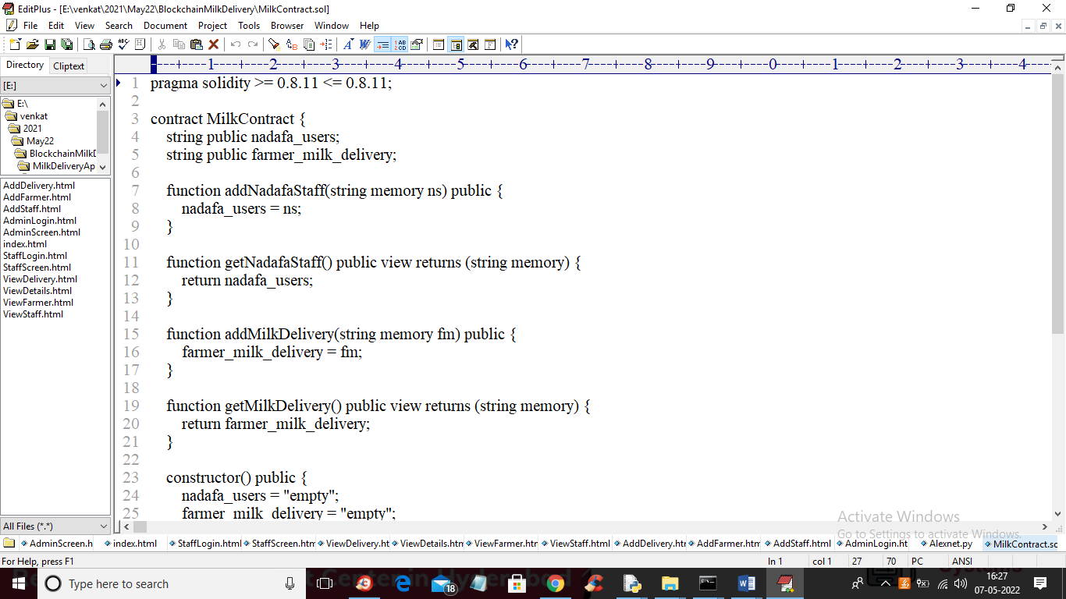

In above screen we have designed two functions where one is used to store staff details and other function is used to store and retrieve milk delivery details. Now to deploy this contract in Blockchain just go inside ‘hello-eth/node_modules/.bin’ folder and then double click on ‘runBlockchain.bat’ file to get below screen

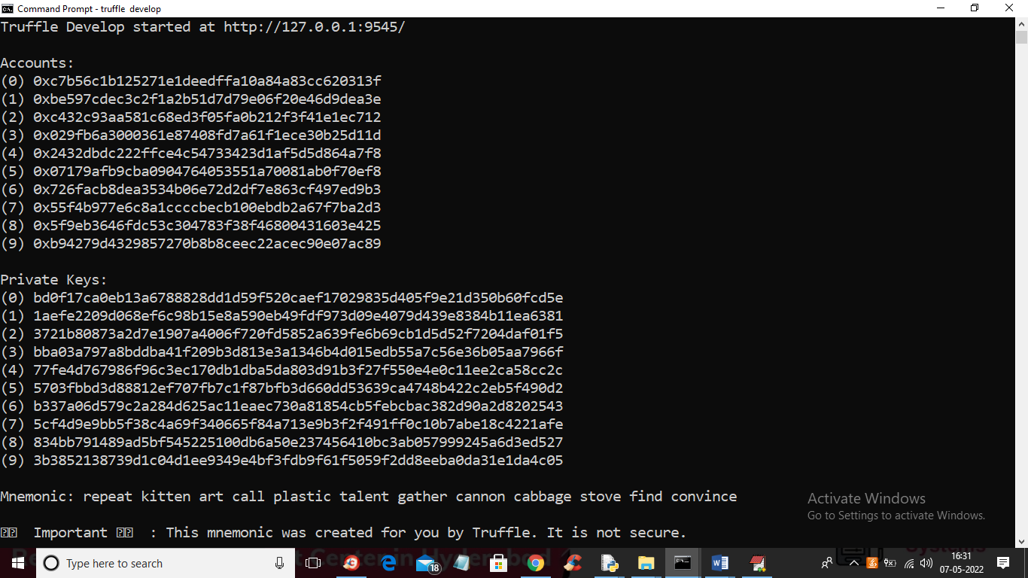

In above screen Blockchain generate some default accounts and keys and now in same console type “truffle migrate” and press enter key to deploy contract to Blockchain and get below output

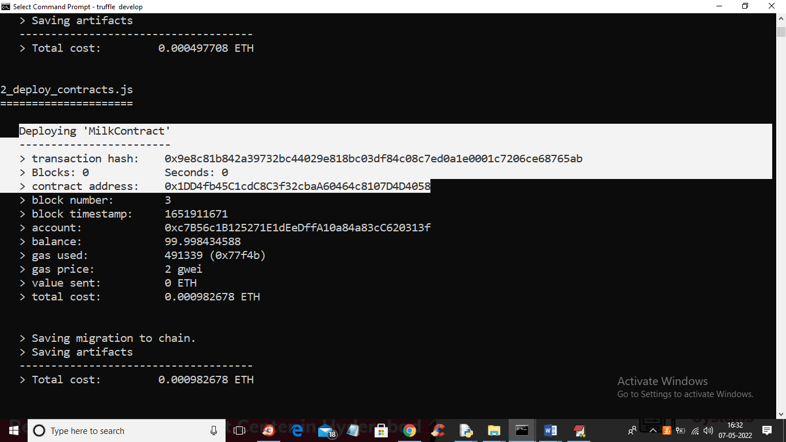

In above screen in white colour text we can see MILK contract deployed and we have to specify that contract address in python code to access this Blockchain function and below is the python code

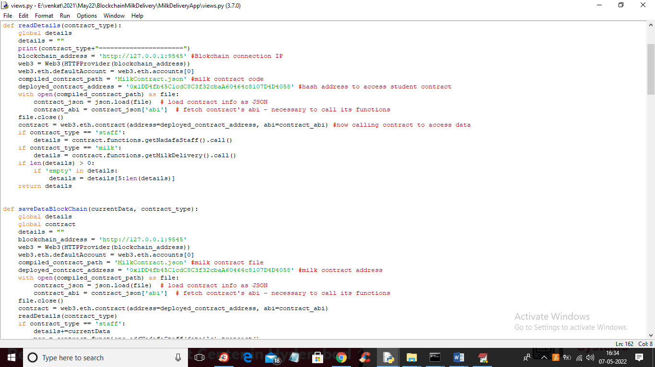

In above screen in red colour comments you can see we are calling MILK contract by using its contract address.

Now double click on ‘run.bat’ file from code folder to start DJANGO server like below screen

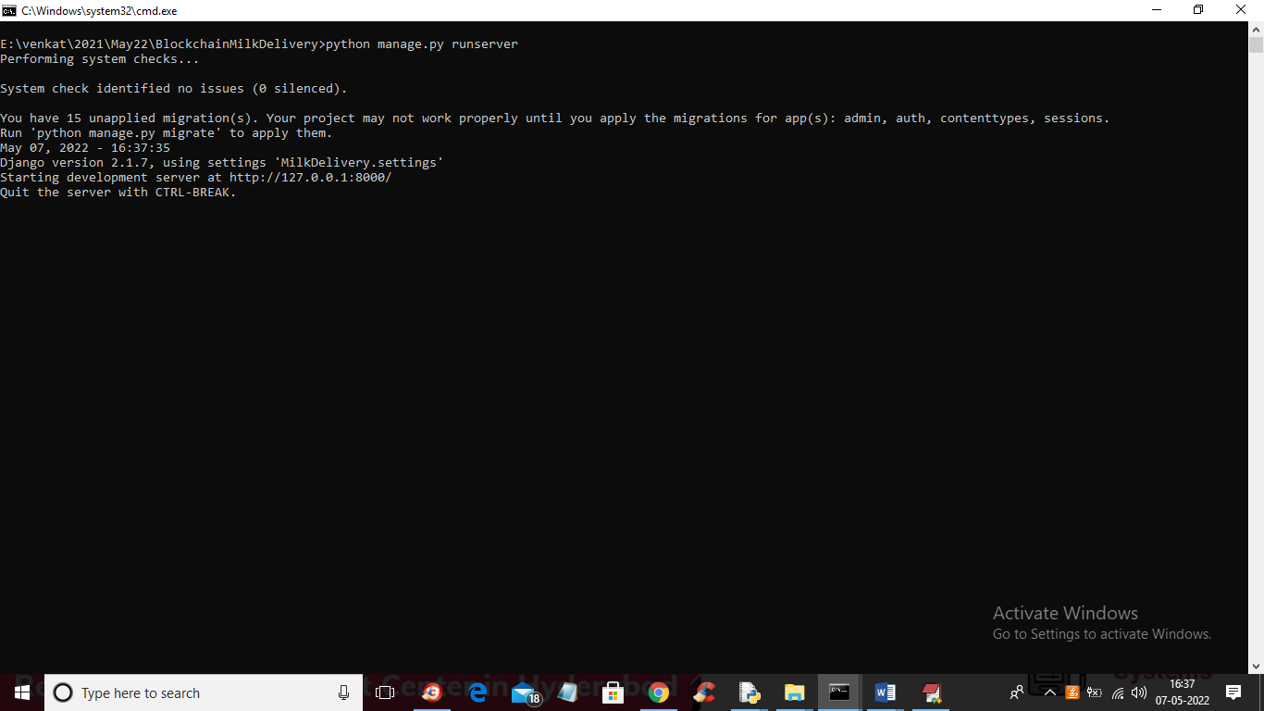

In above screen python DJANGO server started and now open browser and enter URL as <http://127.0.0.1:8000/index.html> and press enter key to get below screen

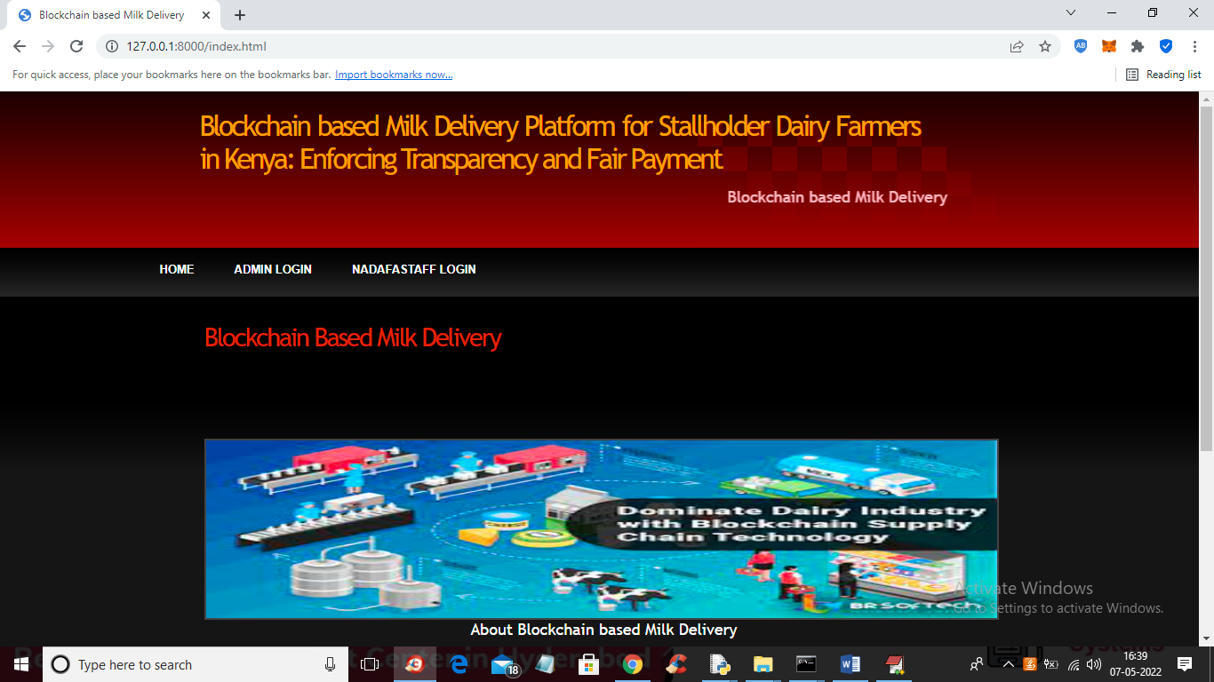

In above screen click on ‘Admin Login’ link to get below login screen

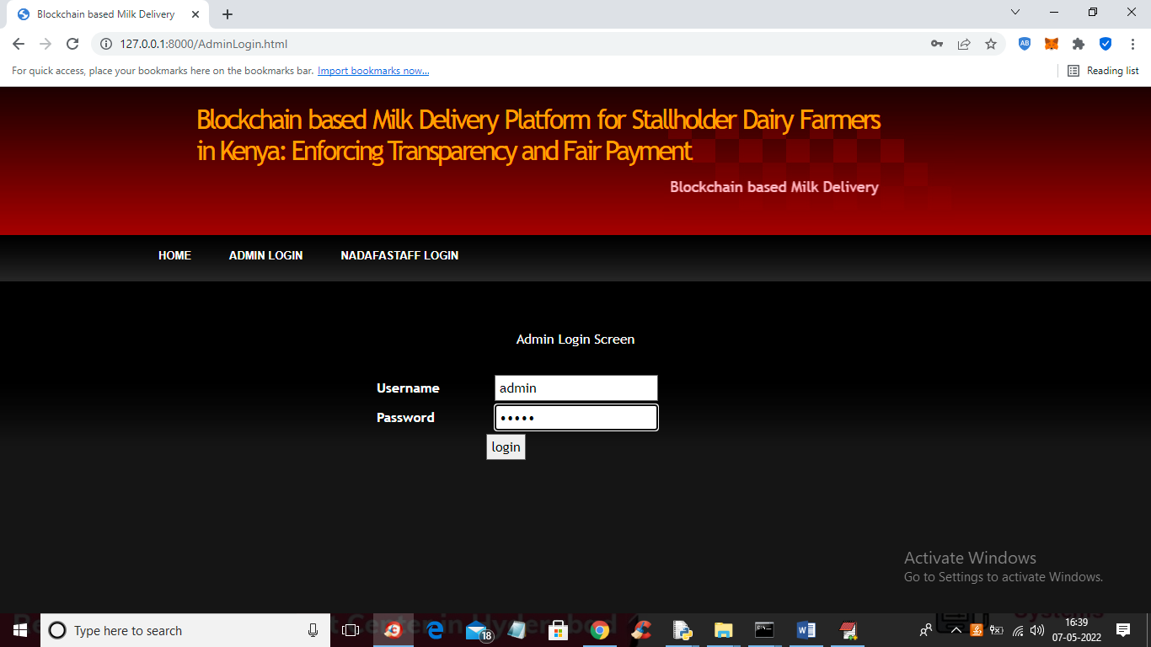

In above screen admin is login and after login will get below screen

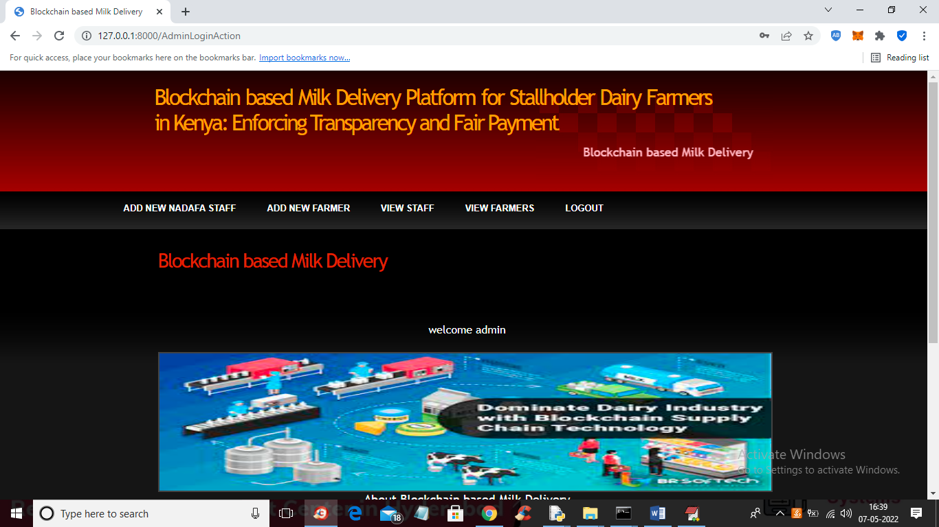

In above screen ‘admin’ can click on ‘Add New NADAFA staff’ link to add staff details and get below output

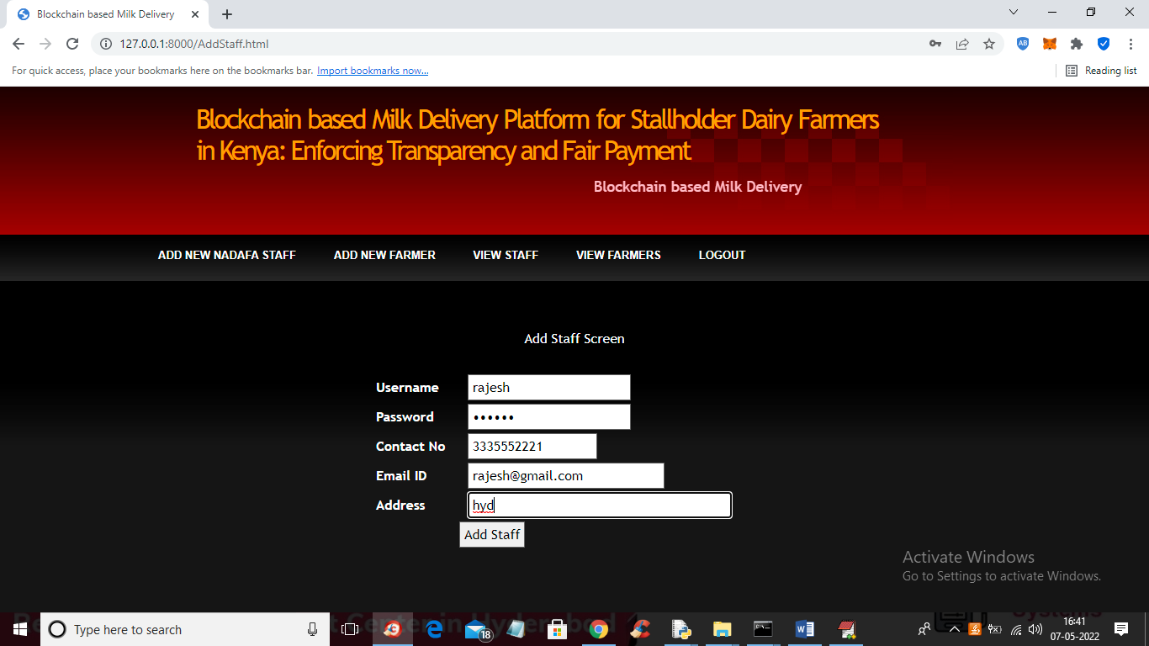

In above screen admin is entering staff details and then press ‘Add Staff’ button to get below output

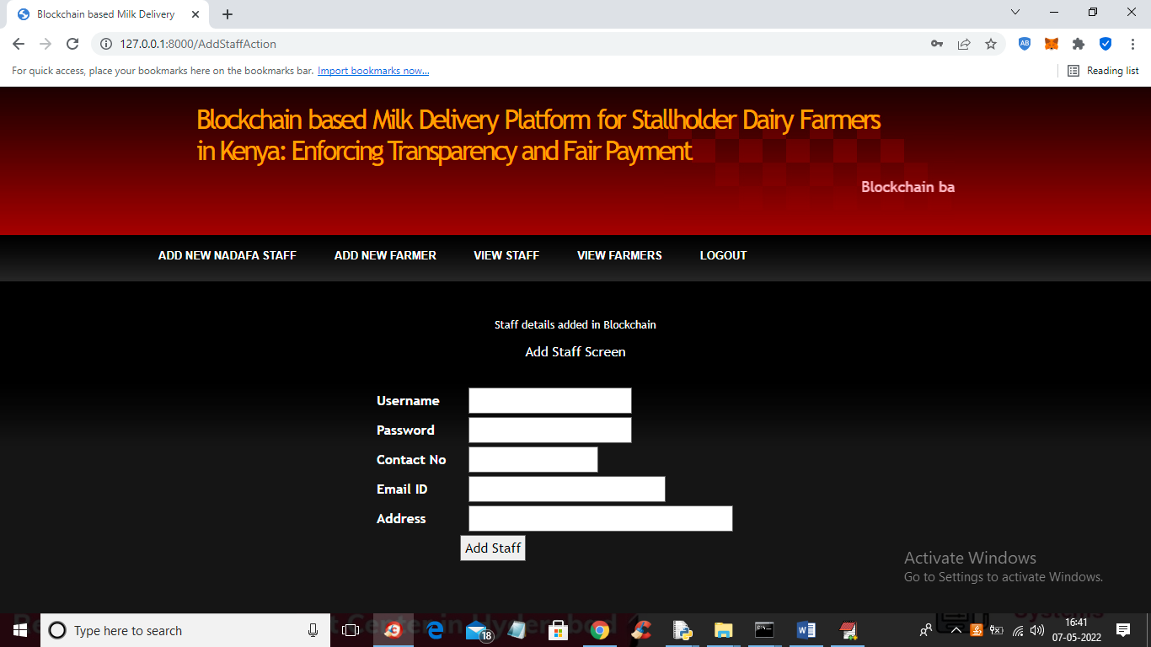

In above screen staff details added in Blockchain and now click on ‘Add New Farmer’ link to add farmer details

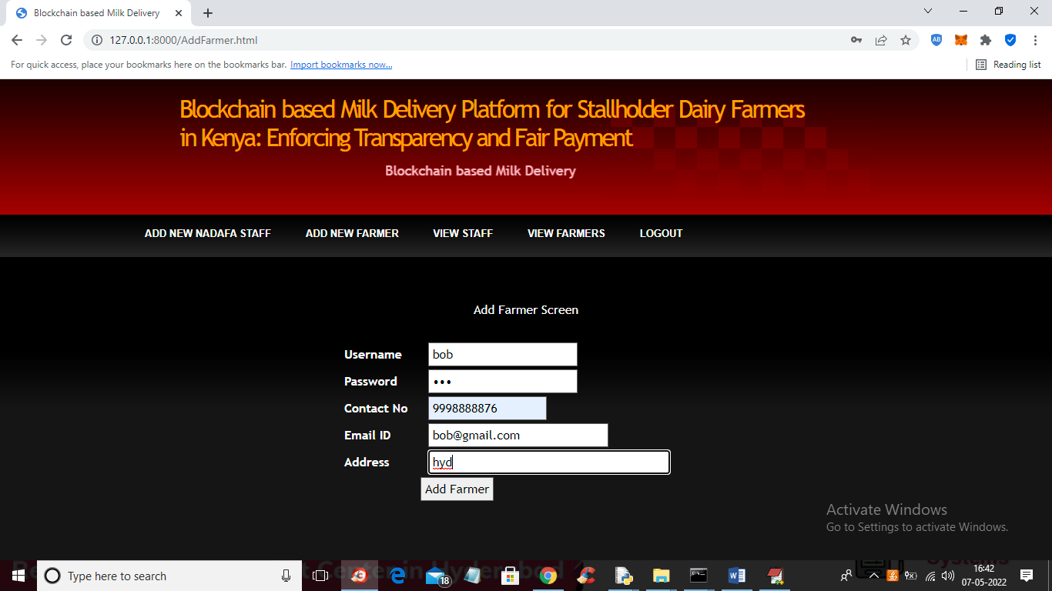

In above screen admin adding Farmer details and then press button to get below output

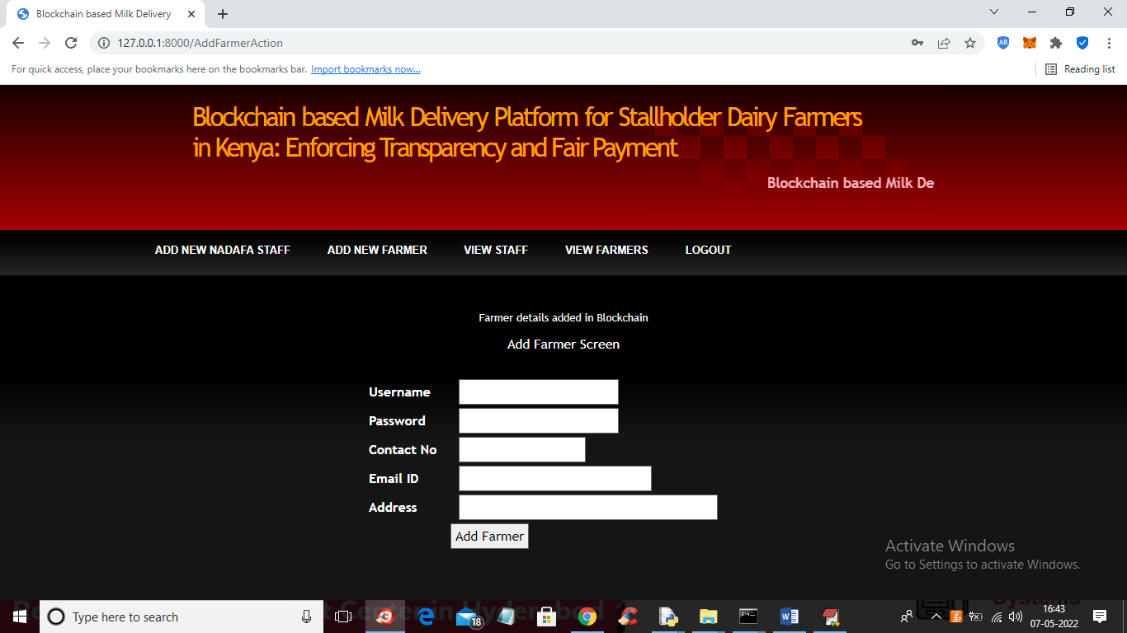

In above screen farmer details added and now click on ‘View Staff’ link to view all staff details saved in Blockchain

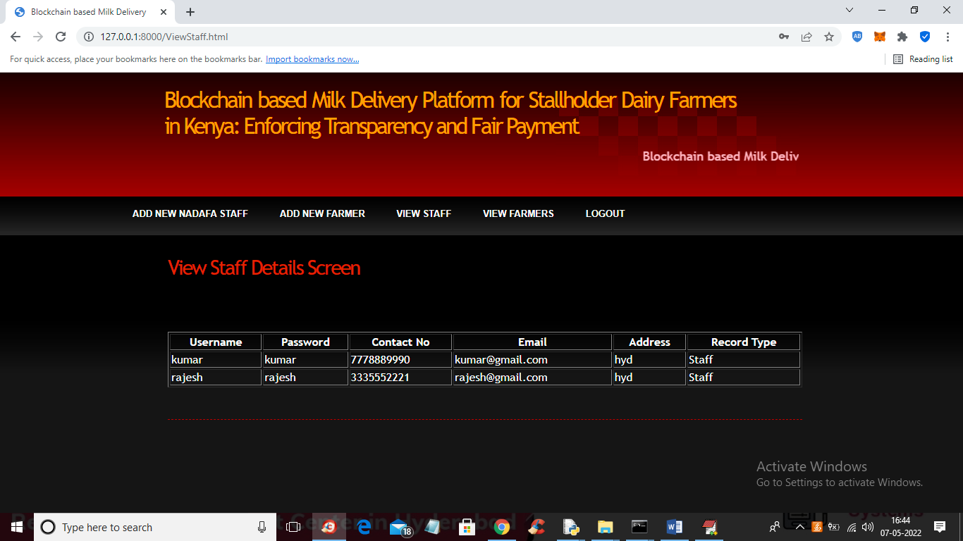

In above screen admin can view all staff details and similarly you can click on ‘View Farmers’ link to view all registered farmers

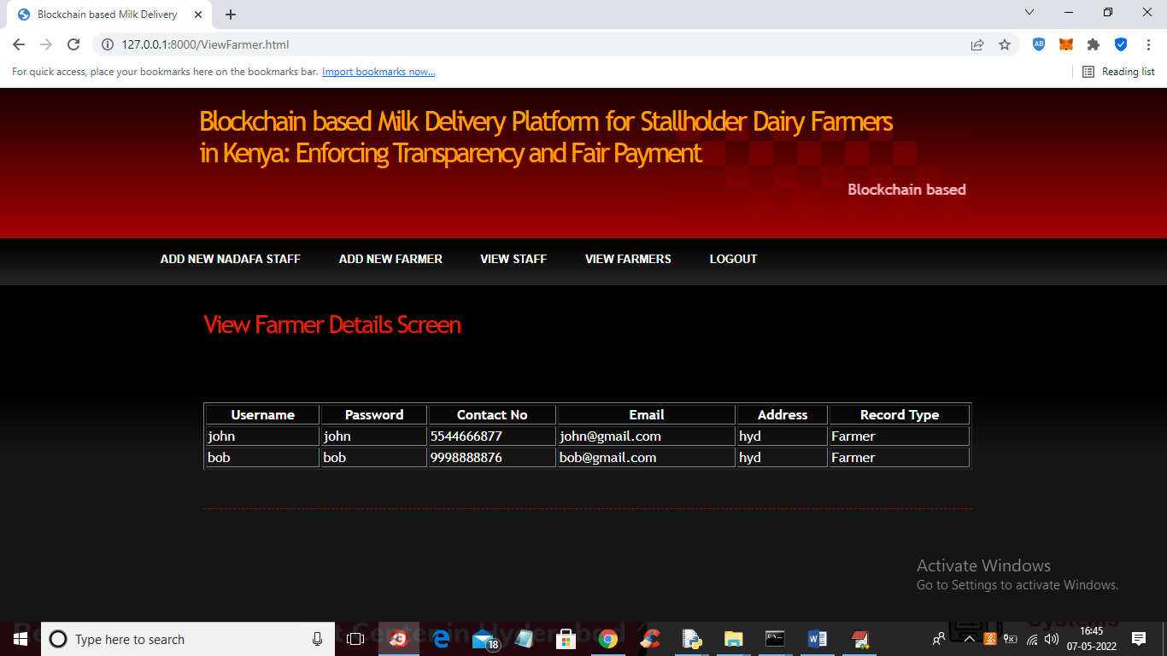

In above screen admin can view all farmer details and now logout and login as ‘Staff Members’

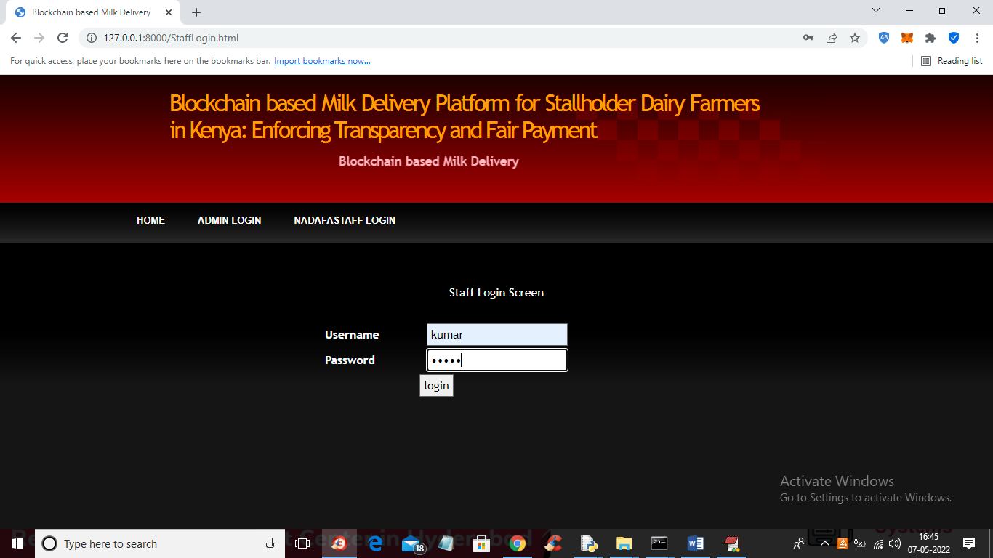

In above screen staff member is login and after login will get below output

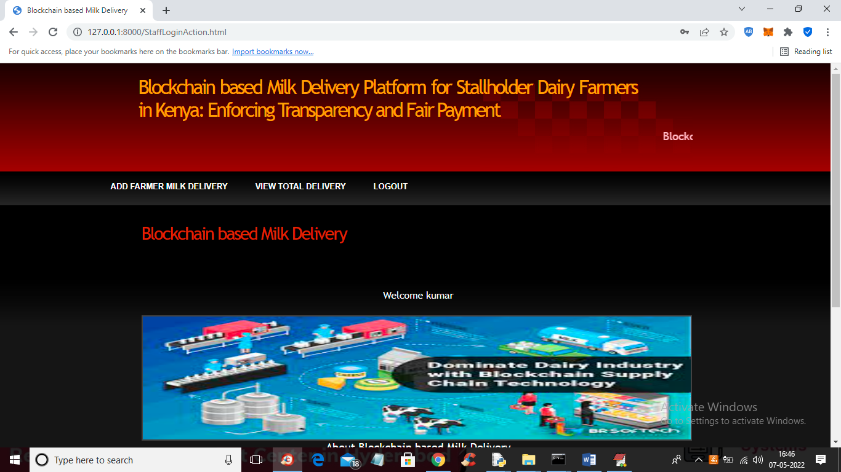

In above scree screen staff member can click on ‘Add Farmer Milk Delivery’ link to add farmer milk deliver details

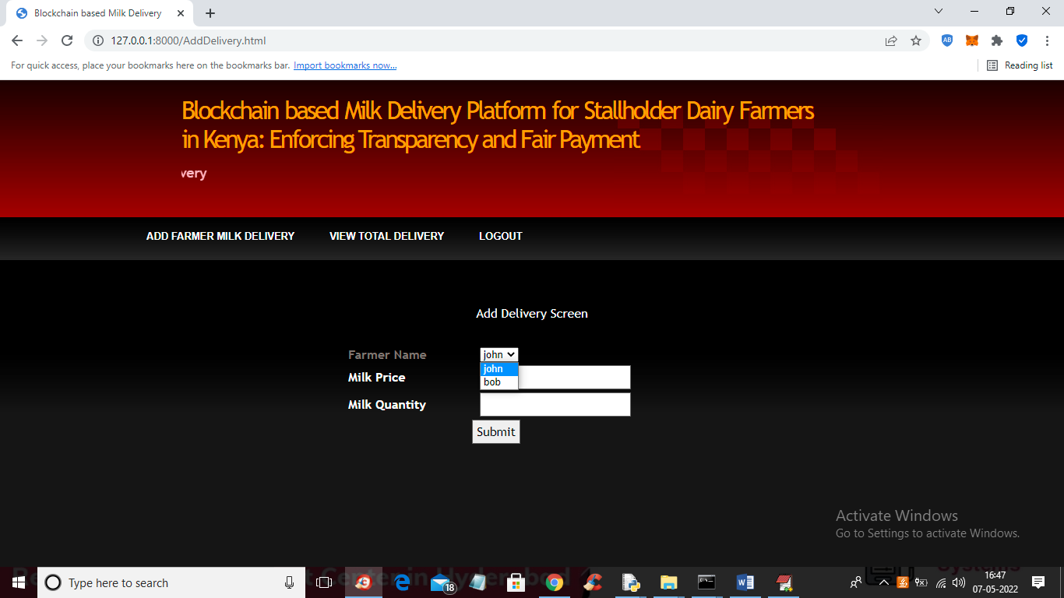

In above screen staff member will select farmer name from drop down box and collect milk from farmer

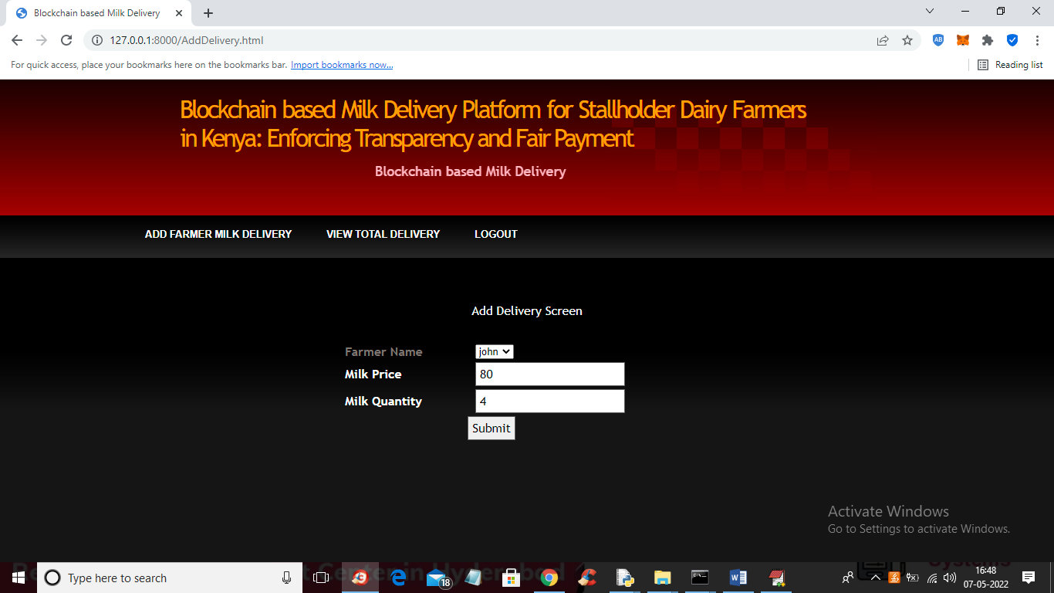

In above screen staff member selected farmer name and entre milk price and quantity and then press button to store milk delivery details in Blockchain and get below output

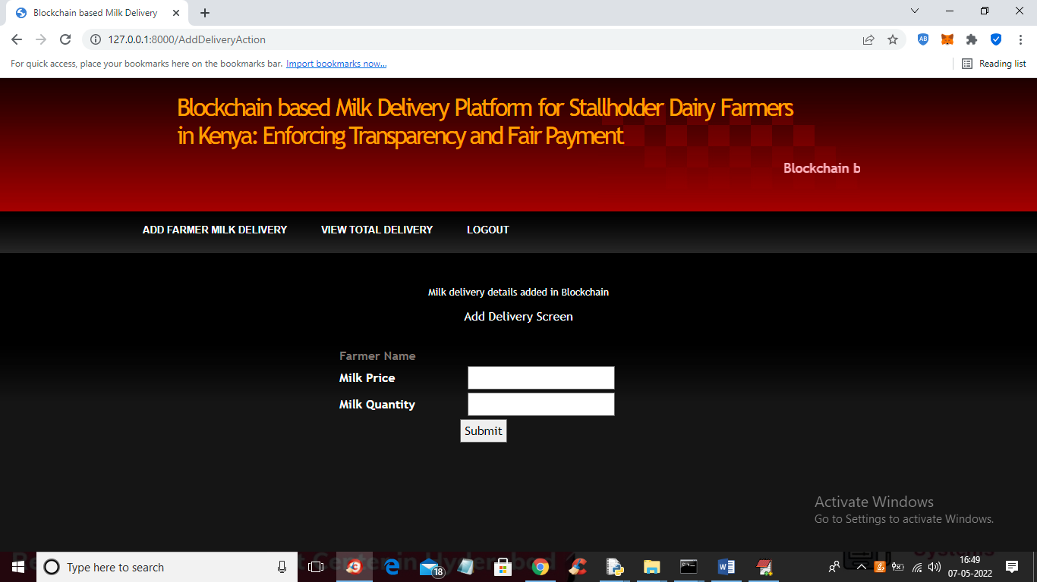

In above screen we can see milk delivery details added and now click on ‘View Total Delivery’ link to view all deliveries from farmers

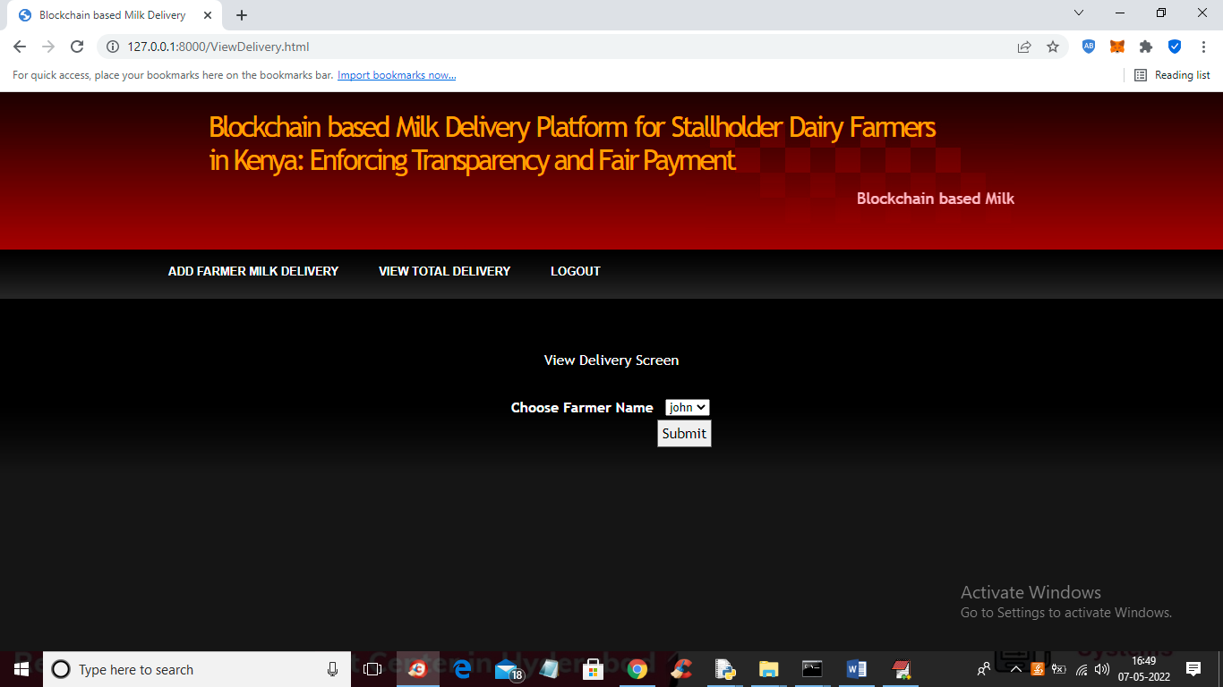

In above screen select farmer name and then press button to view all his deliveries like below screen

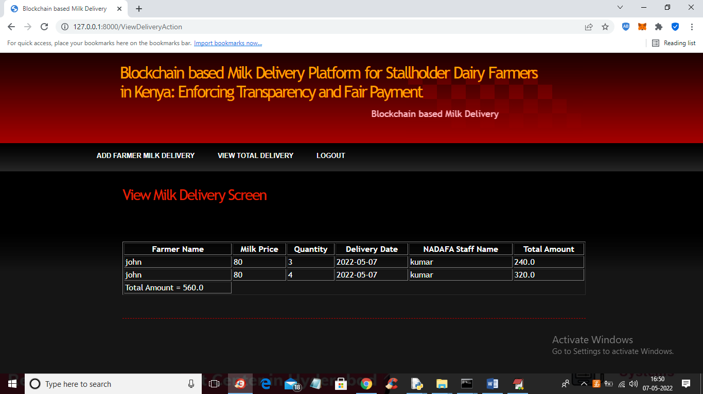

In above screen staff member can view how much delivery done by farmer and how much amount is balanced.

Similarly you can add any number users and then collect milk and store details in Blockchain