**Turtle User Guide**

Discussion of the development and testing aspects.

**Development:**

**Development Environment and Tools:**

1. **Framework:** Laravel (Backend):

I used a PHP framework called Laravel to implement this application. It follows the Model-View-Controller (MVC) architecture and has features and libraries for route, authentication, and database management.

1. **Frontend:** I used HTML, CSS, and JavaScript for the user interface:

HTML (Hypertext Markup Language) to structure the contents of the website pages, CSS (Cascading Style Sheets) to style and layout the web contents, and JavaScript to add dynamic behaviour and interactivity to website contents.

1. **Database:** This application uses MySQL for database development and management of data.
2. **IDE:** This application was developed using Visual Studio Code.

**Major Components or Modules:**

1. **Asset Management**: Manage the zoo's assets, including animals, buildings, attractions, employees, and their hourly wages. This section allows for adding, updating, and viewing these assets.
2. **Daily Zoo Activities**: Track and report daily activities at the zoo. This includes managing attendance and revenue for attractions, concessions, and different types of attendees.
3. **Management and Reporting**: Generate detailed reports for zoo management, covering revenue by date, animal population, top attractions, best days in terms of revenue, and average revenue. This section assists in strategic planning and decision-making.

**Challenges Faced During Implementation:**

* **Internet connection Issues**: most of the Laravel dependencies and other third-party libraries such as composer, php, etc., require a stable internet connection for efficient installation.
* **Complex Relationships:** creating and managing the complex relationships between entities and ensuring data integrity was a challenge.
* **Scalability:** Ensuring the system can handle a growing number of assets, and zoo activities.
* **Version concerns:** tools and some other third-party libraries require the latest versions for others to be compatible such as PHP, composer, and npm.

**Third-Party Libraries or Frameworks:**

1. **Php –** for backend development and connection. Provided by laravel
2. **Node.js** : I used this library to manage frontend assets, build processes, and JavaScript-related tasks to enhance the user interface of the application such “npm run dev”.
3. **Composer** : this library was essential for managing PHP dependencies, including Laravel and other PHP packages, to ensure smooth development and deployment of the backend part of the application such as “php artisan”.
4. **Bootstrap:** For laying out and designing the frontend contents.

**Step by Step Guides:**

**Home page**

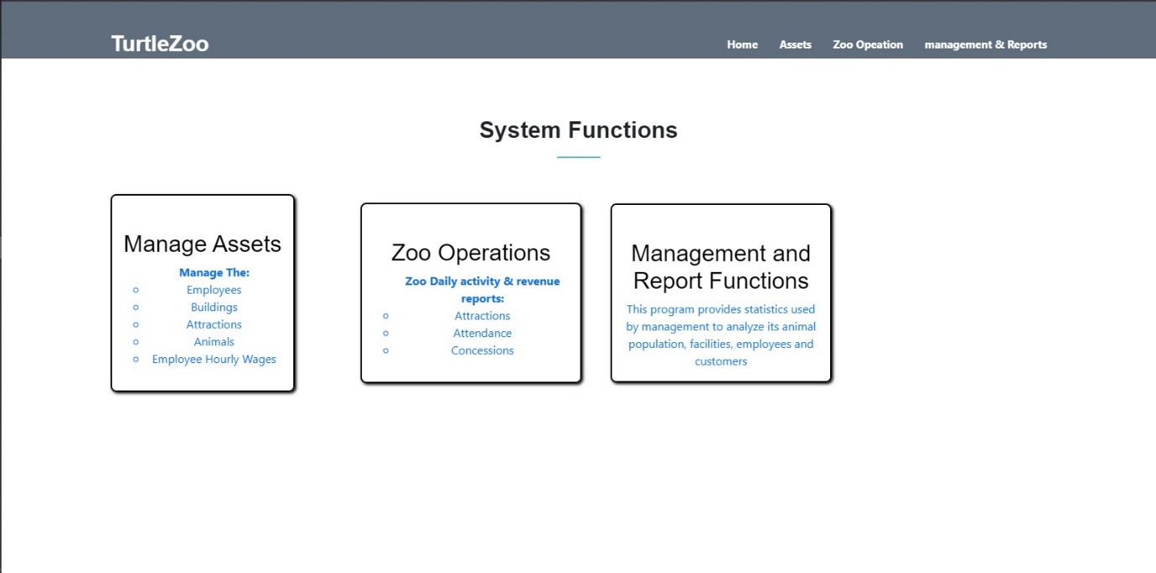

From the homepage, users to select the functions they need to perform e.g manage assets, zoo operations, management & reporting functions

**Manage assets**

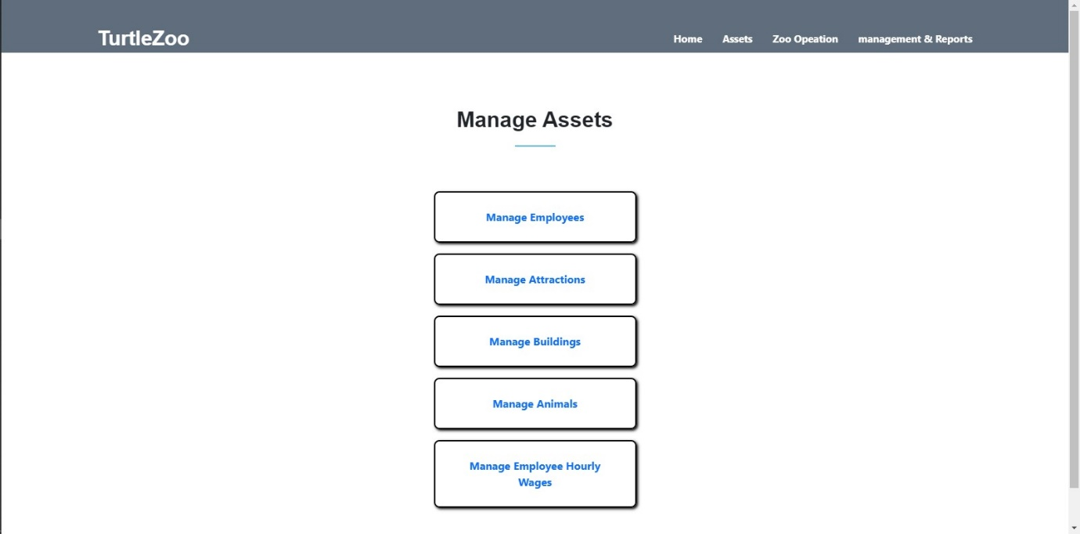

User to select different assets they need to manage by clicking on any from the menu

**Sample asset management page**

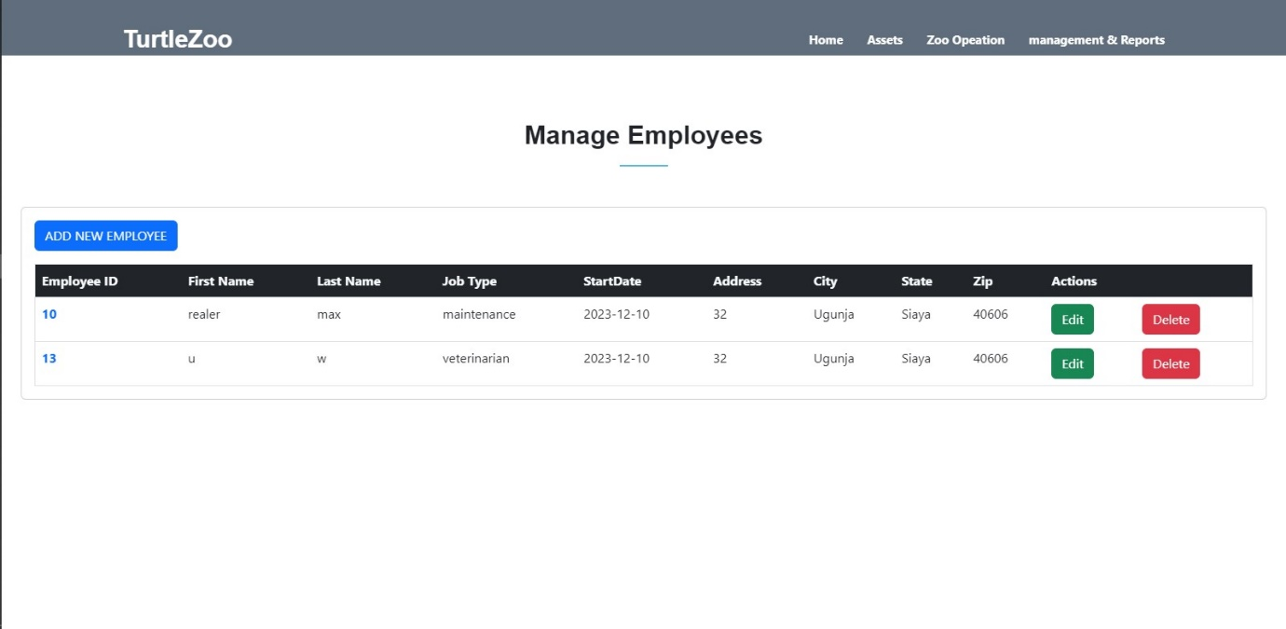

Here, user can create new (asset i.e., employee), they can edit the asset and also delete the asset.

This operation applies to all the assets

**Zoo operations**

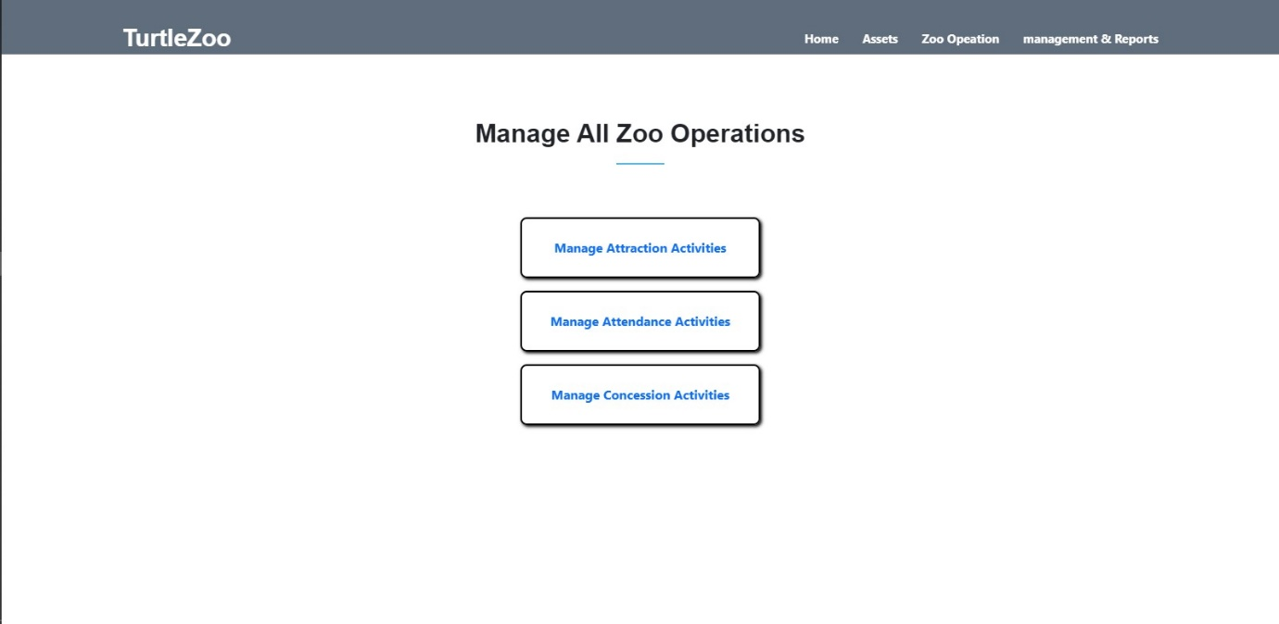

Users to select any zoo operation e.g., attraction, attendance, concession activities

**Sample Zoo activity**

**Zoo attraction activities**

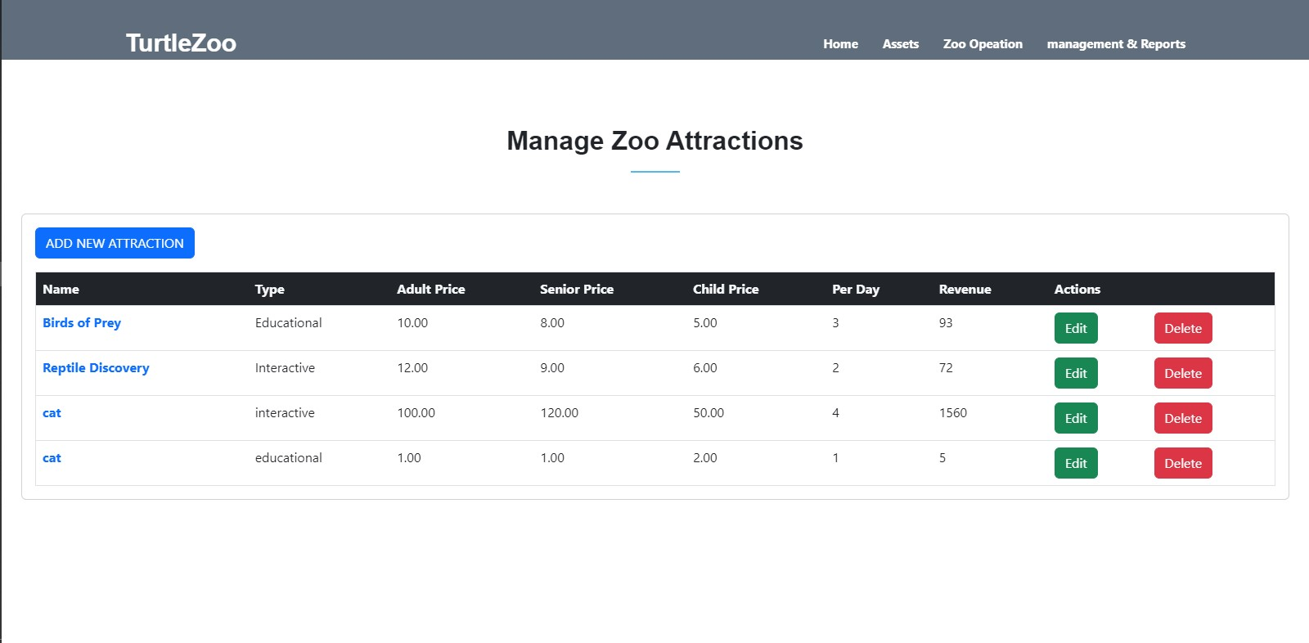

In the zoo activities users can view, and add new activities and optionally delete or update them by clicking on the button on the page

**Manage & Reporting**

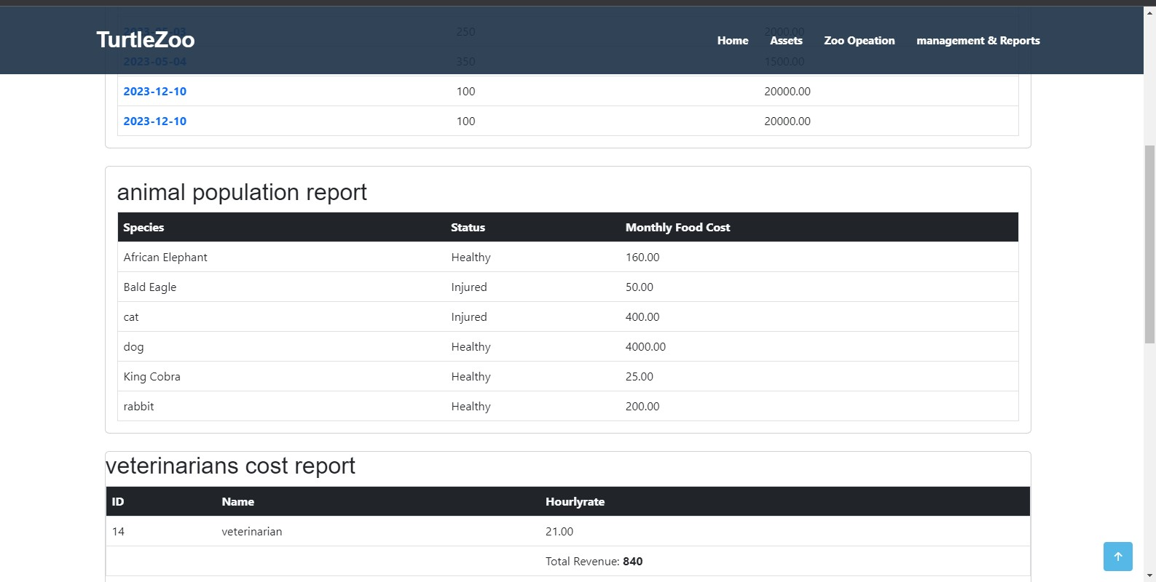

This page displays all the management and activity reports  
it provides the statistics used by the management to analyze its animal population, facilities, employees, and customers

**Troubleshooting**

Page Not Loading: Ensure you have served the project correctly. Try refreshing the page or clearing your browser cache.

Form Submission Errors: Check all form fields for correct data. Look for error messages that may indicate what needs to be corrected.

Report Misalignment: If reports are not displaying data correctly, verify the input data for accuracy.