**Kathmandu University**

**Dhulikhel, Kavre**



**Subject: COMP 202**

**Work: Lab 5**

**Submitted by:**

**Aakriti Banjara**

**Roll No:05**

**Group.: Computer Engineering**

**Level: 2nd year / 1st Sem**

**Submitted to:**

**Rajani Chulyadyo**

**Department of Computer Science and Engineering**

The graph of the data is shown below:

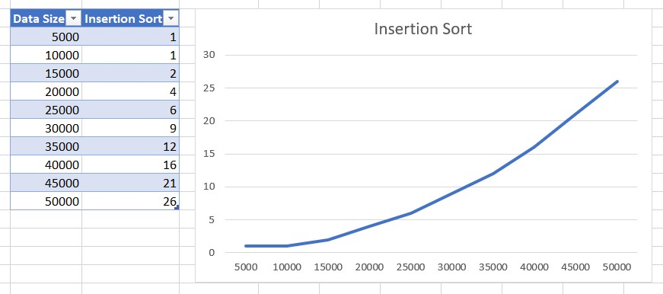

This is the graph of Insertion Sort. The data size used starts from 5000 and is increased by 5000 every time until it reached 50000.

Insertion sorting is a type of sorting in which each element is picked out one at a time, and the following element is picked out and sorted in the sorted list after each loop. It is a type of internal sort because it doesn't need additional storage. It has an O(n2) time complexity, and the graph also displays data that is similar.

The link to GitHub repository is:

https://github.com/Aakriti555/lab4.git

The quick sort is done by my friend Mahip Adhikari and the report of quick sort will be submitted by him.