**DIFFIE HELLMAN EXCHANGE – MAN IN THE MIDDLE ATTACK**

**BY-**

**AAKRITI MEHROTRA**

**22BCE1954**

**CODE**

**SERVER.PY**

import random

import socket

class Server:

def __init__(self, p, g):

self.p = p

self.g = g

self.b = random.randint(1, p)

self.public_value = None

self.secret_key = None

def generate_public_value(self):

self.public_value = (self.g ** self.b) % self.p

return self.public_value

def compute_secret_key(self, client_public_value):

self.secret_key = (client_public_value ** self.b) % self.p

return self.secret_key

def start(self, host, port):

server_socket = socket.socket(socket.AF_INET, socket.SOCK_STREAM)

server_socket.bind((host, port))

server_socket.listen(1)

print(f"Server (Bob) listening on {host}:{port}...")

conn, addr = server_socket.accept()

print(f"Connected to client (Alice) at {addr}")

bob_public_value = self.generate_public_value()

conn.send(str(bob_public_value).encode())

print(f"Bob's public value (gb): {bob_public_value}")

alice_public_value = int(conn.recv(1024).decode())

print(f"Received Alice's public value (ga): {alice_public_value}")

secret_key = self.compute_secret_key(alice_public_value)

print(f"Bob's computed secret key: {secret_key}")

conn.close()

if __name__ == "__main__":

p = int(input("Enter a prime number (p): "))

g = int(input("Enter a number (g): "))

server = Server(p, g)

server.start("127.0.0.1", 12345)

**CLIENT.PY**

import random

import socket

class Client:

def __init__(self, p, g):

self.p = p

self.g = g

self.a = random.randint(1, p)

self.public_value = None

self.secret_key = None

def generate_public_value(self):

self.public_value = (self.g ** self.a) % self.p

return self.public_value

def compute_secret_key(self, server_public_value):

self.secret_key = (server_public_value ** self.a) % self.p

return self.secret_key

def start(self, host, port):

client_socket = socket.socket(socket.AF_INET, socket.SOCK_STREAM)

client_socket.connect((host, port))

print(f"Connected to server (Bob) at {host}:{port}")

alice_public_value = self.generate_public_value()

client_socket.send(str(alice_public_value).encode())

print(f"Alice's public value (ga): {alice_public_value}")

bob_public_value = int(client_socket.recv(1024).decode())

print(f"Received Bob's public value (gb): {bob_public_value}")

secret_key = self.compute_secret_key(bob_public_value)

print(f"Alice's computed secret key: {secret_key}")

client_socket.close()

if __name__ == "__main__":

p = int(input("Enter a prime number (p): "))

g = int(input("Enter a number (g): "))

client = Client(p, g)

client.start("127.0.0.1", 12345)

**OUTPUT**

**SERVER**

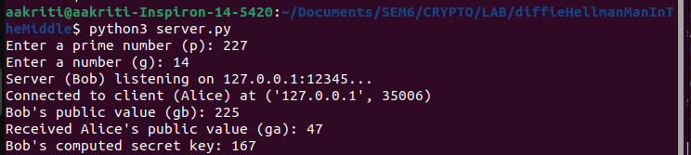

**CLIENT**

