PROJECT REPORT OF CO-OP Project at Industry (Module-2)
ON
Automated Breast Cancer Detection Using Attention-Based CNN
submitted in partial fulfilment of the requirements for the award of degree of

BACHELOR OF ENGINEERING
In
COMPUTER SCIENCE AND ENGINEERING

Submitted by: Supervised By:
Aakriti Shory 2210991110 Dr. Isha Kansal
Harshit 2210991632 Associate Prof.
Bhoomika 2210991446



DEPARTMENT OF COMPUTER SCIENCE AND ENGINEERING

CHITKARA UNIVERSITY INSTITUTE OF ENGINEERING AND TECHNOLOGY
CHITKARA UNIVERSITY, PUNJAB, INDIA

CONTENTS

S.No. | Title | Page No.
 | Acknowledgement | iv
 | List of Figures and Tables | v
 | Abstract
1 | Introduction | 7
2 | Methodology | 9
3 | Tools and Technologies | 12
4 | Implementation | 13
5 | Major Findings/Outcomes/Output/Results | 15
6 | Conclusion and Future Scope | 17
 | References
 | Appendices

DECLARATION

I hereby certify that the work which is being presented in the project report entitled “Automated Breast Cancer Detection Using Attention-Based CNN” in partial fulfilment of requirement for the award of the degree of Bachelor of Engineering (Computer Science and Engineering) submitted in the department of Computer Science and Engineering at Chitkara University Institute of Engineering and Technology, Chitkara University, Punjab, India, is an authentic record of my own work carried out under the supervision of Dr. Isha Kansal. The matter presented in this project report has not been submitted in any other university/institute for the award of any degree.

Place: Rajpura Aakriti Shory 2210991110
Harshit 2210991632
Bhoomika 2210991446
Date :19/05/26

This is to certify that the above statement made by the candidate is correct to the best of my knowledge and belief.

Dr . Isha Kansal
Associate Prof.
Department of Computer Science and Engineering
Chitkara University Institute of Engineering and Technology,
Chitkara University, Punjab, India

ACKNOWLEDGEMENT

We express our sincere gratitude to Chitkara University Institute of Engineering and Technology for providing the opportunity and resources required for carrying out this research work titled “Automated Breast Cancer Detection Using Attention-Based CNN.”
We would like to express our heartfelt thanks to our mentor, Dr. Isha Kansal, Associate Professor, for her valuable guidance, support, and continuous encouragement throughout the development of this project. Her suggestions and insights significantly contributed to the successful completion of this work.
We are also grateful to the faculty members and classmates who provided valuable feedback and suggestions during the research process.
Finally, we extend our gratitude to our families and friends for their constant motivation and support.

LIST OF FIGURES AND TABLES

Figures

Figure 1: Breast Cancer Detection Workflow

Figure 2: Data Preprocessing Pipeline

Figure 3: CNN Architecture

Figure 4: Attention Mechanism

Figure 5: Accuracy Curve

Figure 6: Loss Curve

Figure 7: Attention Heatmap Results

Figure 8: System Architecture

Tables
Table 1: Training Configuration

Table 2: Dataset Distribution

Table 3: Performance Comparison

ABSTRACT

Breast cancer is among the most common and life-threatening diseases affecting women worldwide. Early diagnosis plays an rely heavily on expert interpretation of medical images, which may introduce inconsistencies and errors due to variations in image quality and tumor characteristics.
This project presents an automated breast cancer detection framework using Attention-Based Convolutional Neural Networks. The proposed system combines preprocessing techniques, transfer learning, and an attention mechanism to improve classification performance. The attention module enables the model to focus on important tumor regions while suppressing unnecessary background information.
The proposed model performs binary classification and predicts whether an input image belongs to benign or malignant categories. Experimental results demonstrate superior performance compared with conventional CNN models, achieving an accuracy of 95.6%.

Keywords:
Breast Cancer, Deep Learning, CNN, Attention Mechanism, Medical Imaging, Artificial Intelligence

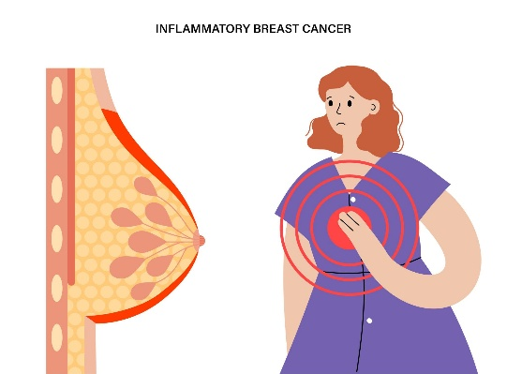
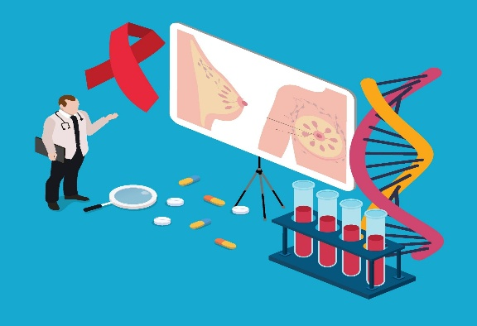

Figure 1: Breast Cancer Awareness Illustration

INTRODUCTION
Breast cancer is one of the most common forms of cancer affecting women globally and is considered a leading cause of cancer-related mortality. The disease develops due to uncontrolled growth of abnormal cells in breast tissues, which can spread to other parts of the body if not detected and treated at an early stage. Early diagnosis and treatment play a critical role in improving survival rates and reducing mortality.
Traditionally, breast cancer diagnosis relies on medical imaging methods such as mammography, ultrasound imaging, magnetic resonance imaging (MRI), and histopathological examination. These techniques provide important information regarding tumor structure, size, and characteristics. However, manual interpretation of medical images can be time-consuming and may depend heavily on the experience of medical professionals.
Human analysis of medical images may sometimes lead to misdiagnosis due to various factors including image noise, low contrast, overlapping tissues, and variations in tumor appearance. Small tumors and subtle abnormalities are often difficult to identify, increasing the risk of delayed diagnosis.
Recent developments in Artificial Intelligence have transformed the healthcare industry by enabling automated systems capable of assisting doctors in diagnosis and decision-making. Deep learning approaches have emerged as powerful techniques for medical image analysis due to their capability to learn complex patterns directly from images.
Convolutional Neural Networks have gained significant popularity because they automatically extract hierarchical features from images without requiring handcrafted feature extraction methods. CNN architectures have demonstrated superior performance in image classification tasks and have achieved promising results in medical applications.
Despite their advantages, conventional CNN models process entire images uniformly and treat all image regions with equal importance. In medical imaging applications, not all image regions contain useful information. Important tumor regions may occupy only a small portion of the image while large background areas may introduce unnecessary information.
To overcome this limitation, attention mechanisms are integrated into CNN architectures. Attention modules allow the network to assign different weights to image regions and focus on the most relevant features. This improves classification performance and enhances interpretability.
The main objective of this work is to develop an automated and reliable breast cancer detection framework capable of assisting healthcare professionals through attention-enhanced deep learning techniques.

METHODOLOGY
The methodology used in this study focuses on developing a complete deep learning framework for automated breast cancer detection. The proposed system consists of multiple stages designed to ensure efficient feature extraction and accurate classification.
The overall workflow includes image preprocessing, feature extraction, attention-based feature refinement, classification, and prediction generation.
The system workflow is:
The input images first undergo preprocessing operations to improve image quality and remove unwanted noise. Image enhancement techniques are applied to increase visibility of important regions.
After preprocessing, images are fed into the CNN model which acts as the primary feature extraction component. CNN layers automatically learn spatial patterns from images and generate feature maps.
The attention mechanism is then applied to the extracted features. The attention module assigns higher weights to tumor-related regions and lower weights to irrelevant background regions.
Finally, fully connected layers perform binary classification and generate predictions regarding whether the image belongs to benign or malignant categories.
Data Preprocessing
Data preprocessing is an essential step in medical image analysis because raw medical images often contain noise, artifacts, and variations in intensity values. Proper preprocessing improves image quality and helps deep learning models learn meaningful features more effectively.
The following preprocessing techniques are applied:

Image Resizing
All images are resized to dimensions of 224 × 224 pixels. Standardizing image size ensures compatibility with CNN architectures and improves computational efficiency.
Normalization
Normalization scales pixel values within a range of 0–1. This process stabilizes training and improves convergence speed.
Contrast Enhancement
Contrast enhancement techniques such as histogram equalization are applied to improve visibility of tumor regions.
Noise Reduction
Noise reduction removes unwanted image distortions that may negatively affect classification performance.
Data Augmentation
Data augmentation artificially increases dataset diversity through transformations such as:
- Rotation
- Horizontal Flip
- Zoom
- Shift
- Scaling
These techniques reduce overfitting and improve generalization
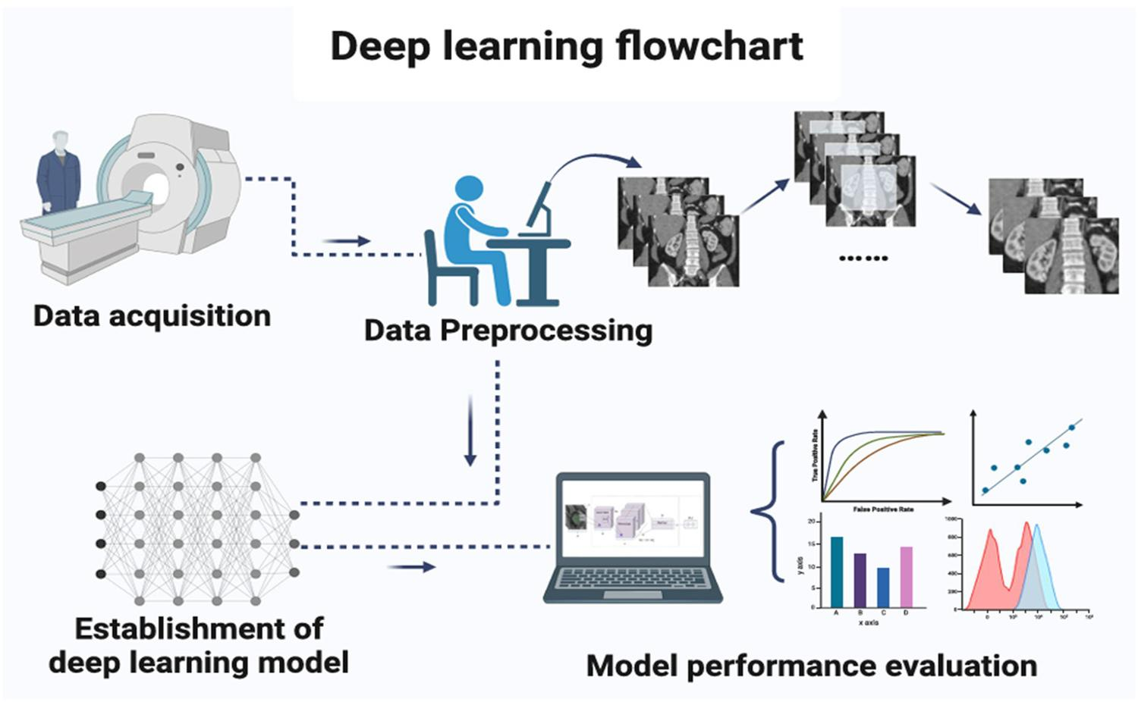

TOOLS AND TECHNOLOGIES
Various software tools and technologies were utilized during project implementation.
Python was selected as the primary programming language because of its flexibility and availability of machine learning libraries.
TensorFlow and Keras were used for developing and training deep learning models. These frameworks provide efficient implementations of CNN architectures and optimization techniques.
OpenCV was used for image preprocessing operations including image enhancement, resizing, and filtering.
NumPy supported numerical computation and matrix operations.
Matplotlib and Seaborn libraries were used to generate graphical visualizations and performance plots.
Jupyter Notebook was utilized as the development environment for experimentation and analysis.

IMPLEMENTATION
The implementation phase involved dataset collection, preprocessing, model development, training, and evaluation.
The medical image dataset was collected from publicly available datasets containing breast cancer images labeled as benign and malignant.
The dataset was divided into:
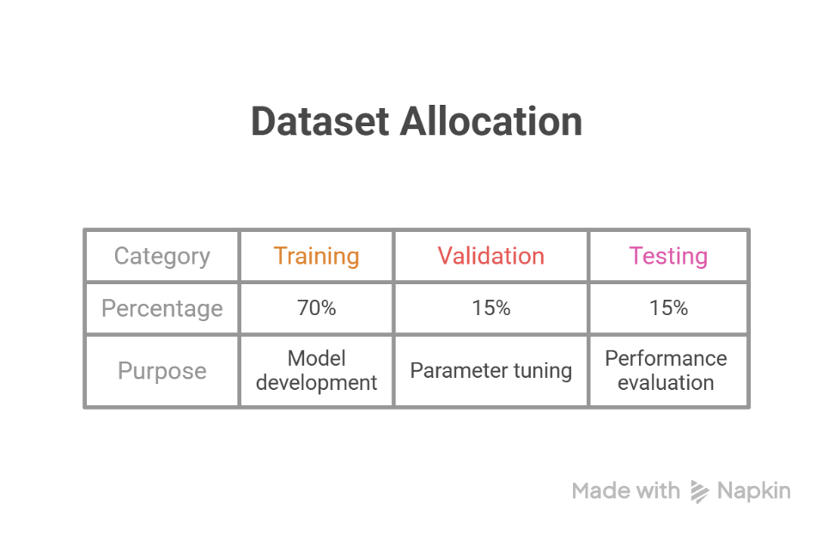

The CNN architecture was developed using transfer learning techniques to leverage previously learned knowledge from pretrained models.
Training was conducted using Binary Cross Entropy loss function and Adam optimizer.
Training parameters:
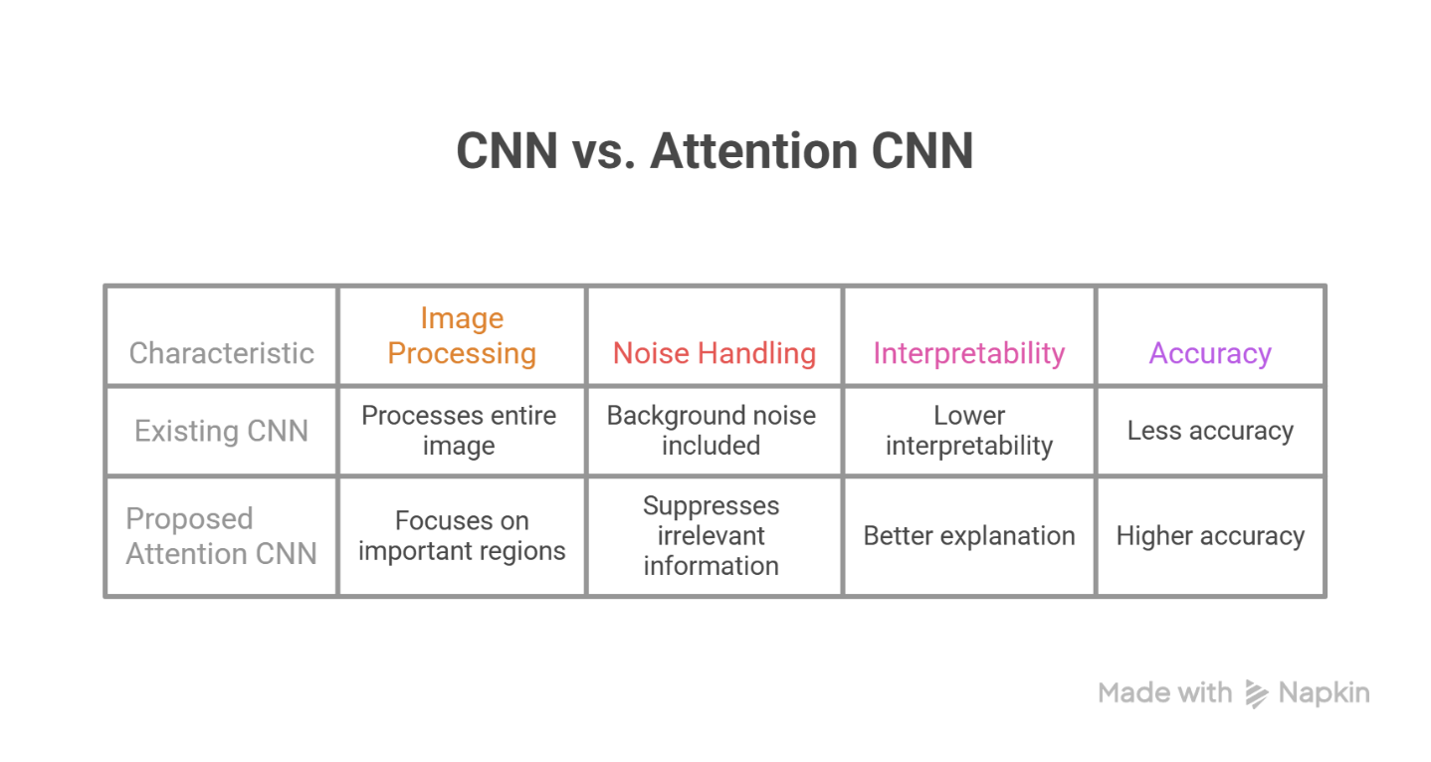Early stopping was applied to avoid overfitting and improve generalization performance.

MAJOR FINDINGS / RESULTS
Experimental analysis indicates that the proposed Attention-Based CNN significantly improves breast cancer classification performance.
The attention mechanism enhances feature extraction by focusing on relevant tumor regions and suppressing unnecessary background information.
The model demonstrated higher performance compared to baseline CNN models.
The model achieved an overall accuracy of 95.6%, showing better prediction capability
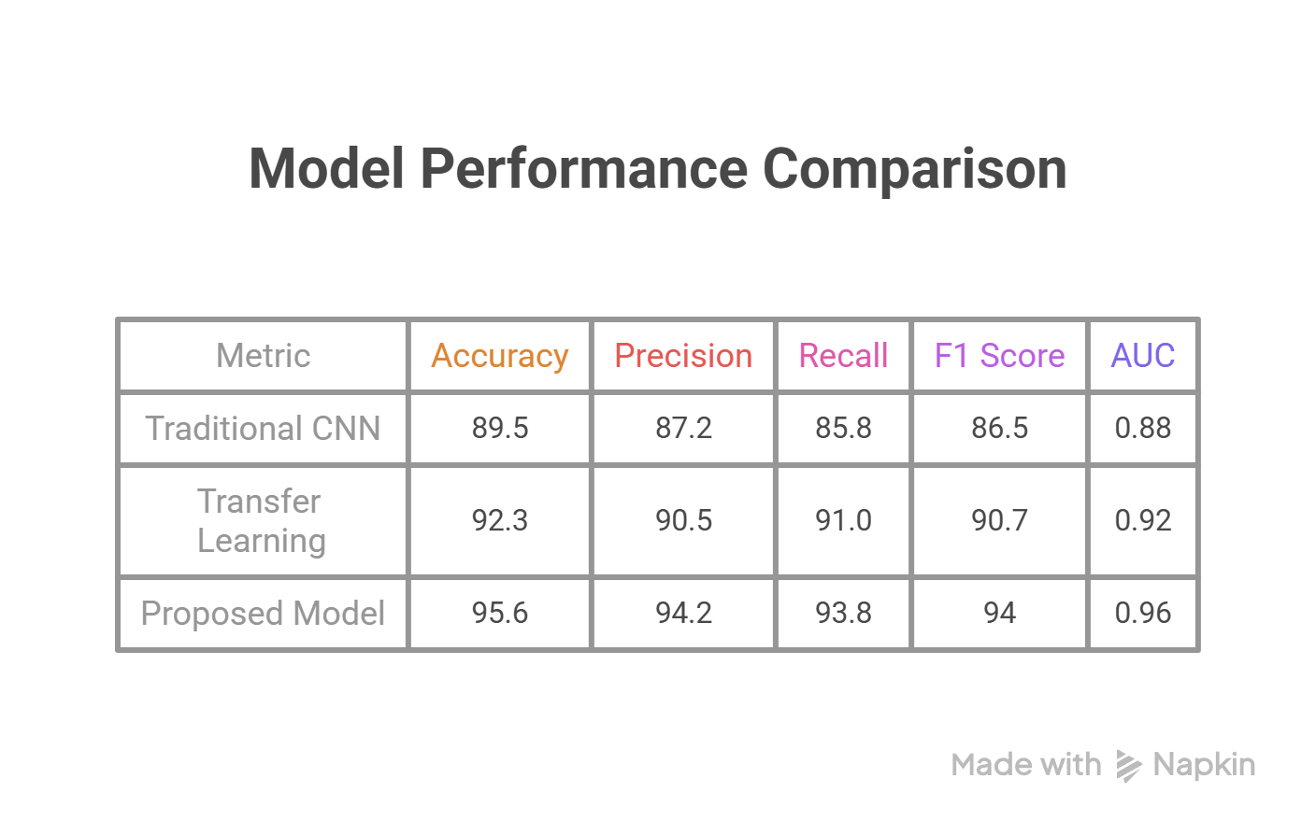
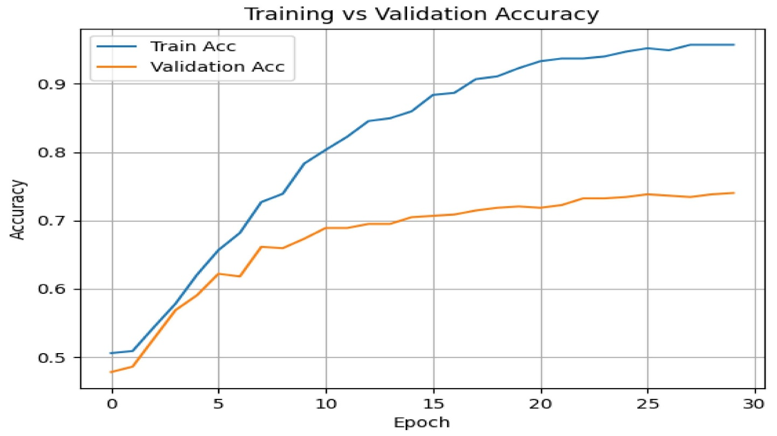
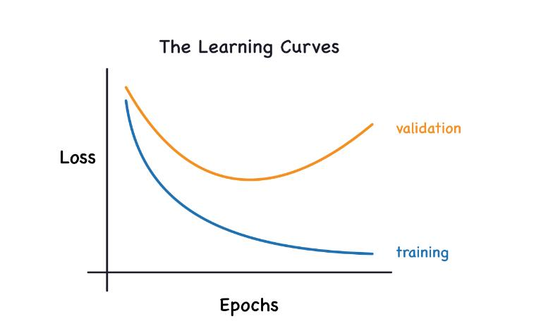
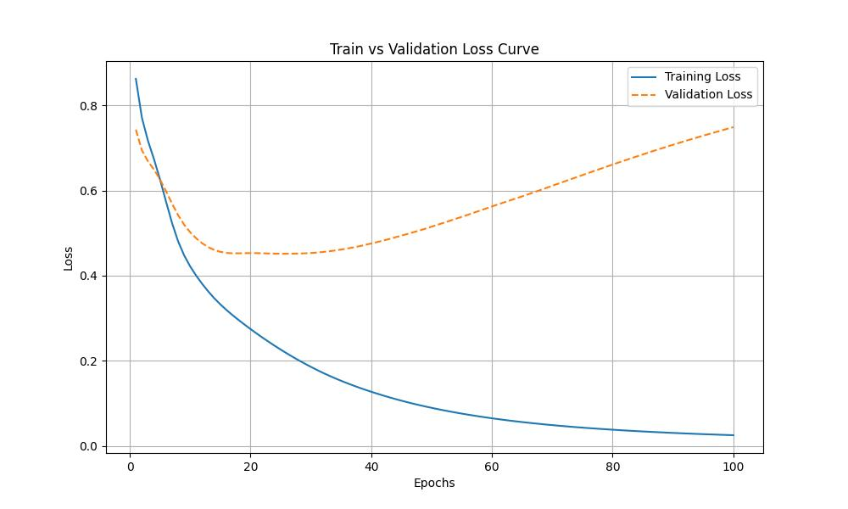
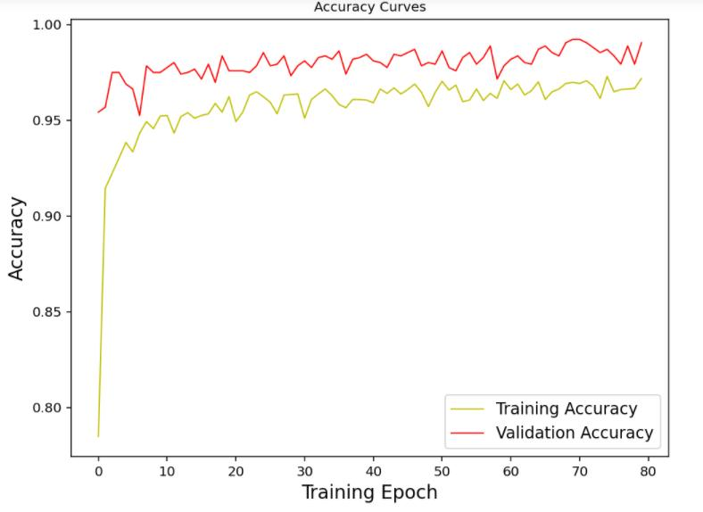

CONCLUSION AND FUTURE SCOPE
The proposed Attention-Based CNN framework successfully demonstrates the application of deep learning techniques for breast cancer detection. By integrating preprocessing techniques and attention mechanisms, the system achieved higher accuracy and improved interpretability.
The attention module effectively focuses on important tumor regions and reduces the influence of background information, resulting in improved classification performance.
Future enhancements include:
- Integration of larger datasets
- Transformer-based architectures
- Multi-class classification
- Real-time deployment in hospitals
- Explainable AI integration
- Cloud-based diagnostic systems
This research demonstrates the potential of Artificial Intelligence to support healthcare professionals and contribute toward early diagnosis and improved patient outcomes.

REFERENCES
[1] L. Breiman, "Random Forests," Machine Learning, vol. 45, no. 1, pp. 5–32, 2001.
[2] T. Cover and P. Hart, "Nearest Neighbor Pattern Classification," IEEE Transactions on Information Theory, vol. 13, no. 1, pp. 21–27, 1967.
[3] Y. LeCun, Y. Bengio, and G. Hinton, "Deep Learning," Nature, vol. 521, no. 7553, pp. 436–444, 2015.
[4] A. Krizhevsky, I. Sutskever, and G. E. Hinton, "ImageNet Classification with Deep Convolutional Neural Networks," Advances in Neural Information Processing Systems, pp. 1097–1105, 2012.
[5] J. Hu, L. Shen, and G. Sun, "Squeeze-and-Excitation Networks," Proceedings of IEEE Conference on Computer Vision and Pattern Recognition (CVPR), pp. 7132–7141, 2018.
[6] A. Vaswani et al., "Attention Is All You Need," Advances in Neural Information Processing Systems, pp. 5998–6008, 2017.
[7] K. He, X. Zhang, S. Ren, and J. Sun, "Deep Residual Learning for Image Recognition," Proceedings of IEEE Conference on Computer Vision and Pattern Recognition (CVPR), pp. 770–778, 2016.
[8] O. Ronneberger, P. Fischer, and T. Brox, "U-Net: Convolutional Networks for Biomedical Image Segmentation," MICCAI, pp. 234–241, 2015.
[9] D. P. Kingma and M. Welling, "Auto-Encoding Variational Bayes," arXiv:1312.6114, 2013.
[10] M. Litjens et al., "A Survey on Deep Learning in Medical Image Analysis," Medical Image Analysis, vol. 42, pp. 60–88, 2017.
[11] S. Hochreiter and J. Schmidhuber, "Long Short-Term Memory," Neural Computation, vol. 9, no. 8, pp. 1735–1780, 1997.
[12] R. Girshick, "Fast R-CNN," Proceedings of IEEE International Conference on Computer Vision (ICCV), pp. 1440–1448, 2015.
[13] J. Redmon et al., "You Only Look Once: Unified, Real-Time Object Detection," Proceedings of IEEE Conference on Computer Vision and Pattern Recognition (CVPR), pp. 779–788, 2016.
[14] K. Simonyan and A. Zisserman, "Very Deep Convolutional Networks for Large-Scale Image Recognition," arXiv:1409.1556, 2014.
[15] C. Szegedy et al., "Going Deeper with Convolutions," Proceedings of IEEE Conference on Computer Vision and Pattern Recognition (CVPR), pp. 1–9, 2015.
[16] G. Huang et al., "Densely Connected Convolutional Networks," Proceedings of IEEE Conference on Computer Vision and Pattern Recognition (CVPR), pp. 4700–4708, 2017.
[17] A. Paszke et al., "PyTorch: An Imperative Style, High-Performance Deep Learning Library," Advances in Neural Information Processing Systems, 2019.
[18] M. Abadi et al., "TensorFlow: Large-Scale Machine Learning on Heterogeneous Systems," 2015.
[19] I. Goodfellow et al., "Generative Adversarial Networks," Advances in Neural Information Processing Systems, pp. 2672–2680, 2014.
[20] J. Long, E. Shelhamer, and D. Darrell, "Fully Convolutional Networks for Semantic Segmentation," Proceedings of IEEE Conference on Computer Vision and Pattern Recognition (CVPR), pp. 3431–3440, 2015.

