Experiment-3

Ques 1:-

**package** com.R1772109002.q1;

**import** java.io.IOException;

**import** java.util.Scanner;

**public** **class** Combination {

**public** **static** **void** main(String[] args)**throws** IOException {

Scanner sc = **new** Scanner(System.***in***);

**int** arr[]=**new** **int**[3];

System.***out***.println("enter any 3 digits number:\t");

**for**(**int** i=0;i<3;i++) {

arr[i]=sc.nextInt();

}

**for**(**int** k=0;k<3;k++) {

**for**(**int** j=0;j<3;j++) {

**for**(**int** x=0;x<3;x++) {

**if**(k!=j&&j!=x&&x!=k) {

System.***out***.println(arr[k]+" "+arr[j]+" "+arr[x]);

}

}

}

}

}

}

Output: -

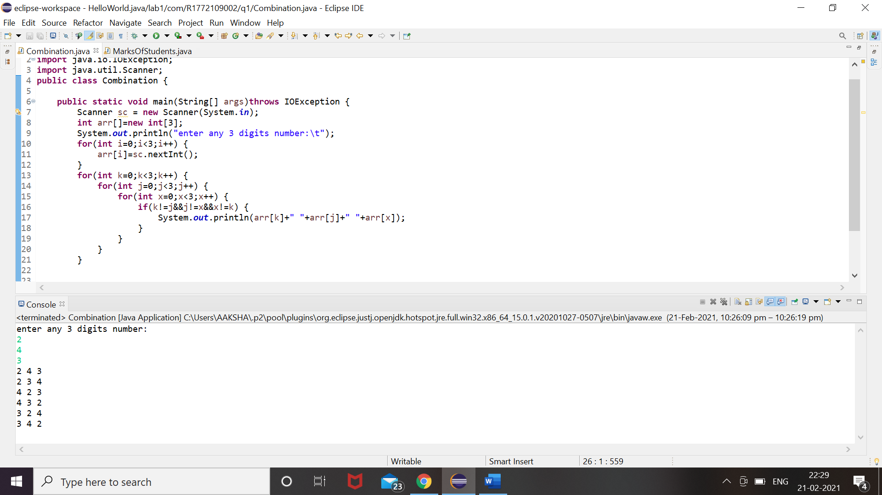

Ques 2: -

**package** com.R1772109002.q2;

**import** java.io.IOException;

**import** java.util.Scanner;

**public** **class** sqsum {

**public** **static** **void** main(String[] args)**throws** IOException {

Scanner sc = **new** Scanner(System.***in***);

**int** arr[]=**new** **int**[10];

System.***out***.println("enter any 10 numbers in array:\t");

**for**(**int** i=0;i<10;i++) {

arr[i]=sc.nextInt();

}

**int** sum =0;

**for**(**int** i=0;i<10;i++) {

sum = sum + arr[i];

}

System.***out***.println("Sum of these numbers is:-\t" + sum);

System.***out***.println("square of each number of array is:-");

**for**(**int** i=0;i<10;i++) {

arr[i]=arr[i]*arr[i];

System.***out***.println(arr[i]);

}

}

}

Output: -

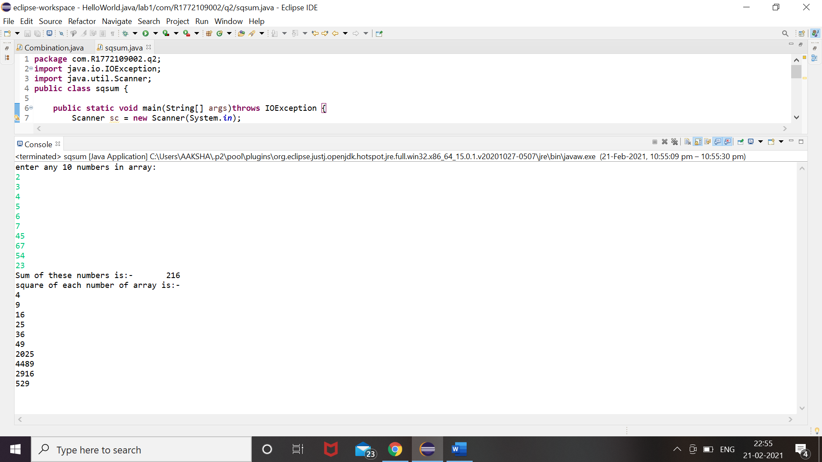

Ques 3: -

**package** com.R1772109002.q3;

**import** java.io.IOException;

**import** java.util.Scanner;

**public** **class** month {

**public** **static** **void** main(String[] args)**throws** IOException {

Scanner sc = **new** Scanner(System.***in***);

System.***out***.println("enter any number from 1 to 12:\t");

**int** num=sc.nextInt();

**switch**(num) {

**case** 1:

System.***out***.println("January");

**break**;

**case** 2:

System.***out***.println("feburary");

**break**;

**case** 3:

System.***out***.println("March");

**break**;

**case** 4:

System.***out***.println("April");

**break**;

**case** 5:

System.***out***.println("May");

**break**;

**case** 6:

System.***out***.println("June");

**break**;

**case** 7:

System.***out***.println("July");

**break**;

**case** 8:

System.***out***.println("August");

**break**;

**case** 9:

System.***out***.println("September");

**break**;

**case** 10:

System.***out***.println("October");

**break**;

**case** 11:

System.***out***.println("November");

**break**;

**case** 12:

System.***out***.println("December");

**break**;

**default**:

System.***out***.println ("You have entered an invalid number");

}

}

}

Output: -

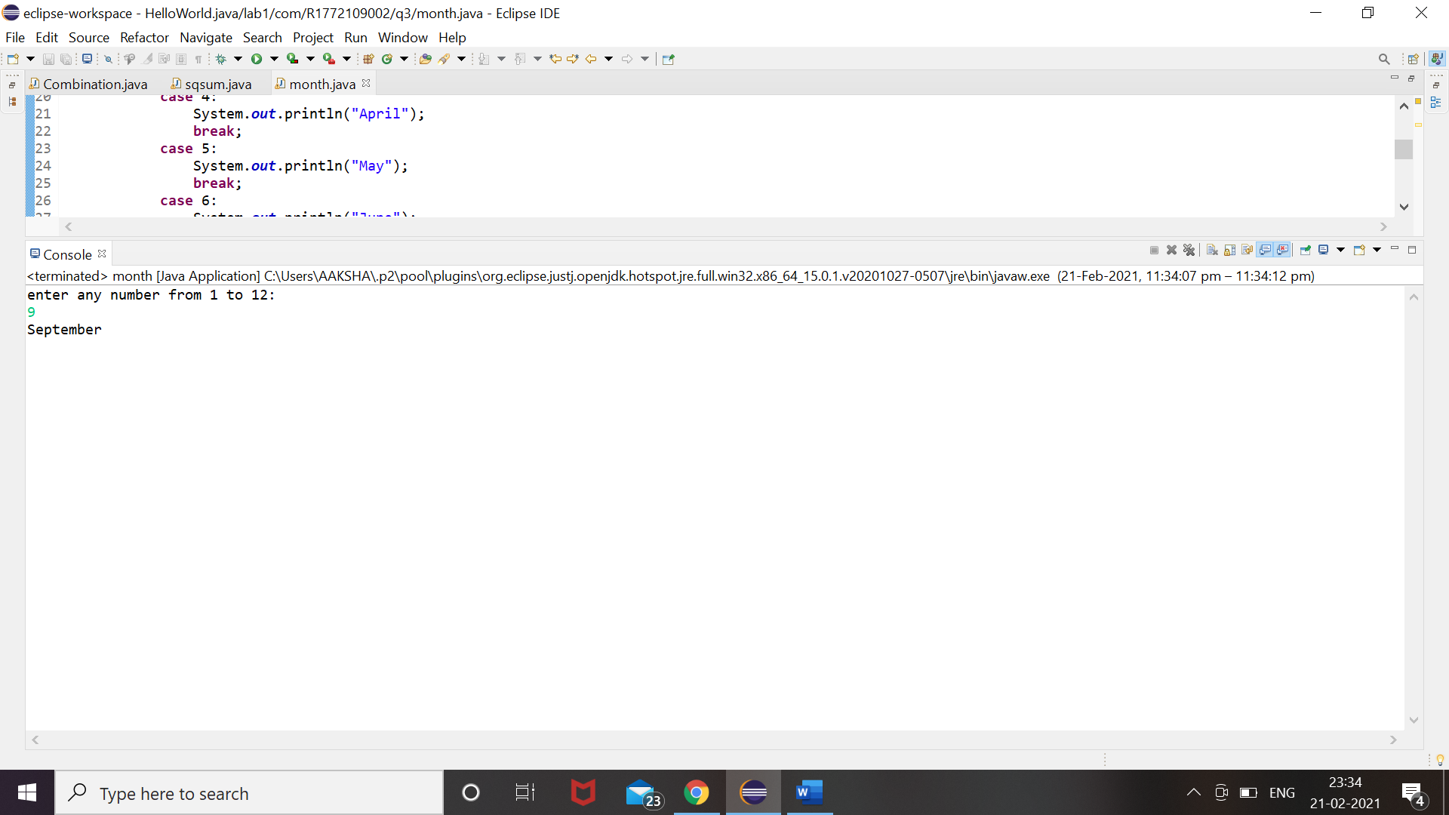

Ques 4:-

**package** com.R1772109002.q4;

**public** **class** SumOfNums {

**public** **static** **void** main(String[] args){

**int** sum =0;

System.***out***.println("numbers greater than 40 and less than 250 that are divisible by 5:-\t");

**for**(**int** i=40;i<250;i++) {

**if**(i%5==0) {

sum =sum + i;

System.***out***.println(i);

}

}

System.***out***.println("Sum of numbers greater than 40 and less than 250 that are divisible by 5:-\t"+sum);

}

}

Output:-

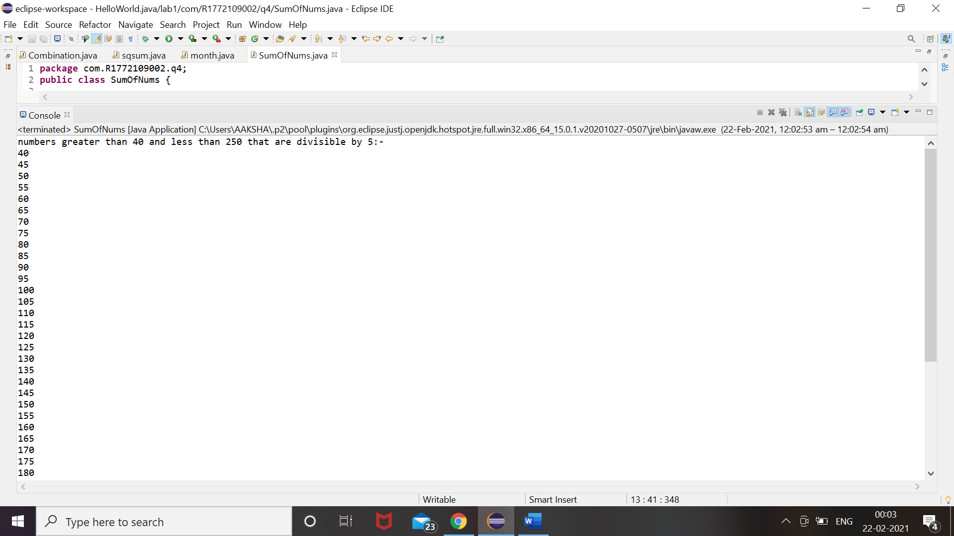

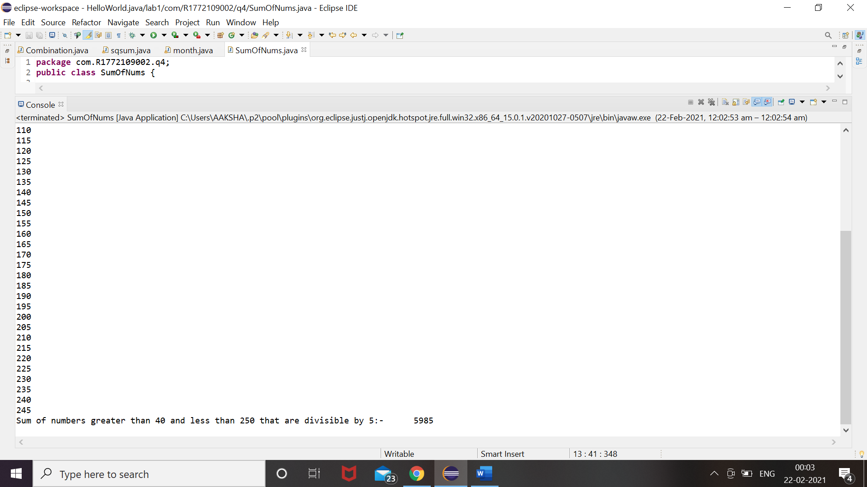

Ques5:-

package com.R1772109002.q5;

import java.io.IOException;

import java.util.Scanner;

public class StuMarks {

public static void main(String[] args) throws IOException {

Scanner sc = new Scanner(System.in);

int n;

System.out.println("Enter no. of elements you want in array:");

n = sc.nextInt();

int temp =0;

int arr[]=new int[n];

String grade[] = new String[n];

System.out.println("enter numbers of students:\t");

for(int i=0;i<n;i++) {

arr[i]=sc.nextInt();

}

for (int i = 0; i < n; i++)

{

for (int j = i + 1; j < n; j++)

{

if (arr[i] > arr[j])

{

temp = arr[i];

arr[i] = arr[j];

arr[j] = temp;

}

}

}

System.out.print("Ascending Order:");

for (int i = 0; i < n - 1; i++)

{

System.out.print(arr[i] + ",");

}

System.out.print(arr[n - 1]);

System.out.println(" ");

for(int i=0;i<n;i++) {

if(arr[i]>=40&&arr[i]<=50) {

grade[i]="Pass";

}

else if(arr[i]>=51&&arr[i]<=75) {

grade[i]=" Merit";

}

else if(arr[i]>75) {

grade[i]=" Distinction";

}

else {

grade[i]=" Fail";

}

}

System.out.println("\tTABLE\t");

System.out.println("MARKS\t"+"GRADES\t");

for (int i=0;i<n;i++) {

System.out.println(arr[i]+"\t"+grade[i]);

}

}

}

