EXPERIMENT -2

Aim :- Implementing given programs using terminal and notepad.

Q1) Write a program to find largest of three numbers.

**CODE: -**

class Greatest

{

public static void main(String args[])

{

int a=10,b=20,c=30;

if(a>b && a>c)

System.out.println(a+"is largest");

else if(b>a && b>c)

System.out.println(b+"is largest");

else

System.out.println(c+"is largest");

}

}

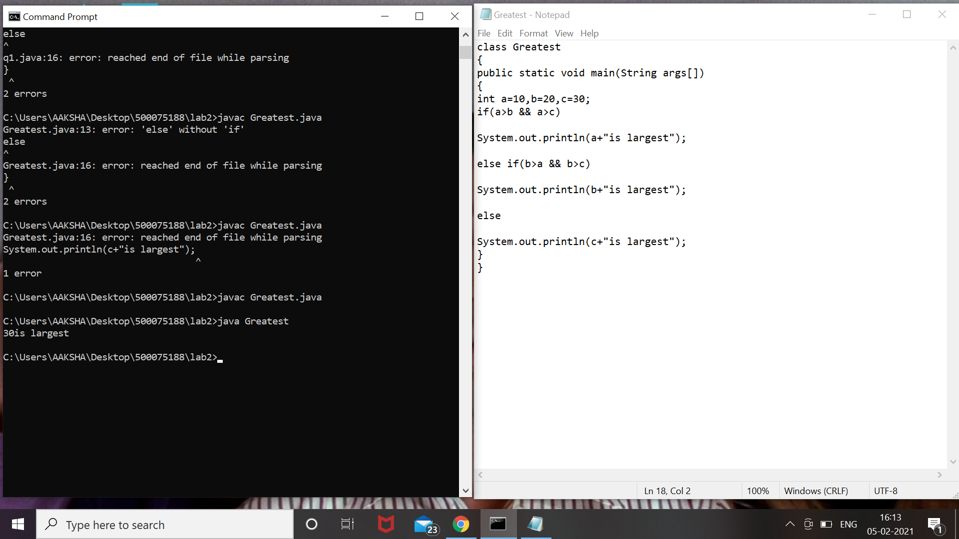

Q2) Write a program to implement a command line calculator.

**CODE :-**

class cmndCal

{

public static void main(String args[])

{

int a = Integer.parseInt(args[0]);

int b = Integer.parseInt(args[2]);

char opr = args[1].charAt(0);

if (opr == '+')

{

System.out.println("Sum of "+a+" and "+b+" is "+(a+b));

}

else if (opr == '-')

{

System.out.println("difference of "+a+" and "+b+" is "+(a-b));

}

else if (opr == 'x' || opr =='X')

{

System.out.println("Product of "+a+" and "+b+" is "+(a*b));

}

else if (opr == '/')

{

System.out.println("division of "+a+" and "+b+" is "+(a/b));

}

else

{

System.out.println("invalid input");

}

}

}

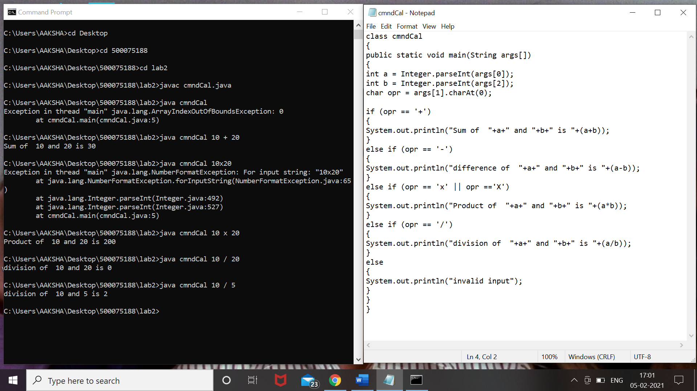

Q3:- Write a program using classes and object in java

**CODE :-**

class SampleNew

{

public static void main(String args[])

{

SomeClass obj=new SomeClass();

obj.setA(10);

System.out.println(obj.getA());

if(args.length!=0)

{

for(int i=0;i<args.length;i++)

{

System.out.println("Argument "+i+"is:"+args[i]);

}

}

else

{

System.out.println("No CLA");

}

}

}

class SomeClass

{

int a;//State

void setA(int a)

{

System.out.println("Value Setted");

this.a=a;

}

int getA()

{

System.out.println("Value Returned");

return this.a;

}

}

