

**Air Conditioning Project**

**Team Members:**

|  |
| --- |
| Alaa Ibrahim |
| Bassel Yasser |
| Sharpel Malek |
| Sherif Khadr |

Contents

INTRODUCTION 1

High Level Design 2

**01)** **Layered Architecture** 2

**02)** **Modules Description** 3

**03)** **Drivers’ Documentation** 4

Low Level Design 14

Figure 1: Project Layered Architecture 2

# INTRODUCTION

# High Level Design

## **Layered Architecture**

Figure : Project Layered Architecture

## **Modules Description**

**MCAL Layer:**

* **DIO:** For controlling GPIO pins
* **External Interrupt:** this module takes place in MCAL layer. it controlsthree external hardware interrupts on pins PD2, PD3, and PB2 which are referred to as INT0, INT1, and INT2 respectively. External interrupts can be level-triggered or edge-triggered.  
  We program this triggering. INT0 and INT1 can be level-triggered and edge-triggered whereas INT2 can be only edge-triggered.
* **Timer:** Provides an interface with timer 0 low-level capabilities.
* **ADC:**

**HAL Layer:**

* **Button:**
* **Keypad:** Deal witha set of buttons arranged in a block. The 3 x 3 matrix keypad usually is used as input in a project
* **LCD:** Use for display data
* **HTimer:** Provides high-level functions using the lower level timer 0 module capabilities.
* **HExtInt:** Provides high-level functions using the lower level External interrupt module capabilities.

**Service Layer:**

**Application Layer:**

## **Drivers’ Documentation**

**MCAL Layer:**

* **DIO:**

/*

* AUTHOR : Bassel Yasser

* Function : DIO_s8SETPinDir

* Description : Set Pin Direction

* Arguments :

* - enPinCopy {DIO_PINA_0...., DIO_PIND_7}

* - enPortDir {INPUT , OUTPUT}

* Return : Sint8_t

*/

Sint8_t **DIO_s8SETPinDir** (enu_pin enPinCopy, enu_dir enPortDir)

/*

* AUTHOR : Bassel Yasser

* Function : DIO_s8SETPinVal

* Description : Set Pin Value

* Arguments :

* - enPinCopy {DIO_PINA_0...., DIO_PIND_7}

* - enPortDir {HIGH , LOW}

* Return : Sint8_t

*/

Sint8_t **DIO_s8SETPinVal** (enu_pin enPinCopy, enu_val enPortVal)

/*

* AUTHOR : Bassel Yasser

* Function : DIO_s8GETPinVal

* Description : Set Pin Value

* Arguments :

* - enPinCopy {DIO_PINA_0...., DIO_PIND_7}

* - pu8Val address of variable that u want to save value on it

* Return : Sint8_t

*/

Sint8_t **DIO_s8GETPinVal** (enu_pin enPinCopy, Uint8_t* pu8Val)

* **External Interrupt:**

// EXT_INT TYPEDEFS

typedef enum EN_EXTINT_ERROR {

EXTINT_OK=0,

EXTINT_NOT_OK

}EN_EXTINT_ERROR;

typedef enum EN_Sence_Control {

LOW_LEVEL=0,

FALLING_EDGE,

RISING_EDGE,

ANY_LOGICAL_CHANGE

}EN_Sence_Control;

typedef enum EN_EXINT_NUMBER{

EXTINT0=0,

EXTINT1,

EXTINT2,

}EN_EXINT_NUMBER;

typedef enum EN_GLOBAL_INT{

DISABLE=0,

ENABLE

}EN_GLOBAL_INT;

// EXT_INT prototypes

/*

Description : This function initializes the GLOBAL_INTERRUPT

ARGS : takes the state ( ENABLE OR DISABLE )

return : return EXTINT_OK if the PIN initializes correctly, EXTINT_NOT_OK otherwise

*/

EN_EXTINT_ERROR SET_GLOBAL_INTERRUPT(EN_GLOBAL_INT state);

/*

Description : This function initializes the external interrupt number and it's detecting type

ARGS : takes the EXINT_NUMBER( INT0,INT1 OR INT2) and sense control.

return : return EXTINT_OK if the EXINT_NUMBER initializes correctly, EXTINT_NOT_OK otherwise

*/

EN_EXTINT_ERROR EXTINT_init(EN_EXINT_NUMBER INTx ,EN_Sence_Control INTxSense);

/*

Description : This function takes the external interrupt number and initialize call back function.

ARGS : takes the EXINT_NUMBER( INT0,INT1 OR INT2) and pointer to the function we want to execute.

return : return EXTINT_OK if the EXINT_NUMBER initializes correctly, EXTINT_NOT_OK otherwise

*/

EN_EXTINT_ERROR EXTINT_CallBack(EN_EXINT_NUMBER INTx,void(*ptrfunc)(void));

* **Timer:**

/**

* \brief Initialize the timer with given mode

* \param u8_a_Mode

* \return en_TIMErrorState_t

*/

en_TIMErrorState_t TIM0_voidInit(en_TIMMode_t u8_a_Mode);

/**

* \brief Start the timer clock after prescaling it with given value

* \param u8_a_prescaler

* \return en_TIMErrorState_t

*/

en_TIMErrorState_t TIM0_Start(en_TIM_CLK_SELECT_t u8_a_prescaler);

/**

* \brief Function to stop timer 0

* \return void

*/

void TIM0_Stop();

/**

* \brief Set the timer to start from a certain value

* \param u8_a_FlagValue The value to start the timer from

* \return void

*/

void TIM0_SetValue(Uchar8_t u8_a_startValue);

/**

* \brief Function to get the value of the overflow flag of timer 0

* \param u8_a_FlagValue reference to a variable to store flag value *

* \return en_TIMErrorState_t

*/

en_TIMErrorState_t TIM0_GetOVF(Uchar8_t* u8_a_FlagValue);

/**

* \brief Function to clear timer 0 overflow flag

* \return void

*/

void TIM0_ClearOVF(void);

/**

* \brief Function to get the timer state (running/stopped)

* \param u8_a_State reference to a variable to store timer state

* \return en_TIMErrorState_t

*/

en_TIMErrorState_t TIM0_GetState(en_TIMState_t* u8_a_State);

/**

* \brief Function to set a function to call when the timer0

* Overflow Interrupt is triggered

* \param pv_a_CallbackFn reference to the function to call

* \return en_TIMErrorState_t

*/

**HAL Layer:**

**Button:**

/**

* \brief : This Function Use To Initialize Button Pin And Port

*

* \param ST_PUSH_BTN_t *btn

*

* \return Std_ReturnType

*/

Std_ReturnType PUSH_BTN_intialize(const ST_PUSH_BTN_t *btn)

/**

* \brief : This Function Will Use To Read Button Statues If It Is Pressed Or Releassed

*

* \param ST_PUSH_BTN_t *btn

* \param EN_PUSH_BTN_state_t *btn_state

*

* \return Std_ReturnType

*/

Std_ReturnType PUSH_BTN_read_state(const ST_PUSH_BTN_t *btn , EN_PUSH_BTN_state_t *btn_state)

* **Keypad:**

// Macros

#define R1 DIO_PINC_2

#define R2 DIO_PINC_3

#define R3 DIO_PINC_4

#define C1 DIO_PINC_5

#define C2 DIO_PINC_6

#define C3 DIO_PINC_7

// user defined datatypes

typedef enum EN_KEYPAD_BTNS

{

KEY_INCREAMENT=0,

KEY_DECREAMENT,

KEY_SET,

KEY_ADJUST,

KEY_RESET,

KEY_6,

KEY_7,

KEY_8,

KEY_9,

KEY_NOTHING

}EN_KEYPAD_BTNS;

// functions prototypes

/*************************************************************************************************************

*

Name : KEYPAD_init()

Description : This Function Initializes keypad pins (Rows are outputs & Columns are inputs).

ARGS : void

return : void

************************************************************************************************************/

void KEYPAD_init(void);

/*************************************************************************************************************

*

Name : KEYPAD_GetButton

Description : This Function loops over other three functions (Checks (R1,R2,R3)).

ARGS : void

return : the pressed key or Nothing pressed

************************************************************************************************************/

EN_KEYPAD_BTNS KEYPAD_GetButton(void);

/*************************************************************************************************************

*

Name : KEYPAD_checkR1 , KEYPAD_checkR2, KEYPAD_checkR3

Description : functions are checking the entire row if it pressed or not.

ARGS : void

return : the pressed key or Nothing pressed

************************************************************************************************************/

EN_KEYPAD_BTNS KEYPAD_checkR1(void);

EN_KEYPAD_BTNS KEYPAD_checkR2(void);

EN_KEYPAD_BTNS KEYPAD_checkR3(void);

* **HTimer:**

/**

* \brief Generate Synchronous delay (busy waiting)*

* \param Copy_delayTime Desired delay

* \param Copy_timeUnit Time units (Seconds, mSeconds, uSeconds)

*

* \return en_HTIMErrorState_t

*/

en_HTIMErrorState_t TIM0_SyncDelay(Uint32_t u32_a_delay, en_timeUnits_t u8_a_timeUnit);

/**

* \brief Generates delay asynchronously

* \param u32_a_delay desired delay

* \param u8_a_timeUnit delay time units

* \param Copy_pvCallbackFn function to call when delay is complete

*

* \return en_TIMErrorState_t

*/

en_HTIMErrorState_t TIM0_AsyncDelay(Uint32_t u32_a_delay, en_timeUnits_t u8_a_timeUnit, void (*Copy_pvCallbackFn)(void));

/**

* \brief Function to end a delay asynchronously

* To Stop Async Delay: No Restrictions

* To Stop Sync Delay: should only be called in an ISR/Callback function

*

* \return void

*/

void TIM0_AsyncEndDelay();

* **HExtInt:**

/*

Description : This function initializes the external interrupt number and it's detecting type and initialize call back function.

ARGS : takes the EXINT_NUMBER( INT0,INT1 OR INT2) and sense control and and pointer to the function we want to execute when interrupt occurs.

return : return EXTINT_OK if the EXINT_NUMBER initializes correctly, EXTINT_NOT_OK otherwise

*/

EN_EXTINT_ERROR H_EXTINT_create(EN_EXINT_NUMBER INTx ,EN_Sence_Control INTxSense,void(*ptrfunc)(void));

* **HLCD:**

/*

* function : HLCD_vidInit

* description : func to set LCD initialization

* input param : void

* return : void

* */

**void** **HLCD_vidInit**(**void**)

/*

* function : HLCD_vidWritecmd

* description : func to configure some commands on lcd

* input param :

* u8commandCopy --> take lcd cmd instructions from instruction table <https://components101.com/sites/default/files/component_datasheet/16x2%20LCD%20Datasheet.pdf>

* return : void

* */

**void** **HLCD_vidWritecmd**(Uint8_t u8commandCopy)

/*

* function : HLCD_vidWriteChar

* description : func to write char on lcd

* input param : u8CharCopy -> take ascii code of char or char address on CGROM

* return : void

* */

**void** **HLCD_vidWriteChar**(Uint8_t u8CharCopy)

/*

* function : HLCD_ClrDisplay

* description : func to clear anything on lcd

* input param : void

* return : void

* */

**void** **HLCD_ClrDisplay**(**void**)

/*

* function : HLCD_gotoXY

* description : func to determine position which char print at this position on lcd ### NOTE : (2rows x 16coloms)

* input param :

* row -> take row number 0 or 1

* pos -> take colom number from 0 ~ 16

* return : void

* */

**void** **HLCD_gotoXY**(Uint8_t row, Uint8_t pos)

/*

* function : HLCD_WriteString

* description : func to write string on lcd

* input param : str --> which take string as argument

* return : void

* */

**void** **HLCD_WriteString**(Uint8_t* str)

/*

* function : HLCD_WriteInt

* description : func to write integer number on lcd

* input param : number --> which take number as argument

* return : void

* */

**void** **HLCD_WriteInt**(Uint32_t number)

/*

* function : HLCD_vidCreatCustomChar

* description : func to store new patterm on CGRAM

* input param :

* pu8custom -> take pointer to array which having LCD Custom Character Generated data ### take only 8 characters

* u8Location -> determine location on CGRAM [0 ~ 8]

* return : void

* */

**void** **HLCD_vidCreatCustomChar**(Uint8_t* pu8custom, Uint8_t u8Location)

**Application Layer:**

# Low Level Design

**MCAL Layer:**

* **DIO:**

Sint8_t **DIO_s8SETPinDir** (enu_pin enPinCopy, enu_dir enPortDir)

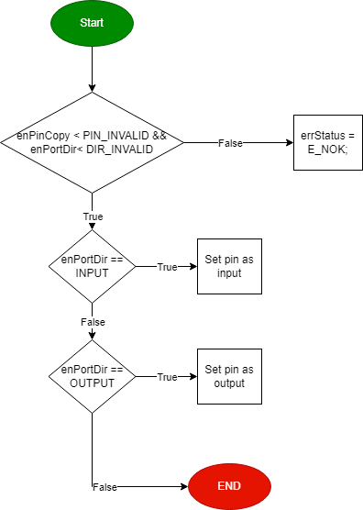

Sint8_t **DIO_s8SETPinVal** (enu_pin enPinCopy, enu_val enPortVal)

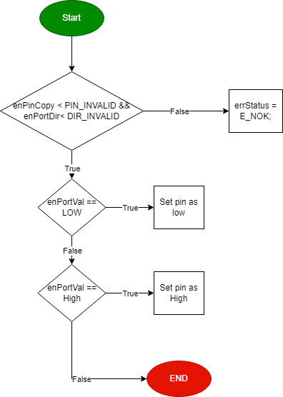

Sint8_t **DIO_s8GETPinVal** (enu_pin enPinCopy, Uint8_t* pu8Val)

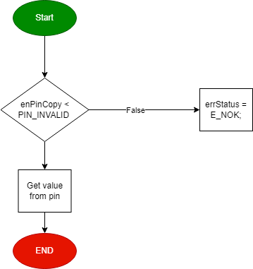

* **External Interrupt:**

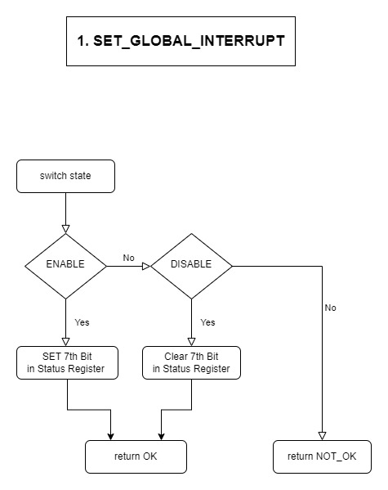

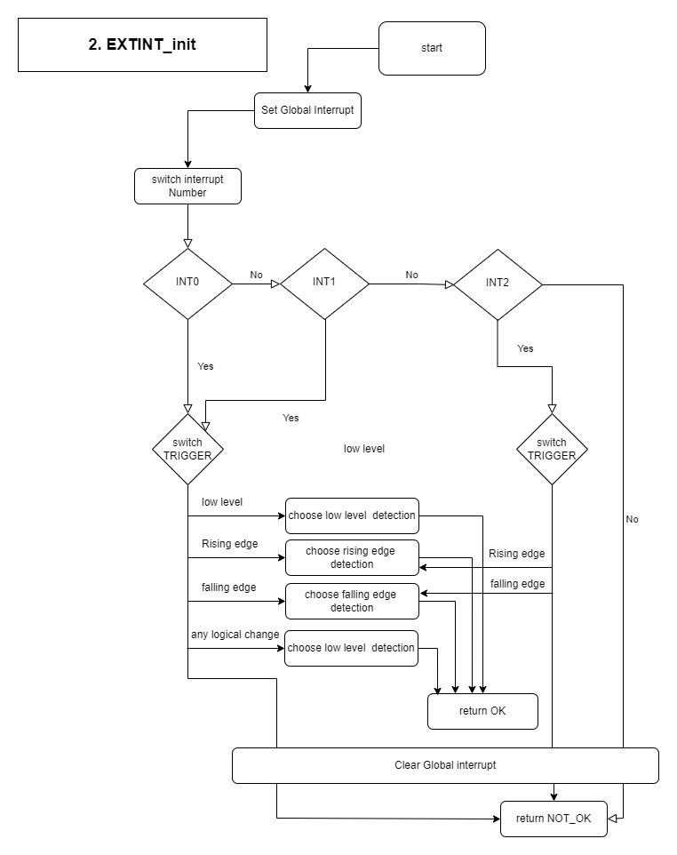

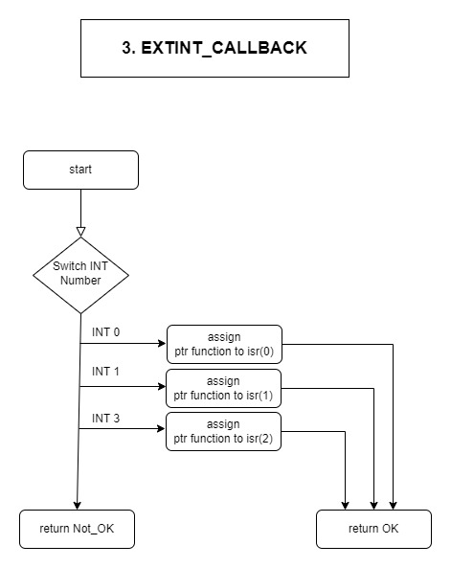

* **Timer:**

**TIM0_Init**

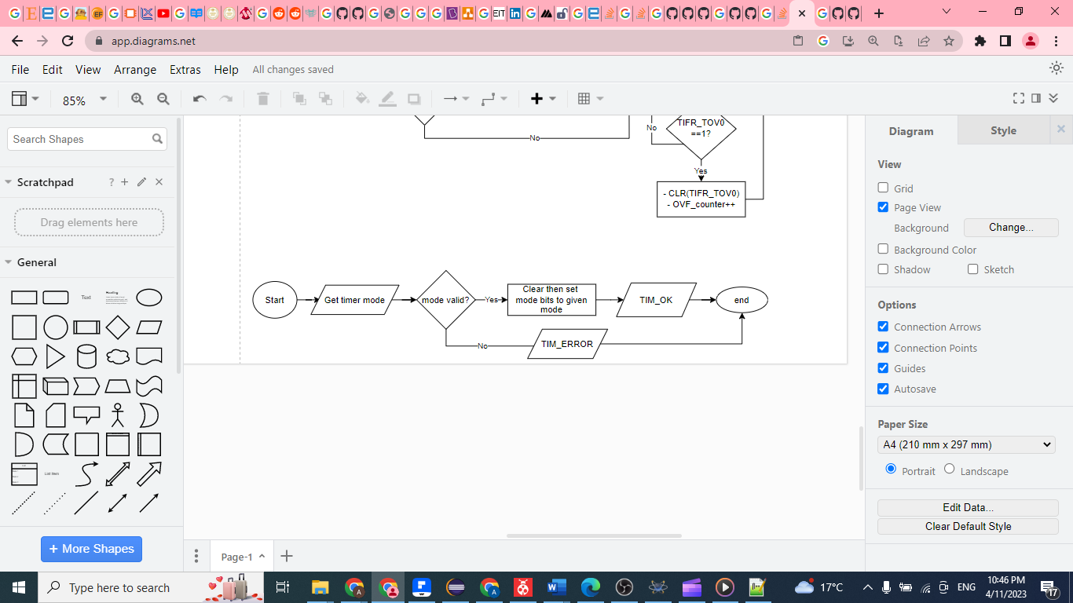

**TIM0_Start**

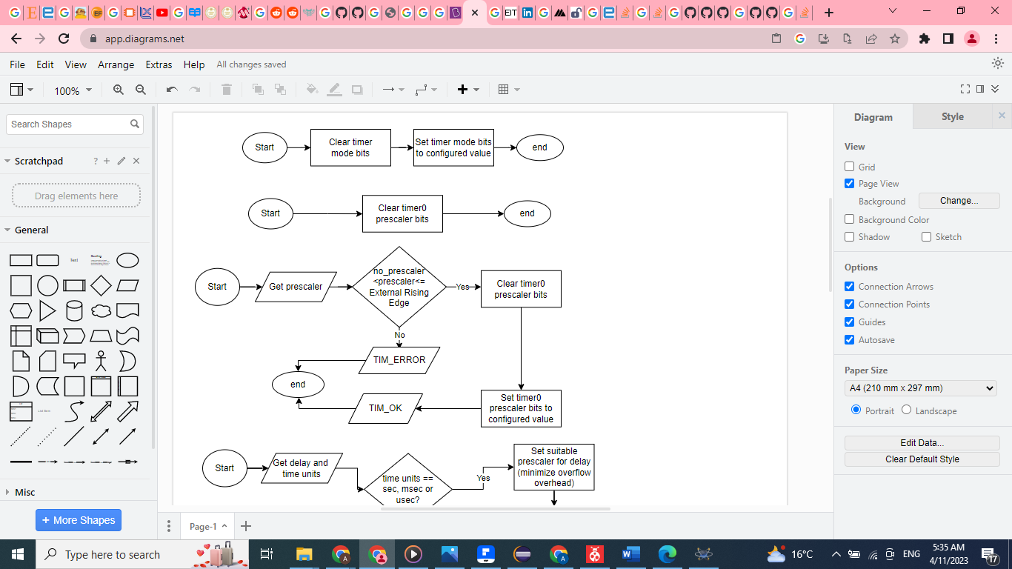

**TIM0_Stop**



**HAL Layer:**

* **Button:**

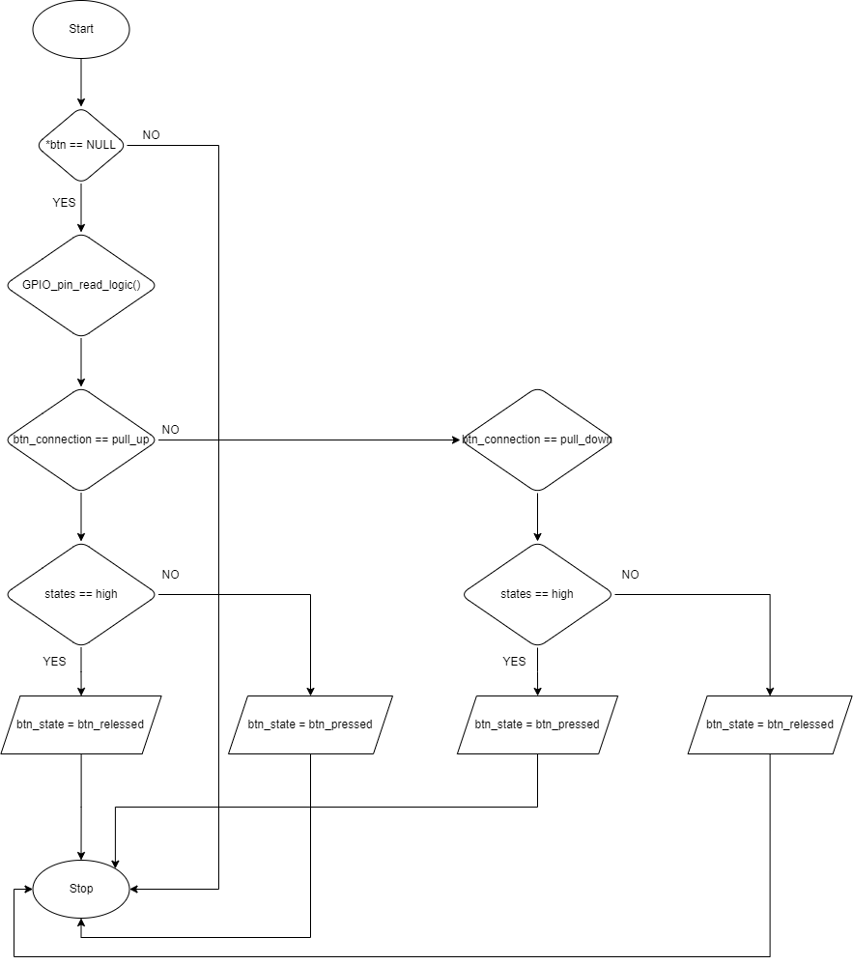

* **Timer0**

**HTIM_SyncDelay**

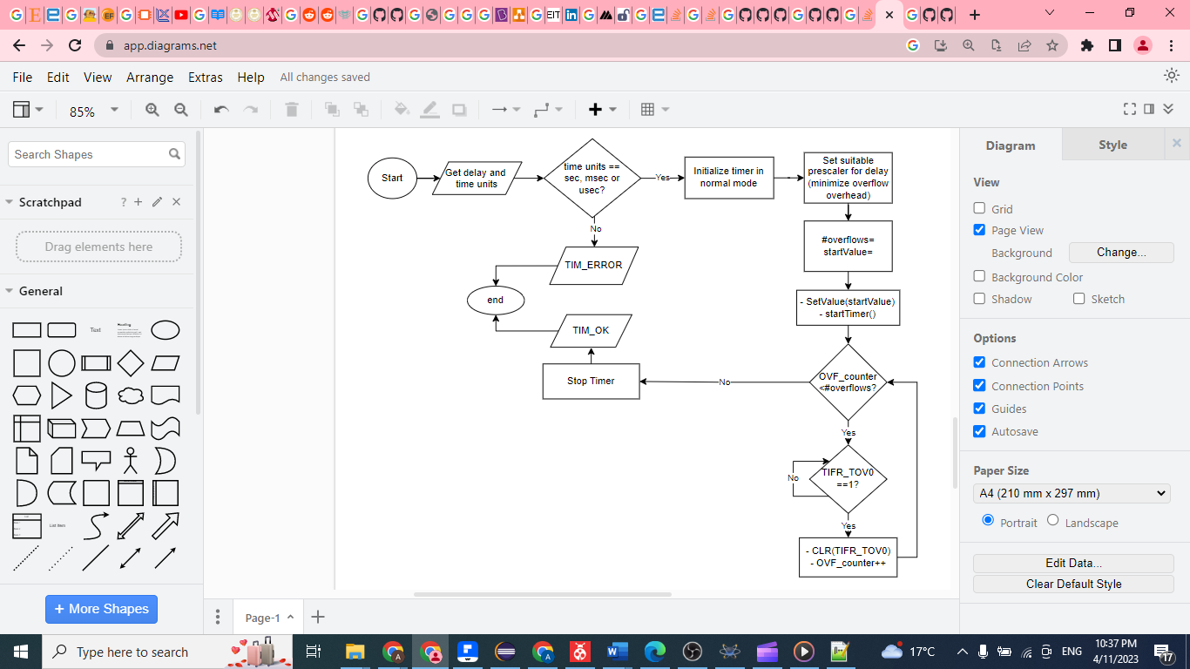

* **LCD:**

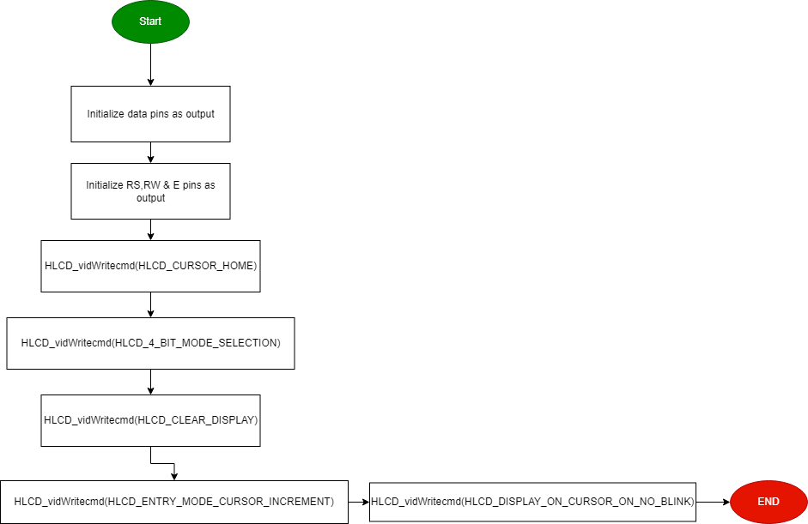**void** **HLCD_vidInit**(**void**)

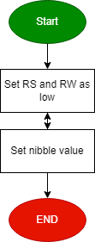**void** **HLCD_vidWritecmd**(Uint8_t u8commandCopy)

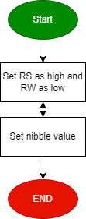

**void** **HLCD_vidWriteChar**(Uint8_t u8CharCopy)

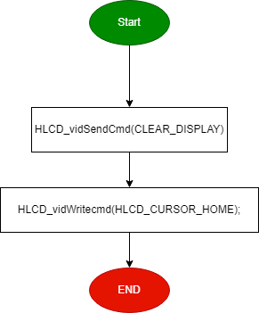**void** **HLCD_ClrDisplay**(**void**)

**void** **HLCD_gotoXY**(Uint8_t row, Uint8_t pos)

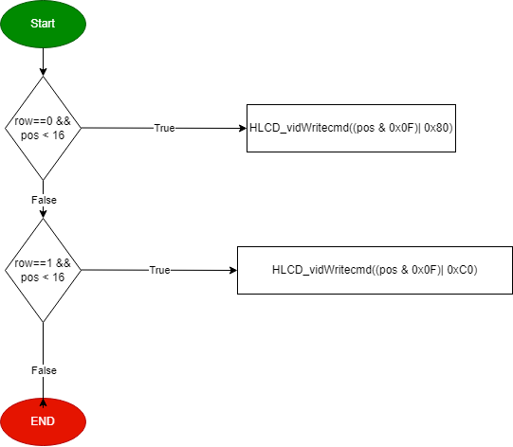

**void** **HLCD_WriteString**(Uint8_t* str)

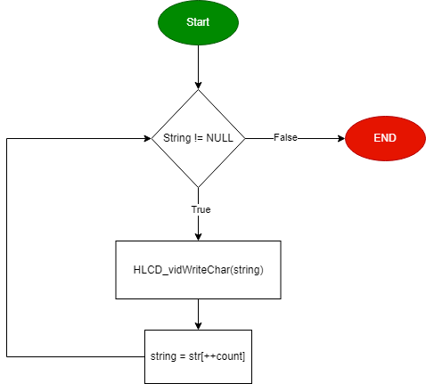

**void** **HLCD_WriteInt**(Uint32_t number)

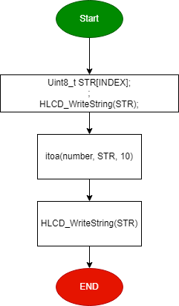

**void** **HLCD_vidCreatCustomChar**(Uint8_t* pu8custom, Uint8_t u8Location)

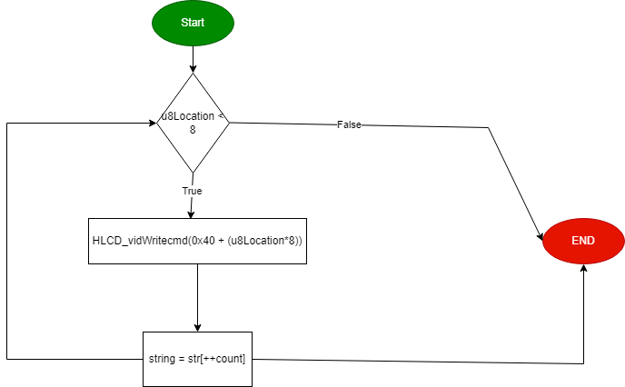

* **Keypad :**

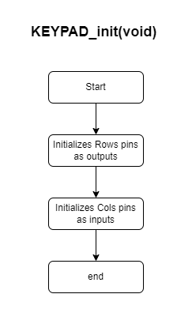

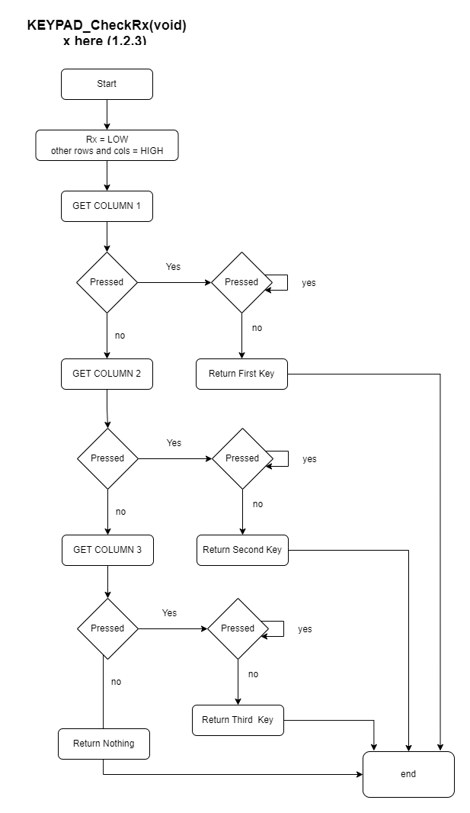

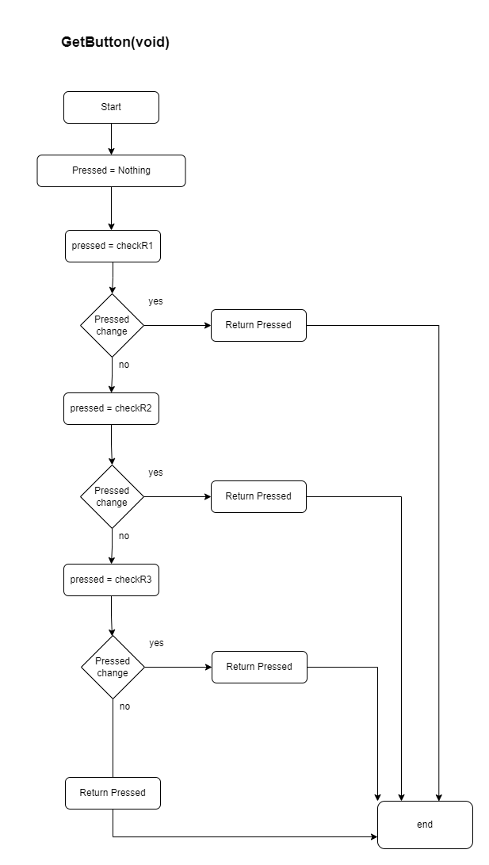

**Application Layer:**

* APP_Init