

**Simple ATM Machine**

**Team Members:**

|  |
| --- |
| Alaa Ibrahim |
| Bassel Yasser |
| Sharpel Malek |
| Sherif Khadr |

Contents

INTRODUCTION 1

High Level Design 1

**01)** **Layered Architecture** 1

**02)** **Modules Description** 2

**03)** **Drivers’ Documentation** 3

**MCAL Layer** 3

• **DIO** 3

• **Timer 0** 4

• **EXTINT:** 5

• **I2C:** 6

• **UART:** 9

• **SPI:** 10

**HAL Layer:** 11

• **Keypad** 11

• **HTimer:** 12

• **HLCD** 13

• **Buzzer** 14

• **Button** 14

• **EEPROM** 15

**Application Layer:** 16

Low Level Design 17

**MCAL Layer:** 17

• **DIO** 17

• **Timer:** 20

• **EXTINT:** 22

• **UART:** 23

• **SPI:** 24

• **I2C:** 25

**HAL Layer** 29

• **HTimer0** 29

• **LCD** 30

• **Keypad** 37

• **Buzzer** 40

• **HEXTINT:** 40

• **Button:** 41

**Application Layer:** 42

Figure 1: Project Layered Architecture 1

Figure 2 DIO_s8SETPinDir Flow Chart 12

Figure 3 DIO_s8SETPinVal Flow chart 13

Figure 4 DIO_s8GETPinVal Flow Chart 14

Figure 5 TIM0_Init Flow Chart 15

Figure 6 TIM0_Start Flow Chart 15

Figure 7 TIM0_Stop Flow Chart 15

Figure 8 TIM0 remaining Flow Charts 16

Figure 9 ADC_Init Flow Chart 17

Figure 10 ADC_SetChannel Flow Chart 18

Figure 11 ADC_Deinit Flow Chart 18

Figure 12 ADC_StartConversion Flow Chart 18

Figure 13 ADC_GetConversionResult Flow Chart 19

Figure 14 ADC_Conversion Flow Chart 20

Figure 15 HTIM0_SyncDelay Flow Chart 21

Figure 16 HTIM0_AsyncDelay and EndDelay 21

Figure 17 HLCD_vidInit Flow Chart 22

Figure 18 HLCD_vidWritecmd Flow Chart 23

Figure 19 HLCD_vidWriteChar Flow Chart 23

Figure 20 HLCD_ClrDisplay Flow Chart 24

Figure 21 HLCD_gotoXY Flow Chart 25

Figure 22 HLCD_WriteString Flow Chart 26

Figure 23 HLCD_WriteInt Flow Chart 27

Figure 24 HLCD_vidCreatCustomChar Flow Chart 28

Figure 25 KEYPAD_Init Flow Chart 29

Figure 26 KEYPAD_CheckRx Flow Chart 30

Figure 27 GetButton Flow Chart 31

Figure 28 Buzzer Init & SetState Flow Charts 32

Figure 29 Temp Sensor Init & ReadValue Flow Charts 32

Figure 30 App. APIs Flow Charts 33

Figure 31 APP_Start & App States Flow Charts 34

Figure 32 Cont. App States Flow Charts 35

# INTRODUCTION

# High Level Design

## **Layered Architecture**

**ATM MACHINE:**

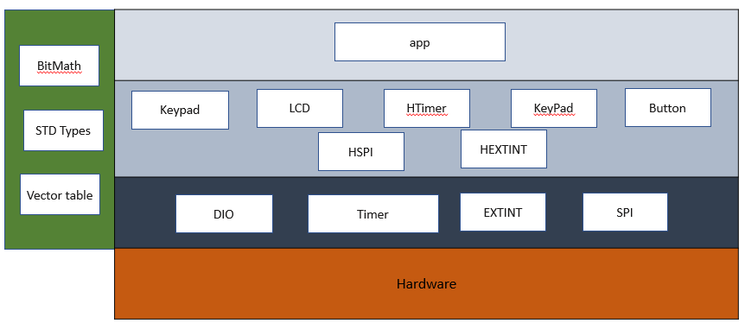

Figure : Project Layered Architecture

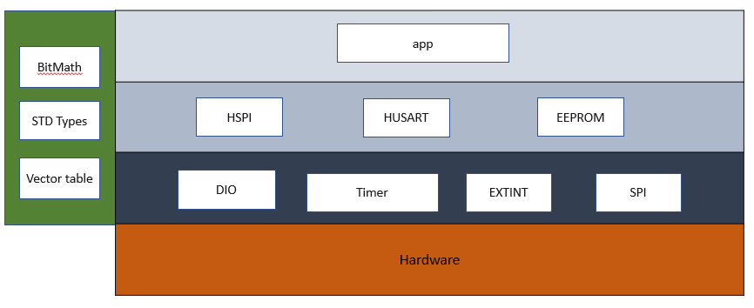**CARD**

## **Modules Description**

**MCAL Layer:**

* **DIO:** For controlling GPIO pins
* **Timer:** Provides an interface with timer 0 low-level capabilities.
* **EXTINT:**
* **USART:**
* **SPI:**
* **I2C:**

**HAL Layer:**

* **Keypad:** Deal witha set of buttons arranged in a block. The 3 x 3 matrix keypad usually is used as input in a project
* **LCD:** Use for display data
* **Buzzer:** Simple module to control a buzzer.
* **HTimer:** Provides high-level functions using the lower-level timer 0 module capabilities.
* **EEPROM:**
* **Button:**
* **Buzzer:**

**Service Layer:**

* **STD_Types:** Contains all the standard types used by all the layers.
* **BIT_Math:** Provides bit-wise operations.
* **Vect_table:** Contains all interrupt vectors and provides macros for dealing with general interrupt.

**Application Layer:**

Contains the main logic of the project.

## **Drivers’ Documentation**

### **MCAL Layer**

#### **DIO**

/*

* AUTHOR : Bassel Yasser

* Function : DIO_s8SETPinDir

* Description : Set Pin Direction

* Arguments :

* - enPinCopy {DIO_PINA_0...., DIO_PIND_7}

* - enPortDir {INPUT , OUTPUT}

* Return : Sint8_t

*/

Sint8_t **DIO_s8SETPinDir** (enu_pin enPinCopy, enu_dir enPortDir)

/*

* AUTHOR : Bassel Yasser

* Function : DIO_s8SETPinVal

* Description : Set Pin Value

* Arguments :

* - enPinCopy {DIO_PINA_0...., DIO_PIND_7}

* - enPortDir {HIGH , LOW}

* Return : Sint8_t

*/

Sint8_t **DIO_s8SETPinVal** (enu_pin enPinCopy, enu_val enPortVal)

/*

* AUTHOR : Bassel Yasser

* Function : DIO_s8GETPinVal

* Description : Set Pin Value

* Arguments :

* - enPinCopy {DIO_PINA_0...., DIO_PIND_7}

* - pu8Val address of variable that u want to save value on it

* Return : Sint8_t

*/

Sint8_t **DIO_s8GETPinVal** (enu_pin enPinCopy, Uint8_t* pu8Val)

#### **Timer 0**

/**

* \brief Initialize the timer with given mode

* \param u8_a_Mode

* \return en_TIMErrorState_t

*/

en_TIMErrorState_t TIM0_voidInit(en_TIMMode_t u8_a_Mode);

/**

* \brief Start the timer clock after prescaling it with given value

* \param u8_a_prescaler

* \return en_TIMErrorState_t

*/

en_TIMErrorState_t TIM0_Start(en_TIM_CLK_SELECT_t u8_a_prescaler);

/**

* \brief Function to stop timer 0

* \return void

*/

void TIM0_Stop();

/**

* \brief Set the timer to start from a certain value

* \param u8_a_FlagValue The value to start the timer from

* \return void

*/

void TIM0_SetValue(Uchar8_t u8_a_startValue);

/**

* \brief Function to get the value of the overflow flag of timer 0

* \param u8_a_FlagValue reference to a variable to store flag value *

* \return en_TIMErrorState_t

*/

en_TIMErrorState_t TIM0_GetOVF(Uchar8_t* u8_a_FlagValue);

/**

* \brief Function to clear timer 0 overflow flag

* \return void

*/

void TIM0_ClearOVF(void);

/**

* \brief Function to get the timer state (running/stopped)

* \param u8_a_State reference to a variable to store timer state

* \return en_TIMErrorState_t

*/

en_TIMErrorState_t TIM0_GetState(en_TIMState_t* u8_a_State);

/**

* \brief Function to set a function to call when the timer0

* Overflow Interrupt is triggered

* \param pv_a_CallbackFn reference to the function to call

* \return en_TIMErrorState_t

*/

#### **EXTINT:**

#### **I2C:**

/***********************************************************************************/

/* 01- i2c_init_master() */

/* ----------------------------------------------------------------------------------

* @func : I2C master Initialization

* @in : void

* @out : void

************************************************************************************/

**void** **i2c_init_master**(**void**);

/***********************************************************************************/

/* 02- i2c_init_slaver() */

/* ----------------------------------------------------------------------------------

* @func : I2C slave Initialization

* @in : void

* @out : void

************************************************************************************/

**void** **i2c_init_slave** (**void**);

/***********************************************************************************/

/* 03- i2c_start() */

/* ----------------------------------------------------------------------------------

* @func : Send start condition

* @in : void

* @out : void

************************************************************************************/

**void** **i2c_start**(**void**);

/***********************************************************************************/

/* 04- i2c_repeated_start() */

/* ----------------------------------------------------------------------------------

* @func : Send repeated start condition

* @in : void

* @out : void

************************************************************************************/

**void** **i2c_repeated_start**(**void**);

/***********************************************************************************/

/* 05- i2c_send_slave_address_with_write_req() */

/* ----------------------------------------------------------------------------------

* @func : send write request from master to slave

* @in[1] : slave_address

* - Slave address that you want to write on it

* @out : void

************************************************************************************/

**void** **i2c_send_slave_address_with_write_req**(Uint8_t slave_address);

/***********************************************************************************/

/* 06- i2c_send_slave_address_with_read_req() */

/* ----------------------------------------------------------------------------------

* @func : send read request from master to slave

* @in[1] : slave_address

* - Slave address that you want to read from it

* @out : void

************************************************************************************/

**void** **i2c_send_slave_address_with_read_req**(Uint8_t slave_address);

/***********************************************************************************/

/* 07- i2c_write_byte() */

/* ----------------------------------------------------------------------------------

* @func : Write data to slave

* @in[1] : byte

* - write data that u need to send

* @out : void

************************************************************************************/

**void** **i2c_write_byte**(Uint8_t byte);

/***********************************************************************************/

/* 08- i2c_read_byte() */

/* ----------------------------------------------------------------------------------

* @func : read data from slave

* @in : void

* @out : returned data

************************************************************************************/

Uint8_t **i2c_read_byte**(**void**);

/***********************************************************************************/

/* 09- i2c_stop() */

/* ----------------------------------------------------------------------------------

* @func : Send Stop condition

* @in : void

* @out : void

************************************************************************************/

**void** **i2c_stopvoid**);

#### **UART:**

#### **SPI:**

### **HAL Layer:**

#### **Keypad**

// Macros

#define R1 DIO_PINC_2

#define R2 DIO_PINC_3

#define R3 DIO_PINC_4

#define C1 DIO_PINC_5

#define C2 DIO_PINC_6

#define C3 DIO_PINC_7

// user defined datatypes

typedef enum EN_KEYPAD_BTNS

{

KEY_INCREAMENT=0,

KEY_DECREAMENT,

KEY_SET,

KEY_ADJUST,

KEY_RESET,

KEY_6,

KEY_7,

KEY_8,

KEY_9,

KEY_NOTHING

}EN_KEYPAD_BTNS;

// functions prototypes

/*************************************************************************************************************

*

Name : KEYPAD_init()

Description : This Function Initializes keypad pins (Rows are outputs & Columns are inputs).

ARGS : void

return : void

************************************************************************************************************/

void KEYPAD_init(void);

/*************************************************************************************************************

*

Name : KEYPAD_GetButton

Description : This Function loops over other three functions (Checks (R1,R2,R3)).

ARGS : void

return : the pressed key or Nothing pressed

************************************************************************************************************/

EN_KEYPAD_BTNS KEYPAD_GetButton(void);

/*************************************************************************************************************

*

Name : KEYPAD_checkR1 , KEYPAD_checkR2, KEYPAD_checkR3

Description : functions are checking the entire row if it pressed or not.

ARGS : void

return : the pressed key or Nothing pressed

************************************************************************************************************/

EN_KEYPAD_BTNS KEYPAD_checkR1(void);

EN_KEYPAD_BTNS KEYPAD_checkR2(void);

EN_KEYPAD_BTNS KEYPAD_checkR3(void);

#### **HTimer:**

/**

* \brief Generate Synchronous delay (busy waiting)*

* \param Copy_delayTime Desired delay

* \param Copy_timeUnit Time units (Seconds, mSeconds, uSeconds)

*

* \return en_HTIMErrorState_t

*/

en_HTIMErrorState_t TIM0_SyncDelay(Uint32_t u32_a_delay, en_timeUnits_t u8_a_timeUnit);

/**

* \brief Generates delay asynchronously

* \param u32_a_delay desired delay

* \param u8_a_timeUnit delay time units

* \param Copy_pvCallbackFn function to call when delay is complete

*

* \return en_TIMErrorState_t

*/

en_HTIMErrorState_t TIM0_AsyncDelay(Uint32_t u32_a_delay, en_timeUnits_t u8_a_timeUnit, void (*Copy_pvCallbackFn)(void));

/**

* \brief Function to end a delay asynchronously

* To Stop Async Delay: No Restrictions

* To Stop Sync Delay: should only be called in an ISR/Callback function

*

* \return void

*/

void TIM0_AsyncEndDelay();

#### **HLCD**

/*

* function : HLCD_vidInit

* description : func to set LCD initialization

* input param : void

* return : void

* */

**void** **HLCD_vidInit**(**void**)

/*

* function : HLCD_vidWritecmd

* description : func to configure some commands on lcd

* input param :

* u8commandCopy --> take lcd cmd instructions from instruction table <https://components101.com/sites/default/files/component_datasheet/16x2%20LCD%20Datasheet.pdf>

* return : void

* */

**void** **HLCD_vidWritecmd**(Uint8_t u8commandCopy)

/*

* function : HLCD_vidWriteChar

* description : func to write char on lcd

* input param : u8CharCopy -> take ascii code of char or char address on CGROM

* return : void

* */

**void** **HLCD_vidWriteChar**(Uint8_t u8CharCopy)

/*

* function : HLCD_ClrDisplay

* description : func to clear anything on lcd

* input param : void

* return : void

* */

**void** **HLCD_ClrDisplay**(**void**)

/*

* function : HLCD_gotoXY

* description : func to determine position which char print at this position on lcd ### NOTE : (2rows x 16coloms)

* input param :

* row -> take row number 0 or 1

* pos -> take colom number from 0 ~ 16

* return : void

* */

**void** **HLCD_gotoXY**(Uint8_t row, Uint8_t pos)

/*

* function : HLCD_WriteString

* description : func to write string on lcd

* input param : str --> which take string as argument

* return : void

* */

**void** **HLCD_WriteString**(Uint8_t* str)

/*

* function : HLCD_WriteInt

* description : func to write integer number on lcd

* input param : number --> which take number as argument

* return : void

* */

**void** **HLCD_WriteInt**(Uint32_t number)

/*

* function : HLCD_vidCreatCustomChar

* description : func to store new patterm on CGRAM

* input param :

* pu8custom -> take pointer to array which having LCD Custom Character Generated data ### take only 8 characters

* u8Location -> determine location on CGRAM [0 ~ 8]

* return : void

* */

**void** **HLCD_vidCreatCustomChar**(Uint8_t* pu8custom, Uint8_t u8Location)

#### **Buzzer**

/**

* \brief Initialize buzzer pin as output

* \param pst_a_buzzer reference to buzzer

* \return void

*/

void BUZ_Init(st_Buzzer_t* pst_a_buzzer);

/**

* \brief Turn the buzzer on/off

* \param pst_a_buzzer reference to buzzer

* \param u16_a_state BUZ_ON (or) BUZ_OFF

* \return en_BuzzerErrorState_t

*/

en_BuzzerErrorState_t BUZ_SetState(st_Buzzer_t* pst_a_buzzer, en_BuzzerState_t en_a_state);

#### **Button**

/*

* AUTHOR : Bassel Yasser Mahmoud

* FUNCTION : HButton_Init

* DESCRIPTION : Initialize specified pin as input and pull up

* RETURN : enu_buttonError_t {BUTTON_NOK, BUTTON_OK}

*/

enu_buttonError_t **HButton_Init**(enu_pin en_pinx);

/*

* AUTHOR : Bassel Yasser Mahmoud

* FUNCTION : HButton_ExtIntInit

* DESCRIPTION : Initialize specified as pull up for external interrupt

* RETURN : enu_buttonError_t {BUTTON_NOK, BUTTON_OK}

*/

enu_buttonError_t **HButton_ExtIntInit**(enu_pin en_pinx);

/*

* AUTHOR : Bassel Yasser Mahmoud

* FUNCTION : HButton_getPinVal

* DESCRIPTION : Get pin status if it is high or low

* RETURN : enu_buttonError_t {BUTTON_NOK, BUTTON_OK}

*/

enu_buttonError_t **HButton_getPinVal**(enu_pin en_pinx, Uint8_t* pu8_refVal );

#### **EEPROM**

### **Application Layer:**

/**

* \brief Initialize all modules and execute welcome routine

*

* \param

*

* \return void

*/

void APP_Init(void);

/**

* \brief Application main logic

*

* \param

*

* \return void

*/

void APP_Start(void);

/**

* \brief Initialize temperature adjustment process

*

* \param

*

* \return void

*/

static void APP_adjustInit(void);

/**

* \brief timeout callback function

*

* \return void

*/

void timeout(void);

# Low Level Design

### **MCAL Layer:**

#### **DIO**

Sint8_t **DIO_s8SETPinDir** (enu_pin enPinCopy, enu_dir enPortDir)

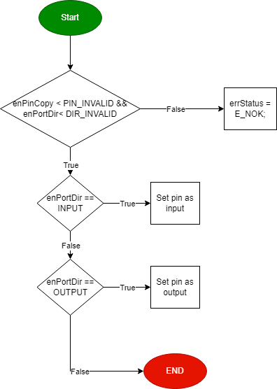

Figure DIO_s8SETPinDir Flow Chart

Sint8_t **DIO_s8SETPinVal** (enu_pin enPinCopy, enu_val enPortVal)

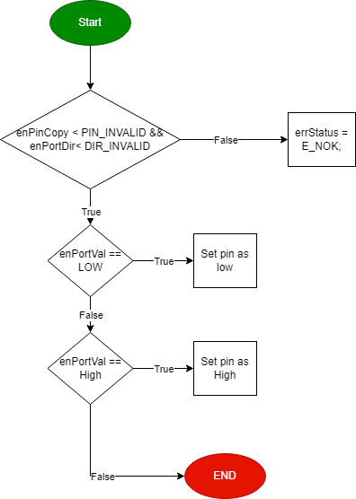

Figure DIO_s8SETPinVal Flow chart

Sint8_t **DIO_s8GETPinVal** (enu_pin enPinCopy, Uint8_t* pu8Val)

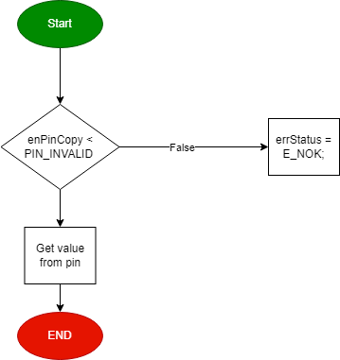

Figure DIO_s8GETPinVal Flow Chart

#### **Timer:**

**TIM0_Init**

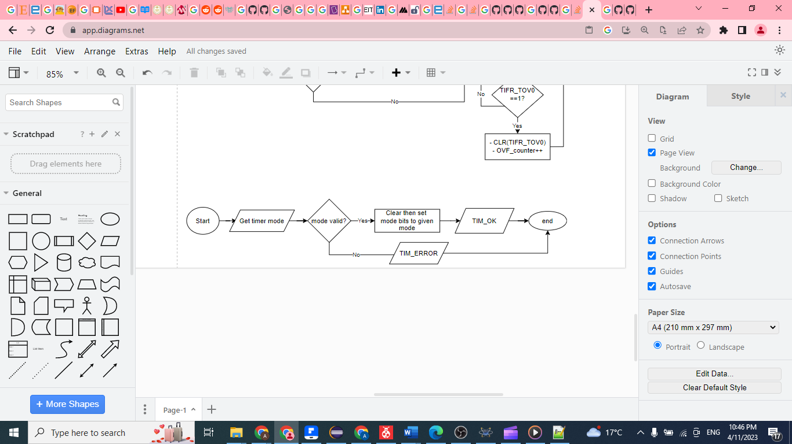

Figure TIM0_Init Flow Chart

**TIM0_Start**

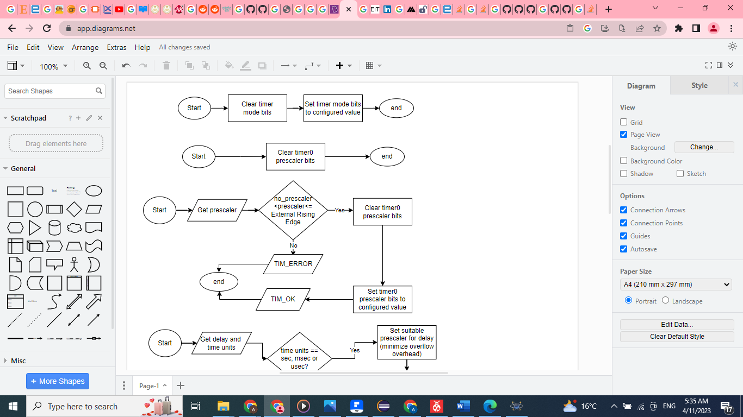

Figure TIM0_Start Flow Chart

**TIM0_Stop**



Figure TIM0_Stop Flow Chart

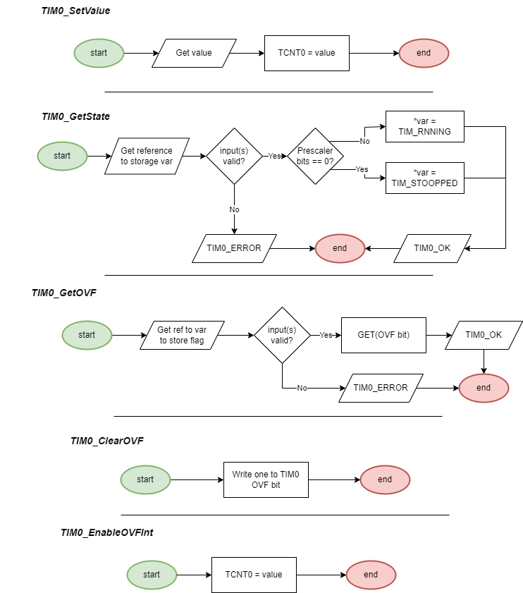

Figure TIM0 remaining Flow Charts

#### **EXTINT:**

#### **UART:**

#### **SPI:**

#### 

#### **I2C:**

**void** **i2c_init_master**(**void**);

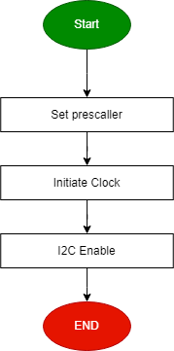

**void** **i2c_start**(**void**);

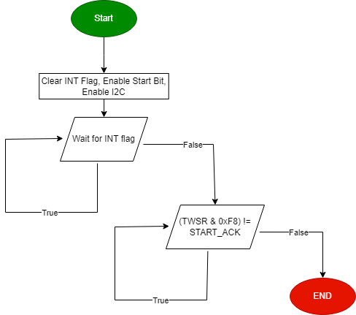

**void** **i2c_repeated_start**(**void**);

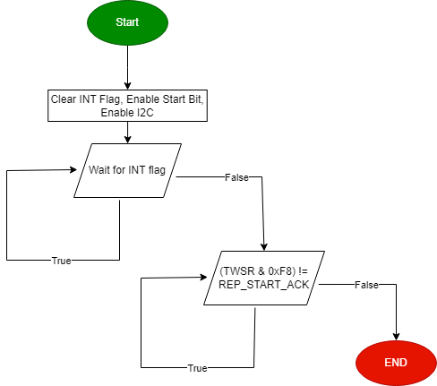

**void** **i2c_send_slave_address_with_write_req**(Uint8_t slave_address);

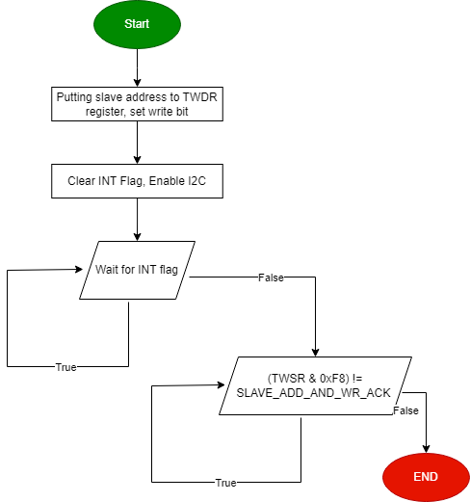

**void** **i2c_send_slave_address_with_read_req**(Uint8_t slave_address);

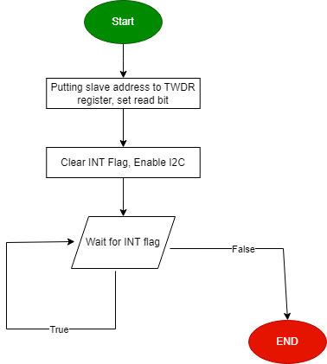

**void** **i2c_write_byte**(Uint8_t byte);

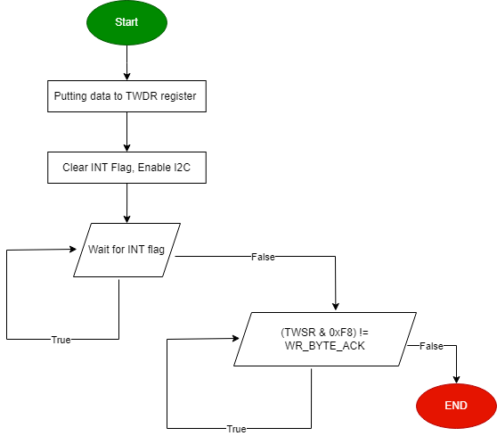

Uint8_t **i2c_read_byte**(**void**);

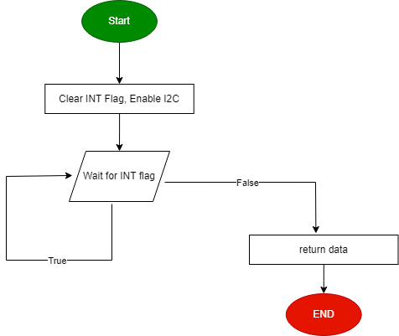

**void** **i2c_stop**(**void**);

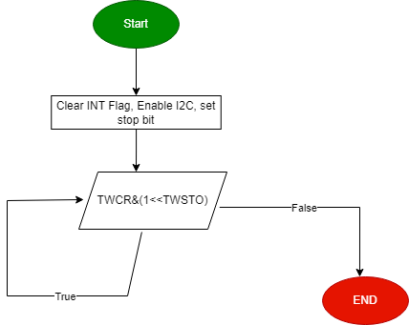

### **HAL Layer**

#### **HTimer0**

**HTIM0_SyncDelay**

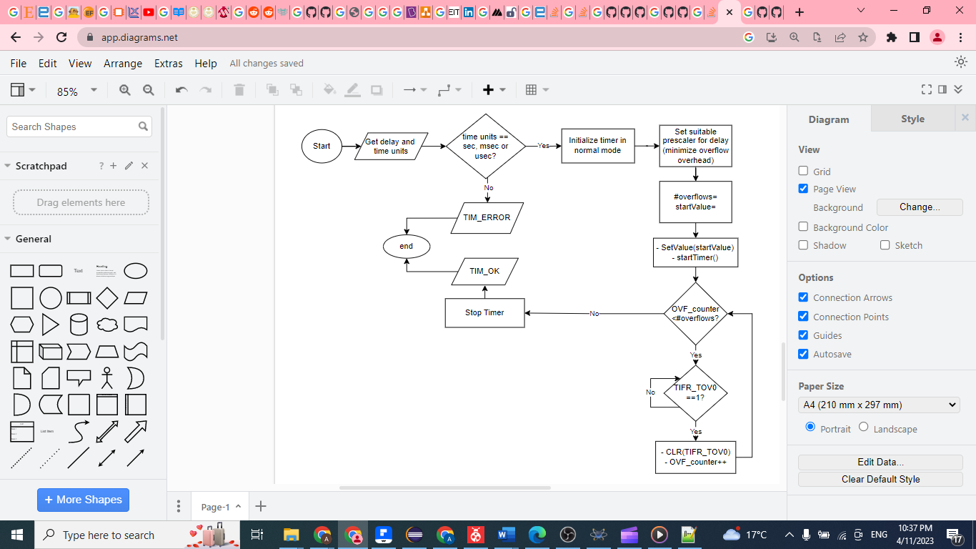

Figure HTIM0_SyncDelay Flow Chart

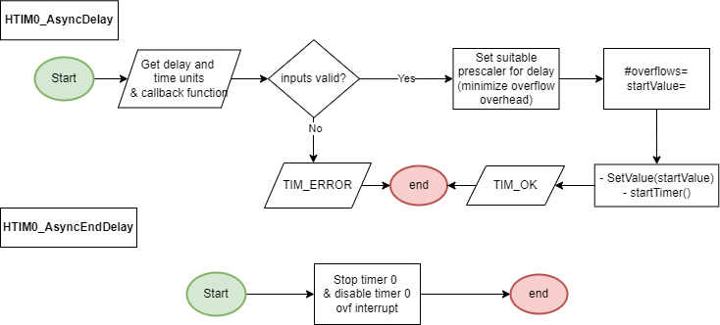

Figure HTIM0_AsyncDelay and EndDelay

#### **HSPI**

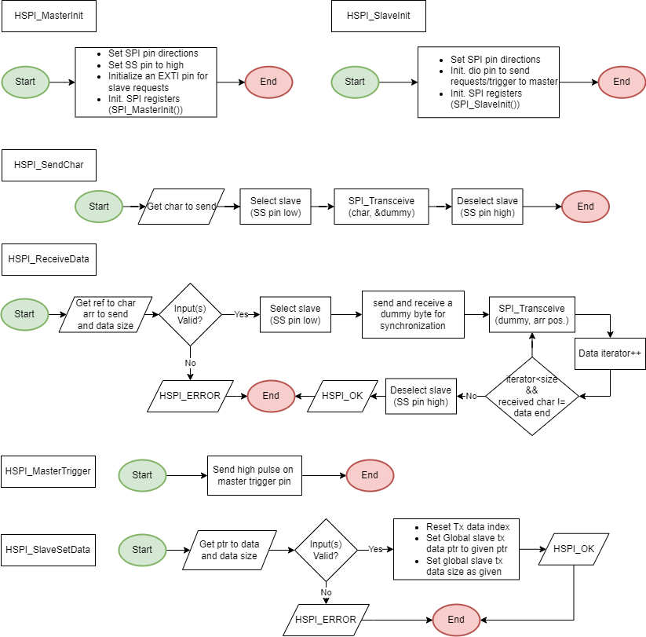

#### **LCD**

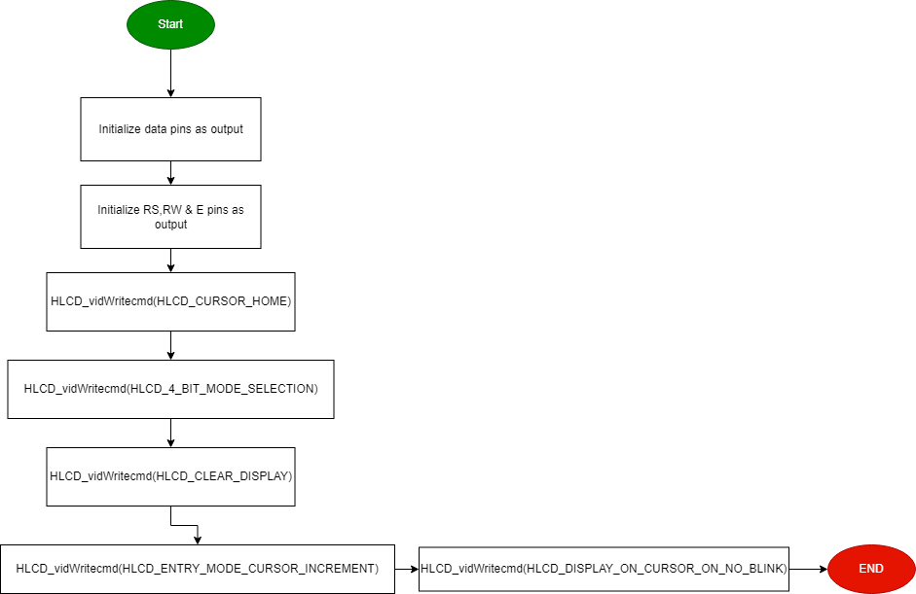**void** **HLCD_vidInit**(**void**)

Figure HLCD_vidInit Flow Chart

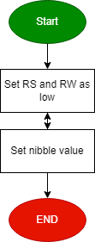**void** **HLCD_vidWritecmd**(Uint8_t u8commandCopy)

Figure HLCD_vidWritecmd Flow Chart

**void** **HLCD_vidWriteChar**(Uint8_t u8CharCopy)

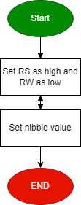

Figure HLCD_vidWriteChar Flow Chart

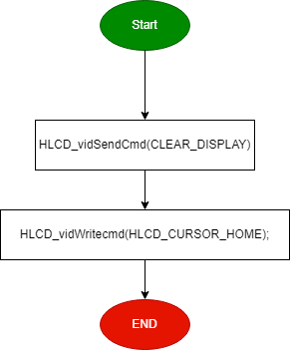**void** **HLCD_ClrDisplay**(**void**)

Figure HLCD_ClrDisplay Flow Chart

**void** **HLCD_gotoXY**(Uint8_t row, Uint8_t pos)

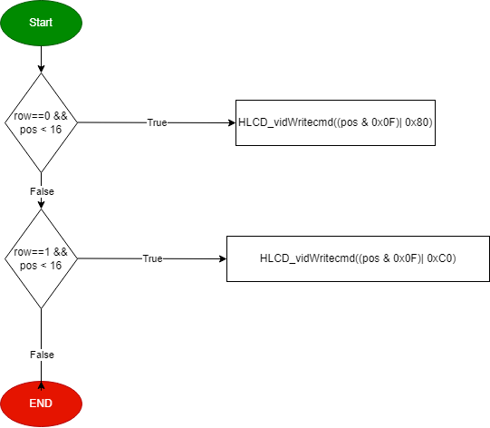

Figure HLCD_gotoXY Flow Chart

**void** **HLCD_WriteString**(Uint8_t* str)

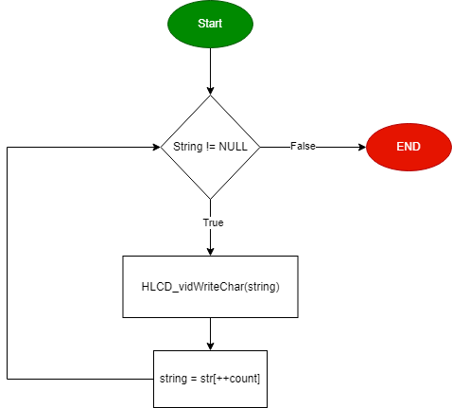

Figure HLCD_WriteString Flow Chart

**void** **HLCD_WriteInt**(Uint32_t number)

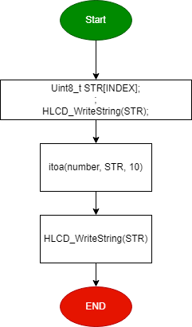

Figure HLCD_WriteInt Flow Chart

**void** **HLCD_vidCreatCustomChar**(Uint8_t* pu8custom, Uint8_t u8Location)

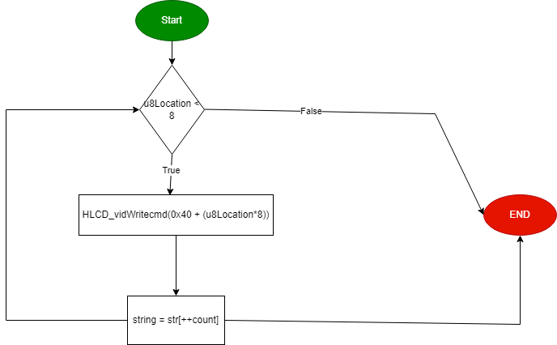

Figure HLCD_vidCreatCustomChar Flow Chart

#### **Keypad**

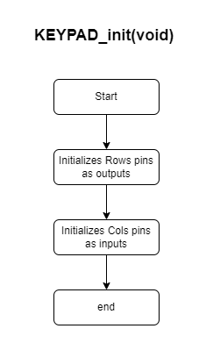

Figure KEYPAD_Init Flow Chart

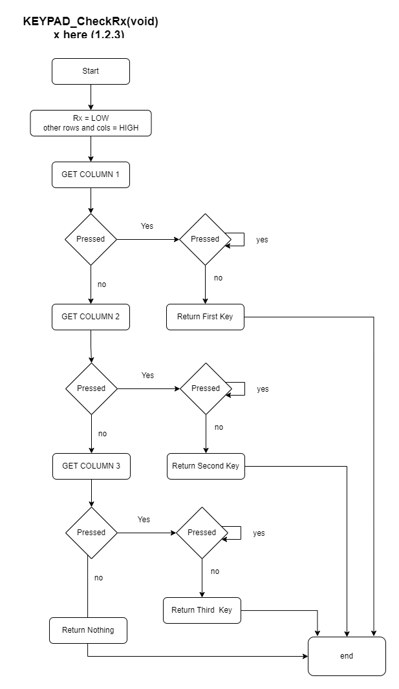

Figure KEYPAD_CheckRx Flow Chart

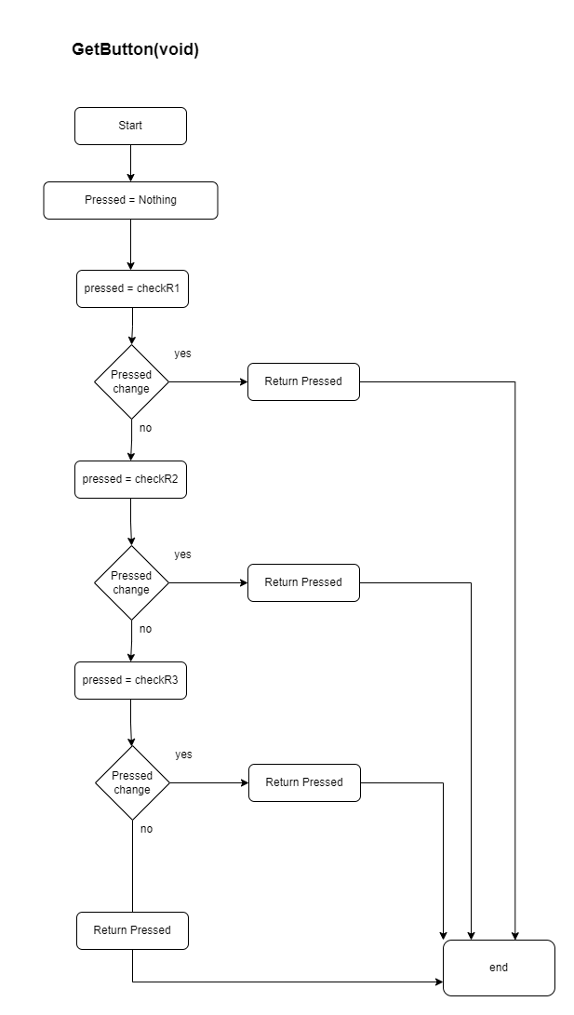

Figure GetButton Flow Chart

#### **Buzzer**

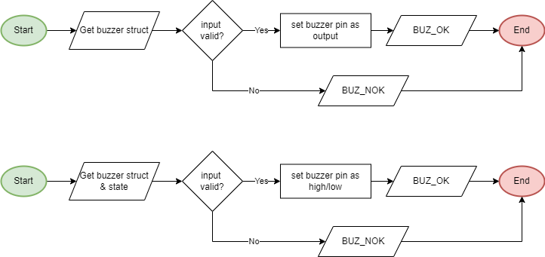

**BUZ_SetState**

Figure Buzzer Init & SetState Flow Charts

**BUZ_Init**

#### **HEXTINT:**

#### **Button:**

enu_buttonError_t **HButton_Init**(enu_pin en_pinx);

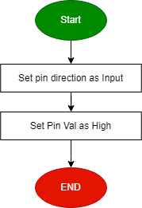

enu_buttonError_t **HButton_ExtIntInit**(enu_pin en_pinx);

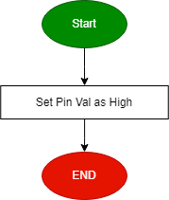

enu_buttonError_t **HButton_getPinVal**(enu_pin en_pinx, Uint8_t* pu8_refVal );

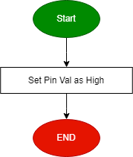

### **Application Layer:**

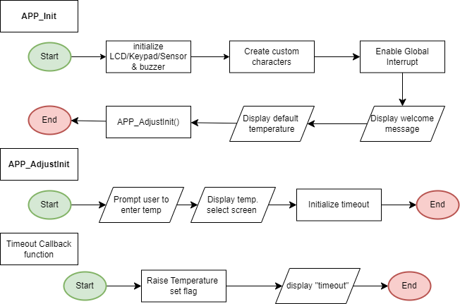

Figure App. APIs Flow Charts

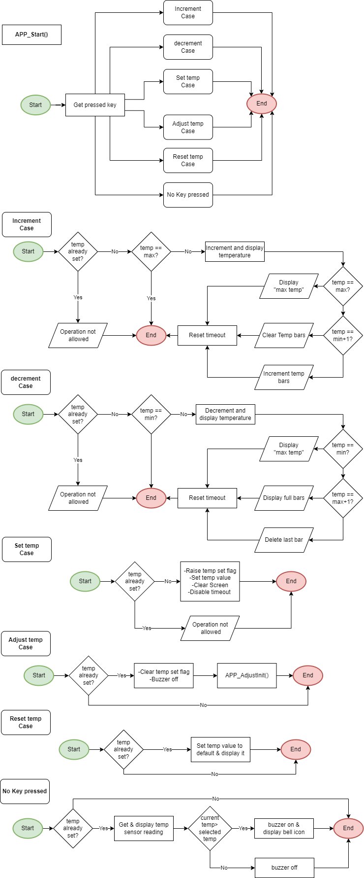

Figure APP_Start & App States Flow Charts



Figure Cont. App States Flow Charts

