An alligator who has to open it's mouth to at least a certain angle to eat different objects

1. Educational Goal
   1. Understand angles in relation to object sizes
   2. From Common Core Math Standards: “understand concepts of angles and measure angles”
   3. CCSS.MATH.CONTENT.4.MD.C.5.A: “An angle is measured with reference to a circle with its center at the common endpoint of the rays, by considering the fraction of the circular arc between the points where the two rays intersect the circle. An angle that turns through 1/360 of a circle is called a "one-degree angle," and can be used to measure angles.”
2. Gameplay
   1. Have 2 conveyor belts if it's too big for the alligator to eat you have to move it to the one that doesn't lead to it.
   2. Lose “tooth” if you open too far(to prevent people from just always opening all the way)
   3. Alligator can only open it’s mouth x degrees
   4. Conveyor moves faster the longer you play
   5. Losing x “teeth” gives you a game over.
   6. Alligator gets larger after eating x number of items making it’s mouth open wider.
3. Menus and Game Flow
   1. Simple Start Menu
      1. Play
      2. How to Play
      3. Credits

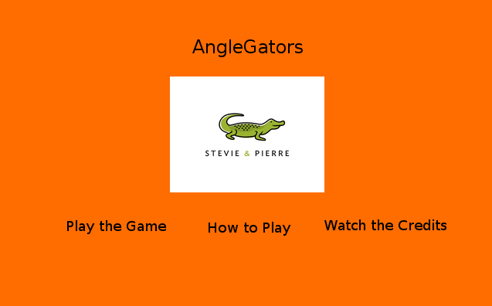

* 1. Game Screen
     1. Pause button in top right corner
     2. Score/Teeth left in top left corner

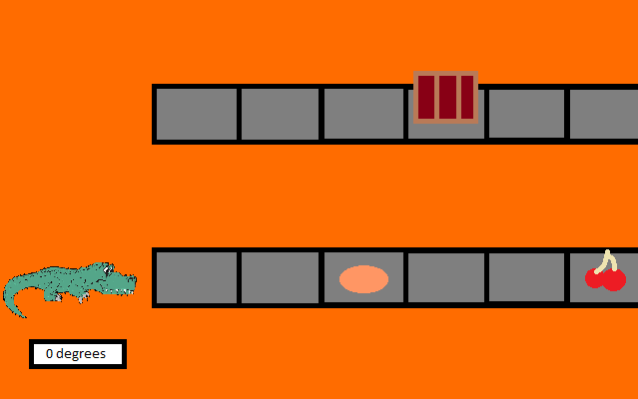

* 1. Pause Screen
     1. Return to Game
     2. Restart Game
     3. Return to Main Menu
     4. Quit Game(Exits the application)

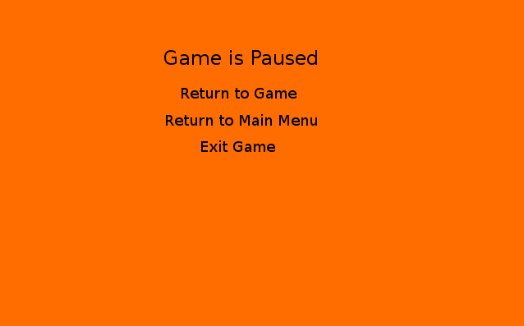

* 1. How to Play Screen
     1. One sentence rundown of the game
     2. The control scheme
     3. Back button in the bottom left corner

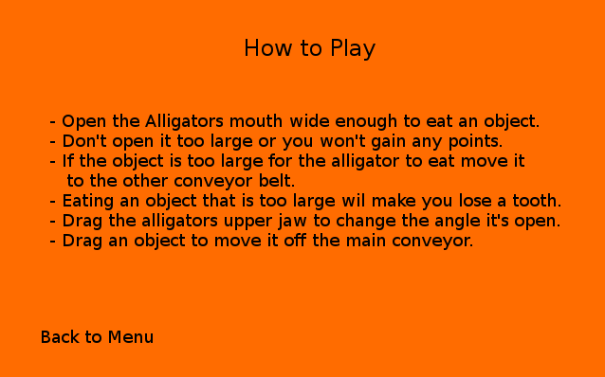

* 1. Credits
     1. Each of the HFOSS people
     2. Artist/Website where art was found
     3. Back button in the bottom left corner

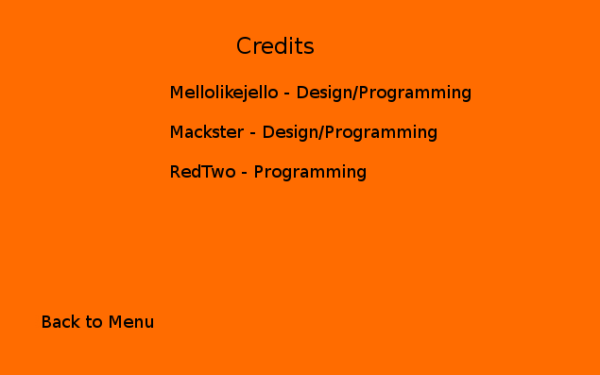

1. Art Style
   1. Simple 2D style with bright colors
   2. Moodboard/Inspiration

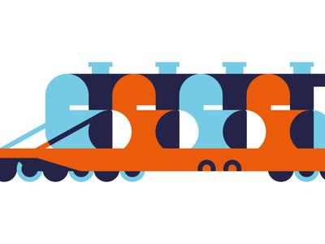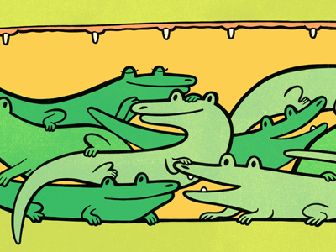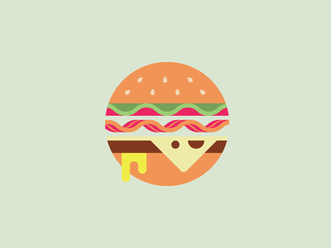



1. User Interfaces
   1. move mouth open by clicking and dragging
   2. mouth angle indicator displays exact degree value
   3. score/teeth left in top left corner
2. Object Design - Sizes
   1. No animals being eaten
   2. Fruits and Veggies

|  |  |
| --- | --- |
| Food | Minimum Angle Size (0-90) |
| Nuts | 10 |
| Cherry | 20 |
| Grape | 25 |
| Kumquats | 50 |
| Tomato | 70 |
| Celery | 75 |
| Potato | 80 |
| Head of Lettuce | 90 |
| Cantaloupe | 110 |
| Watermelon | 120 |