Swasthya Sahay Project Documentation

# Roadmap: From Scratch to Market

Conceptualization  
- Identify the need: streamline healthcare check-in and preliminary diagnosis.  
- Inspiration: Digi Yatri Kiosks for contactless onboarding.

Problem Definition  
- Long queues and delays in hospital registration.  
- Unavailability of doctors in rural/overburdened areas.  
- Difficulty in handling patient information in regional languages.

Prototype Development  
- Face recognition module using OpenCV + LBPH.  
- AI-based preliminary diagnosis using multilingual LLMs.

Integration with India Stack  
- ABHA (Ayushman Bharat Health Account) linking.  
- eKYC and DigiLocker for secure data fetch.

Testing  
- Live trials with kiosk hardware.  
- Facial recognition accuracy and LLM diagnosis testing in multiple languages.

Deployment & Marketing  
- Deploy at healthcare kiosks in rural/urban clinics.  
- Market to government and private hospital chains.

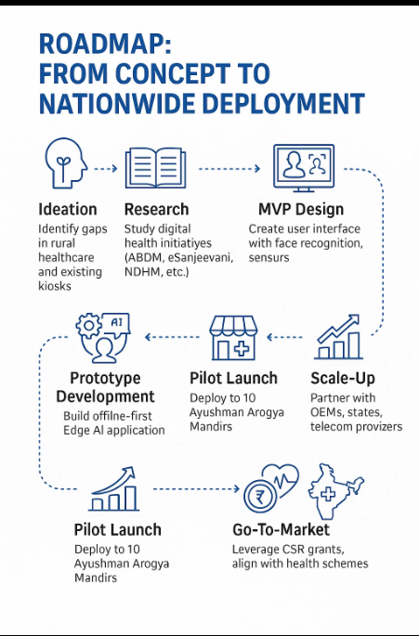

# Problem Objectives & Justifications

**Objective 1: Can face ID recognition be used to fasten the registration and check-in process like Digi Yatri kiosks?**

- Facial recognition removes manual form-filling.  
- Reduces wait time and errors in data entry.  
- Promotes hygienic, contactless systems—ideal post-COVID.  
- Friendly for elderly and semi-literate users.

**Objective 2: Can the kiosk conduct AI-based preliminary diagnosis via LLMs in Indian languages?**

- Helps screen patients even in the absence of doctors.  
- Supports multiple languages—crucial in rural India.  
- Reduces burden on OPDs and junior doctors.  
- AI assists but does not override human doctors—ensures safety and trust.

# Features Demonstration

**1. Face Recognition System**

- Real-time face detection using OpenCV + Haar Cascade.  
- LBPH-based training and recognition.  
- Multi-user support with live confidence scoring.  
- Patient metadata stored and logged in Excel.  
- Auto-fetches PHR from ABHA on match.

**2. LLM-Based Preliminary Diagnosis**

- Accepts text or voice symptom input.  
- Processes in local language (Hindi, Telugu, etc.).  
- GPT/LLaMA-based diagnosis generation.  
- Displays diagnosis in simple language with suggestions.  
- Data can be reviewed/overridden by doctors.

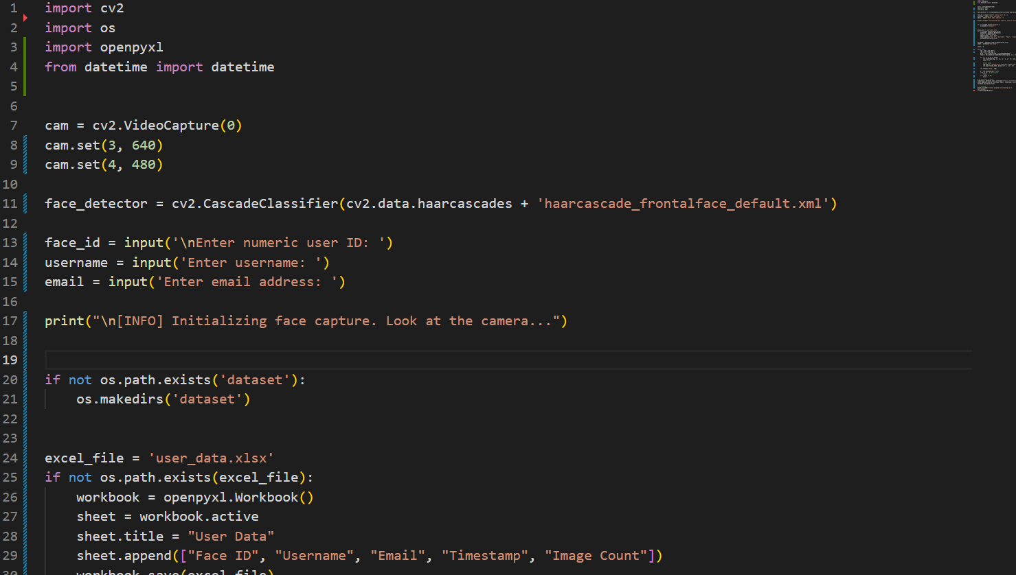

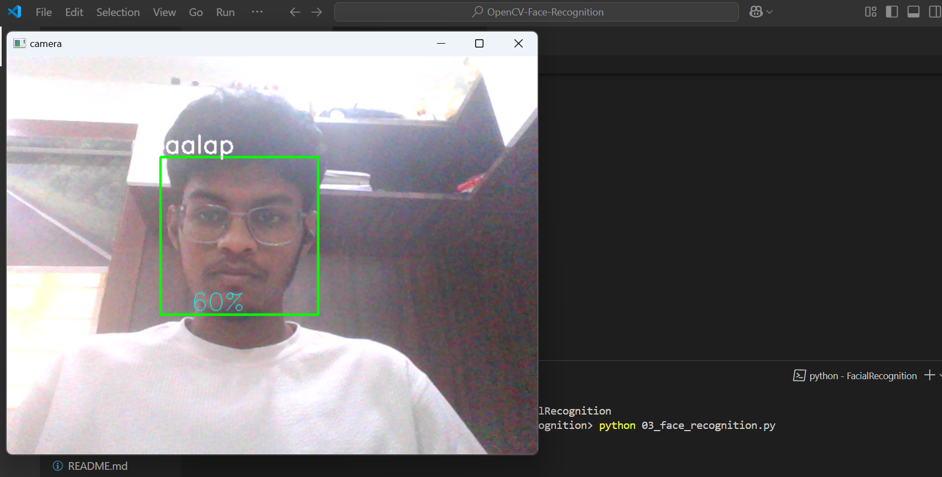

# Uses of the Features

**Face Recognition**

- Use: OPD check-in  
- Impact: Faster registration, improved patient experience, no dependency on physical cards.

**AI Diagnosis**

- Use: Initial symptom triage  
- Impact: Reduces diagnostic load, improves access in underserved regions.

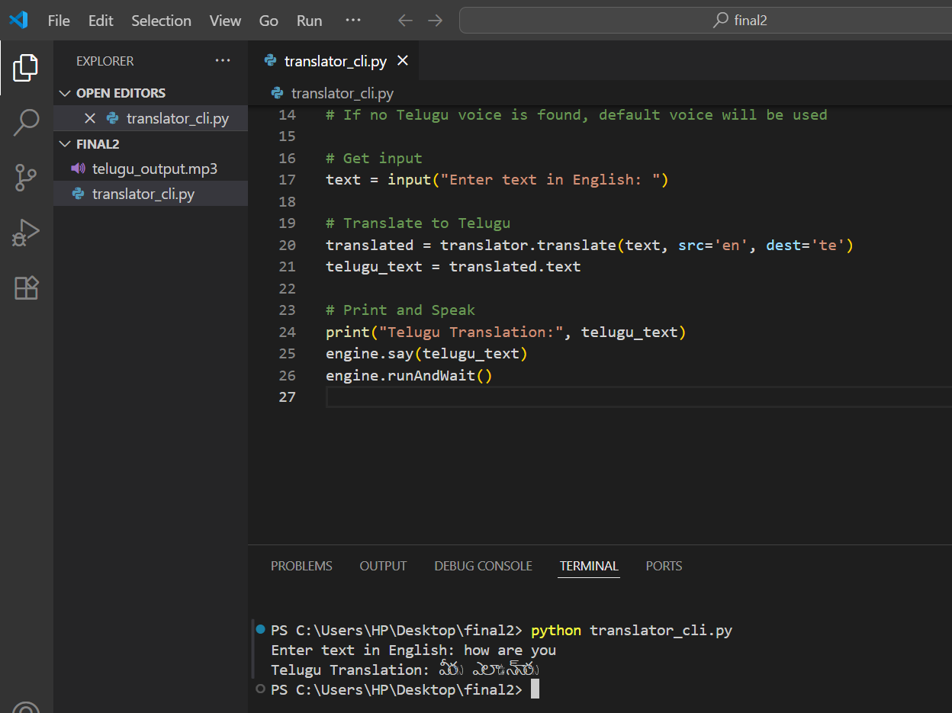

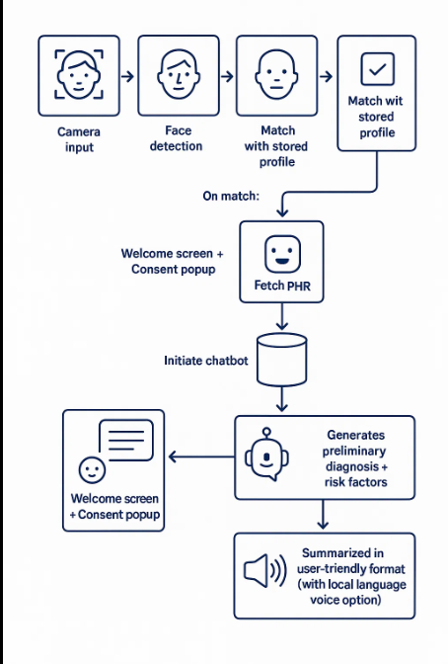

**Market Strategy**

* **Target Clients**:

Government-run PHCs and CHCs

Private clinics and hospitals

NGOs in rural healthcare

* **Unique Selling Propositions (USPs)**:

Contactless onboarding with no paper required

Instant regional-language diagnosis

Support for ABHA ID and NDHM compliance

* **Go-to-Market Channels**:

Partner with health tech companies

Apply under government innovation schemes

Showcase at healthcare expos & digital health missions