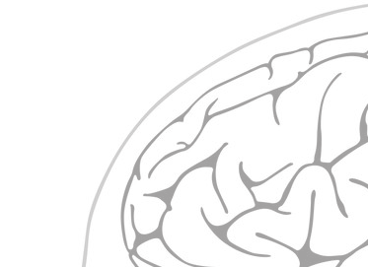
Brain Signal Sources
Scalp Sensors
Skull
Scalp
Noise

