1. **app.py-DESIGNING AN API USING FLASK FOR SPAM FILERTING (app.py)**

# app.py

from flask import Flask, request, jsonify

from utils import load_model_and_vectorizer, train_spam_model_with_grid_search

app = Flask(__name__)

# Global variables to hold the trained model and vectorizer

spam_classifier = None

tfidf_vectorizer = None

@app.route('/')

def home():

    """

    Home route to provide basic information about the API endpoints

    """

    return jsonify({

        "message": "Welcome to the Email Spam Detector API!",

        "endpoints": {

            "/predict": "POST request with 'email_content' in form data to classify text.",

            "/training": "POST request with optional hyperparameters to train/retrain the model using Grid Search and MLflow."

        }

    })

@app.route('/training', methods=['POST'])

def training_endpoint():

    """

    Endpoint to trigger model training with optional hyperparameter grid

    Logs results and artifacts to MLflow

    """

    global spam_classifier, tfidf_vectorizer

    # Get hyperparameters grid from incoming JSON request, or use empty dict

    hyperparams_grid = request.get_json() or {}

    # Call training function with hyperparameters grid

    training_info = train_spam_model_with_grid_search(hyperparams_grid)

    # Reload trained model and vectorizer into global variables

    spam_classifier, tfidf_vectorizer = load_model_and_vectorizer()

    # Prepare classification report for JSON response

    report_output = {}

    if training_info.get('report'):

        for class_name, metrics in training_info['report'].items():

            if isinstance(metrics, dict):

                report_output[class_name] = {k: float(v) if isinstance(v, (float, int)) else v for k, v in metrics.items()}

            else:

                report_output[class_name] = metrics

    # Prepare the full response data

    response_data = {

        "status": training_info.get('status'),

        "best_hyperparameters": training_info.get('best_params'),

        "accuracy": f"{training_info['accuracy']:.4f}" if training_info.get('accuracy') else None,

        "classification_report": report_output if report_output else None,

        "mlflow_run_id": training_info.get('mlflow_run_id')

    }

    # Return appropriate HTTP response based on status

    if "Error" in training_info.get('status', ''):

        return jsonify(response_data), 500

    else:

        return jsonify(response_data), 200

if __name__ == '__main__':

    # Load model and vectorizer at app startup

    spam_classifier, tfidf_vectorizer = load_model_and_vectorizer()

    app.run(debug=True)

# utils.py

import pickle

import os

import mlflow

import mlflow.sklearn

import pandas as pd

from sklearn.feature_extraction.text import TfidfVectorizer

from sklearn.ensemble import RandomForestClassifier

from sklearn.model_selection import train_test_split, GridSearchCV

from sklearn.metrics import classification_report, accuracy_score

# File paths for model and vectorizer persistence

MODEL_PATH = 'spam_model.pkl'

VECTORIZER_PATH = 'tfidf_vectorizer.pkl'

def train_spam_model_with_grid_search(hyperparams_grid):

    """

    Train Random Forest Classifier using Grid Search for hyperparameter tuning

    Log parameters, metrics, and model artifact to MLflow

    """

    try:

        # Load dataset (ensure 'spam_data.csv' exists with 'text' and 'label' columns)

        df = pd.read_csv('spam_data.csv')

        X = df['text']

        y = df['label']

        # Convert text to numerical feature vectors

        vectorizer = TfidfVectorizer(max_features=5000, ngram_range=(1,2))

        X_vectorized = vectorizer.fit_transform(X)

        # Split into training and testing sets

        X_train, X_test, y_train, y_test = train_test_split(X_vectorized, y, test_size=0.2, random_state=42)

        # Set default hyperparameter grid if not provided

        if not hyperparams_grid:

            hyperparams_grid = {

                'n_estimators': [100, 200],

                'max_depth': [10, 20, None],

                'min_samples_split': [2, 5],

                'min_samples_leaf': [1, 2]

            }

        # Initialize Random Forest Classifier

        rf = RandomForestClassifier(random_state=42)

        # Setup Grid Search with cross-validation

        grid_search = GridSearchCV(estimator=rf,

                                   param_grid=hyperparams_grid,

                                   cv=3,

                                   scoring='accuracy',

                                   n_jobs=-1)

        # Start MLflow run for experiment tracking

        with mlflow.start_run() as run:

            grid_search.fit(X_train, y_train)

            best_model = grid_search.best_estimator_

            best_params = grid_search.best_params_

            # Make predictions and evaluate

            y_pred = best_model.predict(X_test)

            accuracy = accuracy_score(y_test, y_pred)

            report = classification_report(y_test, y_pred, output_dict=True)

            # Log best parameters and accuracy to MLflow

            mlflow.log_params(best_params)

            mlflow.log_metric('accuracy', accuracy)

            # Log classification report metrics to MLflow

            for label, metrics in report.items():

                if isinstance(metrics, dict):

                    for metric_name, value in metrics.items():

                        mlflow.log_metric(f"{label}_{metric_name}", value)

            # Log model artifact to MLflow

            mlflow.sklearn.log_model(best_model, "spam_rf_model")

            mlflow.log_artifact('spam_data.csv')

            # Save model and vectorizer locally

            with open(MODEL_PATH, 'wb') as f:

                pickle.dump(best_model, f)

            with open(VECTORIZER_PATH, 'wb') as f:

                pickle.dump(vectorizer, f)

        return {

            'status': 'Model trained successfully with Grid Search and logged to MLflow',

            'accuracy': accuracy,

            'report': report,

            'best_params': best_params,

            'mlflow_run_id': run.info.run_id

        }

    except Exception as e:

        return {

            'status': f'Error during training: {str(e)}'

        }

def load_model_and_vectorizer():

    """

    Load trained model and vectorizer from disk if available

    """

    if not os.path.exists(MODEL_PATH) or not os.path.exists(VECTORIZER_PATH):

        return None, None

    with open(MODEL_PATH, 'rb') as f:

        model = pickle.load(f)

    with open(VECTORIZER_PATH, 'rb') as f:

        vectorizer = pickle.load(f)

    return model, vectorizer

**OUTPUT:** Running app.py in Visual Studio Code shows that the API is running at <http://127.0.0.01:5000> as shown below,

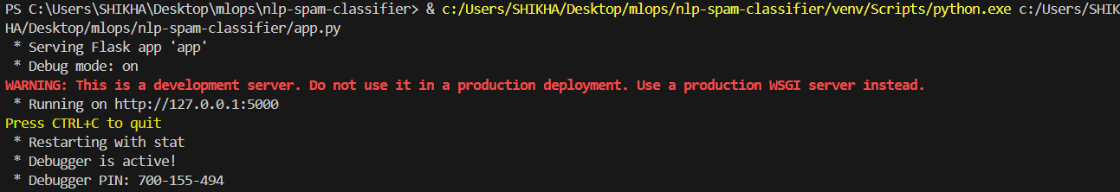

1. **utils.py: TRAINING & TESTING THE MODEL (Random Forest) and tuning Hyper parameters using GridSearch & tracking using MLFLOW**

import pickle

import os

import mlflow

import mlflow.sklearn

import pandas as pd

from sklearn.feature_extraction.text import TfidfVectorizer

from sklearn.ensemble import RandomForestClassifier

from sklearn.model_selection import train_test_split, GridSearchCV

from sklearn.metrics import classification_report, accuracy_score

# Set MLflow to use the running MLflow server

mlflow.set_tracking_uri("http://127.0.0.1:5001")

# File paths for local saving of model and vectorizer

MODEL_PATH = 'spam_model.pkl'

VECTORIZER_PATH = 'tfidf_vectorizer.pkl'

def train_spam_model_with_grid_search(hyperparams_grid):

    """

    Train Random Forest Classifier using Grid Search for hyperparameter tuning

    Log parameters, metrics, and model artifact to MLflow server

    """

    try:

        # Load dataset (must be present in the same directory)

        df = pd.read_csv('spam_data.csv')

        X = df['text']

        y = df['label']

        # Convert text to TF-IDF vectors

        vectorizer = TfidfVectorizer(max_features=5000, ngram_range=(1, 2))

        X_vectorized = vectorizer.fit_transform(X)

        # Split dataset

        X_train, X_test, y_train, y_test = train_test_split(

            X_vectorized, y, test_size=0.2, random_state=42)

        # Set default hyperparameter grid if not provided

        if not hyperparams_grid:

            hyperparams_grid = {

                'n_estimators': [100, 200],

                'max_depth': [10, 20, None],

                'min_samples_split': [2, 5],

                'min_samples_leaf': [1, 2]

            }

        # Initialize model and GridSearchCV

        rf = RandomForestClassifier(random_state=42)

        grid_search = GridSearchCV(estimator=rf,

                                   param_grid=hyperparams_grid,

                                   cv=3,

                                   scoring='accuracy',

                                   n_jobs=-1)

        with mlflow.start_run() as run:

            # Train model

            grid_search.fit(X_train, y_train)

            best_model = grid_search.best_estimator_

            best_params = grid_search.best_params_

            # Evaluate

            y_pred = best_model.predict(X_test)

            accuracy = accuracy_score(y_test, y_pred)

            report = classification_report(y_test, y_pred, output_dict=True)

            # Log parameters and metrics

            mlflow.log_params(best_params)

            mlflow.log_metric('accuracy', accuracy)

            for label, metrics in report.items():

                if isinstance(metrics, dict):

                    for metric_name, value in metrics.items():

                        mlflow.log_metric(f"{label}_{metric_name}", value)

            # Log model artifact

            mlflow.sklearn.log_model(best_model, "spam_rf_model")

            # Log the dataset as artifact (optional)

            mlflow.log_artifact('spam_data.csv')

            # Save locally as well

            with open(MODEL_PATH, 'wb') as f:

                pickle.dump(best_model, f)

            with open(VECTORIZER_PATH, 'wb') as f:

                pickle.dump(vectorizer, f)

        return {

            'status': 'Model trained successfully with Grid Search and logged to MLflow server',

            'accuracy': accuracy,

            'report': report,

            'best_params': best_params,

            'mlflow_run_id': run.info.run_id

        }

    except Exception as e:

        return {

            'status': f'Error during training: {str(e)}'

        }

def load_model_and_vectorizer():

    """

    Load model and vectorizer from disk if available

    """

    if not os.path.exists(MODEL_PATH) or not os.path.exists(VECTORIZER_PATH):

        return None, None

    with open(MODEL_PATH, 'rb') as f:

        model = pickle.load(f)

    with open(VECTORIZER_PATH, 'rb') as f:

        vectorizer = pickle.load(f)

    return model, vectorizer

**3. call_training.py: Calling the util.py to train & test the model by passing the hyper-parameters,**

import requests

import json

# Define the URL of the Flask app's training endpoint

url = "http://127.0.0.1:5000/training"

# Optional: Define hyperparameter grid (can leave empty {})

hyperparams = {

    "n_estimators": [100, 200],

    "max_depth": [10, 20, None],

    "min_samples_split": [2, 5],

    "min_samples_leaf": [1, 2]

}

# Send POST request with hyperparameters as JSON

response = requests.post(url, json=hyperparams)

# Print the response from the server

print("Status Code:", response.status_code)

try:

    print("Response JSON:")

    print(json.dumps(response.json(), indent=4))

except Exception as e:

    print("Error parsing response:", str(e))

**OUTPUT:** Running call_training.py code shows the following output (hyper-parameter tuning) on terminal in Visual Studio Code,

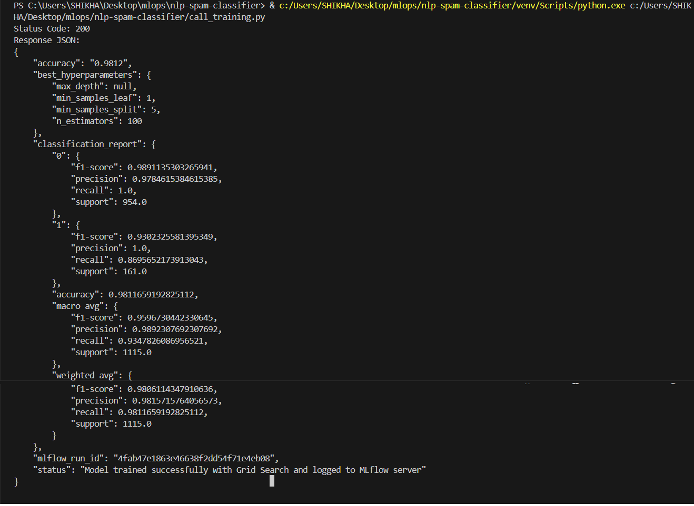

**The MLFlow running @** [**http://127.0.0.1:5001**](http://127.0.0.1:5001) **shows the following progress,**

