PRACTICUM (18/06/2025)

ST10212542 – AALIYAH ALLIE

# Full SQL Code

--preload code

-- creation of tables and populations

CREATE TABLE EVENT (

EVENT_ID INT PRIMARY KEY,

EVENT_NAME VARCHAR(100),

EVENT_RATE DECIMAL(10,2)

);

CREATE TABLE ARTIST (

ARTIST_ID VARCHAR(10) PRIMARY KEY,

ARTIST_NAME VARCHAR(100),

ARTIST_EMAIL VARCHAR(100)

);

CREATE TABLE BOOKINGS (

BOOKING_ID INT PRIMARY KEY,

BOOKING_DATE DATE,

EVENT_ID INT,

ARTIST_ID VARCHAR(10),

FOREIGN KEY (EVENT_ID) REFERENCES EVENT(EVENT_ID),

FOREIGN KEY (ARTIST_ID) REFERENCES ARTIST(ARTIST_ID)

);

INSERT INTO EVENT (EVENT_ID, EVENT_NAME, EVENT_RATE)

VALUES (1001, 'Open Air Comedy Festival', 300.00);

INSERT INTO EVENT (EVENT_ID, EVENT_NAME, EVENT_RATE)

VALUES (1002, 'Mountain Side Music Festival', 280.00);

INSERT INTO EVENT (EVENT_ID, EVENT_NAME, EVENT_RATE)

VALUES (1003, 'Beach Music Festival', 195.00);

INSERT INTO ARTIST (ARTIST_ID, ARTIST_NAME, ARTIST_EMAIL)

VALUES ('A_101', 'Max Trillion', 'maxt@isat.com');

INSERT INTO ARTIST (ARTIST_ID, ARTIST_NAME, ARTIST_EMAIL)

VALUES ('A_102', 'Music Mayhem', 'mayhem@ymail.com');

INSERT INTO ARTIST (ARTIST_ID, ARTIST_NAME, ARTIST_EMAIL)

VALUES ('A_103', 'LOL Man', 'lol@isat.com');

INSERT INTO BOOKINGS (BOOKING_ID, BOOKING_DATE, EVENT_ID, ARTIST_ID)

VALUES (1, TO_DATE('2024-07-15', 'YYYY-MM-DD'), 1002, 'A_101');

INSERT INTO BOOKINGS (BOOKING_ID, BOOKING_DATE, EVENT_ID, ARTIST_ID)

VALUES (2, TO_DATE('2024-07-15', 'YYYY-MM-DD'), 1002, 'A_102');

INSERT INTO BOOKINGS (BOOKING_ID, BOOKING_DATE, EVENT_ID, ARTIST_ID)

VALUES (3, TO_DATE('2024-08-27', 'YYYY-MM-DD'), 1001, 'A_103');

INSERT INTO BOOKINGS (BOOKING_ID, BOOKING_DATE, EVENT_ID, ARTIST_ID)

VALUES (4, TO_DATE('2024-08-30', 'YYYY-MM-DD'), 1003, 'A_101');

INSERT INTO BOOKINGS (BOOKING_ID, BOOKING_DATE, EVENT_ID, ARTIST_ID)

VALUES (5, TO_DATE('2024-08-30', 'YYYY-MM-DD'), 1003, 'A_102');

--QUESTION 1 : SQL QUERY FOR BOOKING DETAILS

SELECT

B.BOOKING_ID,

E.EVENT_NAME,

E.EVENT_RATE,

A.ARTIST_NAME,

A.ARTIST_EMAIL

FROM

BOOKINGS B

JOIN EVENT E ON B.EVENT_ID = E.EVENT_ID

JOIN ARTIST A ON B.ARTIST_ID = A.ARTIST_ID;

--QUESTION 2: SQL QUERY FOR ARTIST WITH LEAST PERFORMANCES

SELECT

A.ARTIST_ID,

A.ARTIST_NAME,

A.ARTIST_EMAIL,

COUNT(B.BOOKING_ID) AS NUM_PERFORMANCES

FROM

ARTIST A

LEFT JOIN BOOKINGS B ON A.ARTIST_ID = B.ARTIST_ID

GROUP BY

A.ARTIST_ID,A.ARTIST_NAME,A.ARTIST_EMAIL

HAVING

COUNT(B.BOOKING_ID) = (

SELECT MIN(COUNT(*))

FROM BOOKINGS

GROUP BY ARTIST_ID

);

--QUESTION 3: SQL QUERY FOR ARTIST REVENUE

SELECT

A.ARTIST_NAME,

SUM(E.EVENT_RATE) AS TOTAL_REVENUE

FROM

BOOKINGS B

JOIN ARTIST A ON B.ARTIST_ID = A.ARTIST_ID

JOIN EVENT E ON B.EVENT_ID = E.EVENT_ID

GROUP BY

A.ARTIST_NAME;

--QUESTION 4: PL/SQL QUERY FOR ARTIST AND BOOKING DATE

SET SERVEROUTPUT ON;

DECLARE

v_artist_name ARTIST.ARTIST_NAME%TYPE;

v_booking_date BOOKINGS.BOOKING_DATE%TYPE;

CURSOR booking_cursor IS

SELECT A.ARTIST_NAME, B.BOOKING_DATE

FROM BOOKINGS B

JOIN ARTIST A ON B.ARTIST_ID = A.ARTIST_ID

WHERE B.EVENT_ID = 1001;

BEGIN

FOR record IN booking_cursor LOOP

v_artist_name := record.ARTIST_NAME;

v_booking_date := record.BOOKING_DATE;

DBMS_OUTPUT.PUT_LINE('ARTIST: ' || v_artist_name || ' | Booking Date: ' || TO_CHAR(v_booking_date, 'YYYY-MM-DD'));

END LOOP;

END;

--QUESTION 5: PL/SQL QUERY FOR EVENT DISCOUNTS

SET SERVEROUTPUT ON;

DECLARE

v_event_name EVENT.EVENT_NAME%TYPE;

v_event_rate EVENT.EVENT_RATE%TYPE;

v_discounted NUMBER;

CURSOR event_cursor IS

SELECT EVENT_NAME, EVENT_RATE

FROM EVENT;

BEGIN

FOR rec IN event_cursor LOOP

v_event_name := rec.EVENT_NAME;

v_event_rate := rec.EVENT_RATE;

IF v_event_rate > 250 THEN

v_discounted := v_event_rate * 0.9; -- 10% discount

DBMS_OUTPUT.PUT_LINE(

'Event: ' || v_event_name ||

' | Original Price: R' || v_event_rate ||

' | Discounted Price: R' || TO_CHAR(ROUND(v_discounted, 2))

);

ELSE

DBMS_OUTPUT.PUT_LINE(

'Event: ' || v_event_name ||

' | Price: R' || v_event_rate ||

' (No Discount)'

);

END IF;

END LOOP;

END;

--QUESTION 6 : CREATE EVENT_SCHEDULES VIEW

CREATE OR REPLACE VIEW Event_Schedules AS

SELECT

E.EVENT_NAME,

B.BOOKING_DATE

FROM

BOOKINGS B

JOIN EVENT E ON B.EVENT_ID = E.EVENT_ID

WHERE

B.BOOKING_DATE BETWEEN TO_DATE ('2024-07-01', 'YYYY-MM-DD')

AND TO_DATE ('2024-08-28', 'YYYY-MM-DD');

SELECT * FROM Event_Schedules;

--QUESTION 7 : STORED PROCEDURE FOR BOOKING DETAILS

CREATE OR REPLACE PROCEDURE Get_Bookings_By_Artist (

p_artist_name IN ARTIST.ARTIST_NAME%TYPE

)

IS

BEGIN

FOR rec IN (

SELECT

B.BOOKING_ID,

A.ARTIST_NAME,

B.BOOKING_DATE,

E.EVENT_NAME,

E.EVENT_RATE

FROM

BOOKINGS B

JOIN ARTIST A ON B.ARTIST_ID = A.ARTIST_ID

JOIN EVENT E ON B.EVENT_ID = E.EVENT_ID

WHERE

A.ARTIST_NAME = p_artist_name

) LOOP

DBMS_OUTPUT.PUT_LINE('Booking ID: ' || rec.BOOKING_ID ||

' | Artist: ' || rec.ARTIST_NAME ||

' | Date: ' || TO_CHAR(rec.BOOKING_DATE, 'YYYY-MM-DD') ||

' | Event: ' || rec.EVENT_NAME ||

' | Rate: R' || rec.EVENT_RATE);

END LOOP;

END;

SET SERVEROUTPUT ON;

BEGIN

Get_Bookings_By_Artist('Lol Man');

END;

--QUESTION 8: CREATE A RELEVANT FUNCTION

--STEP 1

CREATE OR REPLACE FUNCTION Get_Artist_Revenue (

p_artist_name IN ARTIST.ARTIST_NAME%TYPE

)

RETURN NUMBER

IS

v_total_revenue NUMBER := 0;

BEGIN

SELECT

NVL(SUM(E.EVENT_RATE), 0)

INTO

v_total_revenue

FROM

BOOKINGS B

JOIN ARTIST A ON B.ARTIST_ID = A.ARTIST_ID

JOIN EVENT E ON B.EVENT_ID = E.EVENT_ID

WHERE

A.ARTIST_NAME = p_artist_name;

RETURN v_total_revenue;

EXCEPTION

WHEN NO_DATA_FOUND THEN

DBMS_OUTPUT.PUT_LINE('No bookings found for artist: ' || p_artist_name);

RETURN 0;

WHEN OTHERS THEN

DBMS_OUTPUT.PUT_LINE('An unexpected error occurred: ' || SQLERRM);

RETURN -1;

END;

--STEP 2

SET SERVEROUTPUT ON;

DECLARE

v_revenue NUMBER;

BEGIN

v_revenue := Get_Artist_Revenue('Max Trillion');

IF v_revenue = -1 THEN

DBMS_OUTPUT.PUT_LINE('Error occurred while calculating revenue.');

ELSIF v_revenue = 0 THEN

DBMS_OUTPUT.PUT_LINE('Artist has no bookings.');

ELSE

DBMS_OUTPUT.PUT_LINE('Total revenue for Max Trillion: R' || v_revenue);

END IF;

END;

--QUESTION 11: CREATE A TRIGGER TO PREVENT WEEKEND BOOKINGS

SELECT USER FROM DUAL;

CREATE USER C##oneuser IDENTIFIED BY strongpassword123;

GRANT CONNECT, RESOURCE TO C##oneuser;

CREATE OR REPLACE TRIGGER trg_prevent_invalid_booking

BEFORE INSERT ON BOOKINGS

FOR EACH ROW

DECLARE

v_day VARCHAR2(10);

BEGIN

v_day := TO_CHAR(:NEW.BOOKING_DATE, 'DY', 'NLS_DATE_LANGUAGE=ENGLISH');

IF v_day IN ('SAT', 'SUN') THEN

RAISE_APPLICATION_ERROR(-20001, 'Bookings cannot be made on weekends.');

END IF;

END;

/

# Question 1 – Query for Booking Details

## SQL Code:

--QUESTION 1 : SQL QUERY FOR BOOKING DETAILS

SELECT

B.BOOKING_ID,

E.EVENT_NAME,

E.EVENT_RATE,

A.ARTIST_NAME,

A.ARTIST_EMAIL

FROM

BOOKINGS B

JOIN EVENT E ON B.EVENT_ID = E.EVENT_ID

JOIN ARTIST A ON B.ARTIST_ID = A.ARTIST_ID;

## SQL Output:

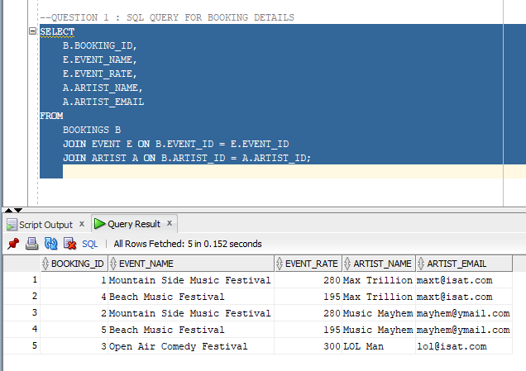

# Question 2 – SQL Query for Artist with Least Performance

## SQL Code:

--QUESTION 2: SQL QUERY FOR ARTIST WITH LEAST PERFORMANCES

SELECT

A.ARTIST_ID,

A.ARTIST_NAME,

A.ARTIST_EMAIL,

COUNT(B.BOOKING_ID) AS NUM_PERFORMANCES

FROM

ARTIST A

LEFT JOIN BOOKINGS B ON A.ARTIST_ID = B.ARTIST_ID

GROUP BY

A.ARTIST_ID,A.ARTIST_NAME,A.ARTIST_EMAIL

HAVING

COUNT(B.BOOKING_ID) = (

SELECT MIN(COUNT(*))

FROM BOOKINGS

GROUP BY ARTIST_ID

);

## SQL Output:

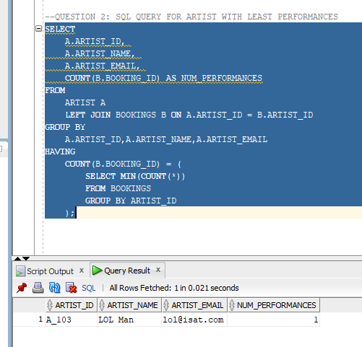

# Question 3 – SQL Query for Artist Revenue

## SQL Code:

--QUESTION 3: SQL QUERY FOR ARTIST REVENUE

SELECT

A.ARTIST_NAME,

SUM(E.EVENT_RATE) AS TOTAL_REVENUE

FROM

BOOKINGS B

JOIN ARTIST A ON B.ARTIST_ID = A.ARTIST_ID

JOIN EVENT E ON B.EVENT_ID = E.EVENT_ID

GROUP BY

A.ARTIST_NAME;

## SQL Output:

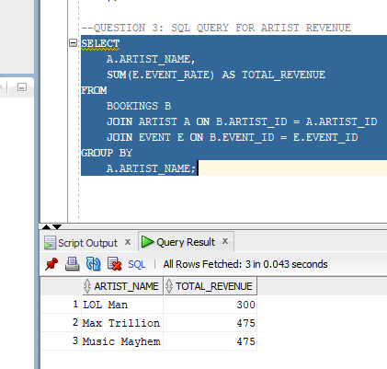

# Question 4- PL/SQL Query for Artist and Booking Date

## SQL Code:

--QUESTION 4: PL/SQL QUERY FOR ARTIST AND BOOKING DATE

SET SERVEROUTPUT ON;

DECLARE

v_artist_name ARTIST.ARTIST_NAME%TYPE;

v_booking_date BOOKINGS.BOOKING_DATE%TYPE;

CURSOR booking_cursor IS

SELECT A.ARTIST_NAME, B.BOOKING_DATE

FROM BOOKINGS B

JOIN ARTIST A ON B.ARTIST_ID = A.ARTIST_ID

WHERE B.EVENT_ID = 1001;

BEGIN

FOR record IN booking_cursor LOOP

v_artist_name := record.ARTIST_NAME;

v_booking_date := record.BOOKING_DATE;

DBMS_OUTPUT.PUT_LINE('ARTIST: ' || v_artist_name || ' | Booking Date: ' || TO_CHAR(v_booking_date, 'YYYY-MM-DD'));

END LOOP;

END;

## SQL Output:

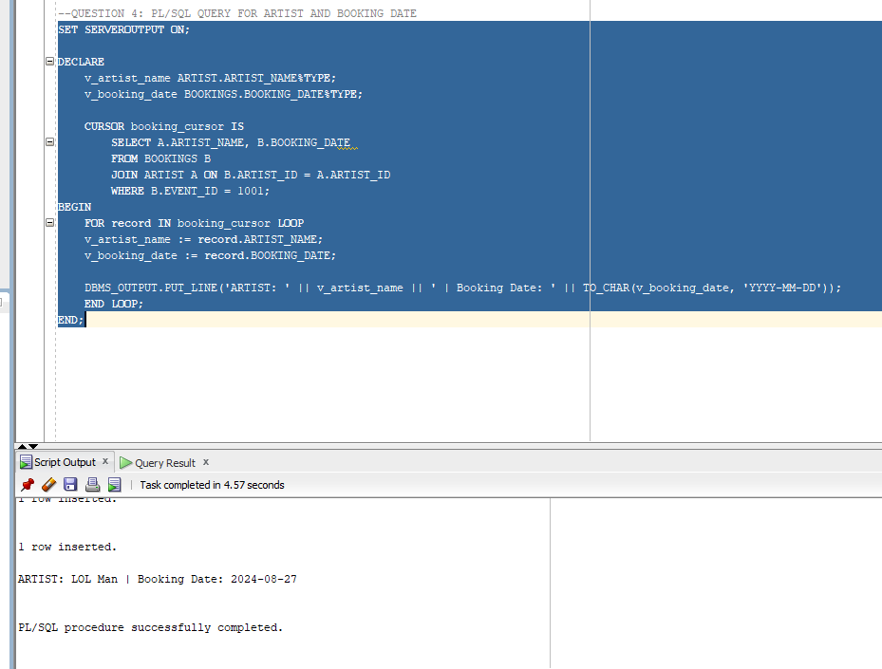

# Question 5 – PL/SQL Query for Event Discounts

## SQL Code:

--QUESTION 5: PL/SQL QUERY FOR EVENT DISCOUNTS

SET SERVEROUTPUT ON;

DECLARE

v_event_name EVENT.EVENT_NAME%TYPE;

v_event_rate EVENT.EVENT_RATE%TYPE;

v_discounted NUMBER;

CURSOR event_cursor IS

SELECT EVENT_NAME, EVENT_RATE

FROM EVENT;

BEGIN

FOR rec IN event_cursor LOOP

v_event_name := rec.EVENT_NAME;

v_event_rate := rec.EVENT_RATE;

IF v_event_rate > 250 THEN

v_discounted := v_event_rate * 0.9; -- 10% discount

DBMS_OUTPUT.PUT_LINE(

'Event: ' || v_event_name ||

' | Original Price: R' || v_event_rate ||

' | Discounted Price: R' || TO_CHAR(ROUND(v_discounted, 2))

);

ELSE

DBMS_OUTPUT.PUT_LINE(

'Event: ' || v_event_name ||

' | Price: R' || v_event_rate ||

' (No Discount)'

);

END IF;

END LOOP;

END; /

## SQL Output:

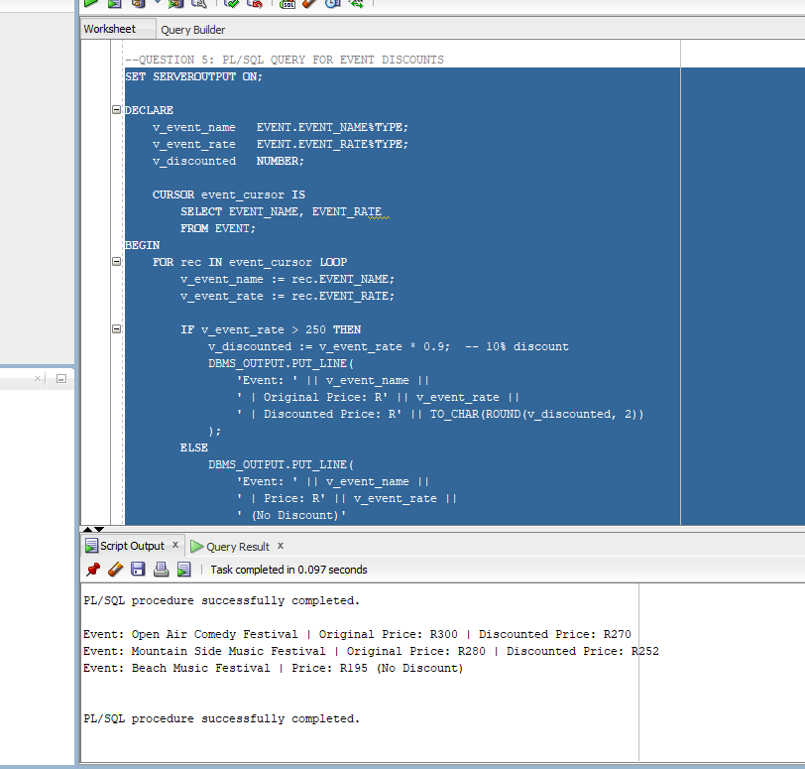

# Question 6 – Create Event_Schedules View

## SQL Code:

--QUESTION 6 : CREATE EVENT_SCHEDULES VIEW

CREATE OR REPLACE VIEW Event_Schedules AS

SELECT

E.EVENT_NAME,

B.BOOKING_DATE

FROM

BOOKINGS B

JOIN EVENT E ON B.EVENT_ID = E.EVENT_ID

WHERE

B.BOOKING_DATE BETWEEN TO_DATE ('2024-07-01', 'YYYY-MM-DD')

AND TO_DATE ('2024-08-28', 'YYYY-MM-DD');

SELECT * FROM Event_Schedules;

## SQL Output:

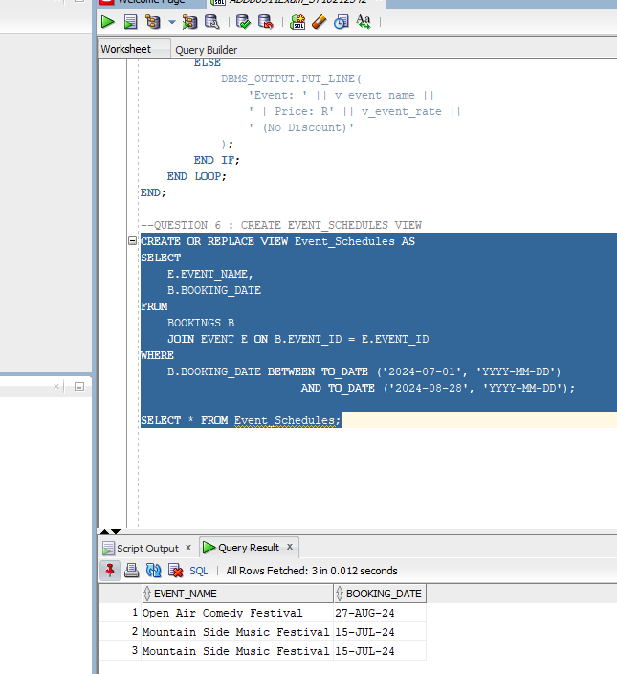

# Question 7 – Stored Procedure for Booking Details

## SQL Code:

--QUESTION 7 : STORED PROCEDURE FOR BOOKING DETAILS

CREATE OR REPLACE PROCEDURE Get_Bookings_By_Artist (

p_artist_name IN ARTIST.ARTIST_NAME%TYPE

)

IS

BEGIN

FOR rec IN (

SELECT

B.BOOKING_ID,

A.ARTIST_NAME,

B.BOOKING_DATE,

E.EVENT_NAME,

E.EVENT_RATE

FROM

BOOKINGS B

JOIN ARTIST A ON B.ARTIST_ID = A.ARTIST_ID

JOIN EVENT E ON B.EVENT_ID = E.EVENT_ID

WHERE

A.ARTIST_NAME = p_artist_name

) LOOP

DBMS_OUTPUT.PUT_LINE('Booking ID: ' || rec.BOOKING_ID ||

' | Artist: ' || rec.ARTIST_NAME ||

' | Date: ' || TO_CHAR(rec.BOOKING_DATE, 'YYYY-MM-DD') ||

' | Event: ' || rec.EVENT_NAME ||

' | Rate: R' || rec.EVENT_RATE);

END LOOP;

END;

SET SERVEROUTPUT ON;

BEGIN

Get_Bookings_By_Artist('Lol Man');

END;

## SQL Output

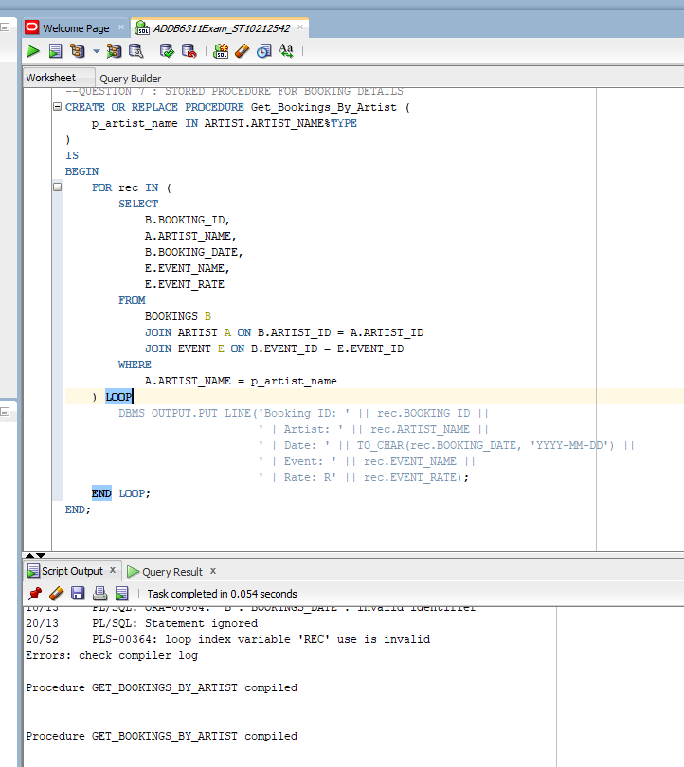

# Question 8 – Create a relevant function

## SQL Code:

--QUESTION 8: CREATE A RELEVANT FUNCTION

--STEP 1

CREATE OR REPLACE FUNCTION Get_Artist_Revenue (

p_artist_name IN ARTIST.ARTIST_NAME%TYPE

)

RETURN NUMBER

IS

v_total_revenue NUMBER := 0;

BEGIN

SELECT

NVL(SUM(E.EVENT_RATE), 0)

INTO

v_total_revenue

FROM

BOOKINGS B

JOIN ARTIST A ON B.ARTIST_ID = A.ARTIST_ID

JOIN EVENT E ON B.EVENT_ID = E.EVENT_ID

WHERE

A.ARTIST_NAME = p_artist_name;

RETURN v_total_revenue;

EXCEPTION

WHEN NO_DATA_FOUND THEN

DBMS_OUTPUT.PUT_LINE('No bookings found for artist: ' || p_artist_name);

RETURN 0;

WHEN OTHERS THEN

DBMS_OUTPUT.PUT_LINE('An unexpected error occurred: ' || SQLERRM);

RETURN -1;

END;

--STEP 2

SET SERVEROUTPUT ON;

DECLARE

v_revenue NUMBER;

BEGIN

v_revenue := Get_Artist_Revenue('Max Trillion');

IF v_revenue = -1 THEN

DBMS_OUTPUT.PUT_LINE('Error occurred while calculating revenue.');

ELSIF v_revenue = 0 THEN

DBMS_OUTPUT.PUT_LINE('Artist has no bookings.');

ELSE

DBMS_OUTPUT.PUT_LINE('Total revenue for Max Trillion: R' || v_revenue);

END IF;

END;

## SQL Output:

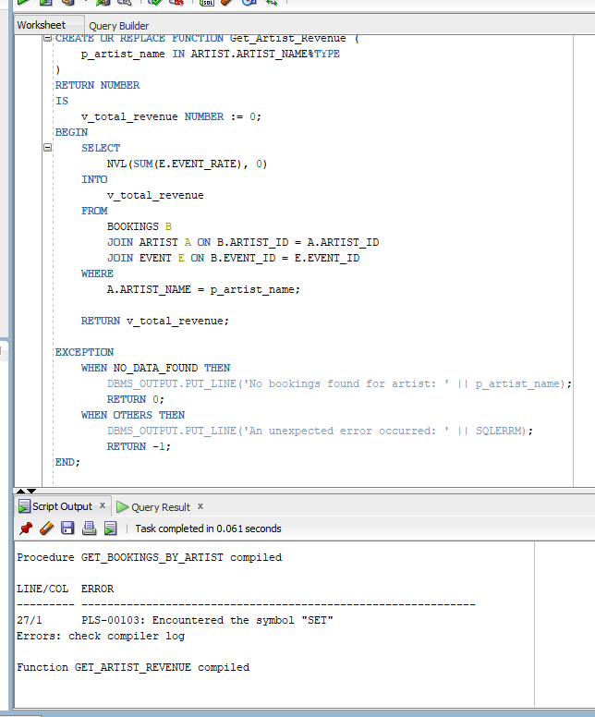

# Question 9 – Database Security Tools and Platforms

Tools and Platforms that were used to excute the creation of this database include the following:

* **Data Encryption**

Since the database handles personal details like ARTIST_EMAIL, data encryption is critical. Oracle Advanced Security helps you encrypt sensitive data both at rest and in transit, ensuring protection even if unauthorized access occurs (Oracle, 2023a).

* **Oracle Data Safe**

This is particularly useful for assessing how securely users interact with the database. Given your schema includes relationships between events and artists, you can audit user behavior, detect anomalies, and mask sensitive data when accessed for testing or development (Oracle, 2023b).

* **Oracle Audit Vault and Database Firewall**

To prevent SQL injection or any malicious activity—especially since stored procedures like Get_Bookings_By_Artist run dynamic queries—this tool logs and monitors all activity, raising flags for suspicious operations (Oracle, 2023c).

* **Access Control**

Only authorized roles should be allowed to modify booking information or access artist contact data. IAM ensures role-based access control, single sign-on, and strong authentication policies (Oracle, 2023d).

* **Oracle Cloud Infrastructure (OCI) Security**

If you deploy the database to the cloud, OCI security features provide network isolation, compartmentalization, and encryption key management. These are essential for compliance and resilience against external threats (Oracle, 2023e).

# Question 10 – PL/SQL Scalar Data Types Discussion

In PL/SQL, scalar data types are fundamental building blocks used to store single, indivisible values. Examples of these include the following:

1. Numeric Types: Used to store numbers, both integers and floating-point values. In the case of the practicum , event rates.

For example:

v_rate EVENT.EVENT_RATE%TYPE; -- Decimal(10,2)

You can also define with native types: v_discounted NUMBER := 250.50;

1. Character Types: Store alphanumeric data such as names, descriptions, and email addresses. Common types to identify them include:
   1. CHAR
   2. VARCHAR2
   3. CLOB

For example:

v_artist_name ARTIST.ARTIST_NAME%TYPE; -- VARCHAR2

v_email VARCHAR2(100) := 'test@example.com';

1. Date/Time Types: Store temporal data such as booking and event dates. The DATE type includes both date and time components. PL/SQL supports date artithmetic and formatting.

For example;

IF TO_CHAR(v_booking_date, 'DY') = 'SAT' THEN

DBMS_OUTPUT.PUT_LINE('Weekend booking');

END IF;

1. Boolean Type: Stores logical values: TRUE,FALSE, or NULL. It is used for control flow and validation logic:

For example:

v_is_valid BOOLEAN := TRUE;

These types help manage data with appropriate validation and formatting in the case study—e.g., DATE for BOOKING_DATE, NUMBER for EVENT_RATE, and VARCHAR2 for ARTIST_EMAIL.

# Question 11 – Create a Trigger to Prevent Weekend Bookings

## SQL Code:

--QUESTION 11: CREATE A TRIGGER TO PREVENT WEEKEND BOOKINGS

SELECT USER FROM DUAL;

CREATE USER C##oneuser IDENTIFIED BY strongpassword123;

GRANT CONNECT, RESOURCE TO C##oneuser;

CREATE OR REPLACE TRIGGER trg_prevent_invalid_booking

BEFORE INSERT ON BOOKINGS

FOR EACH ROW

DECLARE

v_day VARCHAR2(10);

BEGIN

v_day := TO_CHAR(:NEW.BOOKING_DATE, 'DY', 'NLS_DATE_LANGUAGE=ENGLISH');

IF v_day IN ('SAT', 'SUN') THEN

RAISE_APPLICATION_ERROR(-20001, 'Bookings cannot be made on weekends.');

END IF;

END;

/

## SQL Output:

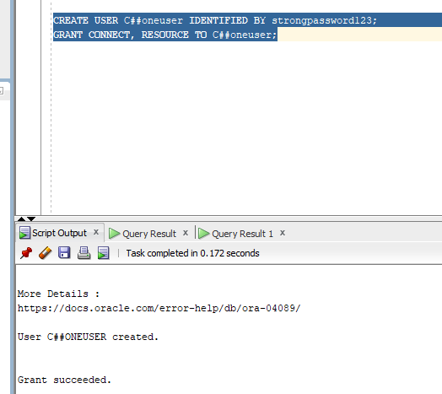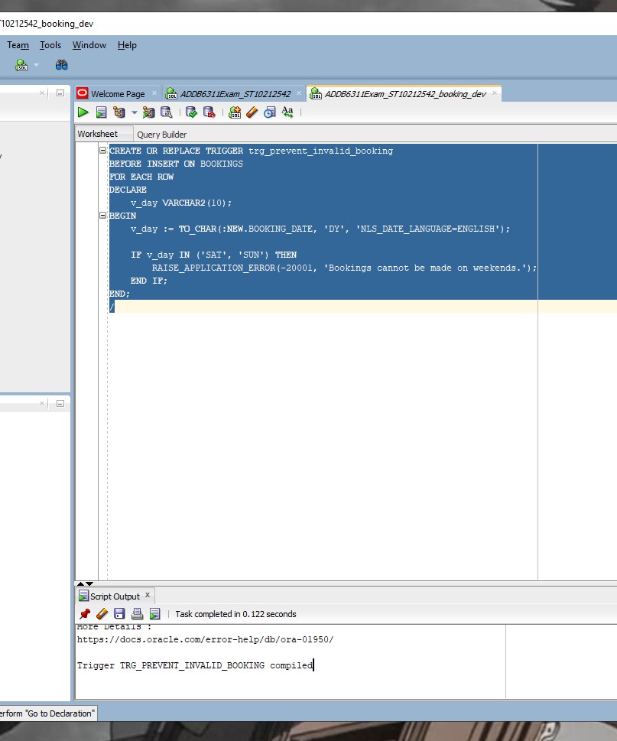

# GitHub Link:

<https://github.com/AaliyahAllie/ADDB63111_PRACTICUM_ST10212542.git>

# References:

Oracle. (2023a) Oracle Advanced Security. Available at: https://www.oracle.com/security/database-security/advanced-security/ (Accessed: 18 June 2025).

Oracle. (2023b) Oracle Data Safe. Available at: https://www.oracle.com/security/database-security/data-safe/ (Accessed: 18 June 2025).

Oracle. (2023c) Oracle Audit Vault and Database Firewall. Available at: https://www.oracle.com/security/database-security/audit-vault-database-firewall/ (Accessed: 18 June 2025).

Oracle. (2023d) Oracle Identity Management. Available at: https://www.oracle.com/security/identity-management/ (Accessed: 18 June 2025).

Oracle. (2023e) Oracle Cloud Infrastructure Security. Available at: https://www.oracle.com/cloud/security/ (Accessed: 18 June 2025).

Oracle. (2023a) PL/SQL Data Types. Available at: https://docs.oracle.com/en/database/oracle/oracle-database/23/lnpls/plsql-data-types.html (Accessed: 18 June 2025).

ComplexSQL. (2023) PL SQL Scalar Datatypes. Available at: https://www.complexsql.com/scalar-datatypes/ (Accessed: 18 June 2025).

TutorialsPoint. (2023) PL/SQL Data Types and Subtypes. Available at: https://www.tutorialspoint.com/plsql/plsql_data_types.htm (Accessed: 18 June 2025).