PROG6212

FINAL SUBMISSION

Aaliyah Allie-ST10212542

2024

Contents

INTRODUCTION 2

Changes 3

Part 3 Automation Features 4

Lecturer View 4

Programme Coordinator View 4

HR VIEW 5

Git Hub Repo Link 6

GIT COMMIT HISTORY 6

Conclusion 7

# INTRODUCTION

For the final part of our POE of the semester, we are tasked with added automation features to our lecturer view and our coordinator view as well as adding in a new view called the HR view.

This document is to display changes made based on lecturer feedback but seeing as I have not received feedback as I received full marks for the last submission, I will just explain all the changes that I thought my application need and explain the new features added as well.

For this part of the POE there has been no changes to my database, and I am still using the WPF .NET FRAMEWORK functionality and there has been zero to no changes in design.

# Changes

For the POE I have made changes to my POE by allowing the application under submit claims to also include saving the hourly rate, the feature also does not have a fixed hourly rate anymore lecturers are allowed to input an hourly rate of their own.

//

# Part 3 Automation Features

## Lecturer View

My lecturer view allows for the total amount of a claim to be automatically generated when a user inserts their Number of Sessions and Hourly Rate. This function is stored in the Submit Claim Window.

## Programme Coordinator View

For this automation I have added a feature that will automatically update claims submitted to be approved if it has 5 or more Sessions and it will change the status of a claim to pending if a user has less than 5 sessions so that programme coordinators can manually approve of it or not.

## HR VIEW

The new feature HR view automatically approves users claims if it is set to “PENDING” and it allows users to update lecturer information if they search for their name and surname, it will allow generate a report based on approved claims and it will download it.

# Git Hub Repo Link

<https://github.com/AaliyahAllie/AaliyahAllie_PROG6212_POE_FINAL_PART.git>

# GIT COMMIT HISTORY

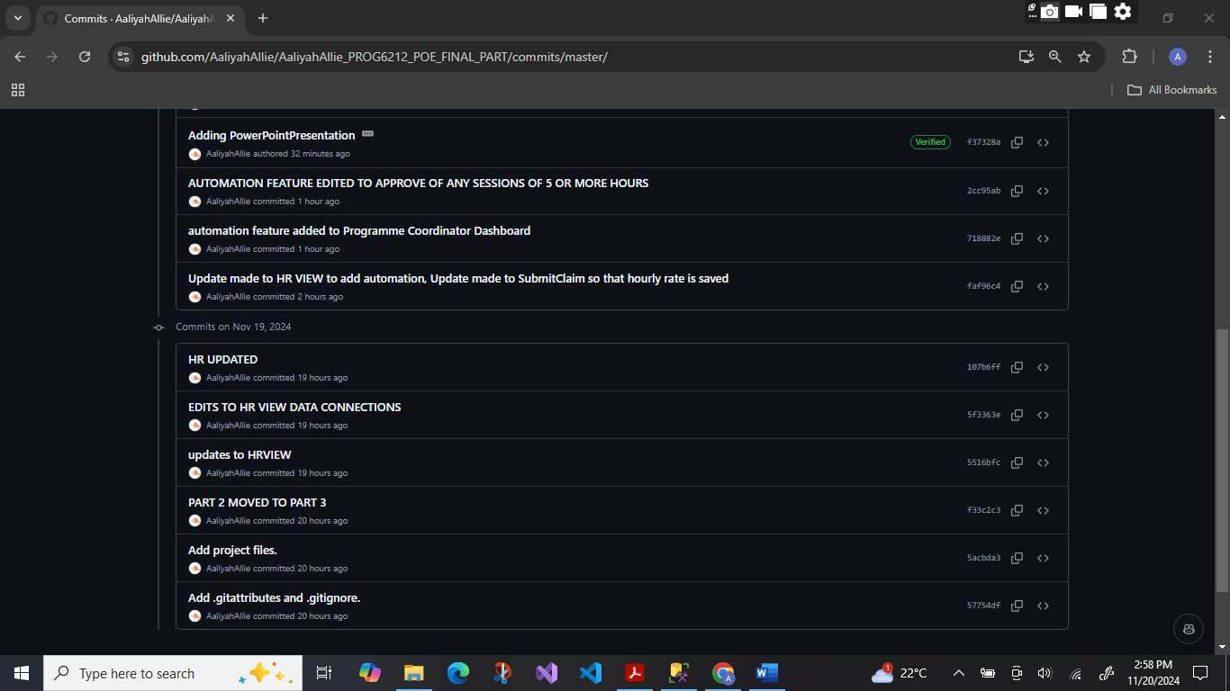

# Conclusion

In conclusion the final POE has successfully implemented essential features of automation to enhance the usability of the application for the lecturers and programme coordinators. The lecturer view allows for flexible input of hourly rates and automated calculation of claim totals, easing the process of making claims. The programme coordinator view incorporates an automated system of categorizing claims based on the number of sessions, thus making the process of approval less cumbersome. The new HR overview allows for the automation of approvals of claims and downloadable reports, thereby managing lecturer information much more effectively. All in all, these changes enhance user experience and administrative efficiency. The completed project is available at GitHub.