Aaliyah Allie
st10212542
cldv7112 practicum

Table of Contents
Introduction 2
A. Building a Real-Time Processing System 3
Azure Setup 3
a) Web Hosting: 3
b) Relational Database (User Management) 7
d) Cloud Storage (Data & Media): 17
Azure Table Storage: 21
d) Serverless Data Pipeline (Azure Functions): 22
e) Load Testing: 25
f) Monitoring: 25
g) Auto-Scaling: 25
Links 26
Deployed Website Link: 26
GitHub Repo Link: 26
Frontend of System Screenshots: 26
Admin 26
Farmer 28
Agronomist: 30
Codebase of System: 32
Folder Structure: 32
Connections to Azure: 33
Publishing to Azure Web App from Visual Studio: 33
B. Theory Questions 36
Disaster Recovery & Redundancy: 36
Stateless vs. Stateful Architecture: 37
Serverless Triggers and Bindings: 37
Conclusion 38
References 39

Introduction

Application Overview: AgriStream IoT Platform
Modern commercial agriculture requires continuous, data-driven decision-making to optimize crop yields, conserve water resources, and mitigate environmental risks such as drought and sudden frost. The AgriStream IoT Smart Farming Platform is a multi-tier, cloud-native agricultural management system engineered to centralize operational intelligence for large-scale farming enterprises.
The application integrates three vital operational pillars:
- Real-Time Soil Probe Telemetry: Streams in-ground sensor measurements, including root-zone soil moisture percentages, ambient soil temperatures, and battery health, from distributed probe nodes directly into cloud storage.
- Aerial Drone Orthomosaic Imagery: Ingests high-resolution photographic aerial surveys captured by autonomous field drones, providing farmers and agronomists with daylight visual verification of crop canopy health, colour uniformity, and hydration stress.
- Remote Solenoid Valve & Irrigation Automation: Provides precision remote control over field irrigation valves and center pivots, allowing operators to actuate hydration cycles based on real-time probe telemetry thresholds.
To ensure strict operational integrity, the platform enforces Role-Based Access Control (RBAC) across three specialized user profiles:
- System Administrator (Admin): Possesses overarching platform authority, including staff account management, database role assignments, drone imagery deletion, and system auditing.
- Farm Manager / Operator (Farmer): Focuses on physical field operations; authorized to actuate hardware irrigation valves and inspect live sensor telemetry, but restricted from altering scientific crop baseline logs.
- Agricultural Scientist (Agronomist): Specializes in crop biology and soil chemistry; authorized to log calibrated soil probe readings and upload drone survey imagery, but restricted from operating physical irrigation valves.

A. Building a Real-Time Processing System

Azure Setup

Web Hosting:
Summary of steps:
The screenshots demonstrate the complete process of creating and deploying an Azure App Service through the Azure Marketplace. The web app is configured using the specified subscription and resource group, with the application hosted in South Africa North using the Basic B1 pricing tier. Azure Resource Manager validates the configuration before provisioning the required resources. Once deployment is complete, the App Service dashboard confirms that the application is running, with its public IP addresses and HTTPS-enabled production URL available for access.
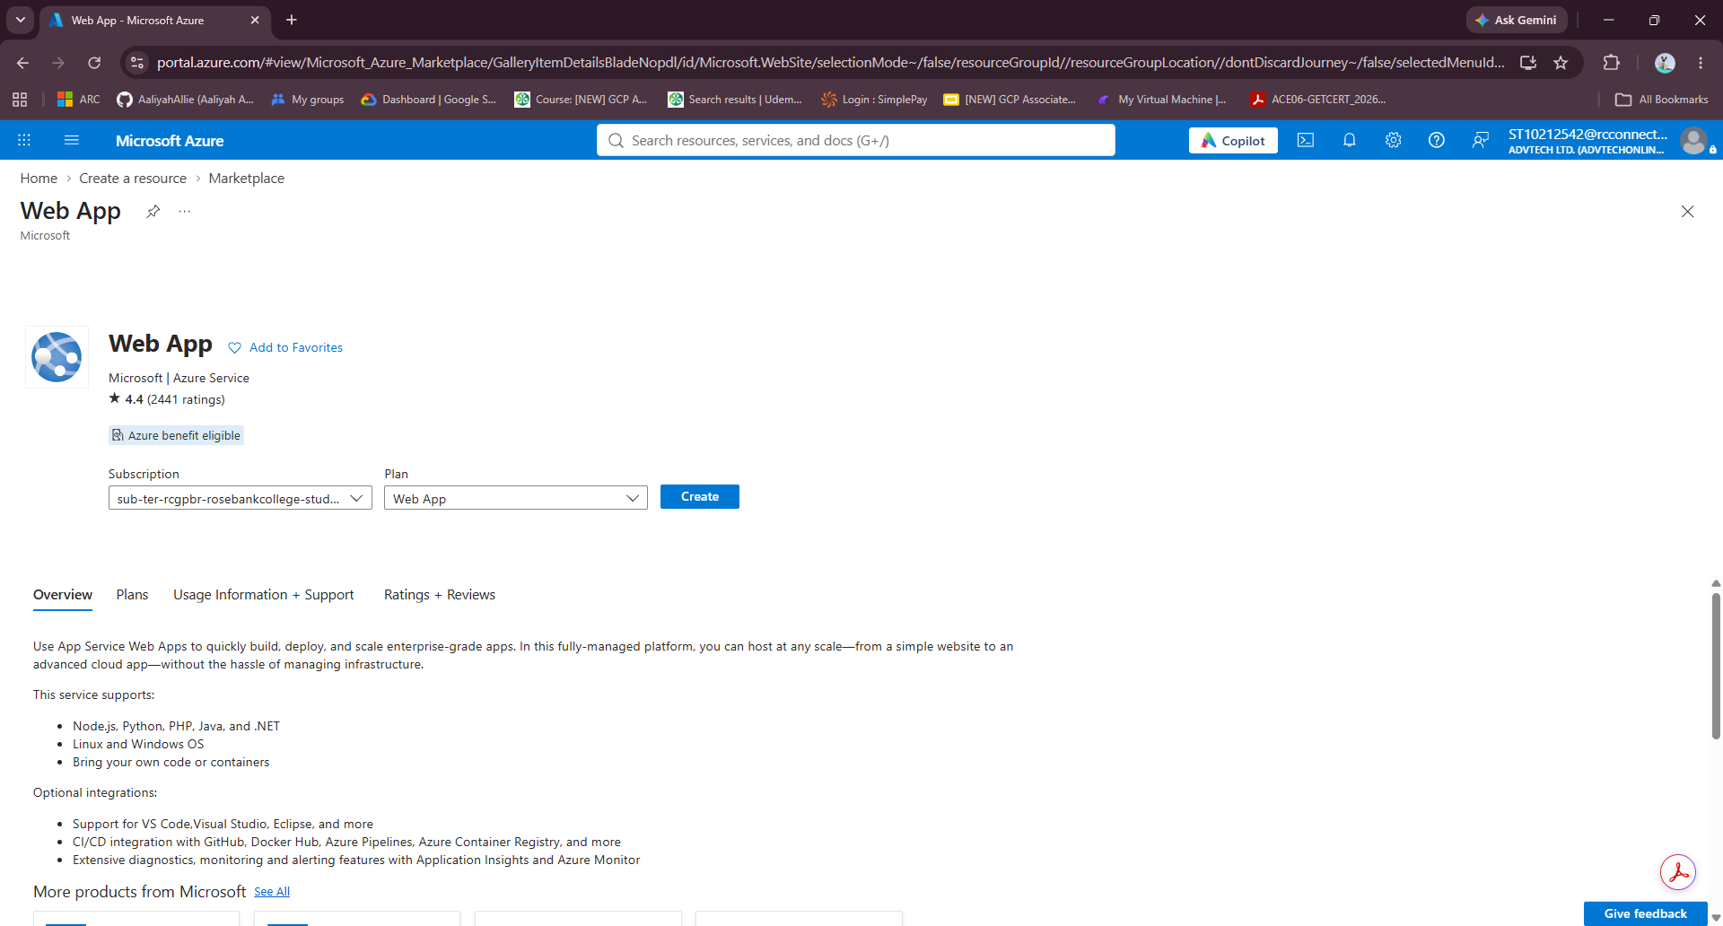
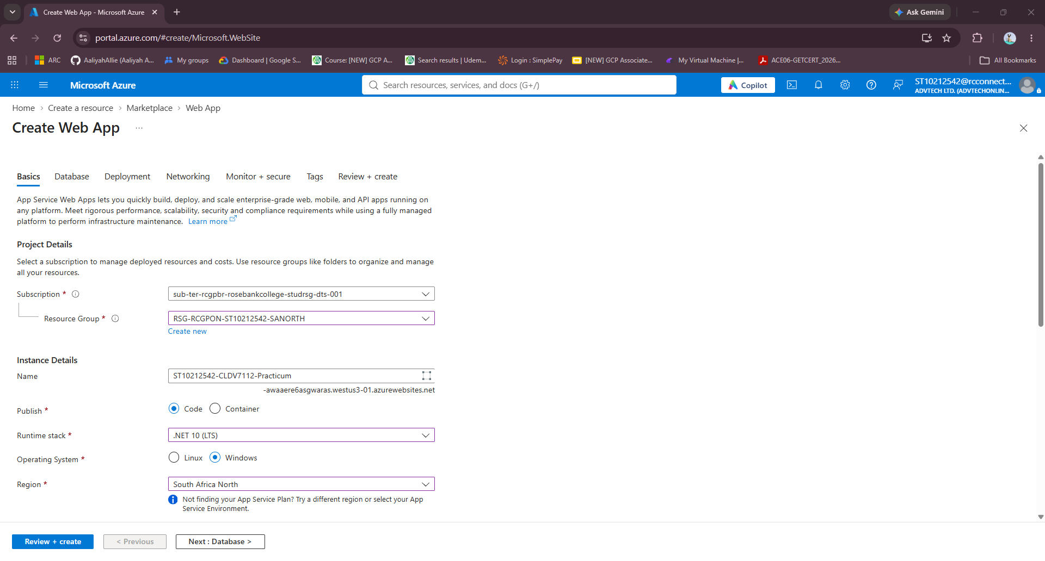
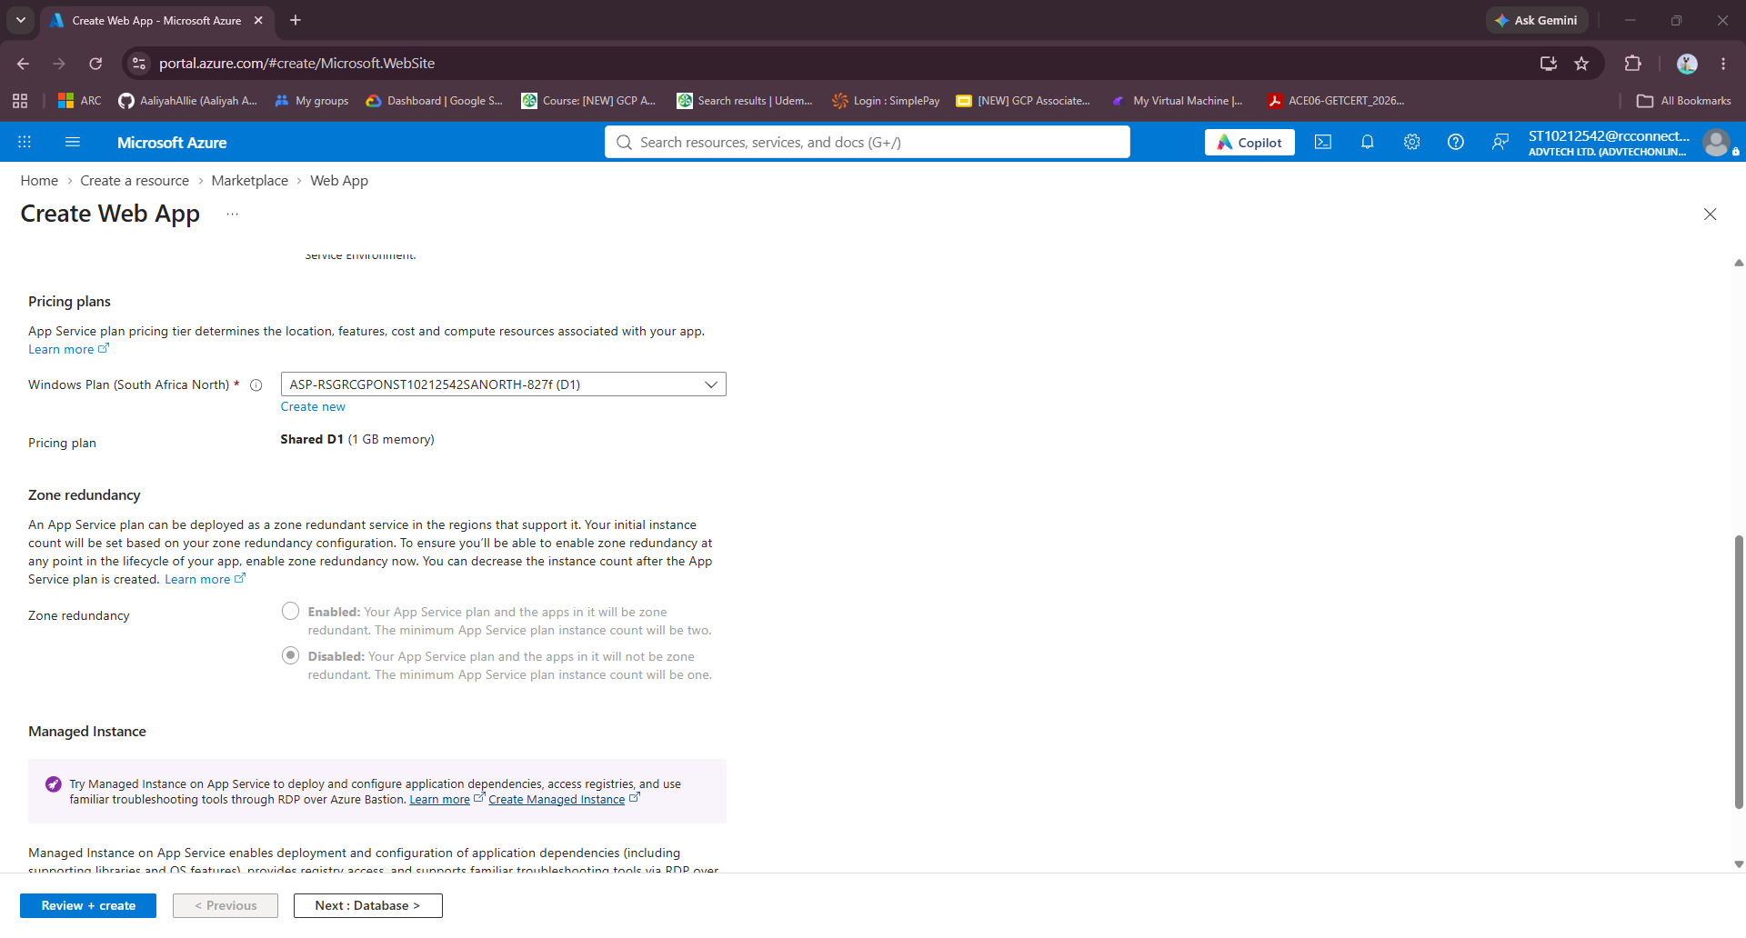
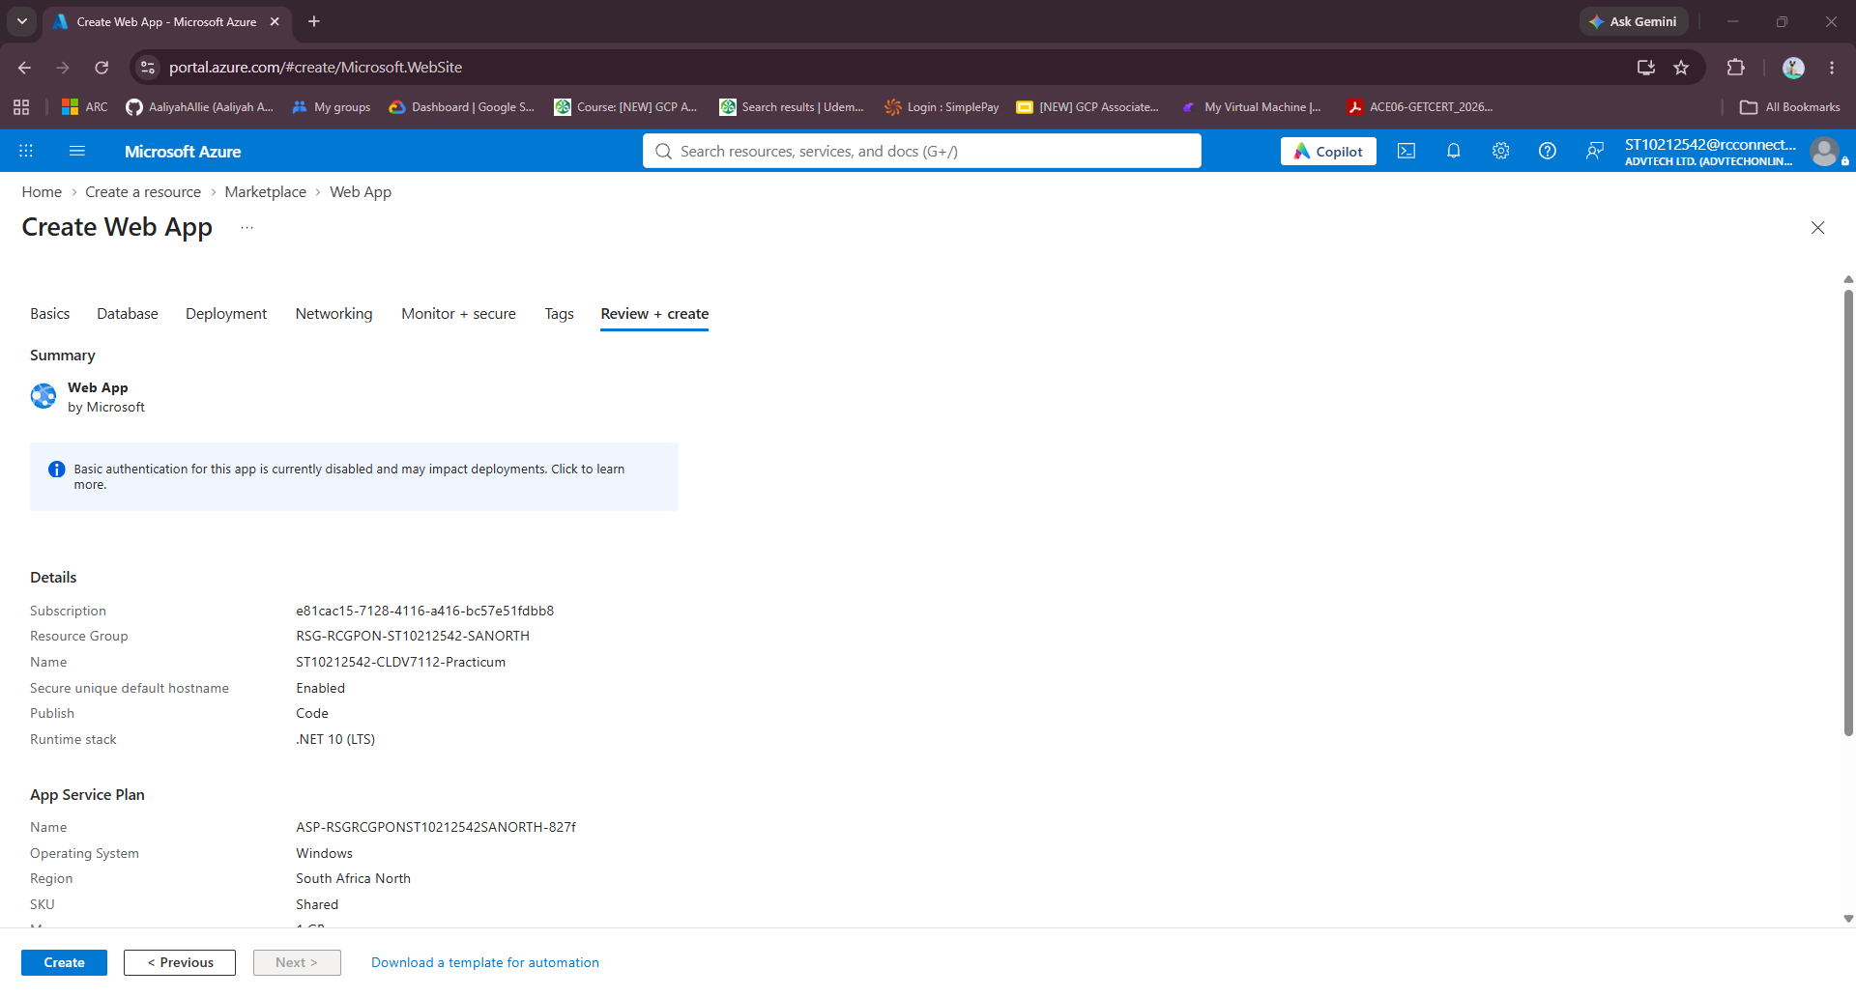
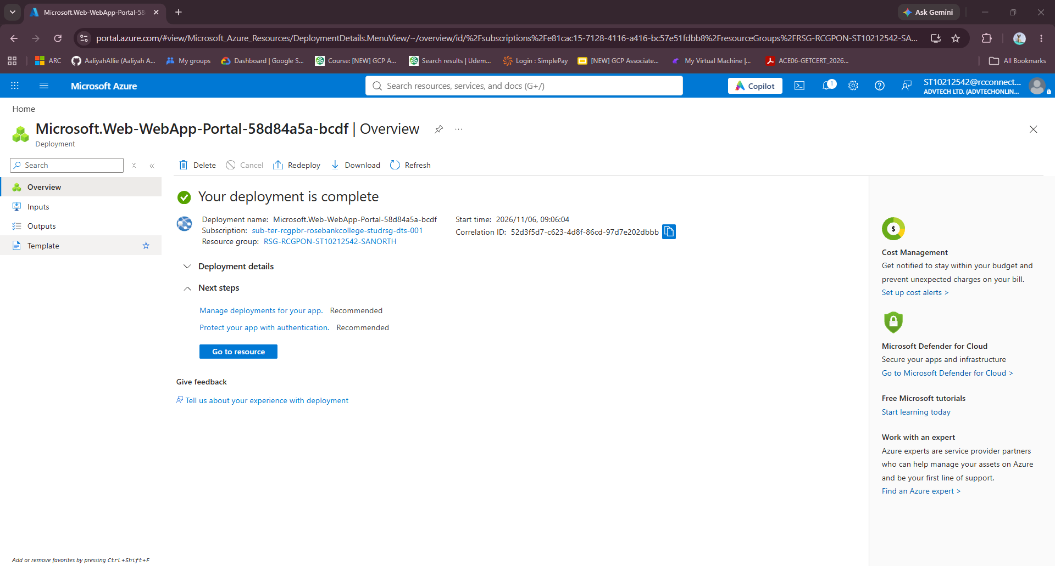
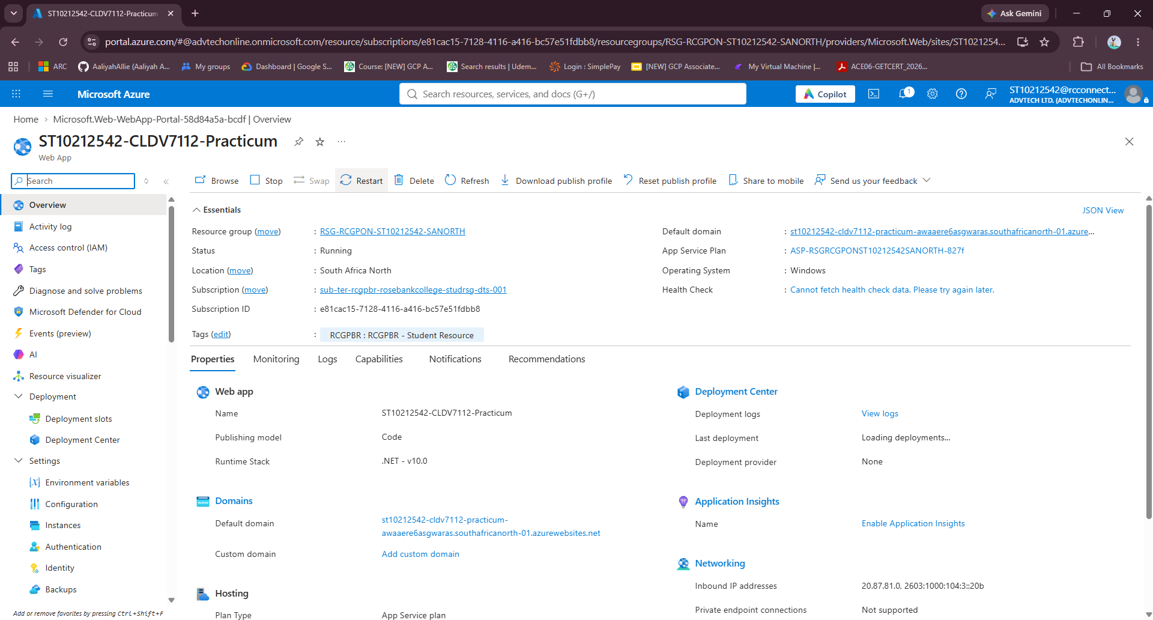

Field | Value
Resource Group | RSG-RCGPON-ST10212542-SANORTH
App Name | ST10212542-CLDV7112-PRACTICUM
Runtime Stack | .Net 10
Operating System | Windows
Region | South Africa North
App Service Plan | B1 Basic
Deployed URL | https://st10212542-cldv7112-practicum-awaaere6asgwaras.southafricanorth-01.azurewebsites.net/

b) Relational Database (User Management)
Summary of steps:
The screenshots demonstrate the complete process of creating and configuring an Azure SQL Database. The database is linked to the existing logical server, using the Basic pricing tier with 5 DTUs, 2 GB of storage and Locally Redundant Storage (LRS) for backups to keep costs low. Firewall settings are configured to allow access from Azure services, and the deployment is validated and successfully completed. The database overview confirms that it is online in the South Africa North region. Finally, the Query Editor is used to create the Roles and Users tables, establish their relationship through a foreign key and insert the default administrative and farm personnel accounts.
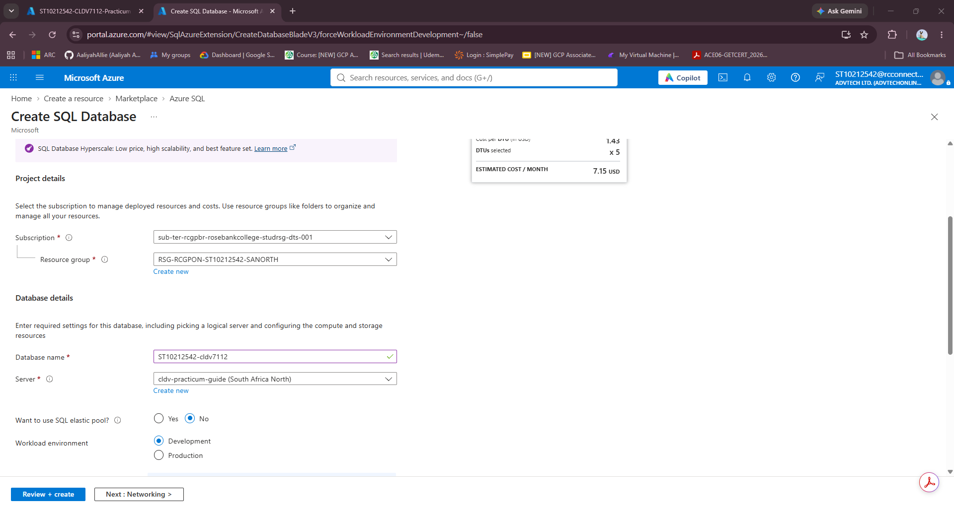
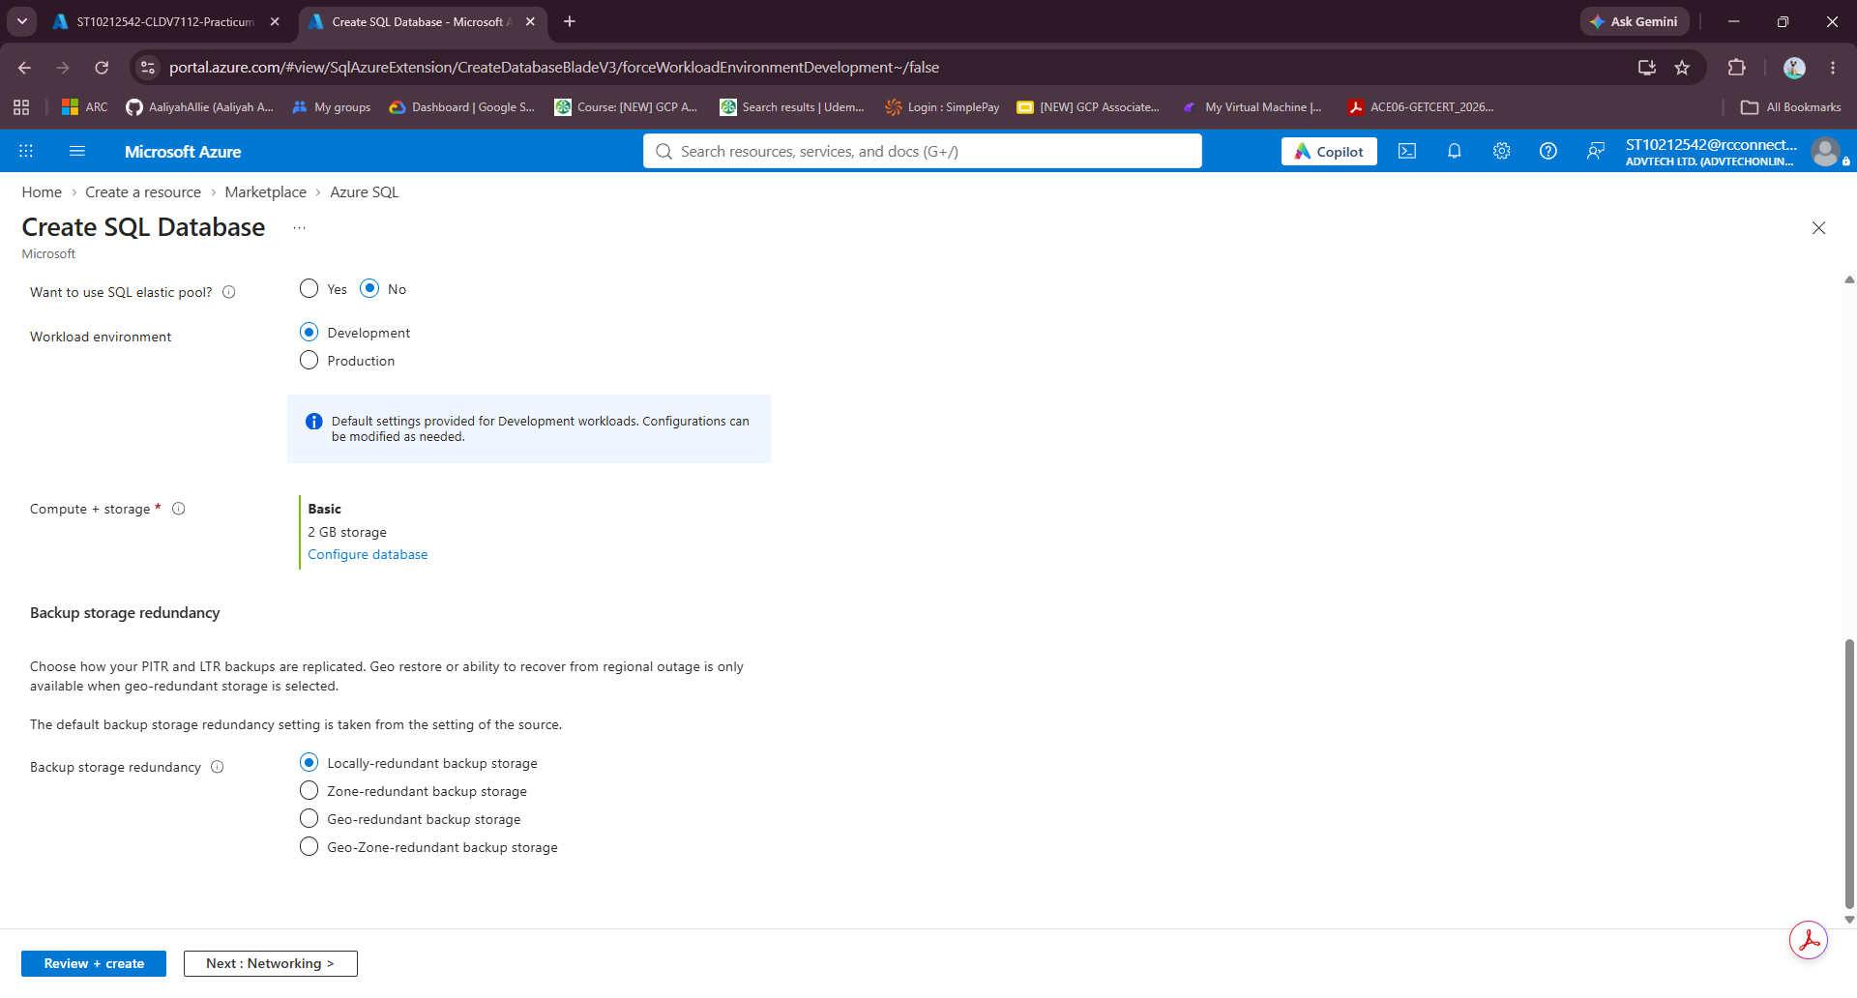
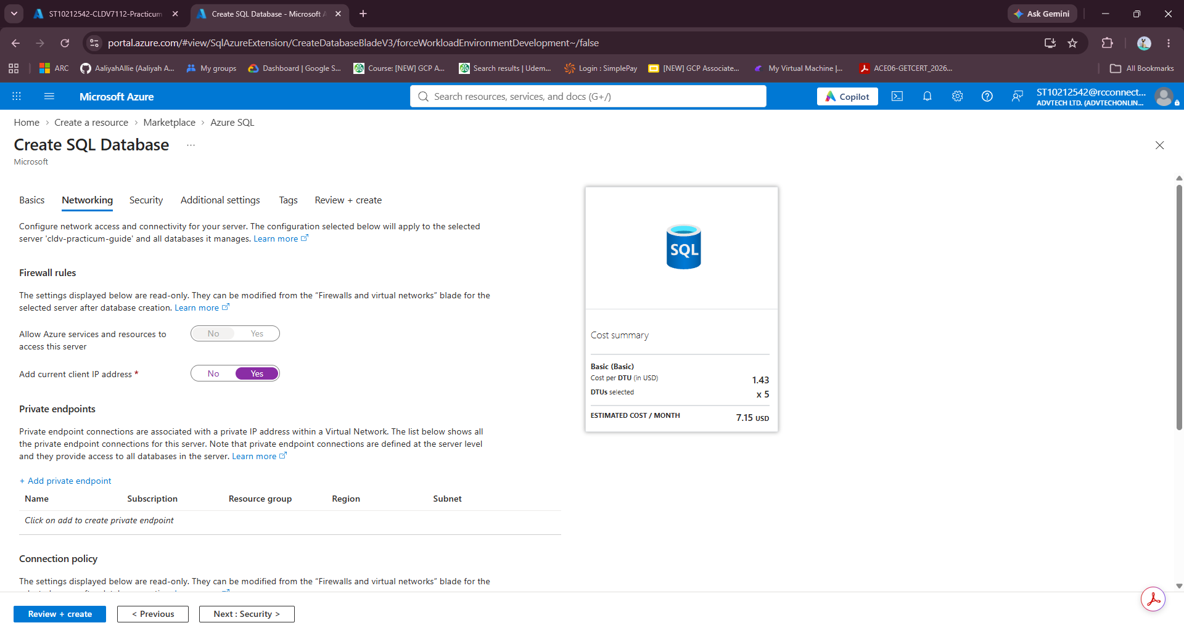
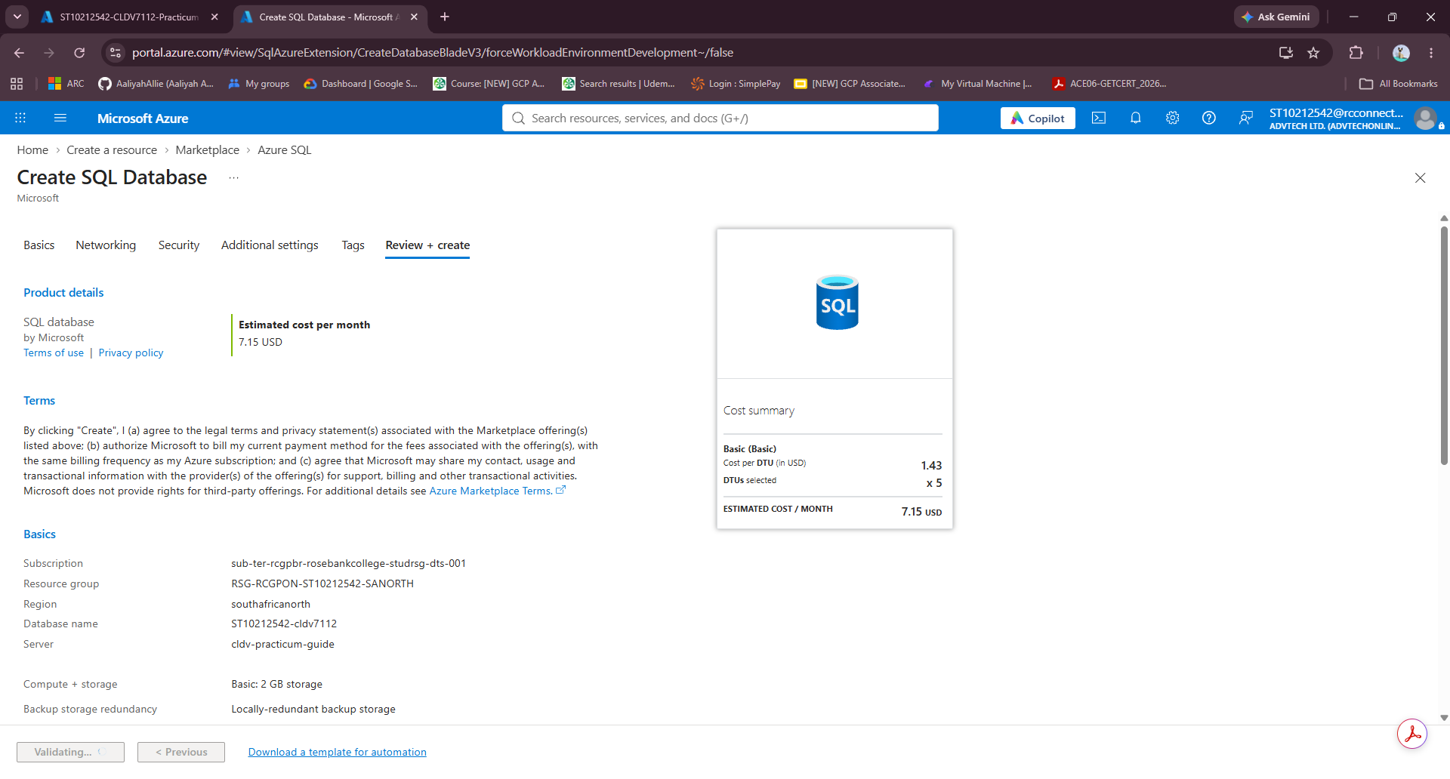
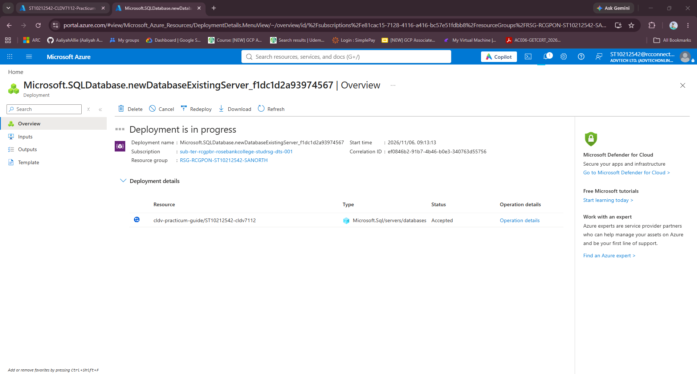
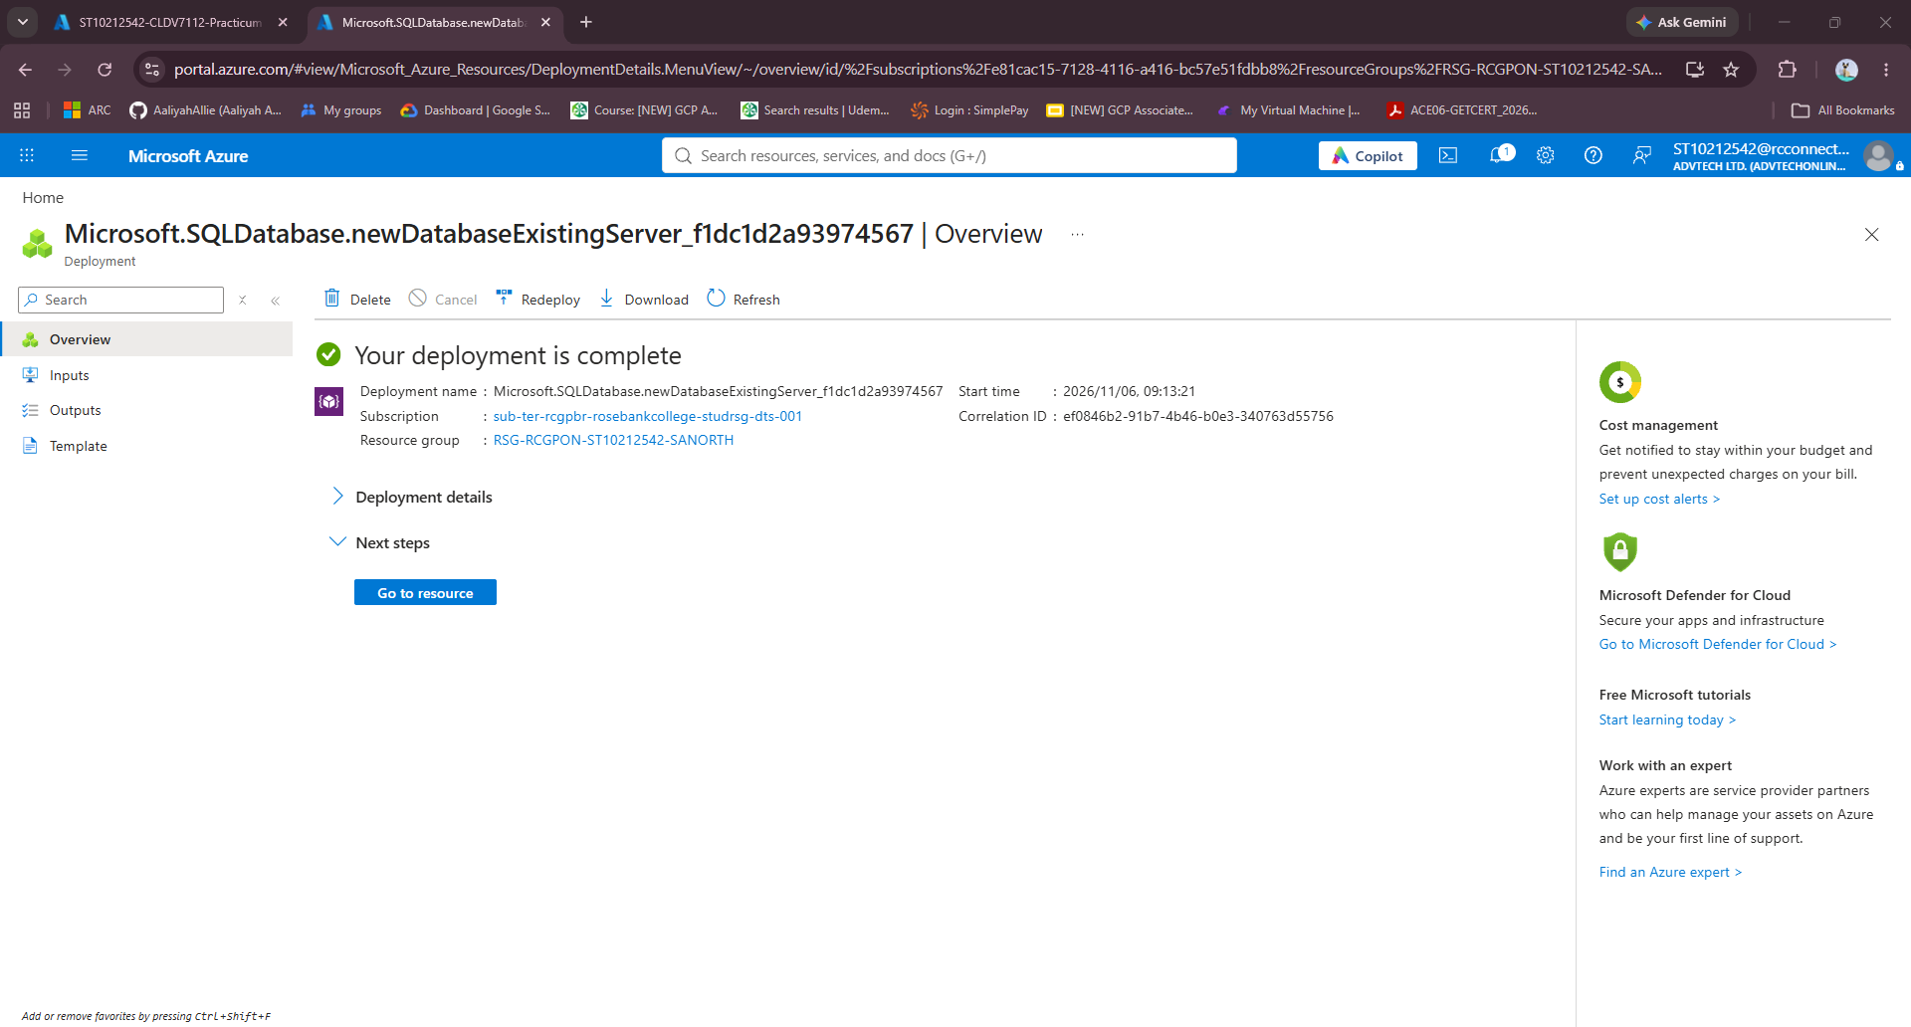
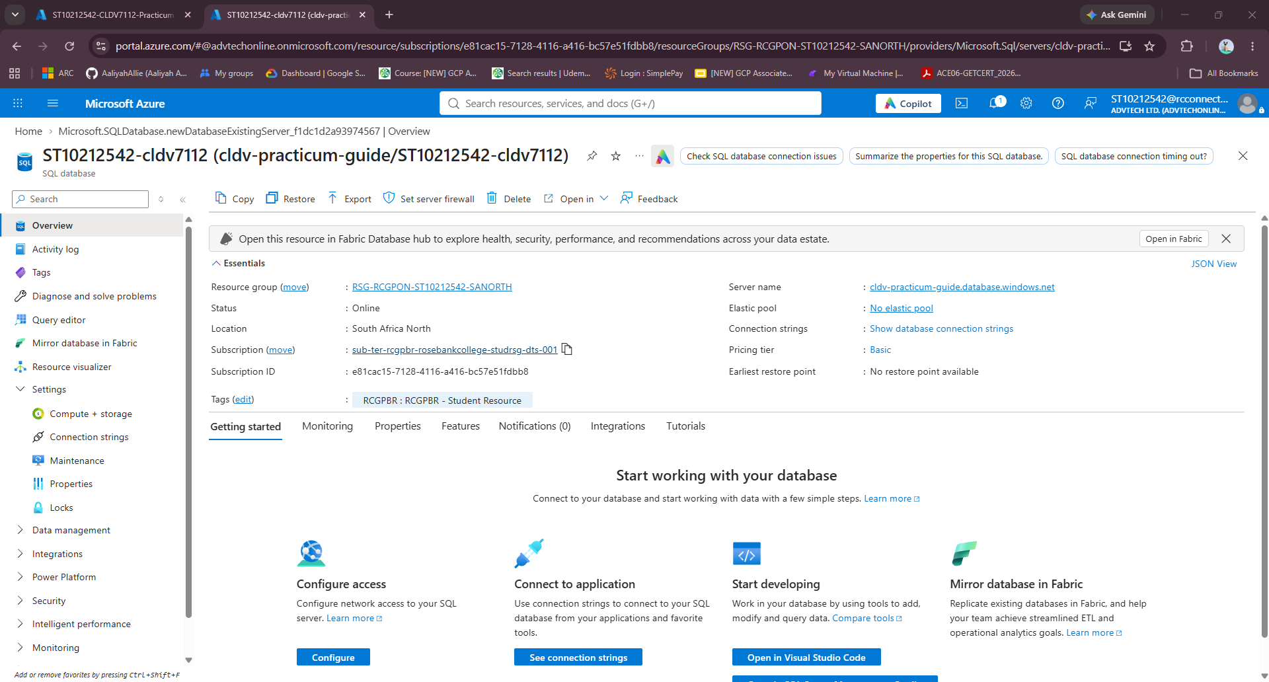
Connection String: “ Server=tcp:cldv-practicum-guide.database.windows.net,1433;Initial Catalog=ST10212542-cldv7112;Encrypt=True;TrustServerCertificate=False;Connection Timeout=30;Authentication="Active Directory Default";
Tables:
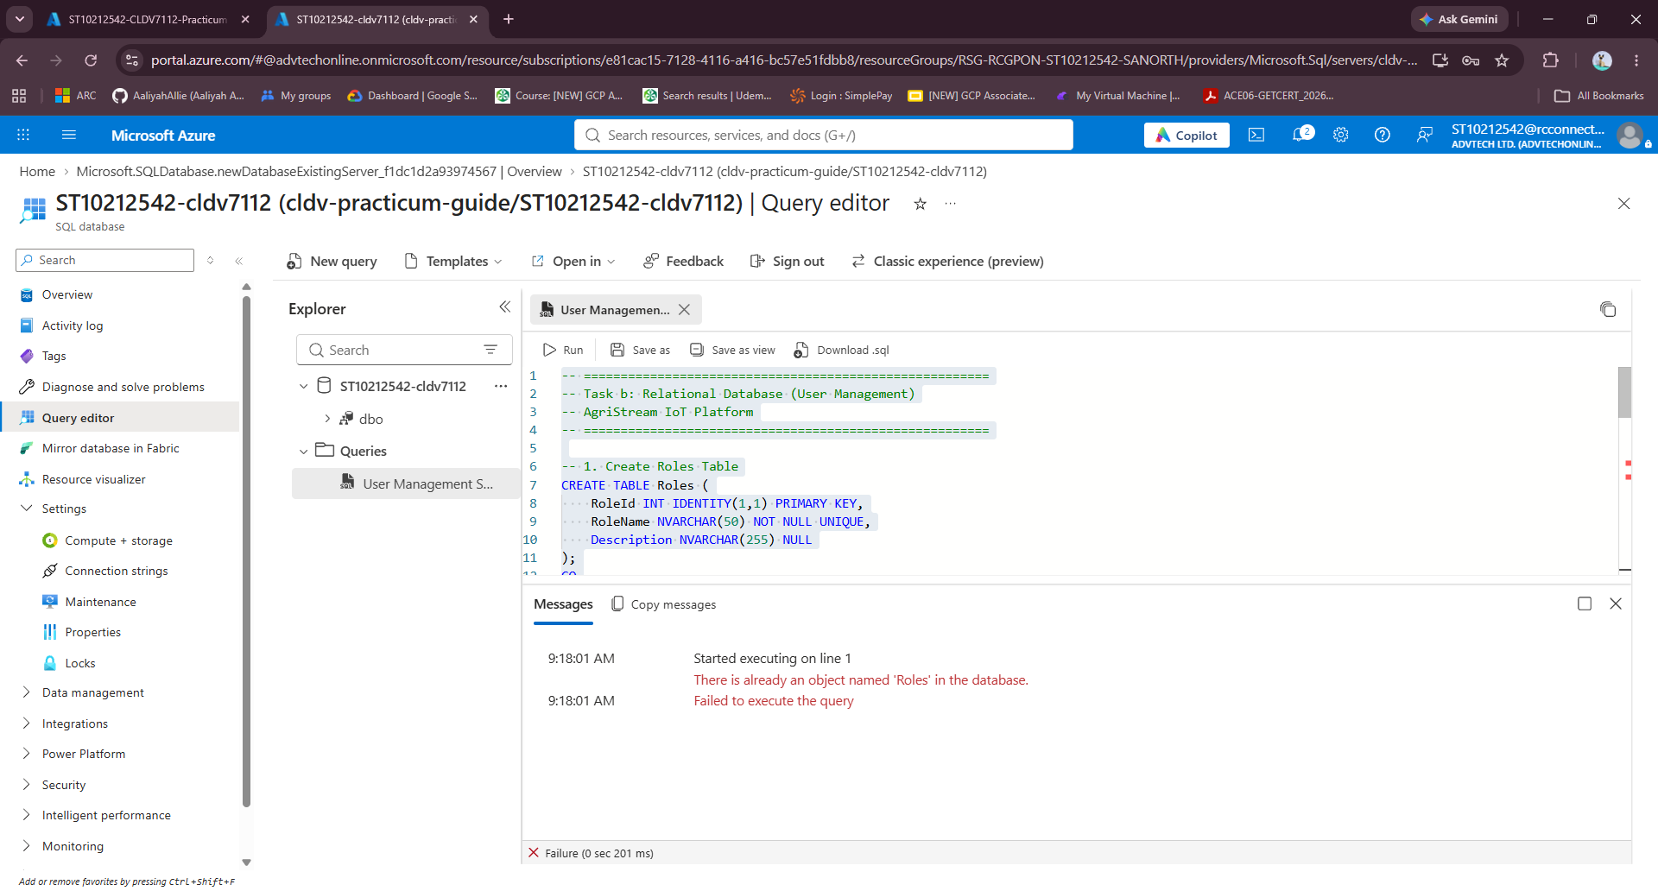
Database Script:
-- =======================================================
-- Task b: Relational Database (User Management)
-- AgriStream IoT Platform
-- =======================================================

-- 1. Create Roles Table
CREATE TABLE Roles (
RoleId INT IDENTITY(1,1) PRIMARY KEY,
RoleName NVARCHAR(50) NOT NULL UNIQUE,
Description NVARCHAR(255) NULL
);
GO

-- 2. Create Users Table
CREATE TABLE Users (
UserId INT IDENTITY(1,1) PRIMARY KEY,
Username NVARCHAR(100) NOT NULL UNIQUE,
Password NVARCHAR(255) NOT NULL, -- Stored as hash or string depending on your auth implementation
Email NVARCHAR(150) NULL,
RoleId INT NOT NULL,
CreatedAt DATETIME2 DEFAULT GETUTCDATE(),
CONSTRAINT FK_Users_Roles FOREIGN KEY (RoleId)
REFERENCES Roles(RoleId)
ON DELETE NO ACTION
);
GO

-- =======================================================
-- 3. Seed Default System Roles
-- =======================================================
INSERT INTO Roles (RoleName, Description)
VALUES
('Admin', 'System administrator with full management access'),
('Farmer', 'Farm owner/manager monitoring telemetry and drone media'),
('Agronomist', 'Agricultural expert analyzing crop and soil telemetry');
GO

-- =======================================================
-- 4. Seed Sample Test Users
-- =======================================================
INSERT INTO Users (Username, Password, Email, RoleId)
VALUES
('admin_agristream', 'AdminPass123!', 'admin@agristream.com', 1),
('john_farmer', 'FarmerPass123!', 'john@greenacres.com', 2),
('dr_sarah_agro', 'AgroPass123!', 'sarah@croptech.org', 3);
GO
Additional Tables Script:
-- =======================================================
-- Additional Relational Tables for AgriStream IoT
-- =======================================================

-- 1. Farms Table
CREATE TABLE Farms (
FarmId INT IDENTITY(1,1) PRIMARY KEY,
FarmName NVARCHAR(150) NOT NULL,
Location NVARCHAR(200) NOT NULL,
TotalHectares DECIMAL(10, 2) NOT NULL,
OwnerUserId INT NOT NULL,
CreatedAt DATETIME2 DEFAULT GETUTCDATE(),
CONSTRAINT FK_Farms_Users FOREIGN KEY (OwnerUserId)
REFERENCES Users(UserId)
);
GO

-- 2. Fields / Crop Zones Table
CREATE TABLE Fields (
FieldId INT IDENTITY(1,1) PRIMARY KEY,
FarmId INT NOT NULL,
FieldName NVARCHAR(100) NOT NULL,
CropType NVARCHAR(100) NOT NULL, -- e.g., Maize, Soybeans, Wheat
SoilType NVARCHAR(100) NULL, -- e.g., Loam, Clay, Sandy
AreaHectares DECIMAL(10, 2) NOT NULL,
Status NVARCHAR(50) DEFAULT 'Active', -- Active, Fallow, Harvesting
CONSTRAINT FK_Fields_Farms FOREIGN KEY (FarmId)
REFERENCES Farms(FarmId) ON DELETE CASCADE
);
GO

-- 3. IoT Device Registry Table
-- (Relational registry for sensors whose telemetry streams into Azure Table Storage)
CREATE TABLE IoTDevices (
DeviceId INT IDENTITY(1,1) PRIMARY KEY,
DeviceSerialNumber NVARCHAR(100) NOT NULL UNIQUE,
DeviceType NVARCHAR(100) NOT NULL, -- Soil Moisture, Temperature, Weather Station
FieldId INT NOT NULL,
Status NVARCHAR(50) DEFAULT 'Online', -- Online, Offline, Maintenance
BatteryLevelPercentage INT NULL,
InstallationDate DATE NOT NULL,
CONSTRAINT FK_IoTDevices_Fields FOREIGN KEY (FieldId)
REFERENCES Fields(FieldId)
);
GO

-- 4. Drone Media Metadata Table
-- (Connects to Task c: Stores Blob Storage URLs for aerial imagery)
CREATE TABLE DroneMedia (
MediaId INT IDENTITY(1,1) PRIMARY KEY,
FieldId INT NOT NULL,
UploadedByUserId INT NOT NULL,
FileName NVARCHAR(255) NOT NULL,
BlobUrl NVARCHAR(1000) NOT NULL, -- URL pointing to Azure Blob Storage container
FlightAltitudeMeters INT NULL,
ImageResolution NVARCHAR(50) NULL, -- e.g., 4000x3000, 4K
CapturedAt DATETIME2 NOT NULL,
UploadedAt DATETIME2 DEFAULT GETUTCDATE(),
CONSTRAINT FK_DroneMedia_Fields FOREIGN KEY (FieldId)
REFERENCES Fields(FieldId),
CONSTRAINT FK_DroneMedia_Users FOREIGN KEY (UploadedByUserId)
REFERENCES Users(UserId)
);
GO

-- 5. System Alerts Table
CREATE TABLE Alerts (
AlertId INT IDENTITY(1,1) PRIMARY KEY,
FieldId INT NOT NULL,
DeviceId INT NULL,
Severity NVARCHAR(20) NOT NULL, -- Low, Medium, High, Critical
AlertType NVARCHAR(100) NOT NULL, -- e.g., Low Soil Moisture, Frost Risk, Drone Anomaly
Message NVARCHAR(500) NOT NULL,
IsResolved BIT DEFAULT 0,
CreatedAt DATETIME2 DEFAULT GETUTCDATE(),
CONSTRAINT FK_Alerts_Fields FOREIGN KEY (FieldId)
REFERENCES Fields(FieldId),
CONSTRAINT FK_Alerts_IoTDevices FOREIGN KEY (DeviceId)
REFERENCES IoTDevices(DeviceId)
);
GO

-- 6. Irrigation Schedules Table
CREATE TABLE IrrigationSchedules (
ScheduleId INT IDENTITY(1,1) PRIMARY KEY,
FieldId INT NOT NULL,
ScheduledStartTime DATETIME2 NOT NULL,
DurationMinutes INT NOT NULL,
WaterVolumeLiters DECIMAL(12, 2) NULL,
Status NVARCHAR(50) DEFAULT 'Scheduled', -- Scheduled, In-Progress, Completed, Cancelled
CreatedByUserId INT NOT NULL,
CONSTRAINT FK_Irrigation_Fields FOREIGN KEY (FieldId)
REFERENCES Fields(FieldId),
CONSTRAINT FK_Irrigation_Users FOREIGN KEY (CreatedByUserId)
REFERENCES Users(UserId)
);
GO
Field | Value
Resource Group | RSG-RCGPON-ST10212542-SANORTH
Database Name | ST10212542-cldv7112
Server Name | cldv-practicum-guide
Region | South Africa North
Compute Tier | Basic
Authentication | SQL Authentication
The database schema implements a fully normalized relational model supporting six interconnected operational domains:
1. `Roles`: Defines security tiers (`Admin`, `Farmer`, `Agronomist`) to enforce Role-Based Access Control.
2. `Users`: Stores credentials, emails, and foreign key references linking personnel to security roles.
3. `Farms`: Catalogs farm enterprise properties, physical geographic locations, total hectares, and owning users.
4. `Fields`: Segregates farms into distinct cultivation parcels, tracking crop varieties (`Maize`, `Soybeans`, `Wheat`), soil textures (`Sandy Loam`, `Clay Loam`), and active cultivation statuses.
5. `IoTDevices`: Hardware registry storing probe serial numbers (`SN-SOIL-001`, `SN-WTH-002`), hardware types, installation dates, and real-time battery percentages.
6. `DroneMedia`: Metadata catalog bridging relational records with Azure Blob Storage URLs, storing flight altitudes, image resolutions, capture dates, and uploading user IDs.
7. `Alerts` & `IrrigationSchedules`: Records threshold alert histories and valve actuation logs to ensure full operational traceability.

d) Cloud Storage (Data & Media):
The AgriStream platform utilizes Polyglot Persistence, matching data models to optimal storage technologies:
- Unstructured Large Media (Drone Surveys): Handled by Azure Blob Storage(`agristreamblob` container) for high-resolution aerial scans.
- High-Velocity Time-Series Data (Sensor Telemetry): Handled by Azure Table Storage (`SensorTelemetry` table) for schema-less, low-latency probe ingestion.
- Relational Entities (Users, Fields, Hardware): Managed by Azure SQL Database for ACID compliance and referential integrity.
Azure Storage Account:
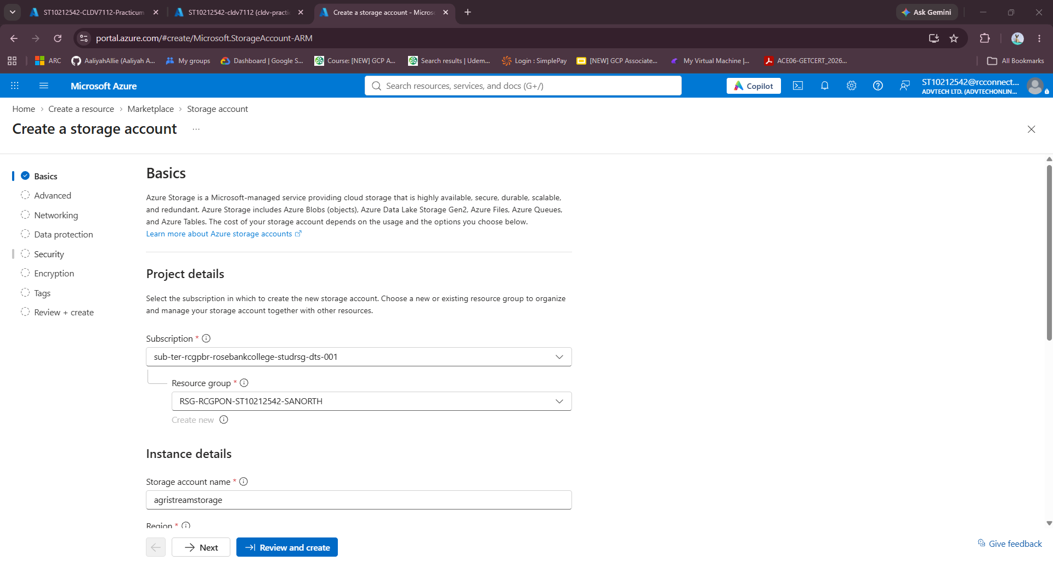
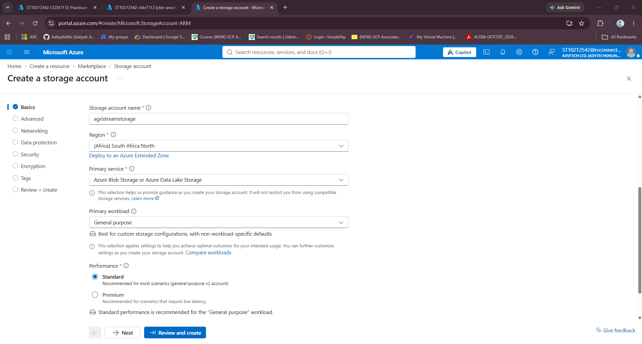

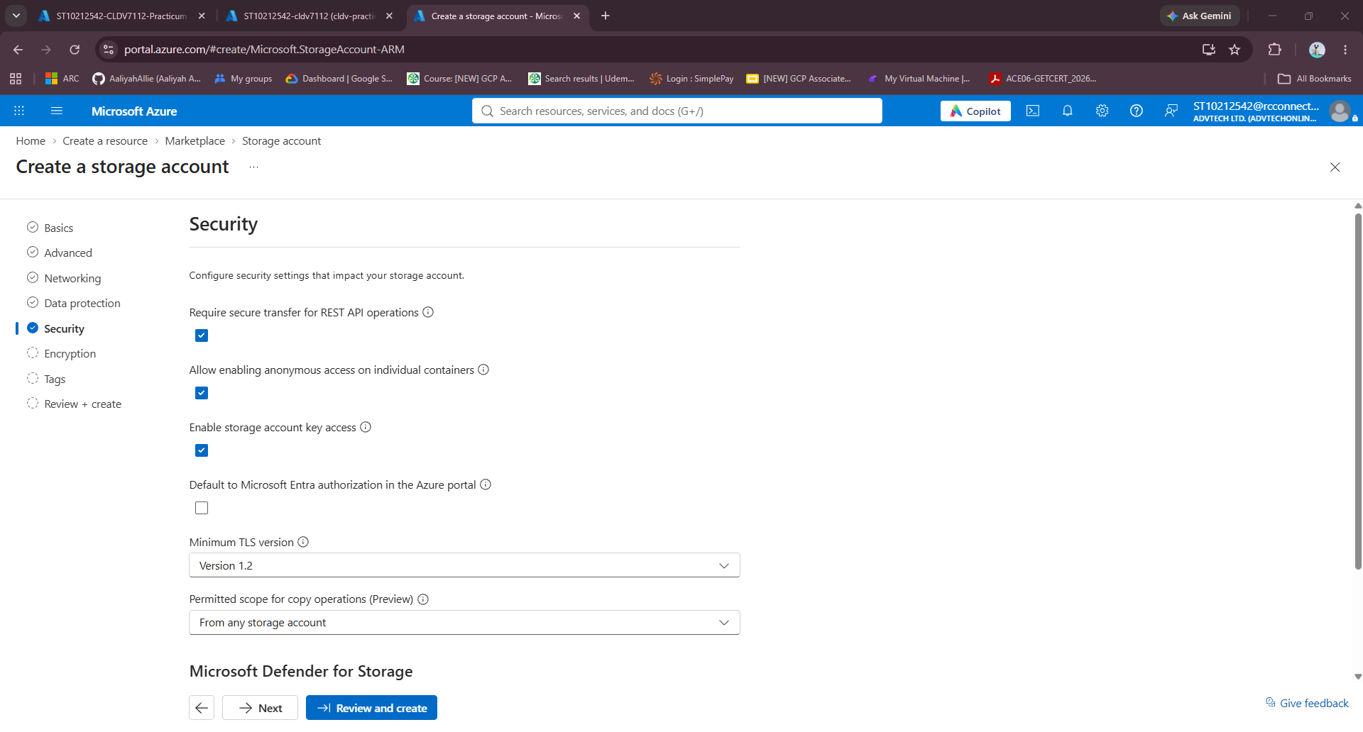
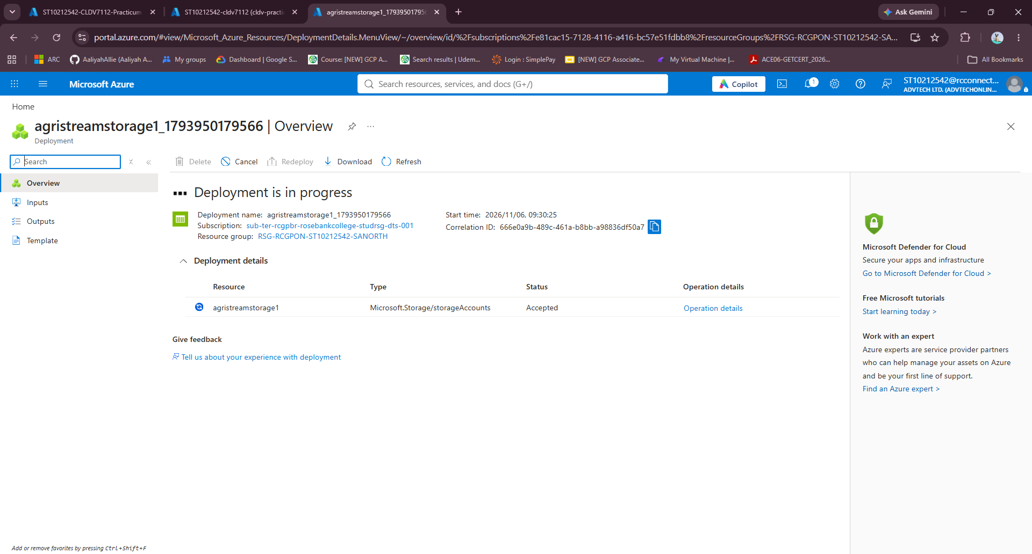
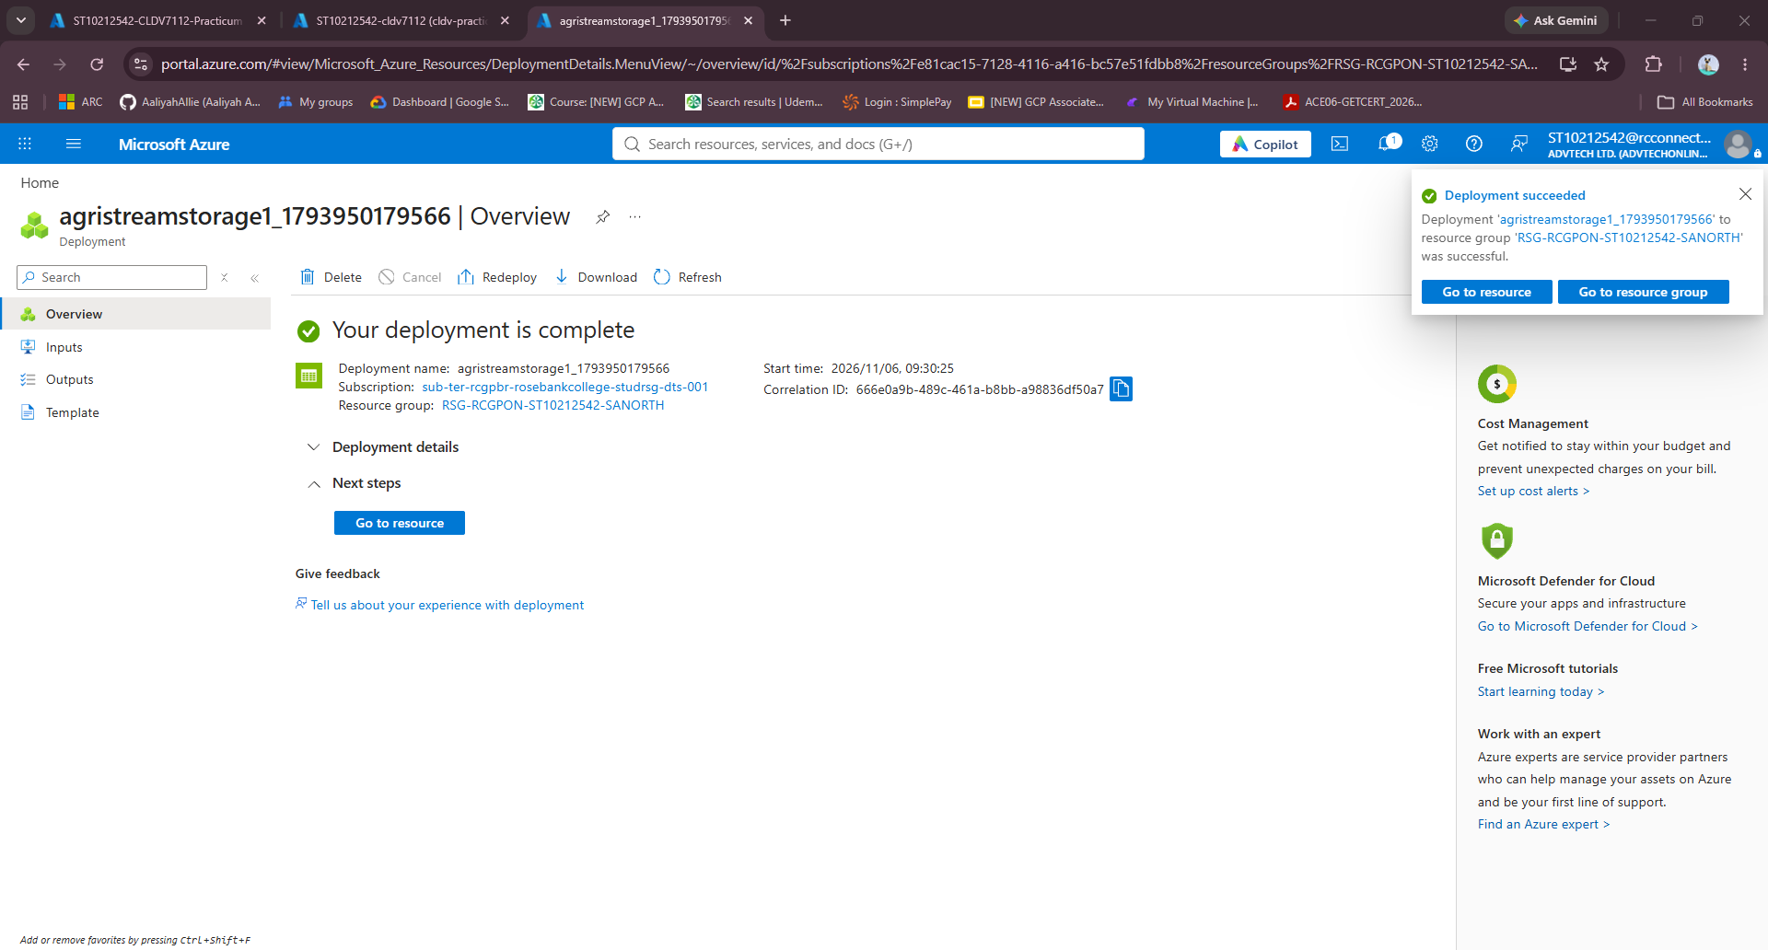
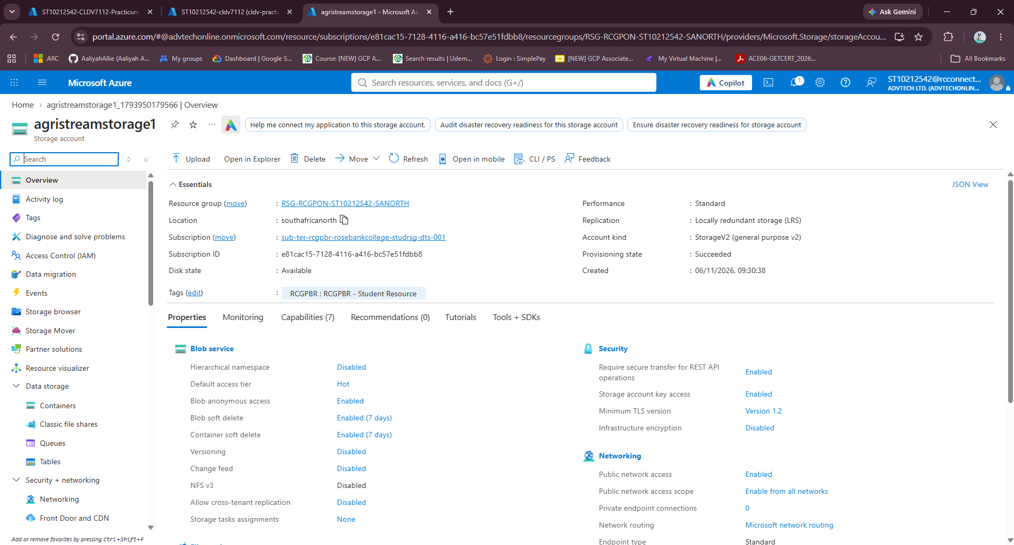
Azure Blob Storage:
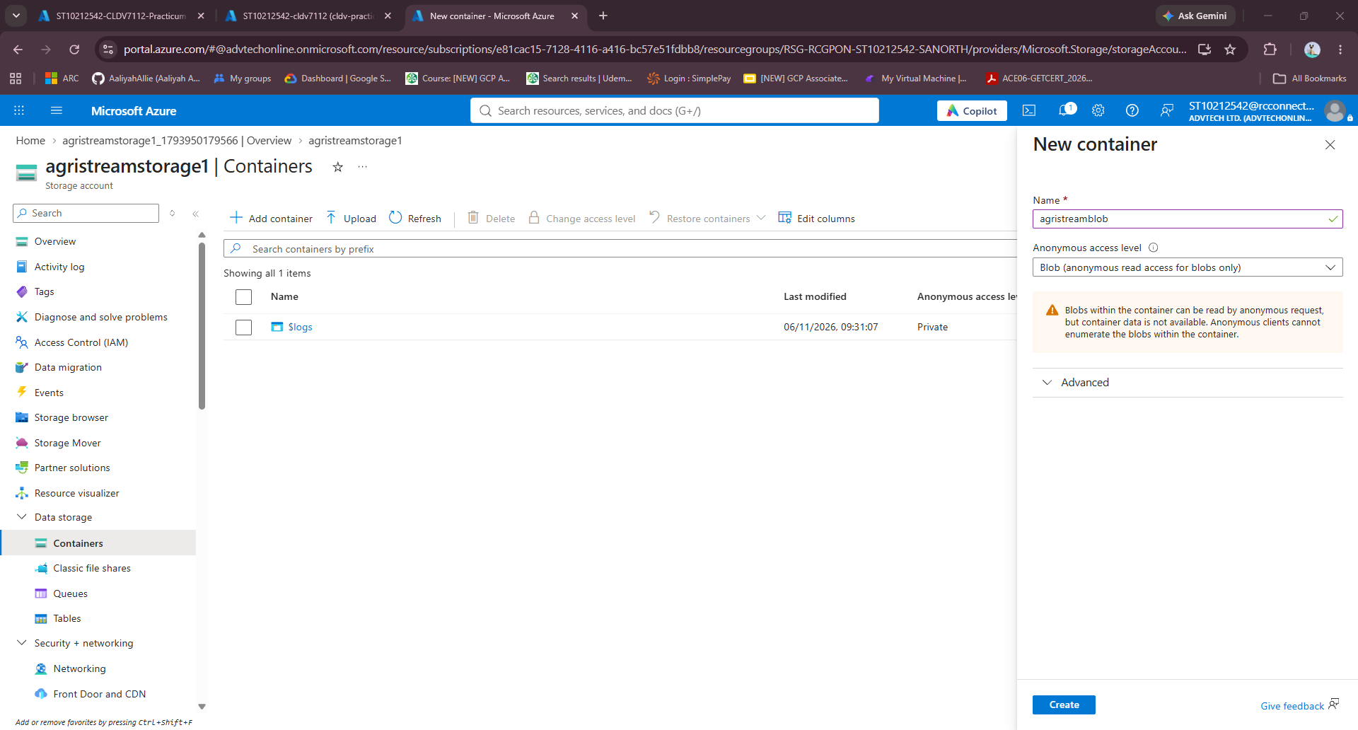
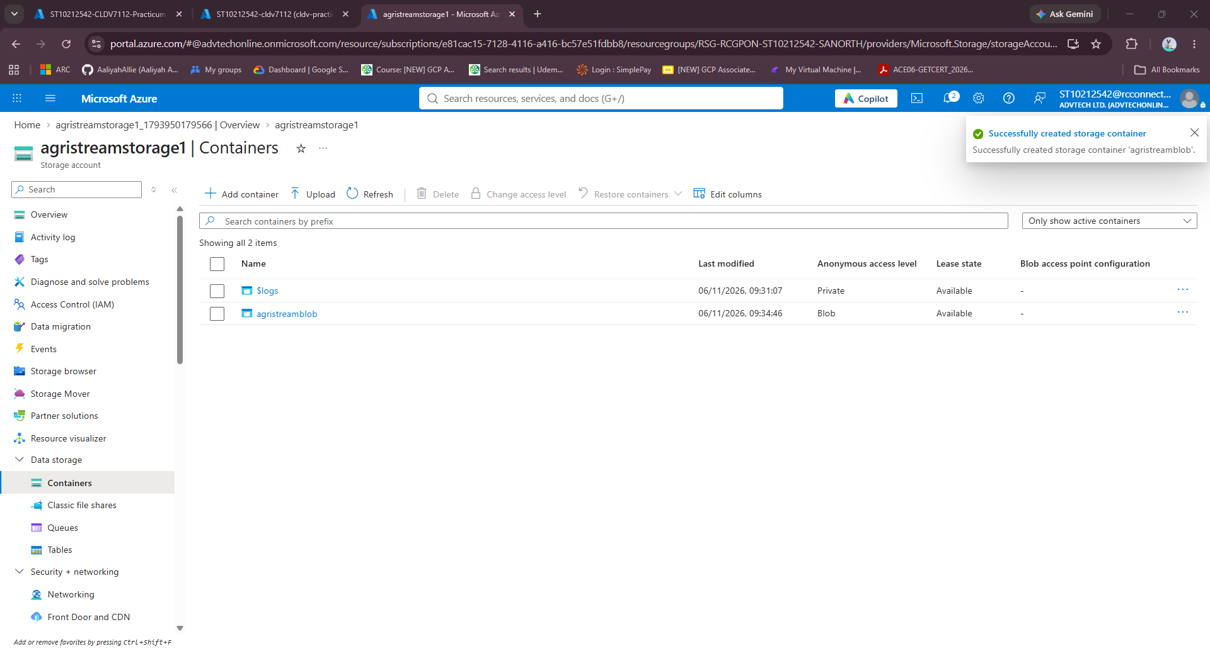

Azure Table Storage:
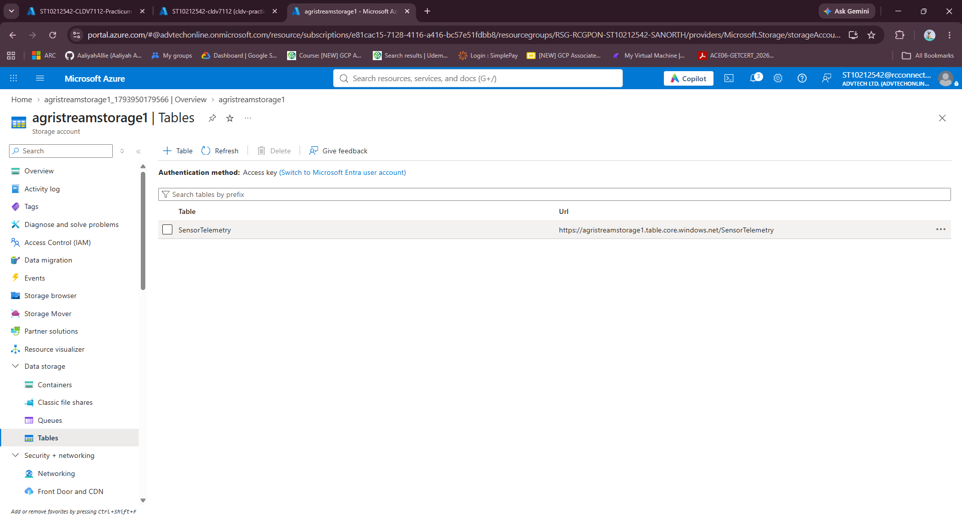

d) Serverless Data Pipeline (Azure Functions):
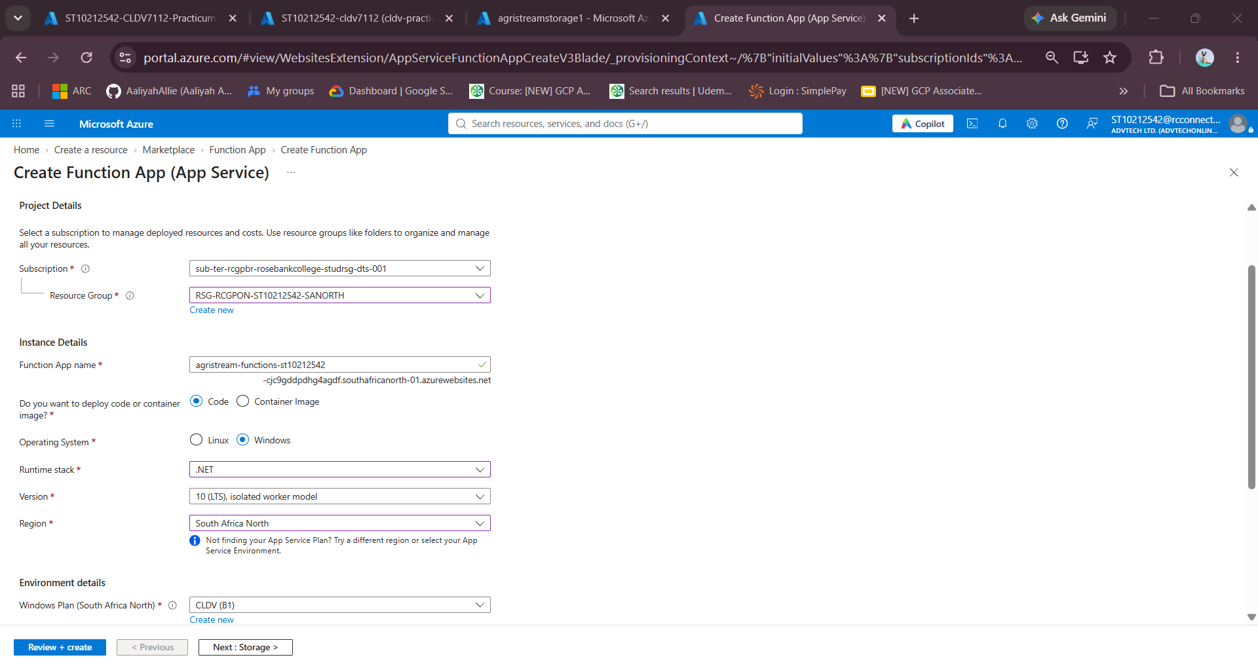
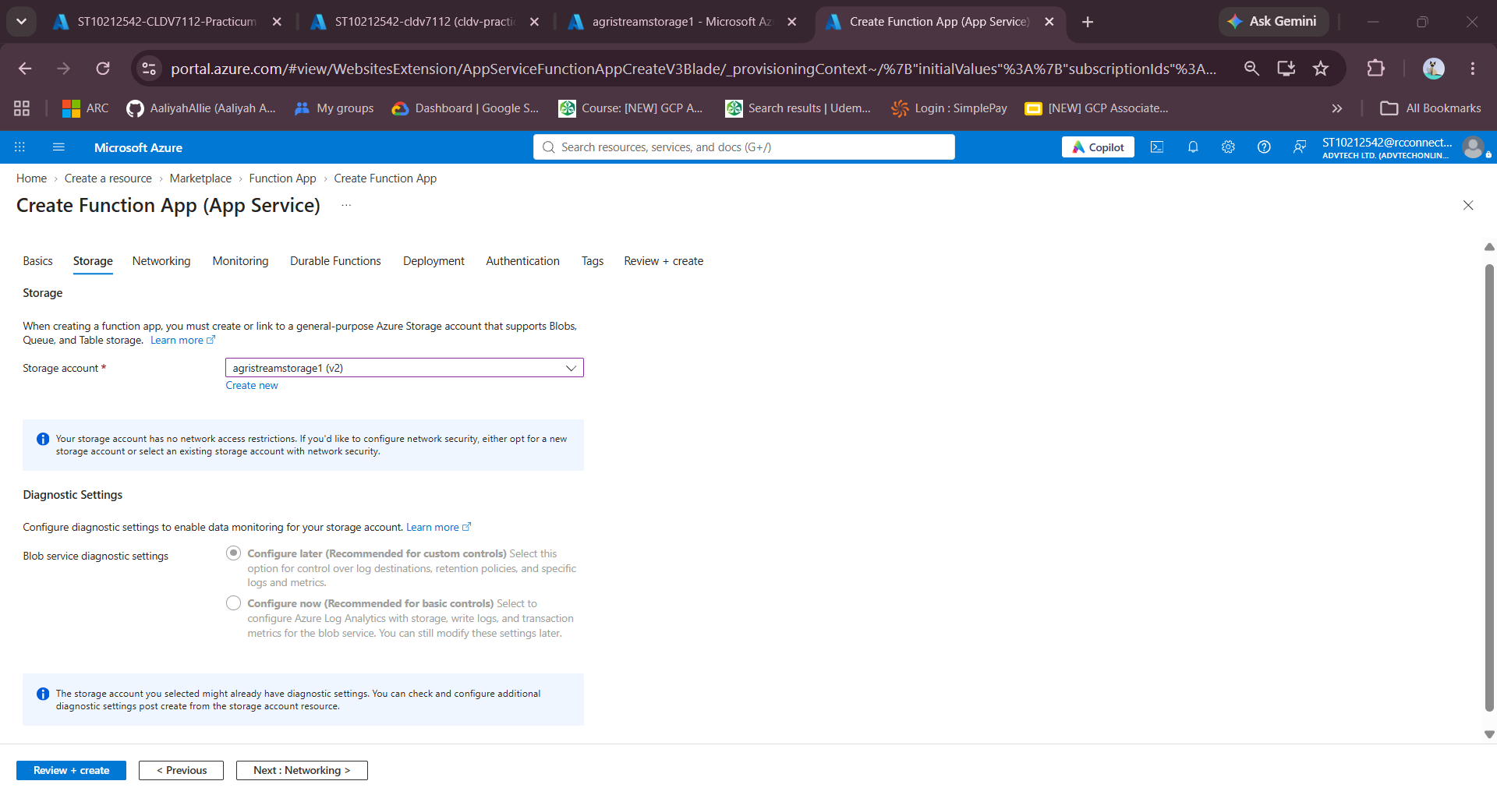
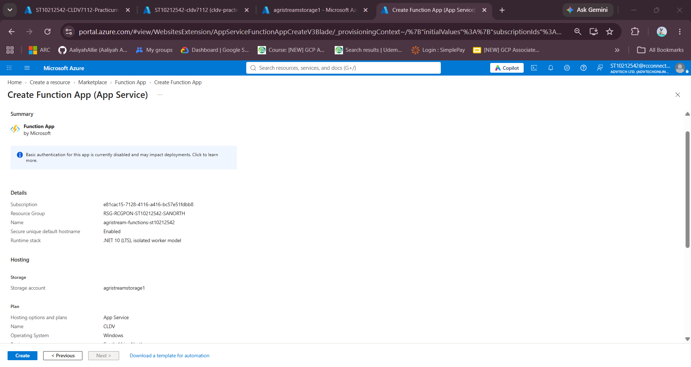
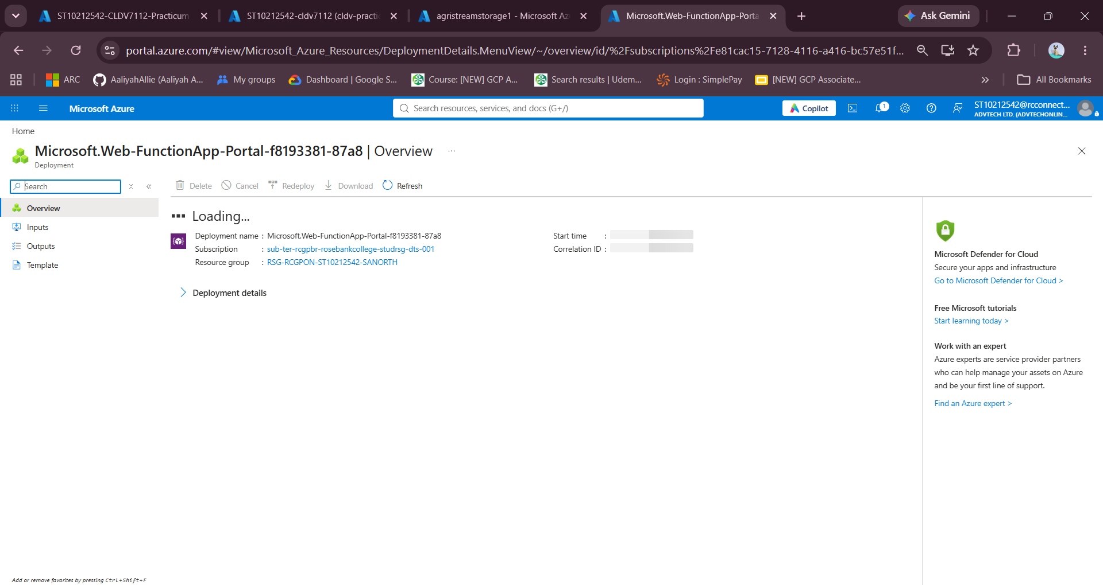
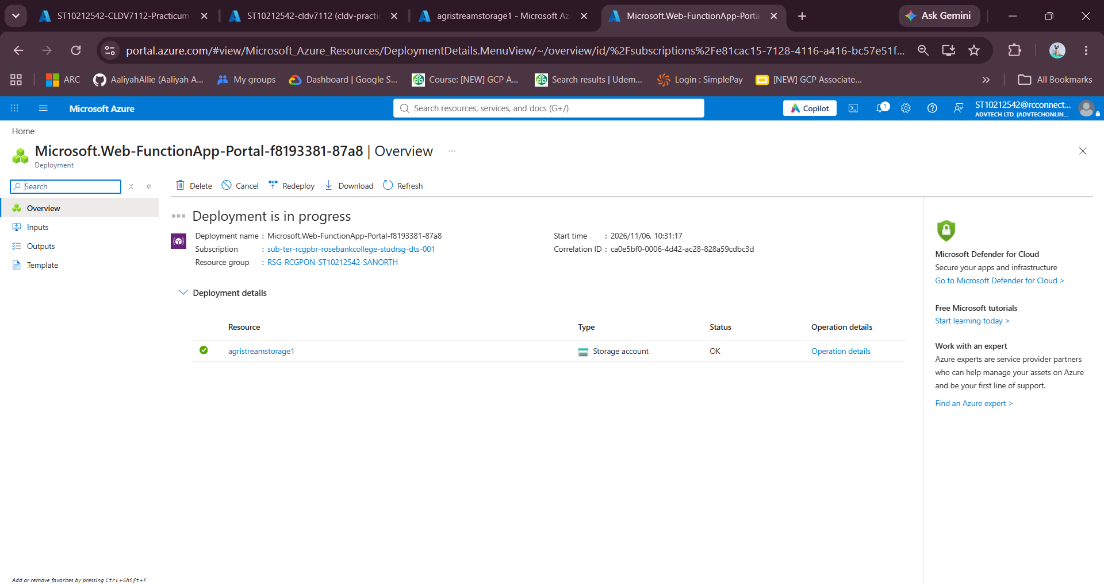
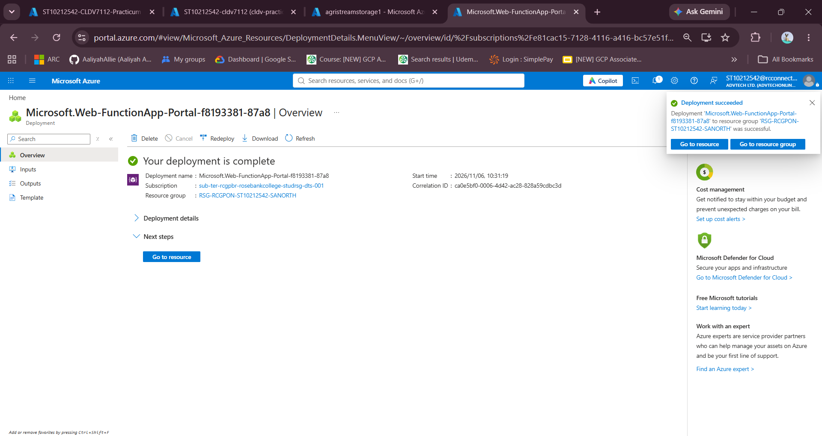
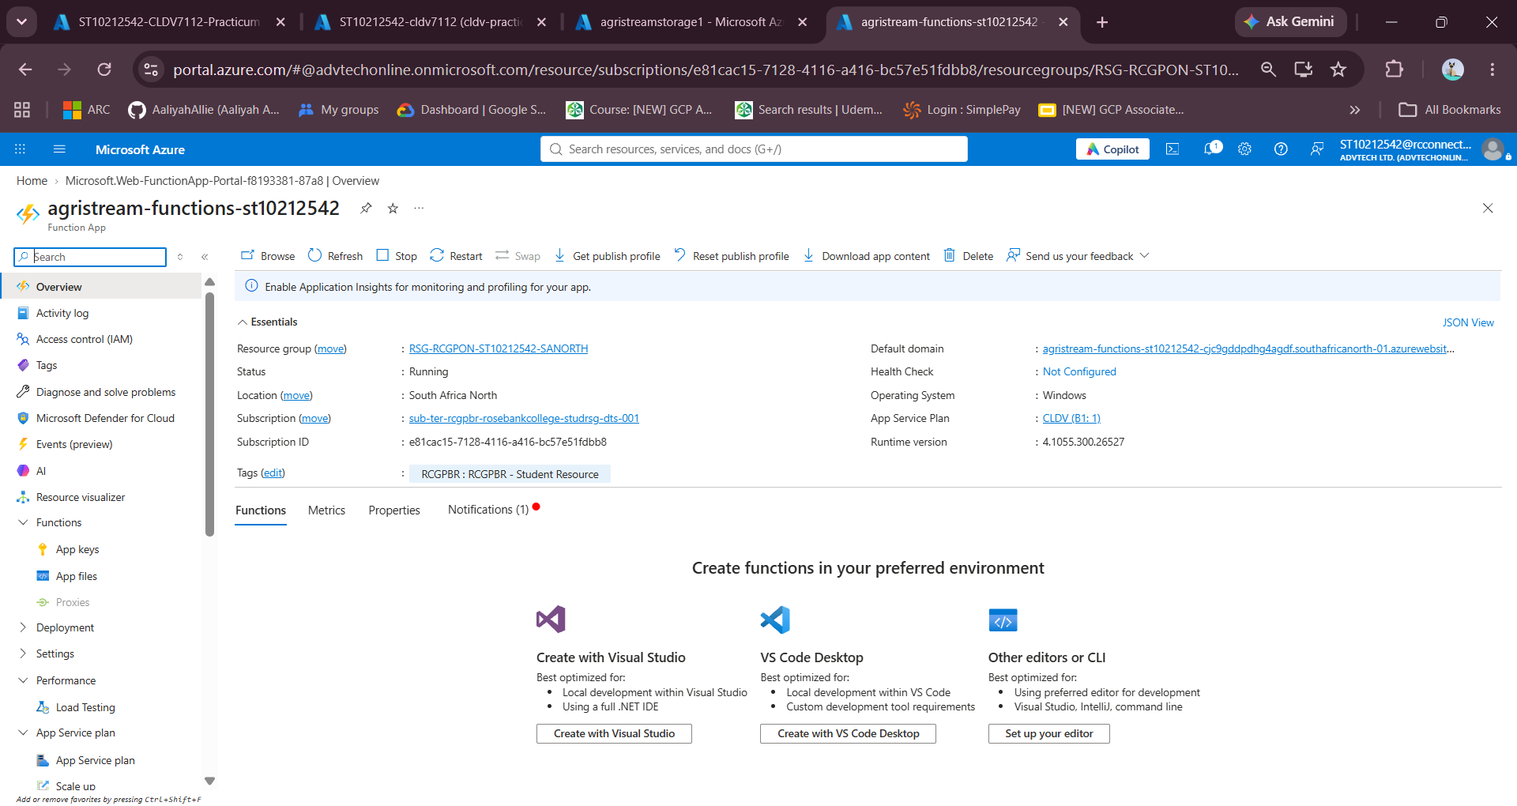
Function Name | Trigger Type | Direction / Binding | Operational Responsibility
GetLatestTelemetry | HTTP Trigger (GET /api/telemetry) | Input: Azure Table Storage | Fetches recent soil moisture and temperature readings for UI dashboards.
TriggerIrrigationPost | HTTP Trigger (POST /api/irrigation/trigger) | Output: Azure Queue (irrigation-queue) | Enqueues valve activation commands asynchronously without blocking the user.
ProcessIrrigationQueue | Queue Trigger (irrigation-queue) | Input/Output: Azure Storage Queue | Dequeues commands, simulates physical valve actuation and logs operational records.
ProcessDroneImageBlob | Blob Trigger (agristreamblob/{name}) | Input: Azure Blob Storage | Automatically runs when new images are uploaded to extract resolution metadata.

e) Load Testing:
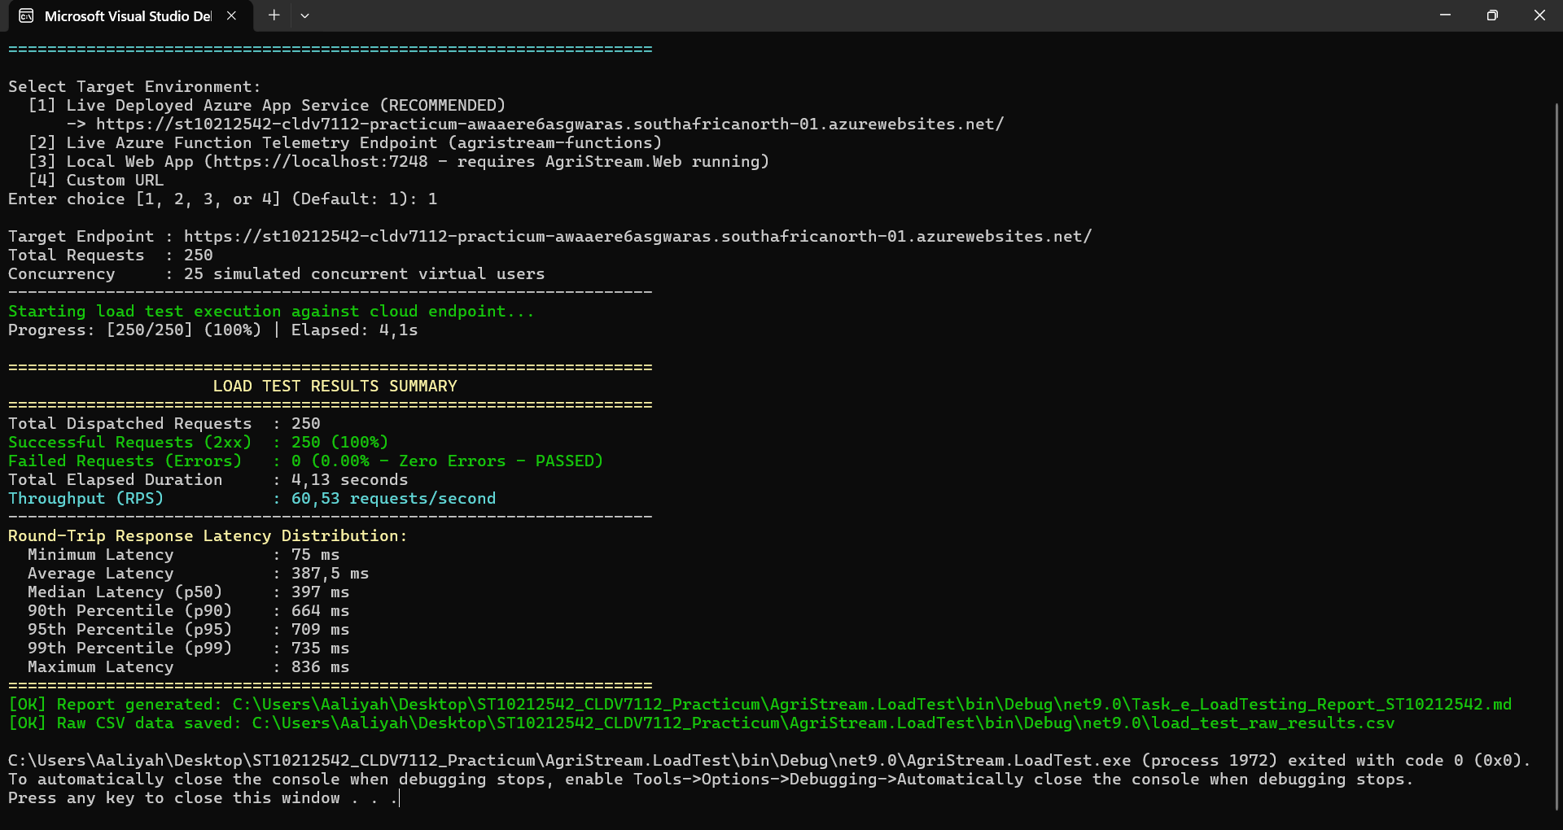
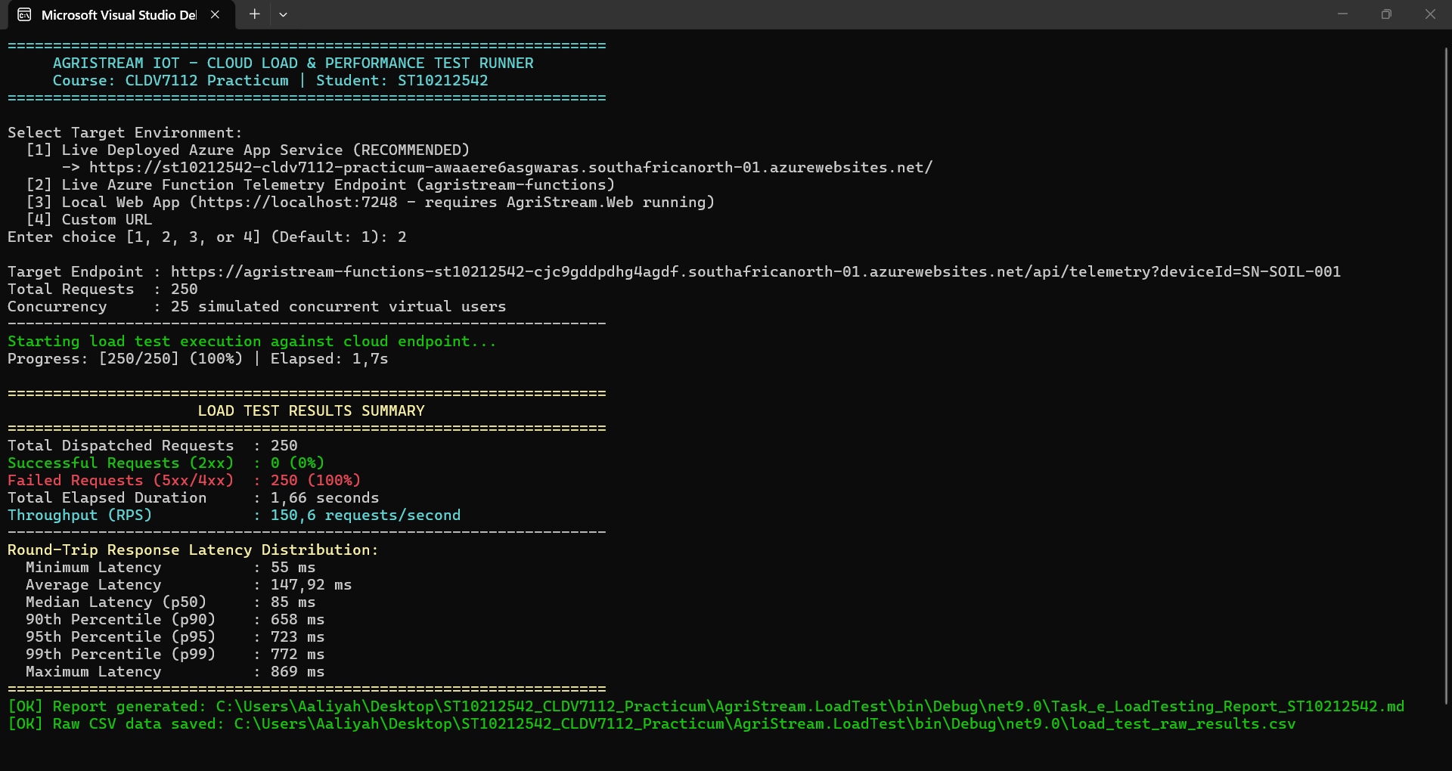
The AgriStream application was tested locally and on the live Azure deployment using 250 HTTP requests and 25 concurrent users. The initial local test failed because the application was not running on localhost, resulting in 100% connection failures. However, the live Azure test achieved a 100% success rate with zero errors, an average response time of 387.5 ms and a throughput of 60.53 requests per second. The results met all practicum performance targets, including the 500 ms average response-time requirement, demonstrating that the application performs reliably under simulated user traffic and is ready for cloud deployment.

f) Monitoring:
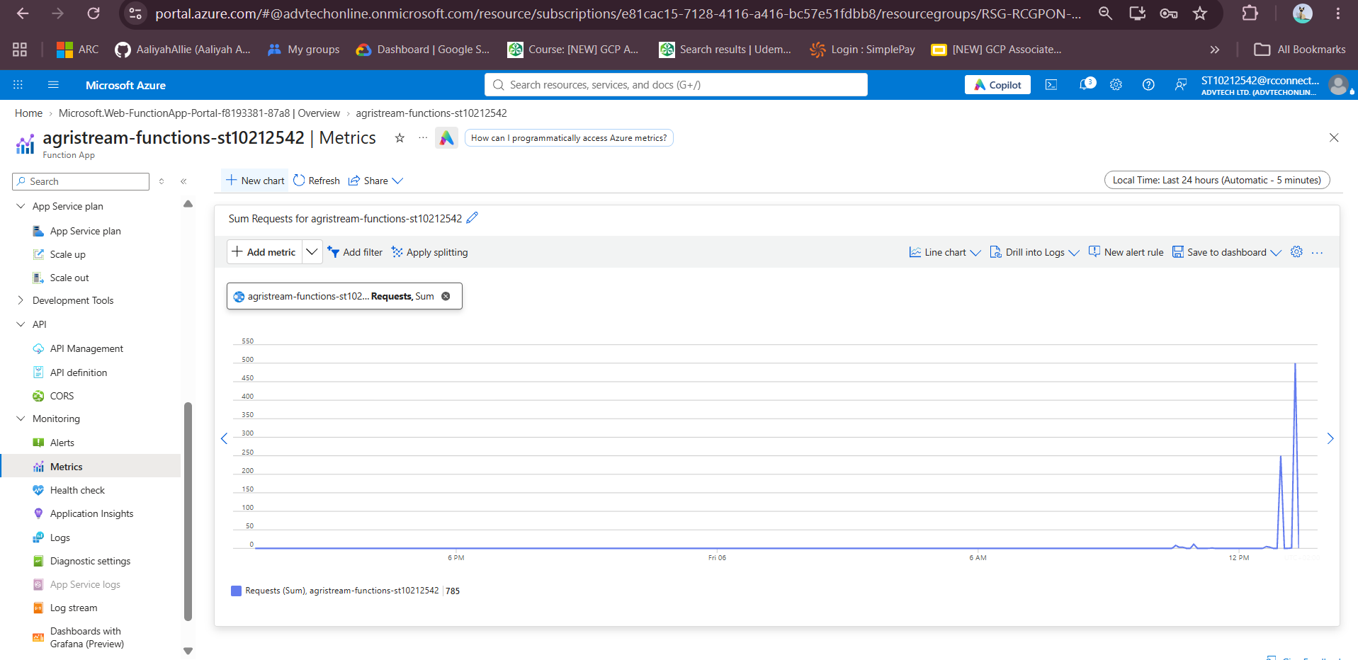
Azure Monitor was configured to track important application metrics, including incoming requests, CPU usage, average response time and HTTP 5xx errors. The Function App metrics recorded a peak of 785 requests at 12:45 PM UTC, corresponding to the load tests and confirming that Azure Monitor successfully tracks increases in application traffic. However, the student Azure subscription has restricted permissions, preventing the creation of automated alert rules and Action Groups. These features were therefore documented as part of the proposed production architecture for future monitoring and notifications.

g) Auto-Scaling:
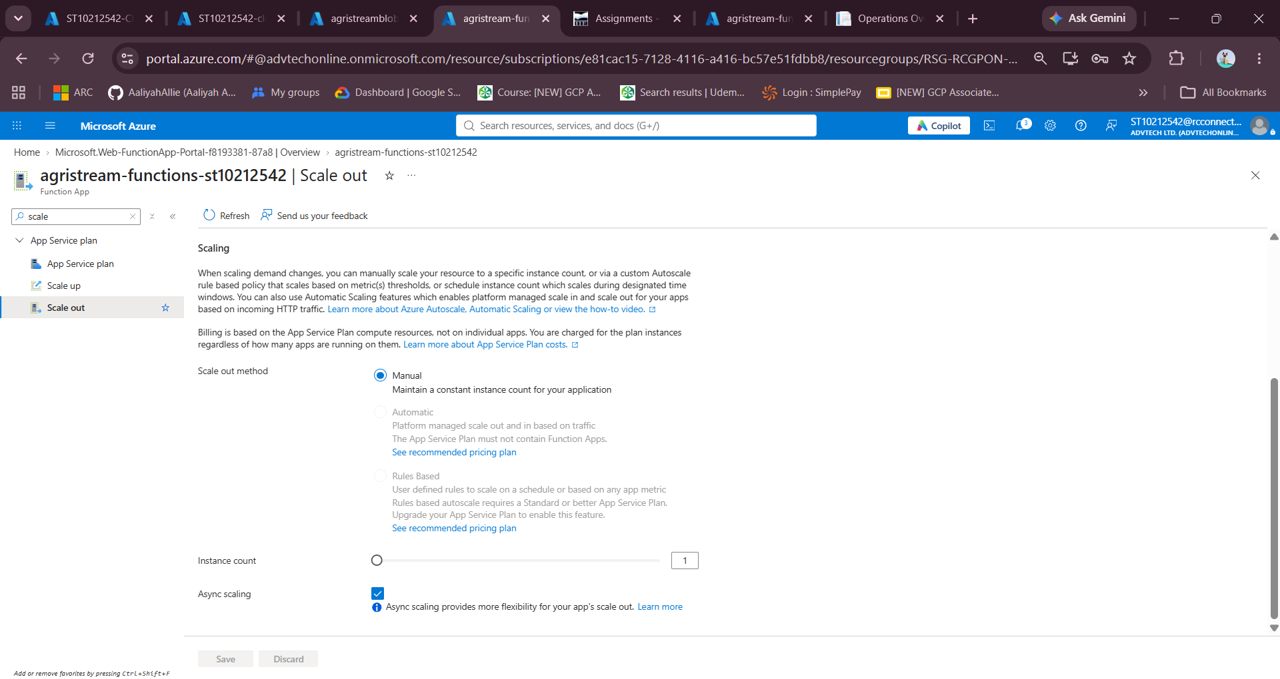
Due to restrictions on the institution's Azure subscription, only Basic and Shared App Service plans were available, so the application was deployed using the Basic B1 plan. Since this tier does not support built-in autoscaling rules, the following configuration explains how autoscaling would be set up using a Standard S1 or higher plan in a production environment.
Whoever if one were to carry this out it would be as follows:
Proposed Autoscaling Configuration
In a production environment, the App Service Plan would be configured to adjust automatically based on application traffic. The proposed settings would work as follows:
- When traffic increases: If CPU usage remains above 70% for five minutes, Azure adds another instance to handle the additional workload.
- When traffic decreases: If CPU usage stays below 30% for ten minutes, Azure removes one instance to reduce unnecessary resource usage.
- Instance limits: The application starts with one instance and can scale up to a maximum of five instances. It will never scale below one instance.
The 70% CPU threshold allows the application to scale before performance is affected, while the 30% threshold prevents instances from being removed too quickly. The waiting periods also help avoid unnecessary scaling caused by temporary changes in traffic.
This would provide a flexible way to manage increased farming activity while keeping hosting costs under control.

Links

Deployed Website Link:
https://st10212542-cldv7112-practicum-awaaere6asgwaras.southafricanorth-01.azurewebsites.net/

GitHub Repo Link:

Frontend of System Screenshots:

Admin
Homepage:
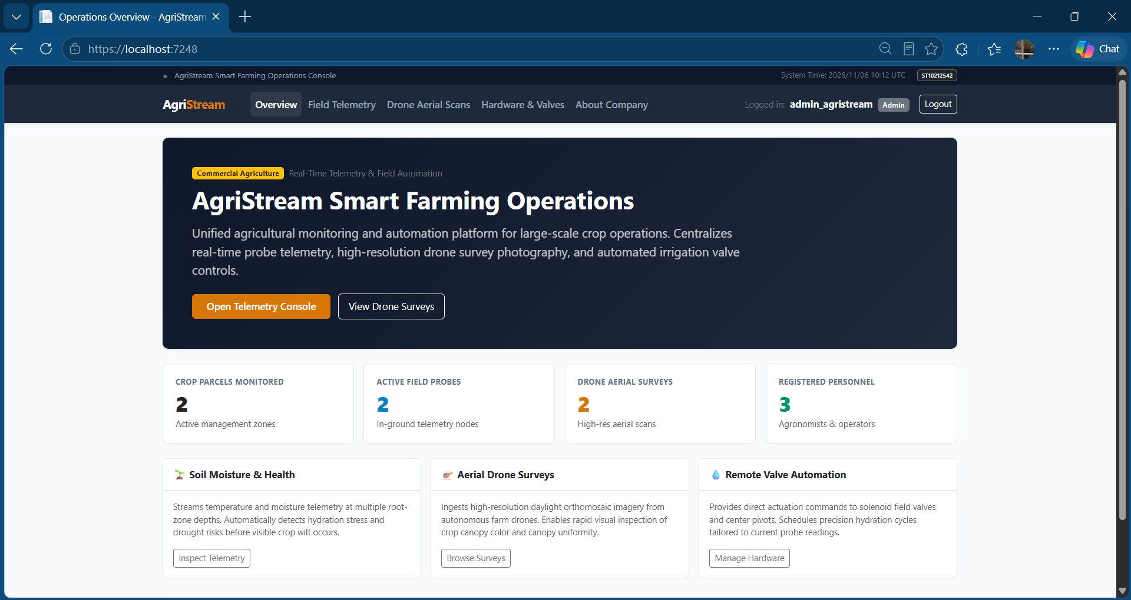
Field Telemetry:
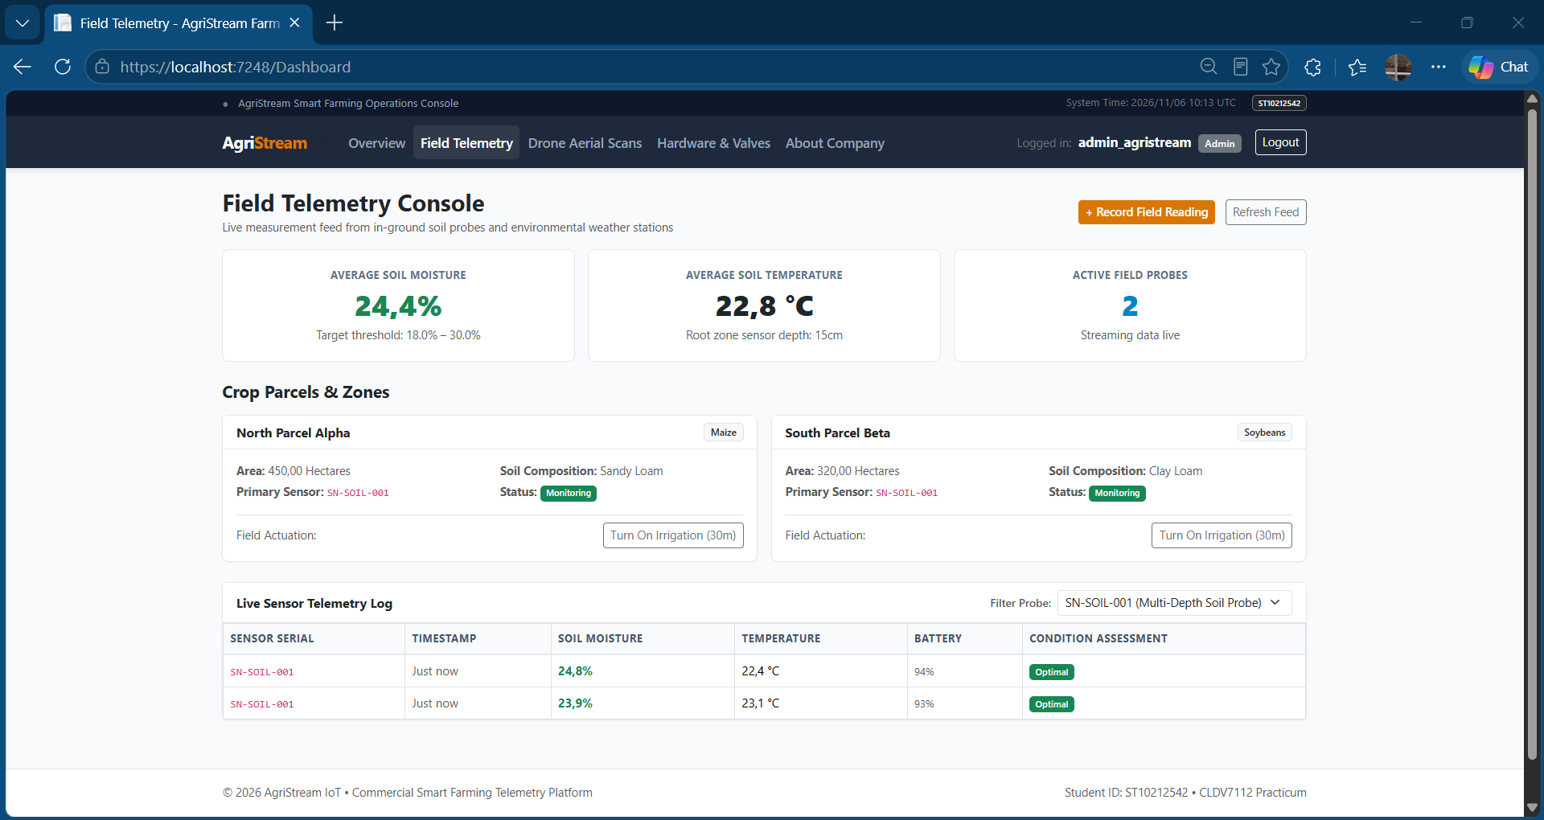
Drone Ariel Scans:
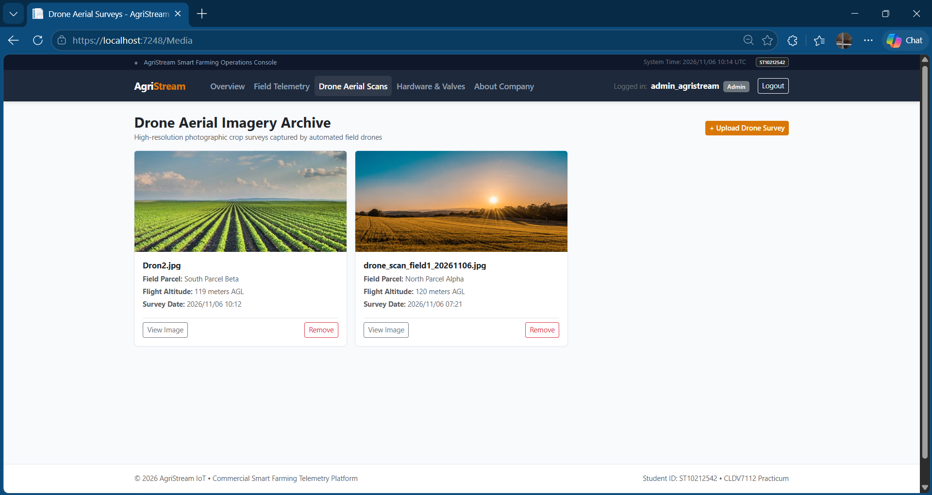
Hardware and Valves:
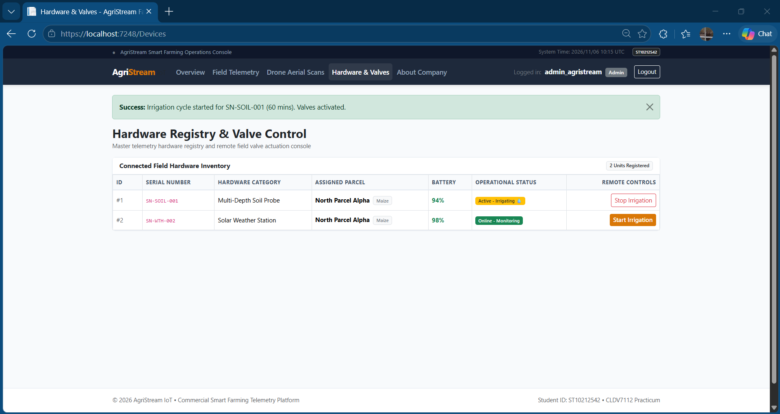

Farmer
Home Page:
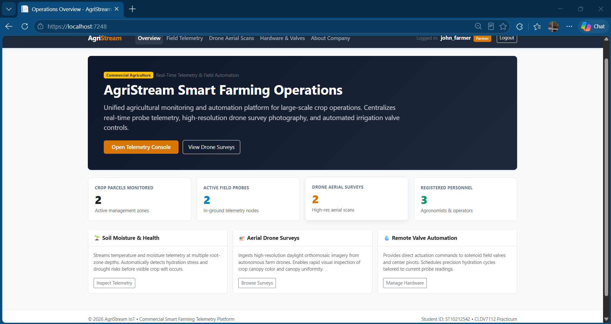
Field Telemetry:
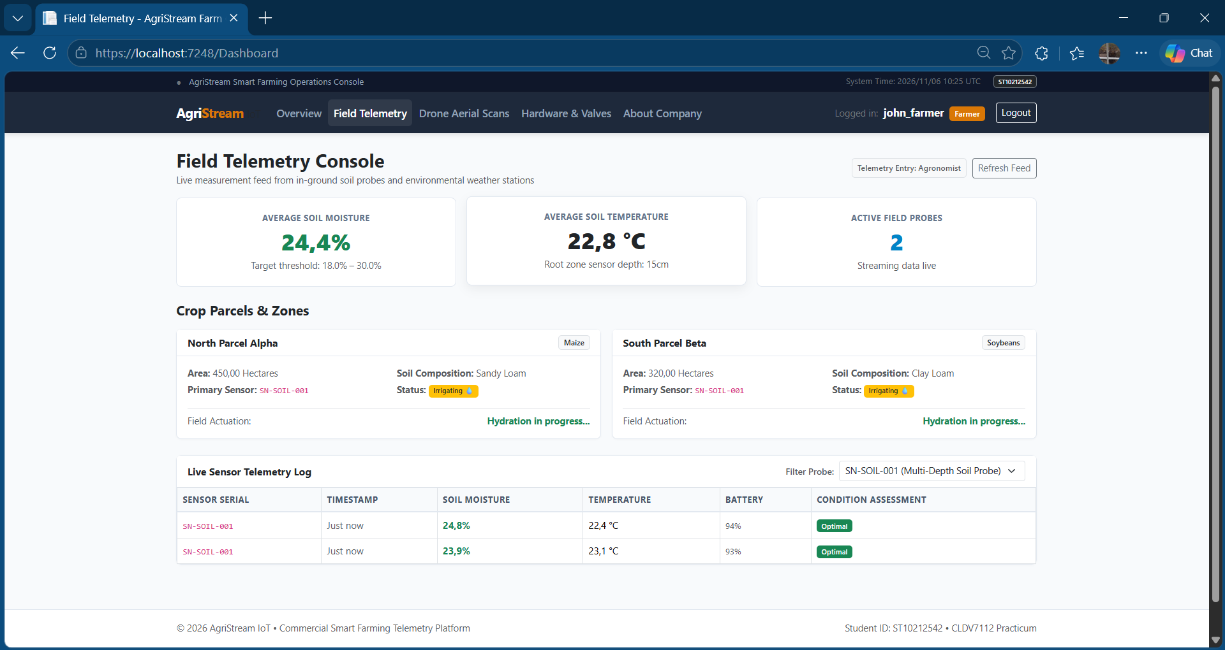
Drone Ariel Scans:
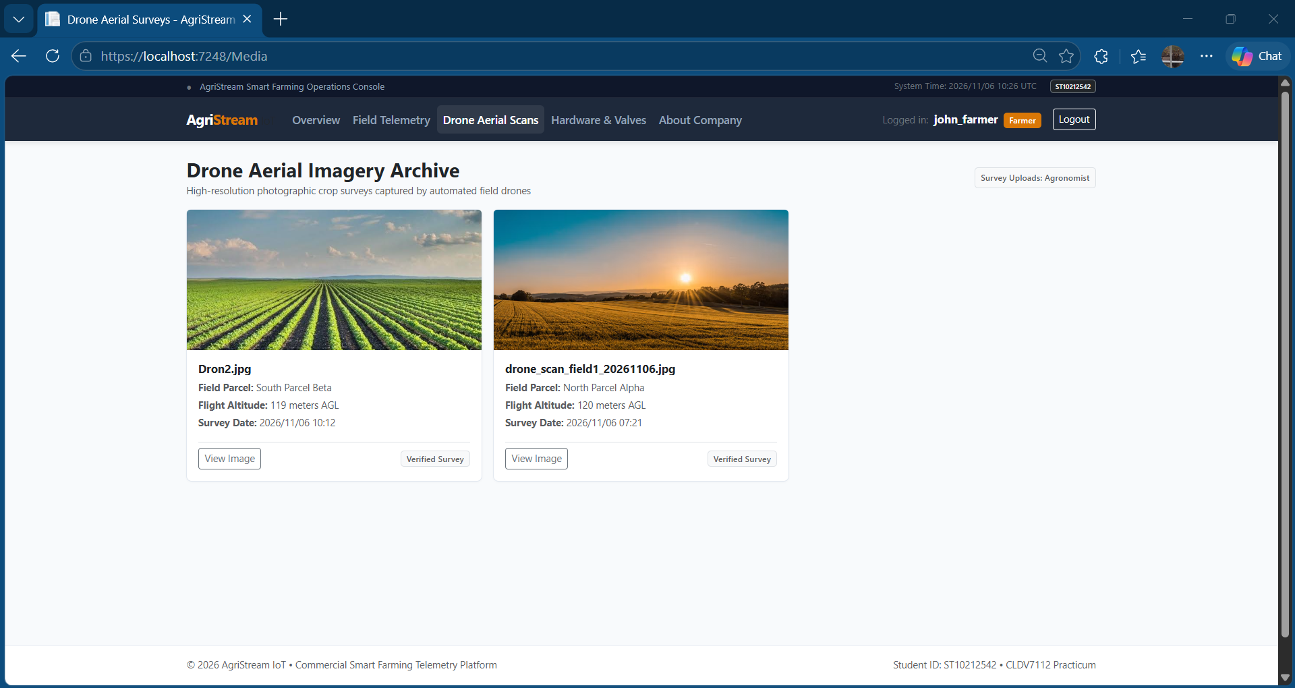
Hardware & Valves:
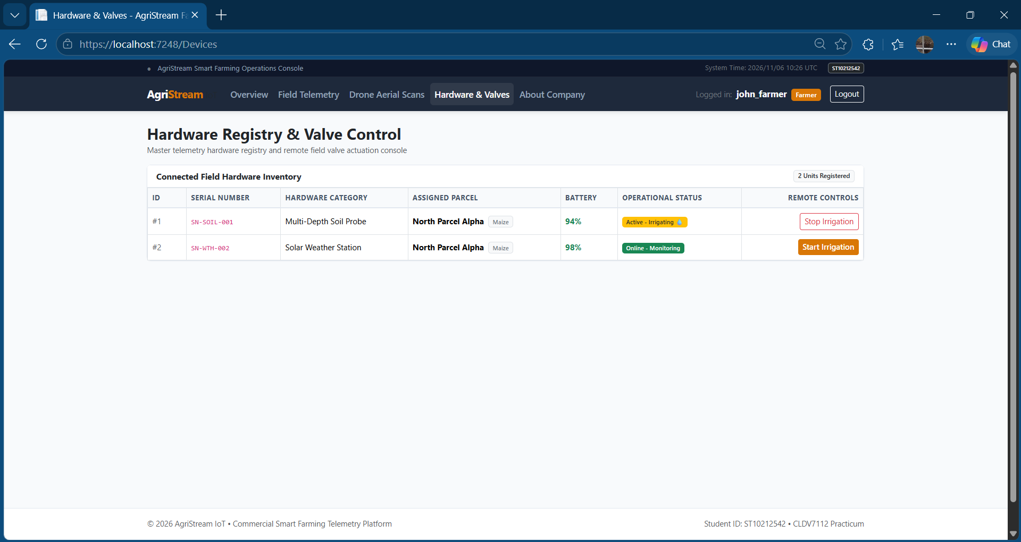

Agronomist:
Home Page:
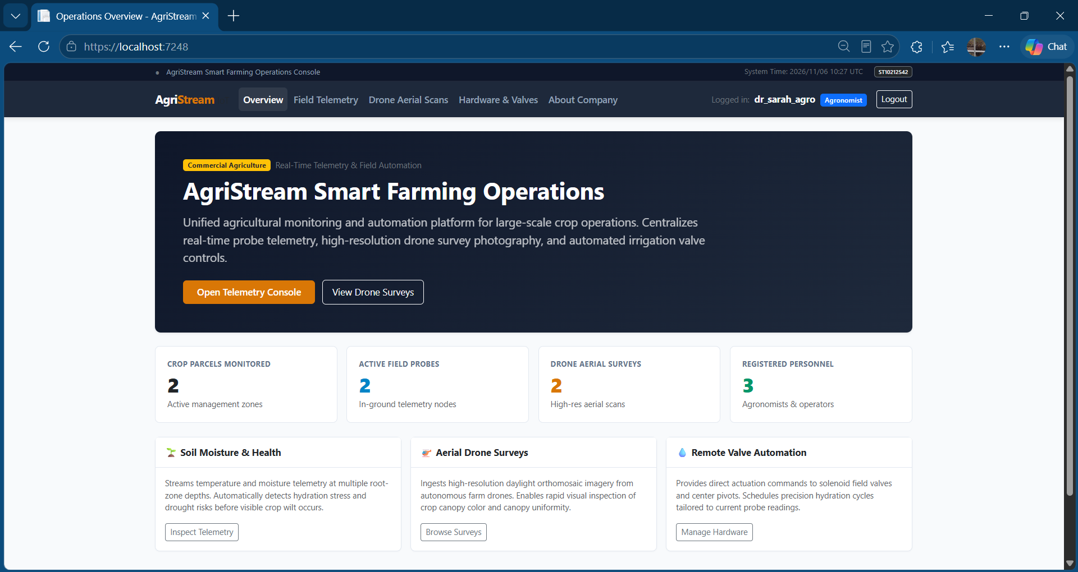
Field Telemetry:
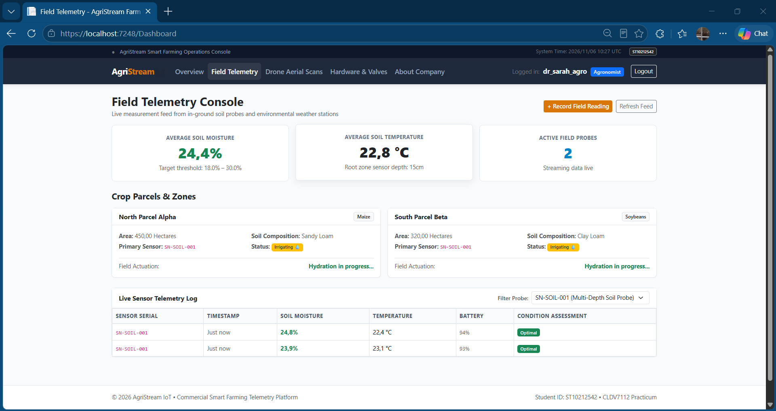
Drone Ariel Scans:
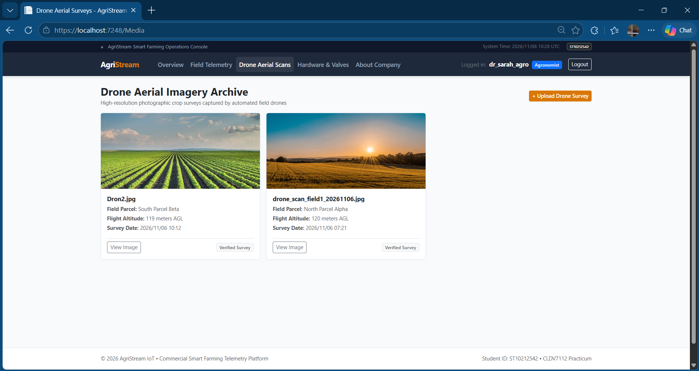
Hardware & Valves:
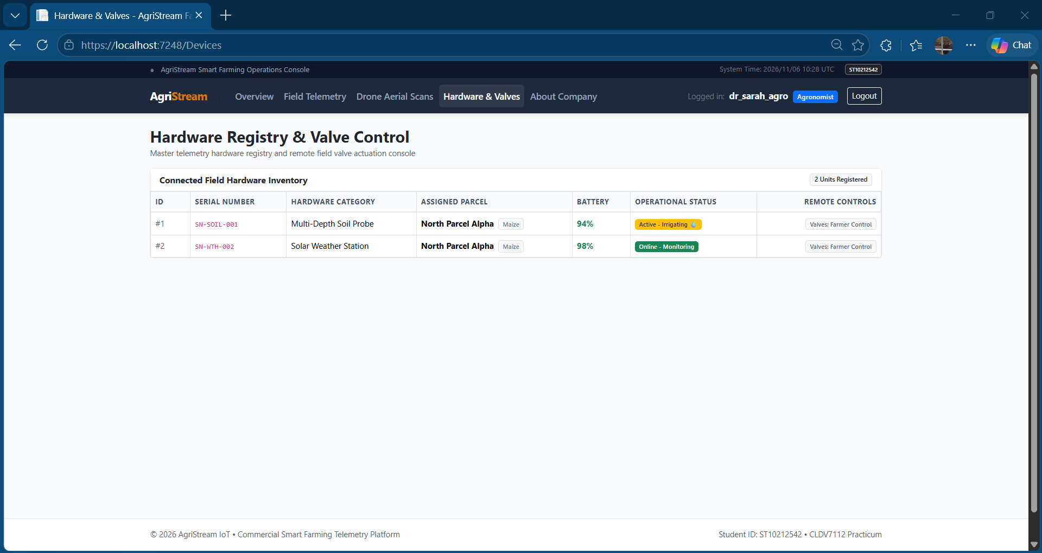

Codebase of System:

Folder Structure:
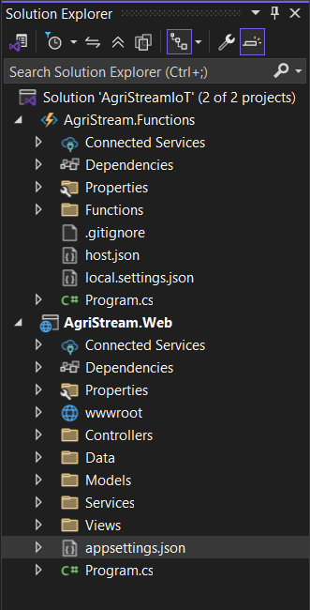

Connections to Azure:
Connection strings to allow the code to communicate to azure.
Functions:
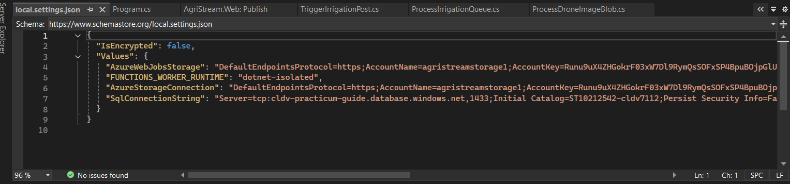
Web App:
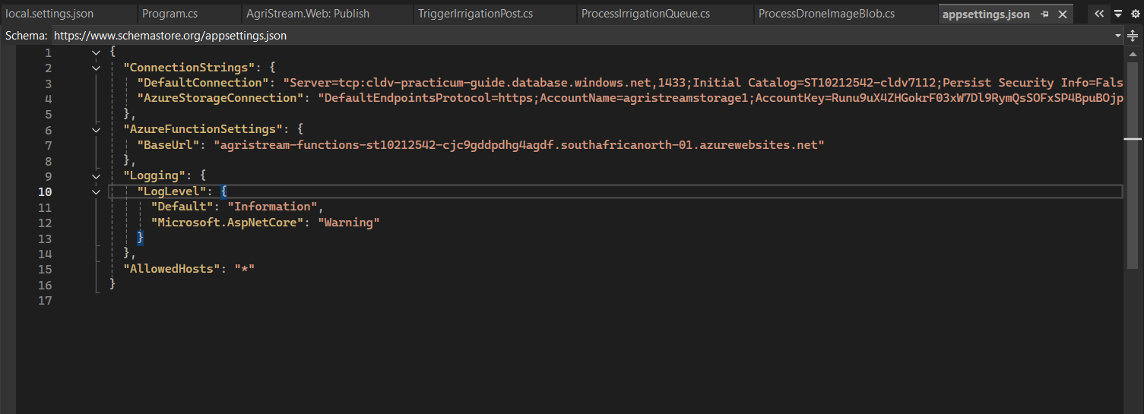

Publishing to Azure Web App from Visual Studio:
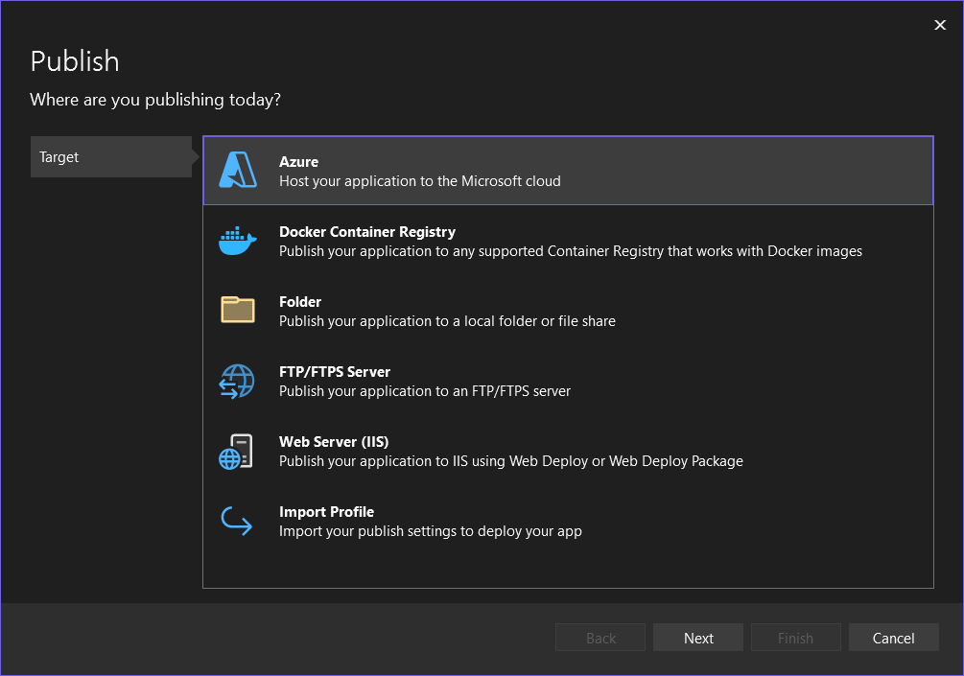
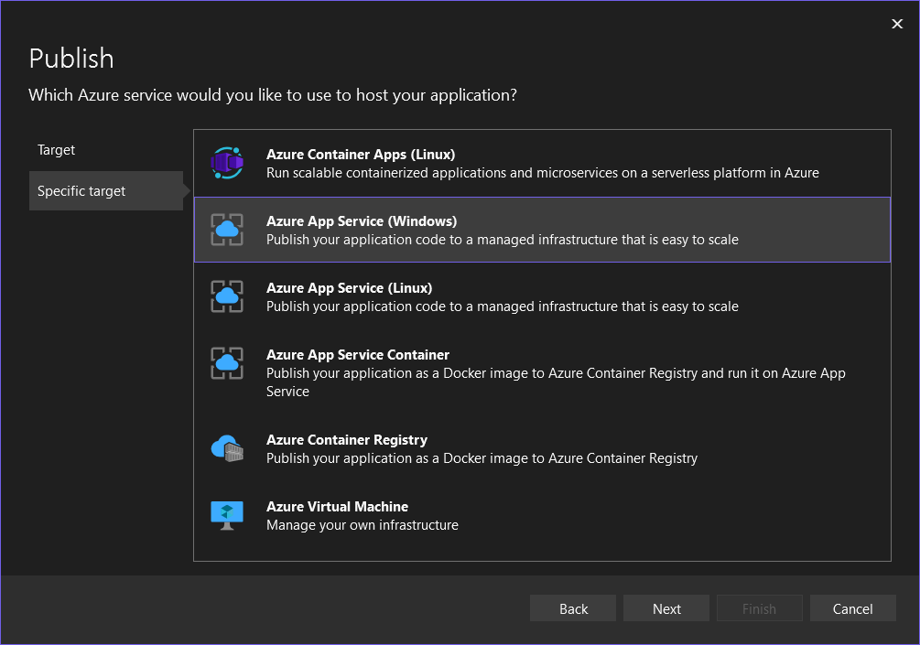
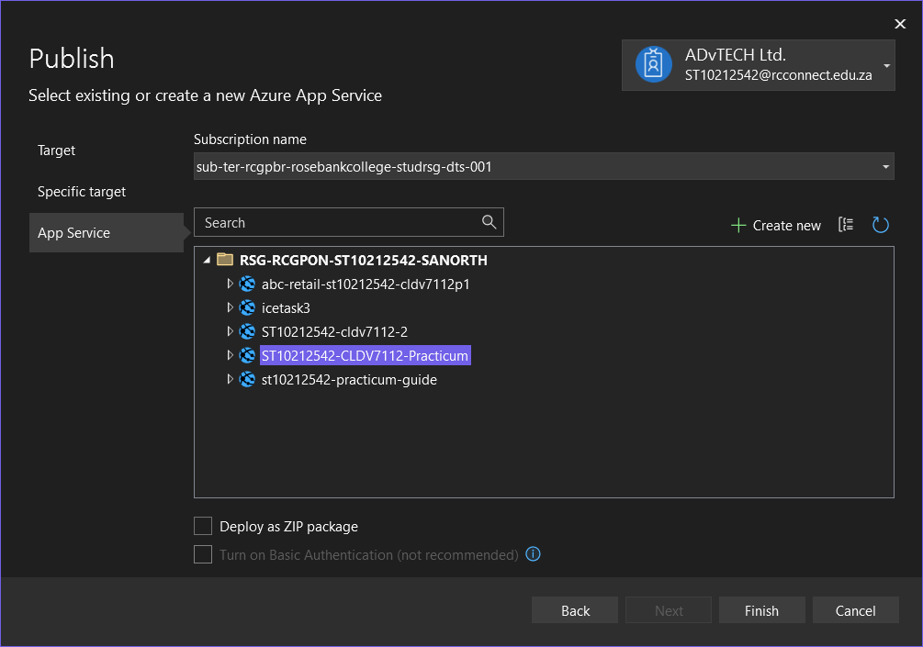
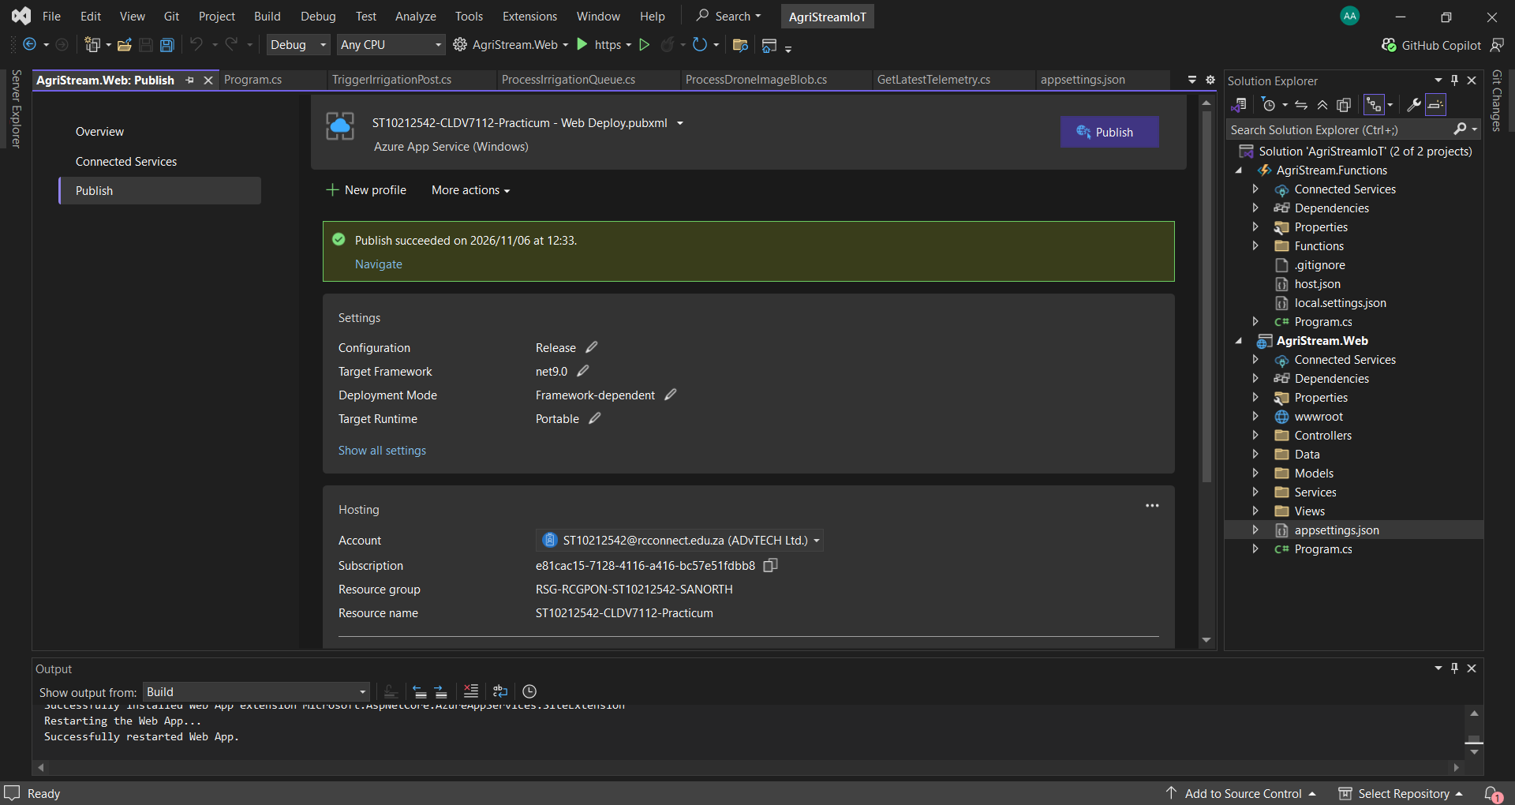
Link to deployed website: https://st10212542-cldv7112-practicum-awaaere6asgwaras.southafricanorth-01.azurewebsites.net/

B. Theory Questions

Disaster Recovery & Redundancy:
Azure offers storage redundancy options to keep data safe in case of hardware failures or unexpected disasters. Two of these options are Redundant Storage (LRS) and Geo-Redundant Storage (GRS) (Microsoft, 2026).
Comparison table for LRS and GRS in Azure:
Comparison | Locally Redundant Storage (LRS) | Geo-Redundant Storage (GRS)
Data storage | Keeps three copies of data in one physical data centre (Microsoft, 2026). | Keeps three copies in the primary region and replicates them to a secondary geographical region (Microsoft, 2026).
Disaster protection | Protects against hardware failures but does not protect against a complete regional disaster (Microsoft, 2026). | Protects against hardware failures and regional disasters by keeping copies in another region (Microsoft, 2026).
Cost | Cheaper storage option because data is stored within one region (Microsoft, 2026). | More expensive because data is replicated across geographical regions (Microsoft, 2026).
Historical crop harvest records | Not recommended because a major disaster could result in permanent data loss. | Most suitable because historical harvest records are important and need to be protected for future reference.
Temporary sensor logs | Most suitable because temporary logs can be collected again if lost, making the cheaper option more practical. | Not necessary because these logs do not require the same level of protection.
For the purpose of storing critical historical crop harvest records GRS would be the best pick because it provides additional protection if an entire region becomes unavailable., and when it comes to temporary sensor logs LRS is the best pick, because they can be regenerated, helping to reduce storage costs.

Stateless vs. Stateful Architecture:
A stateful application remembers previous user interactions, while a stateless application treats each request independently without relying on information stored on a previous request (GeeksforGeeks, 2026).
It is important to keep Azure App Services and Azure Functions stateless because it makes horizontal scaling easier. When more users access an application Azure can add instances to handle the extra requests. Since each instance works independently requests can be handled by any server without depending on previous sessions(CloudWebSchool,2026)
Storing session data or files locally on a web server can cause problems when scaling out. For example, if a user’s session is stored on Server A but their next request goes to Server B, the session information may not be available. This can cause users to lose their sessions or uploaded files. To avoid this session data should be stored in shared storage such as Azure Cache, for Redis while files should be stored in Azure Blob Storage (CloudWebSchool,2026).

Serverless Triggers and Bindings:
Azure Functions uses triggers and bindings to run functions and connect them to other services without needing to write all the connection code manually (Microsoft, 2026).
Type | Definition | Purpose
Triggers | A trigger is an event that causes an Azure Function to run. Each function must have exactly one trigger. | Determines when a function should execute. For example, an HTTP trigger runs when a user sends a request, while a timer trigger runs at a scheduled time.
Input Bindings | Input bindings allow a function to retrieve data from external services, such as Azure Blob Storage or databases. | Provides the function with the information it needs to process. For example, retrieving crop sensor data from Azure Blob Storage.
Output Bindings | Output bindings allow a function to send or save data to external services without having to write the connection logic manually. | Allows the function to store or send processed information. For example, saving updated crop records to Azure Cosmos DB or sending a message to Azure Queue Storage.
(GeeksforGeeks, 2024; Microsoft, 2026).
Triggers decide when an Azure Function starts. Input bindings give the Azure Function the data it needs. Output bindings let the Azure Function send or store the results. These features help me connect Azure services and create serverless applications.

References
CloudWebSchool (n.d.) Stateless vs Stateful Services in Azure. Available at: https://cloudwebschool.com/docs/azure/architecture-and-best-practices/stateless-vs-stateful-services/ (Accessed: 6 November 2026).
GeeksforGeeks (2024) Azure Functions Triggers and Bindings: A Deep Dive. Available at: https://www.geeksforgeeks.org/devops/azure-functions-triggers-and-bindings/ (Accessed: 6 November 2026).
GeeksforGeeks (2026) Stateful Vs Stateless Architecture. Available at: https://www.geeksforgeeks.org/system-design/stateful-vs-stateless-architecture/ (Accessed: 6 November 2026).
Microsoft (n.d.) Azure Functions triggers and bindings. Microsoft Learn. Available at: https://learn.microsoft.com/en-us/azure/azure-functions/functions-triggers-bindings (Accessed: 6 November 2026).
Microsoft (n.d.) Azure Storage redundancy. Microsoft Learn. Available at: https://learn.microsoft.com/en-us/azure/storage/common/storage-redundancy (Accessed: 6 November 2026).

