

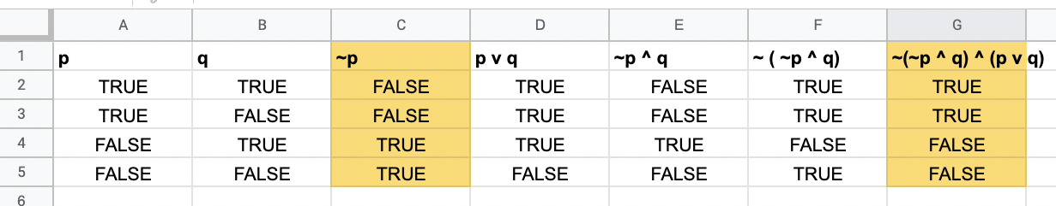



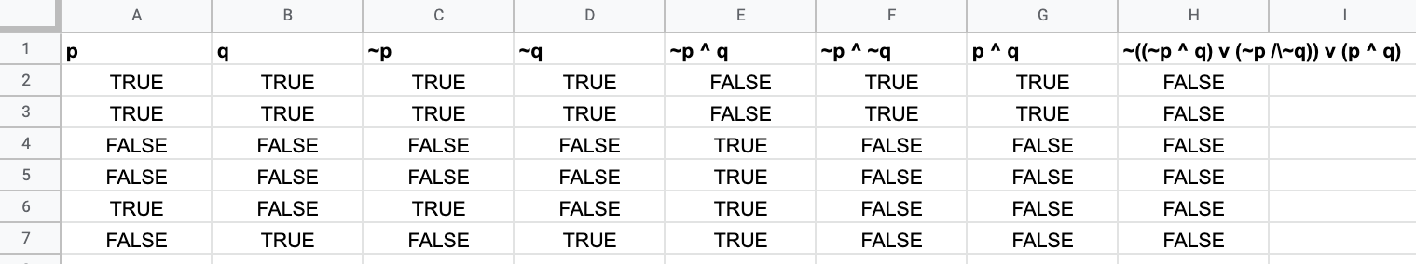

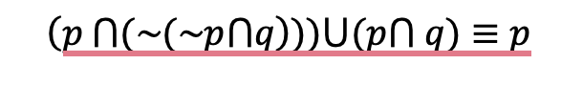

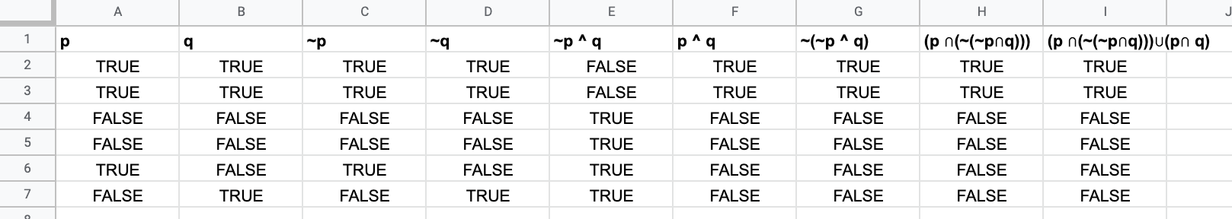

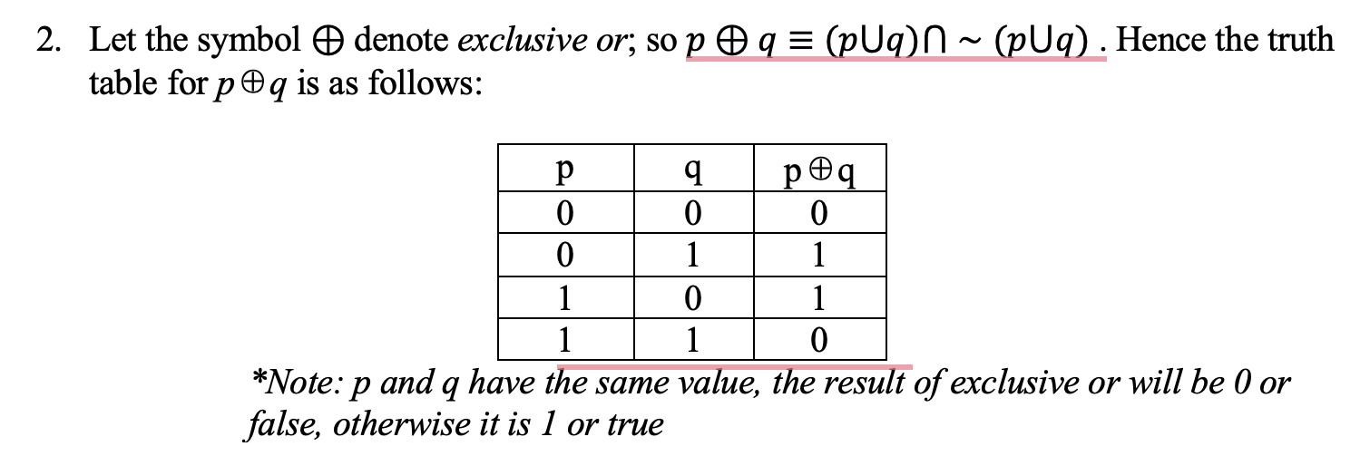







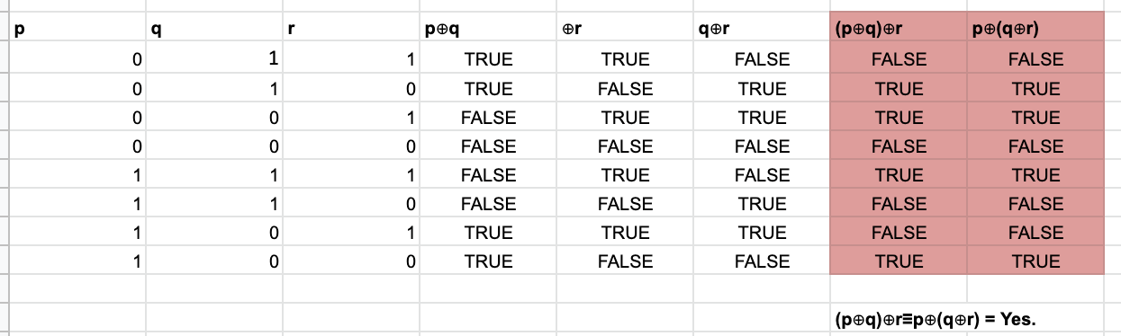



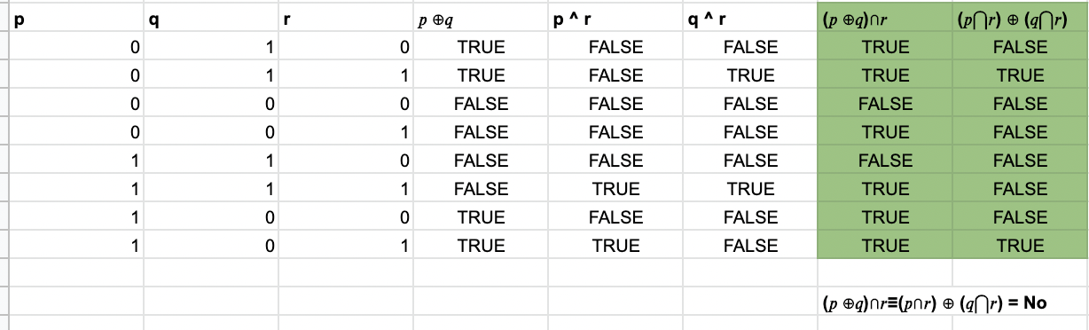

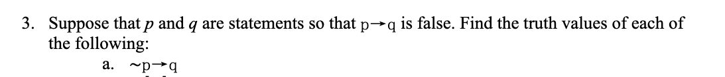

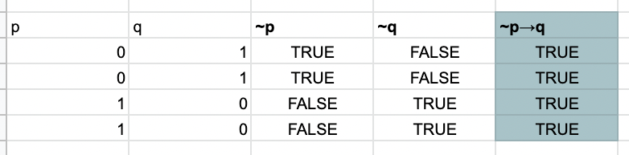

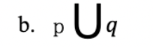

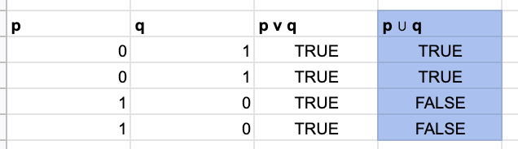



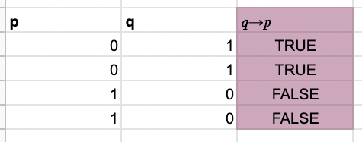

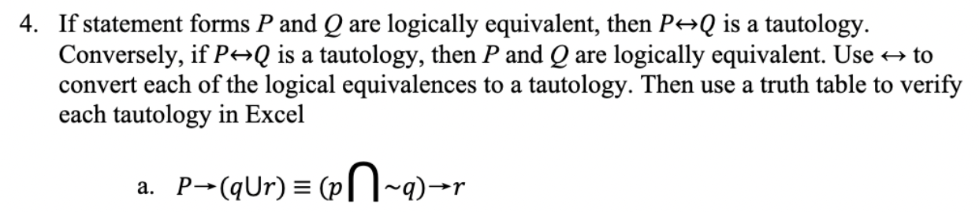

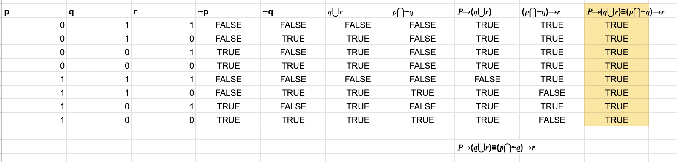

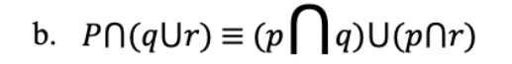

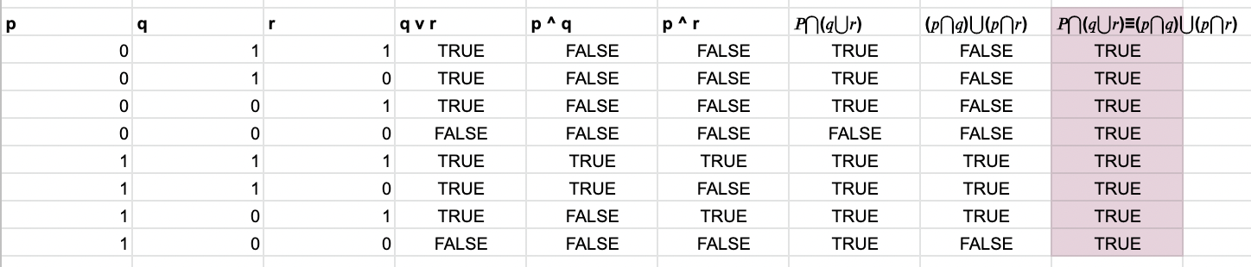



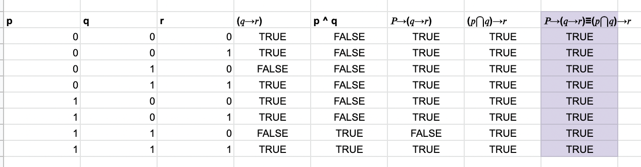

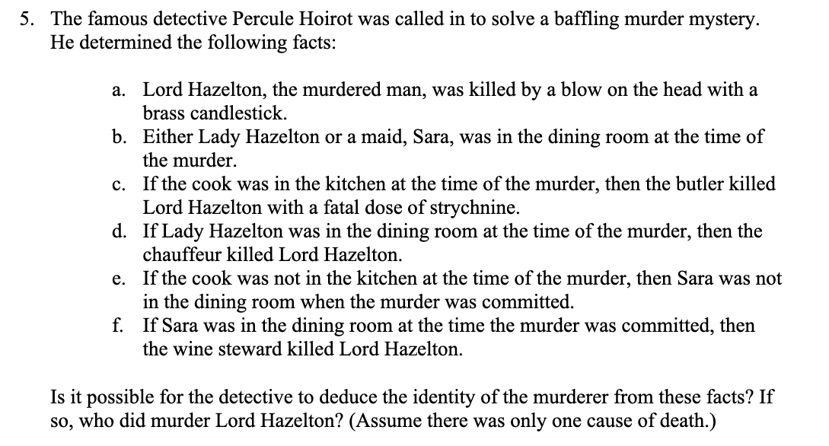

1. D -> E   
   ~ E  
   ∴ ~D  
     
   **Explaination:** If the cook was in the kitchen at the time of the murder, then the butler killed Lord Hazelton with a fatal doze of Strychine. So, Lord Hazelton wasn’t killed with the fatal doze. He was, in fact, killed with a blow to the head. Therefore, the butler didn’t kill Lord Hazelton and the cook wasn’t in the kitchen at the time of the murder.
2. ~D -> ~C  
   ~D  
   ∴ ~C  
     
   **Explaination**: If the cook wasn’t in the kitchen at the time of the murder, then the maid Sara wasn’t in the dining room at the time of the murder. Therefore, the maid Sara wasn’t in the dining room at the time of the murder.
3. B v C  
   ~ C  
   ∴ B  
     
   **Explaination**: Either Lady Hazelton or maid Sara was in the dining room at the time of the murder. Maid Sara wasn’t in the dining room at the time of murder. Therefore, Lady Hazelton was in the room at the time of the murder.

1. B -> G  
   B  
   ∴ G  
     
   **Explaination**: If Lady hazelton was in the dining room at the time of the murder, then the chauffeur killed Lord Hazelton. Lady Hazelton was in the dining room at the time of the murder. Therefore, the chauffeur killed Lord Hazelton.