**A: Use the readings to sketch the graph of the BAC as a function of t in Excel.**

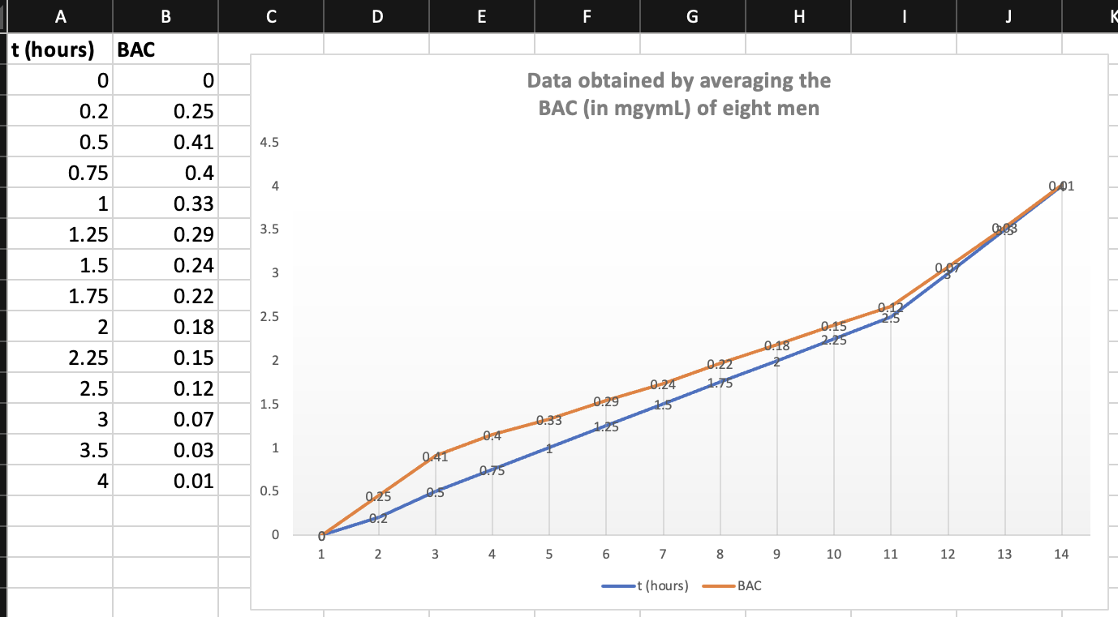

**B: Use your graph to describe how the effect of alcohol varies with time.**

The graph clearly shows that the BAC initially increases after consuming alcohol, but it gradually decreases over time. The BAC values indicate the concentration of alcohol in the bloodstream, typically measured as a percentage. Moreover, as time passes, the body metabolises and eliminates the alcohol, thus leading to decreased BAC.

******************************************************************************



The top half is given by the function f(x) =

**Code to sketch the graph:**

import numpy as np

import matplotlib.pyplot as plt

***#We will calculate the tange of x values***

x = np.linspace(-2, 2, 100)

***#We will calculate the y values for the positive sign***

y1 = 2 + np.sqrt(4 - x**2)

***#We will calculate the y values for the negative sign***

y2 = 2 - np.sqrt(4 - x**2)

plt.plot(x, y1, label='y = 2 + sqrt(4 - x^2)')

plt.plot(x, y2, label='y = 2 - sqrt(4 - x^2)')

plt.xlabel('x')

plt.ylabel('y')

plt.title('Graph of the top half of the circle')

plt.legend()

plt.grid(True)

plt.show()

******************************************************************************

1. A screenshot of a spreadsheet

   Description automatically generated with medium confidence
2. On $14,000, the tax is assessed on $4000, and 10%($4000) = $400.  
   On $26,000, the tax is assessed on $16,000 and 10%($10,000) + 15%($6000) = $1000 + $900 = $1900.
3. As in part (b), there is $1000 tax assessed on $20,000 of income, so the graph of Τ is a line segment from (10,000; 0) to (20,000; 1000). The tax on $30,000 is $2500, so the graph of Τ for is the ray with initial point (20,000; 1000) that passes through (30,000; 2500)

******************************************************************************

1. Since the data appears to be increasing exponentially. A model of the form or is appropriate.

1. The data may exhibit fluctuations or noise, making identifying the underlying trend or pattern challenging. In such cases, a moving average can help smoothen the data and make the trend more apparent. The model would be: Moving Average = (Sum of Data Points in Window) / (Number of Data Points in Window).

Calculating a moving average creates a new series of values that represents the average trend over a specified period. This helps filter out the short-term fluctuations and highlights the overall direction or pattern of the data.

******************************************************************************

1. A screenshot of a spreadsheet

   Description automatically generated with medium confidence

Using a computing device, we obtain the regression line

1. When

******************************************************************************

1. **Τ = 1.000 431 227δ 1.499 528 750**

1. **A screenshot of a table

   Description automatically generated with low confidence**
2. The power model in part (a) is approximately . So squaring both sides gives us . When we compare the equation of the power model to Kepler’s Third Law which states that the square of the period is proportional to the cube of the mean distance. So the model matches Kepler’s Third Law, .

************************************************************************

1. **Graph of**

1. **Graph of**

******************************************************************************

1. . This value is undefined because there is no point on the graph that has -coordinate 6.
2. −2) =