**San Francisco Bay University**

**MATH201 - Calculus-I**

**Homework Assignment #3**

**Due day: 6/23/2023**

**Instruction:**

1. **Push the answer sheet to Github in word file**
2. **Overdue homework submission could not be accepted.**
3. **Takes academic honesty and integrity seriously (Zero Tolerance of Cheating & Plagiarism)**
4. **If a rock is thrown upward on the planet Mars with a velocity of 10 m/s, its height in meters *t* seconds later is given by $y=10t-1.86t^{2}$**

Formula to find the average velocity: $\frac{change in position}{time elapsed}$

**(a) Find the average velocity over the given time intervals:**

**(i) [1, 2] (ii) [1, 1.5] (iii) [1, 1.1]**

**(iv) [1, 1.01] (v) [1, 1.001]**

1. [1, 2]: = $\frac{\left(10*2-{1.86*2}^{2}\right)-(10*1-{1.86*1}^{2})}{2-1}$ = $\frac{20-1.86*4-10+1.86}{1}=4.42 m/s$
2. [1, 1.5] = $\frac{\left(10*1.5-1.86* {1.5}^{2}\right)-(10*1-1.86* 1^{2})}{1.5-1}=5.35 m/s$
3. [1, 1.1] = $\frac{(10*1.1-1.86*\left(.1^{2}\right)-(10*1-1.86* 1^{2})}{1.1-1}=6.095 m/s$
4. [1, 1.01] = $\frac{\left(10*1.01-1.86* {1.01}^{2}\right)-(10*1-1.86* 1^{2})}{1.01-1}=6.2614 m/s$
5. [1, 1.001] = $\frac{\left(10*1.001-1.86*{1.001}^{2}\right)-(10*1-1.86* 1^{2})}{1.001-1}=6.27814 m/s$

(b) Estimate the instantaneous velocity in Excel when $t=1$

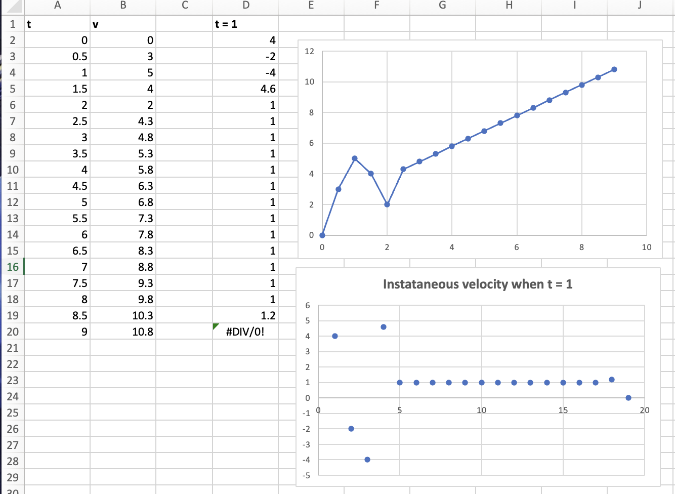

1. The displacement (in centimeters) of a particle moving back and forth along a straight line is given by the equation of motion $s=2\sin\left(πt\right)+3cos⁡(πt)$, where *t* is measured in seconds.

(a) Find the average velocity during each time period:

(i) [1, 2] (ii) [1, 1.1]

(iii) [1, 1.01] (iv) [1, 1.001]

The average velocity in each time period is given by the slope of the line going through two points on the curve of s versus t.

1. [1, 2] : $m= \frac{s\left(2\right)-s(1)}{2-1}=6 \frac{cm}{s}$
2. [1, 1.1] : $m= \frac{s\left(1.1\right)-s(1)}{1.1-1} ≈ -4.71 \frac{cm}{s}$
3. [1, 1.01] : $m= \frac{s\left(1.01\right)-s(1)}{1.01-1} ≈ -6.13 \frac{cm}{s}$
4. [1, 1.001] : $m= \frac{s\left(1.001\right)-s(1)}{1.001-1} ≈ -6.27 \frac{cm}{s}$

(b) Estimate the instantaneous velocity of the particle in Excel when

1. (a) Estimate the value of

$$\lim_{x→0}{\frac{sin⁡(x)}{sin⁡(πx)}}$$

by graphing the function $f\left(x\right)=\frac{\left(\sin{x}\right)}{(\sin{π}x)}$ in Excel. State your answer correct to two decimal places.

Based on the above values, as x approaches 0, f(x) values seem to be approaching 0.479425539. Therefore, we can estimate that the value of the limit as x approaches 0 of sin(x) / sin(πx) is approximately 0.48.

(b) Check your answer in part (a) by evaluating $f(x)$ for values of *x* that approaches 0 in Excel.

Ans: it seems that the values of f(x) for values of x approaching 0 are fluctuating and not converging to a specific value. This suggests that the function f(x) = sin(x) / sin(πx) does not have a well-defined limit as x approaches 0.

When evaluating f(x) for values of x approaching 0, the values should converge to a specific value if the limit exists. In this case, since the values are not approaching a particular value, we can conclude that the limit of f(x) as x approaches 0 does not exist.

1. (a) Estimate the value of the limit $\lim_{x→0}{{(1+x)}^{1/x}}$ to five decimal places. Does this number look familiar?

Ans: Let’s start with the expression V = $\lim_{x→0}{{(1+x)}^{1/x}}$ and take the natural logarithm of both sides. Here, we will assume that the logarithm of the limit is the same as the limit of the logarithm.

Taking the natural logarithm, we get In(V) = $\underset{x→0}{In(lim}{{(1+x)}^{1/x})}$

We will bring down the exponent of the logarithm to get In(V) = $\lim_{x→0}{\frac{1}{x}*In(1+x)}$.

Let’s re-write the expression as a fraction, In(V) = $\underset{x→0}{lim⁡In}{\frac{1+x}{x}}$.

Since both the numerator and denominator go to zero as x approaches zero, we can apply L’Hopital’s rule that states that the derivative of the numerator divided by the derivative of the denominator is equal to the limit of the original expression. Let’s take the derivative of $In\left(1+x\right)$, which gives us $\frac{1}{1+x}.$

After applying L’Hopital’s rule, we have $In\left(V\right)= \lim_{x→0}{\frac{(\frac{1}{1+x})}{1}}.$

Simplifying further, we have $In\left(V\right)= \lim_{x→0}{\frac{1}{1+x}}$.

Taking the limit as x approaches 0, we get $In\left(V\right)=\left(\frac{1}{1+0}\right)=\frac{1}{1}=1.$

Finally, we exponentiate both sides by taking the antilog to obtain V = e.

Therefore, the value of ${\left(1+x\right)}^{1/x}$ as x approaches 0 is equal to the mathemateical constant $e.$

(b) Illustrate part (a) by graphing the function $y={(1+x)}^{1/x}$ in Excel

1. (a) Graph the function $f\left(x\right)=e^{x}+ln⁡|x-4|$ for $0 ≤ x ≤ 5$ in Excel. Do you think the graph is an accurate representation of *f*?

Based on the provided values, it appears that there is an error in calculating the f(x) value for x=4, resulting in the "#NUM!" error. This error can occur when taking the natural logarithm of a negative number or zero, as in this case when calculating ln(|x-4|) with x=4. As a result, the graph doesn’t accurately represent the function f(x) = e^x + ln(|x-4|) for x=4.

We can consider excluding the x=4 data point from the graph, as it does not have a valid y-value. However, by examining the other values, it seems that the graph accurately represents the function for the given range of x-values (0 to 5). The y-values increase exponentially as x increases, which aligns with the behavior of the exponential function e^x. The presence of the natural logarithm term, ln(|x-4|), adds a logarithmic component to the graph, creating a distinct shape.

(b) How would you get a graph that represents *f* better?

Since there is an error in calculating the y-value for x=4 due to the presence of ln(|x-4|), it's recommended to exclude this data point from the graph.

We can then modify the range of x-values to focus on the desired region where the function exhibits interesting behavior. For example, we can choose a narrower range, such as 0 ≤ x ≤ 3 or 3 ≤ x ≤ 5, depending on the specific characteristics of the function we want to highlight.

Furthermore, the ln(|x-4|) term can cause issues when x is close to 4 or takes on values less than 4. One approach is to introduce a piecewise function that handles the different cases separately.

For instance, we can define f(x) as e^x + ln(x-4) for x > 4 and e^x + ln(4-x) for x < 4. This way, we can avoid taking the logarithm of zero or a negative number.

By including more data points in the graph, we can achieve a smoother representation of the function and capture more detail. We can evenly space the x-values within the desired range and calculate the corresponding y-values using the modified function definition.

By implementing these adjustments, we can create a graph that better represents the behavior of the function f(x) = e^x + ln(|x-4|)

1. (a) Use numerical to find the value of the limit and verify it in Excel

(b) How close to *1* does *x* have to be to ensure that the function in part (a) is within a distance *0.5* of its limit?

From the above values, we can see that the function becomes undefined as x approaches 1, resulting in the "#DIV/0!" error. Therefore, we need to exclude x = 1 from our analysis.

We can also see that as x approaches 1 from the left side (values less than 1), the function values are decreasing. Let's examine the values for x closer to 1:

x lim x -> 1 * x^3 - 1 / sqrt of x - 1

1.1 1.046713906

1.01 0.30301

1.001 0.09496323

As we approach 1 from the left side, the function values are converging to a value close to 0. Therefore, we can conclude that for x values close to 1, within a distance of 0.5 from its limit, the function values will be close to 0.

To summarize, as x approaches 1 from the left side, the function values approach 0. Therefore, we can say that x needs to be very close to 1 (less than 0.1 away) to ensure that the function is within a distance of 0.5 from its limit.