Introduction
This report investigates Queensland road crash patterns using visual analytics in Tableau. Drawing on government-provided crash data, it explores when and where crashes occur, their severity, and contributing contextual factors. Five visualisations were developed to examine trends over time, time-of-day patterns, geographic density, regional distribution, and the relationship between speed limits and crash severity. These insights support evidence-based recommendations aimed at improving road safety outcomes across Queensland’s urban and regional areas.

Data Preparation and Cleaning
The dataset was initially processed using Tableau’s Data Interpreter, which helped clean the structure by detecting and removing unnecessary formatting and metadata from the original CSV file. To ensure the accuracy of the visual analysis, null and blank values in critical fields were removed using filters. Additional steps included treating time-based fields like crash hour and year as dimensions for proper categorisation and ensuring consistency in regional naming. These preparations helped ensure the dataset was reliable, complete, and ready for insightful visualisation.

Visualizations
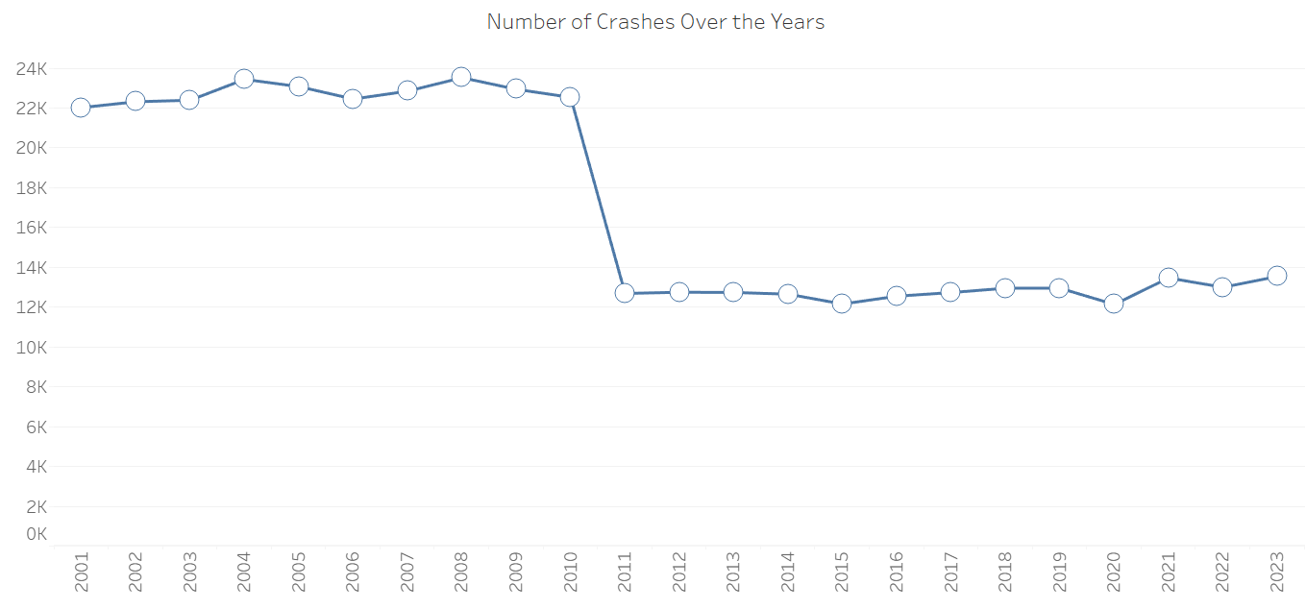
- Crash Trends Over Time

- Visualisation Type
A line chart was selected to illustrate the number of reported crashes per year from 2001 to 2023. This chart type is optimal for detecting long-term trends, identifying outliers, and tracking year-on-year changes in a continuous time series.
- Analysis of Findings
The visualisation reveals a high and relatively stable number of crashes from 2001 to 2010, with annual totals consistently exceeding 22,000 incidents. However, in 2011, there is a dramatic decline to approximately 12,000 crashes, with subsequent years showing similar levels.
Prior to 2011, the dataset included a large volume of crashes classified as “Property damage only”. These accounted for more than a third of total crashes annually. After 2010, these types of crashes appear to be no longer reported or recorded. Meanwhile, the volume of serious crash types such as fatal, hospitalisation, and medical treatment remain largely consistent before and after the drop.
- Interpretation of Patterns
This reporting change is the most likely cause of the sudden decline in total crash counts, rather than any actual shift in road safety outcomes. It highlights the importance of understanding data context when system-level changes in collection methods are not accounted for.

- Crash Severity by Time of Day
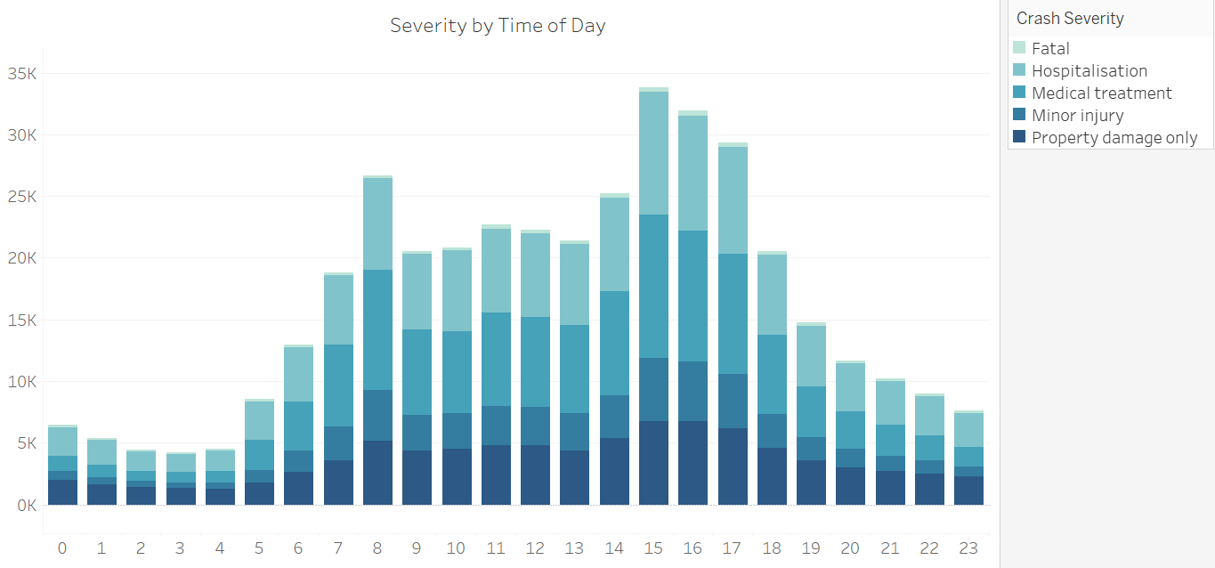

- Visualisation Type
A stacked bar chart was chosen to show the distribution of crash severity levels across each hour of the day. This format allows for direct comparison of crash volume and severity by time segment, making it easy to detect peaks, trends, and dangerous periods throughout a 24-hour cycle.
- Analysis of Findings
Crash volume rises sharply from early morning (around 6 AM), peaks between 3 PM and 6 PM, and gradually declines through the evening and night hours. The highest number of total crashes occurs between 4 PM and 5 PM, aligning with peak traffic during the evening commute.
In terms of severity, property damage only crashes make up the bulk of incidents throughout the day, especially in peak traffic hours. Fatal crashes, while comparatively low in count, are more evenly distributed across the day, with a slight increase during early morning hours and a small spike again around noon.

- Interpretation of Patterns
The spike in total crashes during afternoon hours correlates with increased road usage due to school pickups, work commutes, and high congestion. This period likely results in more low-speed collisions, explaining the dominance of property-damage-only crashes.
The higher proportion of fatal and hospitalisation crashes during late night and early morning hours may be attributed to:
- Lower visibility
- Driver fatigue
- Impaired driving
- Higher average speeds due to reduced traffic

- Crash Density Map
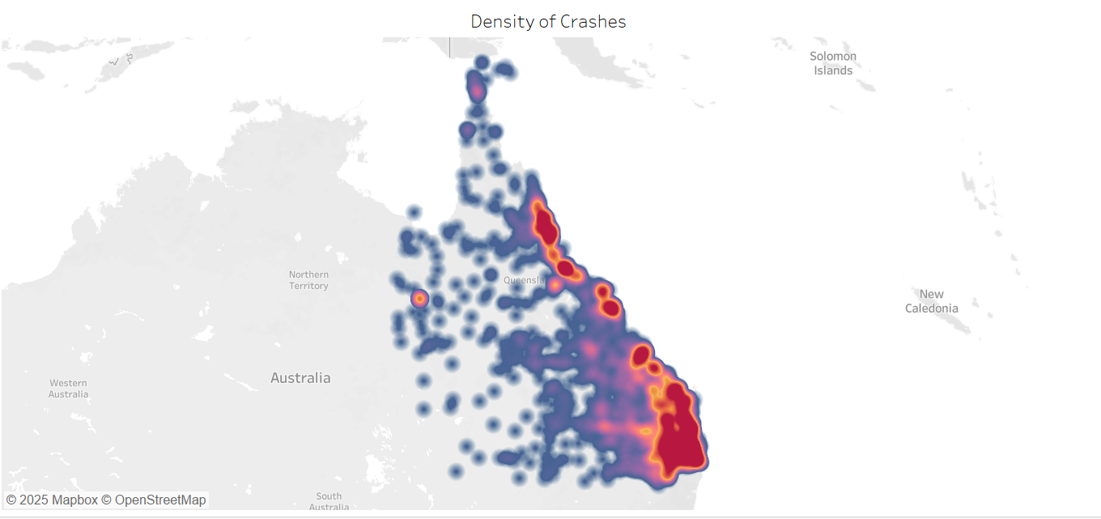
- Visualisation Type
A density map was used to visualise the geographic distribution of crash incidents across Queensland. This format is ideal for showing spatial concentration highlighting areas with a high frequency of crashes using heat intensity or gradient color. Latitude and longitude coordinates provide accurate mapping of crash locations.
- Analysis of Findings
The map reveals distinct high-density crash zones clustered around major urban and transport areas. The Brisbane metropolitan region shows the highest crash concentration, followed by other urban centres like the Gold Coast, Sunshine Coast, and parts of Townsville and Cairns. Low-density areas are generally rural or remote regions, with sparse crash records.

- Interpretation of Patterns
Crash density correlates strongly with population density, traffic volume, and road network complexity. Urban regions not only have more vehicles but also experience higher congestion, intersection density, and varied road user behavior, all of which contribute to increased crash likelihood.
Furthermore, suburbs with the highest crash counts (e.g., Zillmere, Caboolture, Southport) often lie near major highways or interchanges, suggesting that high traffic flow areas deserve closer traffic safety attention and possibly targeted infrastructure upgrades.

- Crash Severity by Speed Limit
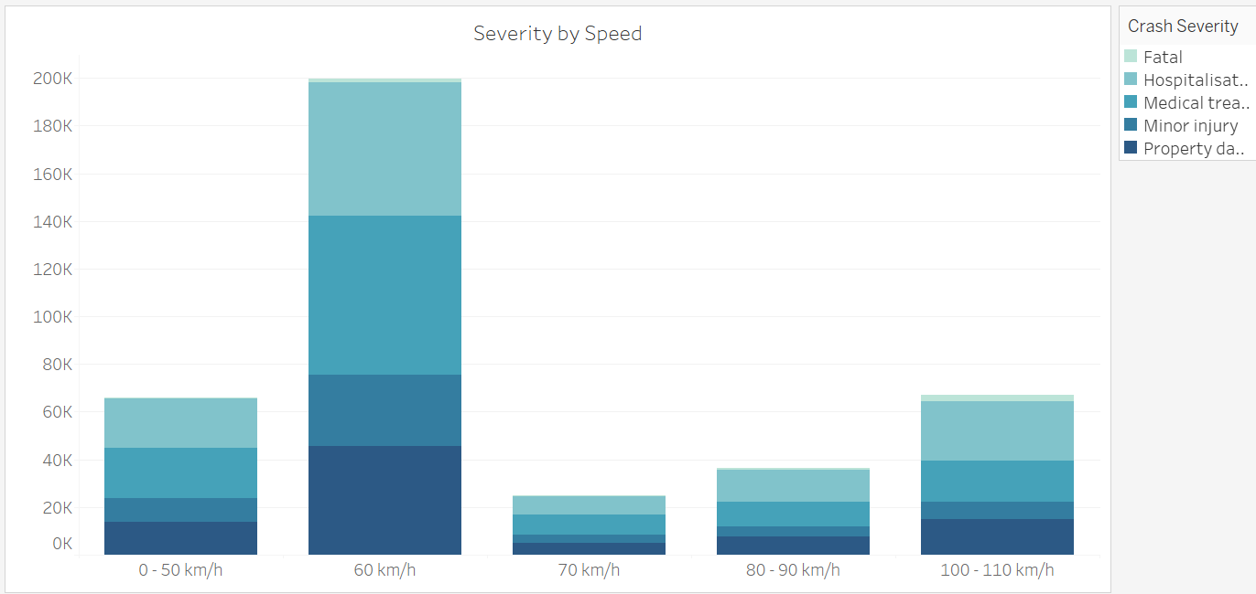
- Visualisation Type
A stacked bar chart was selected to represent crash severity across different posted speed limits. This visual format enables a straightforward comparison of both the total number of crashes and the distribution of severity levels across speed categories.
- Analysis of Findings
The chart reveals that 60 km/h zones account for the highest number of crashes overall, followed by 100–110 km/h and 0–50 km/h zones. These are commonly encountered speed limits in suburban, highway, and urban areas, respectively.
Fatal and hospitalisation crashes are proportionally higher in high-speed zones (especially 100–110 km/h), despite lower total crash counts. In contrast, low-speed zones (0–50 km/h) show a high frequency of crashes, but these are overwhelmingly minor in nature.
- Interpretation of Patterns
Higher-speed areas, such as highways, allow more severe impacts, increasing the likelihood of hospitalisation or fatality when crashes occur. On the other hand, lower-speed zones, often located in urban environments with heavy traffic, result in more frequent but less severe collisions, often due to congestion, stop-start traffic, or pedestrian interactions.
- Crashes by Region
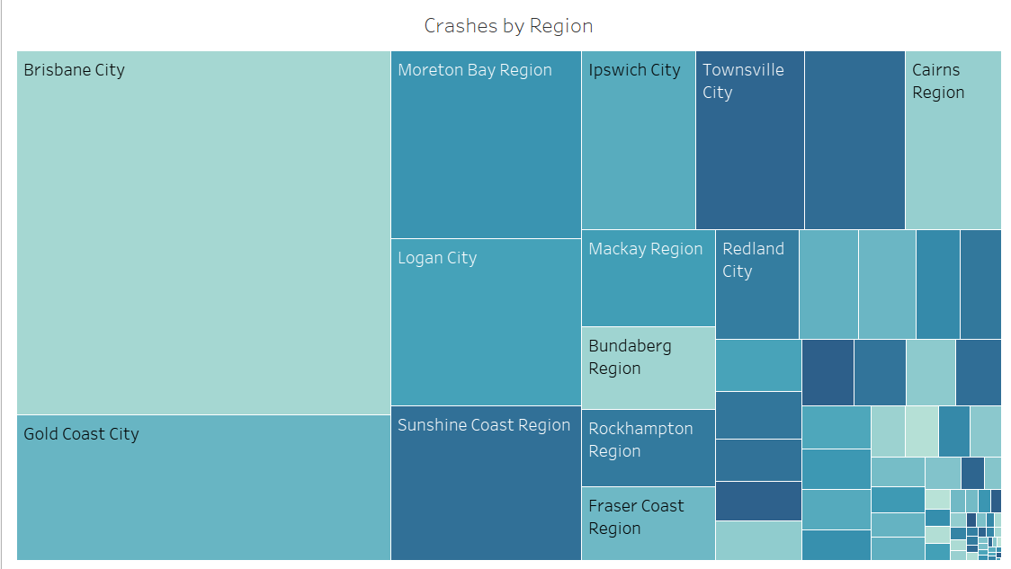
- Visualisation Type
A treemap was selected to visualise crash counts by Local Government Area (LGA). This chart type is ideal for displaying hierarchical or categorical as it visually conveys which regions contribute most to total crashes based on area size.
- Analysis of Findings
The treemap shows that certain LGAs, especially highly urbanised or transit-heavy regions, report substantially more crashes than others. LGAs such as Brisbane City, Gold Coast City, Moreton Bay Region, and Logan City occupy the largest tiles, indicating they have the highest crash volumes in Queensland.
In contrast, regional and remote LGAs like Barcoo Shire, Aurukun Shire, and Diamantina Shire show minimal crash activity, reflected by much smaller tiles.
- Interpretation of Patterns
High-crash LGAs tend to be densely populated, economically active with more vehicle movement and contain major roads or highways. Moreover, these areas have greater traffic complexity, including intersections, public transport, and pedestrian volumes.
In contrast, low-crash LGAs are sparsely populated and geographically remote, resulting in fewer vehicles and interactions despite longer travel distances.

Ethical Principles in Data Visualisation
This analysis followed key ethical principles to ensure data was presented clearly, accurately, and responsibly. Charts were chosen based on their ability to truthfully communicate insights, without exaggeration or distortion. Axes, labels, and legends were applied consistently to support viewer understanding, and no visual tricks (like truncated scales or misleading colours) were used.
Inspired by Kantian ethics, the design process emphasised the need to treat viewers as autonomous individuals capable of making reasoned judgments. This meant respecting their right to fully understand the visuals by presenting them with clarity, completeness, and context. Data was not selectively filtered to favour a narrative; instead, contextual explanations were provided to avoid misinterpretation.
Furthermore, following the ethical model of informed and voluntary engagement, each visualisation aimed to be accessible and inclusive. Consideration was given to colour choice and interactive elements were used responsibly.
Lastly, the report recognises the power of data to influence public perception and policy. Therefore, all visual insights were carefully cross-verified to ensure that the analysis respects both ethical integrity and the real-world impact of data storytelling.

Conclusion and Recommendations
This report explored crash incident patterns across Queensland using five visualisations built in Tableau.
Crash frequency was high and stable until 2010, after which reported incidents dropped significantly, a change linked to the removal of property-damage-only crashes from reporting. Crash volumes peaked during afternoon hours, particularly between 3 PM and 6 PM, indicating that commuter congestion is a key risk factor. Density mapping highlighted urban areas like Brisbane, Gold Coast, and Moreton Bay as high-crash zones, often near major intersections or highways.
Crashes in high-speed zones, although fewer in number, showed a higher proportion of severe outcomes, including fatalities and hospitalisations. Meanwhile, the treemap of regional crash distribution showed a concentration of incidents in populous LGAs, with rural regions reporting far fewer events.
Based on these findings, the following recommendations are proposed:
- Targeted interventions in high-crash LGAs (e.g., traffic calming, signal timing reviews, intersection redesigns).
- Increased enforcement and awareness campaigns during peak crash hours (especially afternoons).
- Road safety infrastructure upgrades in high-speed zones to reduce the severity of crashes (e.g., median barriers, improved signage).
- Enhanced data transparency, including consistent reporting of all crash types, to ensure accurate future analysis and policy evaluation.

