**King Saud University**

**College of Computer and Information Sciences**

**Department of computer science**

**CSC- 212 Data Structure**

**Project Report – phase 1**

AUTHORS:

Abdulaziz Alsaleh

October 2023

1. **INTRODUCTION**

This is the report of the first phase of the CSC-212 project. The goal is to design “Linked tree phonebook”.

Phase 1 of this project contains the following:

-The division of work.

- Assumptions.  
- List of Methods.

-Methods description and BigO of each one

Division of Work:

Assumptions:

List of Methods:

* searchContactByName(String name)
* searchContactByNumber(String phoneNumber)
* InsertContactSorted(T contact)
* deleteEvent(String name)
* deleteContact(String name)
* CheckIfNull()
* InsertEventSorted(T event)
* PrintEventSorted()
* SearchByCriteria(int criteria, String choiceDetails, boolean b)
* CheckByCriteria(int criteria, String choiceDetails)
* SearchEventConflict(String date)
* SearchByEventDetails(int criteria, String choiceDetails)
* Method: searchContactByName(String name)

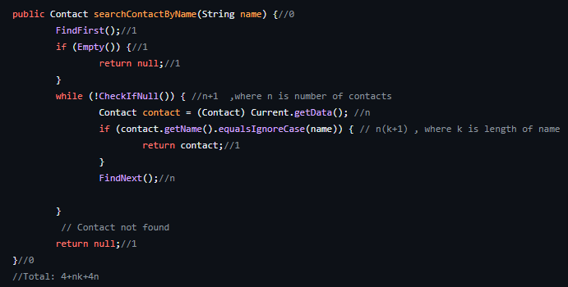

"Picture with big O"

Total Big O: 4+nk+4n

n: is number of contacts

k: is length of phoneNumber

Method`s Description:

This method searches for a contact in the linked list by name. It takes the name of the contact as input and returns the corresponding `Contact` object if found, or `null` if not found.

Method: searchContactByNumber(String phoneNumber)

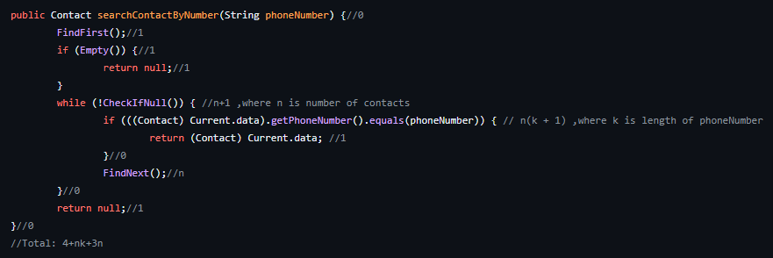"Picture with big O"

Total Big O: 4+nk+3n

n: is number of contacts

k: is length of Name

Method`s Description:

This method searches for a contact in the linked list by phone number. It takes String (phone number) as input and returns the corresponding `Contact` object if found, or `null` if not found.

Method: InsertContactSorted(T contact)

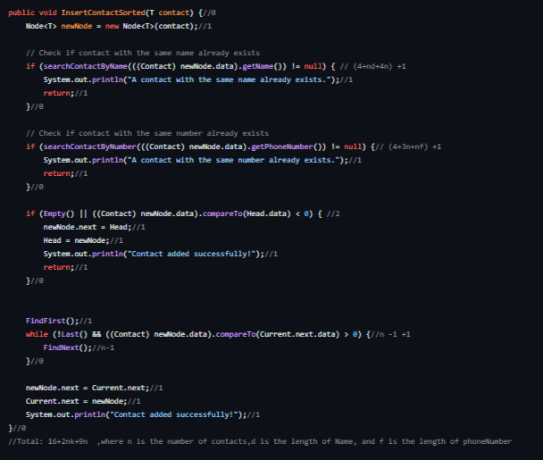

"Picture with big O"

Total Big O: 16+2nk+9

n is the number of contacts

d is the length of Name

f is the length of phoneNumber

Method`s Description:

This method inserts a new contact into the linked list in a sorted order based on the contact's name. It takes a new contact of type `T`(Generic) as input, checks if a contact with the same name or phone number already exists, and inserts the new contact at the appropriate position. If the contact is successfully inserted, it prints a success message. This method has no output (void).

Method: deleteEvent(String name)

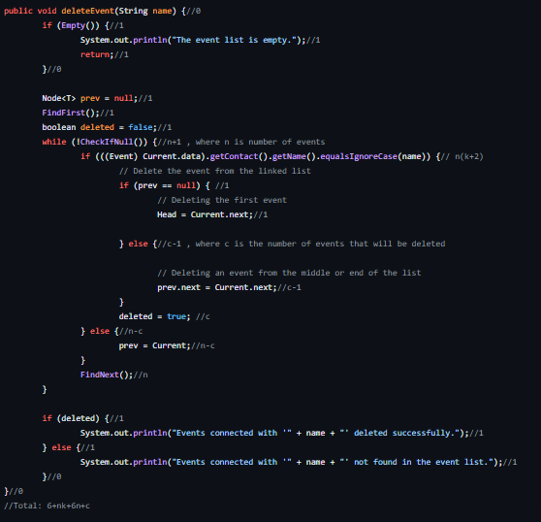

"Picture with big O"

Total Big O: 6+nk+6n+c

n is number of events

c is the number of events that will be deleted

k: is length of Name

Method`s Description:

This method checks if the event list is empty. If it is empty, it prints a message and returns. If the list is not empty, it iterates through the linked list of events and compares the name of the contact associated with each event to the given String (name). If a match is found, the event is deleted from the list. If no events are found for the given contact name, appropriate messages are printed.

Method: deleteContact(String name)

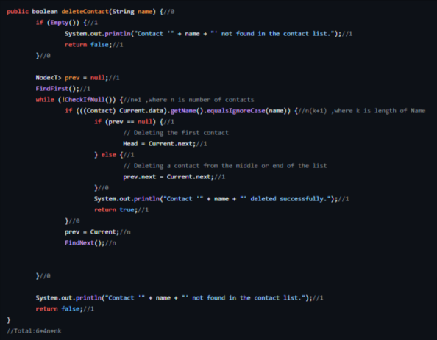

"Picture with big O"

Total Big O: 6+4n+nk

n is number of contacts

k: is length of Name

Method`s Description:

This method checks if the contact list is empty. If it is empty, it prints a message and returns `false`. If the list is not empty, it iterates through the linked list of contacts and compares the name of each contact to the given String (name). If a match is found, the contact is deleted from the list. If no contact is found with the given String (name), appropriate messages are printed. The method returns `true` if the contact is successfully deleted, and `false` otherwise.

Method: CheckIfNull()

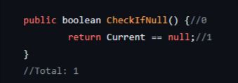

"Picture with big O"

Total Big O: 1

Method`s Description:

This method checks if the current node is null. It takes no inputs and returns a boolean value (`true` if the current node is null, `false` otherwise).

Method: InsertEventSorted(T event)

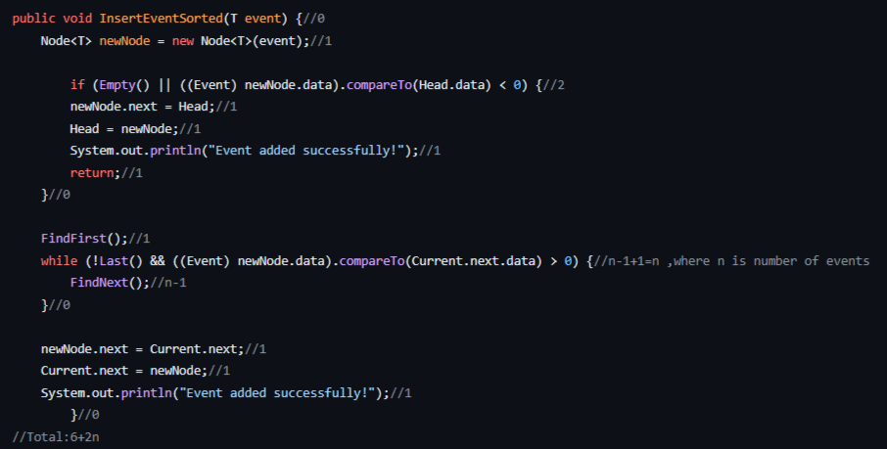

"Picture with big O"

Total Big O: 6+2n

n is number of events

Method`s Description:

This method creates a new node with the given event. If the event list is empty or the given event title compared to the first event title in the list is less than zero, the new node becomes the new head. Otherwise, the method iterates through the linked list to find the appropriate position to insert the event while maintaining the sorted order. Once the position is found, the new node is inserted into the list. A success message is printed.

Method: PrintEventSorted()

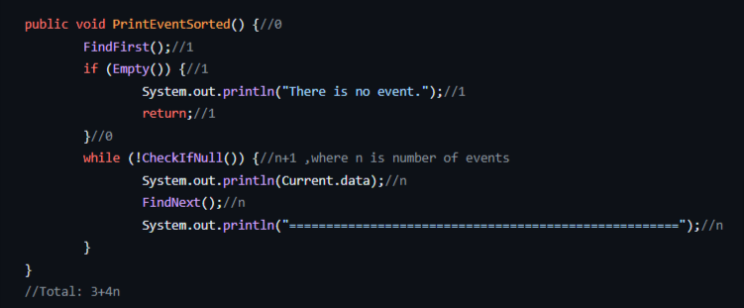

"Picture with big O"

Total Big O: 3+4n

n is number of events

Method`s Description:

This method checks if the event list is empty. If it is empty, it prints a message and returns. If the list is not empty, it iterates through the linked list of events and prints each event. After printing each event, a separator line is printed.

Method: SearchByCriteria(int criteria, String choiceDetails, boolean b)

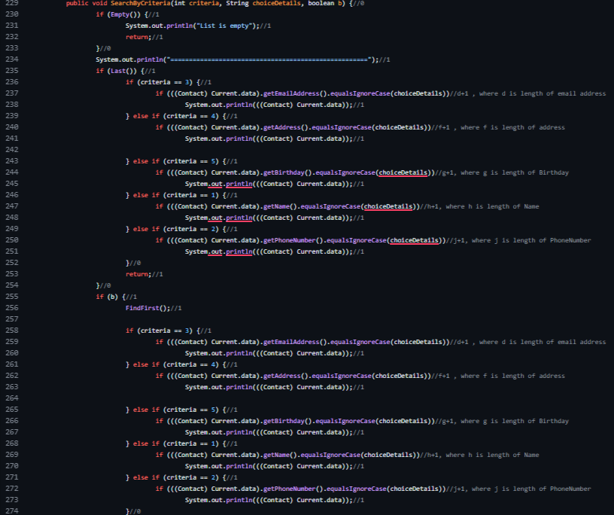

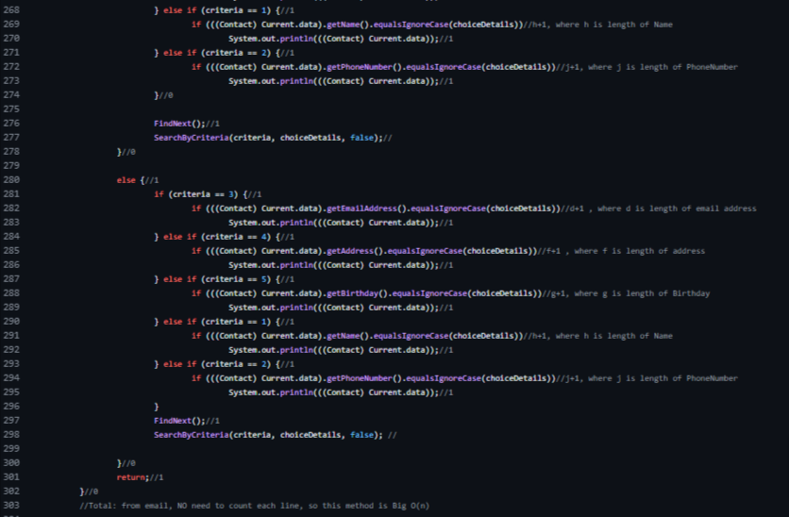

"Picture with big O"

Total Big O:

Method`s Description:

This method checks if the contact list is empty. If it is empty, it prints a message and returns. If the list is not empty, it searches for contacts that match the given criteria and choice details. It iterates through the contact list, comparing the specified criteria (e.g., name, phone number, etc.) with the corresponding details of each contact. If a match is found, the contact is printed. If the `b` flag is set to `true`, indicating there may be more matches, it continues searching by calling itself recursively with the flag set to `false`. The method prints a separator line before returning.

Method: CheckByCriteria(int criteria, String choiceDetails)

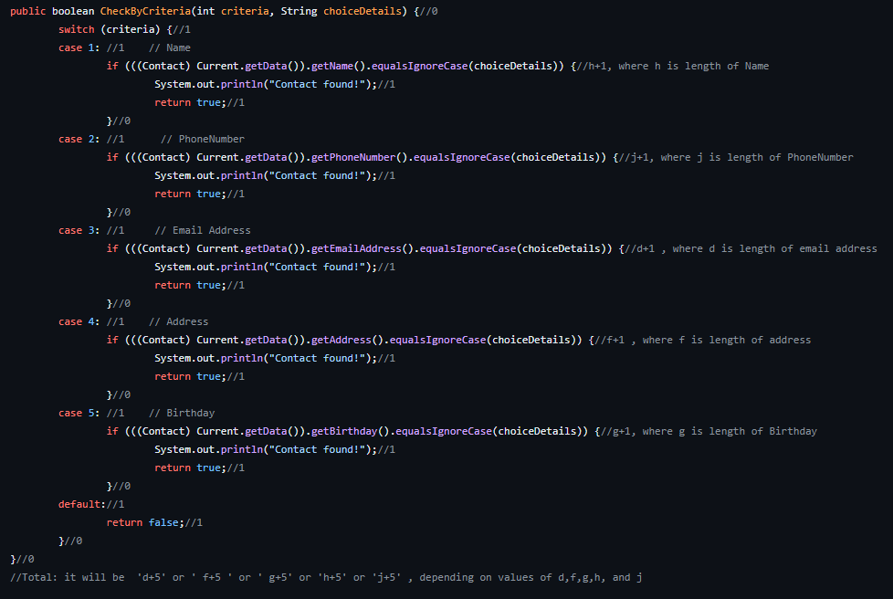

"Picture with big O"

Total Big O: it will be 'd+5' or ' f+5 ' or ' g+5' or 'h+5' or 'j+5' , depending on values of d,f,g,h, and j.

d: is length of email address

f: is length of address

g: is length of Birthday

h: is length of Name

j: is length of PhoneNumber

Method`s Description:

This method checks if the current contact matches the specified criteria and choice details.by using switch, in every case from 1 to 5 It compares the details of the current contact with the given choice details based on the specified criteria ( name, phone number, email address, address, and birthday). If a match is found, it prints a message and returns `true`. If no match is found. If none of the cases match, it returns `false'.

Method: SearchEventConflict(String date)

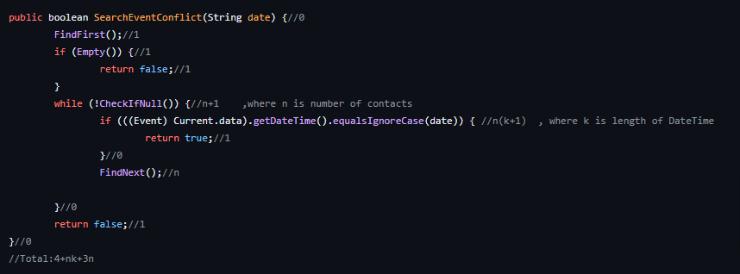

"Picture with big O"

Total Big O: 4+nk+3n

n: is number of events

k: is length of DateTime

Method`s Description:

This method checks if the event list is empty. If it is empty, it returns `false`. If the list is not empty, it iterates through the event list and compares the date of each event with the given date. If a conflict is found (i.e., an event with the same date exists), it returns `true`. If no conflicts are found, it continues to the next event until the end of the list is reached. It returns `false` if no conflicts are found.

Method: SearchByEventDetails(int criteria, String choiceDetails)

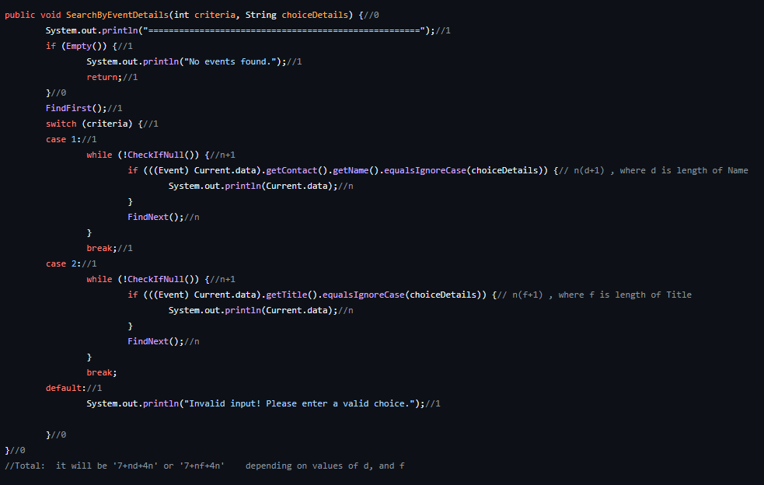

"Picture with big O"

Total Big O: it will be '7+nd+4n' or '7+nf+4n' depending on values of d, and f

d is length of Name

f is length of Title

Method`s Description:

The method checks if the event list is empty. If it is empty, it prints a message and returns. If the list is not empty, it searches for events (by using switch) that match the given criteria and choice details. It iterates through the event list, comparing the specified criteria (contact name, event title) with the corresponding details of each event. If a match is found, the event is printed. The method prints a separator line before returning.