

## User Guide

**Table of Contents**

*Introduction ………………………………………………………………………………………………………* 3

*System requirements …………………………………………………………………………………………* 4

*Quick start …………………………………………………………………………………………………………* 5

**Introduction**

Goes here …………………

**System requirements**

1. Operating system: Windows 7 or later.

2. Processor: Intel Pentium 4 or later.

3. Memory: 2 GB minimum.

4. Screen resolution: 1366 X 768 or larger.

5. Internet connection: Required.

6. Web Browsers: Chrome, Firefox.

**Quick start**

**Login page :**

Admin and user both can login from here.

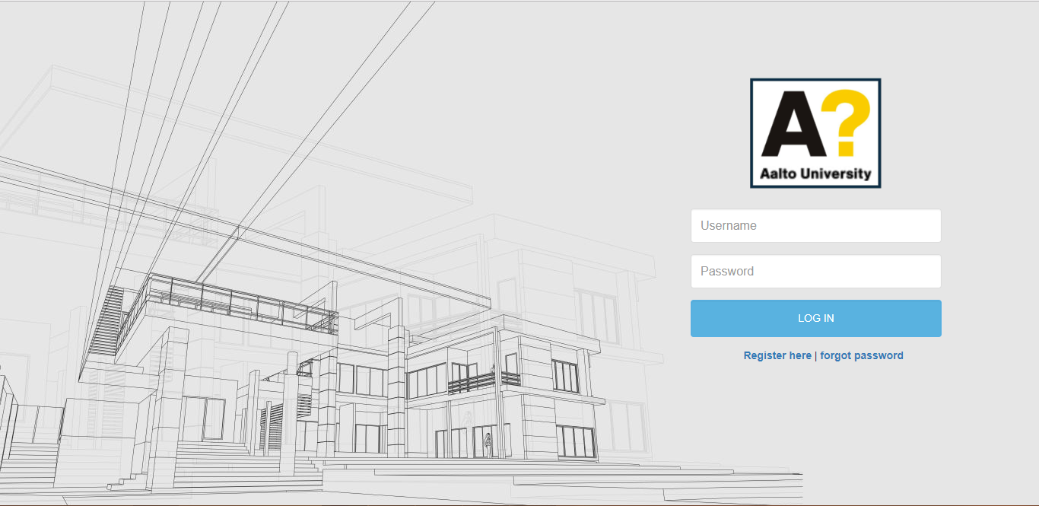

**Register page** :

New user can register from here.

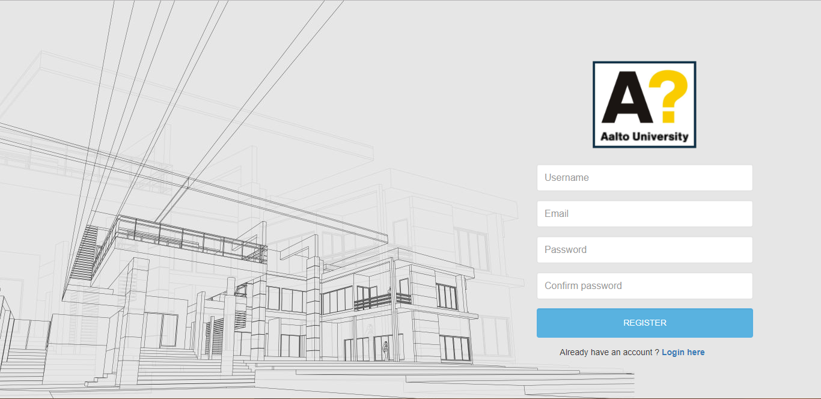

**Forgot password page :**

Enter registered email and submit the form. after that you get a link via email to change the password.

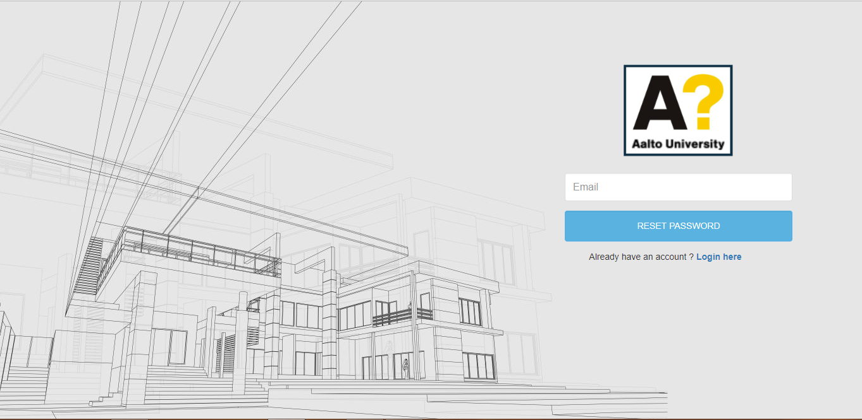

**Reset password page :**

Type new password in both text field and click on ‘Reset password’ button, your password get reset successfully.

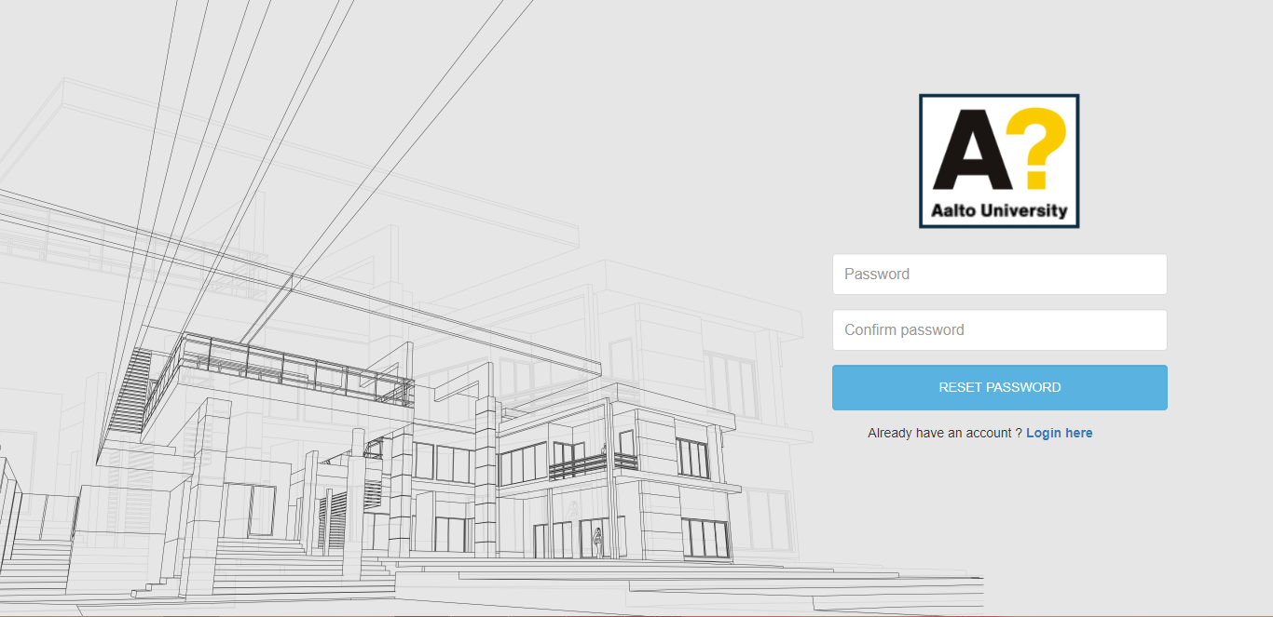

**Dashboard or Home page (Admin) :**

This is admins dashboard page. After successfully login admin redirect on this page.

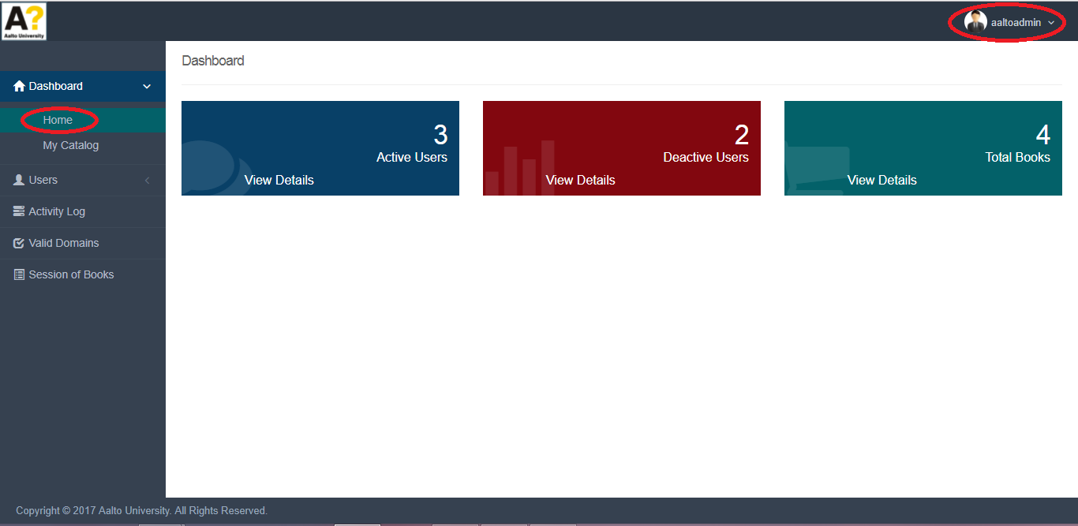

**Catalog page (Admin) :**

In catalog admin can see all the books created by all user.

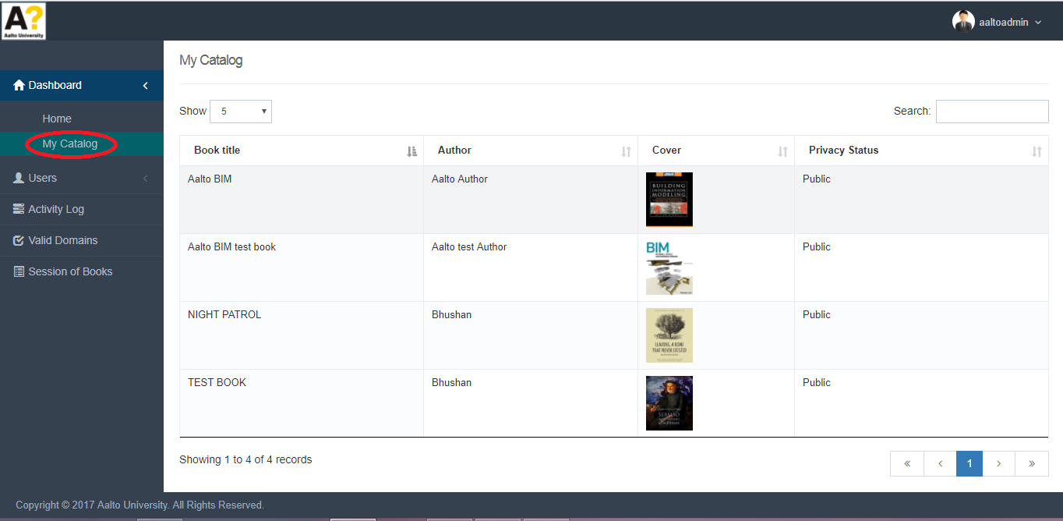

**All user page (Admin) :**

Admin can see all active, deactive users. Admin can approve, reject user’s request using buttons from action column. After approve by admin user received a confirmation mail and user can login to there account. Admin can login to user’s acoount using login button from action column.

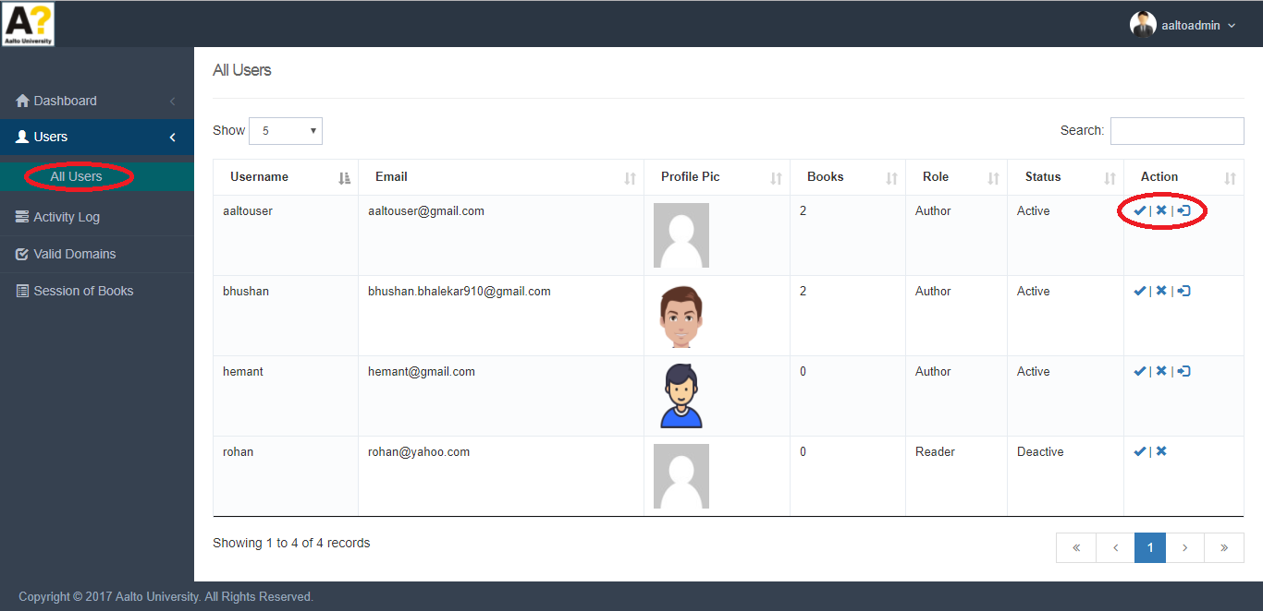

**Activity Log page (Admin) :**

Admin can see all the user’s activity here.

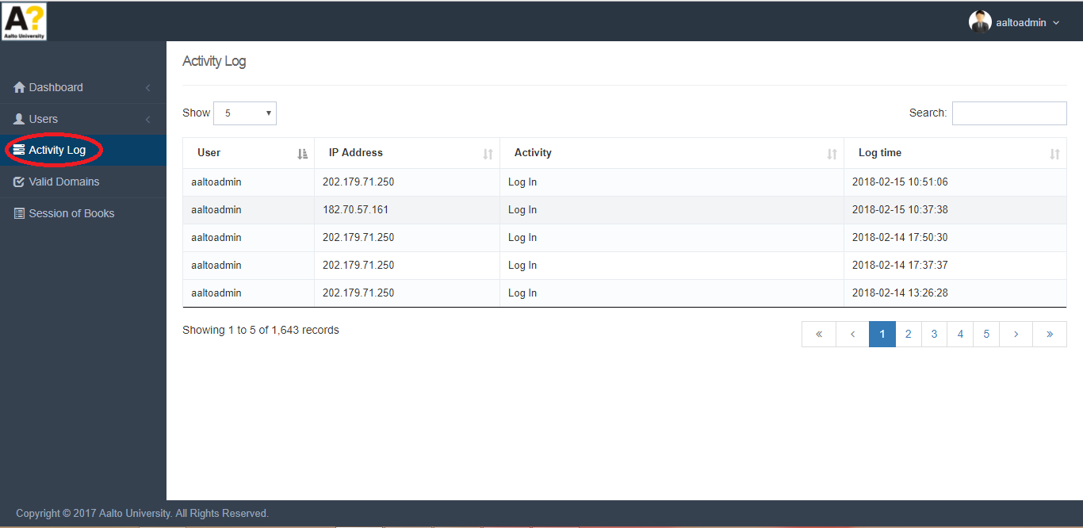

**Valid Domains (Admin) :**

All the domains added by Admin are visible here, user’s with these domain can register.

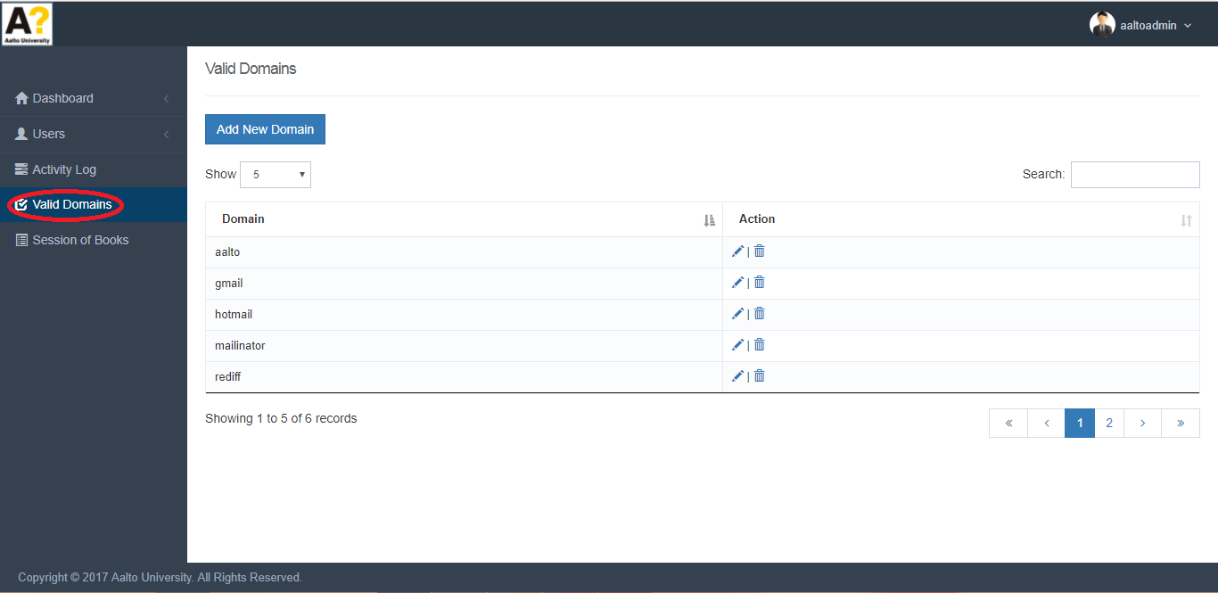

**Add, Edit, Delete Domains (Admin) :**

For adding new domain’s click on ‘Add New Domain’ button. Admin can edit, delete domian’s by clicking on edit and delete icons.

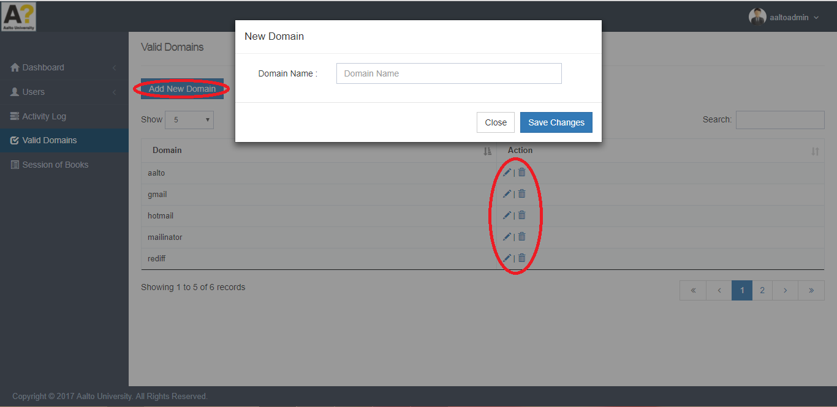

**Session of Book (Admin) :**

Admin can see which user spent how much time on which book and which chapter in the application(fornt end ).

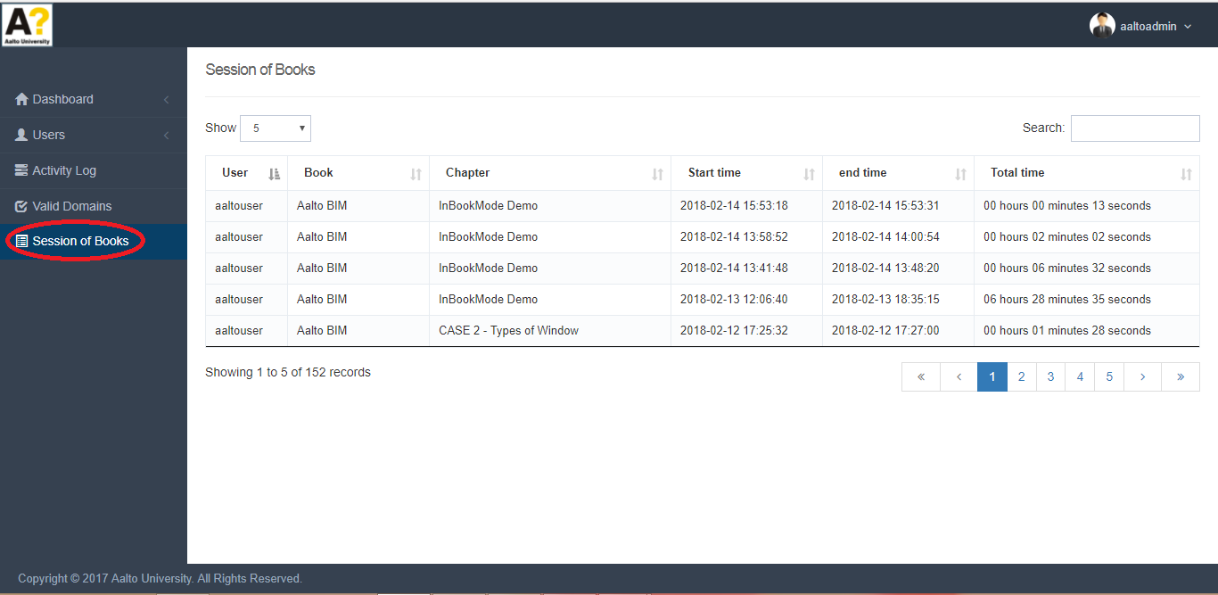

**Profile and Log Out (Admin) :**

Admin can update profile by clicking on ‘My profile’ and Log out by clicking on ‘Log Out’ options populated in top right corner.

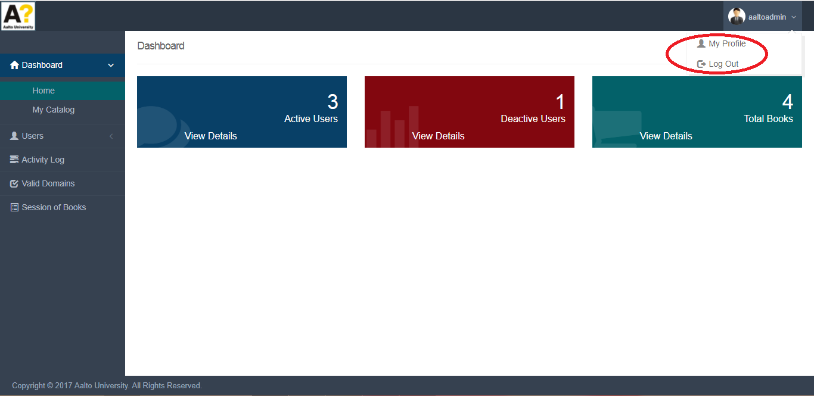

**Edit profile (Admin) :**

Fill profile data and click on ‘Save’ button.

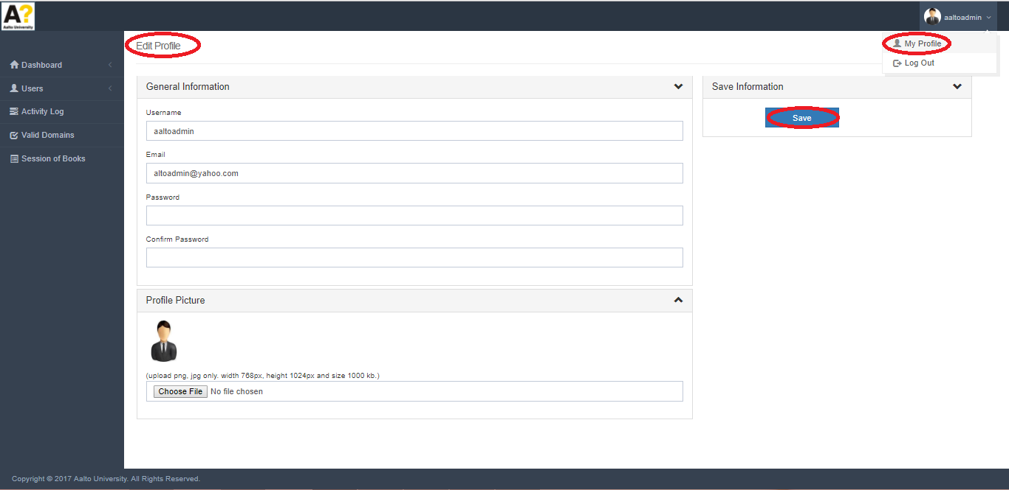

**Dashboard or Home page (User) :**

This is user’s dashboard page. By default user’s first book is selected. Title of selected book is visible in header. If you want to change the book click on ‘My Catalog’ in top left, a dropdown is populated with title of books, select any one of them.

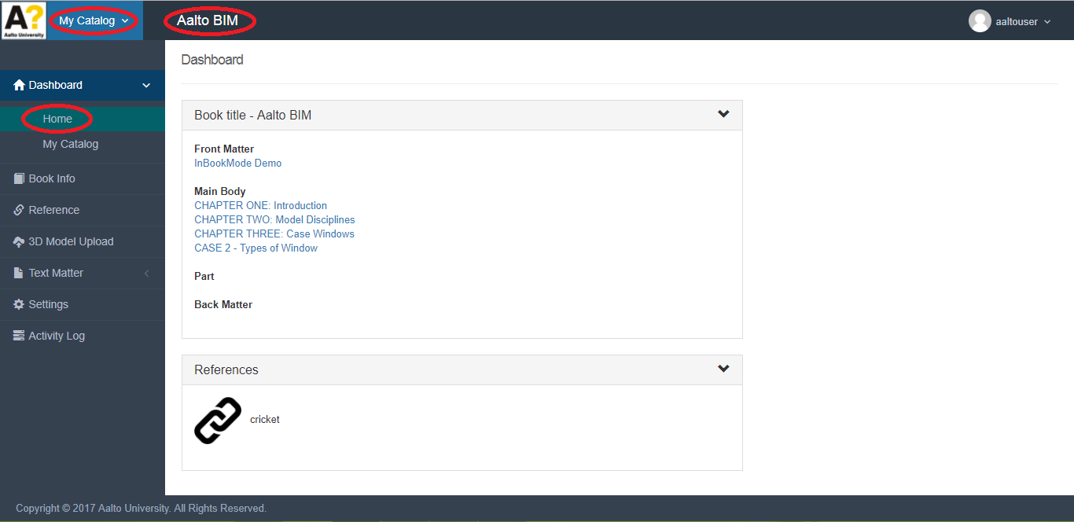

**Create New Book (User) :**

For creating new book click on ‘My Catalog’ in top left corner a dropdown is populated then click on ‘Create New Book’ option. Fill the compulsory fields and click ‘Save’ button.

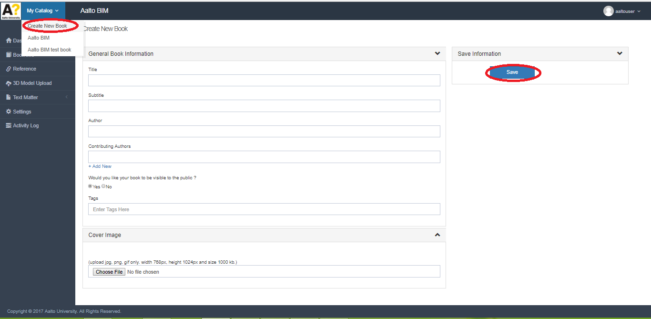

**Catalog (User) :**

In catalog user can see only his created books. User can edit,delete,print book by clicking on particular icons.

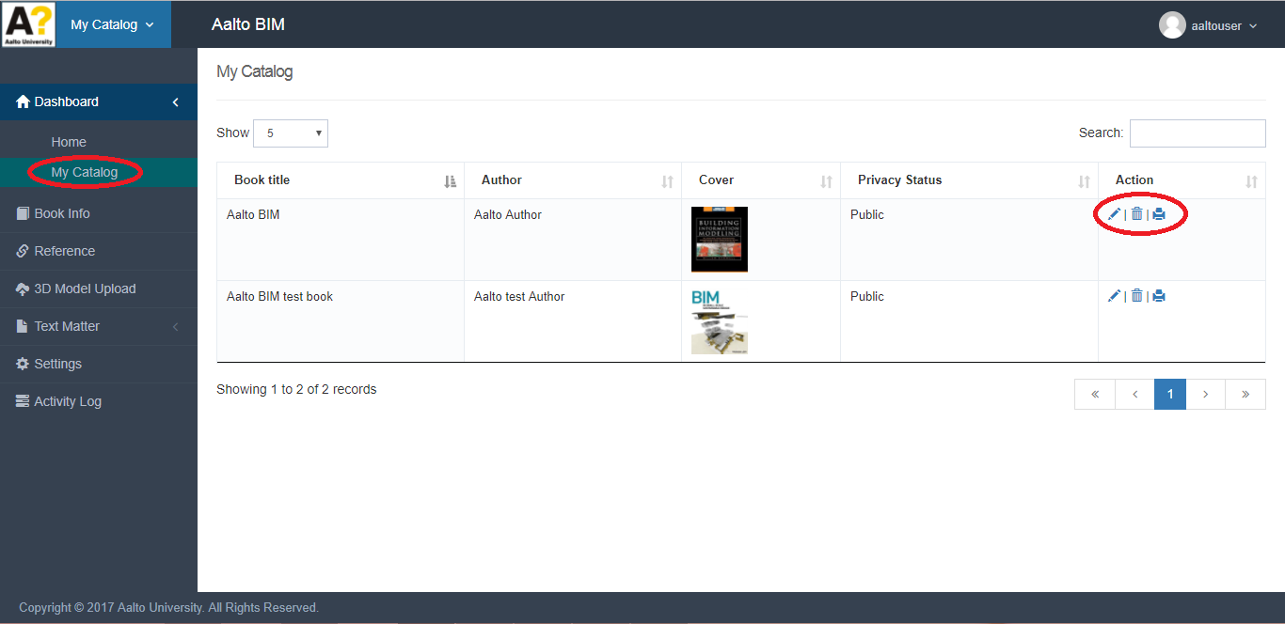

**Edit Book (User) :**

User can edit current book’s information by clicking on ‘Book Info’ in menu bar, fill data and click on ‘Save’ button.

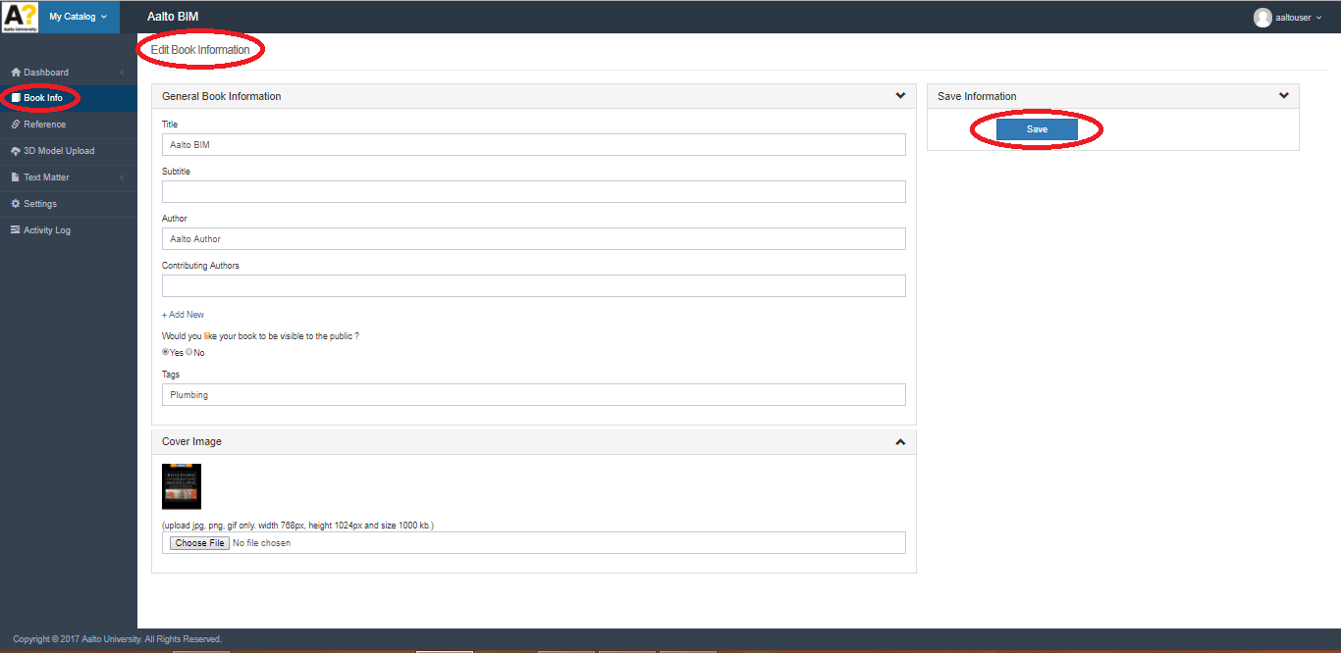

**Reference (User) :**

All references of logged user are visible here. On link and thumbnail click reference url open in browser window.

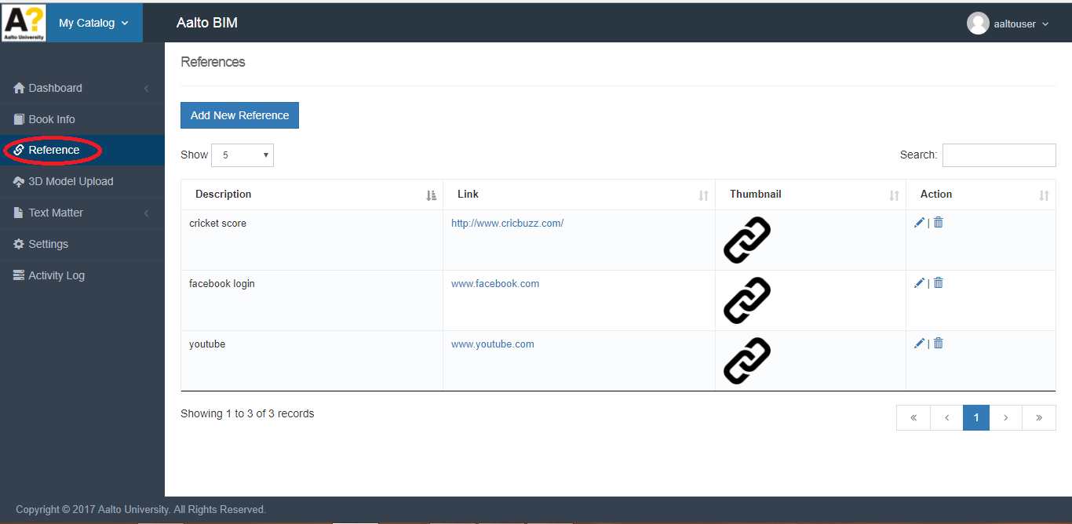

**Add, Edit, Delete Reference (User) :**

For adding reference click on ‘Add New reference’ button a form is popping up fill compulsory data and click on ‘Save Changes’ button. User can edit, delete reference by clicking on edit, delete icon.

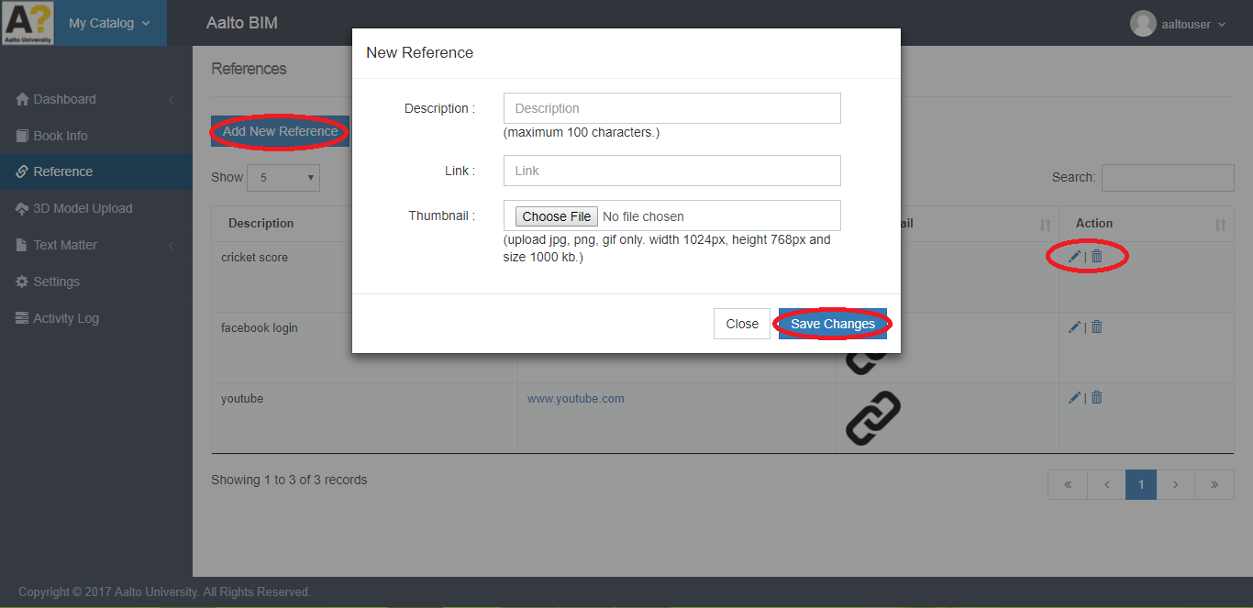

**3D Model Upload (User) :**

All uploaded 3D Model of logged user are visible here.

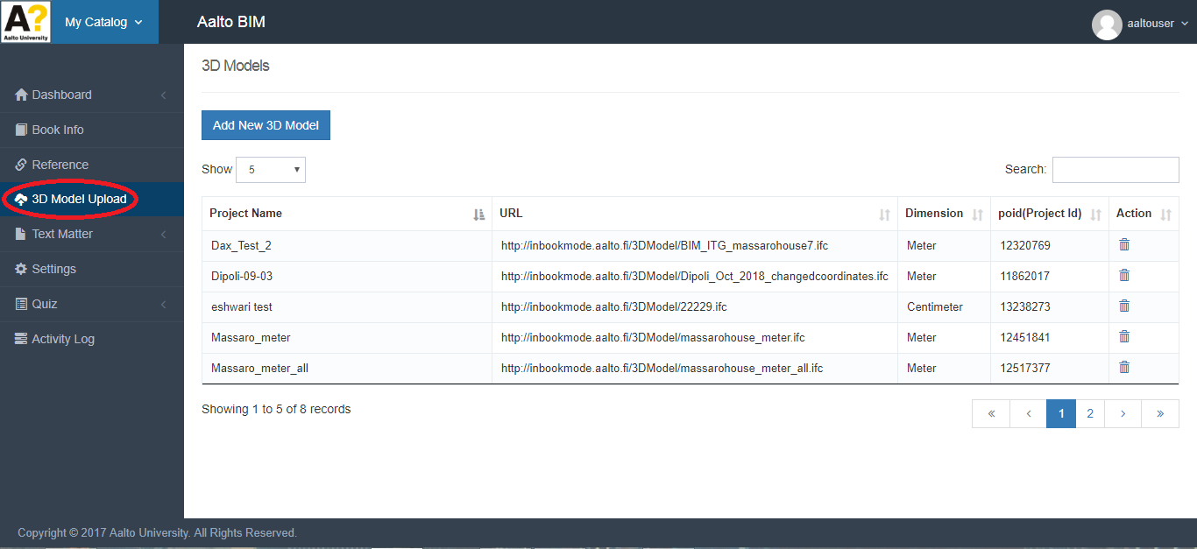

**Add, Edit, Delete 3D Model (User) :**

For uploading 3D Model click on ‘Add New 3D Model’ button a form is popping up fill compulsory data and click on ‘Save Changes’ button. User can edit, delete 3D Model by clicking on edit, delete icon.

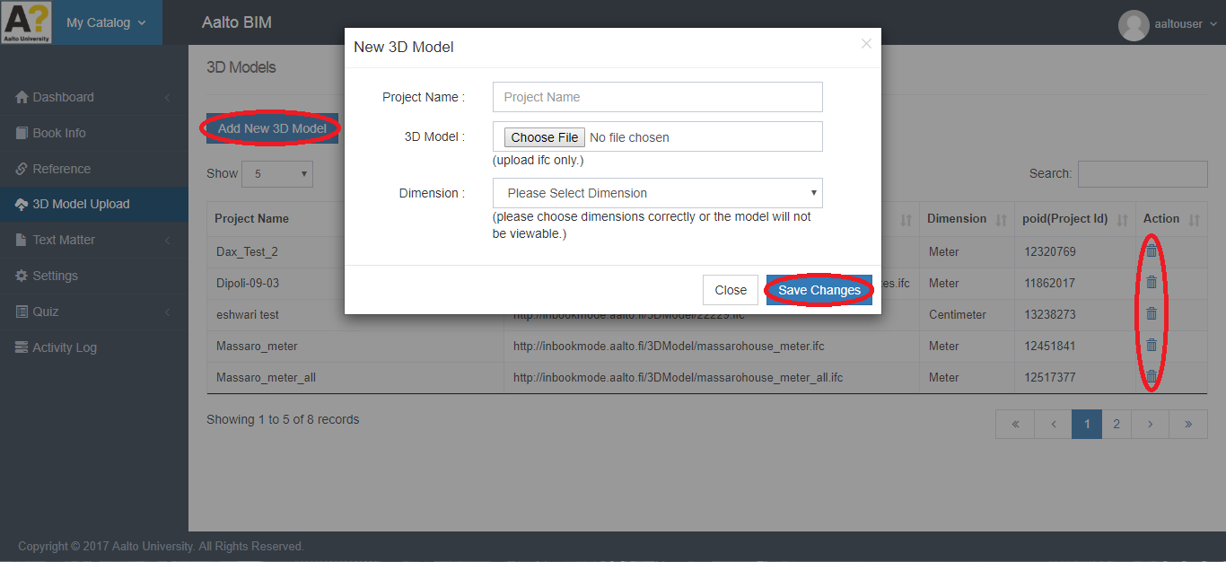

**Organize (User) :**

All front Matters, Chapters, Parts & Back Matters of selected book are visible under **Text Matter -> Organize**. User can add, Edit & Delete front Matters, Chapters, Parts & Back Matters using Add Button, edit & delete icon.

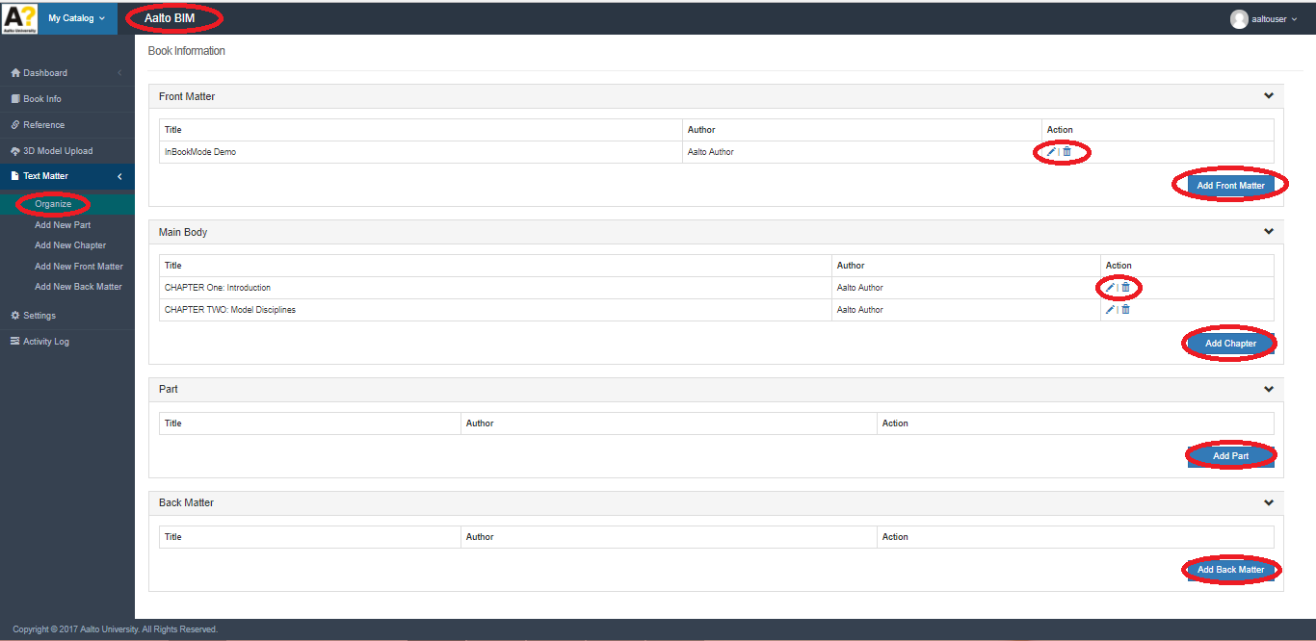

**Add New Front Matter (User) :**

User can add front matter data into the selected book from here. Enter title & type or paste content in textarea and click on save button. same things user can do in Edit Front Matter.

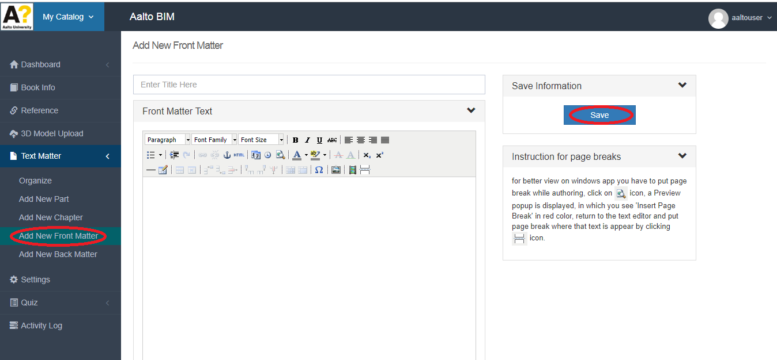

**Add New Chapter (User) :**

User can add chapter data into the selected book from here. Enter title, subtitle & type or paste content in textarea and click on save button. same things user can do in Edit Chapter.

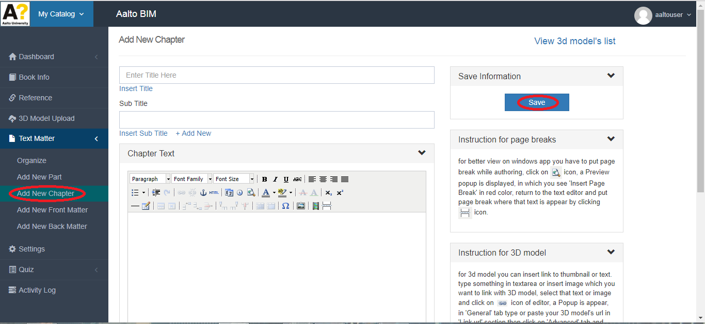

**Add New Part (User) :**

User can add part data into the selected book from here. Enter title & type or paste content in textarea and click on save button. same things user can do in Edit Part.

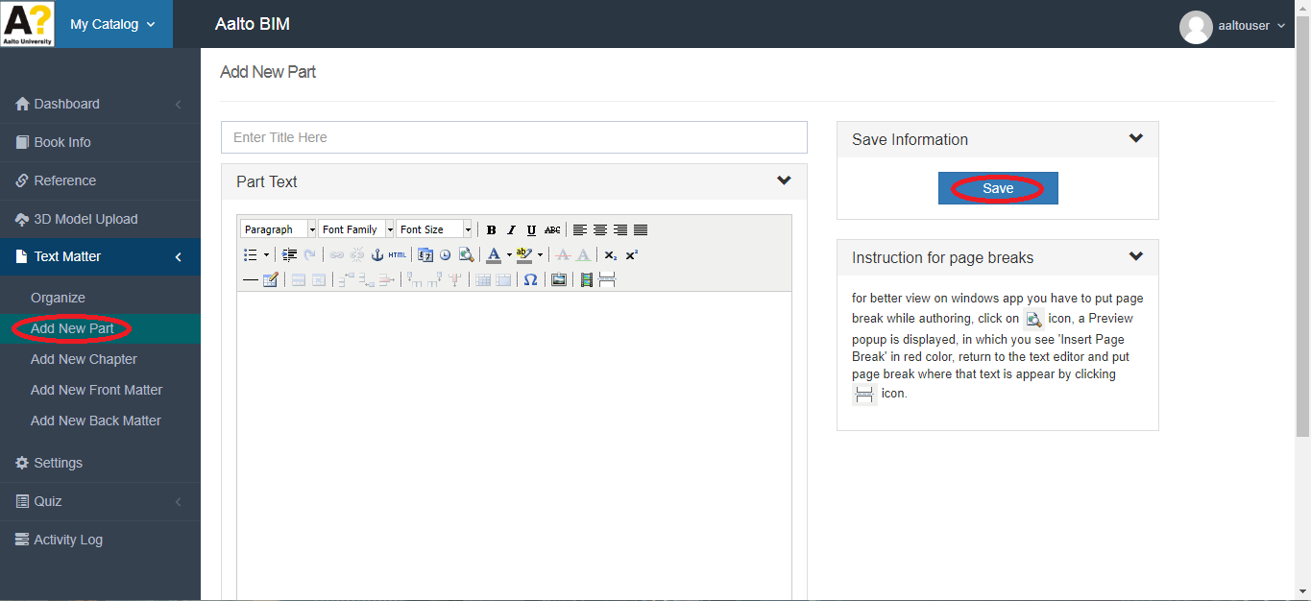

**Add New Back Matter (User) :**

User can add front matter data into the selected book from here. Enter title & type or paste content in textarea and click on save button. same things user can do in Edit Back Matter.

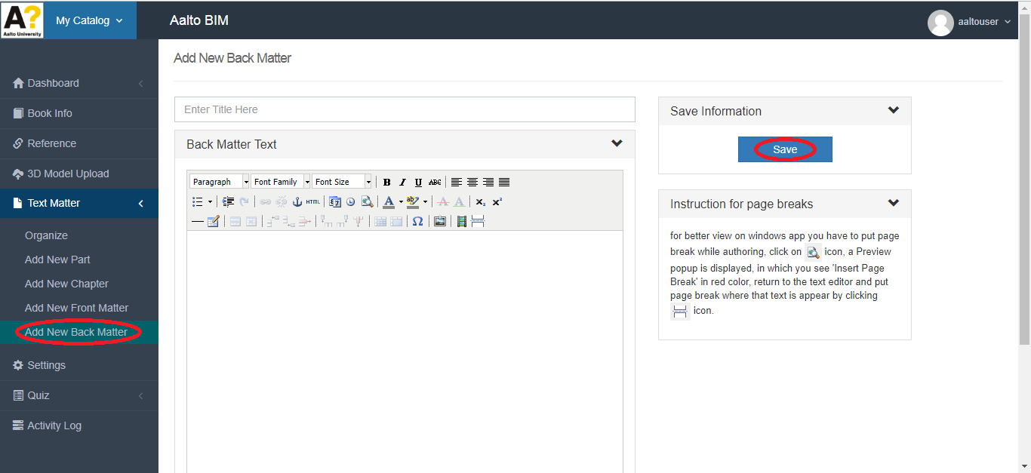

**Settings (User) :**

User can save settings for selected book from here, select radio button and click on ‘Submit’ button.

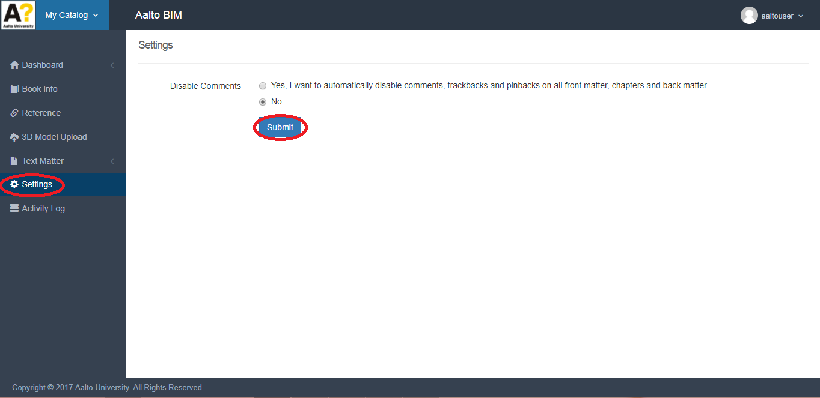

**Activity Log (User) :**

User can see his all the activities here.

