**Table of Contents**

1. Software installation 1

2. System requirements 2

3. User Manual 3

4. Video Tutorial Links 4

1. **Software Installation:**

1. Once you have downloaded InBookModE setup.

2. Double click on it to start installation.

3. Click on Next Buttons to continue with installation.

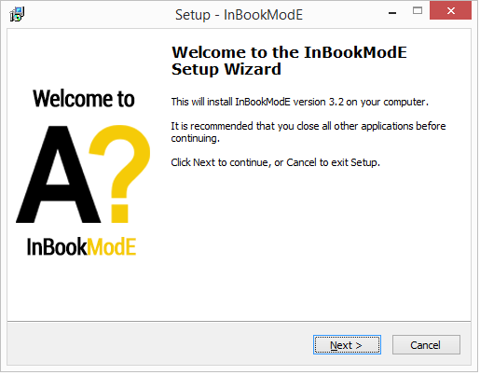

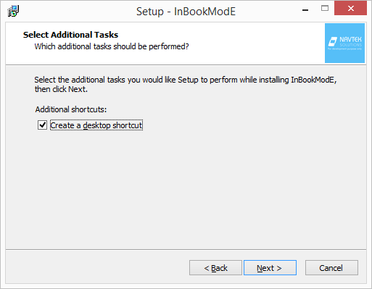

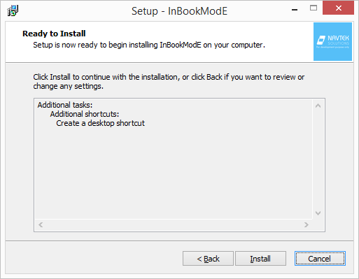

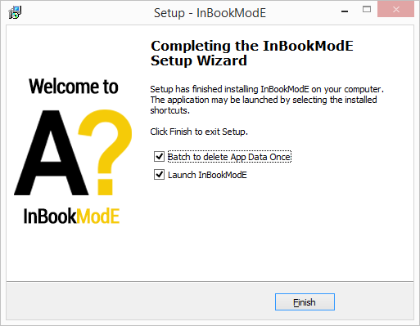

(IMPORTANT)

Select “Batch to Delete App Data once”, if you want a clean installation of InBookModE. This will delete all folders and user files of InBookModE %appdata% if previously installed and not to be confused with the application or its installed files.

1. **Recommended system requirements:**

1. Processor 3 GHz or above with 4 threads preferred

2. Windows 10 preferred

3. 4 GB RAM

4. 500MB Disk Space for Installation

5. 2 GB Graphics Card, Memory required for larger fbx models may vary

1. **User Manual :**

This is the Aalto Front end Login page.

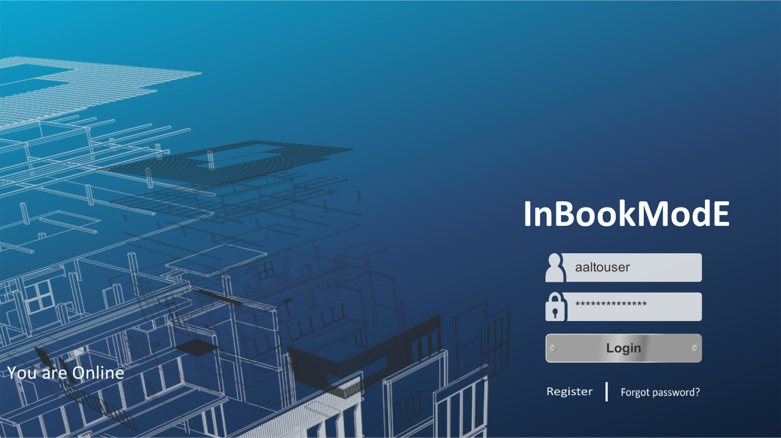

This is the dynamic Book Shelf with delete, search and tagged dropdown.

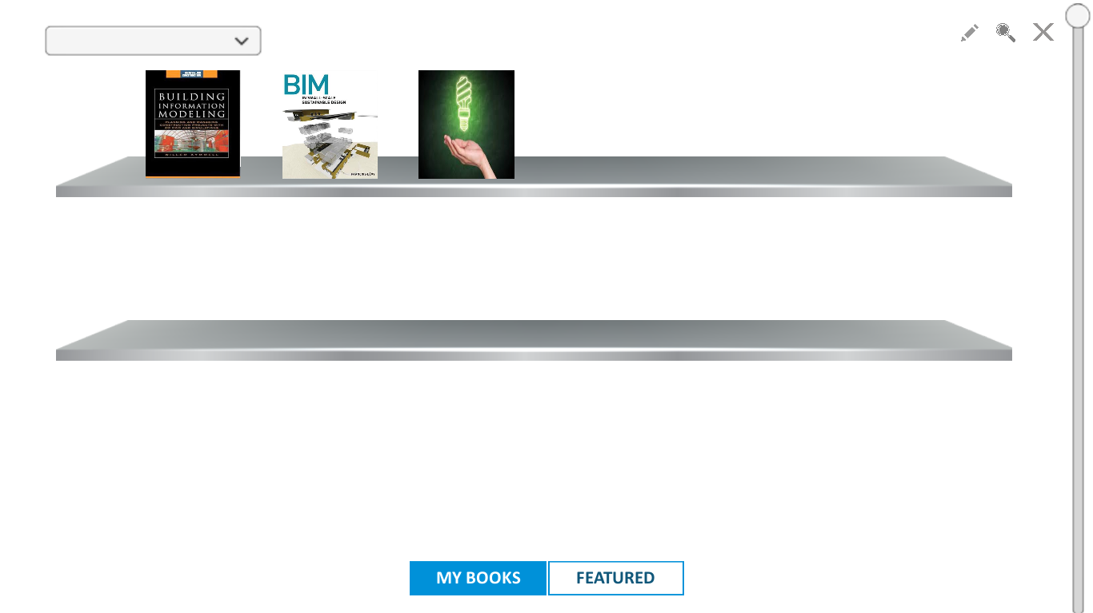

This is the contents page for loaded book.

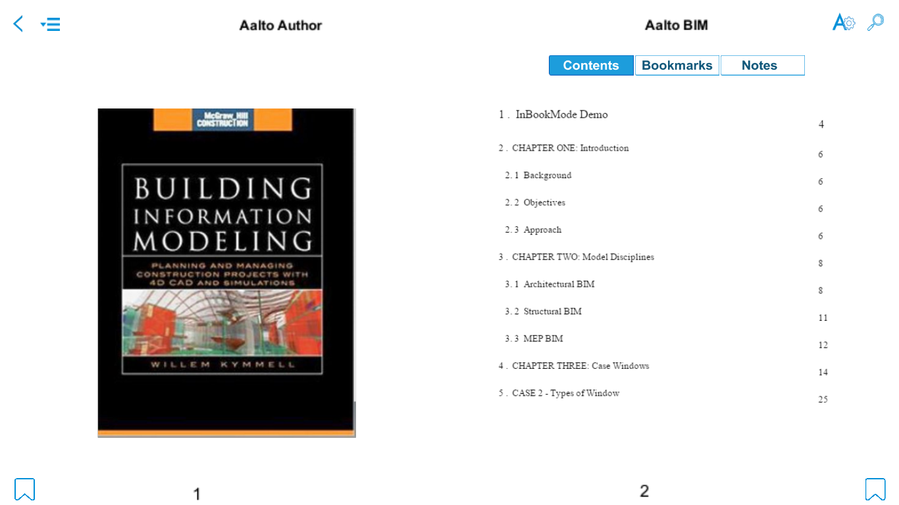

This is a mini 3D preview on the specified 3D element image link.

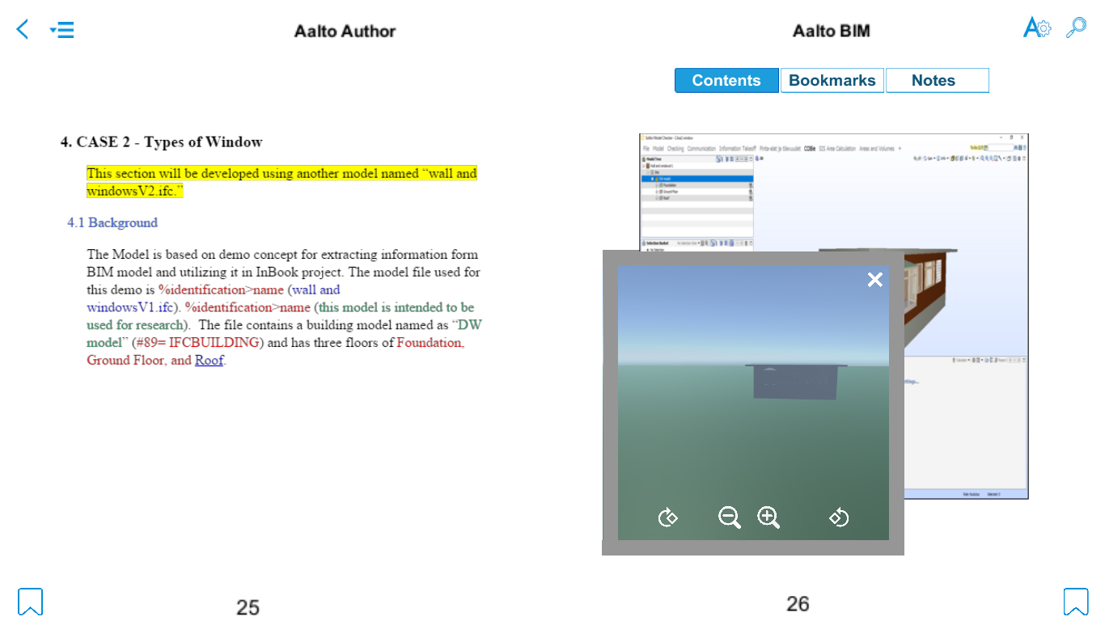

This is the First person Character mode to view the Loaded Model.

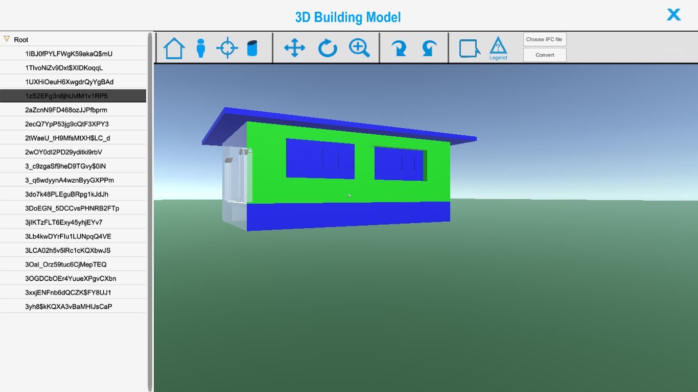

This is object selection in Third person mode.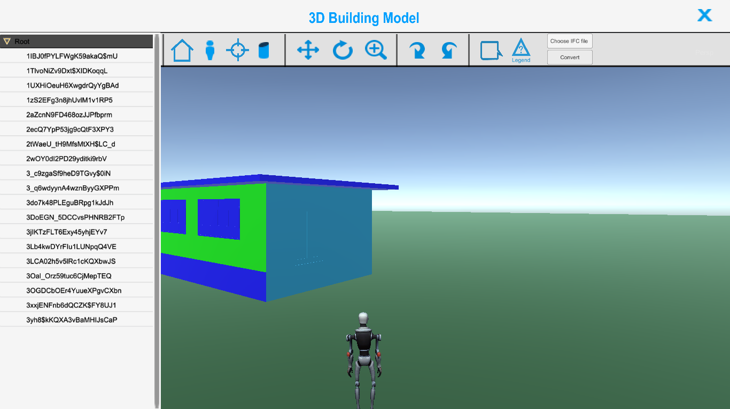

This is the Dissection mode to slice any 3D Model from any angle and position.

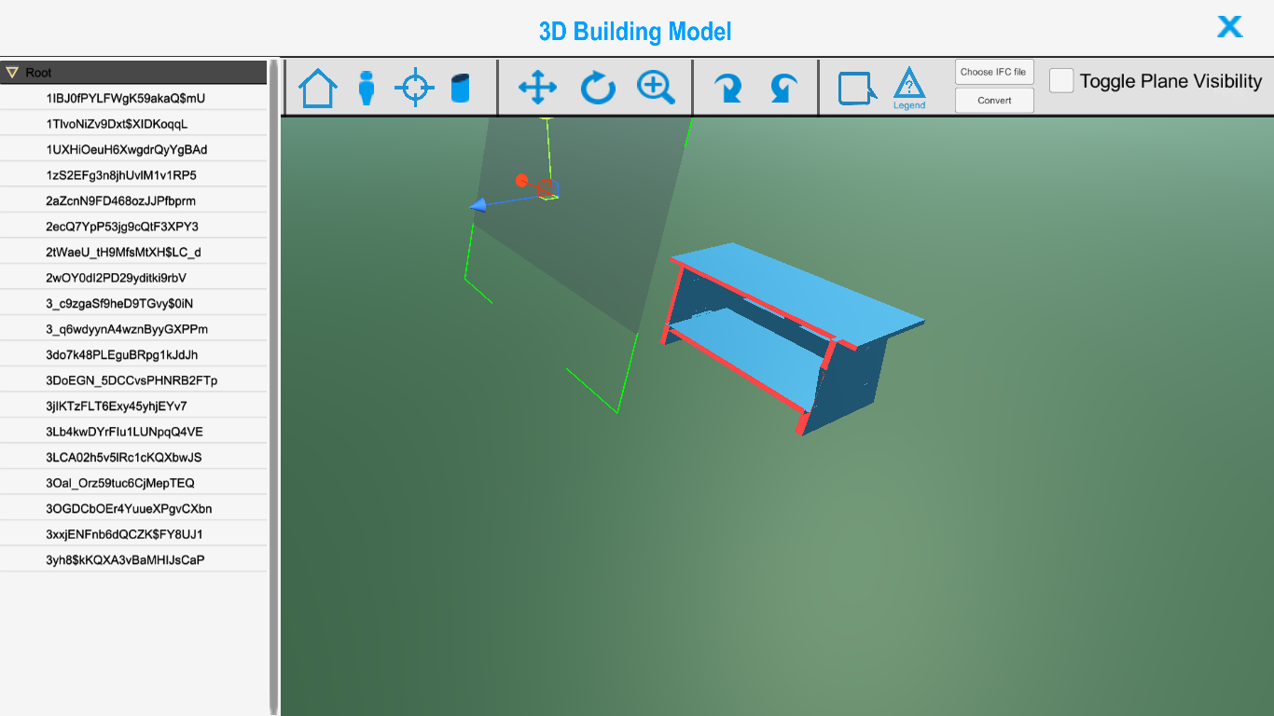

This is Third Person mode and also chat mode enabled. Other users can connect to same 3D model room.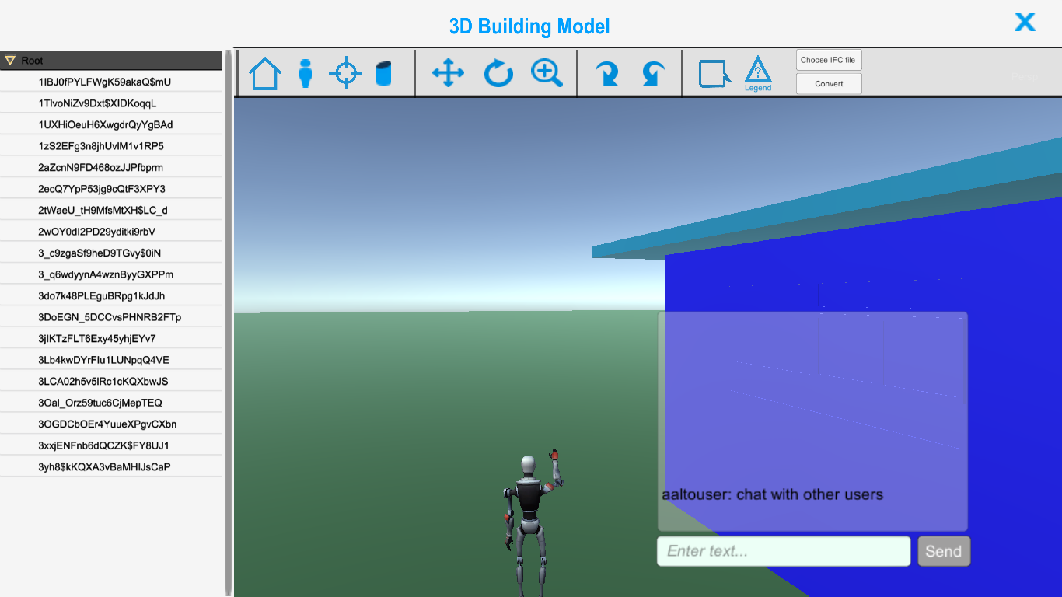This is image tagging on selected element from 3D scene, viewable and further editable by other users in same room.

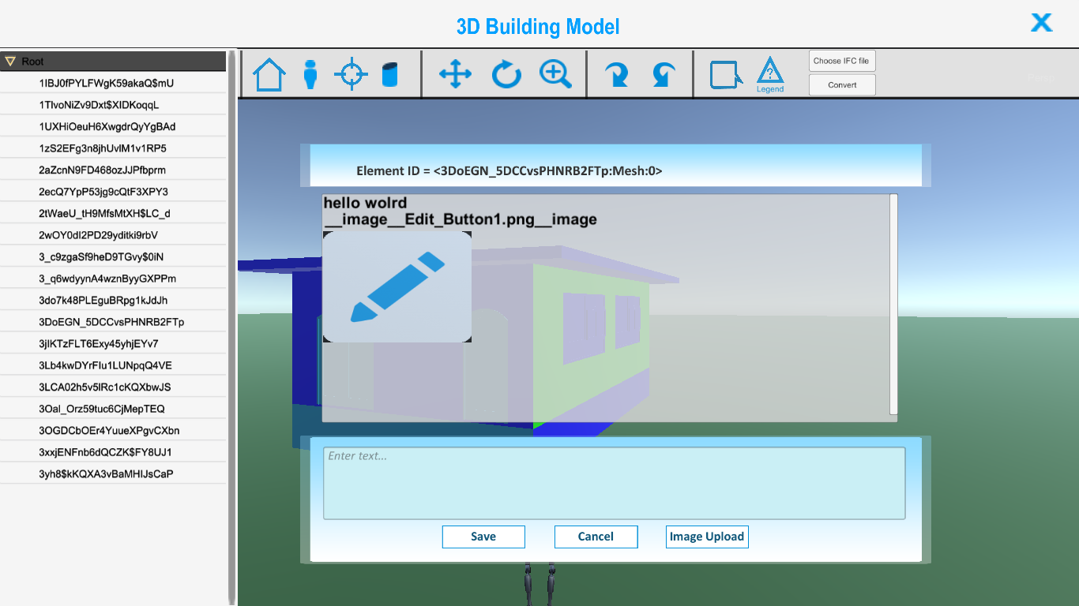

This is an element based guid preview on left and its description and properties on the right.

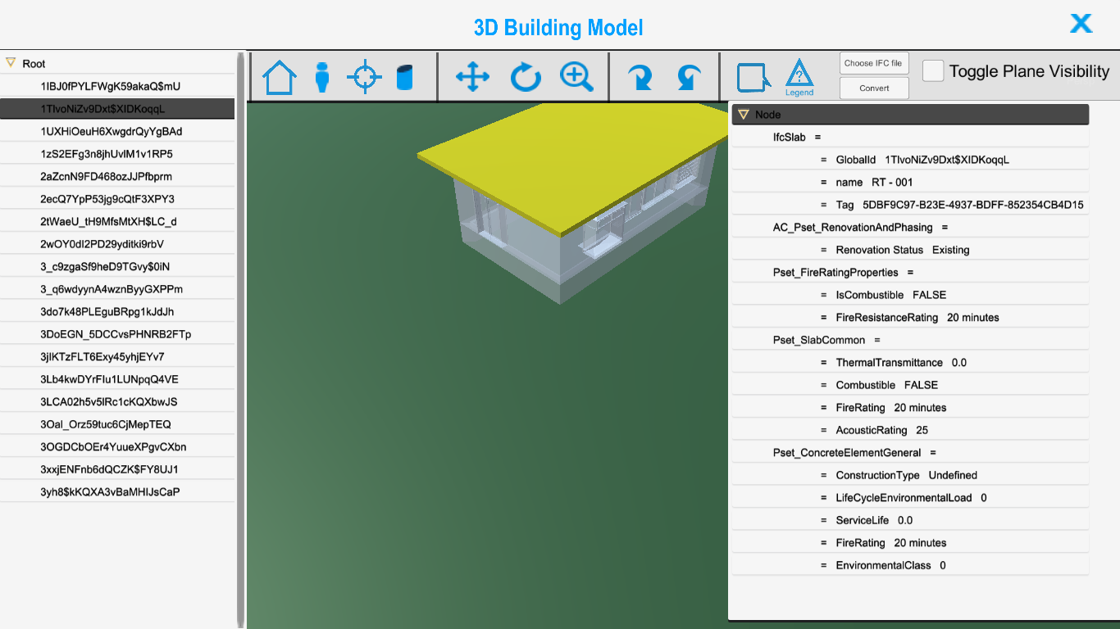

**4. Video Tutorials and Links:**

Watch the tutorials below for in depth knowledge and usage of InBookModE Front End.

1. Start the InBookModE application and Login / Register and Browse from a vast collection of featured Books or private books on the bookshelf. One can also search or delete books.

[http://inbookmode.aalto.fi/tutorial/1-bookshelf.mp4](http://104.199.55.146/tutorial/1-bookshelf.mp4)

1. Use the tools like Notes, Zoom, Bookmarks and settings panels for customization/personalization of reading experience. Take Screen Shots with F9 or F10 keys and store the images to disk in %appdata% (LocalLow\Aalto University\InBookModE) folder.

(Also Convert IFC files to FBX files with 2 easy steps at runtime from inside the 3D front end application.)

[http://inbookmode.aalto.fi/tutorial/2-Interface.mp4](http://104.199.55.146/tutorial/2-Interface.mp4)

1. Hover over Images with predefined links to see 3D models in a mini preview real-time before viewing in a full screen window for full inspection. Click on Specified links with GUIDs to preview a specific element highlighted and located somewhere on the Model. Right mouse click to get the Specific element GUID related properties from the BIM Server.

[http://inbookmode.aalto.fi/tutorial/3-3D_Links.mp4](http://104.199.55.146/tutorial/3-3D_Links.mp4)

1. To inspect the model closely or Image and message Tag an element first select the First person Mode and for further interaction with other users of InBookModE, Use the Third person Mode to Chat message , Image Tag on 3D elements specific information pertaining to that element. When In Dissection Mode you can use the Cutting Plane to cut and preview the models sliced at specific angles.

[http://inbookmode.aalto.fi/tutorial/4-3D_FPS_TPS_image_tag_chat.mp4](http://104.199.55.146/tutorial/4-3D_FPS_TPS_image_tag_chat.mp4)

Watch the tutorials below for in depth knowledge and usage of InBookModE Back End.