This is the instruction manual with screenshots for Quiz Creation from the backend and Quiz application.

**Table of Contents:**

|  |  |  |
| --- | --- | --- |
| **Sr. No** | **Index** | **Page No.** |
| 1. | How to Add A new Quiz | 2 |
| 2. | Adding Questions to a Quiz by using a Question Pool | 3 |
| 3. | Adding questions to Question Pool | 4 |
| 4. | Assigning a quiz to Specific users | 5 |
| 5. | View the reports for attempted quizzes | 5-6 |
| 6. | Review and Scoring Answers | 6 |
| 7. | Emailing Reports to Specific users | 7 |
| 8. | Using the Mobile Quiz Application | 8-10 |

**How to add a new Quiz:**

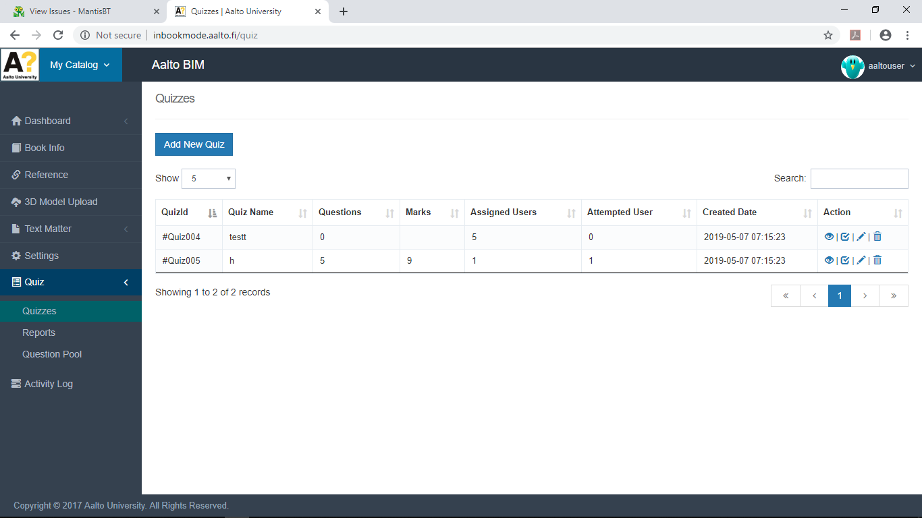

Here one can add a New Quiz.

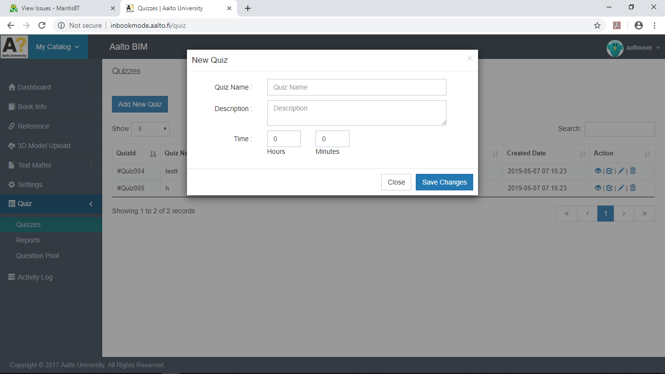

After entering Quiz name , Description and Time one can then save the Quiz.

**Adding Questions to a Quiz by using a Question Pool:**

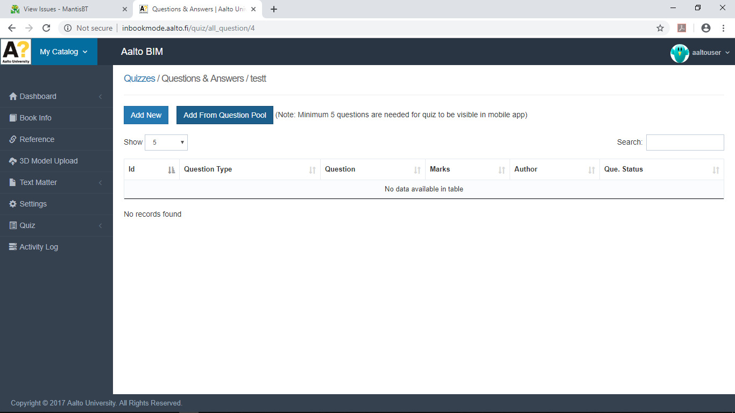

Choose from Addding new questions or Selecting Questions from the pool.

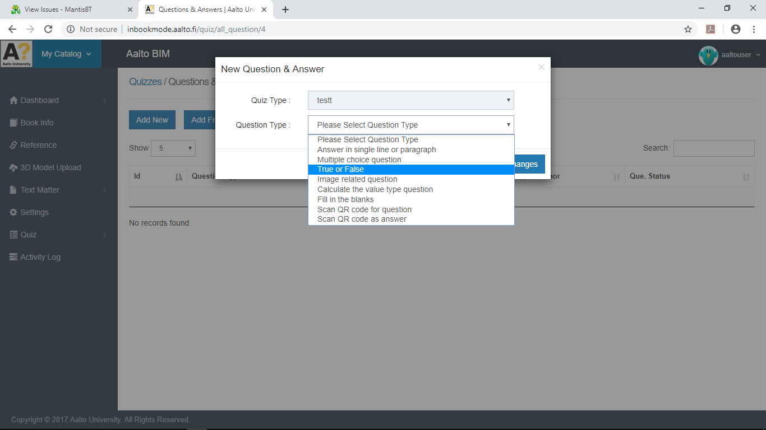

To add a Question , Choose Question Type type, Enter details and Save changes.

**Adding questions to Question Pool:**

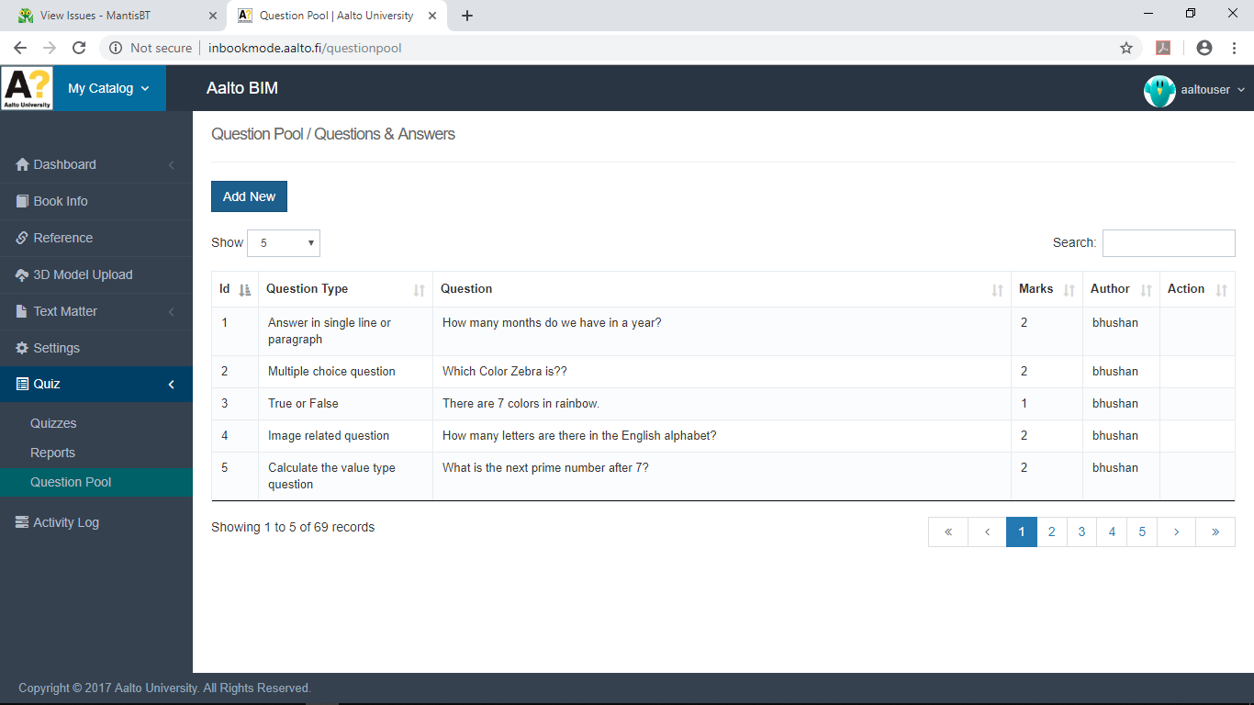

This is the Question Pool. It contains all the Questions of all users.

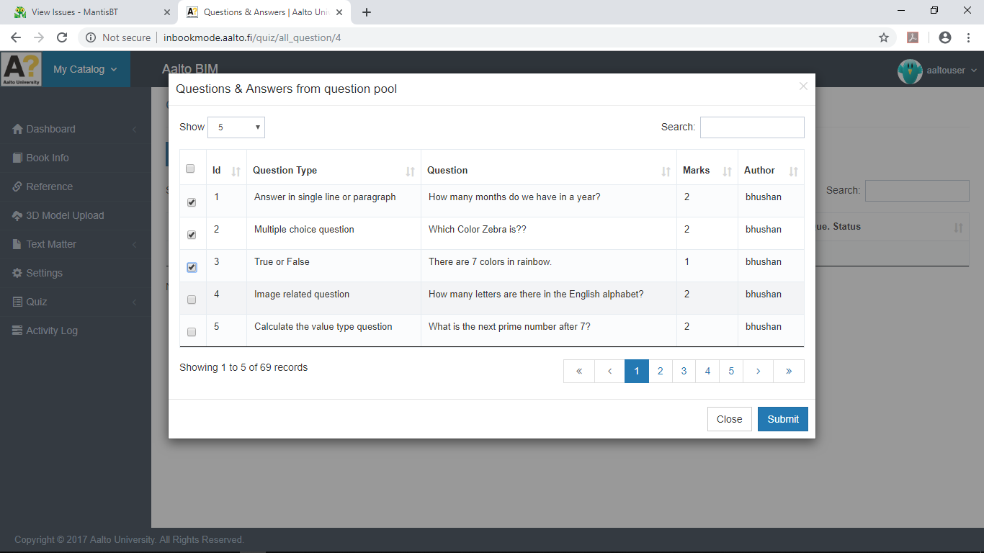

Here one can add Questions to the quiz from the Question Pool

**Assigning a quiz to Specific users:**

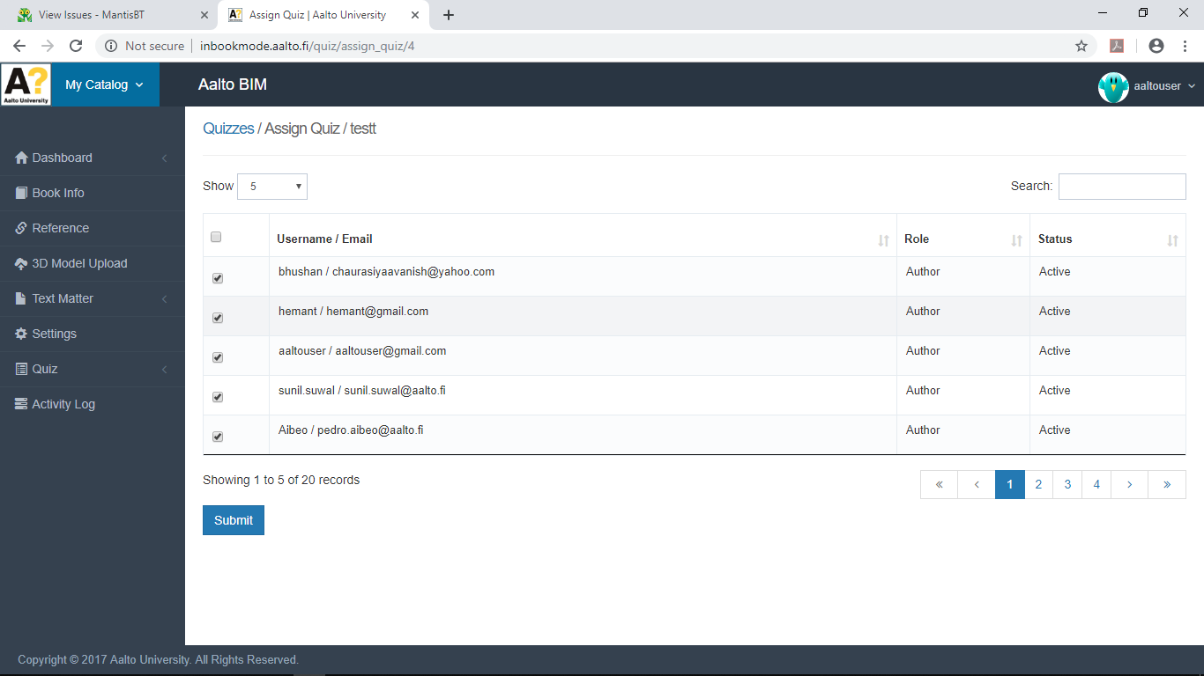

Assign a Quiz to specific users or all users.

**View the reports for attempted quizzes:**

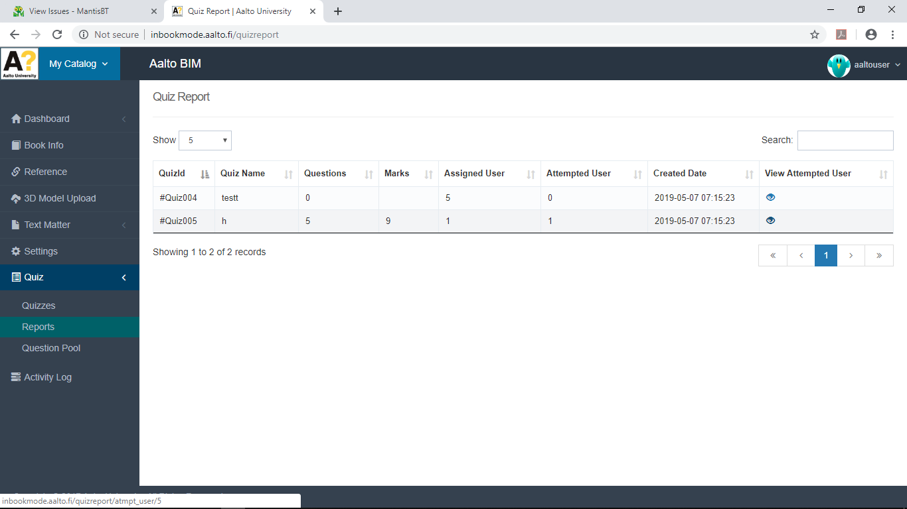

See The Reports for an attempted Quiz here.

**Review and Scoring Answers**:

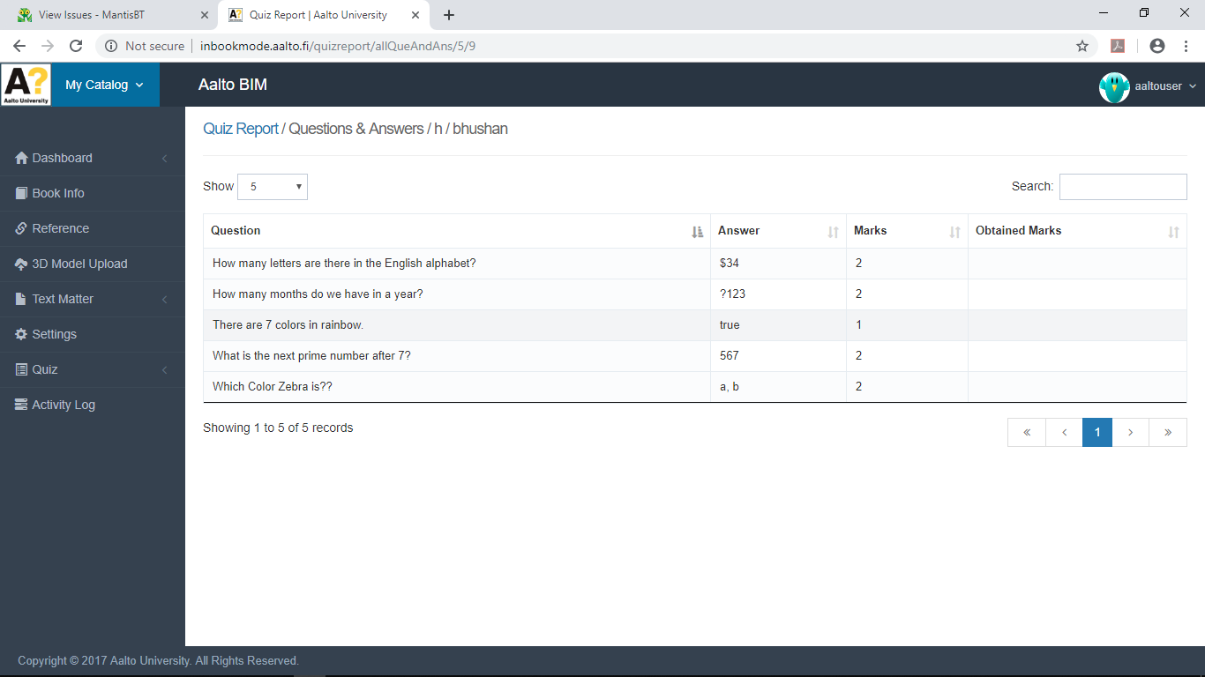

Here the answers are reviewed and scored.

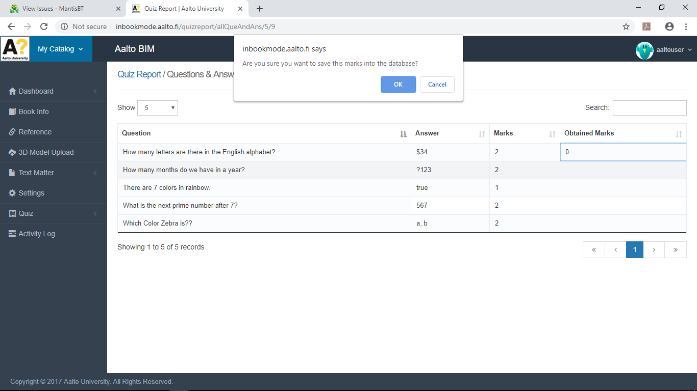

Scoring is done to individual answers.

**Emailing Reports to Specific users:**

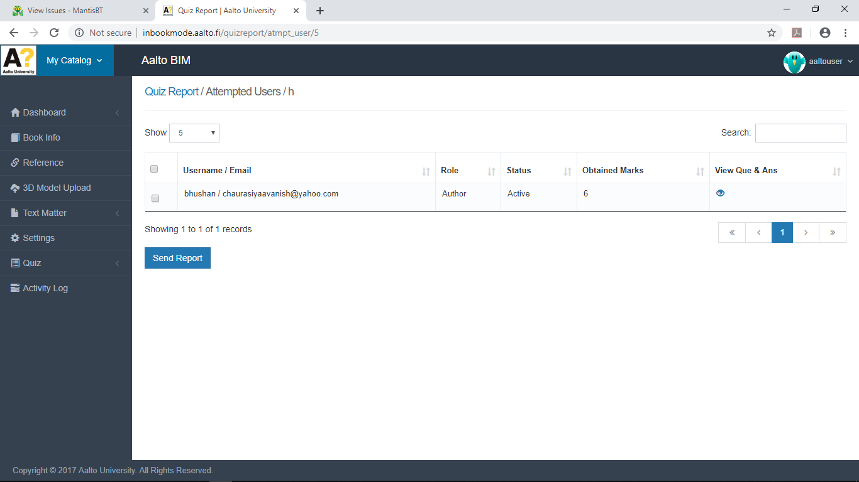

After reviewing a quiz, the report can be emailed to specific users.

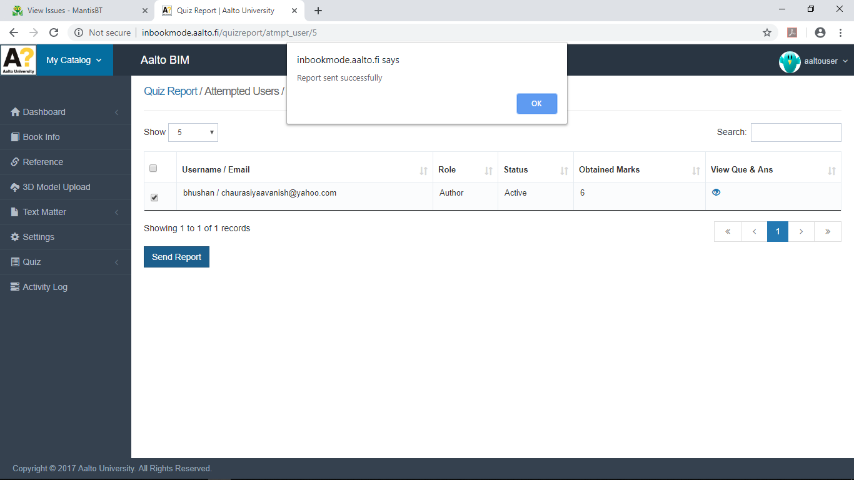

The Report can be sent by clicking on Send Report.

**Using the Mobile Quiz Application:**

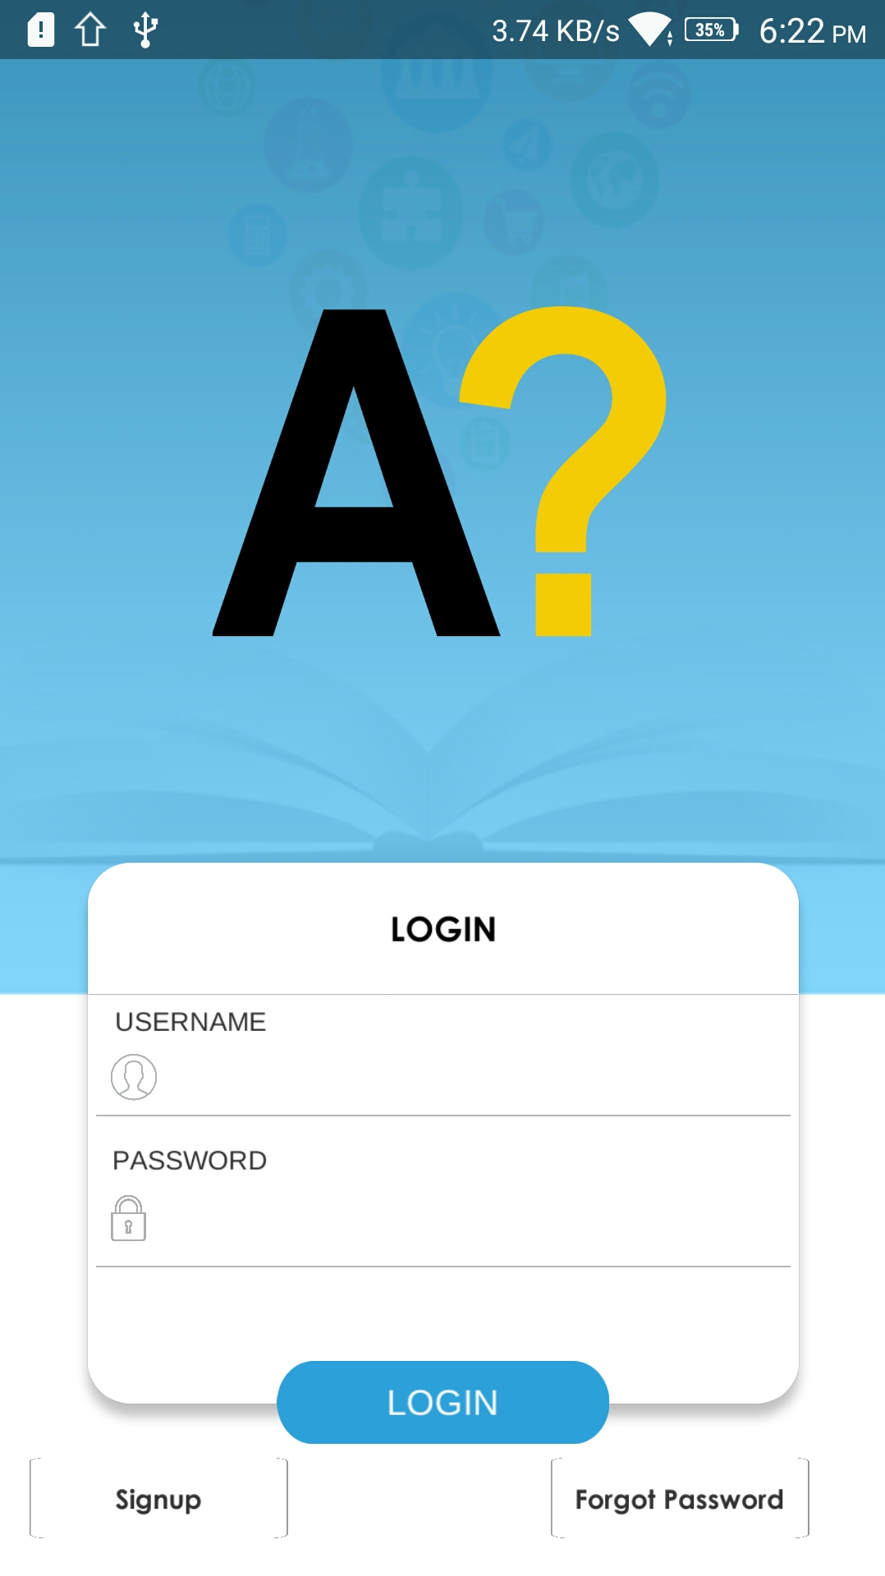

Login From this page.

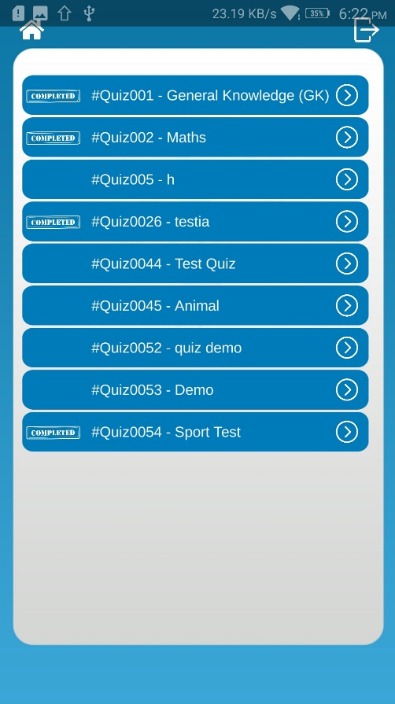

View Available Assigned Quizzes for that user. Select one to begin.

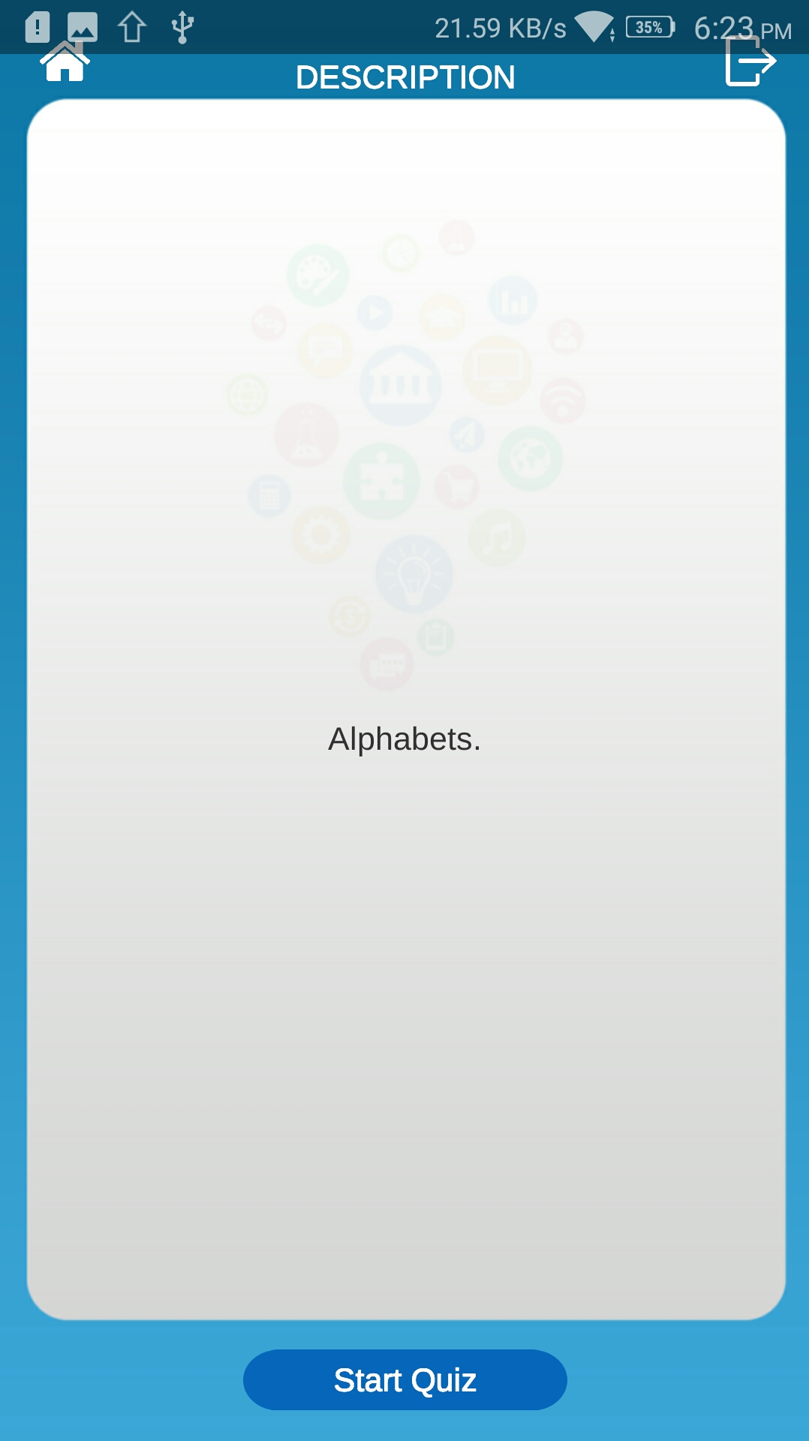

Click on Start Quiz to begin.

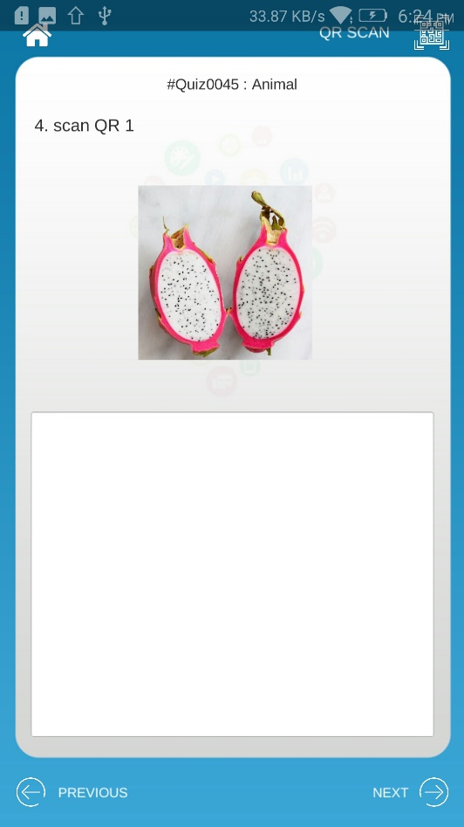

This is a sample Quiz Question with an image and the QR Code Scan option.

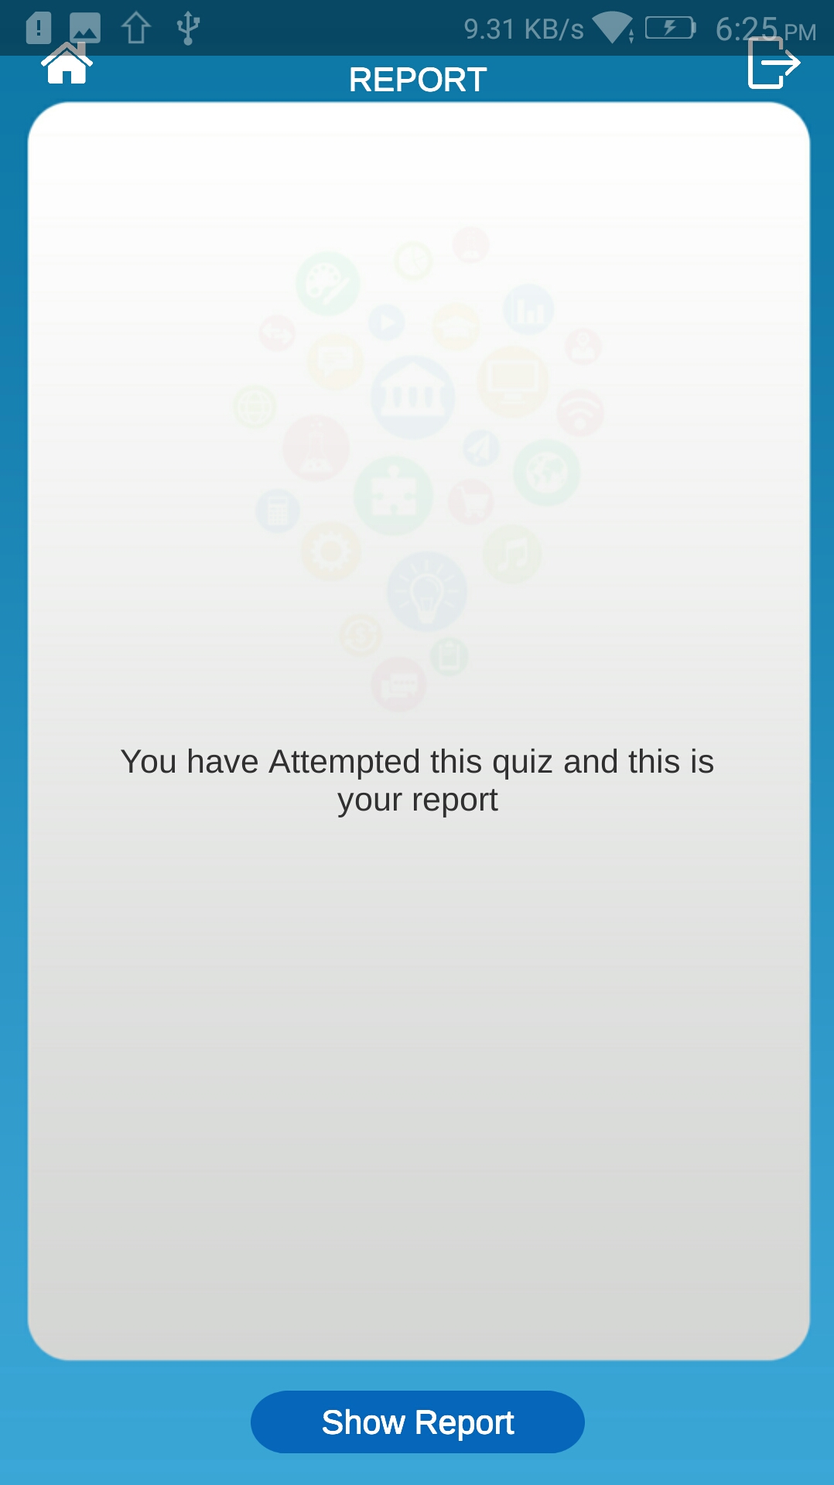

After submitting the quiz, reopening the same quiz will take you to the Show Report Page.