**INT-402**

**MODERN WEB PROGRAMMING TOOLS & TECHNIQUES**

**BLOOD BANK**



## Under the guidance of Ms. Ankita Wadhawan

**Name: Shaik Aamer Sohel– 11609954 – 18**

I had Implemented these below Modules:

I had Implemented these modules Design part as well as I had Connected Database to these Modules.

## Master Page of the Project.

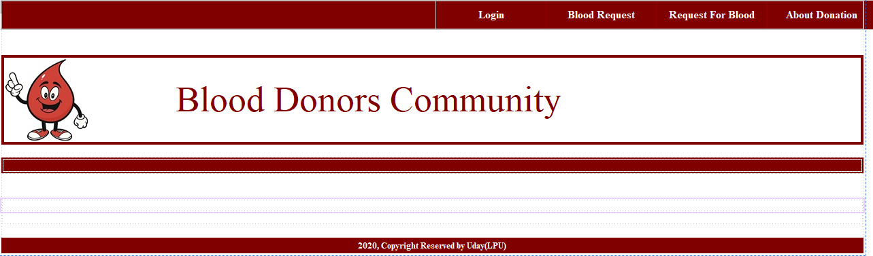

**Master page 2**

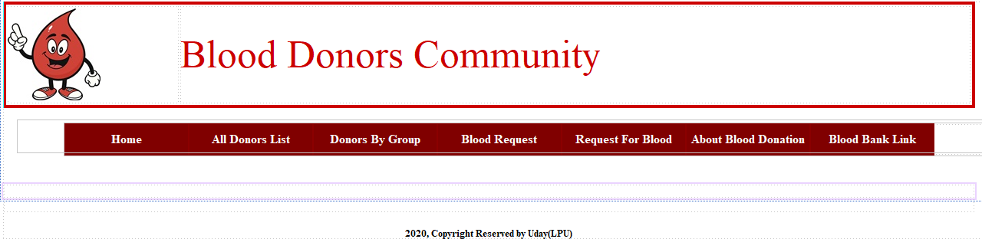

**User Master page:**

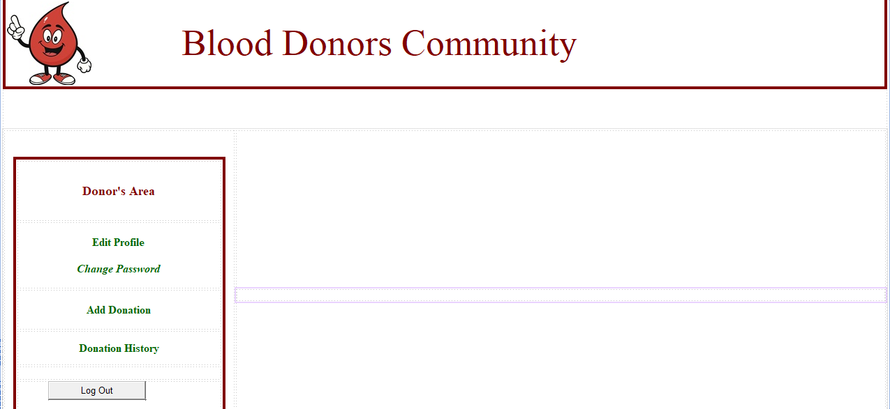

Here user can Donate the Blood to Patient with Details like Blood group and address.

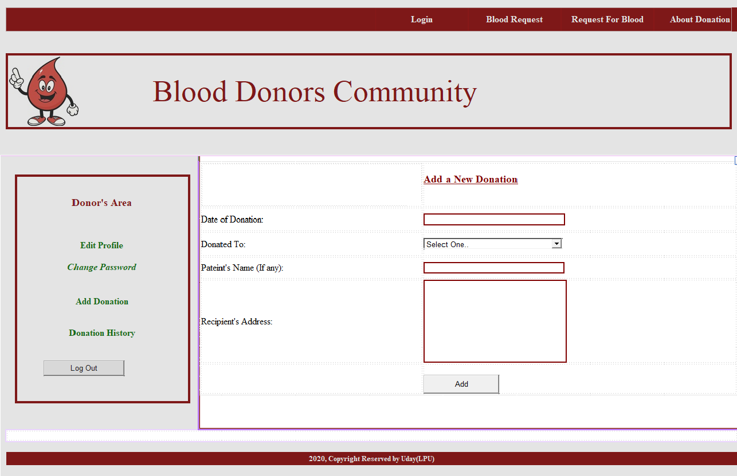

Here user can change his Password.

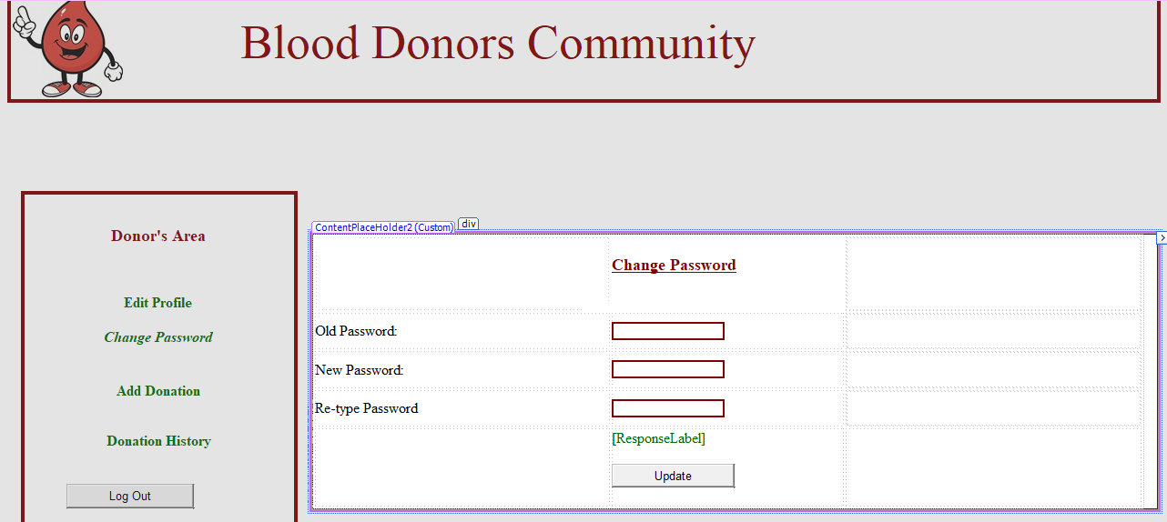

Here user can see his Donation History.

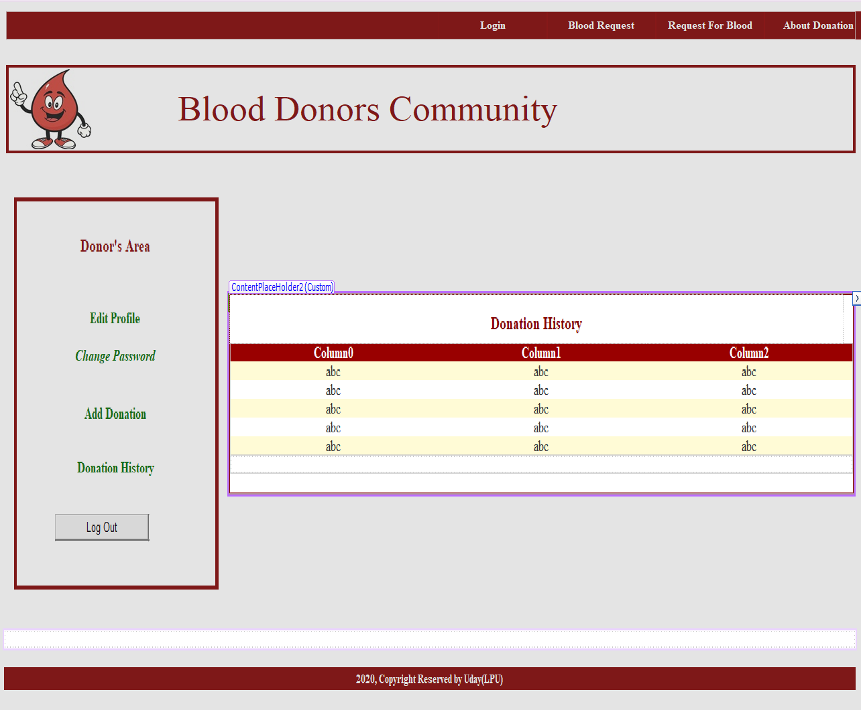

Here User can Edit his profile Details.

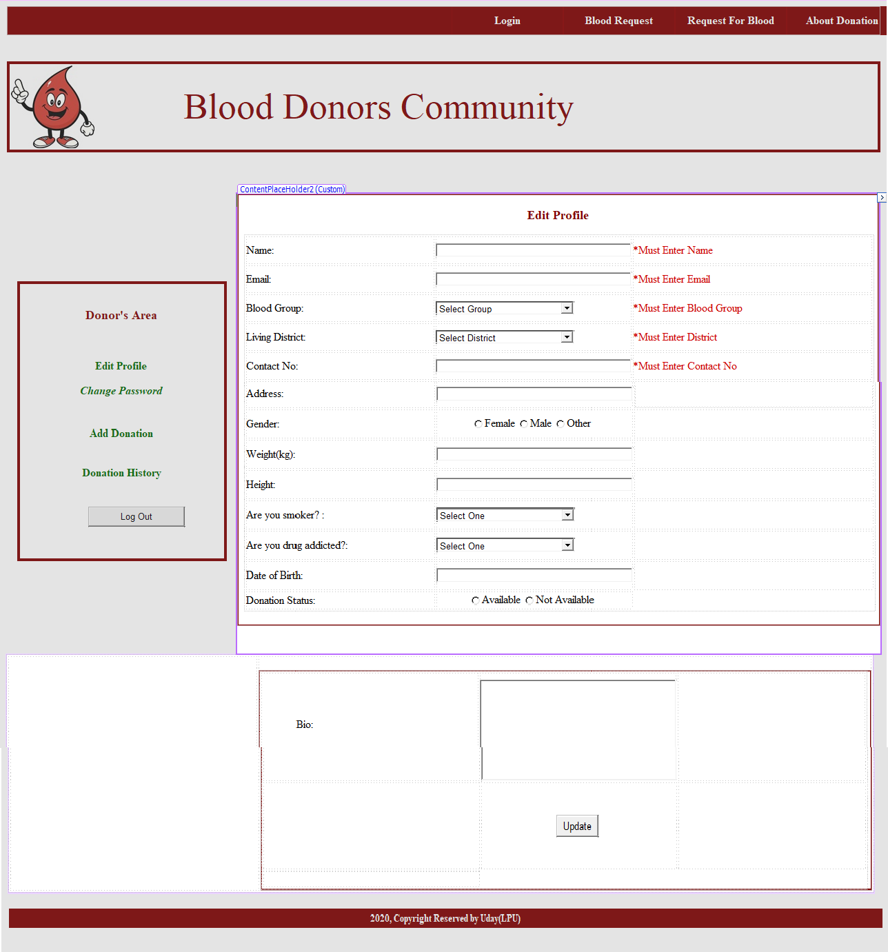

Here user can make a Blood request from Admin.

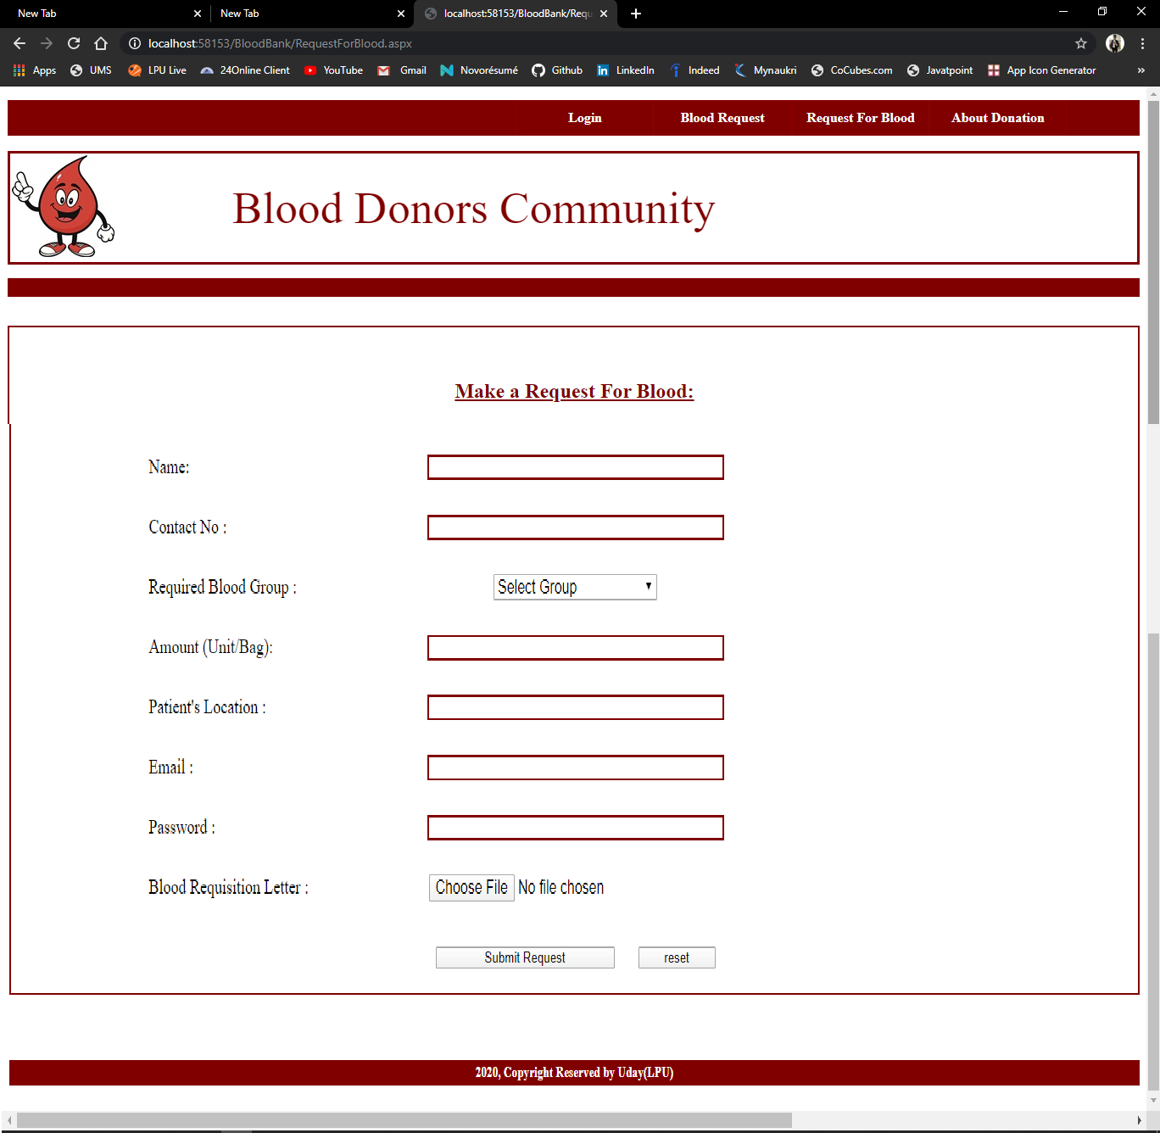

Here We can See About Blood Bank

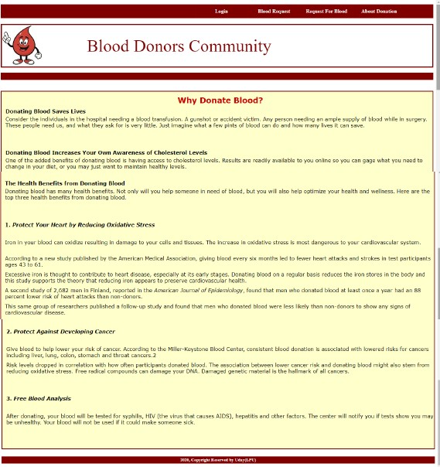

# Name: T Raghu Verma – 11603516 – 42

I had Implemented these below Modules:

I had Implemented these modules Design part as well as I had Connected Database to these Modules.

## Admin Home page.

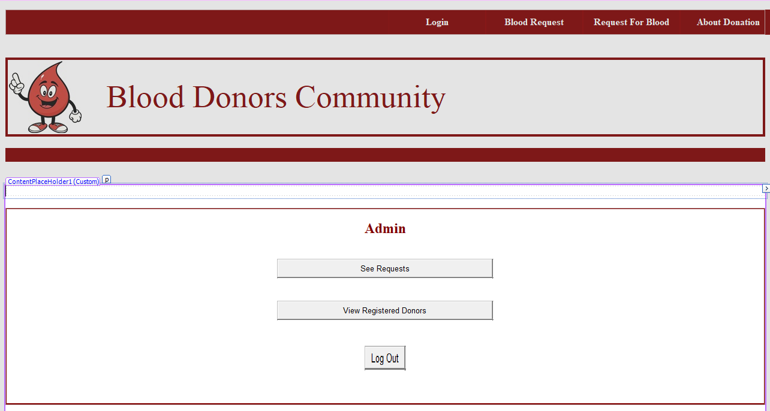

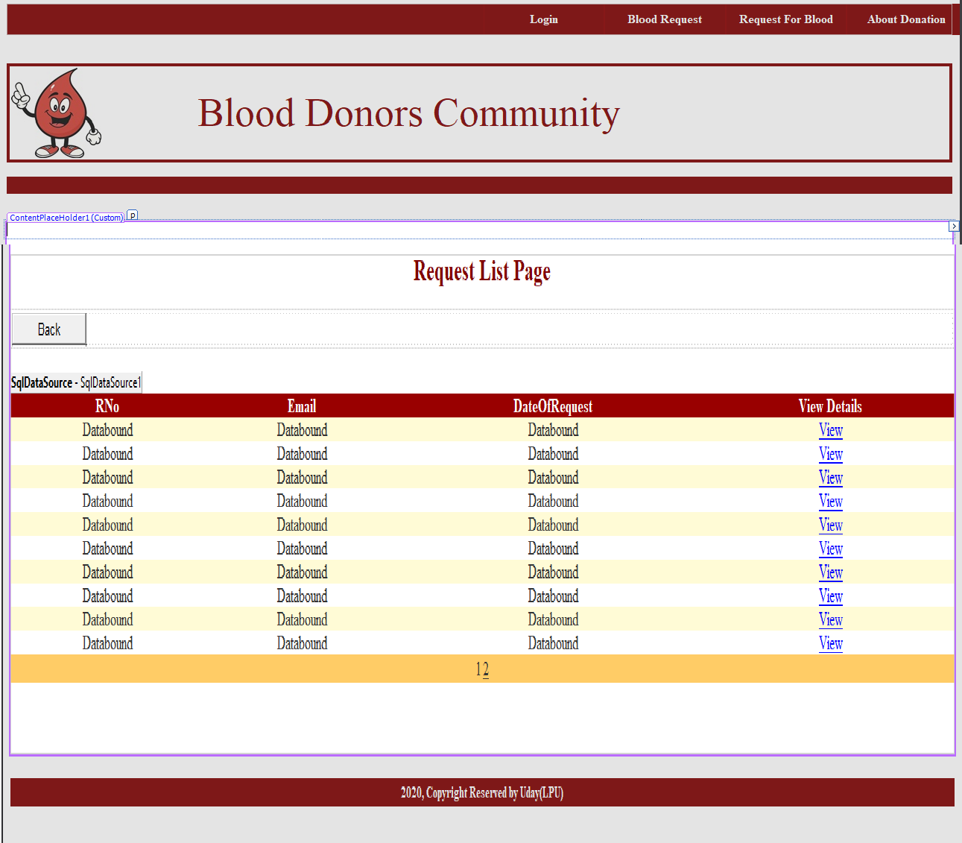**Here Admin Can the See the Blood Requests.**

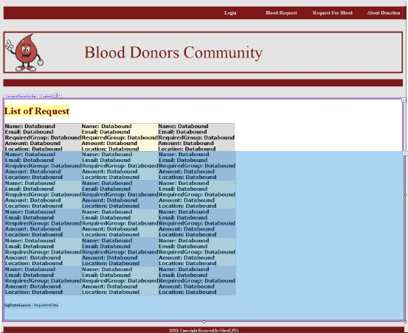

**Here by Clicking on View Admin can see the Full details for request person with that he can Approve or Delete the Request.**

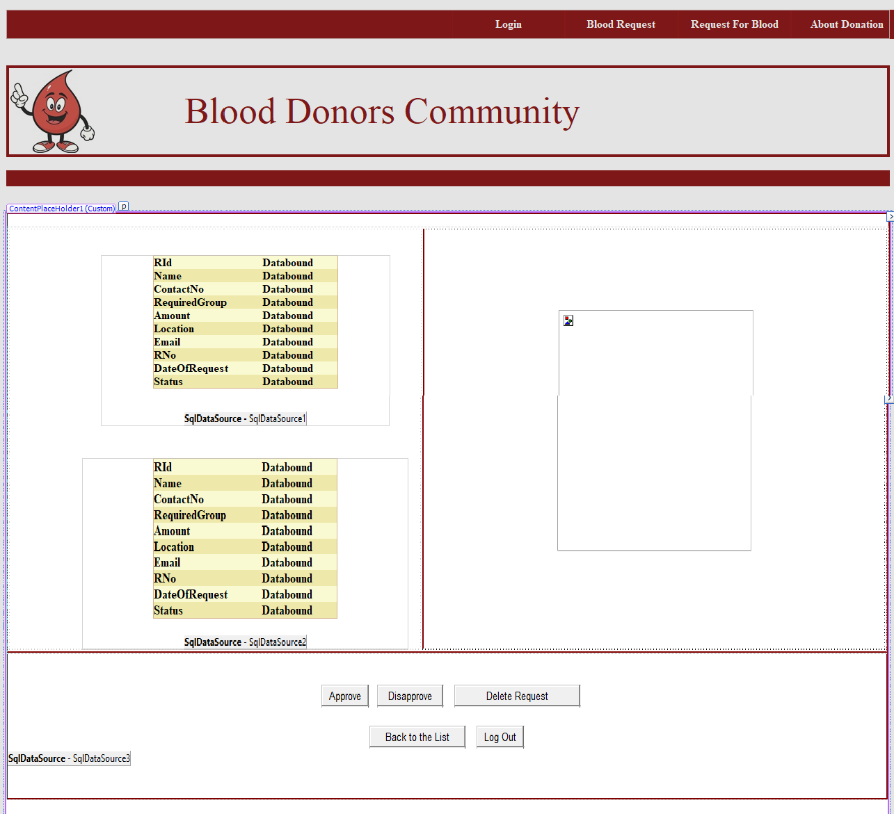

Here Admin can See the registered Donors.

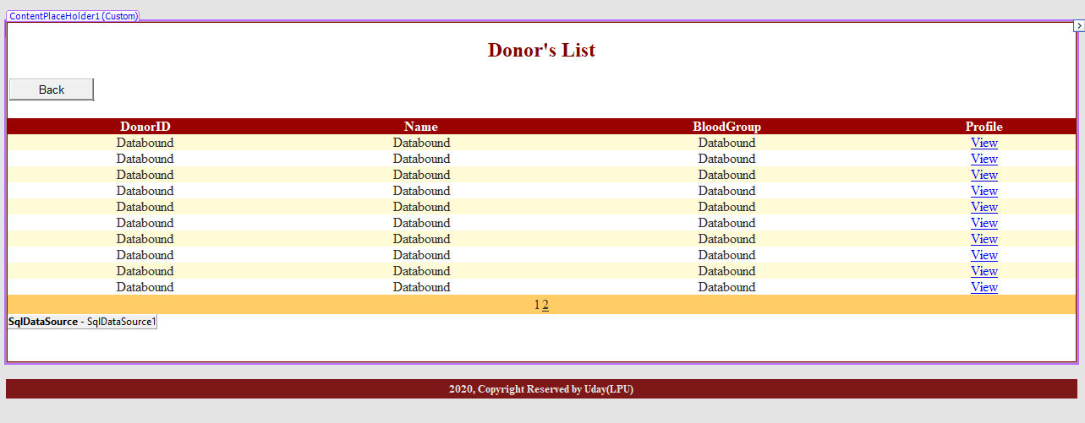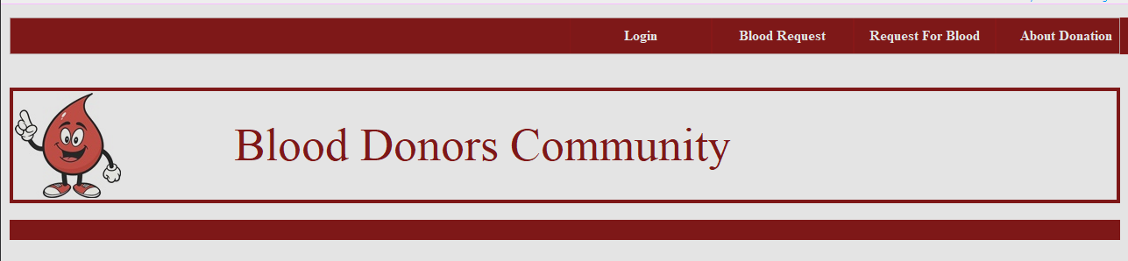

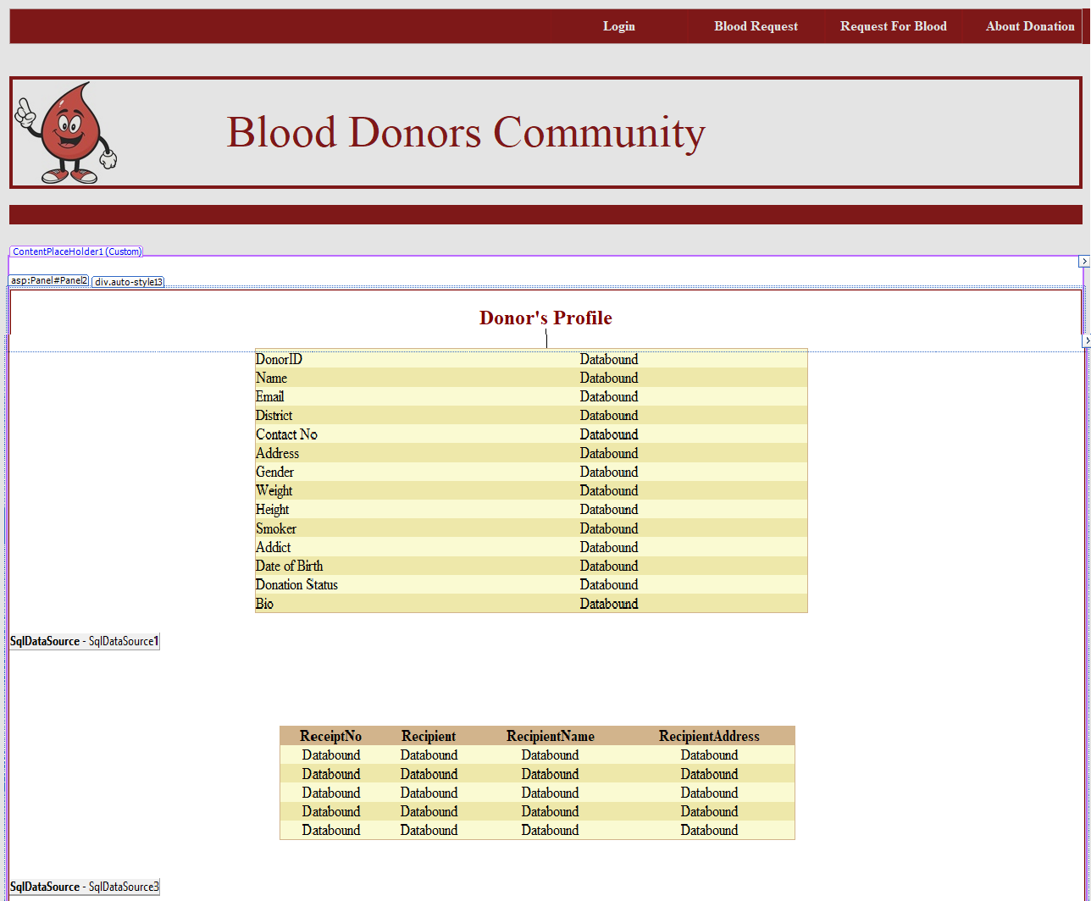Here by clicking on View admin can see the Donor full details.

# Name: K.Santosh – 11609705 – 59

I had Implemented these below Modules:

I had Implemented these modules Design part as well as I had Connected Database to these Modules.

## Blood Requester Home page.

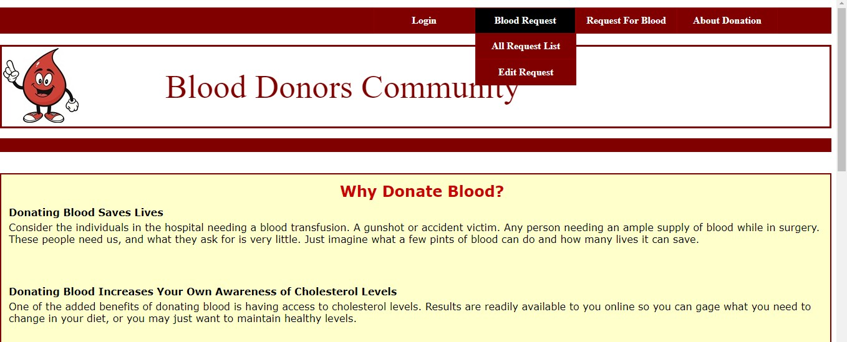

**Here Blood Requester After Register Can login here.**

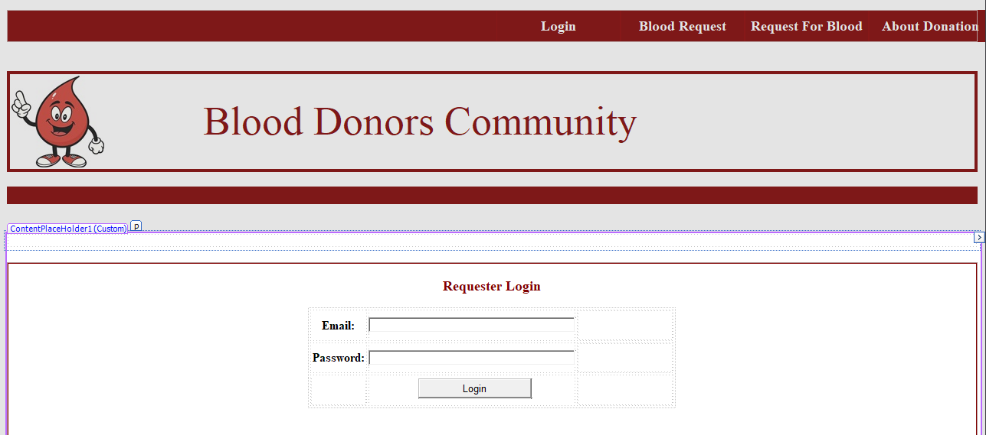

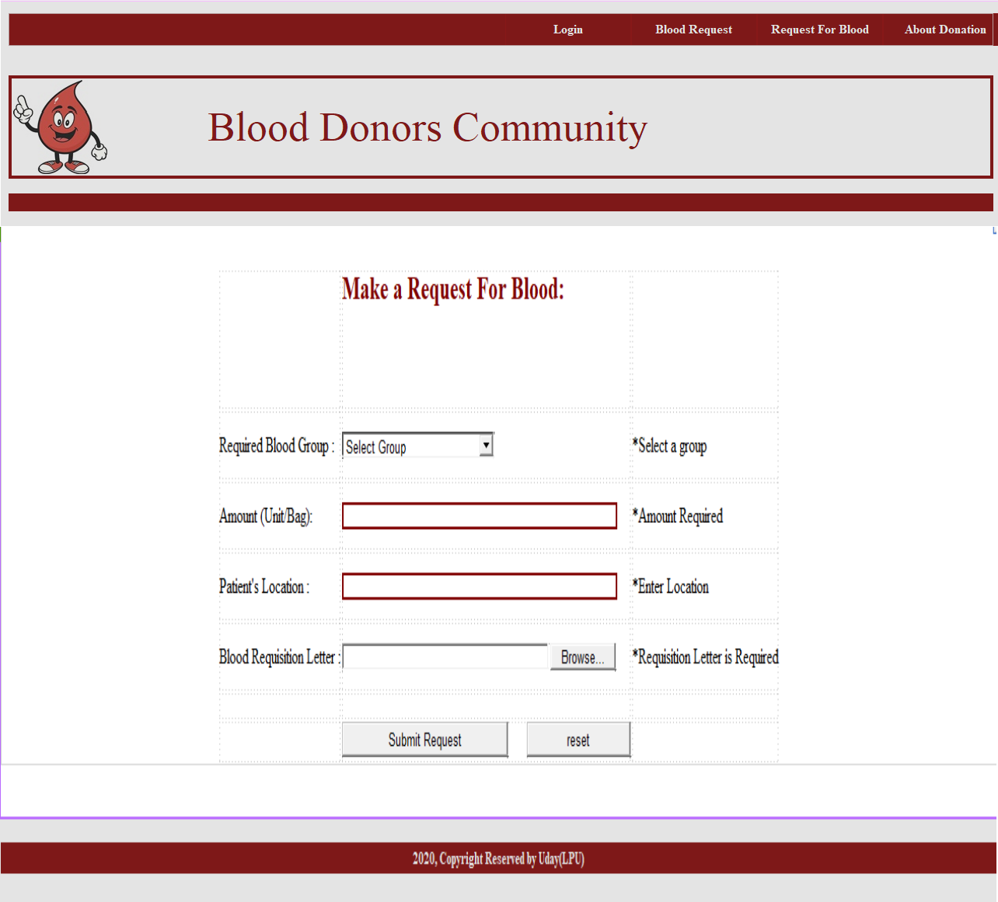**Here Requester can make a request.**

**Here Requester can edit his previous or Add new requests.**

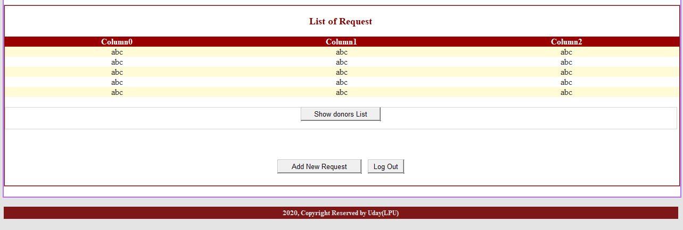

**Here requester can search the Blood donor by District wise.**

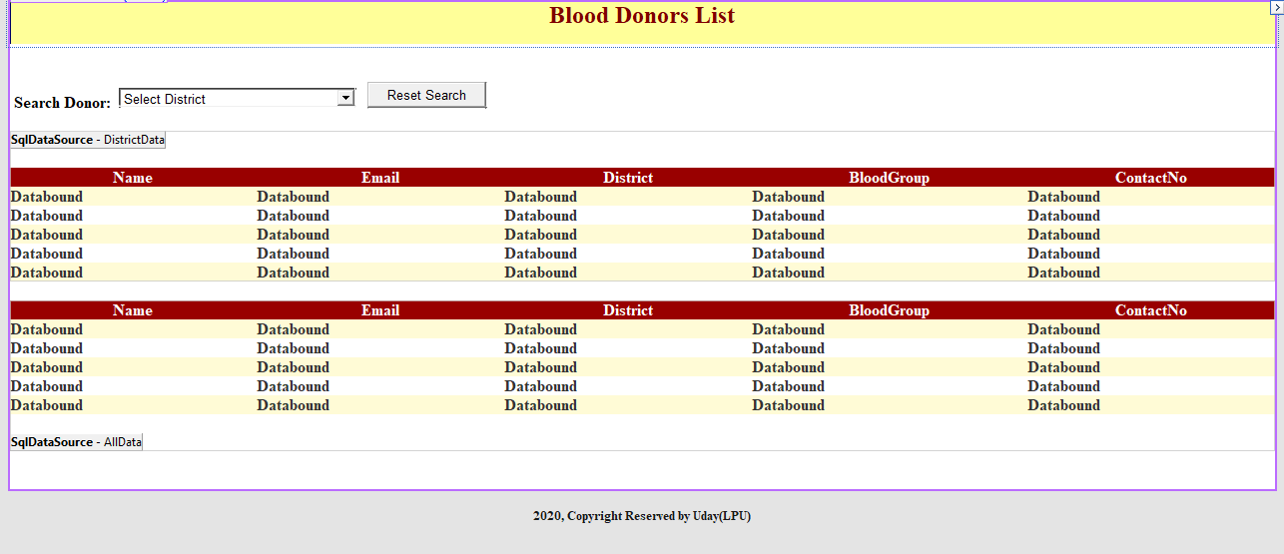

**Here requester can see the donor list.**

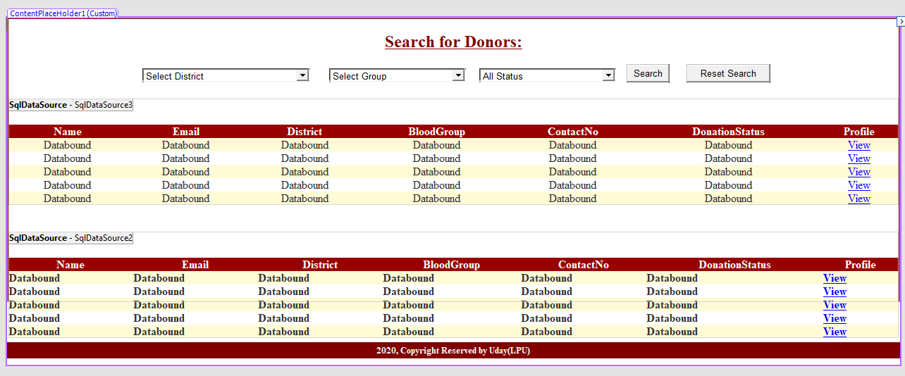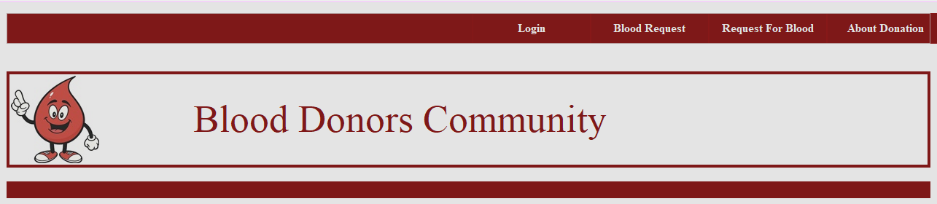

**Here requester can view the donor details and history of donor.**

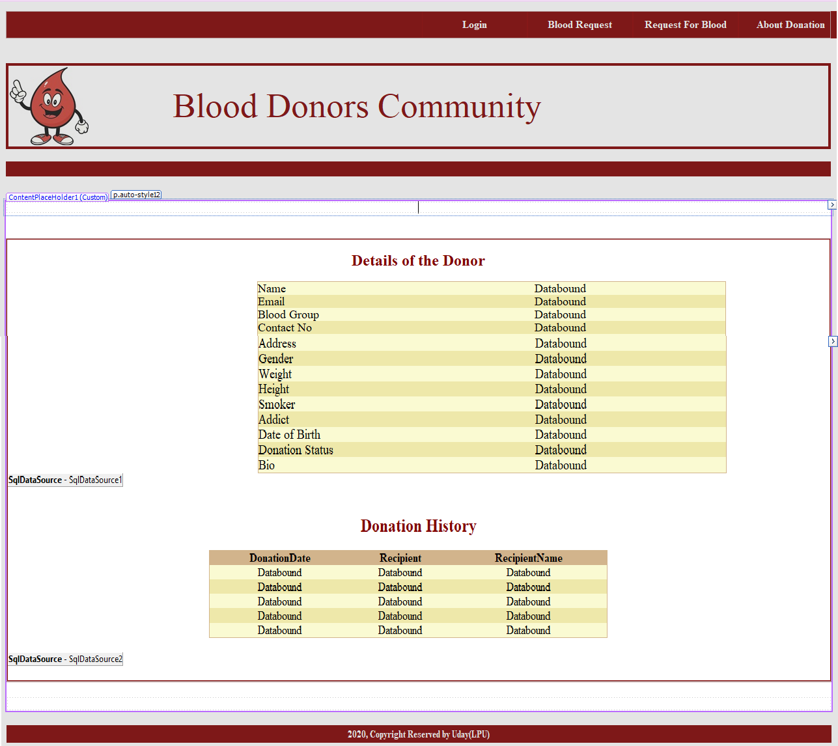

**Name: Shivaram– 11603602–**

I had Implemented these below Modules:

I had Implemented these modules Design part as well as I had Connected Database to these Modules.

## Here user and requester Can Register into the Website.

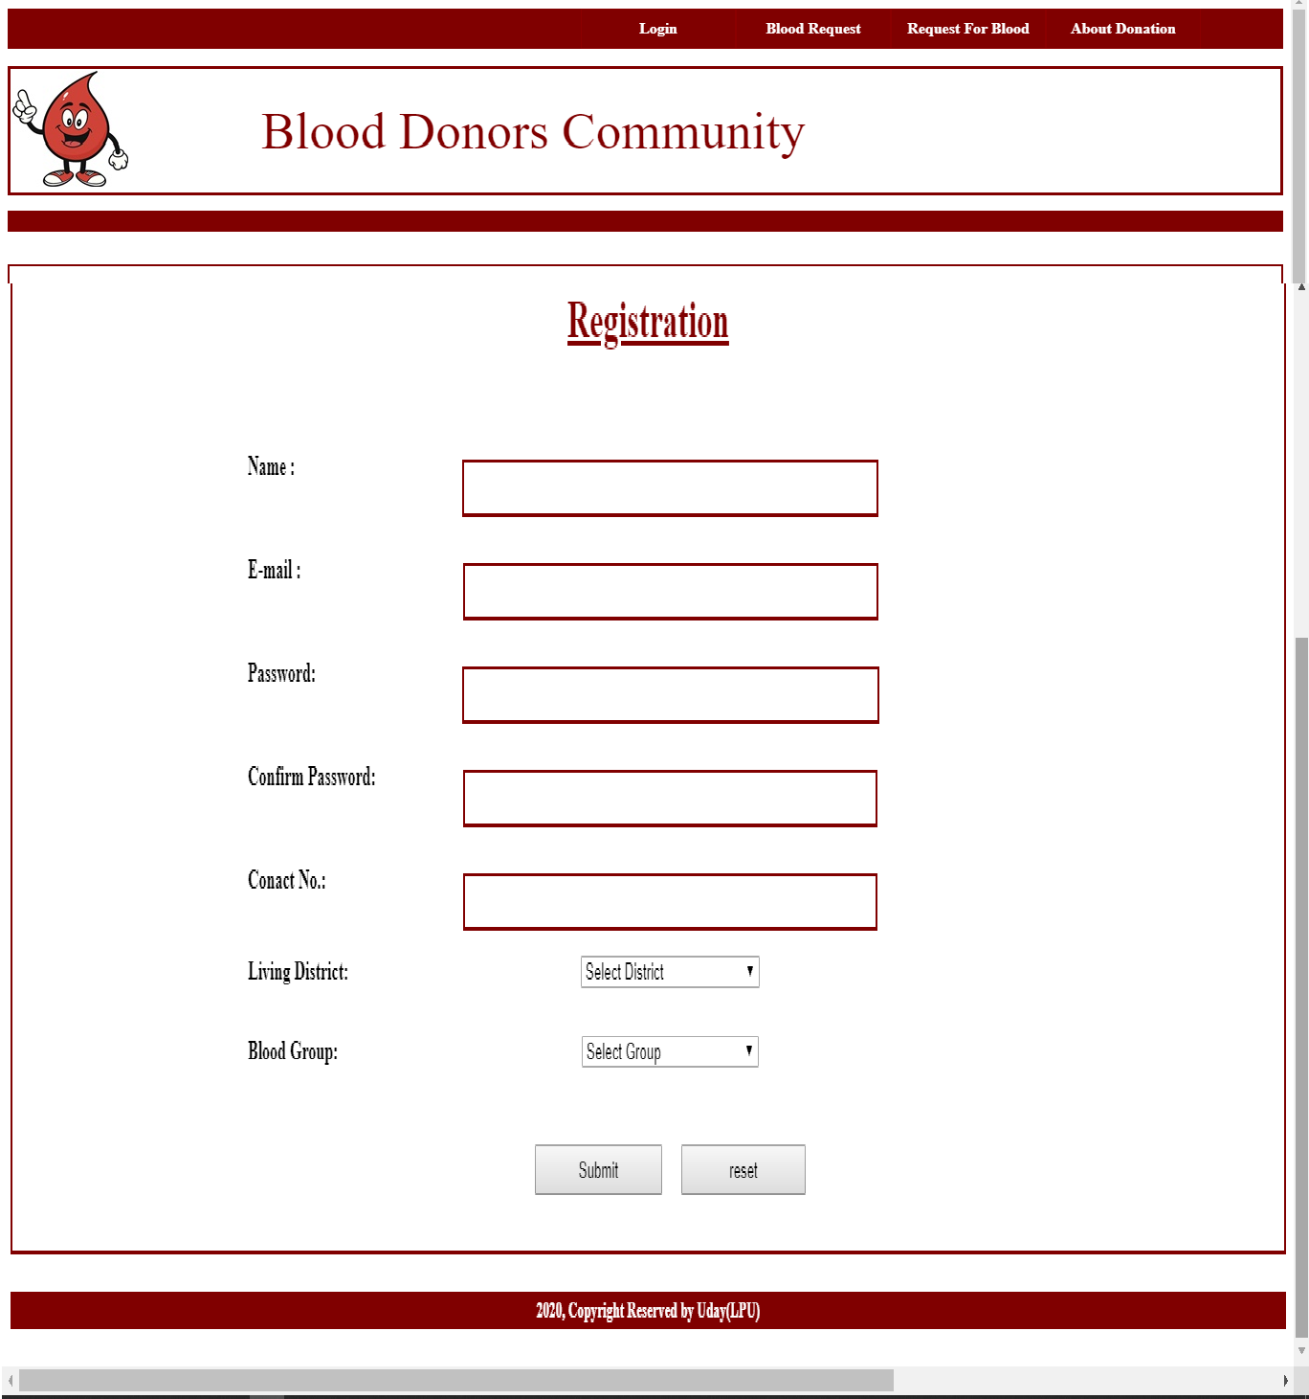

Here user and Requester can login.

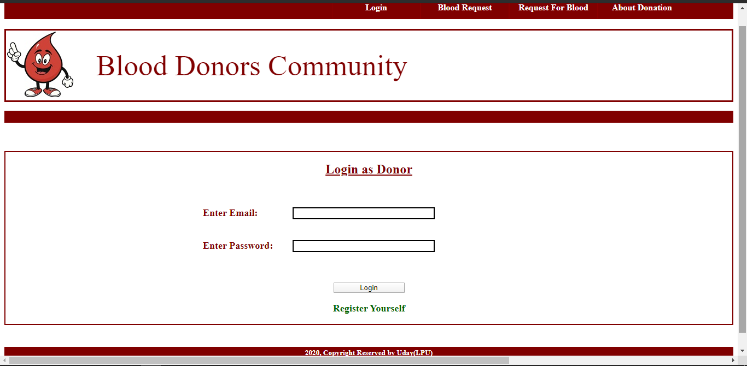



## User and requestercan Search for Donor by Group wise.



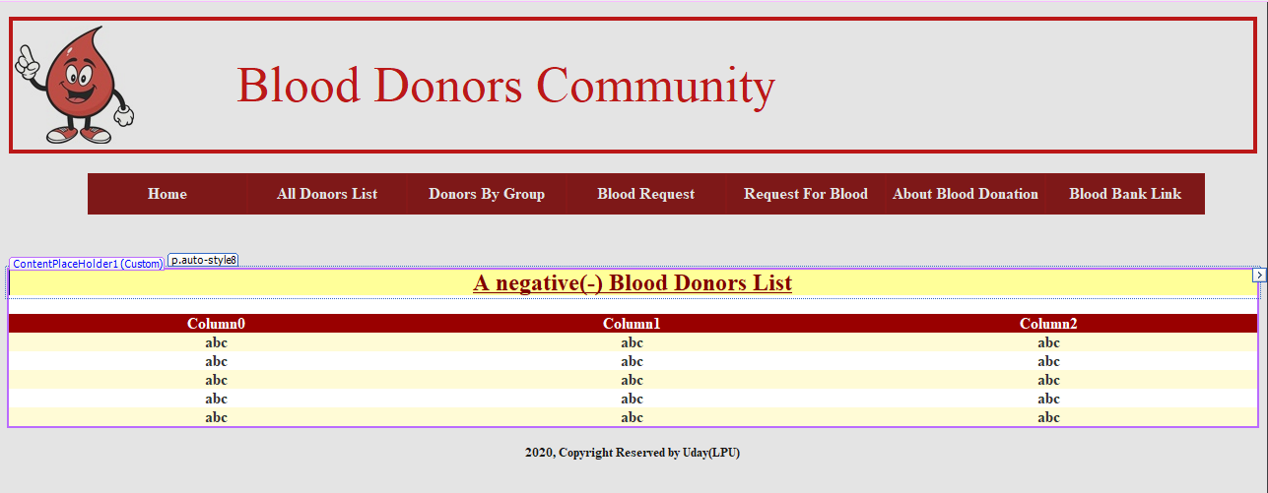

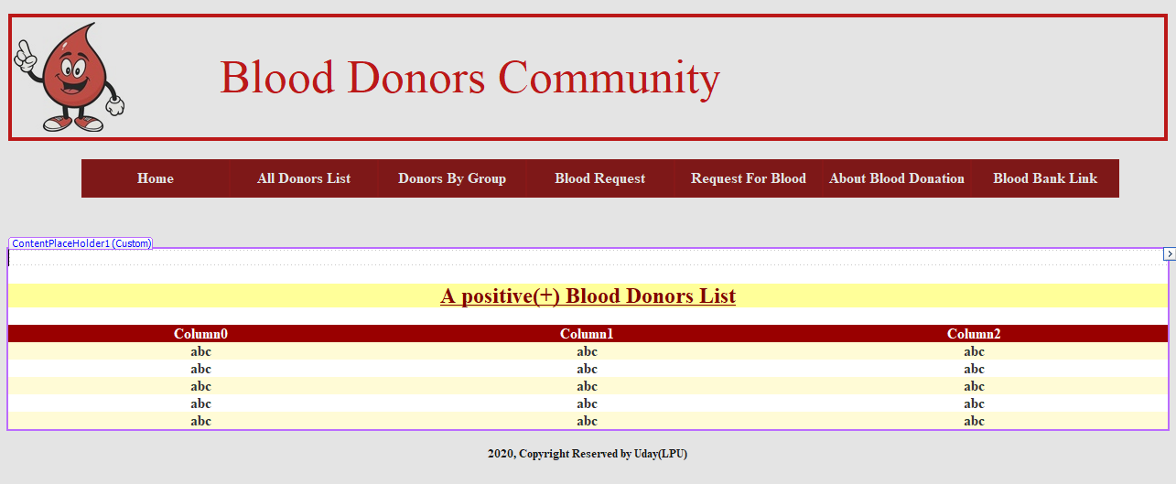

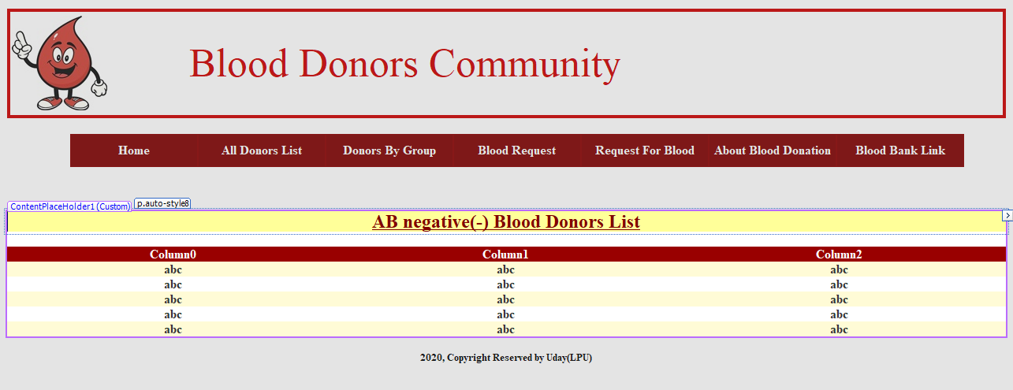

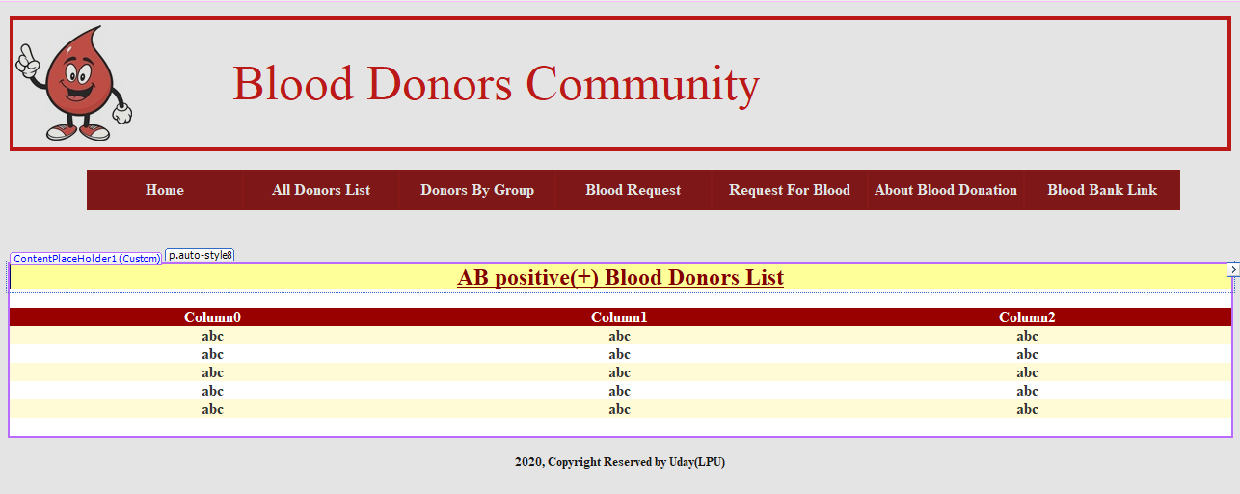

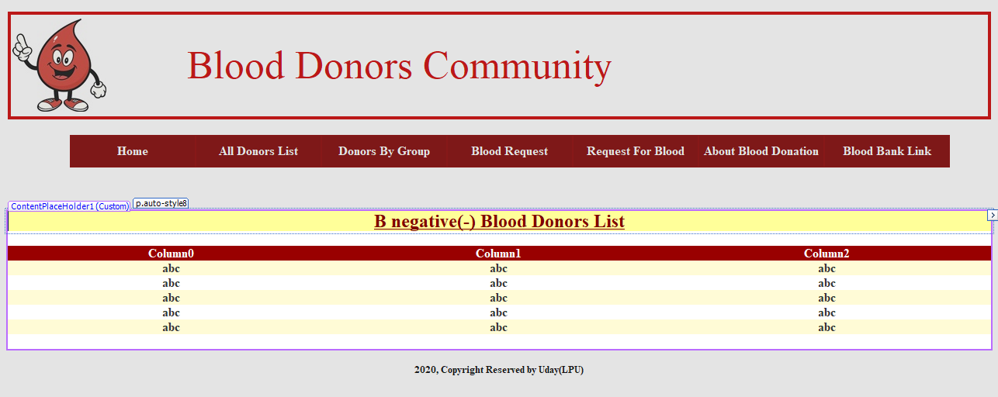

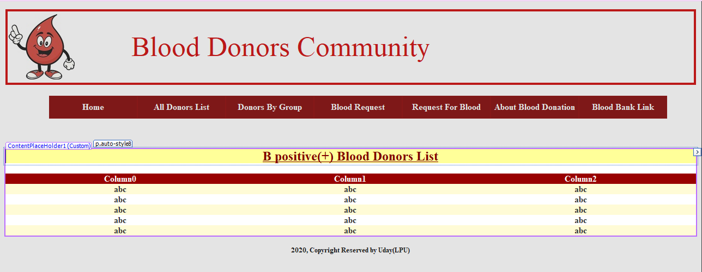

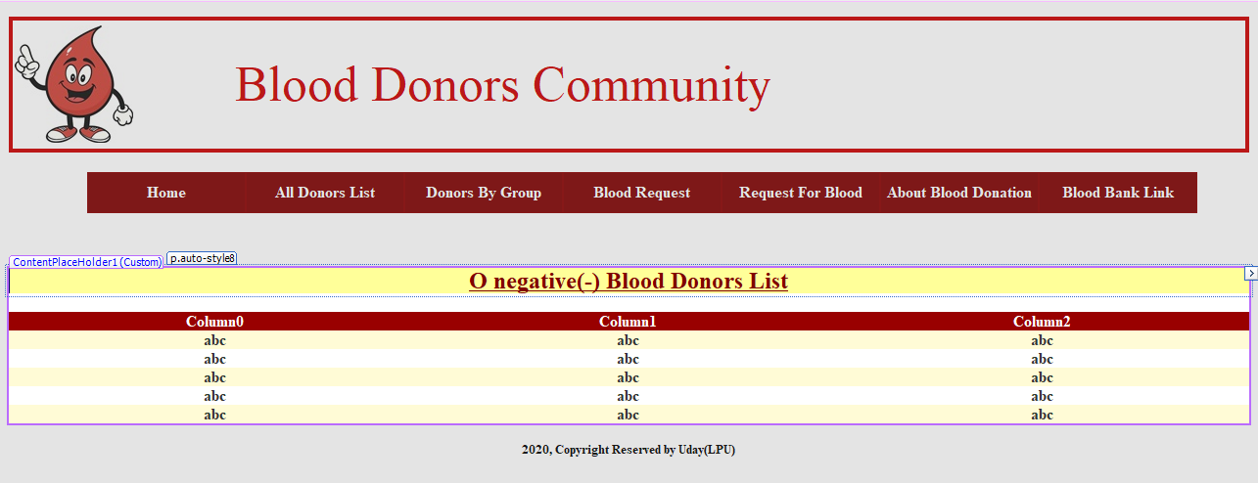

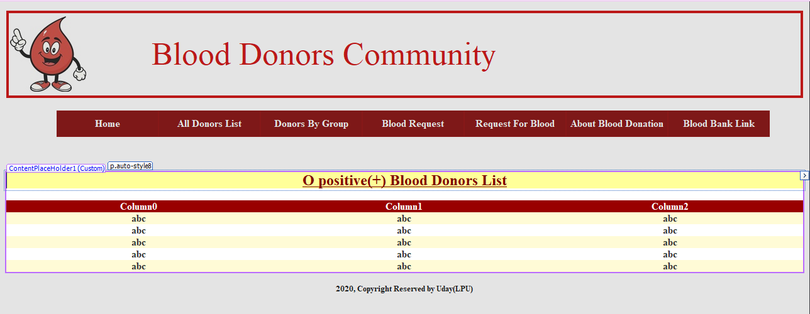

**SYNOPSIS**

The number of persons who need blood are increasing in large number day by day. In order to help people who, need blood, my Online Blood Bank can be used effectively for getting the details of blood donors having the same blood group and within the same city. With the help of my Online Blood Bank people who are having the thought of donating blood gets registered in my Online Blood Bank giving his total details.

My Online Blood Bank site is available to everyone easily. A person who likes to donate blood gives his entire details i.e., fill in the registration form and can create a username with a password by which he can modify his details if at all there are any changes in his information given before.

My site also helps people who are in need of blood by giving the details of the donors by searching, if at all there are no donors having the same group and within their own city they will be given the addresses with phone numbers of some contact persons in major cities who represent a club or an organization with free of cost. If at all the people find any difficulty in getting blood from the contact persons we will give them a Mobilink i.e., India’s Largest Paging Service number through which they can give the message on every ones pagers with the blood group and city they are living in, such that the donors who view the messages in their pagers having the same blood group and the in the same city, he contacts the person on phone who are in need of a blood. Such that the person gets help from us which saves his life.

## INTRODUCTION

The number of persons who need blood are increasing in large number day by day. In order to help people who, need blood, my Online Blood Bank can be used effectively for getting the details of blood donors having the same blood group and within the same city. With the help of my Online Blood Bank people who are having the thought of donating blood gets registered in my Online Blood Bank giving his total details.

## Purpose of the Project:

Online Blood Bank is aims serving for human welfare. We have all the information; you will ever need. Many people are here for you, to help you, willing to donate blood for you anytime. We have done all the job, rest is yours. search the blood group you need.

You can help us by registering on Online Blood Bank if you are willing to donate your blood when needed. As a proud member of Online Blood Bank and a responsible human being, you can help someone in need. So, donate blood in online.

## Modules:

1. Login
2. Registration
3. Admin
4. Donor or User
5. Make a Blood Request from Admin
6. About Blood Bank
7. Feedback
8. **Admin:** This module focuses on the both donors & acceptors. Each member in a donor & acceptor is given a user id and password, which identifies him uniquely. The member is given a login form. he enters the login details user id and password. The options given to

* Change Password
* Maintain donor details
* Maintain referral once
* Update donor details
* View Donor List by Group wise
* Approve the Donor or delete the Donor
* Logout

Whenever a user wants to change his / her password he can select the change password option. The system displays the form, which asks him for his old password and new password. The system then compares the old password with the existing password in the database and if they match then the password is set to the new password in the database. The id for retrieving the details from the database is brought through the session, which is maintained using cookies in the form. This removes the burden on user in typing user id again and maintains security by not allowing one user to change password of other accidentally.

## Donor:

Each member in a Donor is given a user id and password, which identifies him uniquely. The member is given a login form. he enters the login details user id and password. The options given to each member in a staff are

* Change password
* Find a Blood group.
* Edit Profile
* Find A Donor.
* Donate a Blood to patient
* Logout

Whenever a user wants to change his / her password he can select the change password option. The system displays the form, which asks him for his old password and new password. The system then compares the old password with the existing password in the database and if they match then the password is set to the new password in the database. The employee id for retrieving the details from the database is brought through the session, which is maintained using cookies in the form. This removes the burden on user in typing user id again and maintains security by not allowing one user to change password of other accidentally.

At the end the user can log out from the system using the logout option.

## About Blood bank:

Here we can see the importance of Blood bank and the use of blood bank and guidelines of the blood bank.

## Feedback:

Here users or clients can send the feedback to developers.

## Login:

Here user and Admin can login into the Website. Before login user must register into the website.

## Make a Blood request:

Here user or others can request a Blood from Admin which group he want with Submitting the details.

## Registration:

Here user can register before entering the website**.**

## System Development:

The process of building systems has always been complexing with system becoming larger, the costs and complexities get multiplied. So, the need for better methods for developing systems is widely recognized to be effective and the applied model should meet a few basic requirements.

* + The model should be structured and cover the entire system development process from feasibility study to programming, testing and implementation.
  + The model should utilize established methods and techniques like database designs, normalizations and structured programming techniques.
  + The model should consist of building blocks, which define tasks, results and interfaces.
  + The model should separate the logical system from the physical system.
  + Documentation should be a direct result of the development work and should be concise, precise and as non-redundant as possible.

Based on the above requirements of the system model, system study has been made. Various methodologies have been applied for system study, evolving design documents, data modeling, input screen design and report design.

## Project:

The persons who like to donate blood registers in my site as well as he can modify the details if necessary, giving the Login Id and Password. The persons in need of blood searches for the persons having the same blood group and within the city. If he found a donor in his city then he gets the total details of the donor, if he doesn’t find any donor then he is given the contact numbers and addresses of the Life Saving Contact Persons for major cities. If he doesn’t have any chance to contact them then he will be provided with Mobilink Paging Services in order to get the blood.

# SYSTEM REQUIREMENTS

## Software Environment:

Software Environment is a technical specification of requirement of software product. This specifies the environment for development, operation and maintenance of the product.

Technology used:

 ASP C#  SQL

 Xml

 Style sheets  HTML

 Http

## HTTP:

The Hypertext Transfer Protocol is stateless, TCP/IP based protocol used for communicating on the World Wide Web. HTTP defines the precise way Web clients communicate with Web servers. HTTP/1.0 is the most common version in use today. Oddly enough, this protocol is not officially recognized as an Internet standard. It is documented in the informational RFC 1945. Its successor, HTTP/1.1, is currently a proposed Internet standard and many browsers and servers now support this new version.

## HTTP Basics:

The HTTP protocol follows a very simple request/response paradigm. In short, a conversation between a Web browser and Web server goes something like this: the client opens a connection to the server, the client makes a request to the server, the server responds to the request, and the connection is closed.

The four stages of a simple Web transaction:

* The client opens a connection to the server.
* The client makes a request to the server.
* The server responds to the request.
* The connection is closed.

Client opens a connection Client Sends Request

***CLIENT***

***WEB SERVER***

Server Responds Connection Closed

## Connectionless Protocol:

HTTP is a connectionless protocol. As you may have guessed, the difference between a connectionless and a connection-oriented protocol is in the way they handle connections. Using a connectionless protocol, the client opens a connection with the server, sends a request, receives a response, and closes the connection. Each request requires its own connection. With a connection-oriented protocol, the client connects to the server, sends a request, receives response, and then holds the connection open in order to service future requests.

The connectionless nature of HTTP is both strength and a weakness. Because it holds a connection open only long enough to service the request, very few server resources are required to service large numbers of users. In fact, many popular Web sites service millions of users in a single day. The drawback to a connectionless protocol is that a connection must be established with every request. Opening a new connection with each request incurs a performance penalty that translates into additional delays for the user.

Alternatively, a connectionless protocol such as FTP has a strong performance advantage over a connectionless protocol. This is since the overhead required to open a new connection is incurred only once rather than with every request. Unfortunately, each open connection consumes some amount of server resources. These finite resources, such as memory and disk space, limit the number of concurrent users the server can handle. In contrast to a Web site, an FTP site can rarely support more than a few hundred users at a time.

## Stateless Protocol:

As stated in the definition, HTTP is a stateless protocol. A protocol is said to be stateless if it has no memory of prior connections and cannot distinguish one client’s request from that of another. In contrast, FTP is a ***stateful*** protocol, because the connection is not opened and closed with every request. After the initial login, the FTP server maintains the user’s credentials throughout the session. On the other hand, due to its stateless nature, there is no inherent method in HTTP for tracking a client’s traversal of a Web site. Every connection is a new request from an anonymous client.

The stateless nature of HTTP is both strength and a weakness. It is strength in that its stateless nature keeps the protocol simple and straightforward. It also consumes fewer resources on the server and can support more simultaneous users since there are no client credentials and connections to maintain. The disadvantage is in the overhead required to create a new connection with each request and the inability to track a single user as he traverses a Web site.

## Active Server Page 2.0:

**What is ASP?**

ASP is a server-side software component, used for Sever-side Validations for Microsoft Products. This dynamically extends the functionality of a server. Like the way VBScript is used for the making Validations on the client.

## Introduction

Since its introduction, the use of Microsoft’s Active Server Pages or ASP has grown rapidly. Many programmers consider it the tool for dynamic, easily maintainable web content. The real power of ASP derives firstly from the fact that he html for the page is only generated when the specific page is requested by the user, and secondly from purely html, rather than relying on the browser to support a language or application.

ASP enables us to tailor our web pages to the specific requirements of our users and their browser’s type as well as our own needs. It allows us to Interact with the user, which helps to keep our site intersection and up to date. Although it is not first technology to offer dynamic page creation, it is one of the fastest and most powerful.

An Active Server Page is a standard HTML file that is extended with additional features. Like a standard HTML file, an ASP contains HTML tags that can be interpreted and displayed by a web browser.

The ASP has three important features. They are

 An ASP can contain server-side scripts by including server-side scripts in ASP we can create web pages with dynamic context.

 An ASP provides several built-in objects

 By using the built-in objects accessible in the ASP, we can make our script much more powerful. Among other things, there objects enable us to retrieve information from and send information to the browsers.

 An ASP can be included with additional components.

 ASP comes bundled with several standard, server-side Active-x components. These components enable us to do such things as work with databases, send e-mail, and access the file system.

Hypertext transfer protocol is that handles request and response sent between a web server and browser. The HTTP request is the format of any message sent from the client to a server. It includes the URL of the required resource and information about the client and the platform they are using. The HTTP response can contain a resource, a redirection to another page or site, an error message, etc.

ASP provides its own request and response objects, which enables us to access the information stored in the HTTP request message and response headers respectively. Using these objects, we can check for certificates, read and writes cookies, and gets access to Browser information and forms data.

## The relationship between ASP and html can be described as follows:

An Active Server Page is a technology that allows for the programmatic construction of html pages for delivery to the browser.

In other words, with ASP we can write a set of instruction that can be used to generate html and other content just before it is delivered. This makes it a good for html developers, because of its power and flexibility to generate html, and ultimately product more spectacular, interactive personalized and up-to-date web sites.

The increasing integration between the windows operating system, database other Aspects including web services, had a great impact on ASP

* 1. Many more packages, applications and services expose interfaces that enable ASP to utilize them. This increasing complexity, and increased opportunities, means that the destinations between resources on the local system or network and the internet are blurring and we, as developers, must be aware of it.

This increased access to resources means that much of the infrastructure has been built and debugged and if we choose to, we can use

this to our advantage. In fact, everywhere we look, much of the hard work has been done and we are left to concentrate on the business specific implementation of our applications. The popularity of ASP has placed at our disposal a great wealth of expertise. We are also not dependent on Microsoft the prevalence of systems and companies, which use ASP as the core technology, mean that any problems will be resolved quickly, and in fact many of them already have.

## Why to Use?

By using Active server pages, we can create web sites with dynamic context. The parameters submitted by a client can by anything registration data, search arguments, customization, anything. Businesses are interested in the information that is stored in databases. This information must be retrieved from a database. The requested information must be extracted from the database when it’s requested, encoded in HTML format on the fly and transmitted to the client.

The simplest way to create an ASP page is to change the extension of an existing HTML document from HTML to ASP. Then place the file in a new

## SQL:

The name SQL stands for Structural Query Language. SQL is a data access language, like any other language, it is used for communication. SQL communicates with database manager. The database manager could be Oracle, Informix, DB2 and SQL database. SQL is easy to learn. Even though SQL is a computer programming language, it is much simpler than traditional programming language like COBOL, BASIC, FORTRAN or API. This is since SQL is a non-procedural language.

SQL is one of the Oracle facilities. It is important to understand in each case its differences, purpose and place in the Oracle family.

* SQL is the language used to access a relational database, including Oracle.
* SQL May be used with each of the Oracle tools, where access to the database is required.

## Overview of SQL:

A database management system requires a query language to enable users to access data. Structured Query Language (SQL – pronounced ‘sequel’) is the language used by most relational database systems.

IBM developed the SQL language in a prototype relational database management system –System R – in the mid-1970s. In 1979, Oracle Corporation introduced the first commercially available implementation of SQL.

## Features of SQL:

* + - SQL is an English-like language. It uses words such as select, insert, delete as part of its command set.
    - SQL is a non-procedural language: you specify *what* information you require, not how to get it. In other words, SQL does not require you to specify the access method to the data. All SQL statements use the query optimizer – a part of the RDBMS – to determine the fastest means of retrieving the specified data. This feature makes it easier for you to concentrate on obtaining the desired result.
    - SQL processes sets of records rather than a single record at a time. The most common form of a set of records is a table.
    - A range of user including DBAs, application programmers, management personnel, and many other types of end users can use SQL.
    - SQL provides commands for a variety of tasks including:
      * Querying data
      * Inserting, updating and deleting rows in a table
      * Creating, modifying and deleting database objects
      * Controlling access to the database and database objects
      * Guaranteeing database consistency.

## SQL Processing Capabilities:

SQL is composed of a definition language a Data Manipulation Language and a Data Control Language. These three languages support the complete spectrum of Relational Data processing activity. In fact, most SQL based product all access to the data through SQL.

## Data Definition Language:

DDL allows creation, Deletion and Modification of data structure for bar system. These structures include tables, databases and indexes.

Ex: Create, Drop and Alter.

## Data Manipulation Language:

These commands are used to manipulate the data in tables directly or through views. There are four standard DML statements. They are select, delete, insert and update.

## Data control language:

These commands are used to control usage and access of data. The most commonly found one’s will include grant, revoke.

## HTML:

The extended reach of information and services to customers that the Internet has enabled, has created a new challenge for the developer. The developer should develop a user interface that is distributable, available on multiple platforms and supports a wide range of client environments from handheld wireless devices to high-end workstations. So, to maintain a broad reach to client environments and to achieve greatest compatibility with all browsers, this system uses standard HTML.

Hyper Text Markup Language is the standard language for creating documents for the World Wide Web. An HTML document is a text file, which contains the elements, in the form of tags that a web browser uses to display text, multimedia objects, and hyperlinks using HTML; we can format a document for display and add hyperlinks to other documents.

The user interface has been designed in HTML hence can be browsed in any web browser.

## Cascading Style Sheets:

These have been used to separate data form presentation. By using these style sheets throughout the project, a uniform look and feel can be maintained for all the HTML elements and tags that have been used in the project. If there is any revamp the way the content has been presented in the website, the changes can be made to the appropriate style sheet, which will be reflected across all the style sheets.

## C#:

C# is a general-purpose, modern and object-oriented programming language pronounced as “C sharp”. It was developed by Microsoft led by Anders Hejlsberg and his team within the .Net initiative and was approved by the European Computer Manufacturers Association (ECMA) and International Standards Organization (ISO). C# is among the languages for Common Language Infrastructure and the current version of C# is version 7.2. C# is a lot like Java syntactically and is easy for the users who have knowledge of C, C++ or Java.

## A bit about .Net Framework

.Net applications are multi-platform applications and framework can be used from languages like C++, C#, Visual Basic, COBOL etc. It is designed in a manner so that other languages can use it.

know more about .Net Framework

## Why C#?

C# has many other reasons for being popular and in demand. Few of the reasons are mentioned below:

**Easy to start:** C# is a high-level language so it is closer to other popular programming languages like C, C++, and Java and thus becomes easy to learn for anyone.

Widely used for developing Desktop and Web Application: C# is widely used for developing web applications and Desktop applications. It is one of the most popular languages that is used in professional desktop. If anyone wants to create Microsoft apps, C# is their first choice.

**Community**: The larger the community the better it is as new tools and software will be developing to make it better. C# has a large community, so the developments are done to make it exist in the system and not become extinct.

**Game Development:** C# is widely used in game development and will continue to dominate. C# integrates with Microsoft and thus has a large target audience. The C# features such as Automatic Garbage Collection, interfaces, object-oriented, etc. make C# a popular game developing language.

## Beginning with C# programming:

**Finding a Compiler:**

There are various online IDEs such as Geeks for Geeks ide, Code Chef ide etc. which can be used to run C# programs without installing.

**Windows:** Since the C# is developed within .Net framework initiative by Microsoft, it provides various IDEs to run C# programs: Microsoft Visual Studio, Visual Studio Express, Visual Web Developer

**Linux:** Mono can be used to run C# programs on Linux.

## Programming in C#:

Since the C# is a lot like other widely used languages syntactically, it is easier to code and learn in C#.

Programs can be written in C# in any of the widely used text editors like Notepad++, gedit, etc. or on any of the compilers. After writing the program save the file with the extension .cs.

# WORKING ENVIRONMENT

## Hardware Configuration:

Processor : P III 700 MHz.

RAM : 64 MB RAM

Hard Disk Drive : 20 GB HDD

Keyboard : 104 keys

Mouse : Logitech Mouse

Monitor : 15” digital color monitor

Display Type : VGA

## Software Configuration:

Operating System : Windows 8,9,10

Web server : Personal Web Server

Web Browser : Internet Explorer / Chrome

Designing Tool : Microsoft Visual Studio

Server-Side Scripting : ASP.net

Client-Side Scripting : C#

Backend : SQL

# CONCLUSION

This project has given me an ample opportunity to design, code, test and implements an application. This has helped in putting into practice of various Software Engineering principles and Database Management concepts like maintaining integrity and consistency of data. Further, this has helped me to learn more about SQL, ASP 2.0, HTML, C# and Personal Web Server.

I thank my guide for his invaluable contribution in guiding me through out the project. I also thank my parents and friends who have supported and motivated me to complete this project successfully.

## Extensibility:

The other features, which the Blood bank services provide, can also be incorporated into this Blood Bank. The Encryption standards can also be used to make the transactions more secure. The Socket Secure Layer protocol can also used in implementing the system, which gives highest security in the Internet.

## Future Enhancement:

As there was a little number of contact person’s information given, some people may face difficulty in getting blood fast. So i like to gather more information regarding the contact persons in other cities as well as villages and will provide much more services for the people and help everyone with humanity.

## *** THANK YOU ***