**Child Level Analysis**

**Full sample  
ASER Grades 1 - 3**

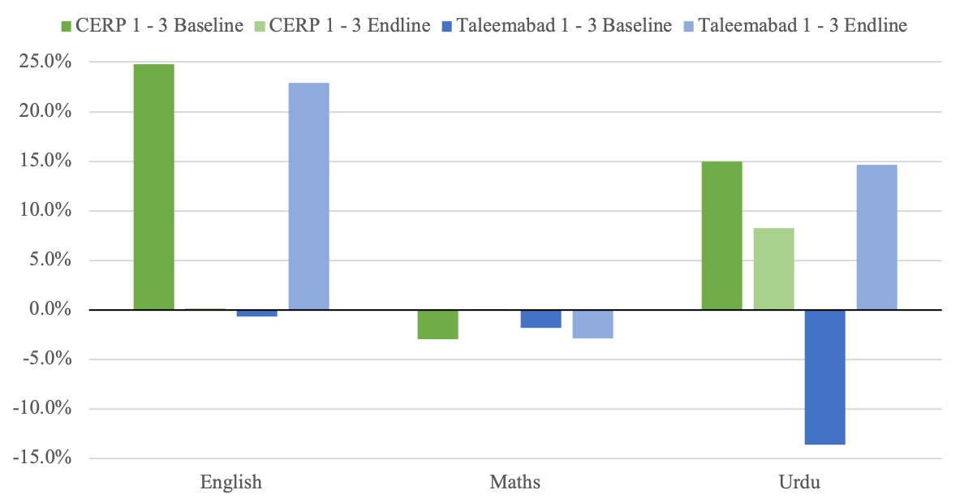

*Figure 1: % Difference in Grade Threshold Clearing Between Treatment and Control Students at Baseline and Endline using ASER Grades 1 - 3 instrument*

At endline, 2.56% of treatment students met the criteria for all 3 subjects compared to .94% of control students. This represents a difference of .17 standard deviations compared to the control students, which is equivalent to 1.31 LAYS.

At baseline, the percentage difference between treatment and control students for English is 24.81% which is statistically significant at the 5% level. At endline, the percentage difference between treatment and control students for English is .16% which is statistically significant at 5%. Expressed in standard deviations, treatment students are .55 standard deviations above control students for English at endline.

At baseline, the percentage difference between treatment and control students for Maths is -3.01% which is statistically insignificant from zero. At endline, the percentage difference between treatment and control students for Maths is .02% which is statistically insignificant from zero. Expressed in standard deviations, treatment students are .04 standard deviations above control students for Maths at endline.

At baseline, the percentage difference between treatment and control students for Urdu is 14.99% which is statistically significant at the 5% level. At endline, the percentage difference between treatment and control students for Urdu is 8.26% which is statistically significant at the 5% level. Expressed in standard deviations, treatment students are .25 standard deviations above control students for Urdu at endline.

**ASER Grades 4 - 5**

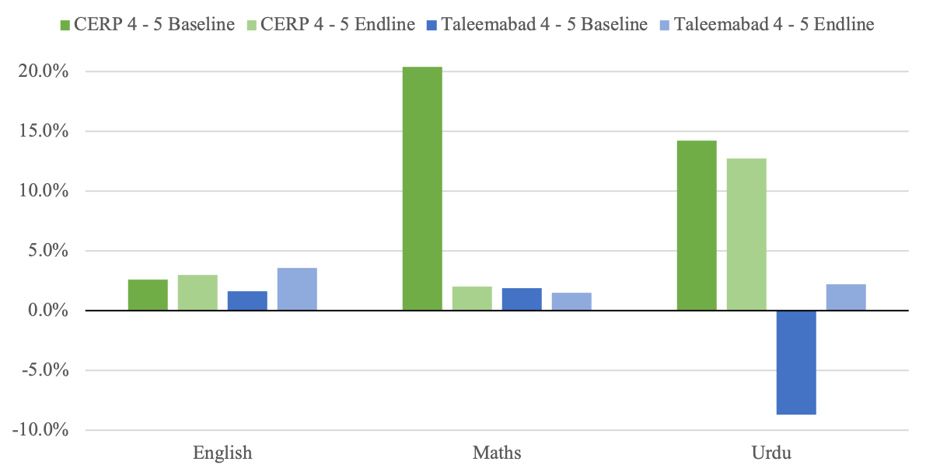

*Figure 2: % Difference in Grade Threshold Clearing Between Treatment and Control Students at Baseline and Endline using ASER Grades 4 - 5 instrument*

At endline, 7.32% of treatment students met the criteria for all 3 subjects compared to 6.04% of control students. This represents a difference of .05 standard deviations compared to the control students, which is equivalent to .38 LAYS.

At baseline, the percentage difference between treatment and control students for English is 2.57% which is statistically insignificant from zero. At endline, the percentage difference between treatment and control students for English is 2.96% which is statistically insignificant from zero. Expressed in standard deviations, treatment students are .09 standard deviations above control students for English at endline.

At baseline, the percentage difference between treatment and control students for Maths is 20.39% which is statistically significant at the 5% level. At endline, the percentage difference between treatment and control students for Maths is 2% which is statistically insignificant from zero. Expressed in standard deviations, treatment students are .04 standard deviations above control students for Maths at endline.

At baseline, the percentage difference between treatment and control students for Urdu is 14.24% which is statistically significant at the 5% level. At endline, the percentage difference between treatment and control students for Urdu is 12.74% which is statistically significant at the 5% level. Expressed in standard deviations, treatment students are .27 standard deviations above control students for Urdu at endline.

**MELQO**

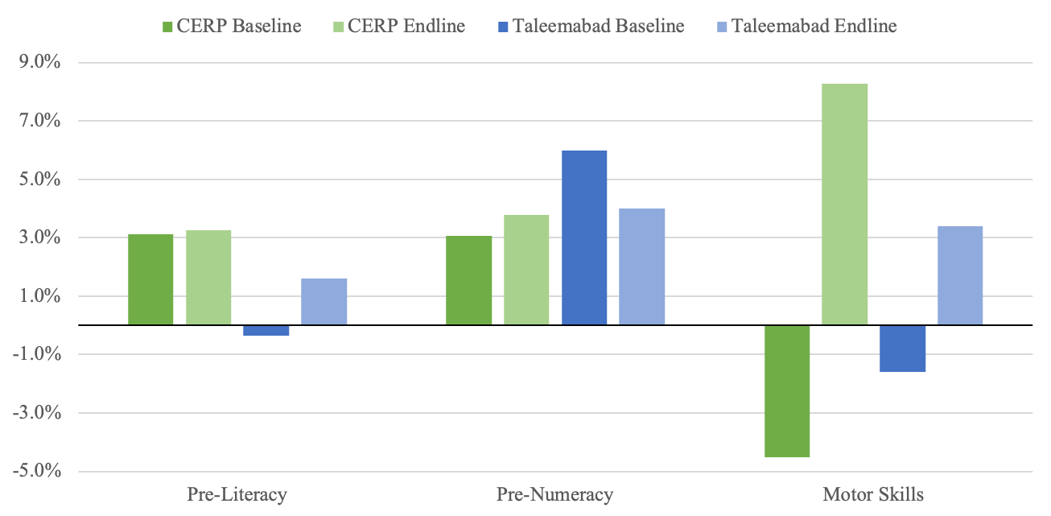

*Figure 3: % Difference in Scores between Treatment and Control Students at Baseline and Endline using MELQO*

At baseline, the percentage difference between treatment and control students for pre-literacy is 3.13% which is statistically significant at the 5% level. At endline, the percentage difference between treatment and control students for pre-literacy is 3.25% which is statistically significant at the 5% level. Expressed in standard deviations, treatment students are .15 standard deviations above control students for pre-literacy at endline.

At baseline, the percentage difference between treatment and control students for pre-numeracy is 3.06% which is statistically significant at the 5% level. At endline, the percentage difference between treatment and control students for pre-numeracy is 3.79% which is statistically significant at the 5% level. Expressed in standard deviations, treatment students are .14 standard deviations above control students for pre-numeracy at endline.

At baseline, the percentage difference between treatment and control students for motor skills is -4.51% which is statistically significant at the 5% level. At endline, the percentage difference between treatment and control students for motor skills is 8.27% which is statistically significant at the 5% level. Expressed in standard deviations, treatment students are .3 standard deviations above control students for motor skills at endline.

**Truncated sample  
ASER Grades 1 - 3**

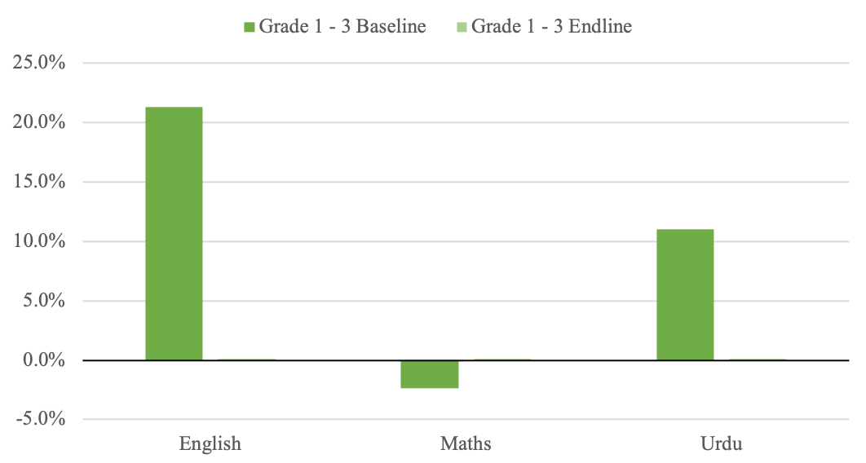

*Figure 4: % Difference in Grade Threshold Clearing Between Treatment and Control Students at Baseline and Endline using ASER Grades 1 - 3 instrument*

At endline, 2.86% of treatment students met the criteria for all 3 subjects compared to .68% of control students. This represents a difference of .26 standard deviations compared to the control students, which is equivalent to 2 LAYS.

At baseline, the percentage difference between treatment and control students for English is 21.35% which is statistically significant at the 5% level. At endline, the percentage difference between treatment and control students for English is .13% which is statistically significant at 5%. Expressed in standard deviations, treatment students are .4 standard deviations above control students for English at endline.

At baseline, the percentage difference between treatment and control students for Maths is -2.38% which is statistically insignificant from zero. At endline, the percentage difference between treatment and control students for Maths is .08% which is statistically significant at the 5% level. Expressed in standard deviations, treatment students are .2 standard deviations above control students for Maths at endline.

At baseline, the percentage difference between treatment and control students for Urdu is 11.01% which is statistically significant at the 5% level. At endline, the percentage difference between treatment and control students for Urdu is .11% which is statistically significant at the 5% level. Expressed in standard deviations, treatment students are .31 standard deviations above control students for Urdu at endline.

**ASER Grades 4 - 5**

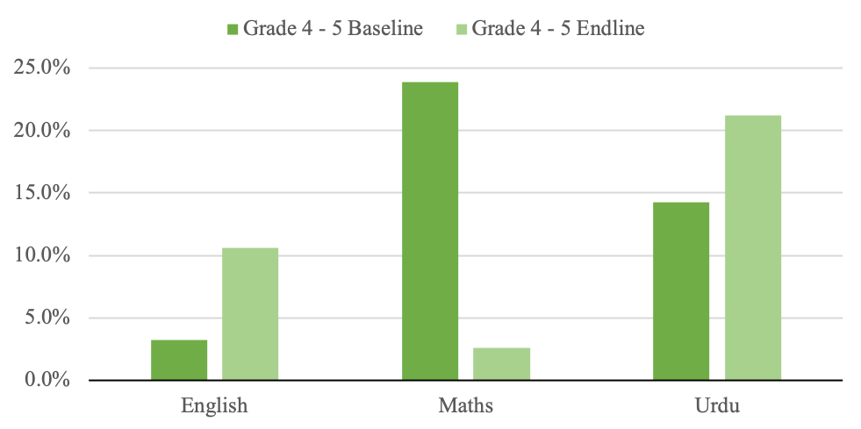

*Figure 5: % Difference in Grade Threshold Clearing Between Treatment and Control Students at Baseline and Endline using ASER Grades 4 - 5 instrument*

At endline, 8.56% of treatment students met the criteria for all 3 subjects compared to 2.04% of control students. This represents a difference of .46 standard deviations compared to the control students, which is equivalent to 3.54 LAYS.

At baseline, the percentage difference between treatment and control students for English is 3.2% which is statistically insignificant from zero. At endline, the percentage difference between treatment and control students for English is 10.63% which is statistically significant at the 5% level. Expressed in standard deviations, treatment students are .46 standard deviations above control students for English at endline.

At baseline, the percentage difference between treatment and control students for Maths is 23.88% which is statistically significant at the 5% level. At endline, the percentage difference between treatment and control students for Maths is 2.58% which is statistically insignificant from zero. Expressed in standard deviations, treatment students are .05 standard deviations above control students for Maths at endline.

At baseline, the percentage difference between treatment and control students for Urdu is 14.29% which is statistically significant at the 5% level. At endline, the percentage difference between treatment and control students for Urdu is 21.24% which is statistically significant at the 5% level. Expressed in standard deviations, treatment students are .43 standard deviations above control students for Urdu at endline.

**MELQO**

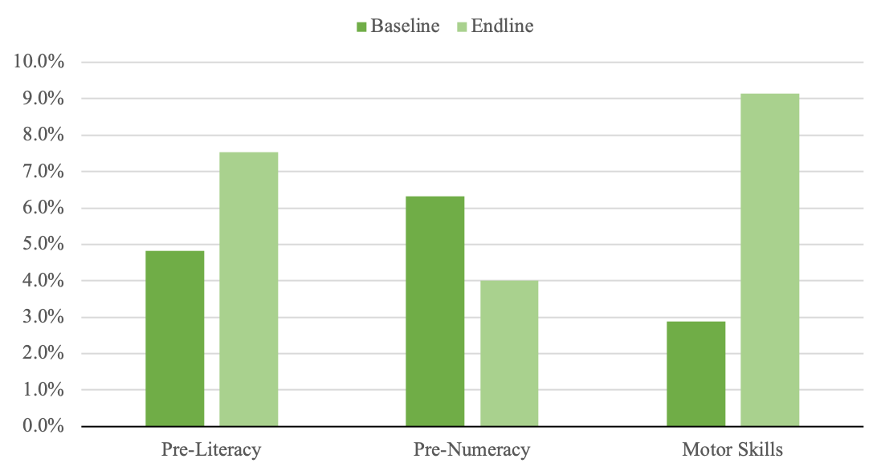

*Figure 6: % Difference in Scores between Treatment and Control Students at Baseline and Endline using MELQO*

At baseline, the percentage difference between treatment and control students for pre-literacy is 4.83% which is statistically significant at the 5% level. At endline, the percentage difference between treatment and control students for pre-literacy is 7.53% which is statistically significant at the 5% level. Expressed in standard deviations, treatment students are .32 standard deviations above control students for pre-literacy at endline.

At baseline, the percentage difference between treatment and control students for pre-numeracy is 6.32% which is statistically significant at the 5% level. At endline, the percentage difference between treatment and control students for pre-numeracy is 4% which is statistically significant at the 5% level. Expressed in standard deviations, treatment students are .15 standard deviations above control students for pre-numeracy at endline.

At baseline, the percentage difference between treatment and control students for motor skills is -2.88% which is statistically insignificant from zero. At endline, the percentage difference between treatment and control students for motor skills is 9.14% which is statistically significant at the 5% level. Expressed in standard deviations, treatment students are .31 standard deviations above control students for motor skills at endline.