**Software Development Plan**

**Course:**

**INTRODUCTION TO SOFTWARE ENGINEERING**

**SEN-210  
Instructor: Engr. Bushra Fazal  
Class: BSE 2A  
Assignment # 4  
Date of Submission: June 2, 2025**

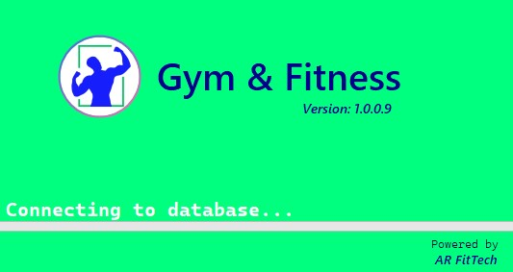

**Submitted by:**

*Aamir Rafique (02-131242-019)*

**Gym And Fitness (C# Desktop App)**

# Table of Content

Contents

Table of Content 1

1. INTRODUCTION 3

2. REQUIREMENTS ANALYSIS 3

2.1. Functional Requirements 3

2.2. Non-Functional Requirements 3

2.3. Operational Environment 4

3. SYSTEM ARCHITECTURE DESIGN 4

3.1. High-Level Architecture 4

3.2. Work Breakdown Structure (WBS) 5

3.3. UML DIAGRAMS 6

3.3.1. Use Case Diagram 6

3.3.2. Class Diagram 7

3.3.3. Sequence Diagram: 8

3.3.4. Context Diagram: 9

3.3.5. Activity Diagram 10

3.3.6. Planning diagram (PERT Chart): 11

4. SOFTWARE DEVELOPMENT METHODOLOGY 12

4.1. Chosen Methodology: 12

➢ Justification: 12

➢ Phases: 12

4.2. Version Control 12

4.3. Milestones 12

5. RISK MANAGEMENT 13

5.1. Risk Identification & Mitigation 13

5.2. Risk Exposure (RE) & Risk Leverage (RL) 13

6. TESTING & VALIDATION 13

6.1. Testing Strategy 13

6.2. Sample Test Case 14

7. DOCUMENTATION & MAINTENANCE 14

7.1. Documentation Plan 14

7.2. Maintenance Strategy 14

8. COST ESTIMATION (COCOMO MODEL) 15

9. FINAL DELIVERABLES 15

9.1. Software Artifacts 15

9.2. Software Engineering Documents 15

9.3. Testing Documents 16

9.4. Risk Management Report 16

9.5. Cost Estimation 16

9.6. Documentation & Maintenance Plan 16

10. CONCLUSION 16

11. REFERENCES 16

12. APPENDICES 17

12.1. Application Interfaces (Output Screenshots) 17

12.1.1. LoadingForm 17

12.1.2. LoginForm 17

12.1.3. MainForm. 18

12.1.4. BMICalculatorForm 18

12.1.5. DashboardForm 19

12.1.6. ProfileForm 19

12.1.7. AboutForm 20

1. INTRODUCTION

This document outlines a detailed software development plan for **“Gym And Fitness”** C# Desktop Application built using Windows Forms (.NET Framework). The application will help users track workouts, nutrition, and progress. The plan covers requirements analysis, system architecture, development methodology, risk management, testing, and maintenance to ensure a user-friendly, efficient, and scalable fitness application.

# REQUIREMENTS ANALYSIS

## Functional Requirements

The system will provide the following core functionalities:

* **Member Management:** Add, update, delete gym member records.
* **BMI Calculator Module:** Users can calculate their Body Mass Index.
* **Personal Profile:** To maintain a proper fitness profile.
* **Workout Module:** Users can access pre-defined workout routines or create their own custom plans.
* **Nutrition Tracking:** A built-in system to search for meals and track calorie intake.
* **Diet Plans (Customizable):** Suggested meal recipes based on fitness goals + customized meal scheduling for breakfast, lunch, dinner, snacks, etc.
* **Water Intake Tracking:** A feature to track daily water intake.
* **Fitness Progress Monitoring:** Users can track their progress through visual analytics and reports.
* **Workout Guides:** Comprehensive workout guides categorized by exercise type.
* **Customized Workout Plans:** Personalized workout plans for structured exercise tracking.
* **Challenges Section & Motivational Quotes:** To keep users motivated throughout their fitness journey.
* **SQL Database Integration:** Secure storage and retrieval of user data, including fitness progress, workouts, and nutrition records.

## Non-Functional Requirements

* **Performance:** Load forms under 2 seconds (Memory optimization).
* **User-Friendly Interface:** Designed using Windows Forms (WinForms) for easy navigation and interaction.
* **Reliability:** 99% uptime and safe error handling.
* **Usability:** Simple GUI with clear labels.
* **Security:** Secure login/signup, Password hashing.
* **Maintainability:** Well-commented code, modular design.

## Operational Environment

* **Platform:** Windows 10/11
* **Framework:** .NET Framework 4.7.2+
* **Database:** SQL Server LocalDB 2022
* **Users:** Any user (since it’s a personal fitness application)

# SYSTEM ARCHITECTURE DESIGN

## High-Level Architecture

* **Frontend (UI Layer):** GDI+ / WinForms Controls
* **Backend (Business Logic Layer):** C# (.NET Framework)
* **Database (Data Layer):** SQL Server (local storage)

**Work Breakdown Structure (WBS)**

## UML DIAGRAMS

### Use Case Diagram

### Class Diagram

### Sequence Diagram:

### Context Diagram:

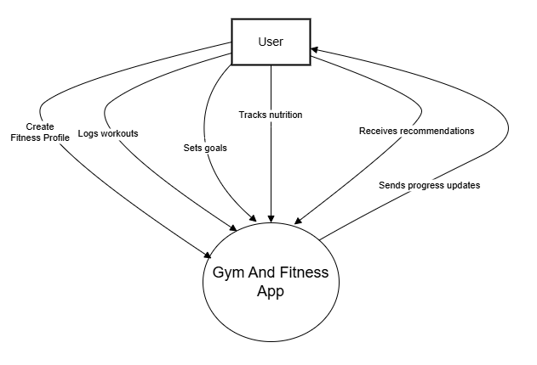

### Activity Diagram

### Planning diagram (PERT Chart):

# SOFTWARE DEVELOPMENT METHODOLOGY

## Chosen Methodology:

“Waterfall Model”

### Justification:

* Clear and fixed requirements
* One-time delivery for university project
* Easy to manage in short timeline

### Phases:

1. Requirements
2. Design (UI + DB)
3. Implementation (Code)
4. Testing (Unit + Integration)
5. Deployment
6. Documentation

## Version Control

* **Tool**: GitHub Desktop
* **Branches**: main, dev, feature/*

## Milestones

|  |  |
| --- | --- |
| **Phase** | **Completion Time** |
| Requirements | Week 1 |
| Design | Week 1,2 |
| Coding | Week 2 |
| Testing | Week 3 |
| Documentation | Week 4 |

# RISK MANAGEMENT

## Risk Identification & Mitigation

| **Risk** | **Probability** | **Impact** | **Mitigation Strategy** |
| --- | --- | --- | --- |
| Requirement changes | Medium | High | Frequent meetings with users to confirm needs |
| Bugs in form logic | High | Medium | Code reviews and thorough testing |
| Database connection failure | Low | High | Use robust error handling and local DB backups |
| User forgets credentials | Medium | Medium | Implement "forgot password" feature |
| Deployment fails on target PCs | Low | High | Use ClickOnce installer with all prerequisites checked |

## Risk Exposure (RE) & Risk Leverage (RL)

**Formula:**

* *RE = Probability × Impact*
* *RL = (RE_before - RE_after) / Cost of solution*

| **Risk** | **RE Before** | **RE After Mitigation** | **Mitigation Cost** | **RL** |
| --- | --- | --- | --- | --- |
| Requirement changes | 0.6 × 0.9 = 0.54 | 0.3 × 0.5 = 0.15 | 0.1 | (0.54 - 0.15)/0.1 = **3.9** |
| Bugs in logic | 0.8 × 0.7 = 0.56 | 0.3 × 0.4 = 0.12 | 0.05 | (0.56 - 0.12)/0.05 = **8.8** |

# TESTING & VALIDATION

## Testing Strategy

* **Unit Testing**: For individual components like BMI calculator, login, forms.
* **Integration Testing**: Ensure forms interact well with database.
* **System Testing**: Complete workflow from login → usage → logout.
* **User Acceptance Testing (UAT)**: Final testing with actual user (yourself or friends).

## Sample Test Case

| **Test Case ID** | **TC-01** |
| --- | --- |
| **Feature** | Login Form |
| **Test Steps** | 1. Open app  2. Enter valid username & password  3. Click Login |
| **Expected Result** | Dashboard loads successfully |
| **Status** | Pass |

# DOCUMENTATION & MAINTENANCE

## Documentation Plan

* **System Overview**: Purpose and flow of the fitness app.
* **UML Diagrams**: Class, use-case, activity, sequence, context.
* **Installation Guide**: How to install using ClickOnce.
* **User Manual**: How to use features (BMI, Membership, etc.).

## Maintenance Strategy

* **Bug Fixes**: Maintain changelog and fix bugs periodically.
* **Updates**: Add new features (e.g., diet planner).
* **Backup Plan**: Regular DB backups recommended.

# COST ESTIMATION (COCOMO MODEL)

Using Basic **COCOMO Model** for an **Organic Project**.

**Formula:**

**Effort (E)** = *a × (KLOC)^b*  
**Time (T)** = *c × (E)^d*

For Organic projects:

* a = 2.4, b = 1.05
* c = 2.5, d = 0.38

Assume:

* Project size = **5 KLOC** (5000 lines of code)

**Calculation:**

* **E = 2.4 × (5) ^1.05 ≈ 2.4 × 5.28** **≈ 12.67 person-months**
* **T = 2.5 × (12.67) ^0.38 ≈ 2.5 × 2.36** ≈ **5.9 months**

# FINAL DELIVERABLES

## Software Artifacts

* **Executable Application (.exe)** – A compiled and installable Windows Forms application via ClickOnce.
* **Project Source Code** – Complete C# codebase including forms, classes, and database connection logic.
* **Database Files** – SQL Server LocalDB (.mdf/.ldf) files used for data persistence.

## Software Engineering Documents

* **Requirements Specification Document**: Functional and non-functional requirements, use-case descriptions.
* **System Design Documents**:
  + UML Class Diagram
  + Use Case Diagram
  + Sequence Diagram
  + Activity Diagram
  + Context Diagram
  + Planning (PERT) Diagram
  + Work Breakdown Structure (WBS)

## Testing Documents

* **Test Plan**: Testing strategy for unit, integration, and system testing.
* **Test Cases Document**: Detailed list of test cases with expected vs actual results.
* **Bug/Issue Log**: Any identified bugs during testing and their resolution status.

## Risk Management Report

* Risk Identification & Mitigation Table
* Risk Exposure (RE) and Risk Leverage (RL) calculations.

## Cost Estimation

* **COCOMO Model Report**: Calculated effort, development time, and team size based on 5KLOC.

## Documentation & Maintenance Plan

* **User Manual**: Instructions for using the software (Login, BMI Calculator, Membership Features, etc.)
* **Maintenance Strategy Document**: Plan for future updates, bug fixes, and feature enhancements.

# CONCLUSION

The Gym & Fitness Windows Forms Application was developed following a systematic software engineering approach. From requirement analysis to cost estimation, all essential phases were addressed to ensure the application is functional, maintainable, and user-friendly. The use of UML diagrams, risk management strategies, and testing plans demonstrates the thorough planning and execution of this project. This software provides a solid foundation for future enhancements and deployment in real-world fitness environments.

# REFERENCES

* Pressman, R. S. Software Engineering: A Practitioner’s Approach, 8th Edition.
* Microsoft Docs. Windows Forms Overview. <https://learn.microsoft.com/en-us/dotnet/desktop/winforms/>
* GitHub Docs. Understanding the GitHub Flow. <https://docs.github.com/>

# APPENDICES

## Application Interfaces (Output Screenshots)

### LoadingForm

### LoginForm

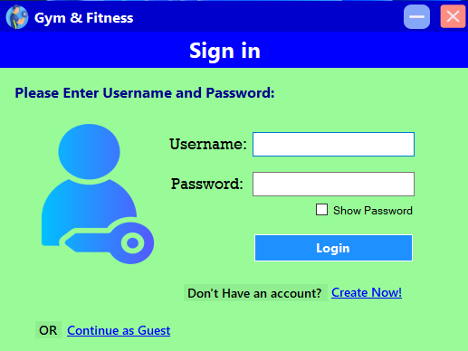

### BMICalculatorForm

### DashboardForm

### ProfileForm

### AboutForm

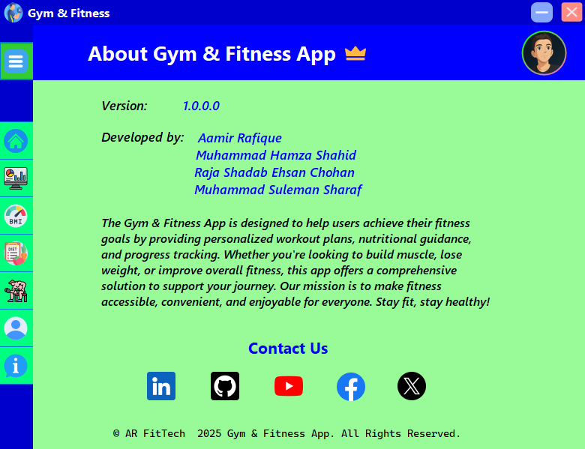

***Aamir Rafique***

***Muhammad Hamza Shahid***

***Raja Shadab Ehsan Chohan***

***Dahir Abdinasir***