-- 1. Display employee name with their department name.
select e.emp_name , d.dept_name
from emp e
left join department d
on e.dept_id=d.dept_id;
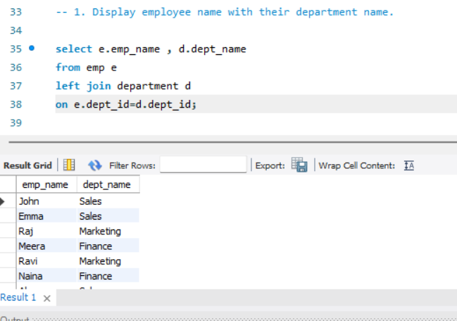

-- 2.List all employees including those with no matching department.

select e.emp_name , d.dept_name
from emp e
left join department d
on e.dept_id=d.dept_id;
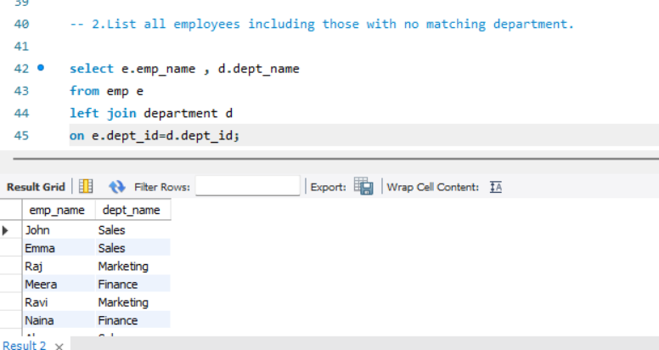

-- 3.List all departments even if no employees.

select d.dept_name, e.emp_name
from department d
left join emp e
on e.dept_id=d.dept_id;

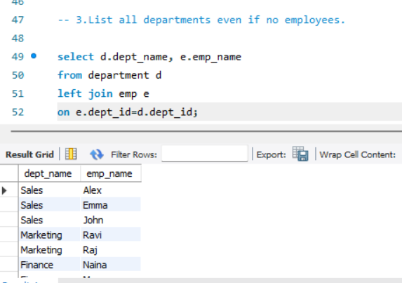
-- 4. Show employees from Sales department.

select e.emp_name , d.dept_name
from emp e
join department d
on e.dept_id=d.dept_id
where dept_name='sales';
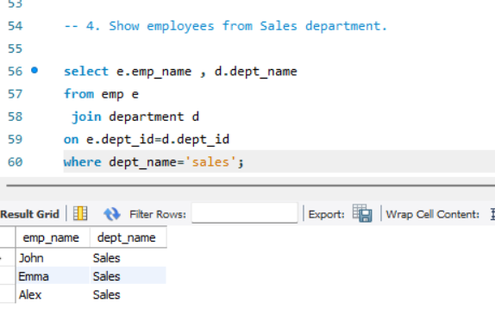
-- 5. Find top 3 highest paid employees.

select emp_name , salary
from emp
order by salary desc limit 3;
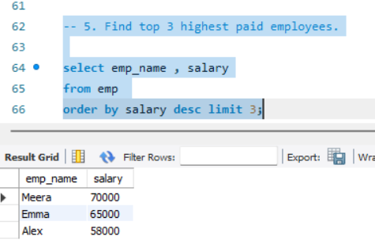
-- 6. Find employees earning more than 50,000 from Marketing.

select e.emp_name , salary
from emp e
join department d
on e.dept_id=d.dept_id
where dept_name='marketing' and salary > 40000;
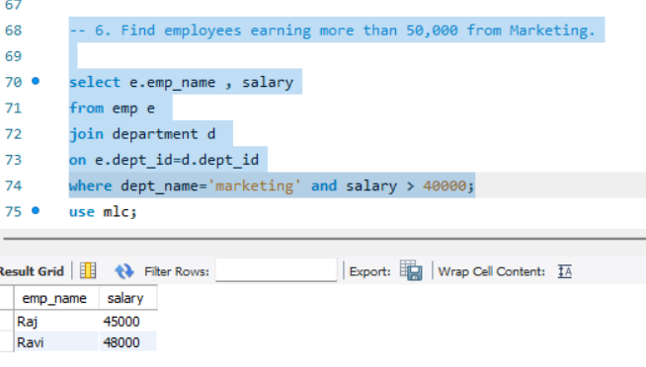
-- 7. Count employees in each department.

select d.dept_name , count(e.emp_id)
from emp e
join department d
on e.dept_id=d.dept_id
group by d.dept_name;
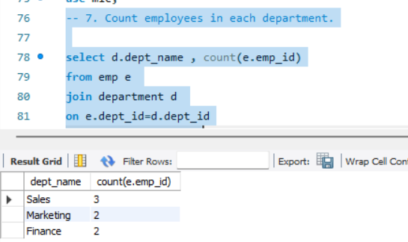
-- 8. Show departments having more than 2 employees.
select d.dept_name , count(emp_name)
from department d
join emp e
on e.dept_id=d.dept_id
group by d.dept_name having count(emp_name)> 2;
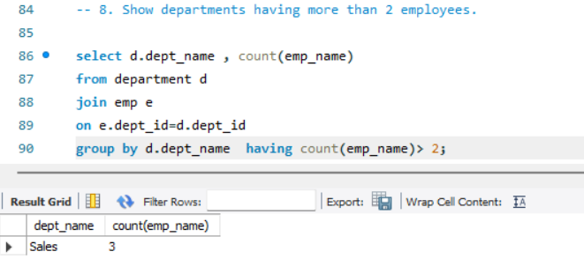

-- 9. Show highest salary in each department.
select d.dept_name , max(e.salary)
from department d
right join emp e
on e.dept_id=d.dept_id group by d.dept_name;
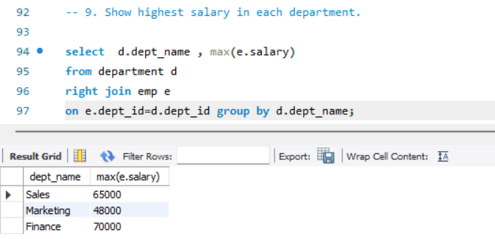
-- 10. Show employees whose salary is above department average.
SELECT e.emp_name,
d.dept_name,
e.salary
FROM emp e
INNER JOIN department d ON e.dept_id = d.dept_id
WHERE e.salary > (
SELECT AVG(salary)
FROM emp
WHERE dept_id = e.dept_id
)
ORDER BY e.salary;

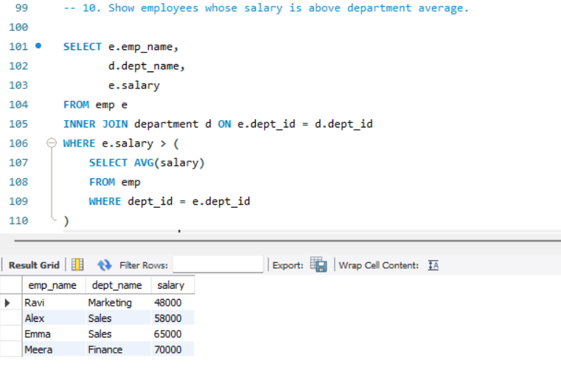
-- 11. Show employees and their departments sorted by department name.
select e.emp_name ,d.dept_name
from emp e
join department d
ON e.dept_id = d.dept_id
order by d.dept_name asc;
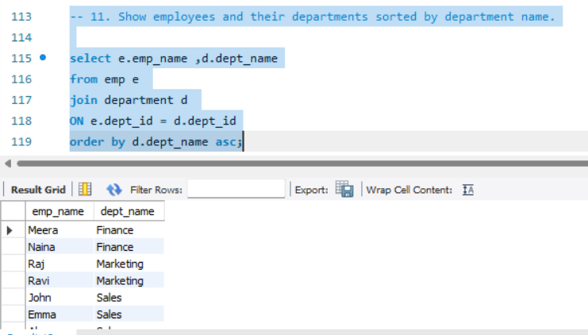

-- 12. List the 2 lowest-paid employees with department names.
select e.emp_name ,d.dept_name , e.salary
from emp e
join department d
ON e.dept_id = d.dept_id
order by e.salary asc limit 2;
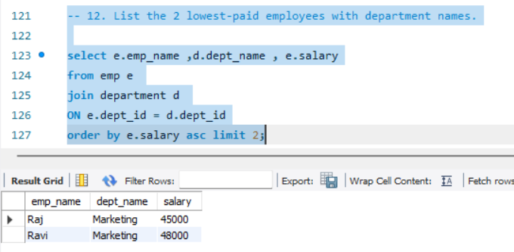
-- 13. Show total salary expenditure per department.
select d.dept_name, sum( e.salary)
from emp e
join department d
ON e.dept_id = d.dept_id
group by d.dept_name ;
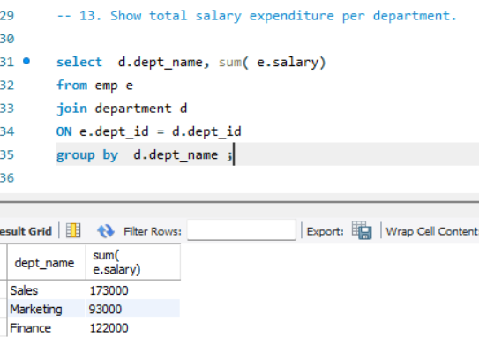
-- 14) Show departments where total salary spent is more than 150,000.
SELECT d.dept_id, d.dept_name, SUM(e.salary) AS total_salary
FROM Department d
JOIN emp e ON d.dept_id = e.dept_id
GROUP BY d.dept_id, d.dept_name
HAVING SUM(e.salary) > 150000;
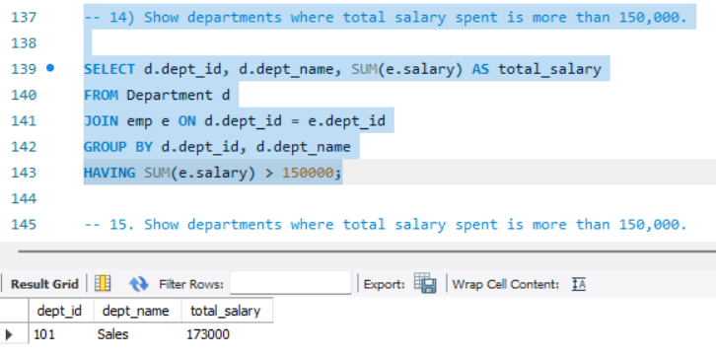

-- 15. Show employees who belong to departments starting with 'S'.
select e.emp_name , d.dept_name
from emp e
join department d
ON e.dept_id = d.dept_id
where d.dept_name like 's%';
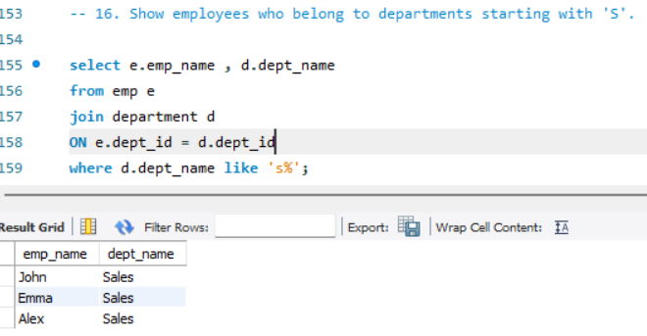
-- 16. Find employees whose salary is the highest in their department.

SELECT e.emp_name, d.dept_name, e.salary
FROM emp e
JOIN department d ON e.dept_id = d.dept_id
WHERE e.salary = (
SELECT MAX(salary)
FROM emp
WHERE dept_id = e.dept_id
);
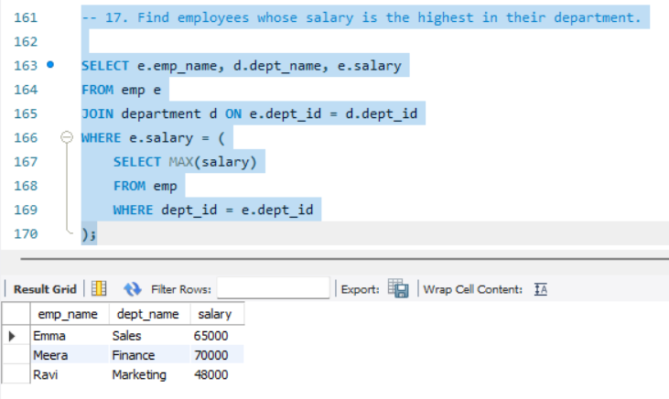

-- 17. Show employees and department sorted by salary descending.
SELECT e.emp_name,
d.dept_name,
e.salary
FROM emp e
JOIN department d
ON e.dept_id = d.dept_id
ORDER BY e.salary DESC;
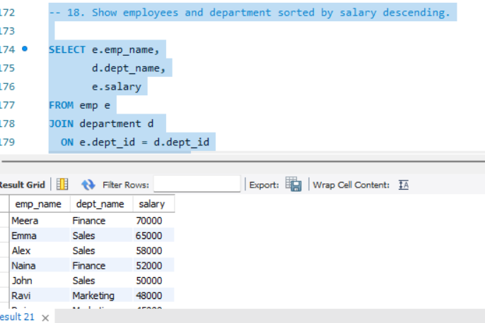

-- 18. Count how many employees earn above 50,000 per department.
SELECT d.dept_name,
COUNT(e.emp_id) AS emp_count
FROM emp e
JOIN department d ON e.dept_id = d.dept_id
WHERE e.salary > 50000
GROUP BY d.dept_name;

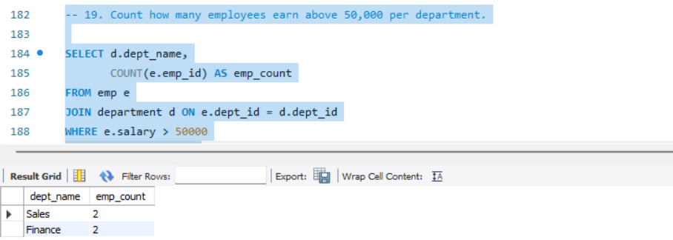

-- 19. Show employee name, department, and salary for employees between 45,000 and 60,000.
SELECT e.emp_name,
d.dept_name,
e.salary
FROM emp e
JOIN department d ON e.dept_id = d.dept_id
WHERE e.salary BETWEEN 45000 AND 60000;
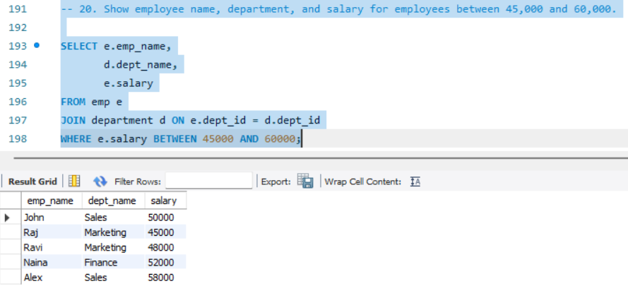

-- 20) Find departments with no employees.
SELECT d.dept_id, d.dept_name
FROM Department d
LEFT JOIN Employee e ON d.dept_id = e.dept_id
WHERE e.emp_id IS NULL;
