
K. R.MangalamUniversity
Gurugram, Haryana

DataBase Management System (DBMS)
Course Code : ENCS204
LAB Assignment

Submitted by: Submitted to: Devi Singh Ruchika Bhakhar
2401730260 Assistant Professor
B.TECH CSE (AI&ML)

Program :- 1

AIM:- Create a SQL table named student with following fields.
- SNo - Integer(3Digit).
- SName - Character string of maximum length 100.
- Marks – Integer(3Digit).
- Grades – Character string of length 2.
(“And show output.”)

Solution:

CREATE TABLE STUDENT (SNO INT(3),SNAME VARCHAR(100),MARKS INT(3));
INSERT INTO STUDENT VALUES(101,'Prakhar Gupta',95); INSERT INTO STUDENT VALUES(102,'Piyush Singh',90); INSERT INTO STUDENT VALUES(103,'Vishal',92);
INSERT INTO STUDENT VALUES(104,'Ashish Kaushik',98);
INSERT INTO STUDENT VALUES(105,'Aryan Sharma',99); INSERT INTO STUDENT VALUES(106,'Risabh Kumar',85); INSERT INTO STUDENT VALUES(107,'Ashish Sharma',78); INSERT INTO STUDENT VALUES(108,'Mohit Yadav',91); INSERT INTO STUDENT VALUES(109,'Aman',65);
INSERT INTO STUDENT VALUES(110,'Jatin',55); SELECT*FROM STUDENT;

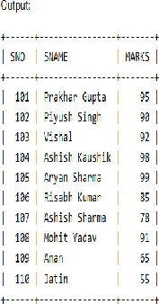

Program (2):-

AIM:- How is searching performed in SQL? Write a query to search a student record using the WHERE clause

Solution:-
(“SELECT*FROM STUDENT WHERE MARKS>90;”)

Output:-
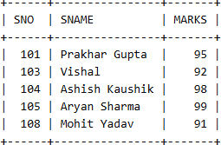

Program (3):-
AIM:- Write an SQL query to delete the record of a student whose SNAME “Mohit Yadav:”.

Solution:-
DELETE FROM STUDENT WHERE SNAME = 'Mohit Yadav'; SELECT * FROM STUDENT;

Output:-
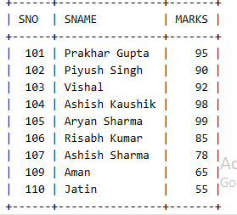

Program (4):-
AIM:- Write an SQL query to insert a new student record into the STUDENT table.

Solution:-
INSERT INTO STUDENT (SNO, SNAME, MARKS) VALUES(111,'Rohan',90);
SELECT*FROM STUDEN

Output:-

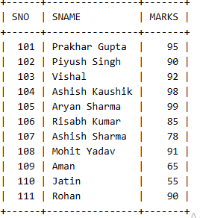

Program(5):-

AIM:- The SQL UPDATE statement is used to modify existing data in a table by changing the values of one or more columns.

Solution:-
UPDATE STUDENT
SET SNAME = 'Vishal Kumar', MARKS = 95 WHERE SNO = 103;
select*FROM STUDENT

Output:-
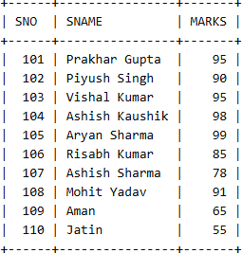

Program(6):-
AIM:- Write an SQL query to add a new column GRADE in the STUDENT table and assign grades to students based on their marks using the following criteria:
- Marks ≥ 90 → Grade A
- Marks ≥ 80 → Grade B
- Marks ≥ 70 → Grade C
- Marks ≥ 60 → Grade D
- Marks<60 → Grade F

Solution:-

ALTER TABLE STUDENT ADD GRADE CHAR(1);

UPDATE STUDENT SET GRADE = CASE
WHEN MARKS >= 90 THEN 'A'
WHEN MARKS >= 80 THEN 'B' WHEN MARKS >= 70 THEN 'C' WHEN MARKS >= 60 THEN 'D' ELSE 'F'
END;

SELECT * FROM STUDENT;

Output:-

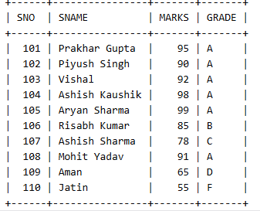

Program(7):-
AIM:- In SQL, aliases provide temporary names for columns or tables to make queries cleaner and easier to understand. They are especially helpful in complex queries or when dealing with lengthy names.

Solution:-
SELECT
SNO AS STUDENT_ID, SNAME AS STUDENT_NAME, MARKS AS TOTAL_MARKS
FROM STUDENT;

Output:-
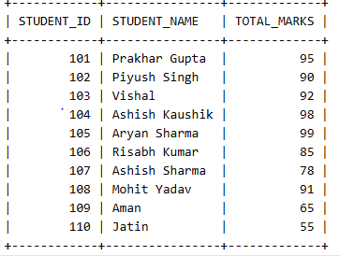





SQL Joins (Inner, Left, Right and Full Join)
CREATE TABLE RESULT ( SNO INT,
RESULT VARCHAR(10));
INSERT INTO RESULT VALUES (101,'PASS'); INSERT INTO RESULT VALUES (102,'PASS'); INSERT INTO RESULT VALUES (103,'PASS'); INSERT INTO RESULT VALUES (104,'PASS'); INSERT INTO RESULT VALUES (105,'PASS'); INSERT INTO RESULT VALUES (106,'PASS'); INSERT INTO RESULT VALUES (107,'FAIL'); INSERT INTO RESULT VALUES (108,'FAIL'); INSERT INTO RESULT VALUES (109,'PASS'); INSERT INTO RESULT VALUES (110,'FAIL'); INSERT INTO RESULT VALUES (111,'PASS');

INNER JOIN
Display only those students who have matching SNO in both STUDENT and RESULT tables.

Solution:-
SELECT S.SNO, S.SNAME, S.MARKS, R.RESULT FROM STUDENT S

INNER JOIN RESULT R
ON S.SNO = R.SNO;

Output:-
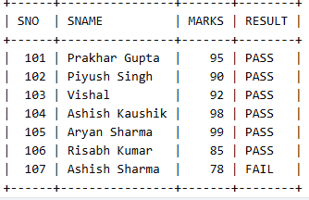

LEFT JOIN
Display all students and their results. If result is not available, show NULL.
Solution:-
SELECT S.SNO, S.SNAME, S.MARKS, R.RESULT FROM STUDENT S
LEFT JOIN RESULT R ON S.SNO = R.SNO;

Output:-

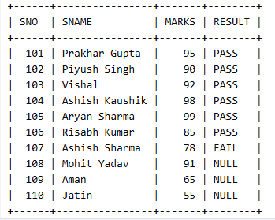

- RIGHT JOIN
Display all results and corresponding student details. If student is missing, show NULL.

Solution:-
SELECT S.SNO, S.SNAME, S.MARKS, R.RESULT FROM STUDENT S
RIGHT JOIN RESULT R ON S.SNO = R.SNO;

Output:-

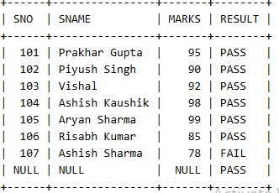

- FULL JOIN
Display all records from both tables whether matching or not.

Solution:-
SELECT S.SNO, S.SNAME, S.MARKS, R.RESULT FROM STUDENT S
LEFT JOIN RESULT R ON S.SNO = R.SNO

UNION

SELECT S.SNO, S.SNAME, S.MARKS, R.RESULT FROM STUDENT S
RIGHT JOIN RESULT R ON S.SNO = R.SNO;

Output:-
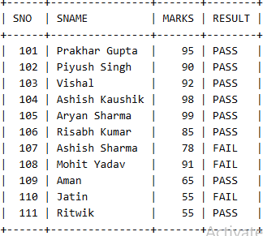

5).CROSS JOIN.
Write an SQL query to display all possible combinations of students and courses using CROSS JOIaN.

Solution:-
CREATE TABLE COURSE ( COURSE_NAME VARCHAR(50)
);

INSERT INTO COURSE VALUES ('Mtech'); INSERT INTO COURSE VALUES ('BCA'); INSERT INTO COURSE VALUES ('MBA'); INSERT INTO COURSE VALUES ('Btech'); SELECT*FROM STUDENT;

SELECT S.SNAME, C.COURSE_NAME FROM STUDENT S
CROSS JOIN COURSE C;

Output:-

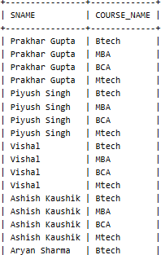

6).Self Join
Write an SQL query to display pairs of students who are enrolled in the same course using SELF JOIN.

Solution:-
CREATE TABLE COURSE ( SNO INT,
NAME VARCHAR(50), COURSE_NAME VARCHAR(50));

INSERT INTO COURSE VALUES (1,'Prakhar Gupta ','Mtech'); INSERT INTO COURSE VALUES (2,'Piyush Singh ','BCA'); INSERT INTO COURSE VALUES (3,'Ravi','MBA');
INSERT INTO COURSE VALUES (4,'Risabh ','Btech');
INSERT INTO COURSE VALUES (5,'Karan','Mtech'); INSERT INTO COURSE VALUES (6,'Simran','BCA');

SELECT A.NAME AS STUDENT1, A.COURSE_NAME FROM COURSE A, COURSE B
WHERE A.COURSE_NAME = B.COURSE_NAME AND A.SNO<B.SNO;

Output:-

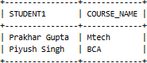

(ER Diagram – Company Database)
Design an Entity-Relationship (ER) diagram for a company database system with the following requirements:
Entities and Attributes:

EMPLOYEE
  - ID (Primary Key)
  - Name
  - Address
  - Gender
  - DOB (Date of Birth)
  - DOJ (Date of Joining)

DEPARTMENT
  - D_NO (Primary Key)
  - Name
  - Location

PROJECT
  - (Project details managed by department)

DEPENDENT
  - D_NAME
  - Gender
  - Relationship

Relationships:

WORK_IN
An Employee works in a Department Attribute: 

MANAGES
An Employee manages a Department

HAS
A Department has Projects

DEPENDENT_OF
An Employee has Dependents

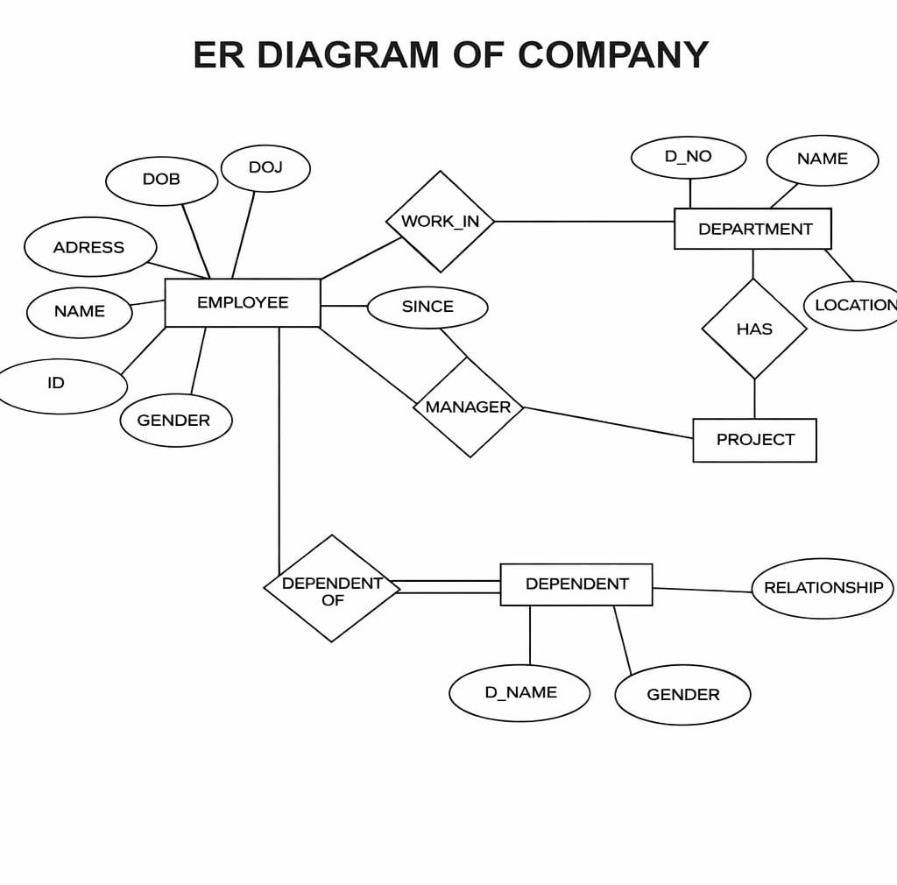

(ER Diagram – University Database)
Design an Entity-Relationship (ER) diagram for a university database system with the following requirements:

Entities and Attributes:

STUDENT
  - Roll_No (Primary Key)
  - Name
  - DOB
  - Address
  - Gender
  - DOJ (Date of Joining)

COURSE
  - C_ID (Primary Key)
  - C_Name
  - Location

PROFESSOR
  - Prof_ID (Primary Key)
  - Name
  - Title

DEPARTMENT
  - D_NO (Primary Key)
  - D_Name

Relationships:

ENROLLED_IN
A Student enrolls in a Course

TEACHES
A Professor teaches a Course

ADVISOR
A Professor acts as an advisor to a Student

WORKS_IN
A Professor works in a Department

