KR MANGALAM UNIVERSITY SESSION 2025-26

SCHOOL OF ENGINEERING AND TECHNOLOGY


R PROGRAMMING FOR DATA SCIENCE AND DATA ANALYTICS
LAB MANUAL

(SEC039)

Submitted by: Aamir Submitted to: Mr. Rishabh Kapoor Sir Roll no.:2401730238
Course: B.Tech CSE (AI & ML) Section: A

INDEX

S.No. | Topic | Page No.
1. | Write a program create a Matrix and Multi-dimensional Array. | 3
2. | Write a program to create a Dataframe and a List of random vectors. | 4-5
3. | Write a program to create a Calculator function which performs Addition, Subtraction, Multiplication and Division. | 6-7
4. | Write a program to perform string operations; count characters , Lowercase, Uppercase and trim whitespaces. | 8-9
5. | Write a program showcasing use of For and While loop. | 10

TOPIC: 1
  - Write a program create a Matrix and Multi-dimensional Array.
CODE.
- Matrix -
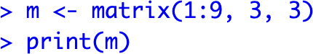

- Multi-Dimensional Array –

OUTPUT:
- Matrix code output -
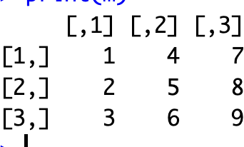
- Multi-dimensional Array output -
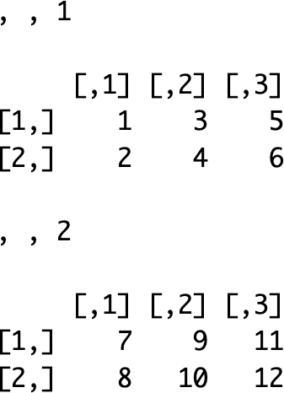
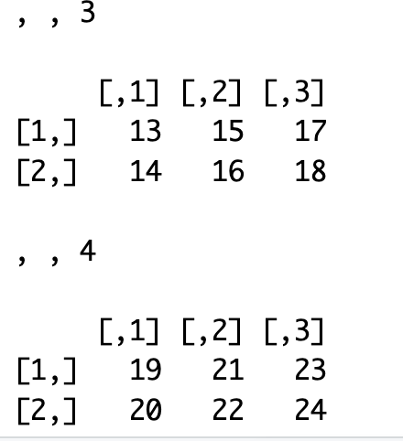

TOPIC: 2
  - Write a program to create a Dataframe and a List of random vectors

CODE:
- DataFrame Code -
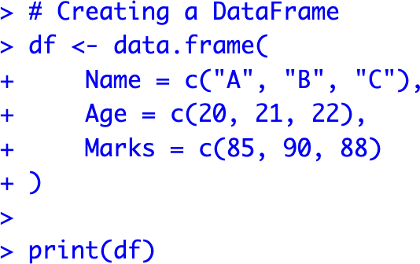
- List of Random Vectors –
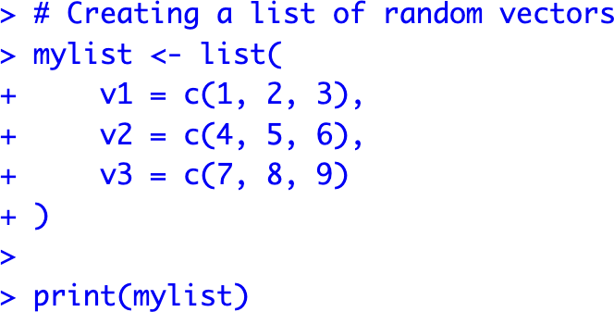

OUTPUT:
- DataFrame output –
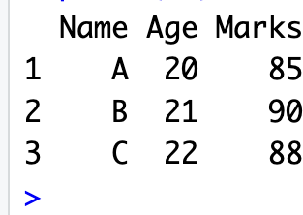
- List of random vector output –
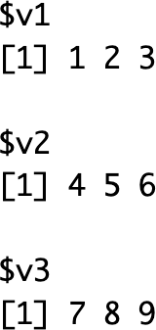

TOPIC: 3
  - Write a program to create a Calculator function which performs Addition, Subtraction, Multiplication and Division.

CODE:
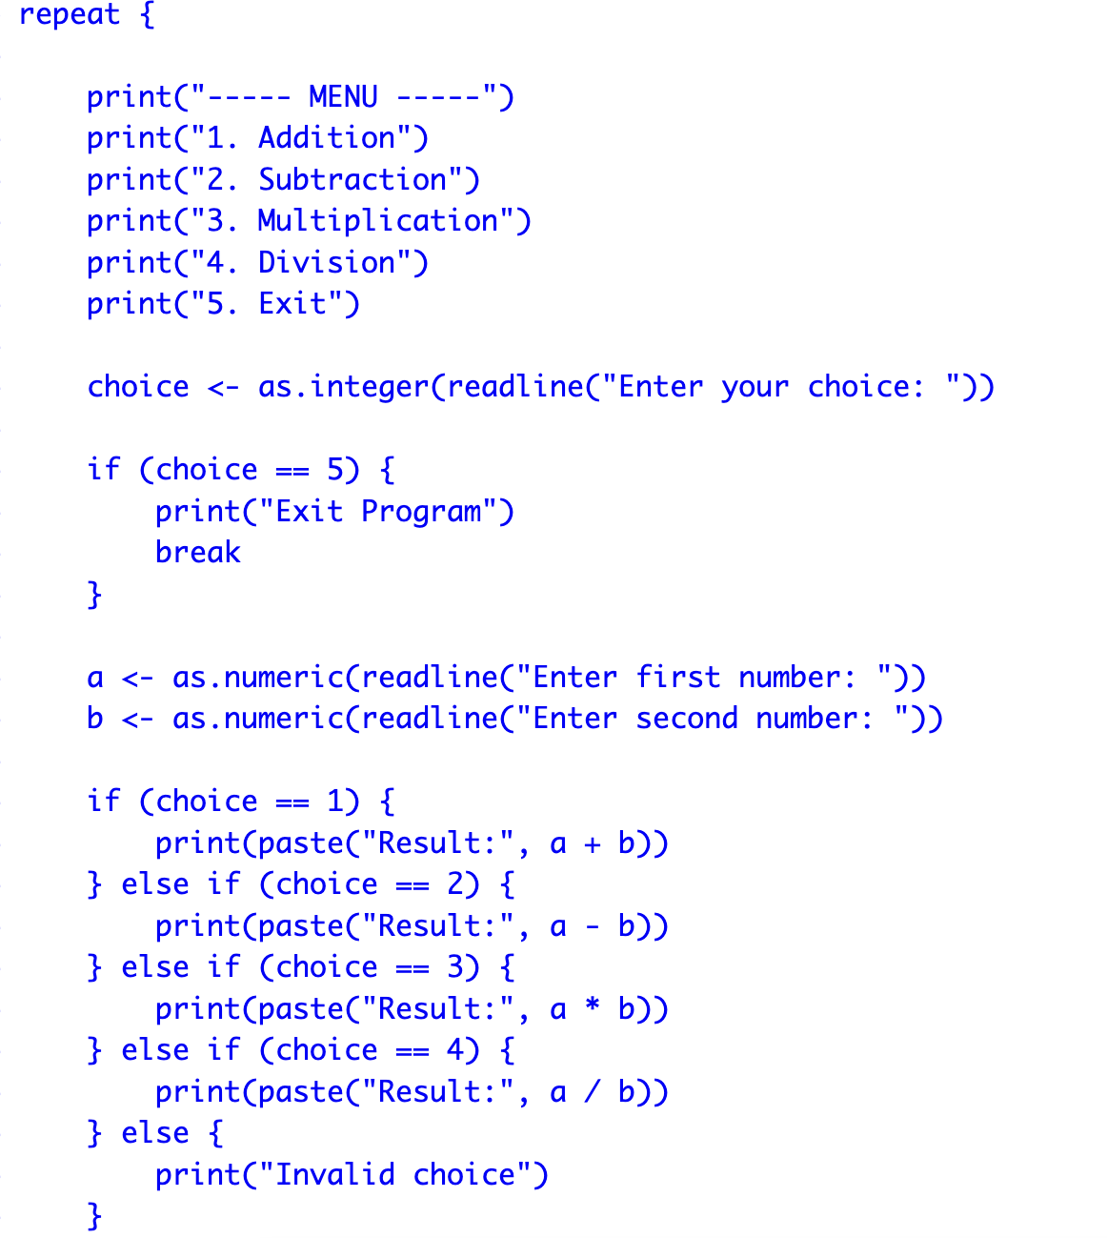
OUTPUT:
- Add output –
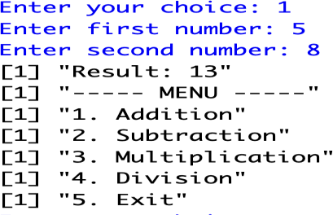
- Subtract output –
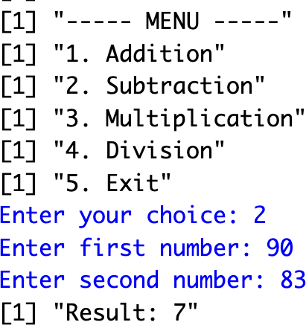
- Multiply output –
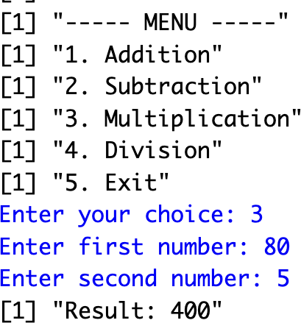
- Divide output –
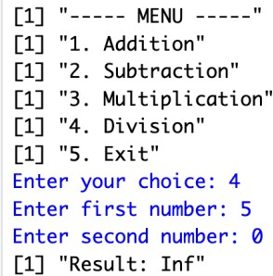
- Exit output –
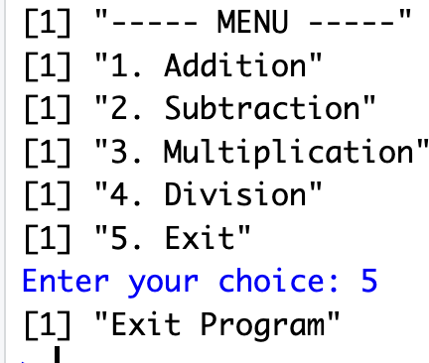

TOPIC: 4
  - Write a program which takes Random Text and covert it to Lowercase, Uppercase and Removes whitespaces

CODE:
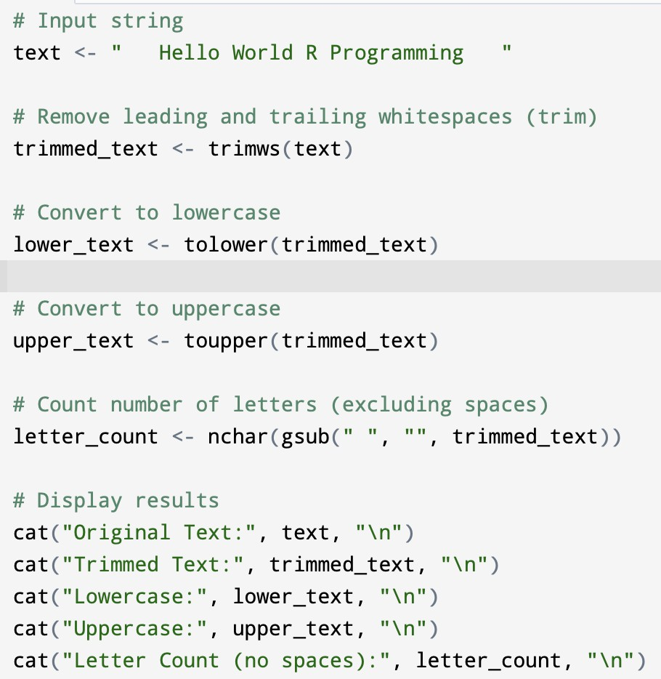
OUTPUT:
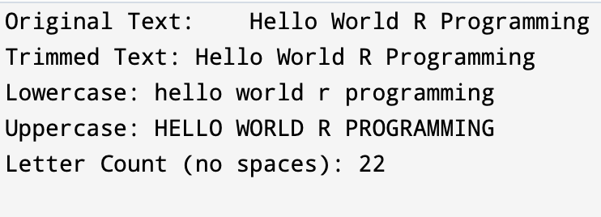

TOPIC: 5
Q.5 Write a program showcasing use of For and While loop.
CODE :
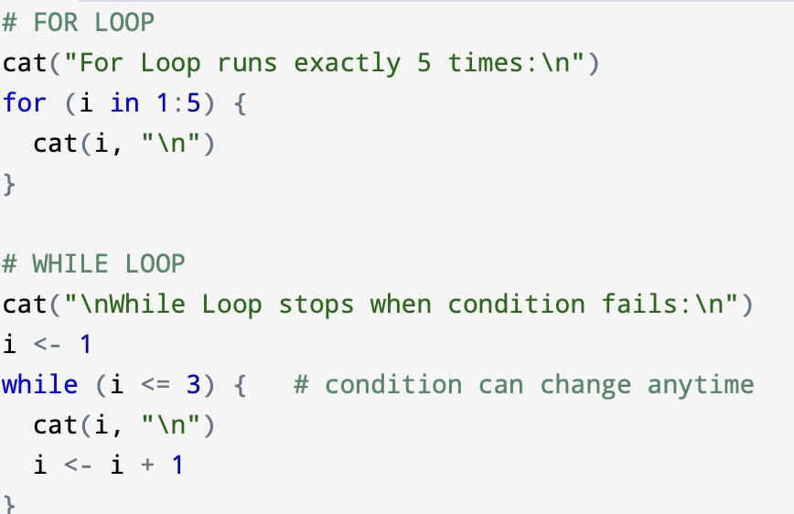
OUTPUT:
