Defect tracking System
CONTENTS

1. ABSTRACT
2. INTRODUCTION
3. DESIGN PRINCIPLES & EXPLANATION
3.1. MODULES
3.2. MODULE DESCRIPTIOIN
4. PROJECT DICTIONARY
4.1. DATAFLOW DIAGRAMS
4.2. E-R DIAGRAMS
4.3. DATA DICTIONARY
5. FORMS & REPORTS
5.1. I/O SAMPLES
6. BIBILIOGRAPHY

1. ABSTRACT

Defect Tracking System is the system which enables to detect the Defects. It not merely detects the Defects but provides the complete information regarding Defects detected.
Defect Tracking System ensures the user of it who needs to know about a provide information regarding the identified Defect. Using this no Defect will be unfixed in the developed application.
The developer develops the project as per customer requirements. In the testing phase the tester will identify the Defects. Whenever the tester encounter ‘n’ number of Defects he adds the Defect id and information in the database.
The tester reports to both project manager and developer. The Defect details in the database table are accessible to both project manager and developer.

2. INTRODUCTION
When a customer puts request or orders for a product to be developed. The project manager is responsible for adding users to Bug Tracking System and assigning projects to the users.
The project manager assigns projects to the developers. The developer develops the projects as per customer requirements. The project manager itself assigns the developed applications to the “Testers” for testing. The tester tests the application and identifies the Defects in the application.
When the testers encounter ‘n’ no. of Defects, he generates a unique id number for each individual Defect. The Defect information along with its id are mailed to the project manager and developer. This is “Defect Report”. These are stored in the database. This is useful for further reference.
Defect information includes the Defect id, Defect name, Defect priority, project name, Defect location, Defect type.
This whole process continues until all the Defects are got fixed in the application.
The Defect report is mailed to the project manager and the developer as soon as the Defect is identified. This makes that no error will go unfixed because of poor communication. It makes ensure that anyone who needs to know about a Defect can learn of it soon after it is reported.
Defect Tracking System plays a vital role in the testing phase. But it supports assigning projects for the developer, tester by the project manager. The Defect Tracking System maintains the different users separately i.e., it provides separate environments for project manager, developer and tester.

The users of Defect Tracking System:
- Project Manager
- Developer
- Tester
Existing System:
In the existing system, the project manager assigns the projects to the developers. The developer develops the projects as per customer requirements. The project managers itself assign the developed applications to the tester for testing. In the testing phase, when the tester encounters no. of Defects then he reports to the project manager and developer about the Defect information.
Bottlenecks of the Existing System:
- The tester report which is called “Defect Report” is in the form of physical document. If the document is damaged then the total information about the Defect will be lost.
- The Defect information is not stored in the database for future reference.

Proposed System:
The purpose of the Defect Tracking System is to test the application for the Defects and report it to the project manager and developer. The main intention behind the Defect Tracking System is that to track Defects and report them. Store the Defect information with a unique id in the database for future reference. So, this makes the job of handling the Defects easy.

Objectives of the Defect Tracking System:
The main objectives of the Defect Tracking System are:
- Identifying the Defects in the developed application.
- No Defect will be unfixed in the developed application.
- Not merely identifying the Defects but also providing the Defect information.
- As soon as the Defects are identified. They are reported to the project manager and developer.
- To ensure that who needs to know about the Defect can learn soon after it is reported.

3. DESIGN PRINCIPLES & EXPLANATION
3.1. MODULES

The main goal of this project is to store Defect information by giving unique id for each Defect in the database. This will be used for future reference while the same Defect arises. The project has the following modules:

- Project Manager
- Developer
- Tester

3.2. MODULE DESCRIPTIOIN
Project Manager:
The project manager has the options to access developer information, project information, and tester information, assign project information, bugs information, self details.
Developer/Tester Information:
The project manager will access the developer/tester information. In this the, the project manager can
- Add developer/tester details into the database.
- Delete developer/tester from the database.
- Modifying the existing developer/tester.

Project Information:
The project manager will access the project information. In this, the project manager can
- Add the project into the database by gathering the information like project name, status, project id, description.
- Delete project from the database by specifying the project name.
- Modify the project details by specifying the project name.

Assign Information:
This can be accessed by the project manager to assign the projects to the other users like developer, tester. Assign information has the following options like view, assign and project. The project manager can
- View all the projects.
- Assign the projects to the developer and tester by gathering the information like user name, project id, assigned date, date of completion.
- Search a particular project details by specifying corresponding project id.

Report i.e., Bug Report:
This is used to view the Defect report after specifying the project id.

Self:
This option is used to view the self details. It has option to change password. This gathers the information like old password, new password. This makes to store the changed password to the database.

Developer:
The developer has an option to view projects and self details.

View Project:
This option will make the developer/tester to view all his assigned projects. It displays the project name, project id, assigned date, expected date of completion.

Developer:
This option is used to view the self details. It has option to change password. This gathers the information like old password, new password. This makes to store the changed password to the database.

Tester:
The tester has to track Defects in the assigned projects and to view his projects, self details.

Assigned Projects:
This makes the tester to view the assigned projects and track Defects in the assigned projects. In this option, the tester can

- View the assigned projects to him by specifying the user id and password.
- Track the Defects. It pop ups a window which takes the details of project id. When the track is clicked the Defects are tracked. Different test cases are also selected for better test.
- Add the Defect information along with Defect id, project id, Defect type, location
- Mail the Defect id and some other details regarding the Defect to the project manager and developer.

Self:
This option is used to view the self details. It has option to change password. This gathers the information like old password, new password. This makes to store the changed password to the database.

Microsoft.NET Framework
The .NET Framework is a new computing platform that simplifies application development in the highly distributed environment of the Internet. The .NET Framework is designed to fulfill the following objectives:
- To provide a consistent object-oriented programming environment whether object code is stored and executed locally, executed locally but Internet-distributed, or executed remotely.
- To provide a code-execution environment that minimizes software deployment and versioning conflicts.
- To provide a code-execution environment that guarantees safe execution of code, including code created by an unknown or semi-trusted third party.
- To provide a code-execution environment that eliminates the performance problems of scripted or interpreted environments.
- To make the developer experience consistent across widely varying types of applications, such as Windows-based applications and Web-based applications.
- To build all communication on industry standards to ensure that code based on the .NET Framework can integrate with any other code.
The .NET Framework has two main components: the common language runtime and the .NET Framework class library. The common language runtime is the foundation of the .NET Framework. You can think of the runtime as an agent that manages code at execution time, providing core services such as memory management, thread management, and remoting, while also enforcing strict type safety and other forms of code accuracy that ensure security and robustness. In fact, the concept of code management is a fundamental principle of the runtime. Code that targets the runtime is known as managed code, while code that does not target the runtime is known as unmanaged code. The class library, the other main component of the .NET Framework, is a comprehensive, object-oriented collection of reusable types that you can use to develop applications ranging from traditional command-line or graphical user interface (GUI) applications to applications based on the latest innovations provided by ASP.NET, such as Web Forms and XML Web services.
The .NET Framework can be hosted by unmanaged components that load the common language runtime into their processes and initiate the execution of managed code, thereby creating a software environment that can exploit both managed and unmanaged features. The .NET Framework not only provides several runtime hosts, but also supports the development of third-party runtime hosts.
For example, ASP.NET hosts the runtime to provide a scalable, server-side environment for managed code. ASP.NET works directly with the runtime to enable Web Forms applications and XML Web services, both of which are discussed later in this topic.
Internet Explorer is an example of an unmanaged application that hosts the runtime (in the form of a MIME type extension). Using Internet Explorer to host the runtime enables you to embed managed components or Windows Forms controls in HTML documents. Hosting the runtime in this way makes managed mobile code (similar to Microsoft® ActiveX® controls) possible, but with significant improvements that only managed code can offer, such as semi-trusted execution and secure isolated file storage.
The following illustration shows the relationship of the common language runtime and the class library to your applications and to the overall system. The illustration also shows how managed code operates within a larger architecture.

Features of the Common Language Runtime
The common language runtime manages memory, thread execution, code execution, code safety verification, compilation, and other system services. These features are intrinsic to the managed code that runs on the common language runtime.
With regards to security, managed components are awarded varying degrees of trust, depending on a number of factors that include their origin (such as the Internet, enterprise network, or local computer). This means that a managed component might or might not be able to perform file-access operations, registry-access operations, or other sensitive functions, even if it is being used in the same active application.
The runtime enforces code access security. For example, users can trust that an executable embedded in a Web page can play an animation on screen or sing a song, but cannot access their personal data, file system, or network. The security features of the runtime thus enable legitimate Internet-deployed software to be exceptionally feature rich.
The runtime also enforces code robustness by implementing a strict type- and code-verification infrastructure called the common type system (CTS). The CTS ensures that all managed code is self-describing. The various Microsoft and third-party language compilers
Generate managed code that conforms to the CTS. This means that managed code can consume other managed types and instances, while strictly enforcing type fidelity and type safety.
In addition, the managed environment of the runtime eliminates many common software issues. For example, the runtime automatically handles object layout and manages references to objects, releasing them when they are no longer being used. This automatic memory management resolves the two most common application errors, memory leaks and invalid memory references.
The runtime also accelerates developer productivity. For example, programmers can write applications in their development language of choice, yet take full advantage of the runtime, the class library, and components written in other languages by other developers. Any compiler vendor who chooses to target the runtime can do so. Language compilers that target the .NET Framework make the features of the .NET Framework available to existing code written in that language, greatly easing the migration process for existing applications.
While the runtime is designed for the software of the future, it also supports software of today and yesterday. Interoperability between managed and unmanaged code enables developers to continue to use necessary COM components and DLLs.
The runtime is designed to enhance performance. Although the common language runtime provides many standard runtime services, managed code is never interpreted. A feature called just-in-time (JIT) compiling enables all managed code to run in the native machine language of the system on which it is executing. Meanwhile, the memory manager removes the possibilities of fragmented memory and increases memory locality-of-reference to further increase performance.
Finally, the runtime can be hosted by high-performance, server-side applications, such as Microsoft® SQL Server™ and Internet Information Services (IIS). This infrastructure enables you to use managed code to write your business logic, while still enjoying the superior performance of the industry's best enterprise servers that support runtime hosting.

.NET Framework Class Library
The .NET Framework class library is a collection of reusable types that tightly integrate with the common language runtime. The class library is object oriented, providing types from which your own managed code can derive functionality. This not only makes the .NET Framework types easy to use, but also reduces the time associated with learning new
features of the .NET Framework. In addition, third-party components can integrate seamlessly with classes in the .NET Framework.
For example, the .NET Framework collection classes implement a set of interfaces that you can use to develop your own collection classes. Your collection classes will blend seamlessly with the classes in the .NET Framework.
As you would expect from an object-oriented class library, the .NET Framework types enable you to accomplish a range of common programming tasks, including tasks such as string management, data collection, database connectivity, and file access. In addition to these common tasks, the class library includes types that support a variety of specialized development scenarios. For example, you can use the .NET Framework to develop the following types of applications and services:
- Console applications.
- Scripted or hosted applications.
- Windows GUI applications (Windows Forms).
- ASP.NET applications.
- XML Web services.
- Windows services.
For example, the Windows Forms classes are a comprehensive set of reusable types that vastly simplify Windows GUI development. If you write an ASP.NET Web Form application, you can use the Web Forms classes.

Client Application Development
Client applications are the closest to a traditional style of application in Windows-based programming. These are the types of applications that display windows or forms on the desktop, enabling a user to perform a task. Client applications include applications such as word processors and spreadsheets, as well as custom business applications such as data-entry tools, reporting tools, and so on. Client applications usually employ windows, menus, buttons, and other GUI elements, and they likely access local resources such as the file system and peripherals such as printers.
Another kind of client application is the traditional ActiveX control (now replaced by the managed Windows Forms control) deployed over the Internet as a Web page. This application is much like other client applications: it is executed natively, has access to local resources, and includes graphical elements.

In the past, developers created such applications using C/C++ in conjunction with the Microsoft Foundation Classes (MFC) or with a rapid application development (RAD) environment such as Microsoft® Visual Basic®. The .NET Framework incorporates aspects of these existing products into a single, consistent development environment that drastically simplifies the development of client applications.
The Windows Forms classes contained in the .NET Framework are designed to be used for GUI development. You can easily create command windows, buttons, menus, toolbars, and other screen elements with the flexibility necessary to accommodate shifting business needs.
For example, the .NET Framework provides simple properties to adjust visual attributes associated with forms. In some cases the underlying operating system does not support changing these attributes directly, and in these cases the .NET Framework automatically recreates the forms. This is one of many ways in which the .NET Framework integrates the developer interface, making coding simpler and more consistent.
Unlike ActiveX controls, Windows Forms controls have semi-trusted access to a user's computer. This means that binary or natively executing code can access some of the resources on the user's system (such as GUI elements and limited file access) without being able to access or compromise other resources. Because of code access security, many applications that once needed to be installed on a user's system can now be safely deployed through the Web. Your applications can implement the features of a local application while being deployed like a Web page.

C#.Net for Windows Application

Overview of the .NET Framework
The .NET Framework is a managed type-safe environment for application development and execution. The .NET Framework manages all aspects of your program’s execution. It allocates memory for the storage of data and instructions, grants or denies the appropriate permissions to your application, initiates and manages application execution, and manages the reallocation of memory from resources that are no longer needed. The .NET Framework consists of two main components: the common language runtime and the .NET Framework class library.
The common language runtime can be thought of as the environment that manages code execution. It provides core services, such as code compilation, memory allocation, thread management, and garbage collection. Through the common type system (CTS), it enforces strict type-safety and ensures that code is executed in a safe environment by also enforcing code access security.
The .NET Framework class library provides a collection of useful and reusable types that are designed to integrate with the common language runtime. The types provided by the .NET Framework are object-oriented and fully extensible, and they allow you to seamlessly integrate your applications with the .NET Framework.
Languages and the .NET Framework
The .NET Framework is designed for cross-language compatibility, which means, simply, that .NET components can interact with each other no matter what supported language they were written in originally. So, an application written in Microsoft Visual Basic .NET might reference a dynamic-link library (DLL) file written in Microsoft Visual C#, which in turn might access a resource written in managed Microsoft Visual C++ or any other .NET language. This language interoperability extends to full object-oriented inheritance. A Visual Basic .NET class might be derived from a C# class, for example, or vice versa.
This level of cross-language compatibility is possible because of the common language runtime. When a .NET application is compiled, it is converted from the language in which it was written (Visual Basic .NET, C#, or any other .NET-compliant language) to Microsoft Intermediate Language (MSIL or IL). MSIL is a low-level language that the common language runtime can read and understand. Because all .NET executables and DLLs exist as MSIL, they can freely interoperate. The Common Language Specification (CLS) defines the minimum standards to which .NET language compilers must conform. Thus, the CLS ensures that any source code successfully compiled by a .NET compiler can interoperate with the .NET Framework.
The CTS ensures type compatibility between .NET components. Because .NET applications are converted to IL prior to deployment and execution, all primitive data types are represented as .NET types. Thus, a Visual Basic Integer and a C# int are both represented in IL code as a System.Int32. Because both languages use a common type system, it is possible to transfer data between components and avoid time-consuming conversions or hard-to-find errors.
Visual Studio .NET ships with languages such as Visual Basic .NET, Visual C#, and Visual C++ with managed extensions, as well as the JScript scripting language. You can also write managed code for the .NET Framework in other languages. Third-party tools and compilers exist for Fortran, Cobol, Perl, and a host of other languages. All of these languages share the same cross-language compatibility and inheritability. Thus, you can write code for the .NET Framework in the language of your choice, and it will be able to interact with code written for the .NET Framework in any other language.
.NET Framework Architecture
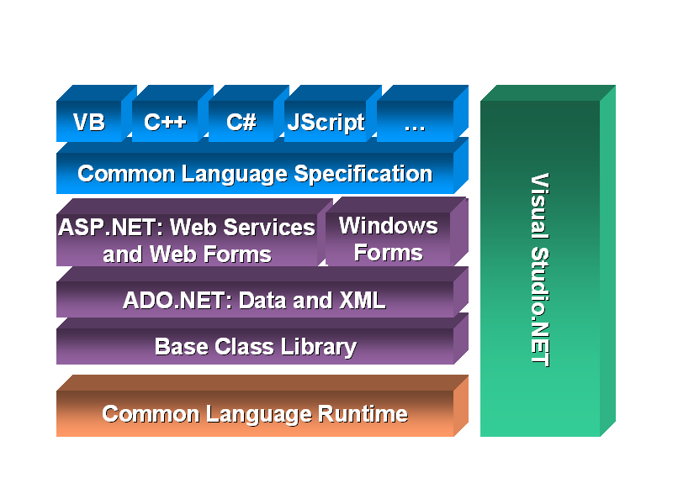
The Structure of a .NET Application
To understand how the common language runtime manages code execution, you must examine the structure of a .NET application. The primary unit of a .NET application is the assembly. An assembly is a self-describing collection of code, resources, and metadata. The assembly manifest contains information about what is contained within the assembly. The assembly manifest provides:
- Identity information, such as the assembly’s name and version number
- A list of all types exposed by the assembly
- A list of other assemblies required by the assembly
- A list of code access security instructions, including permissions required by the assembly and permissions to be denied the assembly
Each assembly has one and only one assembly manifest, and it contains all the description information for the assembly. However, the assembly manifest can be contained in its own file or within one of the assembly’s modules.
An assembly contains one or more modules. A module contains the code that makes up your application or library, and it contains metadata that describes that code. When you compile a project into an assembly, your code is converted from high-level code to IL. Because all managed code is first converted to IL code, applications written in different languages can easily interact. For example, one developer might write an application in Visual C# that accesses a DLL in Visual Basic .NET. Both resources will be converted to IL modules before being executed, thus avoiding any language-incompatibility issues.
Each module also contains a number of types. Types are templates that describe a set of data encapsulation and functionality. There are two kinds of types: reference types (classes) and value types (structures). These types are discussed in greater detail in Lesson 2 of this chapter. Each type is described to the common language runtime in the assembly manifest. A type can contain fields, properties, and methods, each of which should be related to a common functionality. For example, you might have a class that represents a bank account. It contains fields, properties, and methods related to the functions needed to implement a bank account. A field represents storage of a particular type of data. One field might store the name of an account holder, for example. Properties are similar to fields, but properties usually provide some kind of validation when data is set or retrieved. You might have a property that represents an account balance. When an attempt is made to change the value, the property can check to see if the attempted change is greater than a predetermined limit. If the value is greater than the limit, the property does not allow the change. Methods represent behavior, such as actions taken on data stored within the class or changes to the user interface. Continuing with the bank account example, you might have a Transfer method that transfers a balance from a checking account to a savings account, or an Alert method that warns users when their balances fall below a predetermined level.

CLR Execution Model
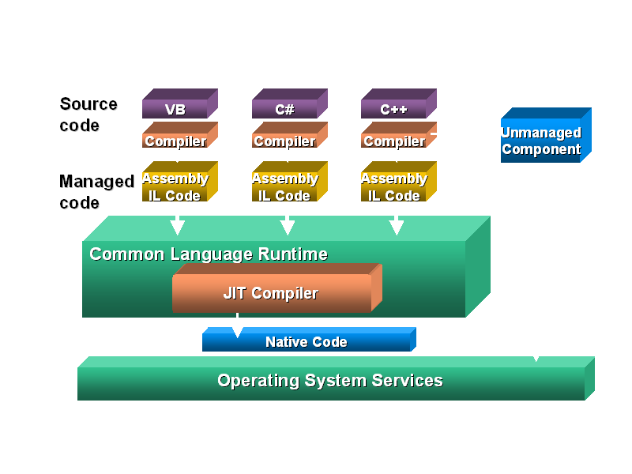
Compilation and Execution of a .NET Application
When you compile a .NET application, it is not compiled to binary machine code; rather, it is converted to IL. This is the form that your deployed application takes—one or more assemblies consisting of executable files and DLL files in IL form. At least one of these assemblies will contain an executable file that has been designated as the entry point for the application.
When execution of your program begins, the first assembly is loaded into memory. At this point, the common language runtime examines the assembly manifest and determines the requirements to run the program. It examines security permissions requested by the assembly and compares them with the system’s security policy. If the system’s security policy does not allow the requested permissions, the application will not run. If the application passes the system’s security policy, the common language runtime executes the code. It creates a process for the application to run in and begins application execution. When execution starts, the first bit of code that needs to be executed is loaded into memory and compiled into native binary code from IL by the common language runtime’s Just-In-Time (JIT) compiler. Once compiled, the code is executed and stored in memory as native code. Thus, each portion of code is compiled only once when an application executes. Whenever program execution branches to code that has not yet run, the JIT compiler compiles it ahead of execution and stores it in memory as binary code. This way, application performance is maximized because only the parts of a program that are executed are compiled.
2: The .NET Base Class Library
- The .NET base class library is a collection of object-oriented types and interfaces that provide object models and services for many of the complex programming tasks you will face. Most of the types presented by the .NET base class library are fully extensible, allowing you to build types that incorporate your own functionality into your managed code.
The .NET Framework base class library contains the base classes that provide many of the services and objects you need when writing your applications. The class library is organized into namespaces. A namespace is a logical grouping of types that perform related functions. For example, the System.Windows.Forms namespace contains all the types that make up Windows forms and the controls used in those forms.
Namespaces are logical groupings of related classes. The namespaces in the .NET base class library are organized hierarchically. The root of the .NET Framework is the System namespace. Other namespaces can be accessed with the period operator. A typical namespace construction appears as follows:
System
System.Data
System.Data.SQLClient
The first example refers to the System namespace. The second refers to the System.Data namespace. The third example refers to the System.Data.SQLClient namespace. Table 1.1 introduces some of the more commonly used .NET base class namespaces.
Table 1-1. Representative .NET Namespaces
Namespace | Description
System | This namespace is the root for many of the low-level types required by the .NET Framework. It is the root for primitive data types as well, and it is the root for all the other namespaces in the .NET base class library.
System.Collections | This namespace contains classes that represent a variety of different container types, such as ArrayList, SortedList, Queue, and Stack. You also can find abstract classes, such as CollectionBase, which are useful for implementing your own collection functionality.
System.ComponentModel | This namespace contains classes involved in component creation and containment, such as attributes, type converters, and license providers.
System.Data | This namespace contains classes required for database access and manipulations, as well as additional namespaces used for data access.
System.Data.Common | This namespace contains a set of classes that are shared by the .NET managed data providers.
System.Data.OleDb | This namespace contains classes that make up the managed data provider for OLE DB data access.
System.Data.SQLClient | This namespace contains classes that are optimized for interacting with Microsoft SQL Server.
System.Drawing | This namespace exposes GDI+ functionality and provides classes that facilitate graphics rendering.
System.IO | In this namespace, you will find types for handling file system I/O.
System.Math | This namespace is home to common mathematics functions such as extracting roots and trigonometry.
System.Reflection | This namespace provides support for obtaining information and dynamic creation of types at runtime.
System.Security | This namespace is home to types dealing with permissions, cryptography, and code access security.
System.Threading | This namespace contains classes that facilitate the implementation of multithreaded applications.
System.Windows.Forms | This namespace contains types involved in creating standard Windows applications. Classes that represent forms and controls reside here as well.
The namespace names are self-descriptive by design. Straightforward names make the .NET Framework easy to use and allow you to rapidly familiarize yourself with its contents.
Reference Types and Value Types
Types in the .NET Framework come in two varieties: value types and reference types. The primary difference between value types and reference types has to do with the way variable data is accessed. To understand this difference, a little background on memory dynamics is required.
Application data memory is divided into two primary components, the stack and the heap. The stack is an area of memory reserved by the application to run the program. The stack is analogous to a stack of dinner plates. Plates are placed on the stack one on top of another. When a plate is removed from the stack, it is always the last one to have been placed on top that is removed first. So it is with program variables. When a function is called, all the variables used by the function are pushed onto the stack. If that function calls additional functions, it pushes additional variables onto the stack. When the most recently called function terminates, all of its variables go out of scope (meaning that they are no longer available to the application) and are popped off the stack. Memory consumed by those variables is then freed up, and program execution continues.
The heap, on the other hand, is a separate area of memory reserved for the creation of reusable objects. The common language runtime manages allocation of heap memory for objects and controls the reclamation of memory from unused objects through garbage collection.
All the data associated with a value type is allocated on the stack. When a variable of a value type goes out of scope, it is destroyed and its memory is reclaimed. A variable of a reference type, on the other hand, exists in two memory locations. The actual object data is allocated on the heap. A variable containing a pointer to that object is allocated on the stack. When that variable is called by a function, it returns the memory address for the object to which it refers. When that variable goes out of scope, the object reference is destroyed but the object itself is not. If any other references to that object exist, the object remains intact. If the object is left without any references, it is subject to garbage collection. (See Lesson 6 of this chapter.)
Examples of value types include primitives, such as Integer (int), Boolean (bool), Char (char), and so on, as well as user-defined types such as Structure (struct) and Enumeration (enum). Classes represent the majority of reference types. Other reference types include the interface, delegate, and array types. Classes and structures are discussed in Lesson 3 of this chapter, and other reference and value types are discussed in Chapter 3.
Using .NET Framework Types in Your Application
When you begin writing an application, you automatically begin with a reference to the .NET Framework base class library. You reference it so that your application is aware of the base class library and is able to create instances of the types represented by it.
Value Types

int myInteger;
This line tells the runtime to allocate the appropriate amount of memory to hold an integer variable. Although this line creates the variable, it does not assign a value to it. You can assign a value using the assignment operator, as follows:
myInteger = 42;
You can also choose to assign a value to a variable upon creation, as shown in this example:
int myInteger = 42;

Reference Types
Creating an instance of a type is a two-step process. The first step is to declare the variable as that type, which allocates the appropriate amount of memory for that variable but does not actually create the object. The following syntax declares an object:
System.Windows.Forms.Form myForm;
This line tells the runtime to set aside enough memory to hold a Form variable and assigns it the name myForm, but it does not actually create the Form object in memory. The second step, called instantiation, actually creates the object. An example of instantiation follows:
myForm = new System.Windows.Forms.Form();
This line makes a call to the constructor method of the type System.Windows.Forms.Form by way of the New (new) keyword. The constructor is a special method that is invoked only at the beginning of an object’s lifetime. It contains any code that must be executed for the object to work (assigning values to properties, for example). If any parameters were required by the constructor, they would be contained within the parentheses at the end of the line. The following example shows declaration and instantiation of a hypothetical Widget class that requires a string as a parameter in the constructor.
Widget myWidget;
myWidget = new Widget("This string is required by the constructor");
If desired, you can also combine both declaration and instantiation into a single statement. By declaring and instantiating an object in the same line, you reserve the memory for the object and immediately create the object that resides in that memory. Although there was a significant performance penalty for this shortcut in previous versions of Visual Basic, Visual Basic .NET and Visual C# are optimized to allow this behavior without any performance loss. The following example shows the one-step declaration and instantiation of a new Form:
System.Windows.Forms.Form myForm = new
System.Windows.Forms.Form();
Both value types and reference types must be initialized before use. For class and structure fields in Visual Basic .NET, types are initialized with default values on declaration. Numeric value types (such as integer) and floating-point types are assigned zero; Boolean variables are assigned False; and reference types are assigned to a null reference.
In C#, variables of a reference type have a default value of null. It is recommended that you do not rely on the default value. These variables should not be used until they have been initialized.
Using Value Type and Reference Type Variables
A variable that represents a value type contains all the data represented by that type. A variable that represents a reference type contains a reference to a particular object. This distinction is important. Consider the following example:
int x, y;
x = 15;
y = x;
x = 30;
// What is the value of y?
In this example, two integer variables named x and y are created. X is assigned a value of 15, and then y is assigned the value of x. Next the value of x is changed to 30, and the question is posed: what is the value of y? The answer to this question might seem obvious, and it is y = 15 because x and y are two separate variables and have no effect on each other when changed. When the line y = x is encountered, the value of x is copied to the value of y, and there is no further connection between the two variables.
This situation changes, however, in the case of reference types. Let’s reconsider the previous example using a reference type (Form) instead of a value type.
System.Windows.Forms.Form x,y;
x = new System.Windows.Forms.Form();
x.Text = "This is Form 1";
y = x;
x.Text = "This is Form 2";
// What value does y.Text return?
What value does y.Text return? This time, the answer is less obvious. Because System.Windows.Forms.Form is a reference type, the variable x does not actually contain a Form; rather, it points to an instance of a Form. When the line y = x is encountered, the runtime copies the reference from variable x to y. Thus, the variables x and y now point to the same instance of Form. Because these two variables refer to the same instance of the object, they will return the same values for properties of that object. Thus, y.Text returns “This is Form 2”.
The Imports and Using Statements
Up to this point of the chapter, if you wanted to access a type in the .NET Framework base class library, you had to use the full name of the type, including every namespace to which it belonged. For example:
System.Windows.Forms.Form
This is called the fully-qualified name, meaning it refers both to the class and to the namespace in which it can be found. You can make your development environment “aware” of various namespaces by using the Imports (Visual Basic .NET) or using (Visual C#) statement. This technique allows you to refer to a type using only its generic name and to omit the qualifying namespaces. Thus, you could refer to System.Windows.Forms.Form as simply Form. In Visual Basic .NET, the Imports statement must be placed at the top of the code window, preceding any other statement (except Option). In Visual C#, the using statement must occur before any other namespace element, such as a class or struct. This example demonstrates use of this statement:
using System.Windows.Forms;
When two types of the same name exist in more than one imported namespace, you must use the fully qualified name to avoid a naming conflict. Thus, if you are using MyNameSpaceOne and MyNameSpaceTwo, and each contains a Widget class, you would have to refer to MyNameSpaceOne.Widget or MyNameSpaceTwo.Widget to ensure the correct result.
In C#, you can resolve namespace conflicts such as these by creating an alias. An alias allows you to choose one name to refer to another class. You create an alias using the using keyword, as shown below:
using myAlias = MyNameSpaceTwo.Widget;
After implementing an alias, you can use it in code to represent the aliased class. For example:
// You can now refer to MyNameSpaceTwo as myAlias. The
// following two lines produce the same result:
MyNameSpaceTwo.Widget anotherWidget = new MyNameSpaceTwo.Widget() ;
myAlias anotherWidget = new myAlias() ;
You cannot create aliases for types in this manner in Visual Basic .NET.
Referencing External Libraries
You might want to use class libraries not contained by the .NET Framework, such as libraries developed by third-party vendors or libraries you developed. To access these external libraries, you must create a reference.
To create a reference to an external library
- In the Solution Explorer, right-click the References node of your project.
- From the pop-up menu, choose Add Reference. The Add Reference dialog box appears.
- Choose the appropriate tab for the library you want to reference. .NET libraries are available on the .NET tab. Legacy COM libraries appear on the COM tab, and local Visual Studio projects appear on the Projects tab.
- Locate the library you want to reference, and double-click it to add it to the Selected components box. Click OK to confirm the choice of that reference.

Introduction to Object-Oriented Programming
Programming in the .NET Framework environment is done with objects. Objects are programmatic constructs that represent packages of related data and functionality. Objects are self-contained and expose specific functionality to the rest of the application environment without detailing the inner workings of the object itself. Objects are created from a template called a class. The .NET base class library provides a set of classes from which you can create objects in your applications. You also can use the Microsoft Visual Studio programming environment to create your own classes. This lesson introduces you to the concepts associated with object-oriented programming.
Objects, Members, and Abstraction
An object is a programmatic construct that represents something. In the real world, objects are cars, bicycles, laptop computers, and so on. Each of these items exposes specific functionality and has specific properties. In your application, an object might be a form, a control such as a button, a database connection, or any of a number of other constructs. Each object is a complete functional unit, and contains all of the data and exposes all of the functionality required to fulfill its purpose. The ability of programmatic objects to represent real-world objects is called abstraction.
Classes Are Templates for Objects
Classes can be thought of as blueprints for objects: they define all of the members of an object, define the behavior of an object, and set initial values for data when appropriate. When a class is instantiated, an in-memory instance of that class is created. This instance is called an object. To review, a class is instantiated using the New (new) keyword as follows:
When an instance of a class is created, a copy of the instance data defined by that class is created in memory and assigned to the reference variable. Individual instances of a class are independent of one another and represent separate programmatic constructs. There is generally no limit to how many copies of a single class can be instantiated at any time. To use a real-world analogy, if a car is an object, the plans for the car are the class. The plans can be used to make any number of cars, and changes to a single car do not, for the most part, affect any other cars.
Objects and Members
Objects are composed of members. Members are properties, fields, methods, and events, and they represent the data and functionality that comprise the object. Fields and properties represent data members of an object. Methods are actions the object can perform, and events are notifications an object receives from or sends to other objects when activity happens in the application.
To continue with the real-world example of a car, consider that a Car object has fields and properties, such as Color, Make, Model, Age, GasLevel, and so on. These are the data that describe the state of the object. A Car object might also expose several methods, such as Accelerate, ShiftGears, or Turn. The methods represent behaviors the object can execute. And events represent notifications. For example, a Car object might receive an EngineOverheating event from its Engine object, or it might raise a Crash event when interacting with a Tree object.
Object Models
Simple objects might consist of only a few properties, methods, and perhaps an event or two. More complex objects might require numerous properties and methods and possibly even subordinate objects. Objects can contain and expose other objects as members. For example, the TextBox control exposes a Font property, which consists of a Font object. Similarly, every instance of the Form class contains and exposes a Controls collection that comprises all of the controls contained by the form. The object model defines the hierarchy of contained objects that form the structure of an object.
An object model is a hierarchical organization of subordinate objects contained and exposed within a main object. To illustrate, let’s revisit the example of a car as an object. A car is a single object, but it also consists of subordinate objects. A Car object might contain an Engine object, four Wheel objects, a Transmission object, and so on. The composition of these subordinate objects directly affects how the Car object functions as a whole. For example, if the Cylinders property of the Engine subordinate object is equal to 4, the Car will behave differently than a Car whose Engine has a Cylinders property value of 8. Contained objects can have subordinate objects of their own. For example, the contained Engine object might contain several SparkPlug objects.
Encapsulation
Encapsulation is the concept that implementation of an object is independent of its interface. Put another way, an application interacts with an object through its interface, which consists of its public properties and methods. As long as this interface remains constant, the application can continue to interact with the component, even if implementation of the interface was completely rewritten between versions.
Objects should only interact with other objects through their public methods and properties. Thus, objects should contain all of the data they require, as well as all of the functionality that works with that data. The internal data of an object should never be exposed in the interface; thus, fields rarely should be Public (public).
Returning to the Car example. If a Car object interacts with a Driver object, the Car interface might consist of a GoForward method, a GoBackward method, and a Stop method. This is all the information that the Driver needs to interact with the Car. The Car might contain an Engine object, for example, but the Driver doesn’t need to know about the Engine object—all the Driver cares about is that the methods can be called and that they return the appropriate values. Thus, if one Engine object is exchanged for another, it makes no difference to the Driver as long as the interface continues to function correctly.
Polymorphism
Polymorphism is the ability of different classes to provide different implementations of the same public interfaces. In other words, polymorphism allows methods and properties of an object to be called without regard for the particular implementation of those members. For example, a Driver object can interact with a Car object through the Car public interface. If another object, such as a Truck object or a SportsCar object, exposes the same public interface, the Driver object can interact with them without regard to the specific implementation of that interface. There are two principal ways through which polymorphism can be provided: interface polymorphism and inheritance polymorphism.
Interface Polymorphism
An interface is a contract for behavior. Essentially, it defines the members a class should implement, but states nothing at all about the details of that implementation. An object can implement many different interfaces, and many diverse classes can implement the same interface. All objects implementing the same interface are capable of interacting with other objects through that interface. For example, the Car object in the previous examples might implement the IDrivable interface (by convention, interfaces usually begin with I), which specifies the GoForward, GoBackward, and Halt methods. Other classes, such as Truck, Forklift, or Boat might implement this interface and thus are able to interact with the Driver object. The Driver object is unaware of which interface implementation it is interacting with; it is only aware of the interface itself. Interface polymorphism is discussed in detail in Lesson 3.
Inheritance Polymorphism
Inheritance allows you to incorporate the functionality of a previously defined class into a new class and implement different members as needed. A class that inherits another class is said to derive from that class, or to inherit from that class. A class can directly inherit from only one class, which is called the base class. The new class has the same members as the base class, and additional members can be added as needed. Additionally, the implementation of base members can be changed in the new class by overriding the base class implementation. Inherited classes retain all the characteristics of the base class and can interact with other objects as though they were instances of the base class. For example, if the Car class is the base class, a derived class might be SportsCar. The SportsCar class might be the base class for another derived class, the ConvertibleSportsCar. Each newly derived class might implement additional members, but the functionality defined in the original Car class is retained.

What is Testing?

A process of executing a program with the explicit intention of finding errors, that is making the program fail.

Software Testing:

It is the process of testing the functionality and correctness of software by running it. Process of executing a program with the intent of finding an error.

A good test case is one that has a high probability of finding an as yet undiscovered error. A successful test is one that uncovers an as yet undiscovered error. Software Testing is usually performed for one of two reasons:
- Defect detection
- Reliability estimation

Black Box Testing:

Applies to software systems or module, tests functionality in terms of inputs and outputs at interfaces.Test reveals if the software function is fully operational with reference to requirements specification.

White Box Testing:

Knowing the internal workings i.e., to test if all internal operations are performed according to program structures and data structures.
To test if all internal components have been adequately exercised.
Software Testing Strategies:

A strategy for software testing will begin in the following order:
- Unit testing
- Integration testing
- Validation testing
- System testing
Unit testing

It concentrates on each unit of the software as implemented in source code and is a white box oriented. Using the component level design description as a guide, important control paths are tested to uncover errors within the boundary of the module. In the unit testing,
The step can be conducted in parallel for multiple components.

Integration testing:

Here focus is on design and construction of the software architecture. Integration testing is a systematic technique for constructing the program structure while at the same time conducting tests to uncover errors associated with interfacing. The objective is to take unit tested components and build a program structure that has been dictated by design.

Validation testing:

In this, requirements established as part of software requirements analysis are validated against the software that has been constructed i.e., validation succeeds when software functions in a manner that can reasonably expected by the customer.
System testing: In this software and other system elements are tested as a whole.

4. PROJECT DICTIONARY
4.1. DATAFLOW DIAGRAMS

A data flow diagram is graphical tool used to describe and analyze movement of data through a system. These are the central tool and the basis from which the other components are developed. The transformation of data from input to output, through processed, may be described logically and independently of physical components associated with the system. These are known as the logical data flow diagrams. The physical data flow diagrams show the actual implements and movement of data between people, departments and workstations. A full description of a system actually consists of a set of data flow diagrams. Using two familiar notations Yourdon, Gane and Sarson notation develops the data flow diagrams. Each component in a DFD is labeled with a descriptive name. Process is further identified with a number that will be used for identification purpose. The development of DFD’s is done in several levels. Each process in lower level diagrams can be broken down into a more detailed DFD in the next level. The lop-level diagram is often called context diagram. It consists a single process bit, which plays vital role in studying the current system. The process in the context level diagram is exploded into other process at the first level DFD.

The idea behind the explosion of a process into more process is that understanding at one level of detail is exploded into greater detail at the next level. This is done until further explosion is necessary and an adequate amount of detail is described for analyst to understand the process.

Larry Constantine first developed the DFD as a way of expressing system requirements in a graphical from, this lead to the modular design.

A DFD is also known as a “bubble Chart” has the purpose of clarifying system requirements and identifying major transformations that will become programs in system design. So it is the starting point of the design to the lowest level of detail. A DFD consists of a series of bubbles joined by data flows in the system.

DFD SYMBOLS:

In the DFD, there are four symbols

- A square defines a source(originator) or destination of system data
- An arrow identifies data flow. It is the pipeline through which the information flows
- A circle or a bubble represents a process that transforms incoming data flow into outgoing data flows.
- An open rectangle is a data store, data at rest or a temporary repository of data

Process that transforms data flow.

Source or Destination of data

Data flow

Data Store

CONSTRUCTING A DFD:

Several rules of thumb are used in drawing DFD’s:

- Process should be named and numbered for an easy reference. Each name should be representative of the process.

- The direction of flow is from top to bottom and from left to right. Data Traditionally flow from source to the destination although they may flow back to the source. One way to indicate this is to draw long flow line back to a source. An alternative way is to repeat the source symbol as a destination. Since it is used more than once in the DFD it is marked with a short diagonal.
- When a process is exploded into lower level details, they are numbered.
- The names of data stores and destinations are written in capital letters. Process and dataflow names have the first letter of each work capitalized

A DFD typically shows the minimum contents of data store. Each data store should contain all the data elements that flow in and out.

Questionnaires should contain all the data elements that flow in and out. Missing interfaces redundancies and like is then accounted for often through interviews.

SAILENT FEATURES OF DFD’s

- The DFD shows flow of data, not of control loops and decision are controlled considerations do not appear on a DFD.

- The DFD does not indicate the time factor involved in any process whether the dataflows take place daily, weekly, monthly or yearly.
- The sequence of events is not brought out on the DFD.

TYPES OF DATA FLOW DIAGRAMS
- Current Physical
- Current Logical
- New Logical
- New Physical

CURRENT PHYSICAL:

In Current Physical DFD proecess label include the name of people or their positions or the names of computer systems that might provide some of the overall system-processing label includes an identification of the technology used to process the data. Similarly data flows and data stores are often labels with the names of the actual physical media on which data are stored such as file folders, computer files, business forms or computer tapes.

CURRENT LOGICAL:

The physical aspects at the system are removed as mush as possible so that the current system is reduced to its essence to the data and the processors that transform them regardless of actual physical form.

NEW LOGICAL:

This is exactly like a current logical model if the user were completely happy with he user were completely happy with the functionality of the current system but had problems with how it was implemented typically through the new logical model will differ from current logical model while having additional functions, absolute function removal and inefficient flows recognized.

NEW PHYSICAL:

The new physical represents only the physical implementation of the new system.

RULES GOVERNING THE DFD’S

PROCESS
- No process can have only outputs.
- No process can have only inputs. If an object has only inputs than it must be a sink.
- A process has a verb phrase label.

DATA STORE
- Data cannot move directly from one data store to another data store, a process must move data.
- Data cannot move directly from an outside source to a data store, a process, which receives, must move data from the source and place the data into data store
- A data store has a noun phrase label.

SOURCE OR SINK
The origin and /or destination of data.

- Data cannot move direly from a source to sink it must be moved by a process
- A source and /or sink has a noun phrase land

DATA FLOW
- A Data Flow has only one direction of flow between symbol. It may flow in both directions between a process and a data store to show a read before an update. The later is usually indicated however by two separate arrows since these happen at different type.
- A join in DFD means that exactly the same data comes from any of two or more different processes data store or sink to a common location.
- A data flow cannot go directly back to the same process it leads. There must be atleast one other process that handles the data flow produce some other data flow returns the original data into the beginning process.
- A Data flow to a data store means update ( delete or change).
- A data Flow from a data store means retrieve or use.
A data flow has a noun phrase label more than one data flow noun phrase can appear on a single arrow as long as all of the flows on the same arrow move together as one package.

3.1. DATA FLOW DIAGRAMS
Data flow diagrams represent the flow of data through a system. A DFD is composed of:
Data movement shown by tagged arrows.
Transformation or process of data shown by named bubbles.
Sources and destination of data represented by named rectangles.
Static storage or data at rest denoted by an open rectangle that is named.
The DFD is intended to represent information flow but it is not a flow chart and it is not intended to indicate decision-making, flow of control, loops and other procedural aspects of the system. DFD is a useful graphical tool and is applied at the earlier stages of requirements analysis. It may be further refined at preliminary design states and is used as mechanism for creating a top level structural design for software.
The DFD drawn first at a preliminary level is further expanded into greater details:
The context diagram is decomposed and represented with multiple bubbles.
Each of these bubbles may be decomposed further and documented as more detailed DFD’s.

CONTEXT LEVEL DIAGRAM

Project manager
Developer

DTS
Tester
Fig.5.1 Context Level DFD for DTS

User
Login
Process
File
Handler
D1 User info infoinfoinfo
Project manager
Developer
Tester
A1
Pass

Fail

A1: User id, Password, Designation
Fig.5.2 First Level DFD for DTS

User
info

Display
Bug report
Project manager
Project
info
Assign info
Change
password
D1 User info
New Password

Bug id
D4 Bug info

Fig 5.3 2nd Level DFD for Project Manager

Developer
Display
Assigned
Display
Bug info
D4 Bug info
D1 User info
Details
Bug id
Change
Password
D2 Assign info

Fig 5.4 2nd Level DFD for Developer

Tester
Track
Defects
D4 defect info
D1 User info
View Assign projects
D2 Assign info
Change
Password
A2
New Password
A2: Defect id, Details
Fig 5.5 2nd Level DFD for Tester

Modify
User

User info

Add user
Delete
User
D 1 User info
User details
User
id
User Details
Fig 5.6 3rd Level DFD for Project Manager

Project
info
Add
Project
Delete
Project
Modify
Project
Project
Details
Project
id
Project Details
Project info

Fig 5.7 3rd Level DFD for Project Manager

Assigning
Projects

Assign
info
D3 Assign info

Display
Projects

D2 Project info

Fig 5.8 3rd Level for Project Manager

Uml Diagrams for defect tracking system
Use case for project manager
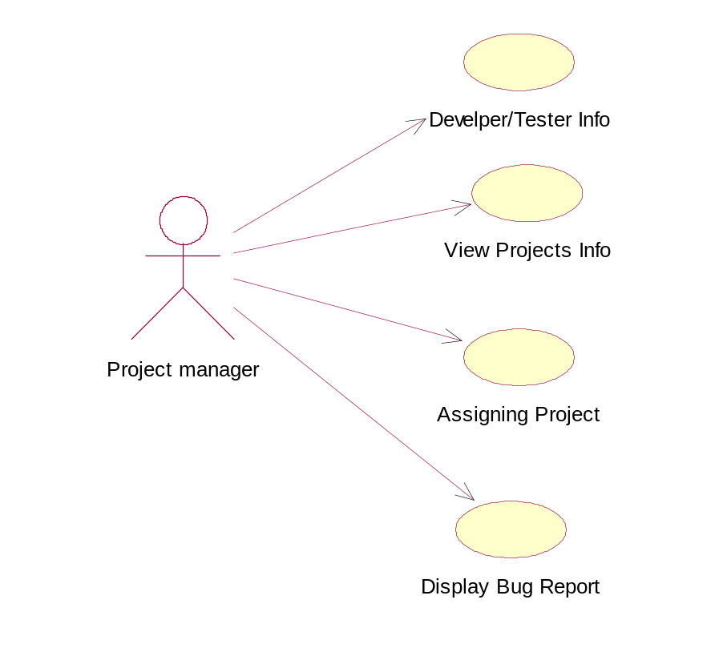

Use case for developer

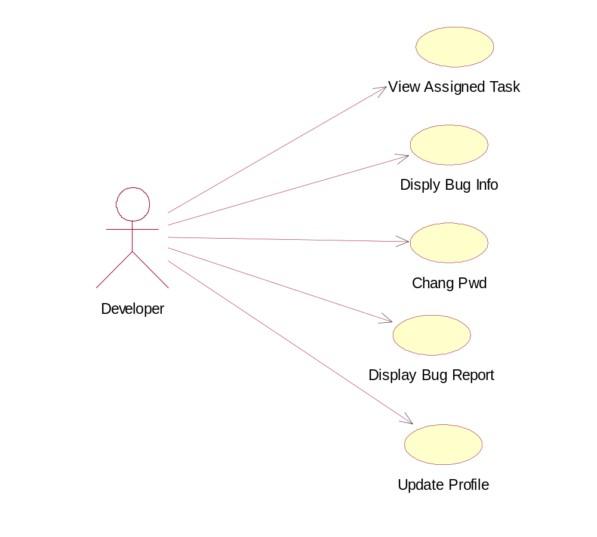

Use case for tester

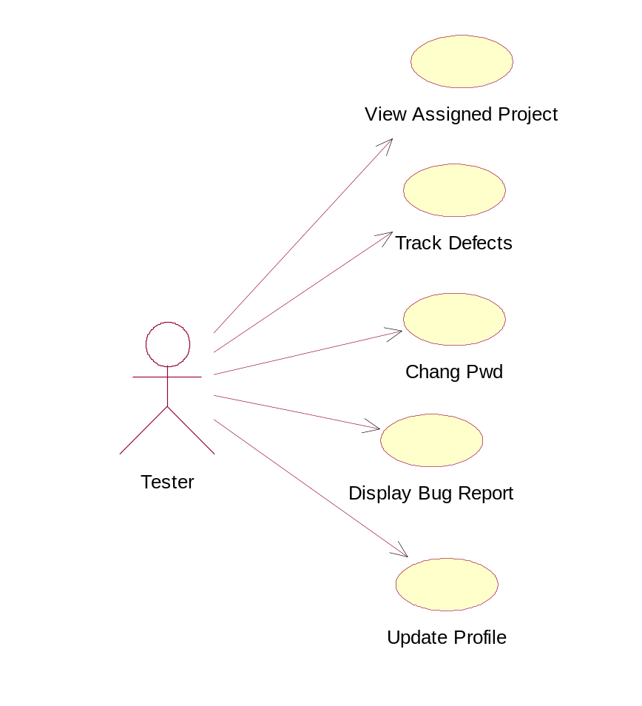

Use Case Diagram for Defect Tracking System
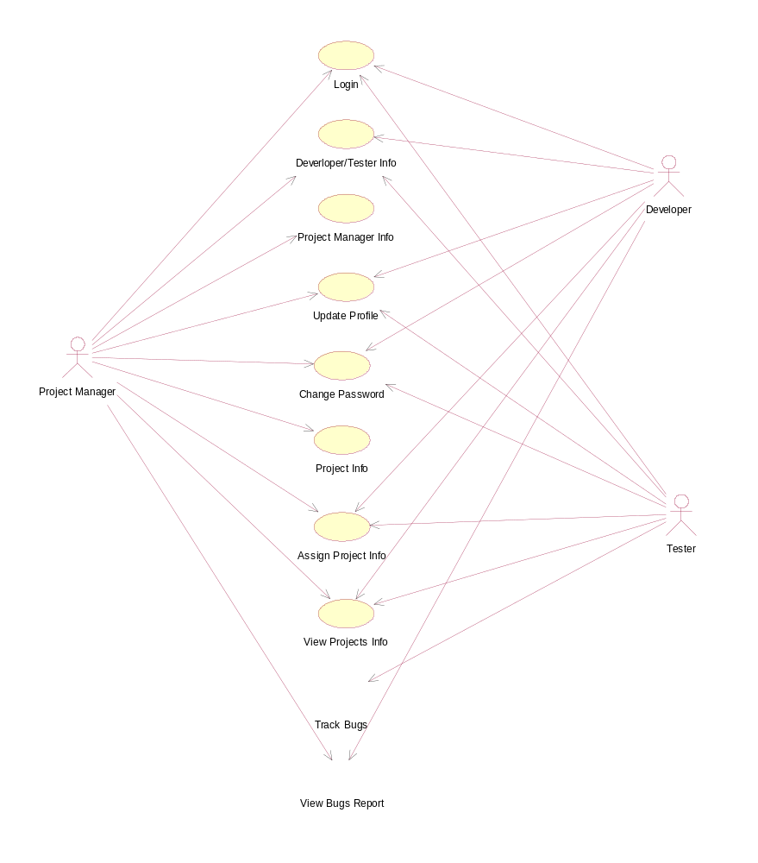

Class diagram for defect tracking system

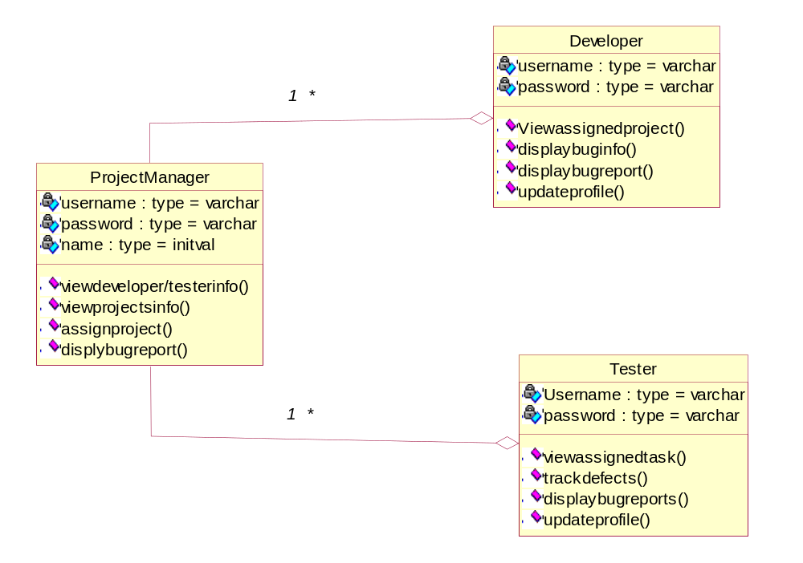

Sequence for project manager

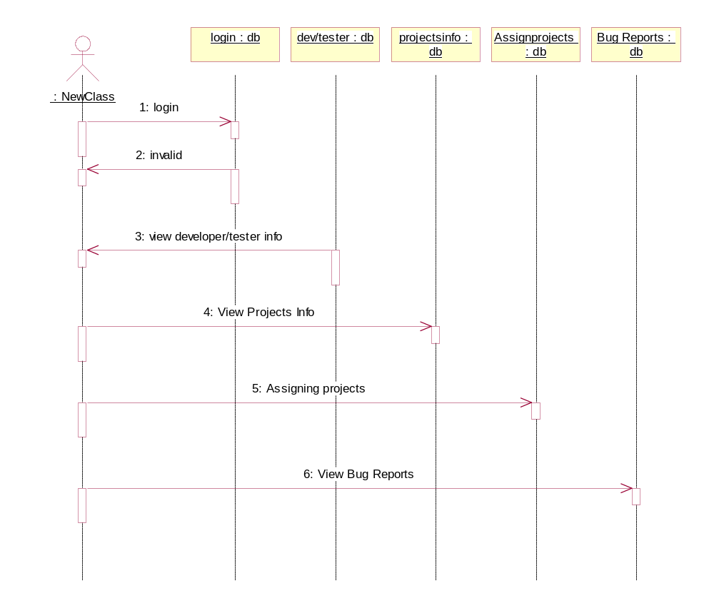

Sequence diagram for developer

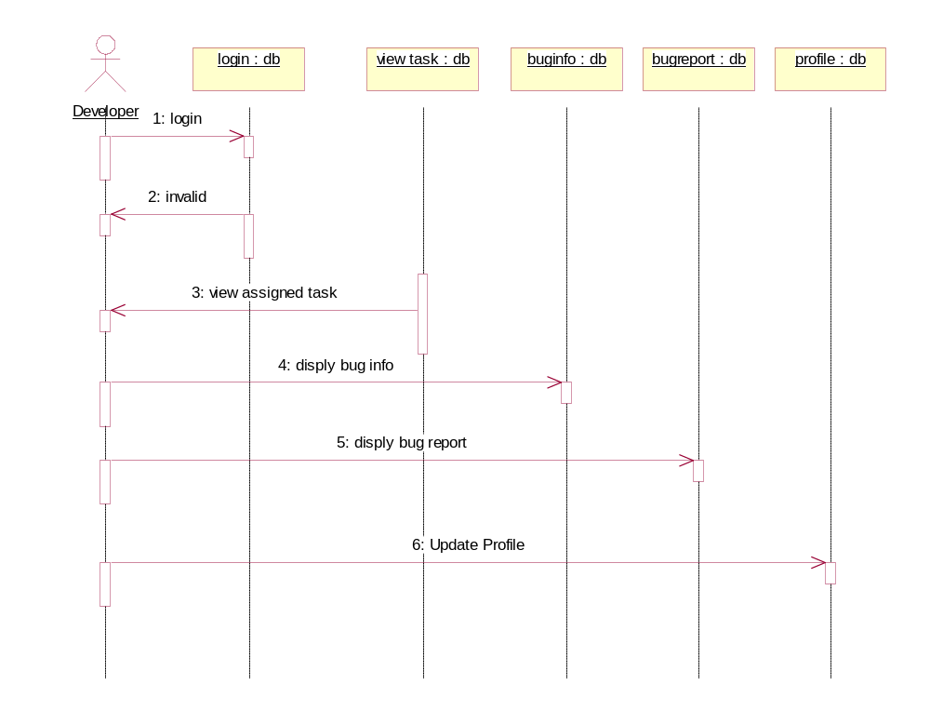

Sequence diagram for tester
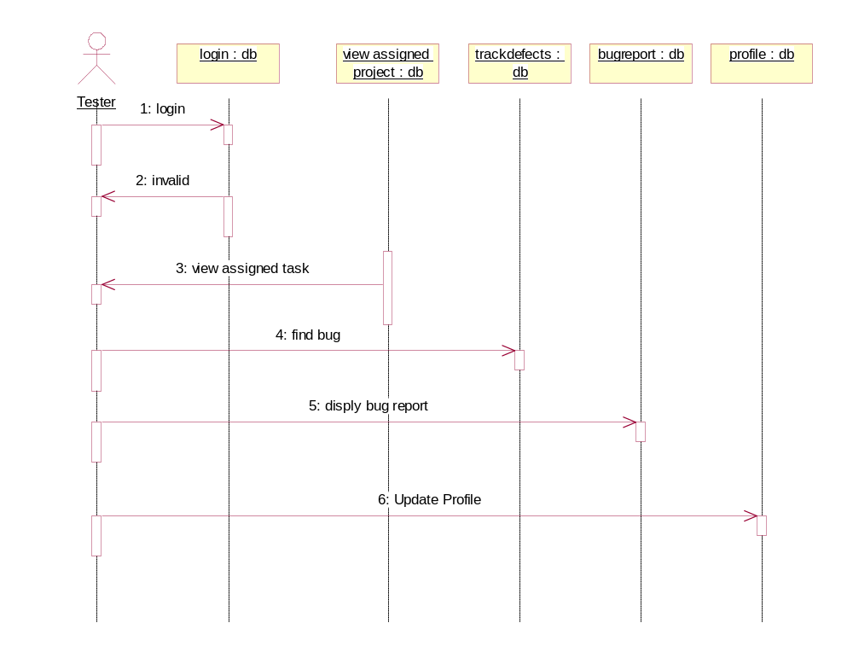

Collaboration diagram of Project Manager

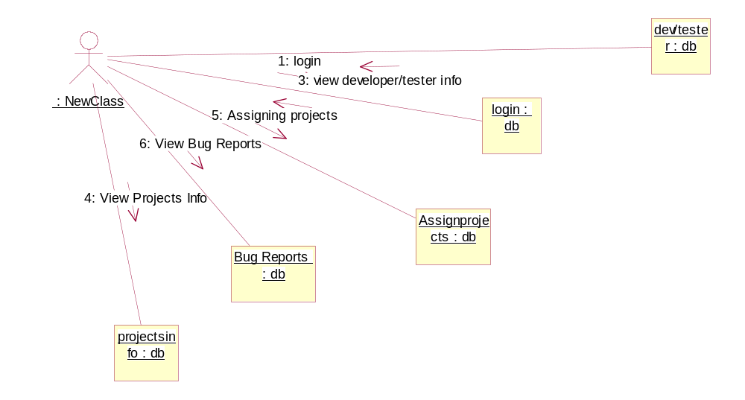

Collaboration diagram of Developer

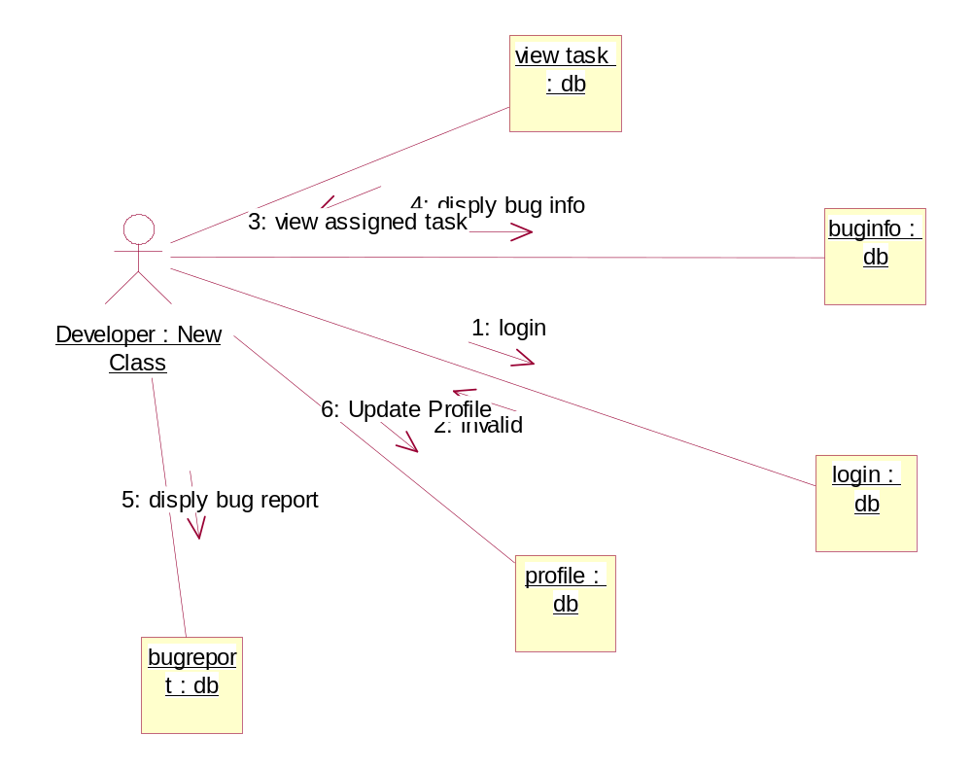

Collaboration diagram of Tester

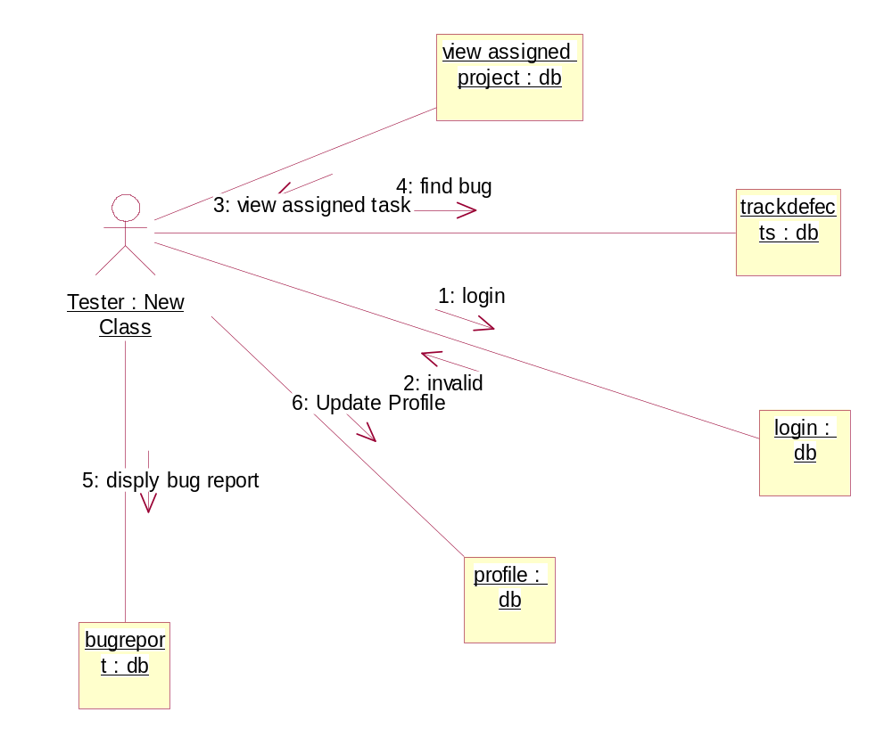

4.2. ER-Diagram
Empid
Empname
Password
Login
Empid
Empname
Login
Password
Empid
Empname
Login
Password
Adding New Developer/Tester Details
Add Project Details
Assign Projects
Modify Profile
Status Report
Bug Report
Project Manager
Developer
Tester
*
*
*
*
*
*
1
1
1
1
1
1
1
1
1
1
1
1
1
1
1
1

Login
User Login i.e., Project Manager, Developer, Tester
Project Manager
Developer
Tester
Valid
Invalid

4.3. DATA DICTIONARY
Table Name: employees
Column Name | Data Type
Employee_id | Int
Employee_name | Varchar(50)
phoneno | Varchar(50)
doj | Varchar(50)
login | Varchar(50)
pwd | Varchar(50)
email | Varchar(50)
Security_level | Varchar(50)

Table Name: priorities
Column Name | Data Type
Priority_id | int
Priority_desc | Varchar(150)

Table Name: statuses
Column Name | Data Type
status_id | int
status | Varchar(150)

Table Name: projmger
Column Name | Data Type
projmger_id | Int
projmger_name | Varchar(50)
phoneno | Varchar(50)
doj | Varchar(50)
login | Varchar(50)
pwd | Varchar(50)
email | Varchar(50)

Table Name: tester
Column Name | Data Type
tester_id | Int
tester_name | Varchar(50)
phoneno | Varchar(50)
doj | Varchar(50)
login | Varchar(50)
pwd | Varchar(50)
email | Varchar(50)

Table Name: projects
Column Name | Data Type
project_id | Int
project_name | Varchar(50)
Employee_id | int

Table Name: bugs
Column Name | Data Type
bug_id | Int
project_id | int
Priority_id | Int
Status_id | Int
Bug_name | Varchar(100)
Bug_desc | Varchar(200)
Resolution | Varchar(200)
Assigned_by | Varchar(75)
Assigned_to | Int
Date_assigned | Datetime
Date_resolved | Datetime
Testedby | Varchar(75)
Testedby_id | Int

Table Name: assignto
Column Name | Data Type
assignto_id | Int
Project_id | Int
Project_name | Varchar(75)
Employee_id | Int
Employee_name | Varchar(75)
Assignedby | Varchar(75)
Assignby_id | Int

5.1. I/O SAMPLES
Project Manager Module
Home Page
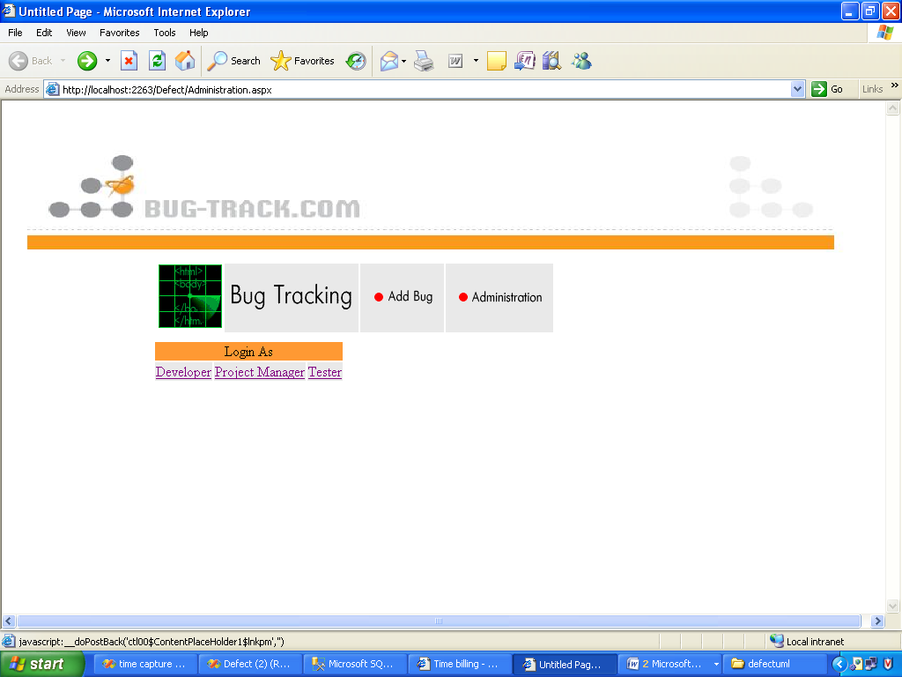

Login Page for project Manager
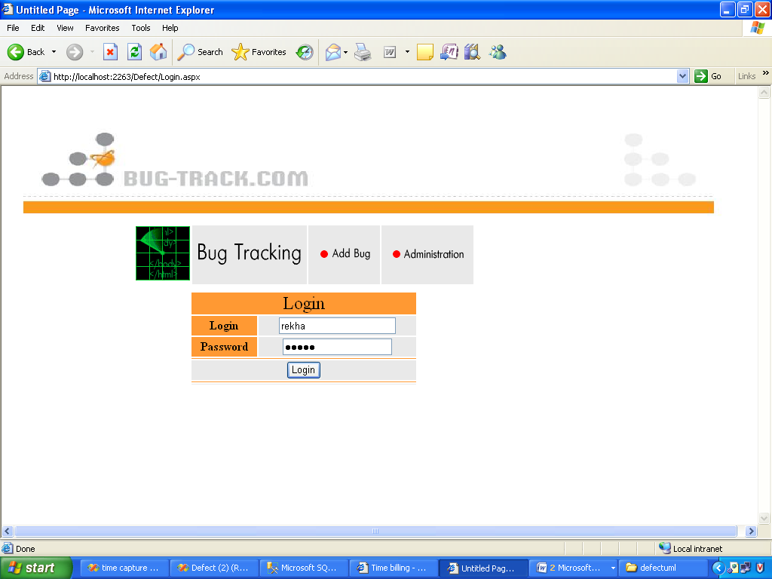

Project Manager Home Page

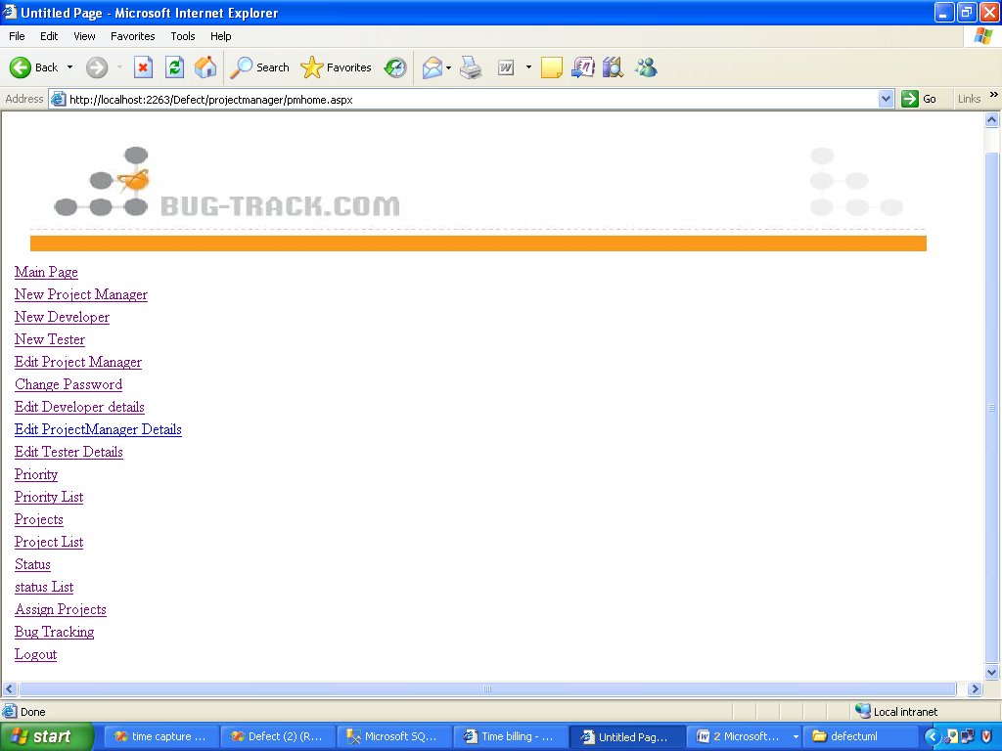

Add New Project Details

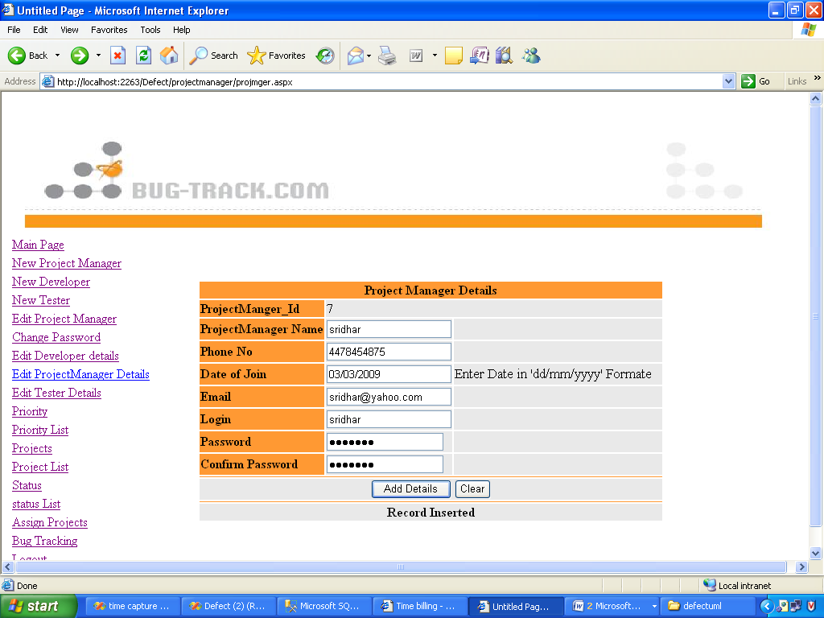

Add New Developer Details

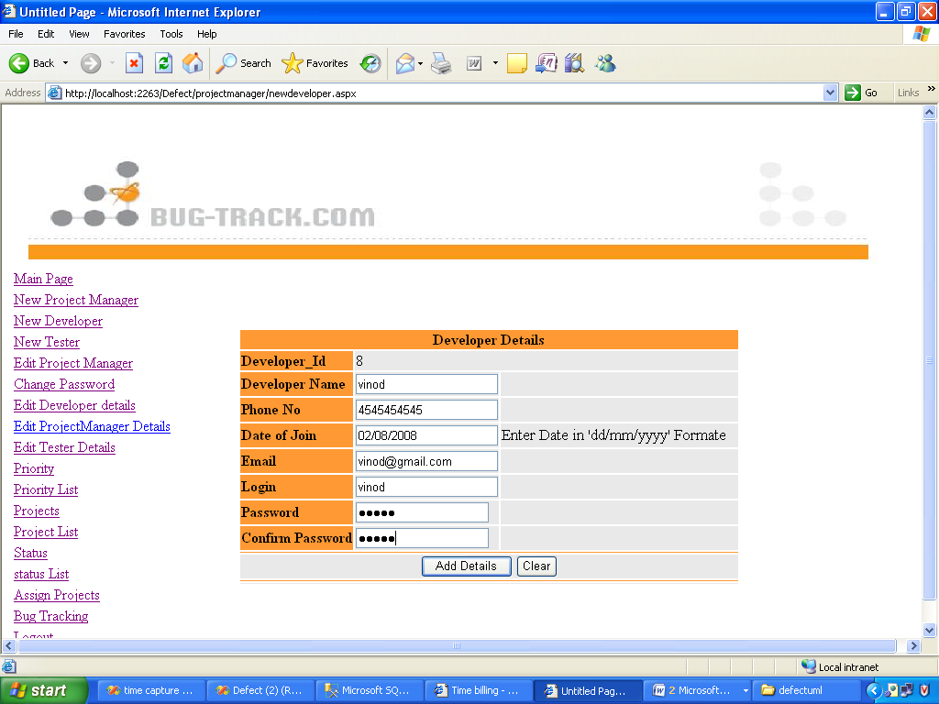

Add New tester Details

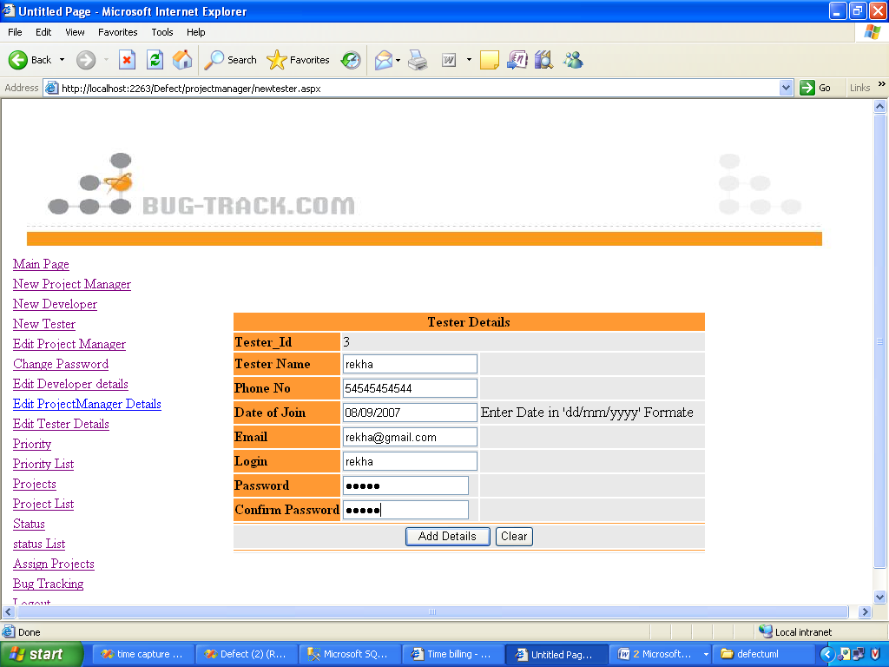

Edit Project Manager Details

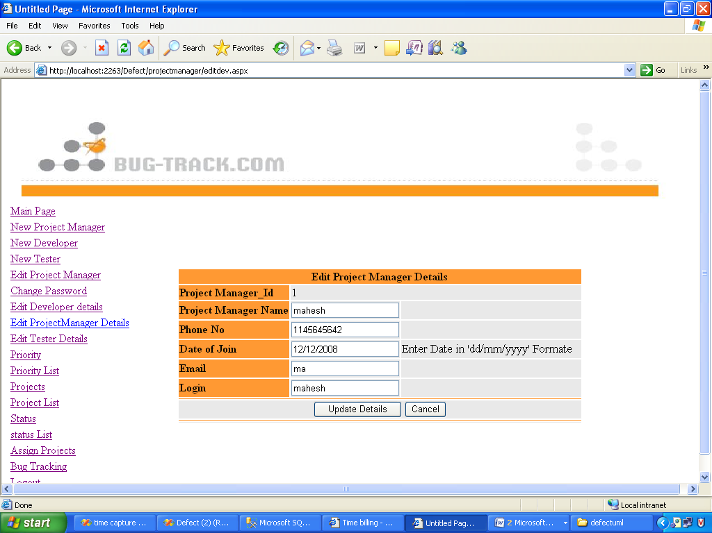

Change Password

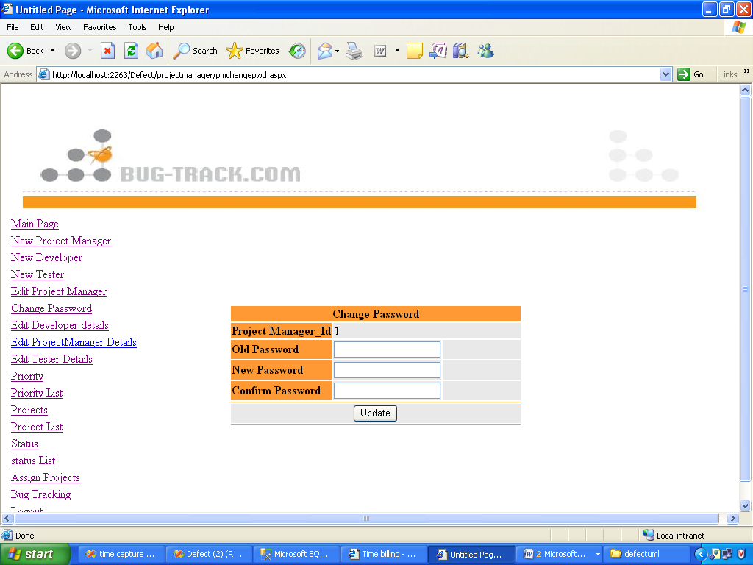

Edit Developer Details
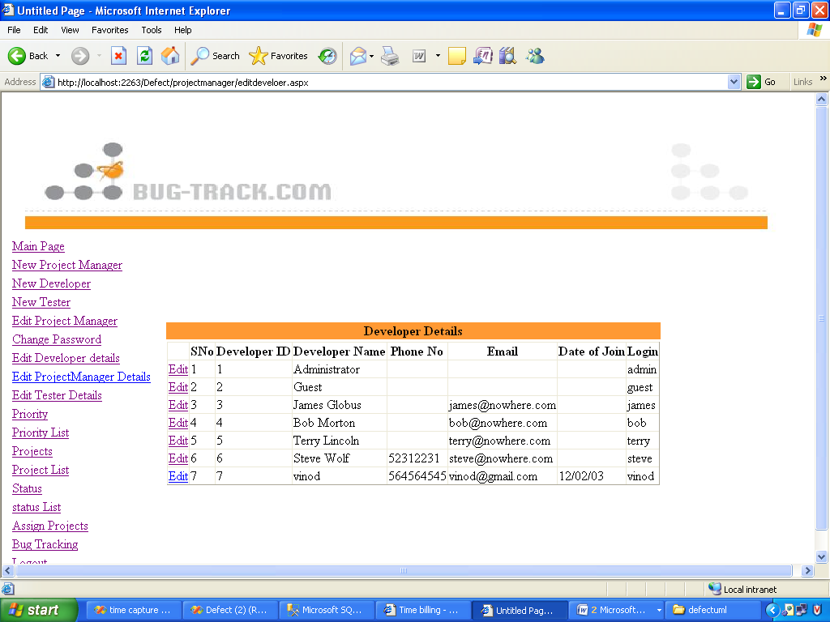

Edit Tester Details

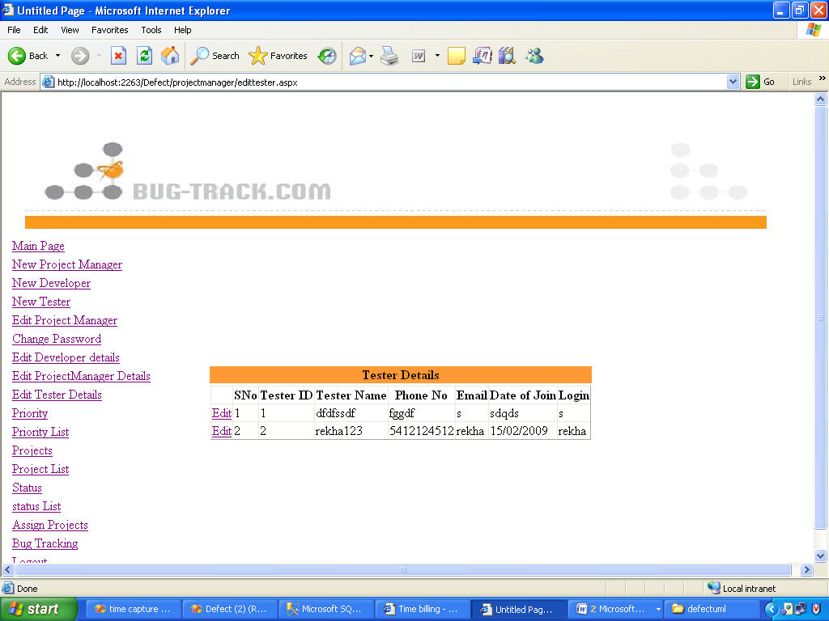

Edit Project Managers Details

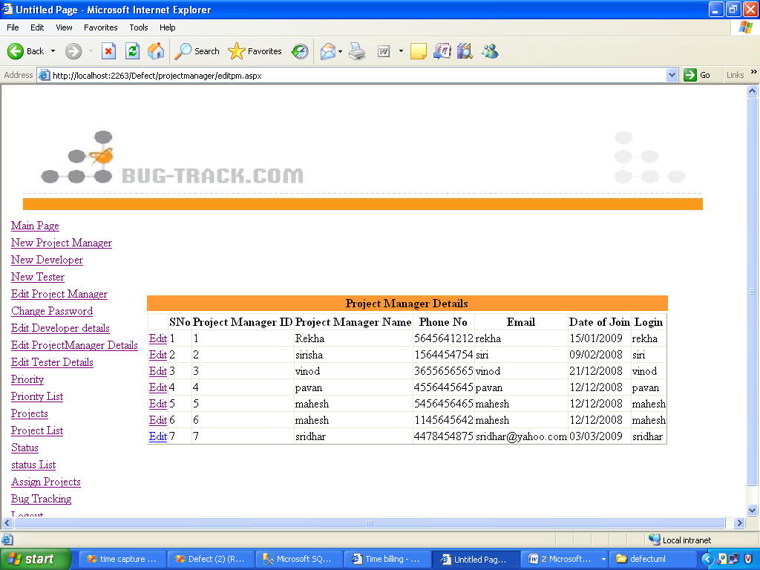

Priority

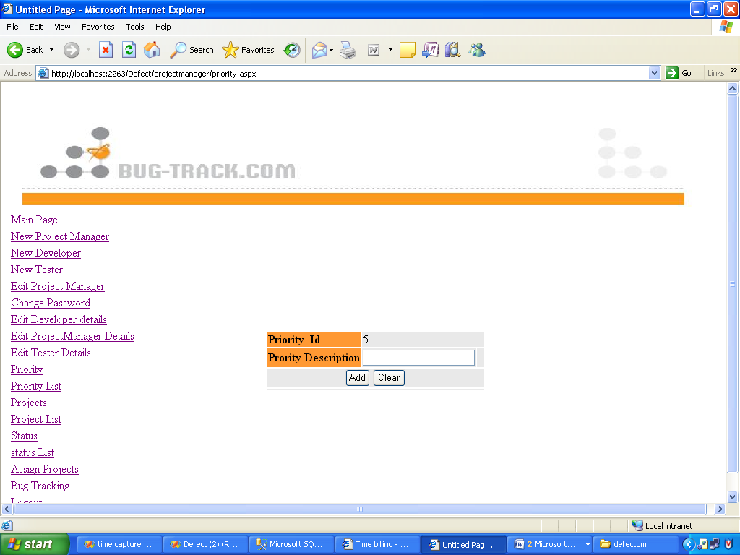

Priority List

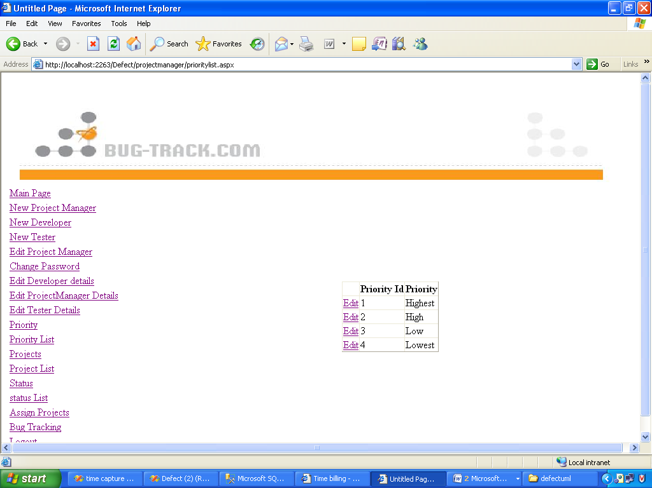

Project Details

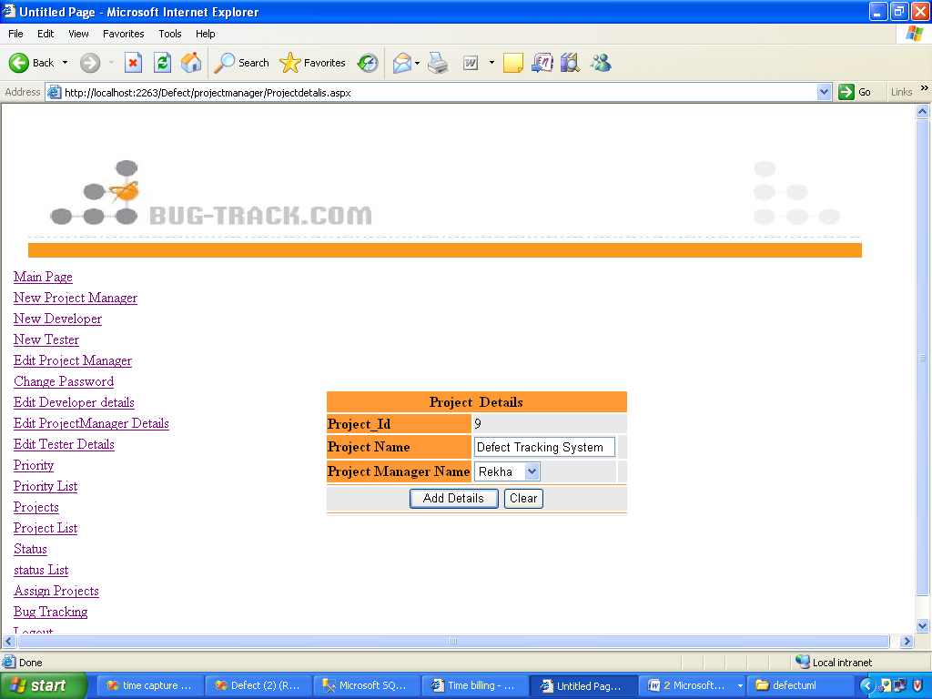

Project Lists

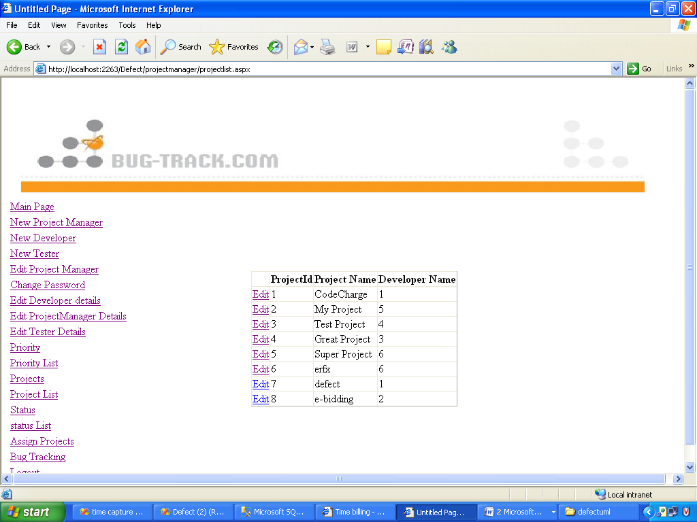

Status List

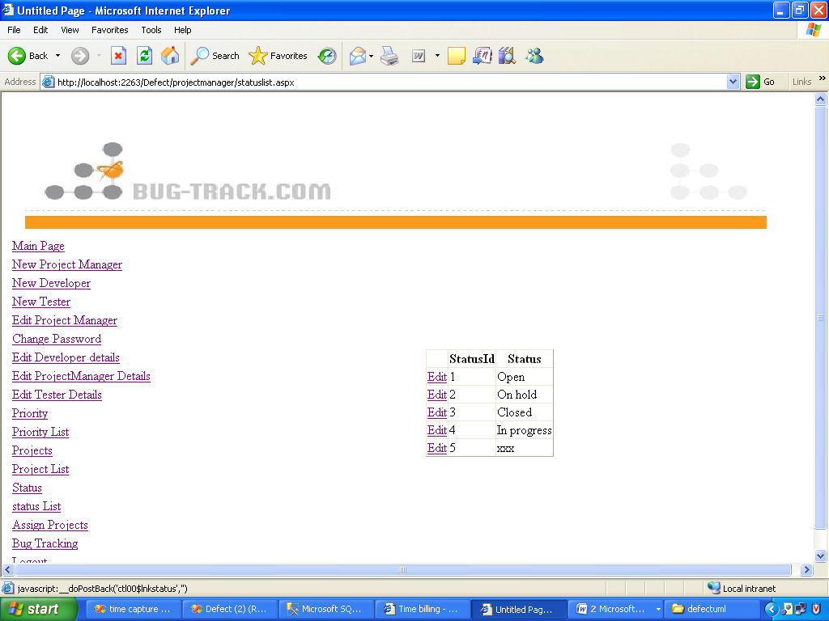

Assign Projects to Developer/Tester

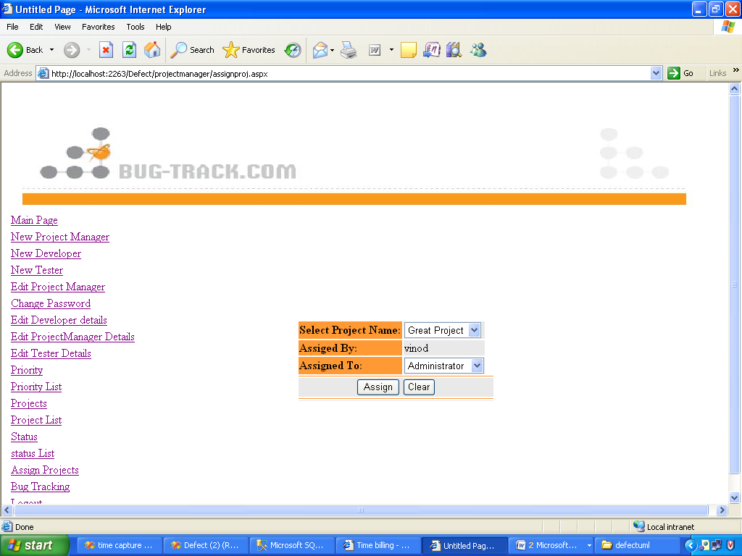

Bug Report

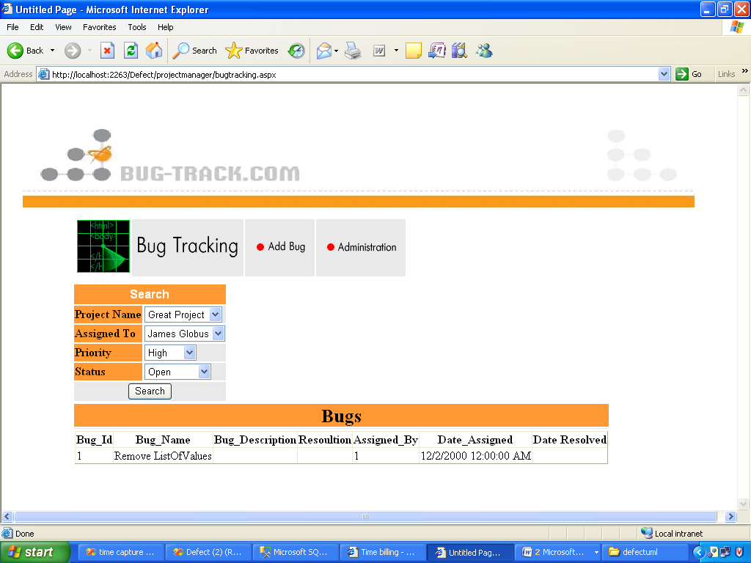

Developer Module

Developer Login Page

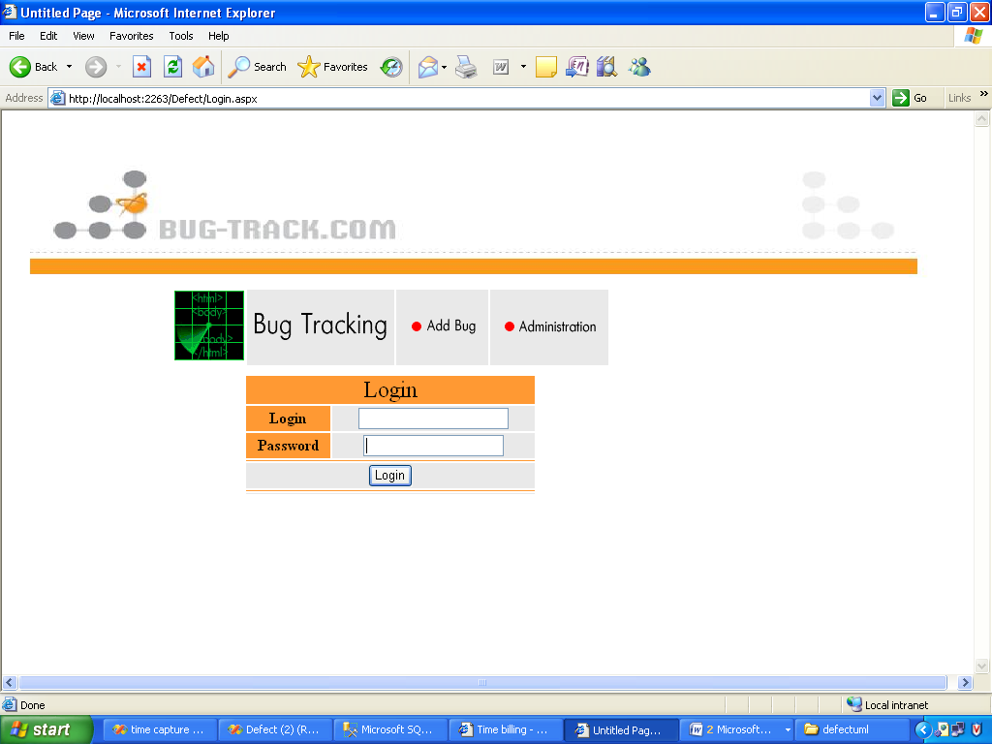

Developer Home Page

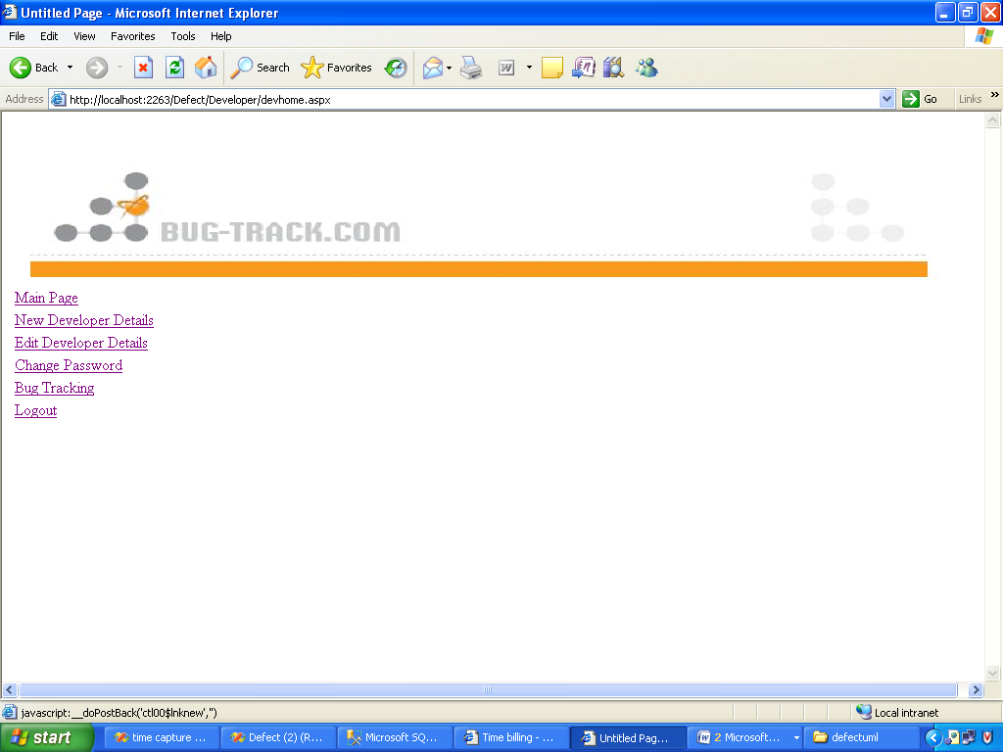

Add New Developer Details

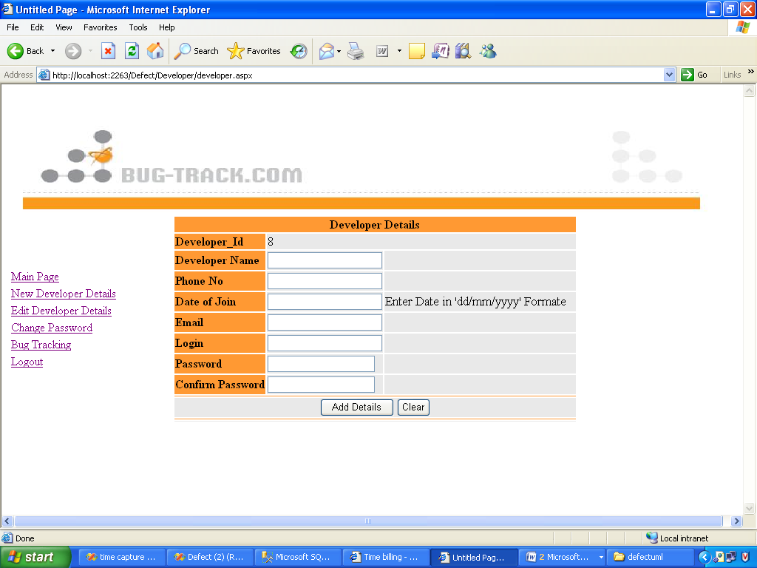

Edit Developer Details

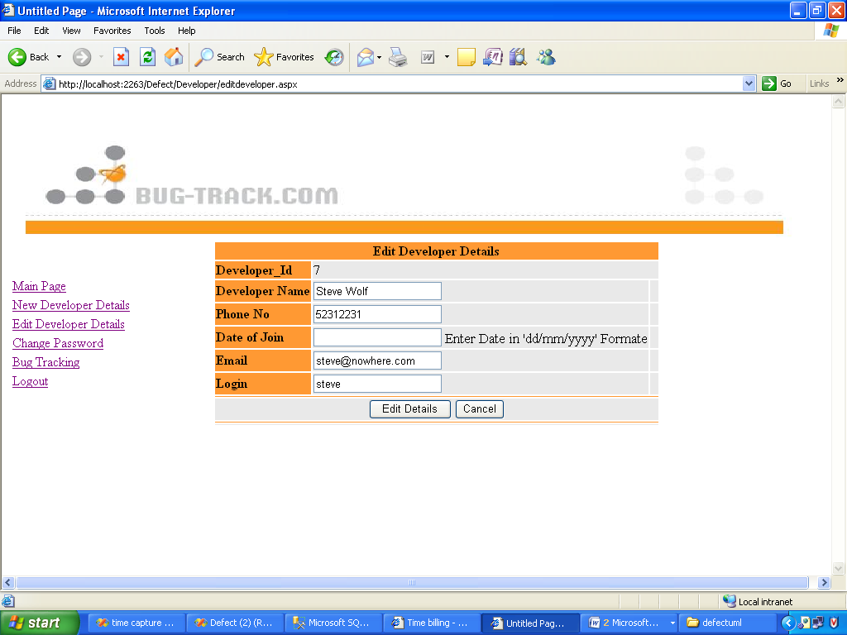

Change Password for Developer

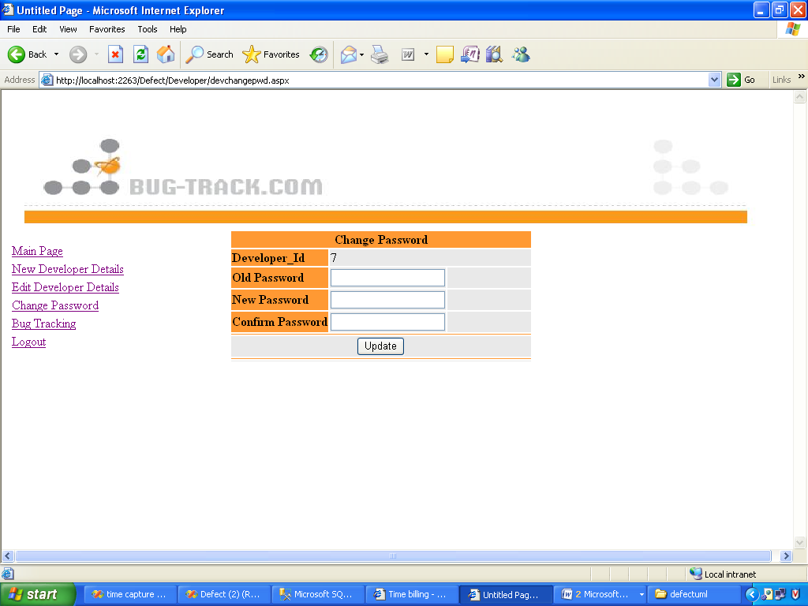

Bug Tracking

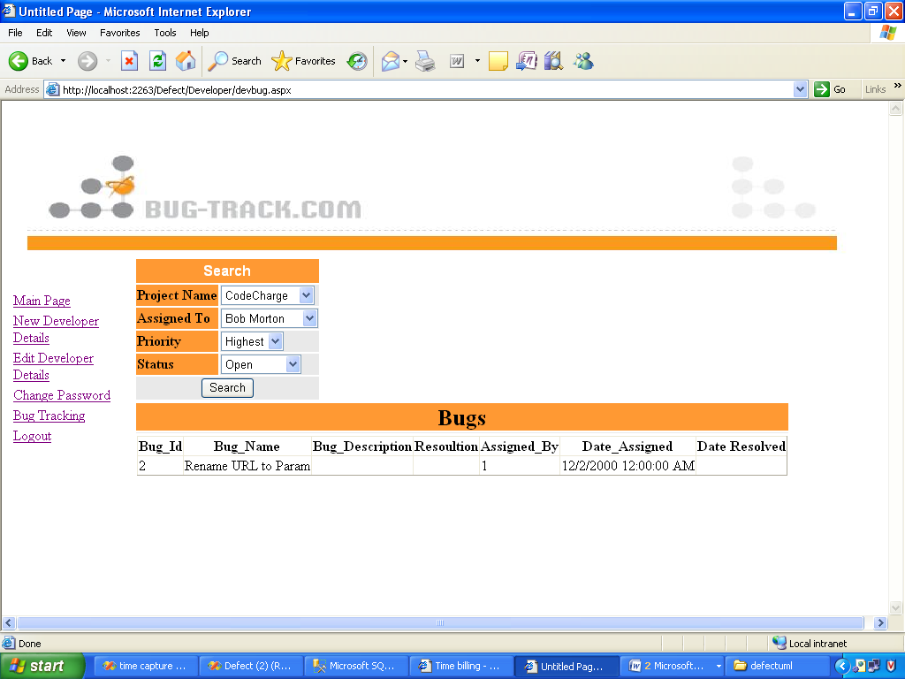

Tester Module

Tester Login

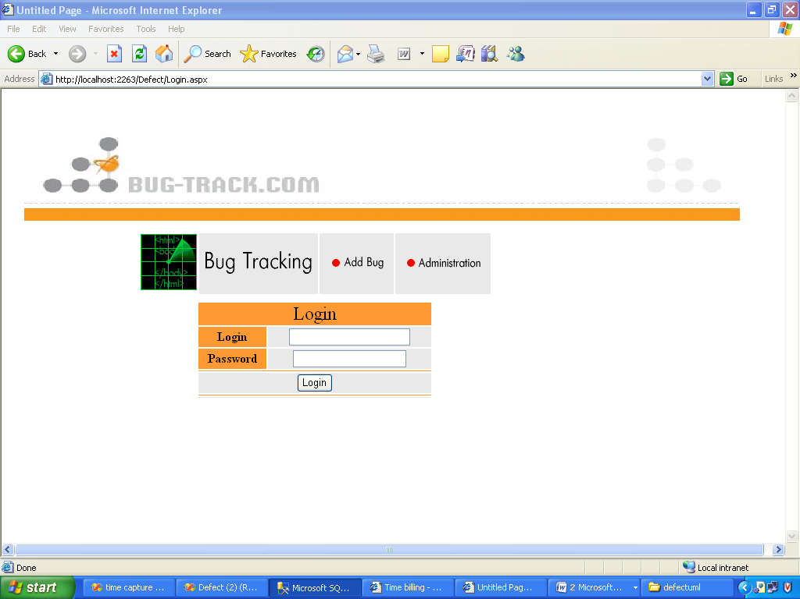

Tester Home Page

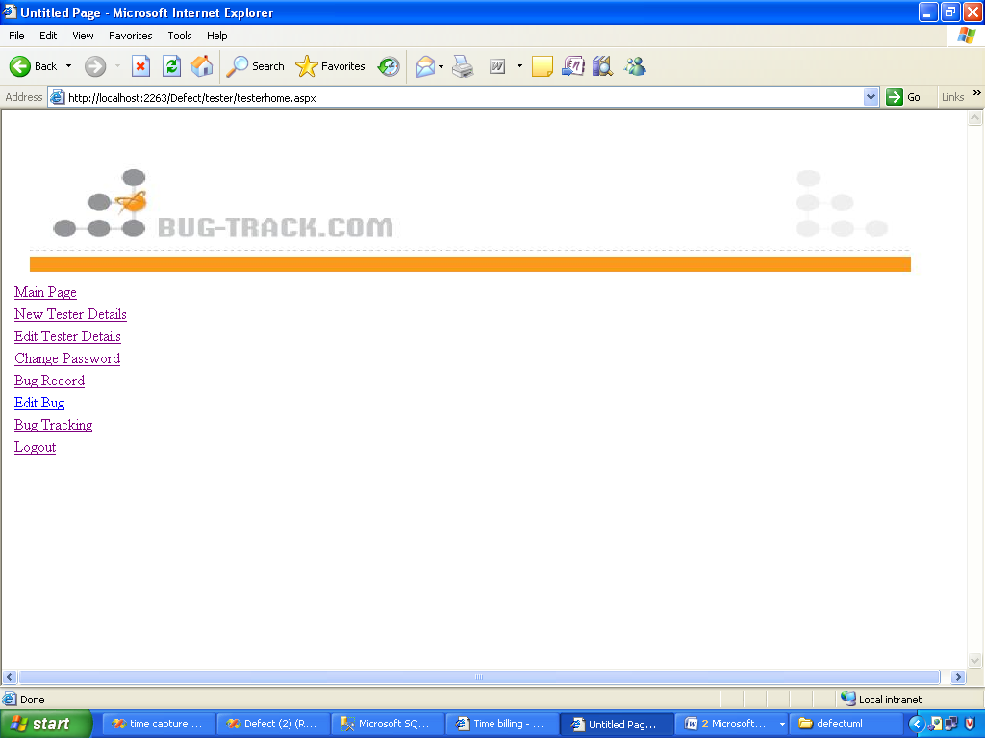

Add new tester details

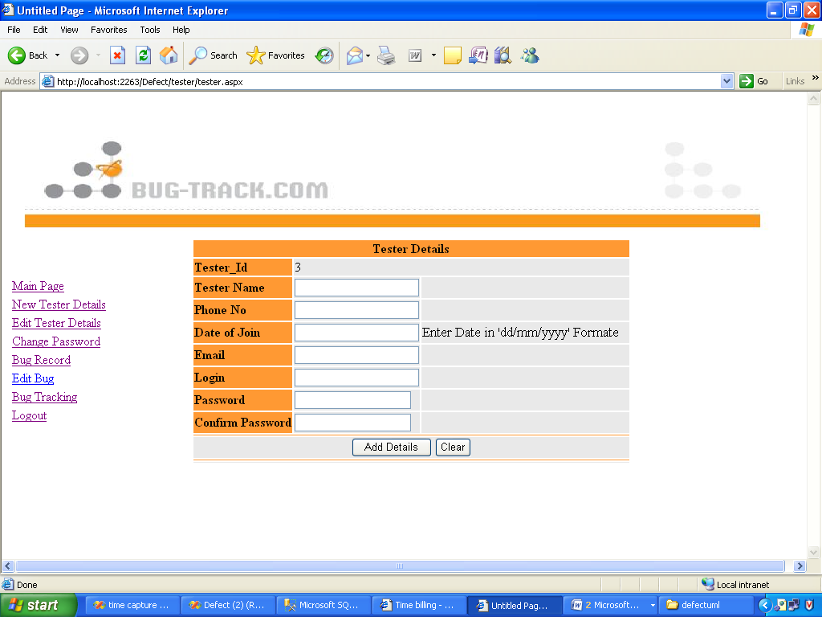

Edit Tester Details

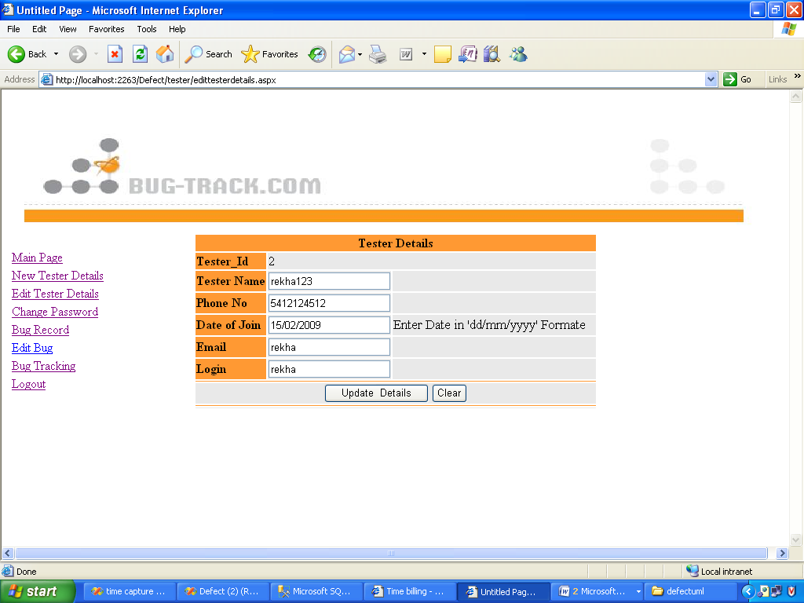

Change Password

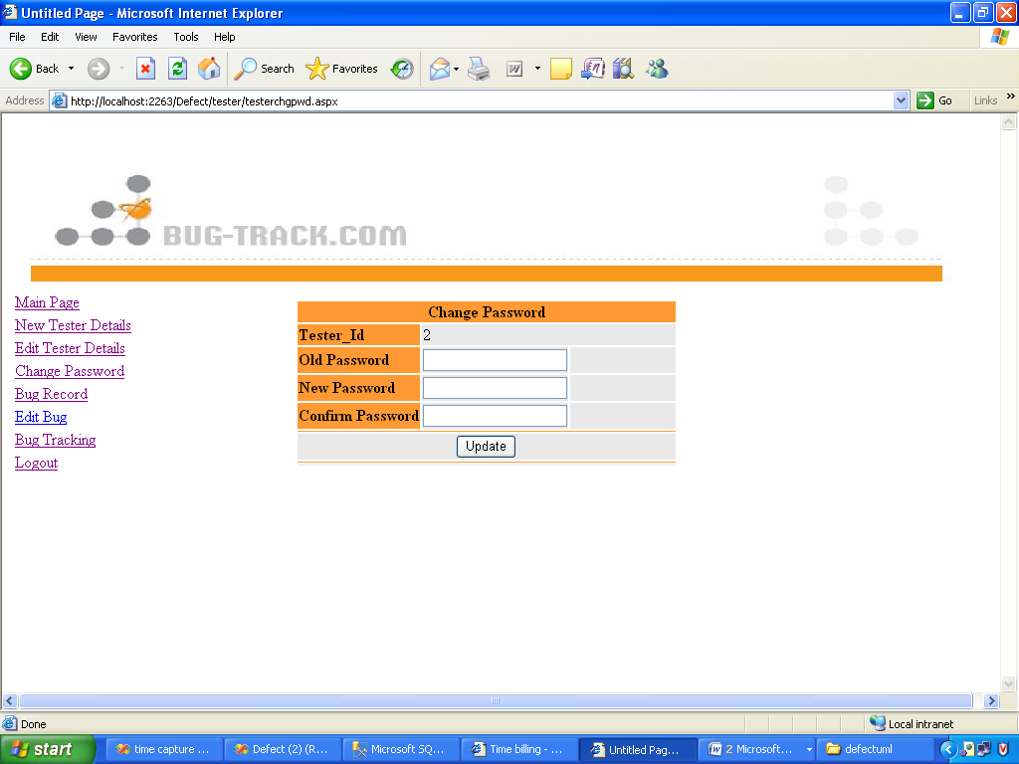

Add Bug Details

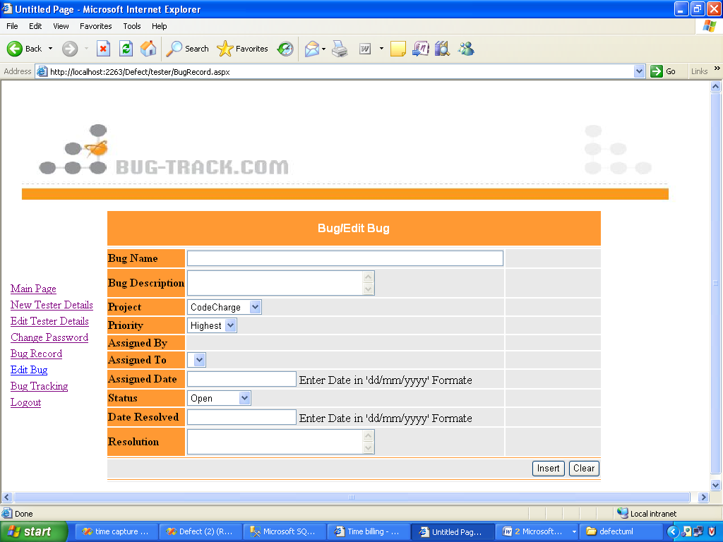

Bug Report

