Assignment-1

1. SELECT ProductID, ProductName, UnitPrice
FROM Products
WHERE (UnitPrice<20) AND (Discontinued=0);

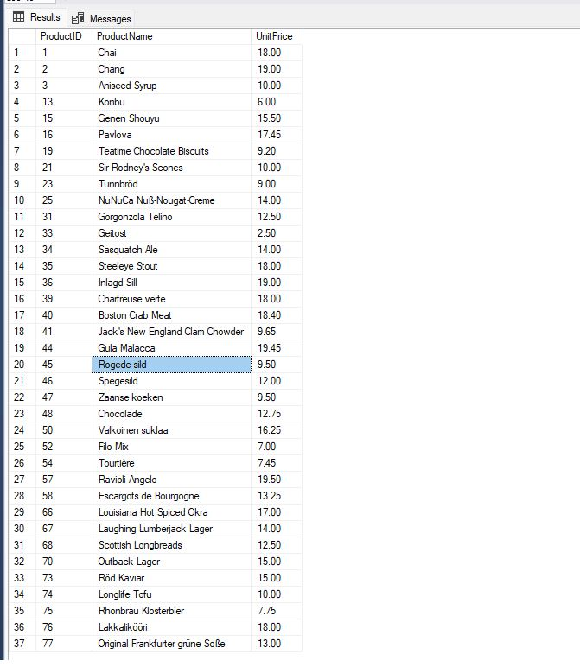

2. SELECT ProductID, ProductName, UnitPrice
FROM Products
WHERE UnitPrice BETWEEN 15 AND 25;

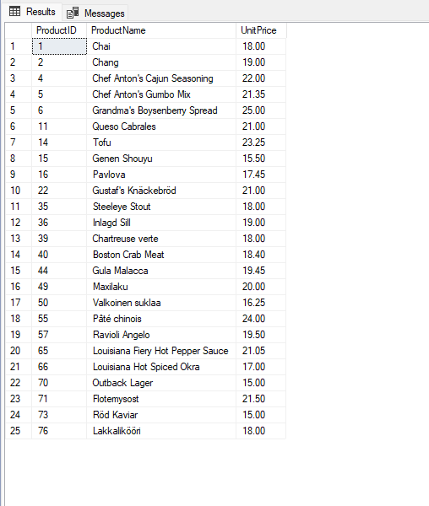

3. SELECT ProductName, UnitPrice
FROM Products
WHERE UnitPrice >(SELECT avg(UnitPrice) FROM Products);

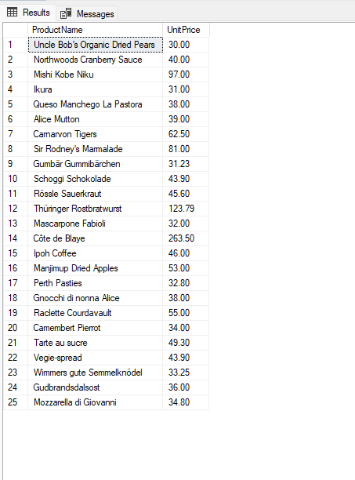

4. SELECT TOP 10 ProductName, UnitPrice
FROM Products
ORDER BY UnitPrice DESC;

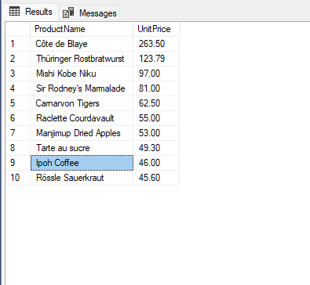

5. SELECT COUNT(discontinued) as Current_Count
FROM Products
WHERE (discontinued=0);

SELECT count(discontinued) as Disontinued_Count
from products
where (discontinued=1);

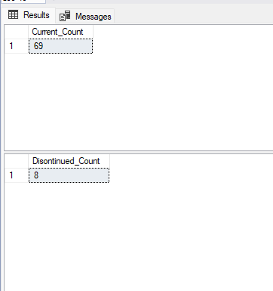

6. SELECT ProductName, UnitsOnOrder, UnitsInStock
FROM Products
WHERE UnitsInStock < UnitsOnOrder;

