User Guide

# Project Name

Claude AI

# Introduction and Overview

Welcome to the Claude AI User Guide! This document is designed to introduce you to Claude AI, a state-of-the-art conversational assistant developed by Anthropic. Claude AI stands out as a versatile, intelligent platform that helps users enhance productivity and creativity across a wide range of tasks—from writing and research to document analysis, coding, and visual data interpretation.

In this guide, you will learn how to get started with Claude AI, explore its intuitive interface, and take advantage of its powerful features. Whether you are a student, researcher, business professional, or simply looking for a reliable AI assistant, Claude offers tailored support through natural language interaction and context-aware responses. You will discover how to upload and analyze documents, interpret images, and engage in dynamic dialogues that make Claude feel more like a collaborative partner than a traditional tool.

Safety and trust are at the heart of Claude’s design. Engineered with constitutional AI principles, Claude prioritizes responsible behavior, user alignment, and secure interactions—making it an ideal choice for environments where accuracy and ethical standards matter. Its robust safeguards ensure that your experience remains productive and appropriate, whether you’re working in education, business, healthcare, law, or other fields.

By the end of this guide, you will be equipped to:

- Create and verify your Claude AI account

- Navigate the user interface and access core features

- Upload and analyze documents and images

- Communicate effectively with Claude for a variety of tasks

- Understand how Claude’s safety and ethical principles benefit your workflow

Let’s begin your journey with Claude AI and unlock new possibilities for intelligent, collaborative automation.

# Key Features and Capabilities

**Conversational Intelligence and Natural Language Interaction**

Claude AI offers highly advanced conversational abilities, allowing users to interact with the system using intuitive, natural language. The assistant maintains context over multiple exchanges, enabling dynamic back-and-forth dialogue that feels collaborative and intelligent. This makes Claude ideal for brainstorming, scheduling, note-taking, and any task where nuanced conversation is needed.

**Multi-Modal Input: Document and Image Handling**

Claude stands out for its robust support of both text and visual data. Users can upload up to five documents at a time (each up to 10 MB), enabling complex tasks such as summarizing dense reports, comparing contracts, extracting structured data, and preparing detailed analyses. Additionally, Claude can interpret images—including graphs, diagrams, infographics, and handwritten notes—providing contextual responses that link visual information to textual insights. This capability is particularly valuable in fields like business intelligence, academic research, and data journalism.

**Content Creation and Writing Assistance**

The platform excels as a writing assistant, capable of generating blog posts, articles, emails, fictional stories, social media captions, whitepapers, scripts, and newsletters. Claude adapts its tone and style to match the format, audience, and objective, streamlining creative workflows for authors, marketers, and professionals. Users benefit from faster content generation and tailored outputs that meet specific requirements.

**Programming and Technical Support**

Claude functions as a smart programming assistant, supporting a wide range of languages such as Python, JavaScript, C++, and HTML. Developers can generate code snippets, debug errors, understand algorithms, and learn new languages with Claude’s help. The assistant provides clear explanations alongside solutions, making it especially helpful for students, self-taught coders, and professionals tackling complex technical challenges.

**Iterative Prompting and Context Management**

One of Claude’s notable strengths is its ability to handle iterative prompting. Users can refine their requests step-by-step, and Claude will remember the context, updating responses to become more targeted and accurate. This interactive workflow is invaluable for complex tasks, such as focusing on specific sections of a research paper or clarifying technical documentation.

**Safety, Alignment, and Responsible AI**

Anthropic has engineered Claude with a strong focus on safety and ethical behavior, guided by constitutional AI principles. The platform is designed to avoid producing harmful, misleading, or toxic content, making it a trustworthy partner in professional, educational, and sensitive environments. Users can rely on Claude for responsible outputs, even in regulated industries like law, healthcare, and business.

**Accessible User Experience**

Claude features a clean, minimalistic interface that reduces cognitive friction and encourages exploration. The onboarding process is straightforward and secure, with email and phone verification ensuring authenticity. Users of all technical levels can quickly access and utilize Claude’s powerful capabilities.

**Developer Resources and Advanced Functionality**

For those seeking deeper integration or advanced use, Claude offers extensive developer documentation, including sample prompts, tutorials, and a “cookbook” of effective query examples. This supports businesses and developers in customizing workflows, chaining prompts, and creating reusable templates, further extending Claude’s practical value.

**Industry Versatility**

Claude’s features are applicable across a wide range of domains, including education (tutoring, feedback, study support), business (report writing, data analysis, strategic planning), healthcare (research summarization, policy drafting), law (legal drafting, precedent analysis), and everyday personal productivity. Its versatility empowers users to accomplish more, faster, and with greater confidence.

# Getting Started

**Introduction to Claude AI**

Claude AI is an advanced conversational assistant developed by Anthropic, designed to help users across various domains such as writing, research, coding, and data analysis. Its intuitive interface and powerful features make it accessible to users of all technical backgrounds, ensuring a safe and productive experience through responsible AI principles.

**Creating Your Account**

To begin using Claude AI, follow these simple steps:

- Visit the official Claude website at [claude.ai](https://claude.ai).

- On the homepage, you’ll see options to sign up. You can choose to continue with your email address or use your Google account for quick registration.

- After selecting your preferred sign-up method, enter your details as prompted.

- You’ll be asked to verify your email address and phone number. This step is essential for security and ensures your interactions remain authentic.

- Once verification is complete, you’ll gain access to the Claude AI platform.

**Navigating the User Interface**

Claude’s interface is clean and minimalistic, designed to reduce distractions and make exploration easy:

- At the center of the screen, you’ll find the main input box. Here, you can type questions, upload documents, or submit images.

- The platform supports back-and-forth conversation, maintaining context over multiple exchanges for a seamless experience.

- Claude responds quickly with clear, conversational answers tailored to your queries.

**Uploading Documents and Images**

Claude AI excels at handling both text and visual data:

- You can upload up to five documents at a time, with each file up to 10 megabytes in size. This is ideal for tasks such as summarizing reports, comparing contracts, or extracting structured data.

- To upload a document, simply click the upload button near the input box and select your files.

- For visual information, Claude supports image uploads including graphs, diagrams, infographics, and handwritten notes. Upload images in the same way as documents.

**Starting Your First Conversation**

Once you’re set up:

- Enter your question or task in the input box. For example, you might ask Claude to summarize a document, explain a concept, or analyze an image.

- Upload any relevant files or images if your task requires them.

- Submit your request and review Claude’s response. You can continue the conversation, ask follow-up questions, or request further analysis.

**Tips for Success**

- Explore different types of tasks—Claude can assist with writing, research, coding, data analysis, and more.

- Take advantage of the platform’s ability to maintain context in ongoing conversations.

- Refer to the help or support section on the website if you encounter any issues or have questions about features.

By following these steps, you’ll be ready to harness the full potential of Claude AI for your personal, academic, or professional projects.

*Relevant Embedded Image Placeholders (from source document):*

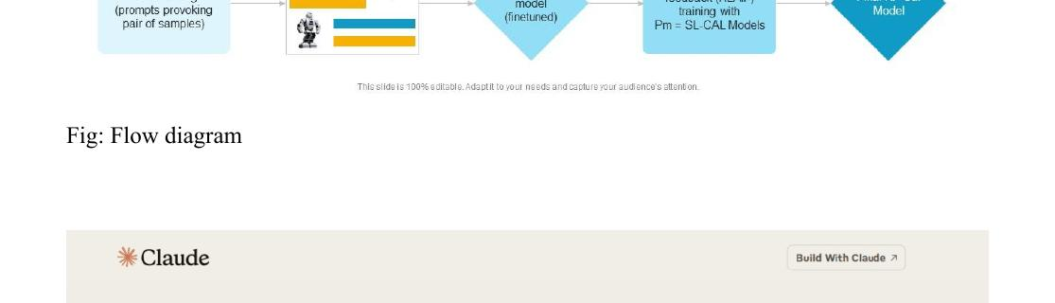

*Figure: Figure 2 (Source Page 4). A screenshot of the Claude sign-in page visually guides users through the account creation process and reinforces the step-by-step instructions.*

# Account Creation and Sign-in

**Creating a New Account**

- To begin using Claude AI, visit the official website at [claude.ai](https://claude.ai).

- You can create an account using either your Google login or a valid email address.

- After entering your email or choosing to sign in with Google, you will be prompted to verify your email address. This step helps ensure your account’s authenticity and security.

- The platform also requests verification of your phone number. This additional layer of verification protects your account and supports safe interactions.

- Once your email and phone number are verified, you will gain access to the Claude interface, which is designed to be clean, minimalistic, and easy to navigate for users of all technical backgrounds.

**Signing In**

- On the Claude sign-in page, you will see options to continue with Google or enter your personal or work email address.

- If you have previously registered, select your preferred sign-in method:

- Choose 'Continue with Google' to authenticate via your Google account.

- Or enter your registered email address and select 'Continue with email'.

- By continuing, you agree to Anthropic's Consumer Terms, Acceptable Use Policy, and acknowledge their Privacy Policy.

- After successful authentication, you will be directed to the Claude workspace, where you can start interacting with the AI assistant.

**Password Reset**

- If you forget your password or are unable to sign in, look for a 'Forgot password?' link on the sign-in page.

- Follow the prompts to reset your password using your registered email address.

- You may be required to verify your identity through a code sent to your email or phone number before resetting your password.

- After resetting, you can sign in as usual with your new credentials.

**Prerequisites and Required Information**

- You must have a valid email address or Google account to register.

- Access to your email and phone is required for verification during account creation.

- Agreeing to Anthropic’s Consumer Terms, Acceptable Use Policy, and Privacy Policy is mandatory for account creation and sign-in.

**Security and Privacy**

- Claude AI emphasizes a privacy-first approach, ensuring that your personal information is protected throughout the account creation and sign-in process.

- Verification steps for both email and phone number add layers of security to safeguard your account and interactions.

*Relevant Embedded Image Placeholders (from source document):*



*Figure: Figure 2 (Source Page 4). Screenshot of the Claude sign-in page visually demonstrates the available sign-in options and introductory text.*

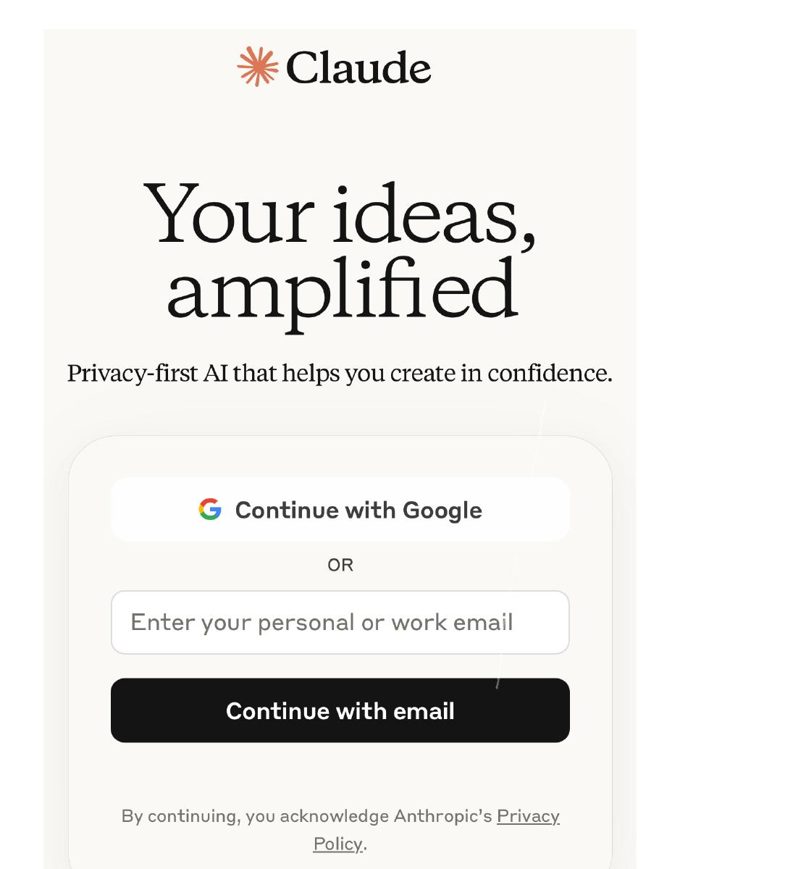

*Figure: Figure 1 (Source Page 5). Screenshot of the Claude sign-in interface, showing options to continue with Google or email, and privacy policy notice, helps illustrate the sign-in process for users.*

# Core Functionality

**Conversational Assistance and Natural Dialogue**

• Access Claude AI by visiting claude.ai and completing the simple onboarding process, which includes account creation and verification of your email and phone number.

• Use the main input box on the interface to type questions or requests in natural language. Claude responds instantly, maintaining context over multiple exchanges for dynamic, back-and-forth conversations.

• Engage with Claude as an intelligent collaborator for brainstorming, scheduling, note-taking, and more. The AI adapts its responses to your specific needs and maintains a conversational, easy-to-understand tone.

**Document Analysis and Management**

• Upload up to five documents at once, each up to 10 megabytes in size, directly through the interface.

• Request Claude to summarize lengthy reports, compare clauses in contracts, extract structured data, or identify key insights from your uploaded files.

• Ask for explanations of complex sections, development of discussion points, or preparation of reports based on document content.

• Use iterative prompting to refine your requests, such as focusing on specific sections or simplifying explanations, with Claude remembering context for accurate, targeted responses.

**Image Interpretation and Visual Data Analysis**

• Upload images including graphs, infographics, engineering diagrams, illustrations, or handwritten notes via the input box.

• Ask Claude to analyze visual content by describing trends, identifying anomalies, explaining correlations, and providing statistical interpretations.

• Link image uploads to textual data for contextual responses, enhancing business intelligence, marketing analysis, and academic research workflows.

**Content Creation and Writing Assistance**

• Prompt Claude to generate a wide variety of written content, such as blog posts, articles, emails, fictional stories, social media captions, whitepapers, scripts, and newsletters.

• Specify your desired tone, style, format, audience, and objective for tailored outputs, whether you need formal business writing or creative storytelling.

• Refine your prompts step-by-step to achieve richer, more targeted content, such as requesting a summary, focusing on methodology, or simplifying language.

**Programming Support and Code Generation**

• Use Claude to assist with coding tasks in languages like Python, JavaScript, C++, HTML, and more.

• Request code snippets, bug fixes, explanations of complex algorithms, or help with learning new programming languages.

• Ask for DevOps assistance, software architecture advice, or help with documentation writing.

• Benefit from Claude’s contextual explanations that clarify the logic behind generated code, supporting both students and professionals.

**Security, Safety, and Ethical Alignment**

• Rely on Claude’s built-in safeguards, which prevent toxic behavior, misinformation, and unsafe outputs.

• Use Claude confidently in professional, educational, and research settings, knowing that it adheres to ethical standards and responsible AI principles.

• Take advantage of Anthropic’s “constitutional AI” framework, which ensures trustworthy and precise interactions.

**Advanced Usage and Integration**

• Explore Anthropic’s developer documentation for advanced features, including a “cookbook” of examples, sample prompts, and tutorials.

• Learn how to chain prompts, manage context, and create reusable templates for repetitive tasks.

• Integrate Claude into business workflows or develop prompt engineering techniques for specialized use cases.

**Best Practices for Effective Interaction**

• Be specific and detailed in your prompts to help Claude interpret your intent and provide relevant output.

• Clearly define the scope, format, and objective of your requests for optimal results, such as specifying word count, target audience, or desired style.

• Use iterative prompting to refine answers and ensure clarity, especially for complex topics.

# Advanced Configuration options

Claude offers several advanced configuration options that allow users to tailor its behavior for specialized workflows, improved accuracy, and seamless integration into business or development environments. These advanced settings are designed for users who want to maximize the AI’s capabilities beyond basic usage.

**Prompt Engineering and Iterative Prompting**

- Purpose: Enables users to refine and chain prompts for more nuanced and targeted responses.

- Impact: Allows for step-by-step clarification and contextual updates, resulting in more precise answers, especially for complex or layered queries.

- Guidance: Use iterative prompting when your task requires depth or multiple stages of clarification. For example, start with a general request and gradually narrow the focus based on Claude’s responses.

**Reusable Prompt Templates**

- Purpose: Lets users create and store templates for frequently used queries or tasks.

- Impact: Streamlines repetitive workflows by ensuring consistency and saving time.

- Guidance: Develop templates for common tasks such as summarization, code review, or content generation. Adjust template variables as needed for each new use case.

**Context Management**

- Purpose: Controls how much previous conversation or data Claude considers when generating responses.

- Impact: Proper context management ensures relevant and coherent outputs, especially in multi-turn conversations or long-form content creation.

- Guidance: For complex projects, specify which parts of previous interactions Claude should remember or ignore. This can be managed through prompt structure or API parameters (see developer documentation for details).

**Developer Integration Settings**

- Purpose: Provides extended functionality for integrating Claude into business workflows or custom applications via API.

- Impact: Enables automation, custom UI development, and advanced data handling.

- Guidance: Consult Anthropic’s developer documentation for API keys, usage limits, and integration examples. Adjust settings based on your organization’s security policies and workflow requirements.

**Security and Privacy Controls**

- Purpose: Ensures that data handling aligns with organizational security and privacy standards.

- Impact: Protects sensitive information and maintains compliance with ethical guidelines.

- Guidance: Review and configure privacy settings as recommended in Anthropic’s documentation. Limit data retention and access as appropriate for your use case.

**Access to Cookbook and Tutorials**

- Purpose: Offers a library of advanced examples, sample prompts, and best practices.

- Impact: Accelerates learning and improves the effectiveness of advanced configurations.

- Guidance: Refer to the “cookbook” section in the Claude documentation for inspiration and to troubleshoot specific advanced use cases.

By leveraging these advanced configuration options, users can unlock the full potential of Claude, ensuring it adapts to specialized needs, maintains security, and delivers consistently high-quality results.

# Troubleshooting

**The application won't start**

- Ensure your device meets the minimum system requirements.

- Check that all necessary software dependencies are installed.

- Restart your device and try launching the application again.

- If the problem persists, reinstall the application.

**I forgot my password**

- Click the 'Forgot Password' link on the login screen.

- Follow the instructions to reset your password via email.

- If you do not receive a reset email, check your spam or junk folder.

**The application is running slowly**

- Close any unnecessary programs running in the background.

- Ensure your device has sufficient free memory and storage space.

- Check for available updates to the application and install them.

- Restart your device to clear temporary issues.

**Error messages appear during use**

- Read the error message carefully for specific instructions.

- Consult the user guide or support resources for error code explanations.

- Try restarting the application.

- If the issue continues, contact customer support with the error details.

**How do I update the application?**

- Open the application and navigate to the 'Help' or 'About' section.

- Select 'Check for Updates' if available.

- Download and install any available updates.

**How can I contact customer support?**

- Visit the official website and go to the 'Support' or 'Contact Us' page.

- Use the provided email address or support form to submit your issue.

- Include as much detail as possible for faster assistance.

**Why am I not receiving notifications?**

- Check your device's notification settings to ensure notifications are enabled for the application.

- Verify that you are connected to the internet.

- Make sure you are logged into the correct account.

**Can I recover deleted data?**

- Check if the application has a recycle bin or undo feature.

- If backups are enabled, restore your data from the most recent backup.

- Contact support if you need further assistance with data recovery.

**Where can I find the user manual or help documentation?**

- Access the 'Help' or 'Support' section within the application.

- Visit the official website for downloadable user guides and FAQs.