“IMPORT EXPORT MANAGEMENT SYSTEM”
A
MINI PROJECT REPORT
SUBMITTED FOR THE COURSE
“DATABASE MANAGEMENT SYSTEM”

Submitted By
AAMIR HAFIEZ – 1614110182
AMAR NATH PANDEY - 1614110174

B. Tech Sem - V Computer-I
Under: PROF. S.B. Nikam


DEPARTMENT OF COMPUTER ENGINEERING
BHARATI VIDYAPEETH
(DEEMED TO BE UNIVERSITY)
COLLEGE OF ENGINEERING, PUNE - 43

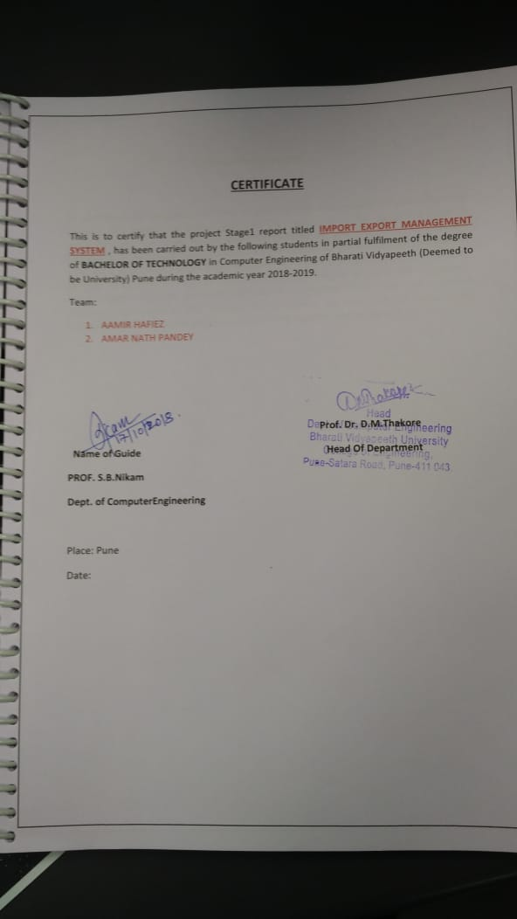
Acknowledgement

In performing our assignment, we had to take the help and guideline of some respected persons, who deserve our greatest gratitude. The completion of this assignment gives us much Pleasure. We would like to show our gratitude to. prof S.B Nikam of computer department of Bharati vidyapeeth (deemed to be) university for giving us a good guideline for assignment throughout numerous consultations. We would also like to expand our deepest gratitude to all those who have directly and indirectly guided us in writing this assignment. Many people, especially our classmates and team members itself, have made valuable comment suggestions on this proposal which gave us an inspiration to improve our assignment. We thank all the people for their help to complete our assignment.

INDEX

1. TITLE I
2. CERTIFICATE II
3. ACKNOWLEDGEMENT III
4. INDEX IV
5. LIST OF FIGURES V
6. LIST OF TABLES VI
7. ABSTRACT VII

CHAPTERS
1. INTRODUCTION 1
2. BACKGROUND 2
3. SYSTEM ANALYSIS 3
4. DBMS ARCHITECTURE 4
5. DATA MODELLING 7
6. DATABASE DESIGN 16
7. MODEL MAPPING 29
8. USER INTERFACE DESIGN 33
9. DATABASE CONNECTIVITY 40
10. SYSTEM IMPLEMENTATION 47
11. REFERENCE 55
12. POWERPOINT PRESENTATION 56

LIST OF FIGURES IN THE FILE IN THE PAGE NUMBER
S.NO | FIGURE | PAGE
1 | Fig. 2.1 case study | 2
2 | Fig. 4.1 2-tier architecture | 5
3 | Fig. 4.2 3-tier architecture | 5
4 | Fig 5.1 Entity | 9
5 | Fig 5.2 Attribute | 10
6 | Fig 5.3 composite attribute | 10
7 | Fig 5.4 multivalued attribute | 10
8 | Fig 5.5 Derived attribute | 11
9 | Fig 5.6 Relationship type | 12
10 | Fig 5.7 ER diagram | 15
11 | Fig 7.1 Mapping Entity | 29
12 | Fig 7.2 Mapping Relationship | 30
13 | Fig 7.3 Mapping Weak Entity | 30
14 | Fig 7.4 Mapping Hierarchical Entities | 31
15 | Fig 7.5 ER model for Exporter | 32
16 | Fig 7.5 ER model for Importer | 32
17 | Fig 7.6 ER model for Product | 32
18 | Fig 8.1 Windows Form1 | 34
19 | Fig 8.2 Windows Form2 | 35
20 | Fig 9.1 MySQL Database1 | 41
21 | Fig 9.2 MySQL Database2 | 42
22 | Fig 9.3 MySQL Database3 | 43
23 | Fig 9.4 MySQL Database4 | 44
24 | Fig 9.5 VB.Net1 | 45
25 | Fig 9.6 VB.Net2 | 46

LIST OF THE TABLE IN THE FILE WITH PAGE NUMBER

S.NO | TABLE | PAGE
1 | Table 6.1 Anomalies | 17
2 | Table 6.2 1NF (a) | 18
3 | Table 6.3 1NF (b) | 19
4 | Table 6.4 2NF(a) | 20
5 | Table 6.5 2NF (b) | 21
6 | Table 6.6 3NF (a) | 22
7 | Table 6.7 3NF(b) | 23
8 | Table 6.8 3NF (c) | 24
9 | Table 6.9 BCNF (a) | 25
10 | Table 6.10 BCNF (b) | 26
11 | Table 6.11 Normalization (a) | 27
12 | Table 6.12 Normalization (b) | 28
13 | Table 6.13 Normalization (c) | 28
14 | Table 8.1 Control Events | 40

ABSTRACT
Our assignment is solely concentrated on management operations which are required and implemented for maintaining and smooth running of Bus-Ticket Booking. Our project is epitome of options which are provided to the user which consist of various facility to the user like options
You can book your ticket and choosing the respective place you want to travel. The main objective is to provide the user with innovation and user friendly environment which make our project ready for upgrade any time, that is it can be easily altered, updated anytime without any drag which opposes it. The booking of ticket is as simple as it sounds the user only needs to fill the ticket detail i.e. name of the traveller, destination and date. The detail of the traveller as well as bus detail is being stored in the data base after the ticket is being booked.

