NextGen SIEM & AI-Driven Threat Intelligence
Academic Capstone Project Report
Prepared by: Mohammad Aamir Siddique

1. Executive Summary
This project demonstrates the engineering and deployment of a custom Security Information and Event Management (SIEM) pipeline. Designed to move beyond static, rule-based detection, the architecture ingests raw authentication logs and applies an Isolation Forest Machine Learning algorithm to identify behavioral anomalies. Furthermore, the system incorporates a Security Orchestration, Automation, and Response (SOAR) workflow that dynamically cross-references identified threats with global intelligence databases and autonomously generates firewall blocklists. The pipeline culminates in a real-time, single-pane-of-glass executive dashboard built for Security Operations Center (SOC) analysts.

Core Technologies Utilized:
- Infrastructure: Docker, Docker Compose
- SIEM Database & Visualization: Elasticsearch, Kibana (ELK Stack)
- Machine Learning & Scripting: Python, Pandas, Scikit-Learn (Isolation Forest)
- Threat Intelligence API: AbuseIPDB

2. Infrastructure & Containerization
The foundation of the pipeline was established using containerized microservices to ensure scalability and environment consistency. Elasticsearch and Kibana were deployed locally via Docker. This approach allowed for rapid provisioning of the SIEM backend and simulated an enterprise-grade infrastructure deployment.
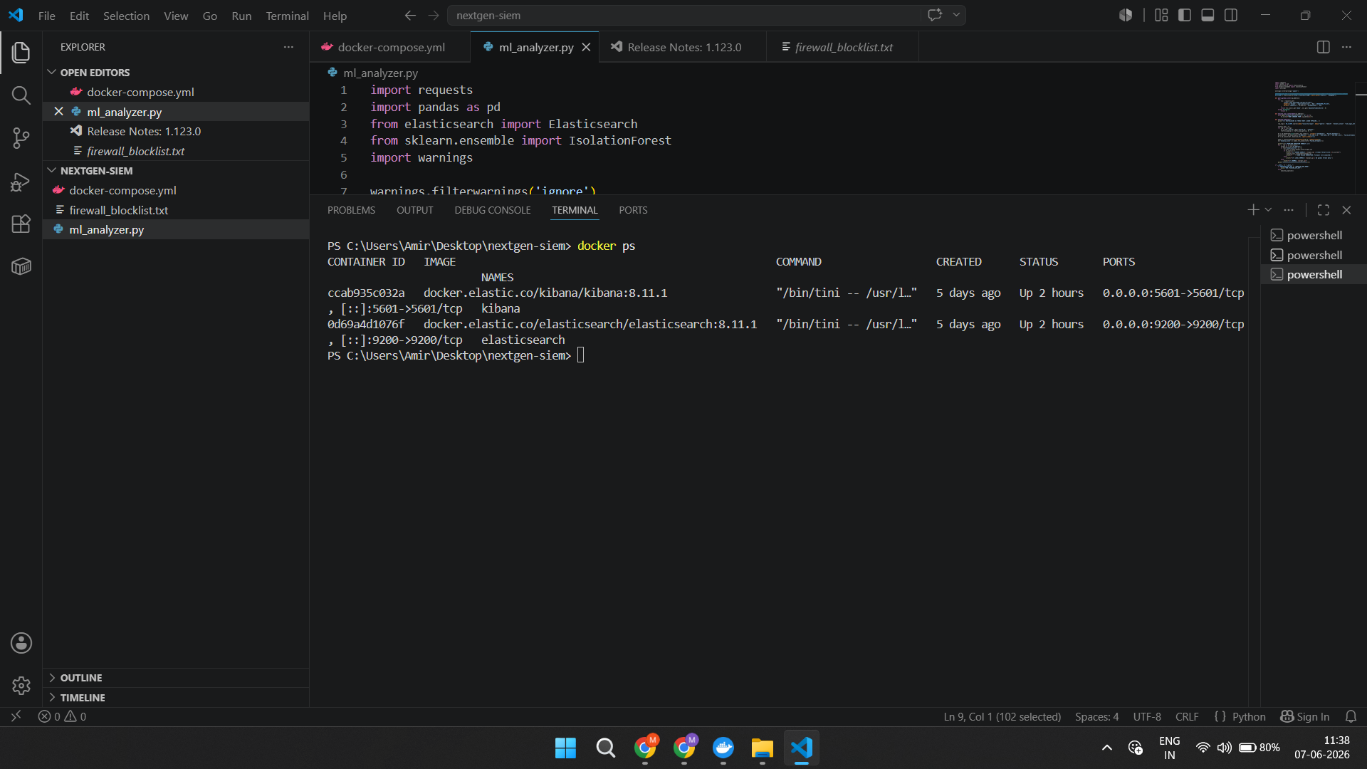

3. Data Ingestion & Schema Mapping
A custom Python ingestion engine was developed to stream simulated SSH brute-force authentication logs directly into the Elasticsearch database. The raw JSON payloads were successfully parsed, indexing critical fields such as timestamps, source IP addresses, targeted usernames, and event outcomes. This structured mapping is critical for enabling both the machine learning model and downstream visualizations.
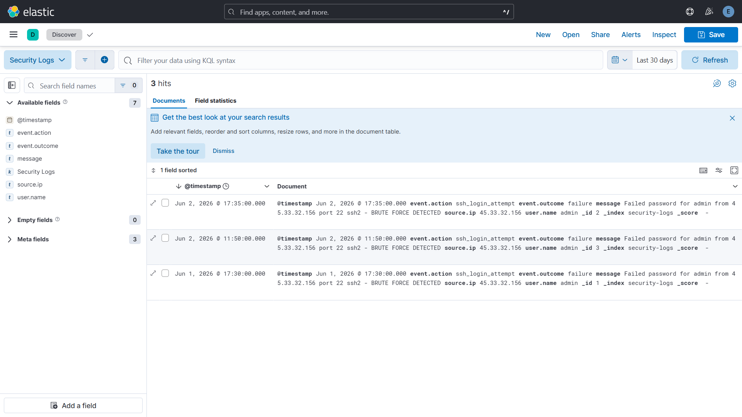

4. Machine Learning Behavioral Detection
To detect sophisticated threats that bypass traditional thresholds, an anomaly detection engine was engineered using Python. The script establishes a behavioral baseline of normal network traffic within local memory. It then utilizes the Isolation Forest machine learning algorithm to mathematically evaluate inbound Elasticsearch logs against this baseline. The model successfully identified a persistent brute-force attack originating from a Russian IP address (45.33.32.156), flagging it with an anomaly score of -1.

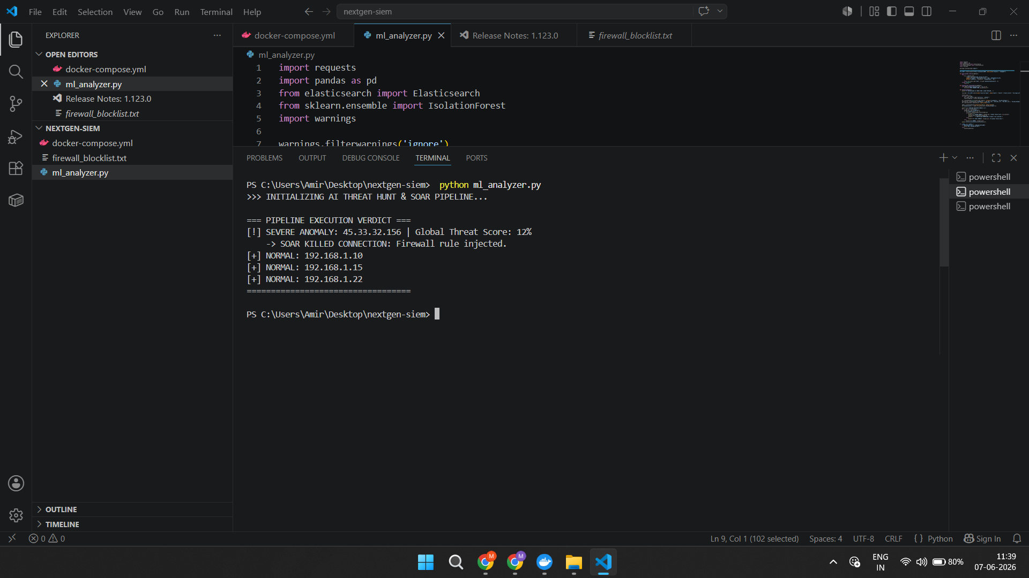

5. Automated SOAR Response & Threat Containment
Following the detection of the anomaly, the pipeline initiates an automated SOAR response. The system queries the AbuseIPDB global threat intelligence API to verify the mathematical anomaly against known malicious actors. Upon confirming a high global threat score (12%), the Python script autonomously generates a local firewall blocklist, effectively terminating the connection without requiring manual analyst intervention.

6. Executive SOC Visualization
The final phase of the project bridges raw engineering with operational business value. Raw JSON logs were visualized using Kibana Lens to construct an interactive Command Center. The dashboard provides SOC analysts with immediate situational awareness, featuring metric cards for total ingested volume, dynamic donut charts isolating geographical threat origins, and a raw data ledger for detailed incident investigation.
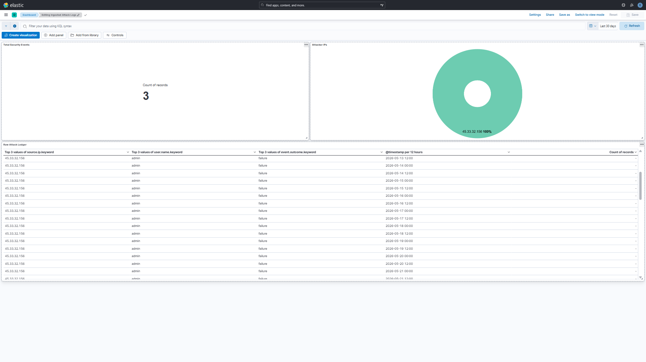

7. Conclusion
This capstone successfully bridges the gap between infrastructure deployment, AI-driven behavioral detection, and automated threat mitigation. By building a full-lifecycle SIEM pipeline from scratch, it demonstrates advanced capabilities in Python scripting, machine learning application, database mapping, and executive-level security visualization.

