Data Se Baten — User & Deployment Guide
  - Chat with your data: setup, usage and deployment
Table of Contents

Data Se Baten (Urdu for "talking with data") is an AI agent that lets you upload a dataset, get an automatic data profile, and ask questions in plain English, Urdu or Roman Urdu. An OpenAI model writes and runs the analysis for you and replies with real numbers and interactive charts.

1. What the agent does
The agent follows a four-step workflow:
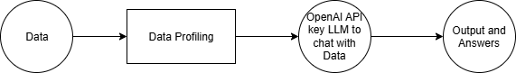
Step | What happens | Where in the code
1. Data | You upload CSV, TSV, Excel, JSON or Parquet (up to 200 MB), or use the built-in sample. | profiling.load_data
2. Data Profiling | Column types, missing values, duplicates, statistics, distributions, correlations, quality alerts and a 0–100 quality score. | profiling.profile_data
3. OpenAI LLM | A LangGraph agent gets the profile as context. For each question it writes pandas / Plotly code and runs it against your data. | agent.build_agent
4. Output & Answers | A Markdown answer with the key numbers, any charts, and a collapsible "Worked for … · N analysis steps" panel with the exact code it ran. | app.render_chat
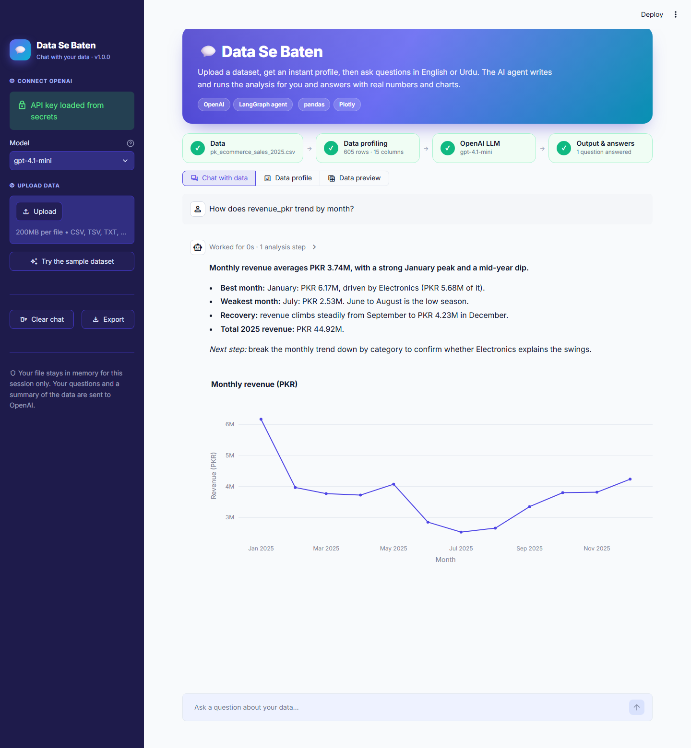

Key features
- Instant profiling dashboard. KPI cards, a column-type donut, quality alerts, and tabs for columns, statistics, missing values, distributions and correlations.
- Chat with your data. Ask follow-up questions; the agent remembers the conversation.
- Grounded answers. The agent computes every number with code instead of guessing.
- Interactive charts. Ask for a chart and you get a Plotly chart you can zoom and hover.
- Transparent. Every answer shows the Python code behind it.
- Bilingual. It replies in the language you write in.
- Exports. Download the profile report (.md), the chat transcript (.md) and the dataset (.csv).

2. Project structure
ai_agent_to_deployment/
├── app.py # Streamlit app (UI + workflow)
├── data_se_baten/
│ ├── __init__.py # app name & version
│ ├── profiling.py # Step 2: loading + data profiling
│ └── agent.py # Step 3: LangGraph + OpenAI agent and its tool
├── sample_data/
│ └── pk_ecommerce_sales_2025.csv # demo dataset (605 orders, 15 columns)
├── .streamlit/
│ ├── config.toml # theme & upload limit
│ └── secrets.toml.example # template for your OpenAI key
├── requirements.txt # dependencies for Streamlit Community Cloud
├── docs/screenshots/ # images used in this guide
├── GUIDE.md / .html / .pdf / .docx
└── workflow.png

3. Run it on your computer

3.1 Prerequisites
- Python 3.11 – 3.13 (python.org)
- An OpenAI API key. Create one at https://platform.openai.com/api-keys. Your account needs billing credit.

3.2 Set up the virtual environment
Windows (PowerShell)
cd "path\to\ai_agent_to_deployment"
py -3.13 -m venv .venv
.\.venv\Scripts\Activate.ps1
python -m pip install --upgrade pip
pip install -r requirements.txt
If PowerShell blocks Activate.ps1, run Set-ExecutionPolicy -Scope CurrentUser RemoteSigned once, or skip activation and call .\.venv\Scripts\python.exe directly.
macOS / Linux
cd path/to/ai_agent_to_deployment
python3 -m venv .venv
source .venv/bin/activate
pip install --upgrade pip
pip install -r requirements.txt

3.3 Add your API key (optional but recommended)
Copy .streamlit/secrets.toml.example to .streamlit/secrets.toml and put your key in it:
OPENAI_API_KEY = "sk-..."
If you skip this, you can paste the key into the sidebar each time you open the app. You can also set an OPENAI_API_KEY environment variable.

3.4 Start the app
streamlit run app.py
Your browser opens at http://localhost:8501. On Windows without activating the venv:
.\.venv\Scripts\python.exe -m streamlit run app.py

4. Using the app
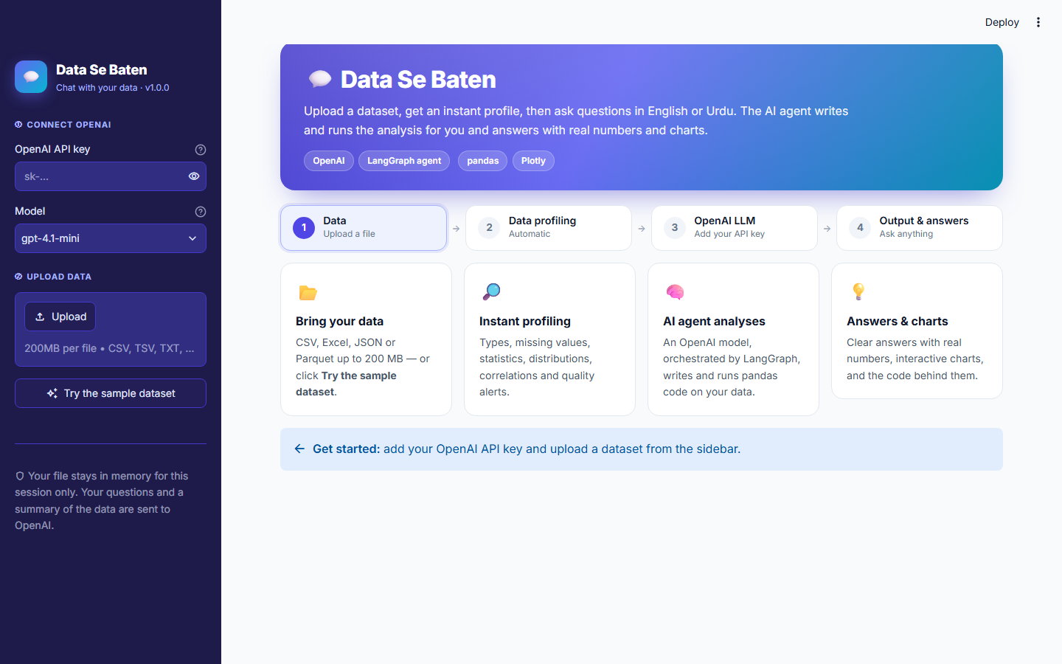

4.1 Sidebar
- ① Connect OpenAI. Paste your API key, or you'll see "API key loaded from secrets" if you set one up. Choose a model. gpt-4.1-mini is fast and cheap, and you can type any other OpenAI chat model name.
- ② Upload data. Drag a file in, or click Try the sample dataset.
- Clear chat / Export. Start over, or download the conversation as Markdown.
The workflow bar at the top tracks your progress through Data → Data Profiling → OpenAI LLM → Output & Answers. Completed steps turn green and the current step is highlighted. Below it, switch between the three views: Chat with data, Data profile and Data preview.

4.2 Chat with data
- Click a suggested question or type your own in the box at the bottom.
- A "Thinking" indicator shows each analysis step (the code, then its output) while it runs.
- The answer appears with its charts below it.
- Click Worked for … · N analysis steps above an answer to see the exact code and output behind it.
Example questions (for the sample dataset):
Type | Example
Summary | Give me an executive summary of this dataset
Aggregation | What is total revenue by region? Which region is best?
Ranking | Top 5 products by revenue, with their average rating
Trend | Show monthly revenue as a line chart
Comparison | Do Corporate customers spend more per order than Consumers?
Data quality | Which columns have problems and how should I clean them?
Statistics | Is there a relationship between discount and rating?
Urdu / Roman Urdu | Sab se zyada returns kis category mein hain?
Tips for good answers
- Use the column names you see in the profile.
- Ask for a chart explicitly: "…as a bar chart", "…plot it".
- Build on earlier answers: "now break that down by city".
- If an answer looks wrong, open the analysis steps and tell the agent what to change.

4.3 Data profile
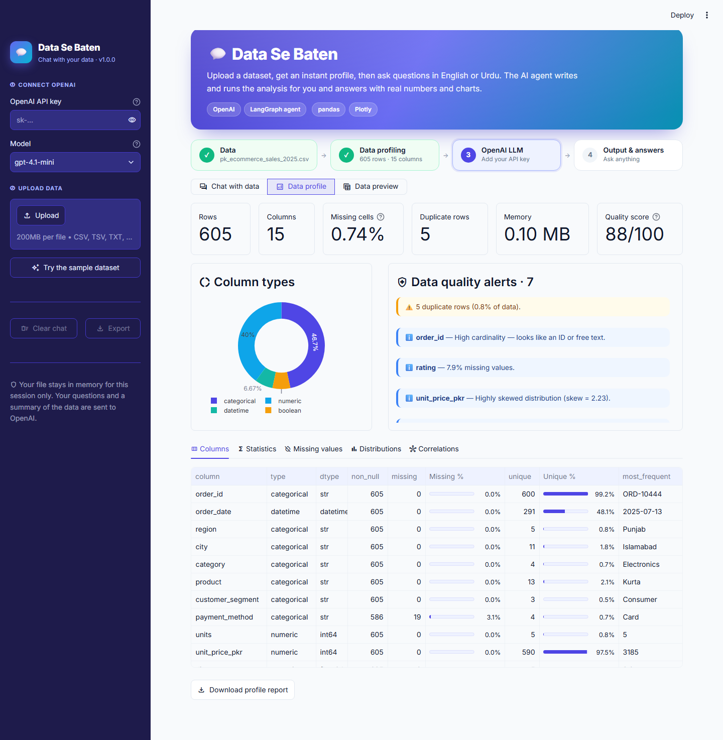
Section | What it shows
KPI cards | Rows, columns, missing %, duplicate rows, memory, quality score
Column types | Donut of numeric / categorical / datetime / boolean columns
Quality alerts | Duplicates, heavy missingness, constant columns, ID-like columns, skew, outliers (IQR rule), near-duplicate columns (|r| ≥ 0.9)
Columns tab | Per-column type, missing %, unique %, most frequent value
Statistics tab | describe() + skew for numeric columns; count/unique/top for categorical
Missing values tab | Bar chart of missing % per column
Distributions tab | Histogram + box plot (numeric), monthly counts (dates) or top-20 values (categorical)
Correlations tab | Pearson correlation heatmap
Click Download profile report to save it as Markdown.

4.4 Data preview
This view has a scrollable, sortable, searchable table of the full dataset and a CSV download button.

5. How it works (for developers)

5.1 The LangGraph agent
┌──────────────────────────────┐
START ─►│ agent (OpenAI chat model) │── no tool call ─► END (final answer)
└──────────────┬───────────────┘
│ tool call
▼
┌──────────────────────────────┐
│ tools (python_analysis) │── result ─► back to agent
└──────────────────────────────┘
- State: a list of messages (AgentState with the add_messages reducer).
- System prompt: the role, the rules, and the data profile text from step 2, so the model knows the columns, types and data-quality issues before it writes any code.
- Tool python_analysis(code): runs code with df, pd, np, px and go in scope, on a copy of the data. It returns the printed output and last expression to the model (truncated to 6 000 characters). Plotly figures and tables go back to the UI as artifacts and are never sent to the model.
- Self-correction: if code raises an error, the error text goes back to the model and it retries.
- Memory: earlier questions and final answers (the last 12 turns) are replayed each time, which keeps token usage low.
- Safety limit: recursion_limit = 24 graph steps per question.

5.2 Customising
What | Where
Colours, fonts, radius | .streamlit/config.toml and the CSS block at the top of app.py
Model list / default model | MODELS in app.py, or OPENAI_MODEL in secrets
Agent behaviour / tone | SYSTEM_PROMPT in data_se_baten/agent.py
Extra tools (e.g. SQL, web search) | Add a @tool in make_tools(); LangGraph wires it automatically
Profiling rules and alert thresholds | _build_alerts() in data_se_baten/profiling.py
Upload size limit | maxUploadSize in .streamlit/config.toml

6. Deploy to Streamlit Community Cloud
- Push the project to GitHub. Commit everything except .venv/ and .streamlit/secrets.toml (the included .gitignore already excludes both).
- git init
git add .
git commit -m "Data Se Baten AI agent"
git branch -M main
git remote add origin https://github.com/<you>/data-se-baten.git
git push -u origin main
- Go to https://share.streamlit.io and sign in with GitHub.
- Click Create app → Deploy a public app from GitHub.
- Pick your repository, set branch = main and main file path = app.py.
- Open Advanced settings:
  - Python version: 3.12 or 3.13 (3.11 minimum).
  - Secrets: paste
  - OPENAI_API_KEY = "sk-..."
  - Skip this if you want every visitor to use their own key through the sidebar.
- Click Deploy. The first build installs requirements.txt and takes 2–5 minutes.
- Share your app URL (https://<your-app>.streamlit.app).
⚠️ Cost warning: if you put your key in Secrets, every visitor's questions are billed to you. For a public app, leave Secrets empty so visitors bring their own key, or set a monthly spending limit at https://platform.openai.com/settings/organization/limits.
To update the app, push to GitHub and Streamlit Cloud redeploys automatically. To change the key, go to App → Settings → Secrets.

7. Troubleshooting
Problem | Fix
"Your OpenAI API key was rejected" | Check the key has no spaces, is active, and your account has billing credit.
"Rate limit or quota reached" | Wait a minute, add credit, or switch to a smaller model.
"Model … isn't available" | Your key has no access to that model. Pick gpt-4.1-mini or gpt-4o-mini.
"Could not read file" | Save Excel as .xlsx (not password-protected), or export as UTF-8 CSV.
"Too many steps" | Ask a more specific question, or split it into two.
streamlit not recognised | Activate the venv, or use .\.venv\Scripts\python.exe -m streamlit run app.py.
Cloud build fails | Check the logs under Manage app. Usually a typo in requirements.txt or an unsupported Python version.
App is slow on big files | Profiling is cached per file. For files over 1M rows, sample them first.

8. Privacy & security
- Uploaded data lives in memory for your session only. Nothing is written to disk.
- The data profile, the first five rows and tool outputs (aggregated results) are sent to OpenAI to answer questions. Don't upload data you aren't allowed to share with OpenAI.
- API keys typed in the sidebar are kept only in that browser session.
- The agent runs model-generated Python on the server. That's fine for personal and classroom use. For a multi-tenant production system, run the tool in an isolated sandbox (a container or a service such as E2B) and add authentication.

9. FAQ
Which files are supported? CSV, TSV, TXT (delimiter auto-detected), XLSX, JSON / JSON-lines and Parquet. Save old .xls files as .xlsx first.
Can I use a model other than OpenAI? Yes. Replace ChatOpenAI in agent.py with any LangChain chat model that supports tool calling (for example ChatAnthropic) and add its package to requirements.txt.
How much does a question cost? A question usually takes 1–3 model calls, each sending the data profile (about 1,000 tokens) plus the conversation. Smaller models such as gpt-4.1-mini cost far less than larger ones. See https://openai.com/api/pricing for current prices.
Does it remember previous chats after I close the tab? No. Use Export in the sidebar to keep a copy.

Data Se Baten v1.0.0 — built with Streamlit, LangGraph, LangChain-OpenAI, pandas and Plotly.

