Mockup of Application Interface (Documentation)

Home Page:

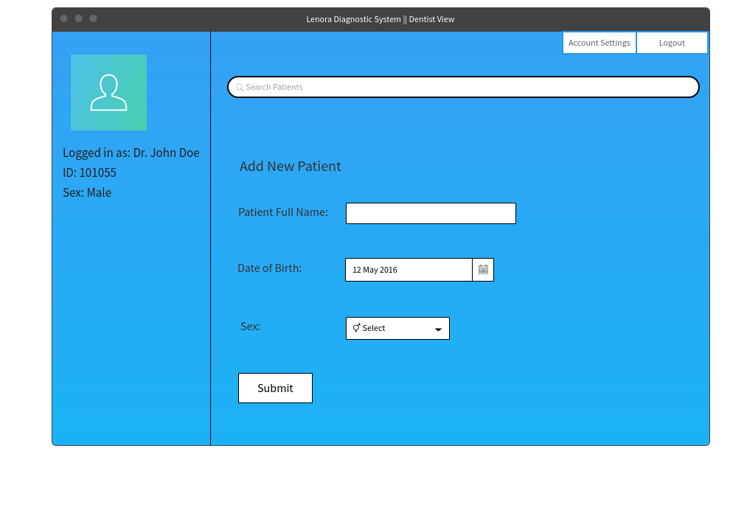

Description:

The image shown above illustrates a mockup or what we would consider a prototype of the

application interface after the dentist has logged in. This interface would display user

information of the dentist that was just authenticated, a form to add new patients, two buttons

for account controls along with a search bar which gives the user the ability to navigate around

patient records where they could view, modify and delete patients and/or patient data from

the system.

Patient Record Page:

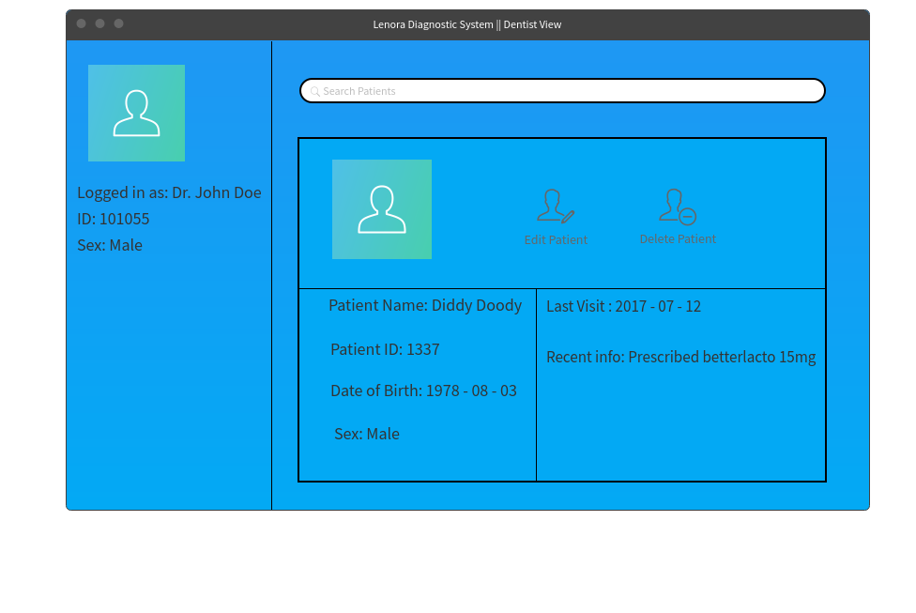

Description:

This is the page that would be shown to the dentist logged in after that user searches for a

patient. This page displays user information, a search bar to look for other patients, and patient

record information of the patient just that was just searched for along with the edit and delete

button.