Java Collection Programs - ArrayList and HashSet

Name : G AAMNA KHAN
REG N0 : 192371084

1. Employee Name List (ArrayList)
import java.util.ArrayList;
public class EmployeeList {
public static void main(String[] args) {
ArrayList<String> employees = new ArrayList<>();
employees.add("Ramesh");
employees.add("Suresh");
employees.add("Priya");
employees.add("Anu");
employees.add("Karthik");
System.out.println("Employee Names:");
for (String name : employees)
System.out.println(name);
}
}
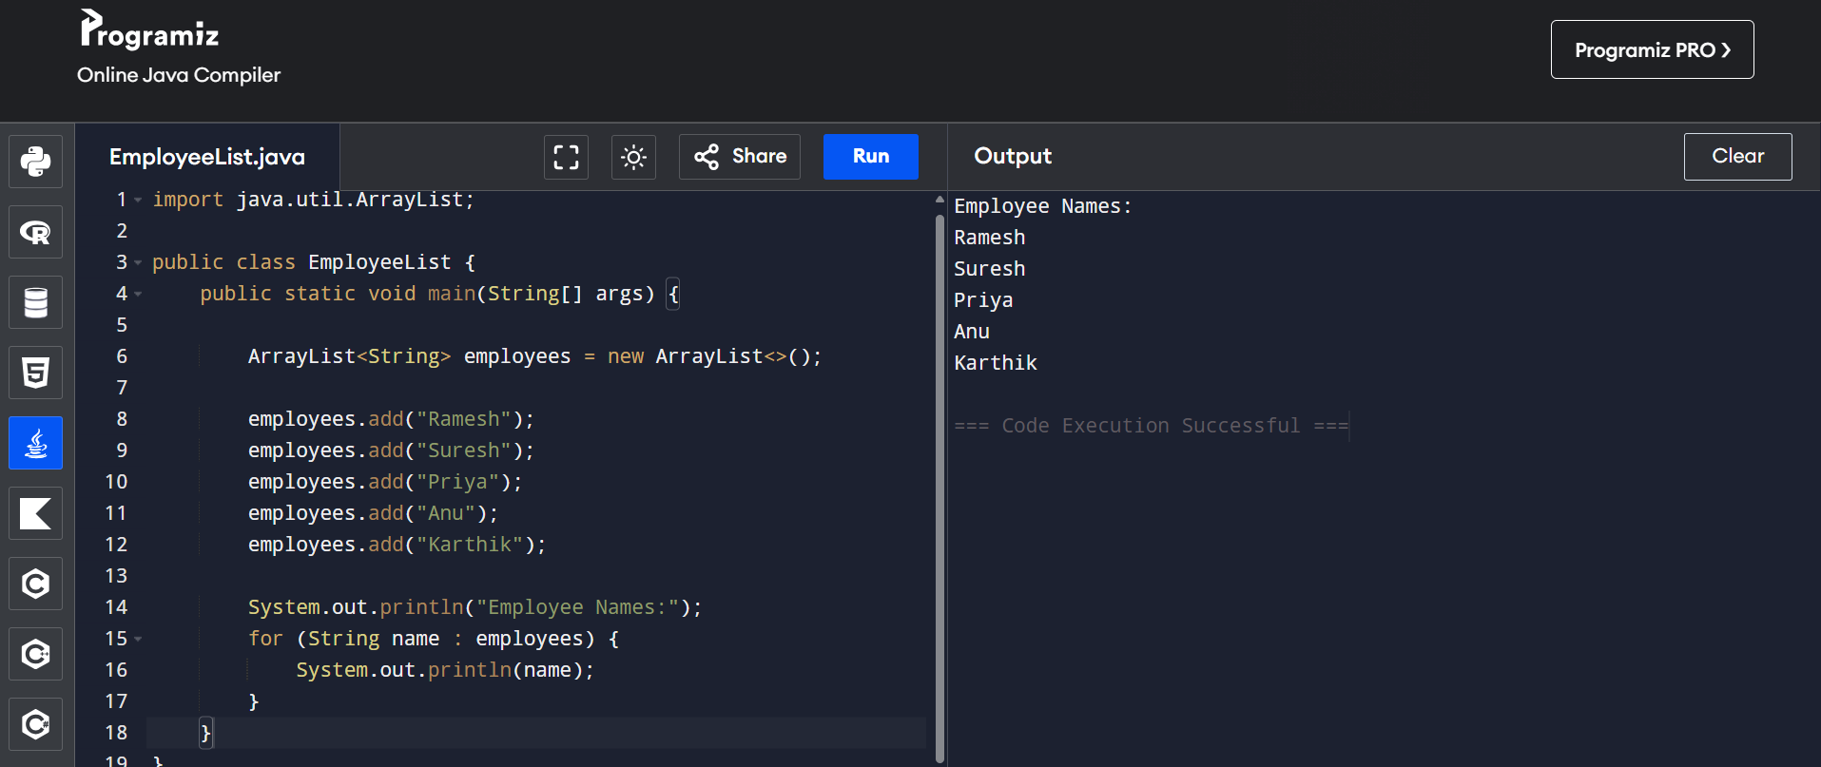

2. Restaurant Order Management (ArrayList)
import java.util.ArrayList;
public class RestaurantOrder {
public static void main(String[] args) {
ArrayList<String> order = new ArrayList<>();
order.add("Dosa");
order.add("Idli");
order.add("Pongal");
order.add("Coffee");
order.remove("Pongal");
System.out.println("Updated Order List:");
for (String item : order)
System.out.println(item);
System.out.println("Total Items: " + order.size());
}
}
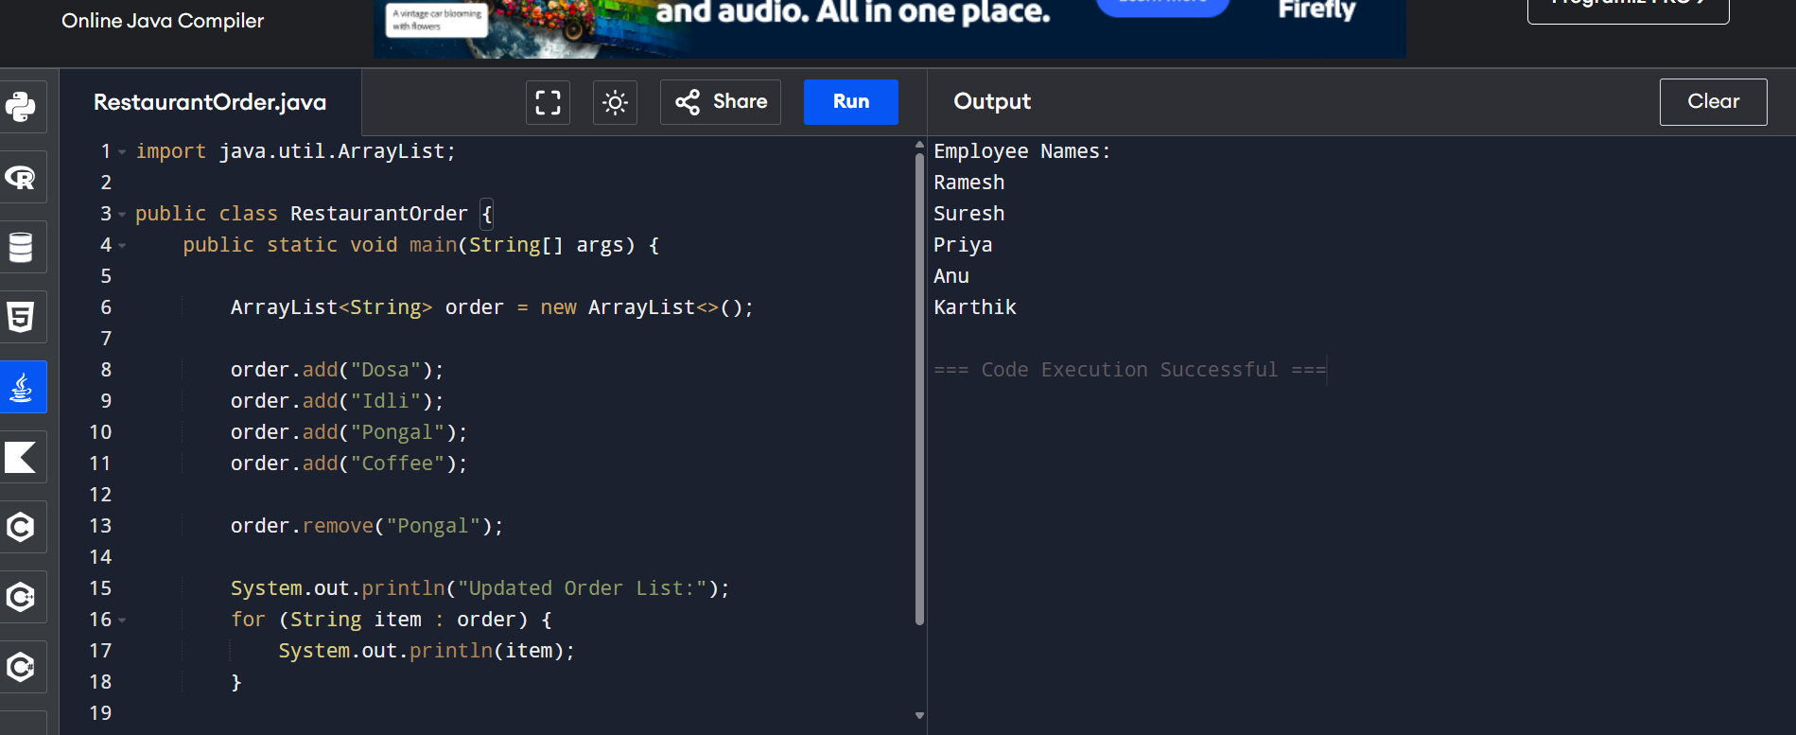

3. Online Course Enrollment (ArrayList)
import java.util.ArrayList;
public class CourseEnrollment {
public static void main(String[] args) {
ArrayList<String> students = new ArrayList<>();
students.add("Meena");
students.add("Ravi");
students.add("Anu");
students.add("Priya");
students.add("Karthik");
if (students.contains("Meena"))
System.out.println("Enrolled");
else
System.out.println("Not Enrolled");
}
}


4. Unique Email Registration (HashSet)
import java.util.HashSet;
public class EmailRegistration {
public static void main(String[] args) {
HashSet<String> emails = new HashSet<>();
emails.add("a@gmail.com");
emails.add("b@gmail.com");
emails.add("a@gmail.com");
emails.add("c@gmail.com");
System.out.println("Unique Email Addresses:");
for (String email : emails)
System.out.println(email);
System.out.println("Total Unique Users: " + emails.size());
}
}
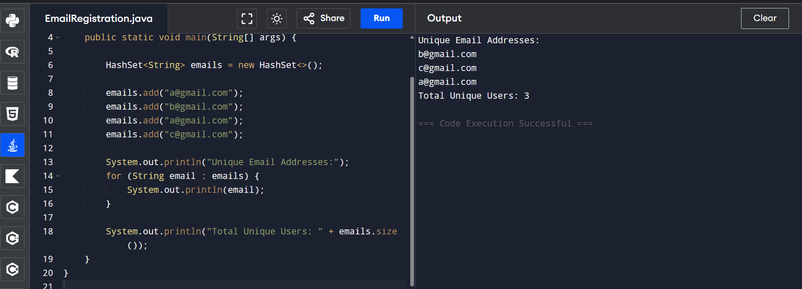

5. Library Book ID Tracking (HashSet)
import java.util.HashSet;
public class LibraryBookID {
public static void main(String[] args) {
HashSet<Integer> bookIds = new HashSet<>();
int[] ids = {101,102,103,101,104};
for(int id: ids){
if(!bookIds.add(id))
System.out.println("Duplicate Book ID Found");
}
System.out.println("Unique Book IDs:");
for(int id: bookIds)
System.out.println(id);
}
}
