Beautiful Beaches

|  |  |  |
| --- | --- | --- |
| **Supervisor.** | Sir Owais | |
| **Batch.** | PRIME-202307-D | |
| **Serial No.** | **Student ID** | **Student Name** |
| 1. | Student1499773 | AAMNA ANSARI |
| 2. | Student1499753 | AHSAN ALI |
| 3. | Student1501260 | EZMA FATIMA |

# ACKNOWLEDGEMENT

The thirst for learning, upgrading technical skills and applying the concepts in real life environment at a fast pace is what the industry demands from IT professionals today. However busy work schedules, far-flung locations, and unavailability of convenient time-slots pose as major barriers when it comes to applying the concepts into realism. And hence the need to look out for alternative means of implementation in the form of laddered approach.

The above truly pose as constraints especially for our students too! With their busy schedules, it is indeed difficult for our students to keep up with the genuine and constant need for integrated application which can be seen live especially so in the field of IT education where technology can change on the spur of a moment. *Well, technology does come to our rescue at such times!!*

Keeping the above in mind and in tune with our constant endeavour to use Technology in our training model, we at Aptech have thought of revolutionizing the way our students learn and implement the concepts using tools themselves by providing a *live and synchronous eProject learning environment!*

# SYNOPSIS

eProject is a step by step learning environment that closely simulates the classroom and Lab based learning environment into actual implementation. It is a project implementation at your fingertips!! An electronic, live juncture on the machine that allows you to

* Practice step by step i.e. laddered approach.
* Build a larger more robust application.
* Usage of certain utilities in applications designed by user.
* Single program to unified code leading to a complete application.
* Learn implementation of concepts in a phased manner.
* Enhance skills and add value.
* Work on real life projects.
* Give a real life scenario and help to create applications more complicated and useful.
* Mentoring through email support.

The students at the centre are expected to complete this eProject and send complete documentation with source code within the time allotted to eProjects Team

Looking forward to a positive response from your end!!

# PROBLEM DEFINITION

The most important economic benefit of beaches is that they serve as a tourist attraction site. Tourism is the largest economic activity in the world and it not only earns countries foreign revenue, but also acts as a large employer for the local population. “BeautyOfBeaches” will be the website that will provide the information about famous beaches in the world. The information can be categorized based on zone wise (NORTH, SOUTH, WEST and EAST).

# REQUIREMENT SPECIFICATION:

The Web site is to be created based on the following requirements.

1. The Home Page should be created making use of Sections with a suitable logo, the header section can be added which will show different famous images of respective beaches.
2. The site must contain the links to navigate through any zone for the information.
3. Links of monuments can be categorized by zone wise like (East, North, West and South)
4. Gallery section can be added for viewing different images.
5. Feedback must be allowed to enter by the viewer.
6. Site map, Gallery, about us, Queries link, Contact us link must be added.
7. The complete details and description must be allowed to get download as pdf or doc file.
8. The advertise section of bus, flights can be included for reaching the places.

# SCOPE OF THE WORK (IN BRIEF)

The Objective of this program is to give a sample project to work on real life projects. These applications help you build a larger more robust application.

The objective is not to teach you the software’s but to provide you with a real life scenario and help you create basic applications using the tools.

You can revise the topics before you start with the project.

These programs should be done in the Lab sessions with assistance of the faculty if required.

It is very essential that a student has a clear understanding of the subject.

Kindly get back to eProjects Team in case of any doubts regarding the application or its objectives.

# Screen Shot of the Project

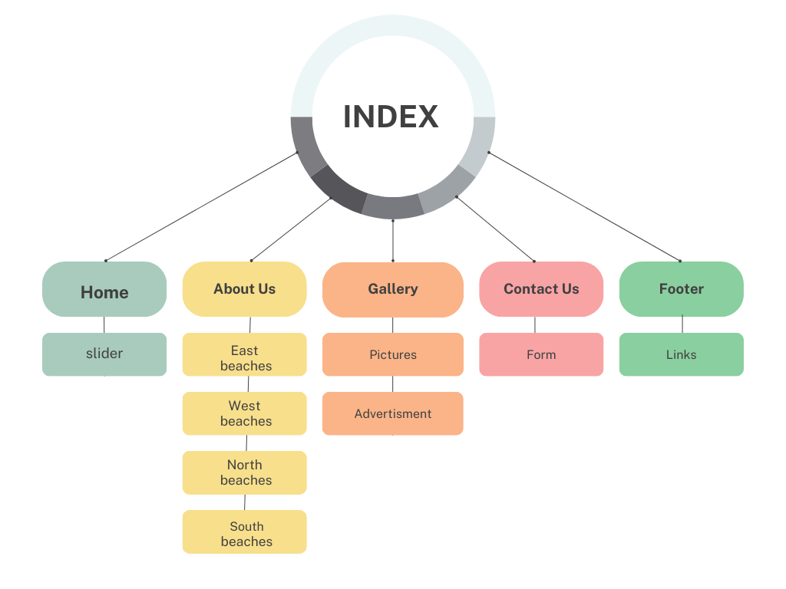

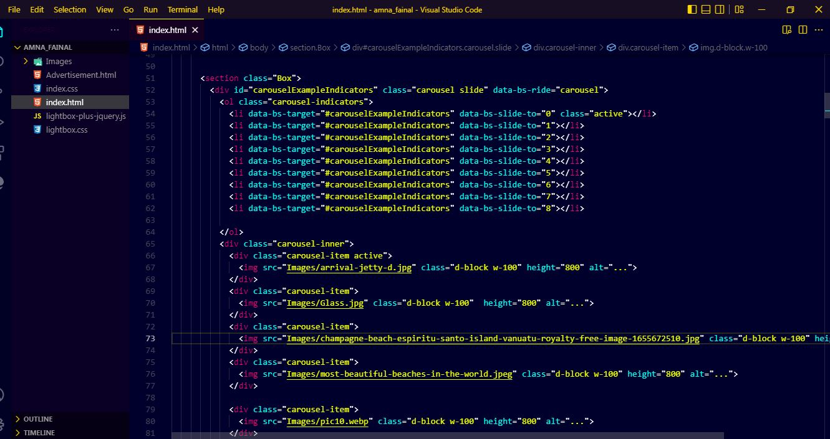

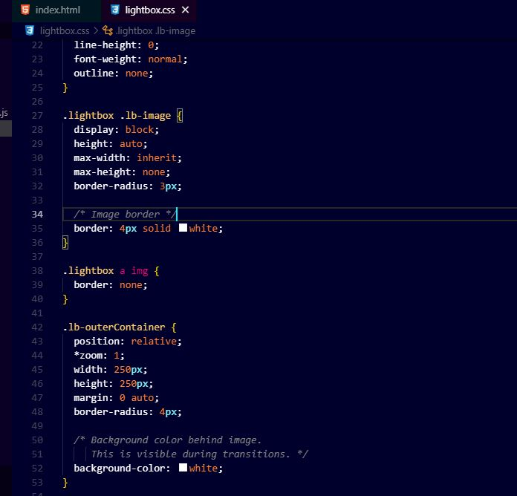

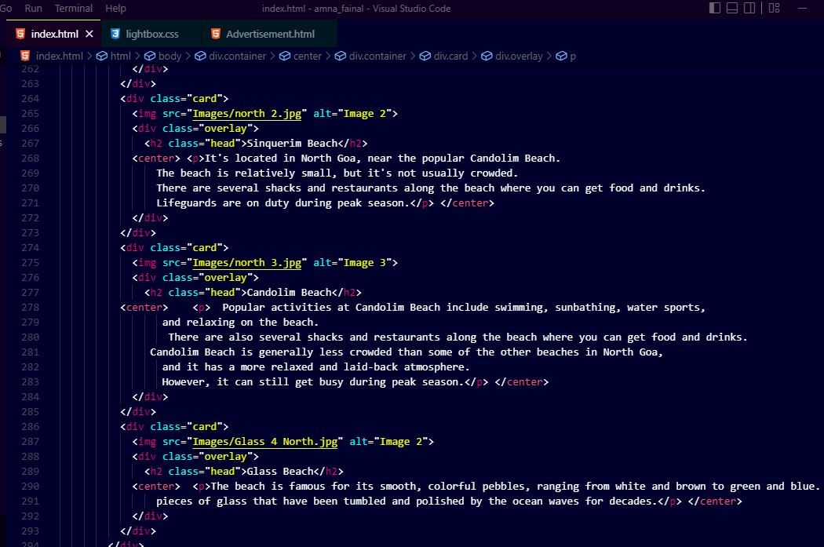

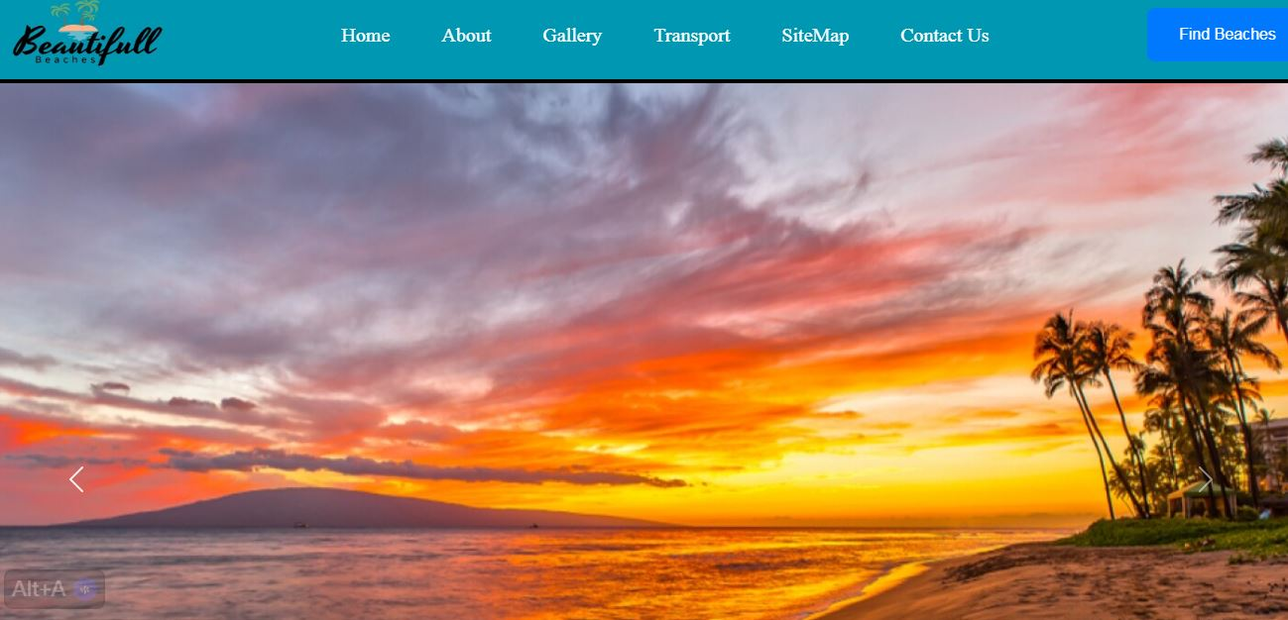





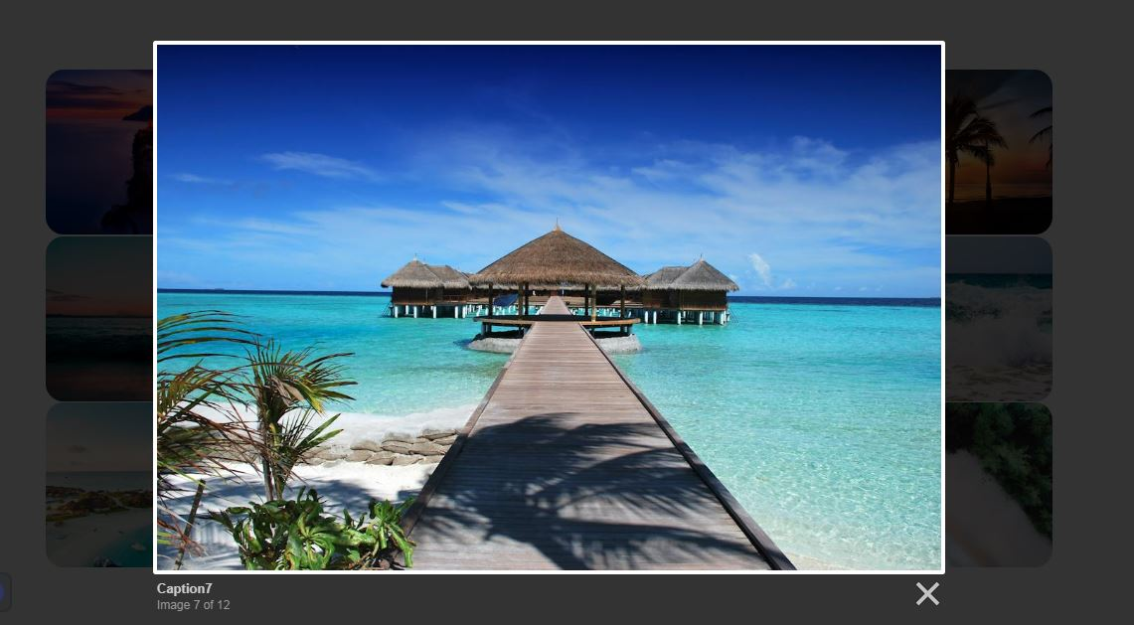

# TASK SHEET REVIEW

|  |  |  |  |  |  |
| --- | --- | --- | --- | --- | --- |
| **Date:** | **Project Plan/ Milestone** | **Work**  **Specification** | **Status of the Activity** | **Remarks** | **Responsibility** |
| 14/2/2024 | Analysis | Requirements  Get from SRS/  Paper working/  Project plain | Yes | 2 days | Ezma  Aamna  Ahsan |
| 18/2/2024 | Data Collection like (images,  Video, audio) | Data Collect  As per requirement | Yes | 4 days | Ezma |
| 25/2/2024 | Web Pages  Designing | Complete all  Website screen | Yes | 6 days | Aamna  Ezma  Ahsan |
| 28/2/2024 | Create minor  animations | Animations  (Lightbox) | Yes | 3 days | Aamna  Ezma  Ahsan |
| 3/3/2024 | Testing | All website testing | Yes | 2 days | Aamna |

**THANK**

**YOU**

**THANK**

**YOU**

**THANK**

**YOU**

**THANK**

**YOU**