AAMNA NAZ AWAN

BIG DATA ANALYTICS

FINAL EXAM

**DATASET:** **Football data from transfer markt**

**ABOUT DATA SET:**

Clean, structured and automatically updated football data from [Transfermarkt](https://www.transfermarkt.co.uk/" \t "_blank), including

60,000+ games from many seasons on all major competitions

400+ clubs from those competitions

30,000+ players from those clubs

400,000+ player market valuations historical records

1,200,000+ player appearance records from all games

FILE NAMES:

1. appearances.csv
2. club\_games.csv
3. clubs.csv
4. competitions.csv
5. game\_events.csv
6. game\_lineups.csv
7. games.csv
8. player\_valuations.csv
9. players.csv
10. transfers.csv

QUERY NO:1 **Top Players by Total Goals**

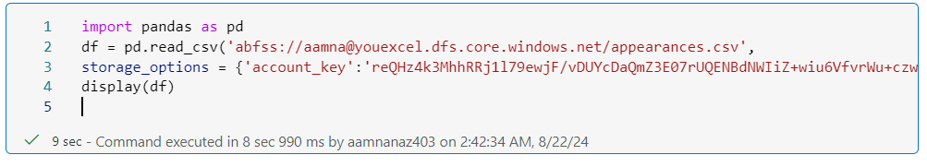

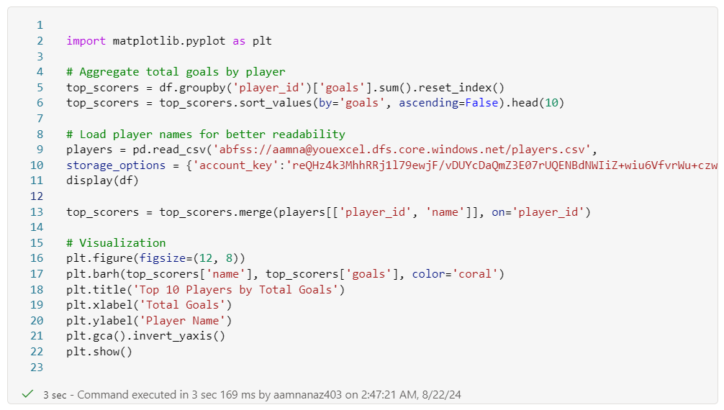

OUTPUT:-

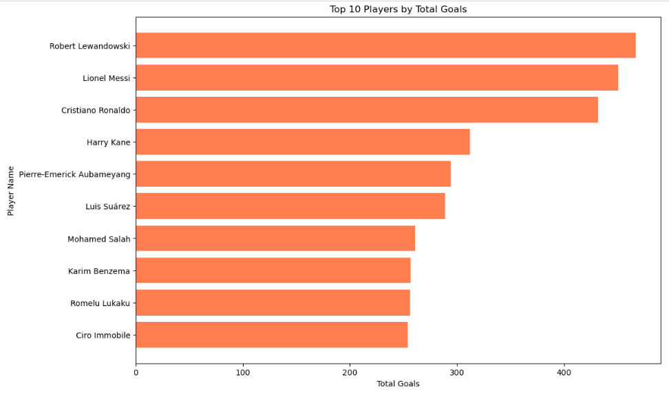

QUERY NO:2 **Top Competitions by Number of Games**

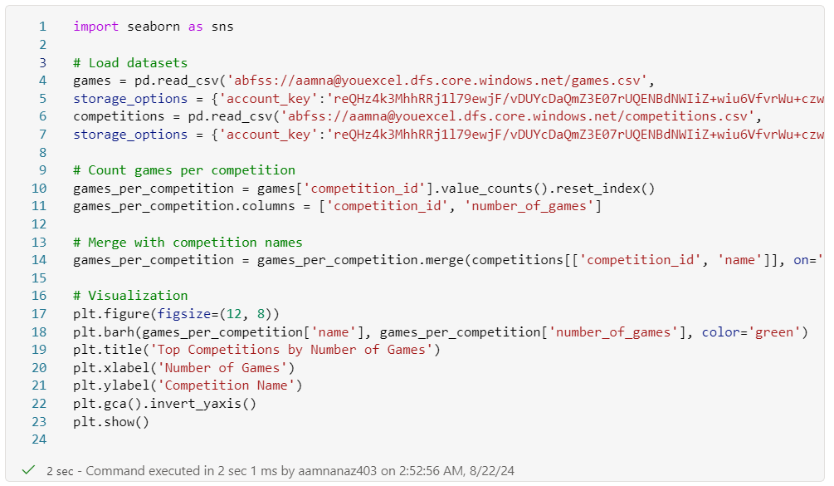

OUTPUT:-

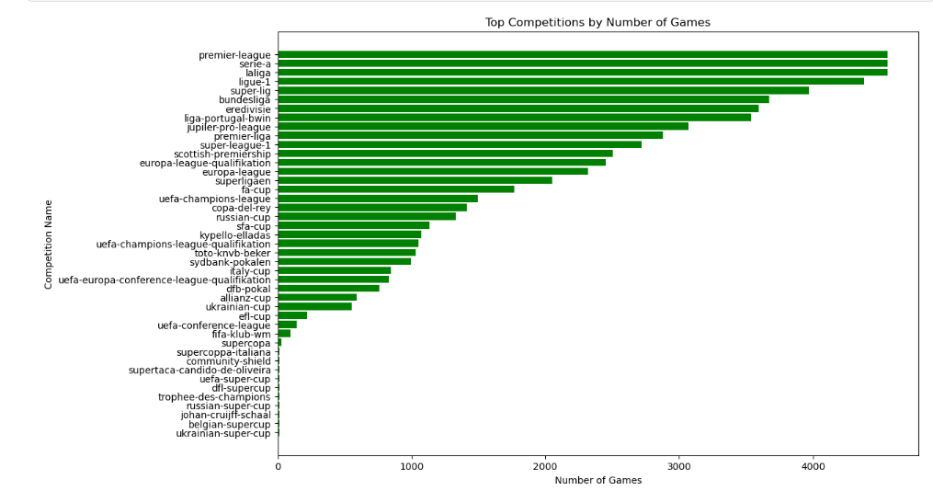

QUERY : 3 **Goal Distribution by Position**

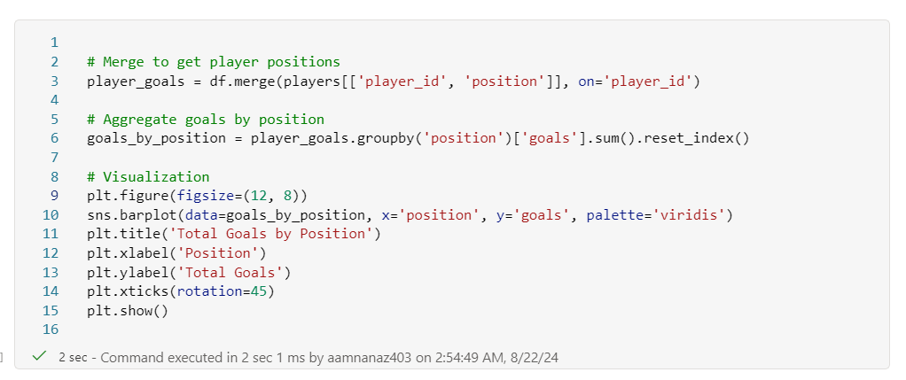

OUTPUT:-

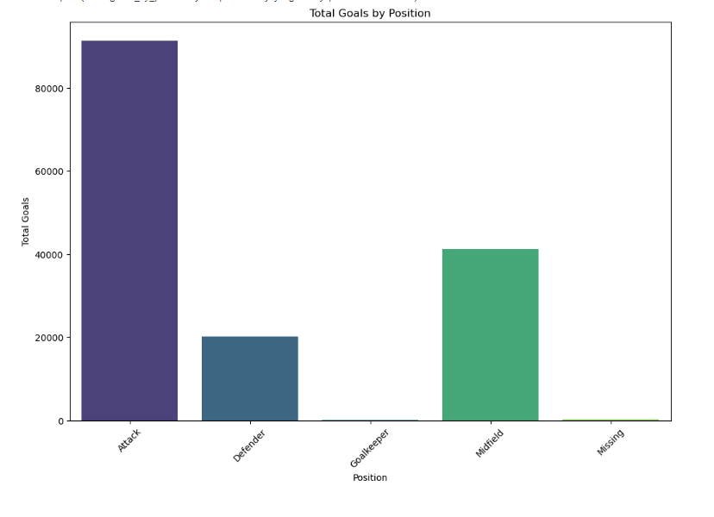

QUERY : 4 **Player Performance Over Different Seasons**

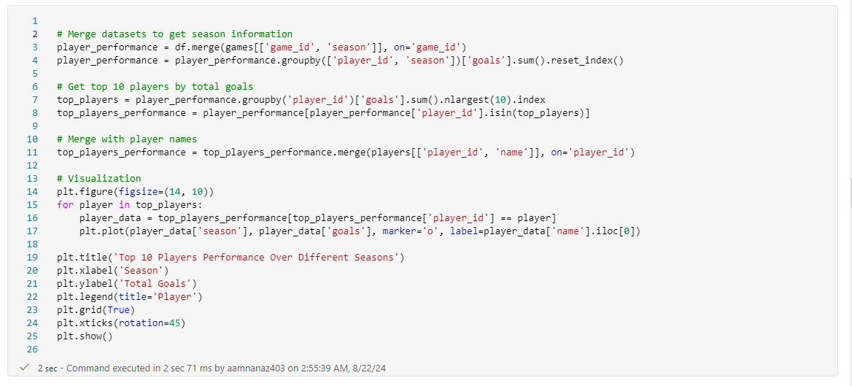

OUTPUT:-

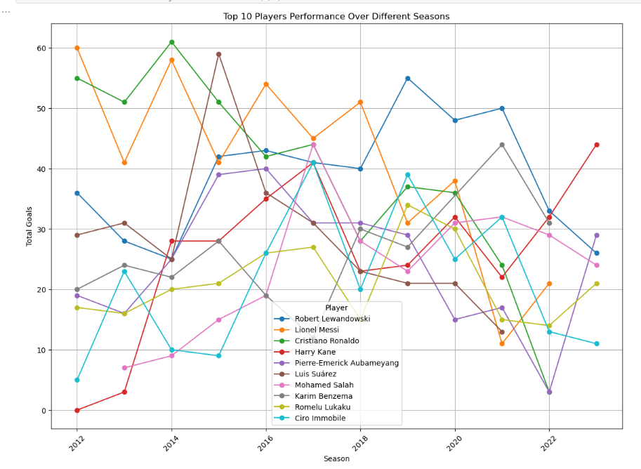

QUERY: 5 **Comparison of Total Assists by Competition**

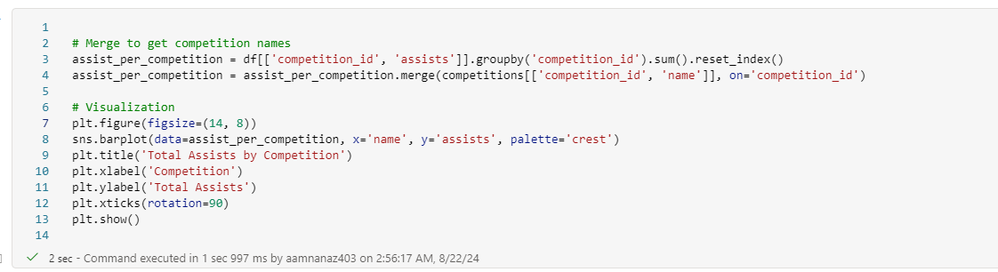

OUTPUT:-

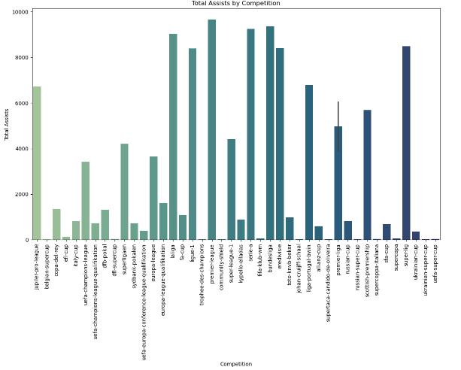

QUERY: 6 **Top 10 Players with Most Goals in the Last Season**

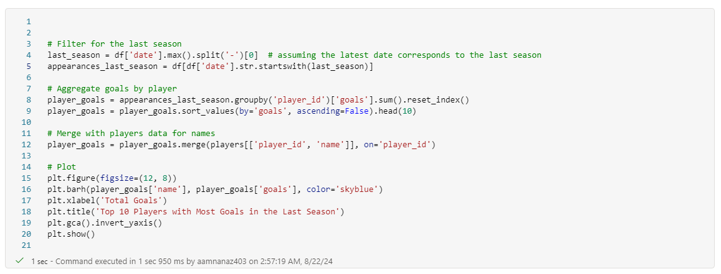

OUTPUT:-

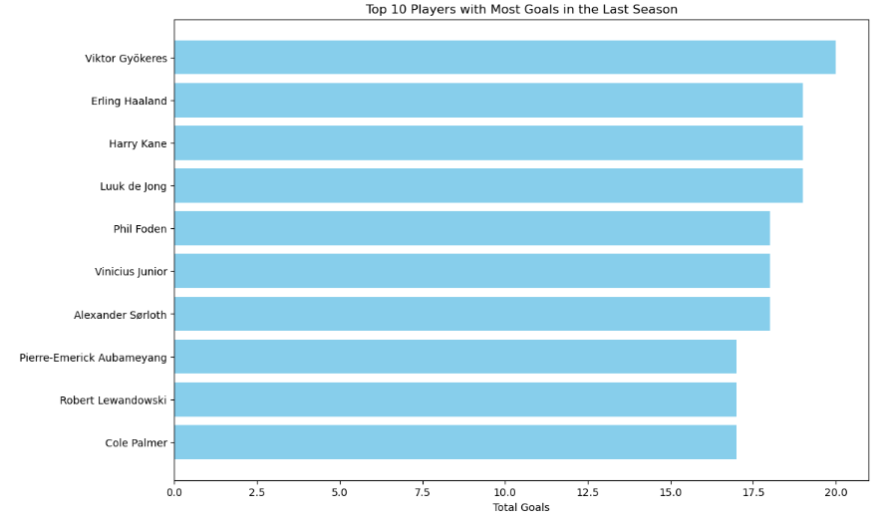

QUERY: 7 **Comparison of Average Player Market Value by Nationality**

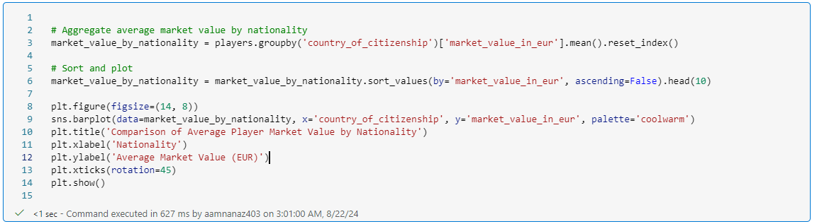

OUTPUT:-

