use this data set and give me atleast 8 complex but clear queries in pandas with visualization

https://www.kaggle.com/datasets/davidcariboo/player-scores

i have multiple files with column name

1.transfers(player_id transfer_date transfer_season from_club_id to_club_id from_club_name to_club_name transfer_fee market_value_in_eur player_name)

2.competitions(competition_id competition_code name sub_type type country_id country_name domestic_league_code confederation url is_major_national_league)

3.clubs(club_id club_code name domestic_competition_id total_market_value squad_size average_age foreigners_number foreigners_percentage national_team_players stadium_name stadium_seats net_transfer_record coach_name last_season filename url)

4.club_games(game_id club_id own_goals own_position own_manager_name opponent_id opponent_goals opponent_position opponent_manager_name hosting is_win)

5.appearences(appearance_id game_id player_id player_club_id player_current_club_id date player_name competition_id yellow_cards red_cards goals assists minutes_played)

6.game_events(game_event_id date game_id minute type club_id player_id description player_in_id player_assist_id)

7.players(player_id first_name last_name name last_season current_club_id player_code country_of_birth city_of_birth country_of_citizenship date_of_birth sub_position position foot height_in_cm contract_expiration_date agent_name image_url url current_club_domestic_competition_id current_club_name market_value_in_eur highest_market_value_in_eur)

8.player_valuation(player_id date market_value_in_eur current_club_id player_club_domestic_competition_id)

9.games(game_id competition_id season round date home_club_id away_club_id home_club_goals away_club_goals home_club_position away_club_position home_club_manager_name away_club_manager_name stadium attendance referee url home_club_formation away_club_formation home_club_name away_club_name aggregate competition_type)

10.game_lineups(game_lineups_id date game_id player_id club_id player_name type position number team_captain)

import pandas as pd

df = pd.read_csv('abfss://aamna@youexcel.dfs.core.windows.net/football/goalscorers.csv',

storage_options = {'account_key':'/dhYW+OiOeruQ2q2lRlOVQHX+VYV50A1MDZYASkOS6BP6NqNMeL12c2uqhhUzDp92mNhSurH6uI++AStKYyqpQ=='})

display(df)

1. **Top Players by Total Goals**

import pandas as pd  
import matplotlib.pyplot as plt  
  
# Load datasets  
appearances = pd.read_csv('appearances.csv')  
  
# Aggregate total goals by player  
top_scorers = appearances.groupby('player_id')['goals'].sum().reset_index()  
top_scorers = top_scorers.sort_values(by='goals', ascending=False).head(10)  
  
# Load player names for better readability  
players = pd.read_csv('players.csv')  
top_scorers = top_scorers.merge(players[['player_id', 'name']], on='player_id')  
  
# Visualization  
plt.figure(figsize=(12, 8))  
plt.barh(top_scorers['name'], top_scorers['goals'], color='coral')  
plt.title('Top 10 Players by Total Goals')  
plt.xlabel('Total Goals')  
plt.ylabel('Player Name')  
plt.gca().invert_yaxis()  
plt.show()

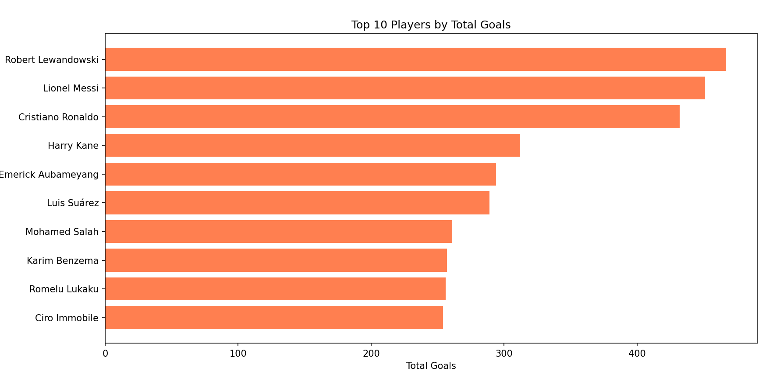

2. **Top Competitions by Number of Games**

import pandas as pd  
import matplotlib.pyplot as plt  
  
import seaborn as sns  
  
# Load datasets  
games = pd.read_csv('games.csv')  
competitions = pd.read_csv('competitions.csv')  
  
# Count games per competition  
games_per_competition = games['competition_id'].value_counts().reset_index()  
games_per_competition.columns = ['competition_id', 'number_of_games']  
  
# Merge with competition names  
games_per_competition = games_per_competition.merge(competitions[['competition_id', 'name']], on='competition_id')  
  
# Visualization  
plt.figure(figsize=(12, 8))  
plt.barh(games_per_competition['name'], games_per_competition['number_of_games'], color='green')  
plt.title('Top Competitions by Number of Games')  
plt.xlabel('Number of Games')  
plt.ylabel('Competition Name')  
plt.gca().invert_yaxis()  
plt.show()

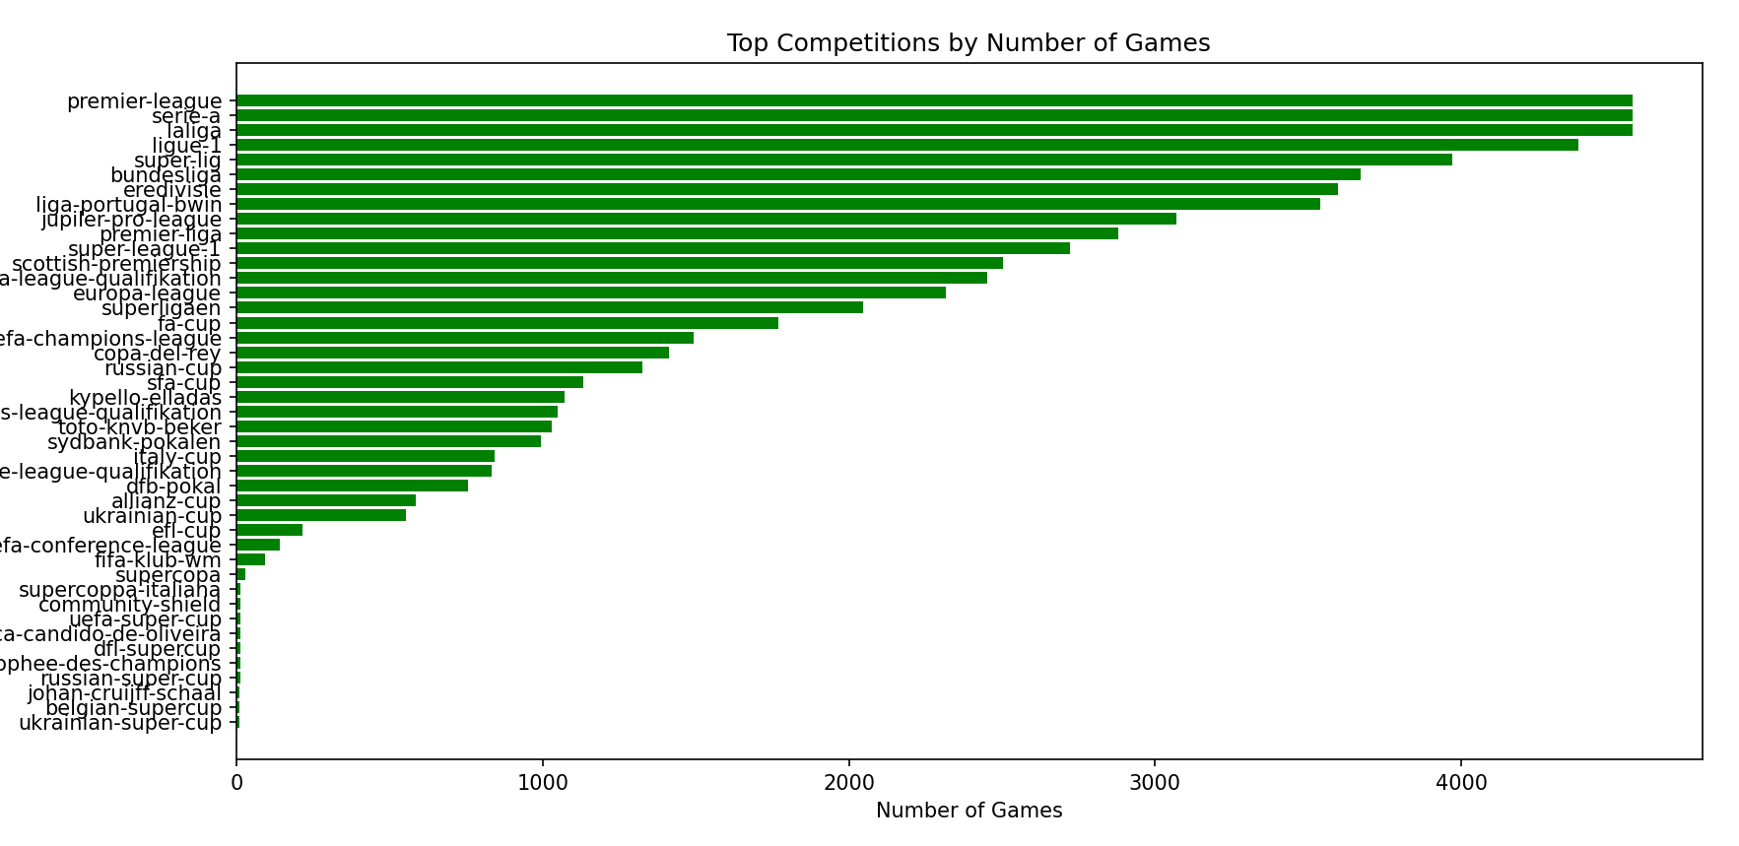

3. **Goal Distribution by Position**

import pandas as pd  
import matplotlib.pyplot as plt  
  
import seaborn as sns  
  
# Load datasets  
appearances = pd.read_csv('appearances.csv')  
players = pd.read_csv('players.csv')  
  
# Merge to get player positions  
player_goals = appearances.merge(players[['player_id', 'position']], on='player_id')  
  
# Aggregate goals by position  
goals_by_position = player_goals.groupby('position')['goals'].sum().reset_index()  
  
# Visualization  
plt.figure(figsize=(12, 8))  
sns.barplot(data=goals_by_position, x='position', y='goals', palette='viridis')  
plt.title('Total Goals by Position')  
plt.xlabel('Position')  
plt.ylabel('Total Goals')  
plt.xticks(rotation=45)  
plt.show()

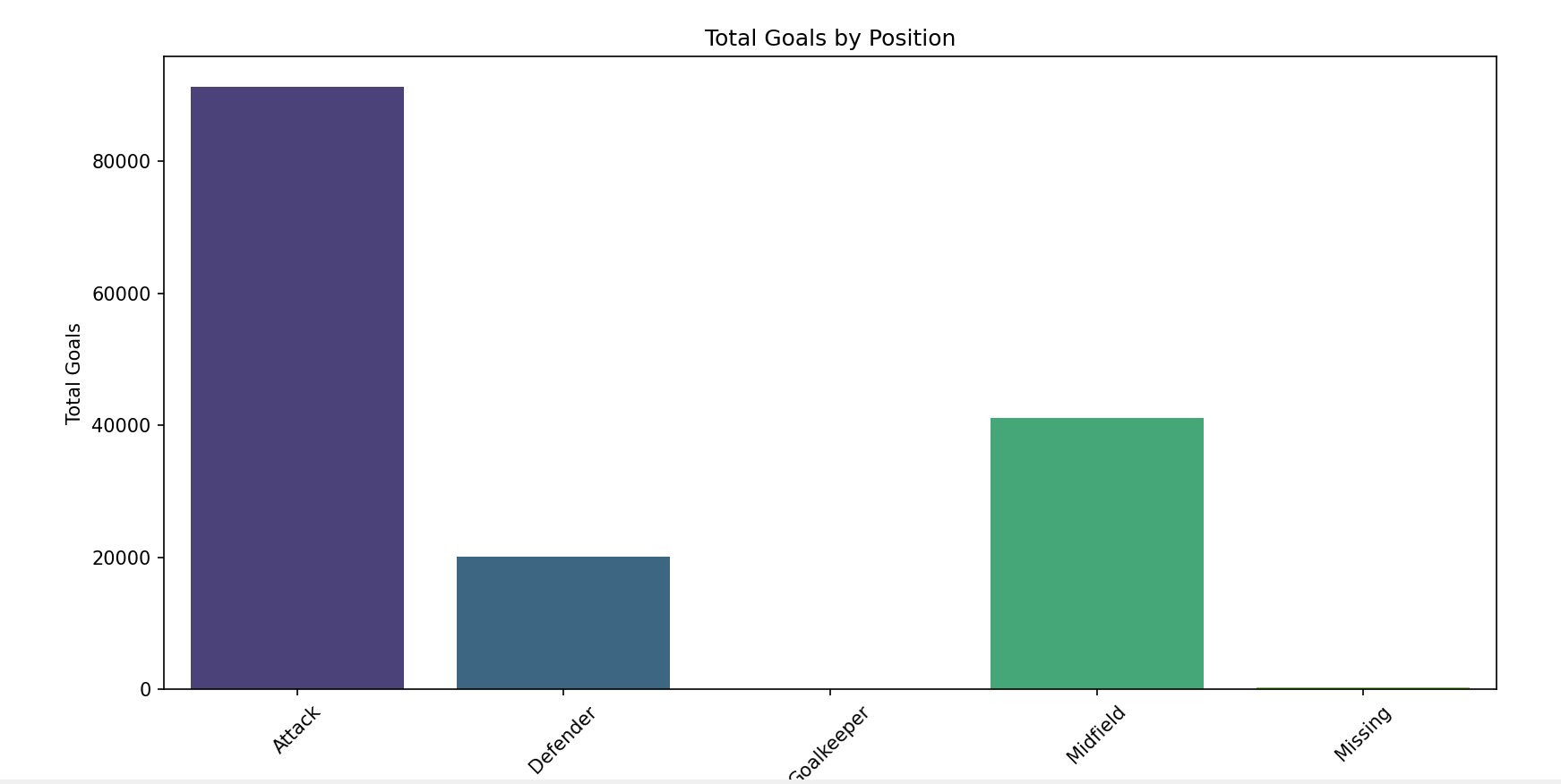

4. **Player Performance Over Different Seasons**

import pandas as pd  
import matplotlib.pyplot as plt  
  
# Load datasets  
appearances = pd.read_csv('appearances.csv')  
players = pd.read_csv('players.csv')  
games = pd.read_csv('games.csv')  
  
# Merge datasets to get season information  
player_performance = appearances.merge(games[['game_id', 'season']], on='game_id')  
player_performance = player_performance.groupby(['player_id', 'season'])['goals'].sum().reset_index()  
  
# Get top 10 players by total goals  
top_players = player_performance.groupby('player_id')['goals'].sum().nlargest(10).index  
top_players_performance = player_performance[player_performance['player_id'].isin(top_players)]  
  
# Merge with player names  
top_players_performance = top_players_performance.merge(players[['player_id', 'name']], on='player_id')  
  
# Visualization  
plt.figure(figsize=(14, 10))  
for player in top_players:  
 player_data = top_players_performance[top_players_performance['player_id'] == player]  
 plt.plot(player_data['season'], player_data['goals'], marker='o', label=player_data['name'].iloc[0])  
  
plt.title('Top 10 Players Performance Over Different Seasons')  
plt.xlabel('Season')  
plt.ylabel('Total Goals')  
plt.legend(title='Player')  
plt.grid(True)  
plt.xticks(rotation=45)  
plt.show()

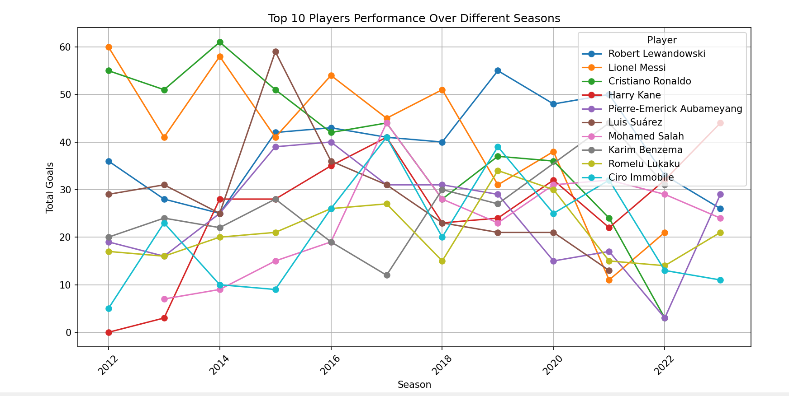

5. **Comparison of Total Assists by Competition**

import pandas as pd  
import matplotlib.pyplot as plt  
import seaborn as sns  
# Load datasets  
appearances = pd.read_csv('appearances.csv')  
competitions = pd.read_csv('competitions.csv')  
  
# Merge to get competition names  
assist_per_competition = appearances[['competition_id', 'assists']].groupby('competition_id').sum().reset_index()  
assist_per_competition = assist_per_competition.merge(competitions[['competition_id', 'name']], on='competition_id')  
  
# Visualization  
plt.figure(figsize=(14, 8))  
sns.barplot(data=assist_per_competition, x='name', y='assists', palette='crest')  
plt.title('Total Assists by Competition')  
plt.xlabel('Competition')  
plt.ylabel('Total Assists')  
plt.xticks(rotation=90)  
plt.show()

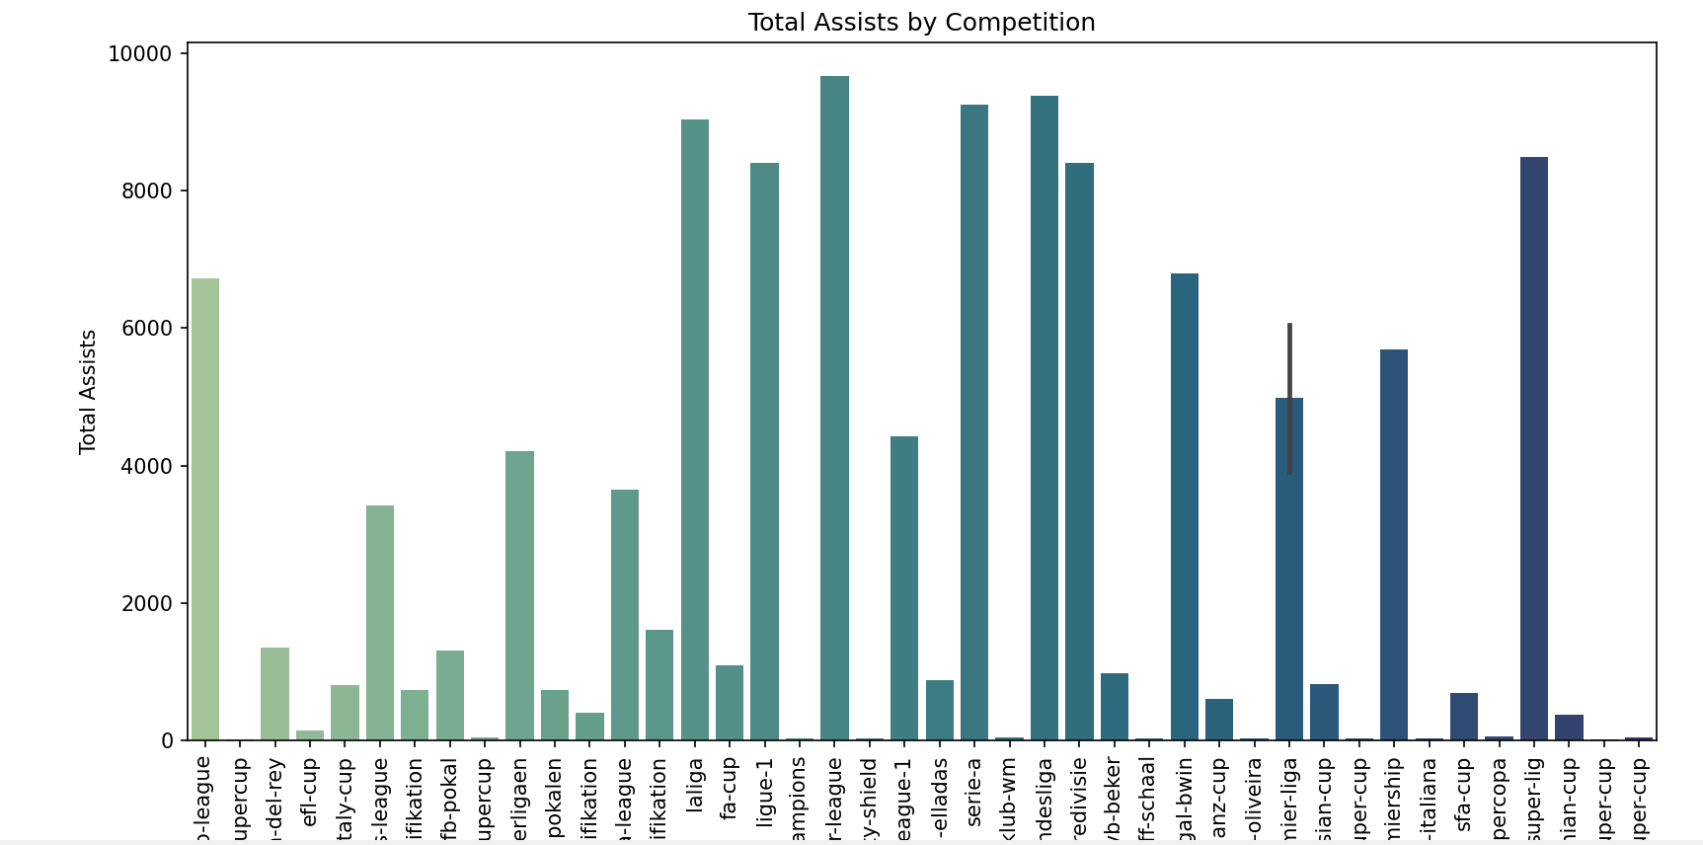

6. **Top 10 Players with Most Goals in the Last Season**

import pandas as pd  
import matplotlib.pyplot as plt  
  
# Load the data  
appearances = pd.read_csv('appearances.csv')  
players = pd.read_csv('players.csv')  
  
# Filter for the last season  
last_season = appearances['date'].max().split('-')[0] # assuming the latest date corresponds to the last season  
appearances_last_season = appearances[appearances['date'].str.startswith(last_season)]  
  
# Aggregate goals by player  
player_goals = appearances_last_season.groupby('player_id')['goals'].sum().reset_index()  
player_goals = player_goals.sort_values(by='goals', ascending=False).head(10)  
  
# Merge with players data for names  
player_goals = player_goals.merge(players[['player_id', 'name']], on='player_id')  
  
# Plot  
plt.figure(figsize=(12, 8))  
plt.barh(player_goals['name'], player_goals['goals'], color='skyblue')  
plt.xlabel('Total Goals')  
plt.title('Top 10 Players with Most Goals in the Last Season')  
plt.gca().invert_yaxis()  
plt.show()

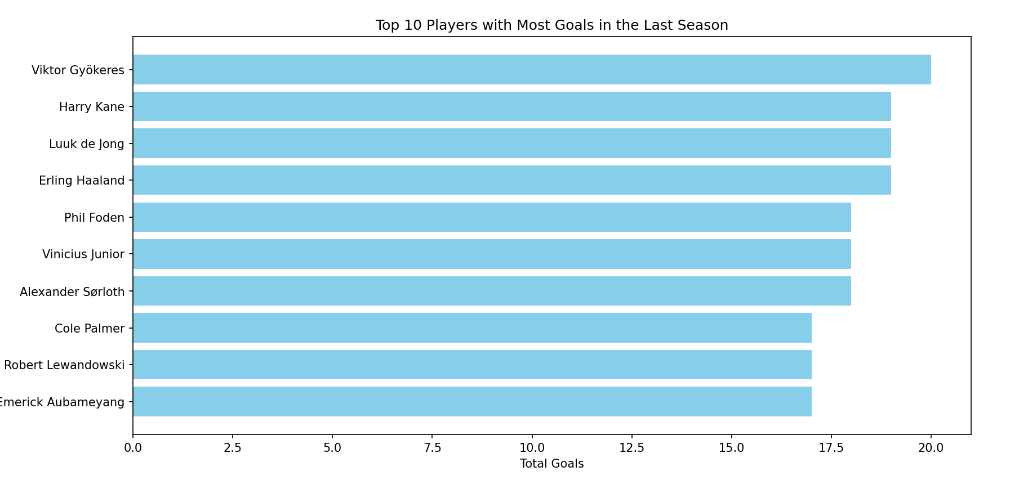

7. **Top 5 Clubs with Highest Average Attendance**

import pandas as pd  
import matplotlib.pyplot as plt  
  
# Load the data  
games = pd.read_csv('games.csv')  
clubs = pd.read_csv('clubs.csv')  
  
# Group by home and away clubs, and aggregate attendance  
home_attendance = games.groupby('home_club_id')['attendance'].mean().reset_index()  
away_attendance = games.groupby('away_club_id')['attendance'].mean().reset_index()  
  
# Combine and average attendance  
attendance = pd.concat([home_attendance.rename(columns={'home_club_id': 'club_id', 'attendance': 'average_attendance'}),  
 away_attendance.rename(columns={'away_club_id': 'club_id', 'attendance': 'average_attendance'})])  
attendance = attendance.groupby('club_id')['average_attendance'].mean().reset_index()  
  
# Merge with club names  
attendance_clubs = attendance.merge(clubs[['club_id', 'name']], left_on='club_id', right_on='club_id')  
top_clubs = attendance_clubs.sort_values(by='average_attendance', ascending=False).head(5)  
  
# Plot  
plt.figure(figsize=(12, 8))  
plt.barh(top_clubs['name'], top_clubs['average_attendance'], color='salmon')  
plt.xlabel('Average Attendance')  
plt.title('Top 5 Clubs with Highest Average Attendance')  
plt.gca().invert_yaxis()  
plt.show()

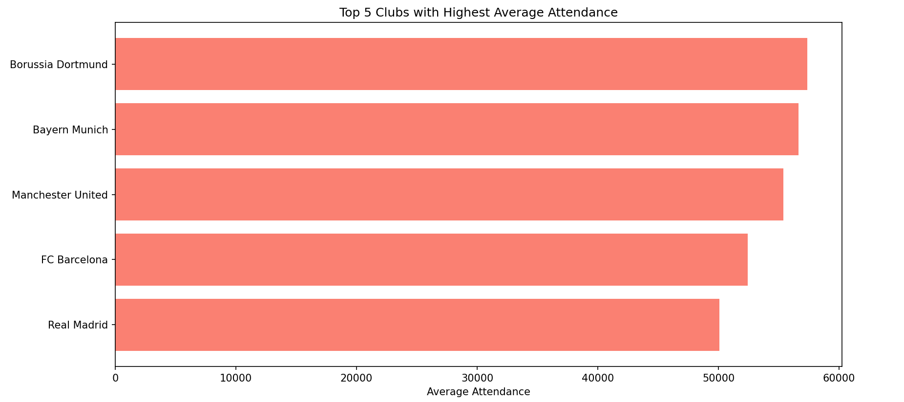

8. **Comparison of Average Player Market Value by Nationality**

import pandas as pd  
import seaborn as sns  
import matplotlib.pyplot as plt  
  
# Load the data  
players = pd.read_csv('players.csv')  
  
# Aggregate average market value by nationality  
market_value_by_nationality = players.groupby('country_of_citizenship')['market_value_in_eur'].mean().reset_index()  
  
# Sort and plot  
market_value_by_nationality = market_value_by_nationality.sort_values(by='market_value_in_eur', ascending=False).head(10)  
  
plt.figure(figsize=(14, 8))  
sns.barplot(data=market_value_by_nationality, x='country_of_citizenship', y='market_value_in_eur', palette='coolwarm')  
plt.title('Comparison of Average Player Market Value by Nationality')  
plt.xlabel('Nationality')  
plt.ylabel('Average Market Value (EUR)')  
plt.xticks(rotation=45)  
plt.show()

