CC Lab Terminal
Aamna Zahid
Fa20-bcs-151
Section: C
Sub. To: Mam Sana Aslam
Q1:
Ans:
from collections import defaultdict

# Define the grammar
grammar = {
'E': [['T', 'E\'']],
'E\'': [['+', 'T', 'E\''], ['ε']],
'T': [['F', 'T\'']],
'T\'': [['*', 'F', 'T\''], ['ε']],
'F': [['id'], ['(', 'E', ')']]
}

# Initialize FIRST and FOLLOW sets
first_sets = defaultdict(set)
follow_sets = defaultdict(set)
start_symbol = 'E'

# Compute FIRST sets
def compute_first(symbol):
if symbol not in grammar:
return {symbol}
if symbol in first_sets:
return first_sets[symbol]
for production in grammar[symbol]:
for sym in production:
first_sets[symbol].update(compute_first(sym) - {'ε'})
if 'ε' not in compute_first(sym):
break
else:
first_sets[symbol].add('ε')
return first_sets[symbol]

# Compute FOLLOW sets
def compute_follow(symbol):
if symbol == start_symbol:
follow_sets[symbol].add('$')
for lhs, productions in grammar.items():
for production in productions:
if symbol in production:
pos = production.index(symbol)
rest = production[pos+1:]
if rest:
follow_sets[symbol].update(compute_first_sequence(rest) - {'ε'})
if not rest or 'ε' in compute_first_sequence(rest):
follow_sets[symbol].update(follow_sets[lhs])
return follow_sets[symbol]

# Compute FIRST set of a sequence
def compute_first_sequence(sequence):
first = set()
for symbol in sequence:
first.update(compute_first(symbol) - {'ε'})
if 'ε' not in compute_first(symbol):
break
else:
first.add('ε')
return first

# Generate FIRST and FOLLOW sets
for non_terminal in grammar:
compute_first(non_terminal)
for non_terminal in grammar:
compute_follow(non_terminal)

# Generate LL(1) parse table
parse_table = {nt: {t: '' for t in ['id', '(', ')', '+', '*', '$']} for nt in grammar}
for nt, productions in grammar.items():
for prod in productions:
for term in compute_first_sequence(prod):
if term != 'ε':
parse_table[nt][term] = prod
if 'ε' in compute_first_sequence(prod):
for term in follow_sets[nt]:
parse_table[nt][term] = prod

# Print FIRST sets
print("FIRST sets:")
for nt, first in first_sets.items():
print(f"FIRST({nt}) = {first}")

# Print FOLLOW sets
print("\nFOLLOW sets:")
for nt, follow in follow_sets.items():
print(f"FOLLOW({nt}) = {follow}")

# Print LL(1) parse table
print("\nLL(1) parse table:")
header = ['Non-terminal'] + list(parse_table[next(iter(parse_table))].keys())
print(f"{header[0]:<15} {' '.join(f'{term:<5}' for term in header[1:])}")
for nt, row in parse_table.items():
print(f"{nt:<15} {' '.join(f'{str(row[term]):<5}' for term in header[1:])}")
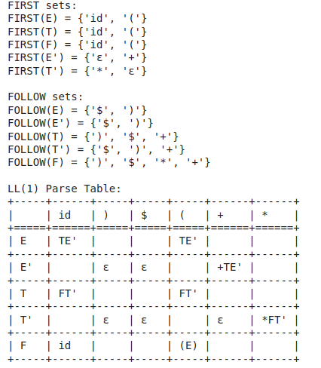
Output:

Q2:
from collections import defaultdict

# Augmented grammar
grammar = {
"E'": [["E"]],
"E": [["E", "+", "T"], ["T"]],
"T": [["T", "*", "F"], ["F"]],
"F": [["(", "E", ")"], ["id"]]
}

# Helper functions
def closure(items):
closure_set = set(items)
while True:
new_items = set()
for (A, alpha, dot) in closure_set:
if dot < len(alpha) and alpha[dot] in grammar:
B = alpha[dot]
for production in grammar[B]:
new_items.add((B, tuple(production), 0))
if new_items.issubset(closure_set):
break
closure_set.update(new_items)
return closure_set

def goto(items, X):
goto_set = set()
for (A, alpha, dot) in items:
if dot < len(alpha) and alpha[dot] == X:
goto_set.add((A, alpha, dot + 1))
return closure(goto_set)

# Compute the canonical collection of LR(0) items
def items(grammar):
start_item = closure([("E'", ("E",), 0)])
canonical_collection = [start_item]
transitions = defaultdict(dict)
symbols = set(sym for prods in grammar.values() for prod in prods for sym in prod)

for i, I in enumerate(canonical_collection):
for X in symbols:
goto_I_X = goto(I, X)
if goto_I_X and goto_I_X not in canonical_collection:
canonical_collection.append(goto_I_X)
if goto_I_X:
j = canonical_collection.index(goto_I_X)
transitions[i][X] = j
return canonical_collection, transitions

canonical_collection, transitions = items(grammar)

# Print the canonical collection
print("Canonical collection of LR(0) items:")
for i, I in enumerate(canonical_collection):
print(f"I{i}: {I}")

# Print the transitions
print("\nTransitions:")
for state, trans in transitions.items():
for sym, next_state in trans.items():
print(f"I{state} --{sym}--> I{next_state}")

# Initialize parse table
num_states = len(canonical_collection)
symbols = set(sym for prods in grammar.values() for prod in prods for sym in prod)
terminals = {sym for sym in symbols if sym.islower() or sym in {'+', '*', '(', ')', 'id'}}
nonterminals = symbols - terminals

ACTION = [defaultdict(str) for _ in range(num_states)]
GOTO = [defaultdict(int) for _ in range(num_states)]

# Fill the ACTION and GOTO tables
for state, trans in transitions.items():
for symbol, next_state in trans.items():
if symbol in terminals:
ACTION[state][symbol] = f"s{next_state}"
else:
GOTO[state][symbol] = next_state

for i, I in enumerate(canonical_collection):
for (A, alpha, dot) in I:
if dot == len(alpha): # At the end of production
if A == "E'" and alpha == ("E",):
ACTION[i]["$"] = "acc"
else:
for terminal in terminals | {"$"}:
ACTION[i][terminal] = f"r{list(grammar[A]).index(list(alpha)) + 1}"

# Print the ACTION and GOTO tables
print("\nACTION table:")
print("State", " ".join(f"{t:<6}" for t in sorted(terminals | {"$"})))
for i, row in enumerate(ACTION):
print(f"{i:<5}", " ".join(f"{row[t]:<6}" for t in sorted(terminals | {"$"})))

print("\nGOTO table:")
print("State", " ".join(f"{nt:<6}" for nt in sorted(nonterminals)))
for i, row in enumerate(GOTO):
print(f"{i:<5}", " ".join(f"{str(row[nt]):<6}" for nt in sorted(nonterminals)))
Output: 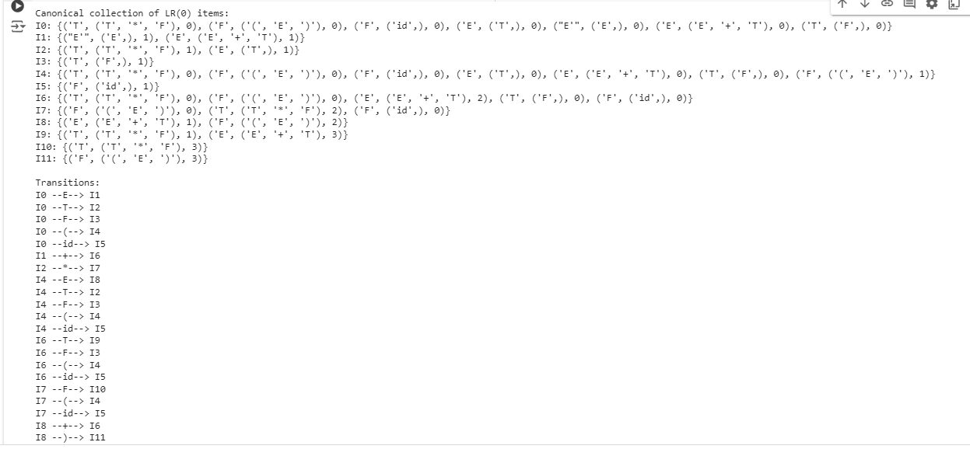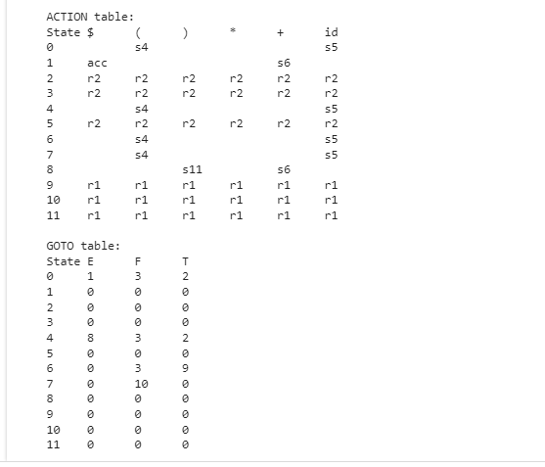
Q3:
from collections import defaultdict, deque

# Grammar definition
grammar = {
"S'": [["S"]],
"S": [["E"]],
"E": [["E", "+", "T"], ["T"]],
"T": [["T", "*", "F"], ["F"]],
"F": [["id"]]
}

# Function to compute FIRST sets
def compute_first(grammar):
first = {non_terminal: set() for non_terminal in grammar}
nullable = {non_terminal: False for non_terminal in grammar}

# Compute nullable non-terminals
while True:
changed = False
for lhs, productions in grammar.items():
for production in productions:
if all(symbol in nullable and nullable[symbol] for symbol in production):
if not nullable[lhs]:
nullable[lhs] = True
changed = True
if not changed:
break

# Compute FIRST sets
for non_terminal in grammar:
compute_first_recursive(non_terminal, grammar, first, nullable)

return first

def compute_first_recursive(non_terminal, grammar, first, nullable):
if non_terminal in first:
return first[non_terminal]

first_set = set()
for production in grammar[non_terminal]:
for symbol in production:
if symbol in grammar:
first_set |= compute_first_recursive(symbol, grammar, first, nullable)
if not nullable[symbol]:
break
else:
first_set.add(symbol)
break
else:
first_set.add('ε')
first[non_terminal] = first_set
return first_set

# Function to compute FOLLOW sets
def compute_follow(grammar, start_symbol, first):
follow = {non_terminal: set() for non_terminal in grammar}
follow[start_symbol] = {'$'}
changed = True

while changed:
changed = False
for lhs in grammar:
for production in grammar[lhs]:
trailer = follow[lhs]
for symbol in reversed(production):
if symbol in grammar:
original_len = len(follow[symbol])
follow[symbol] |= trailer
if 'ε' in first[symbol]:
trailer |= first[symbol] - {'ε'}
else:
trailer = first[symbol].copy()
if len(follow[symbol]) > original_len:
changed = True

return follow

# Function to compute LR(0) items
def compute_lr0_items(grammar):
start_item = frozenset([("S'", ("S",), 0)])
canonical_collection = [start_item]
transitions = defaultdict(dict)
symbols = {symbol for productions in grammar.values() for production in productions for symbol in production}

def closure(items):
closure_set = set(items)
while True:
new_items = set()
for item in closure_set:
A, alpha, dot = item
if dot < len(alpha) and alpha[dot] in grammar:
B = alpha[dot]
for production in grammar[B]:
new_item = (B, tuple(production), 0)
if new_item not in closure_set:
new_items.add(new_item)
if not new_items.issubset(closure_set):
closure_set.update(new_items)
else:
break
return frozenset(closure_set)

def goto(items, X):
goto_set = set()
for item in items:
A, alpha, dot = item
if dot < len(alpha) and alpha[dot] == X:
goto_set.add((A, alpha, dot + 1))
return closure(goto_set)

for i, I in enumerate(canonical_collection):
for X in symbols:
goto_I_X = goto(I, X)
if goto_I_X and goto_I_X not in canonical_collection:
canonical_collection.append(goto_I_X)
transitions[i][X] = len(canonical_collection) - 1
elif goto_I_X:
transitions[i][X] = canonical_collection.index(goto_I_X)

return canonical_collection, transitions

# Compute FIRST and FOLLOW sets
first = compute_first(grammar)
follow = compute_follow(grammar, "S'", first)

# Compute LR(0) items and transitions
canonical_collection, transitions = compute_lr0_items(grammar)

# Print FIRST and FOLLOW sets
print("FIRST sets:")
for non_terminal, first_set in first.items():
print(f"{non_terminal}: {first_set}")

print("\nFOLLOW sets:")
for non_terminal, follow_set in follow.items():
print(f"{non_terminal}: {follow_set}")

# Print LR(0) items and transitions
print("\nCanonical LR(0) items:")
for i, item_set in enumerate(canonical_collection):
print(f"I{i}: {item_set}")

print("\nTransitions:")
for state, trans in transitions.items():
for symbol, next_state in trans.items():
print(f"I{state} --{symbol}--> I{next_state}")

# Construct SLR(1) parsing table
num_states = len(canonical_collection)
terminals = {symbol for symbol in grammar if symbol.islower()}
nonterminals = {symbol for symbol in grammar if not symbol.islower()}

ACTION = [{} for _ in range(num_states)]
GOTO = [{} for _ in range(num_states)]

for state, trans in transitions.items():
for symbol, next_state in trans.items():
if symbol in terminals:
ACTION[state][symbol] = f"s{next_state}"
elif symbol in nonterminals:
GOTO[state][symbol] = next_state

for state, item_set in enumerate(canonical_collection):
for A, alpha, dot in item_set:
if dot == len(alpha):
if A == "S'":
ACTION[state]['$'] = 'acc'
else:
prod_num = list(grammar[A]).index(list(alpha)) + 1
for terminal in follow[A]:
ACTION[state][terminal] = f"r{prod_num}"

# Print SLR(1) parsing table
print("\nSLR(1) Parsing Table:")
print("STATE\t", "\t".join(terminals | {'$', 'S'}), "\t", "\t".join(nonterminals))
for i in range(num_states):
print(f"I{i}\t", end="")
for terminal in terminals | {'$'}:
print(f"{ACTION[i].get(terminal, '')}\t", end="")
print("\t", end="")
for nonterminal in nonterminals:
print(f"{GOTO[i].get(nonterminal, '')}\t", end="")
print()
Output: 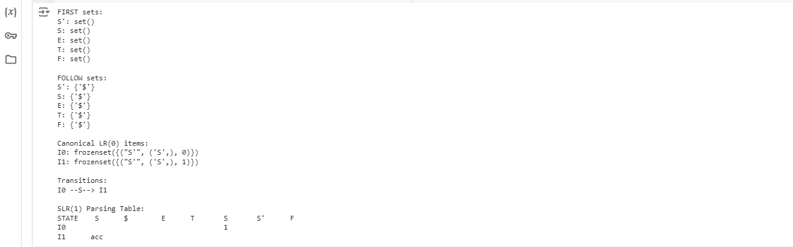
Q4:
from collections import defaultdict, deque

# Grammar definition
productions = {
'S': [['A', 'A']],
'A': [['a', 'A'], ['b']]
}

# Augment the grammar
start_symbol = 'S'
augmented_grammar = {'S\'': [['S']]}
augmented_grammar.update(productions)

# Function to compute FIRST sets iteratively
def compute_first(productions):
first = defaultdict(set)
changed = True

while changed:
changed = False
for lhs in productions:
for prod in productions[lhs]:
initial_len = len(first[lhs])
if prod[0] not in productions:
first[lhs].add(prod[0])
else:
for symbol in prod:
first[lhs].update(first[symbol] - {'ε'})
if 'ε' not in first[symbol]:
break
else:
first[lhs].add('ε')
if len(first[lhs]) > initial_len:
changed = True

return first

# Function to compute FOLLOW sets
def compute_follow(productions, first):
follow = defaultdict(set)
follow[start_symbol].add('$')
changed = True

while changed:
changed = False
for lhs in productions:
for prod in productions[lhs]:
trailer = follow[lhs].copy()
for symbol in reversed(prod):
if symbol in productions:
initial_len = len(follow[symbol])
follow[symbol].update(trailer)
if 'ε' in first[symbol]:
trailer.update(first[symbol] - {'ε'})
else:
trailer = first[symbol]
if len(follow[symbol]) > initial_len:
changed = True
else:
trailer = {symbol}

return follow

# Function to compute closure for LR(1) items
def closure_lr1(items):
closure_set = set(items)
added = True
while added:
added = False
items = list(closure_set)
for lhs, rhs, dot, lookahead in items:
if dot < len(rhs):
symbol = rhs[dot]
if symbol in augmented_grammar:
for prod in augmented_grammar[symbol]:
for la in (first[rhs[dot + 1]] if dot + 1 < len(rhs) else {lookahead}):
new_item = (symbol, tuple(prod), 0, la)
if new_item not in closure_set:
closure_set.add(new_item)
added = True
return closure_set

# Function to compute goto for LR(1) items
def goto_lr1(items, symbol):
goto_set = set()
for lhs, rhs, dot, lookahead in items:
if dot < len(rhs) and rhs[dot] == symbol:
goto_set.add((lhs, rhs, dot + 1, lookahead))
return closure_lr1(goto_set)

# Compute FIRST and FOLLOW sets
first = compute_first(productions)
follow = compute_follow(productions, first)

# Build DFA from LR(1) items
start_item = closure_lr1([('S\'', tuple(['S']), 0, '$')])
states = [start_item]
transitions = {}
state_map = {frozenset(start_item): 0}
queue = deque([start_item])

while queue:
current = queue.popleft()
state_id = state_map[frozenset(current)]
symbols = set()
for lhs, rhs, dot, lookahead in current:
if dot < len(rhs):
symbols.add(rhs[dot])
for symbol in symbols:,
next_state = goto_lr1(current, symbol)
if next_state:
if frozenset(next_state) not in state_map:
new_id = len(states)
states.append(next_state)
state_map[frozenset(next_state)] = new_id
queue.append(next_state)
transitions[(state_id, symbol)] = state_map[frozenset(next_state)]

# Generate CLR(1) parse table
parse_table = defaultdict(dict)

for state_id, items in enumerate(states):
for lhs, rhs, dot, lookahead in items:
if dot == len(rhs):
if lhs == 'S\'':
parse_table[state_id]['$'] = 'accept'
else:
parse_table[state_id][lookahead] = f'reduce {lhs} -> {" ".join(rhs)}'
else:
symbol = rhs[dot]
if (state_id, symbol) in transitions:
next_state = transitions[(state_id, symbol)]
if symbol in productions:
parse_table[state_id][symbol] = f'goto {next_state}'
else:
parse_table[state_id][symbol] = f'shift {next_state}'

# Check if the grammar is CLR(1)
is_clr1 = True
for state in parse_table:
actions = [action for action in parse_table[state].values() if action.startswith('shift') or action.startswith('reduce')]
if len(actions) > 1:
is_clr1 = False
break

# Print results
print("CLR(1) States and Transitions:")
for state_id, items in enumerate(states):
print(f"I{state_id}: {items}")
for (from_state, symbol), to_state in transitions.items():
if from_state == state_id:
print(f" {symbol} -> I{to_state}")

print("\nCLR(1) Parse Table:")
for state in parse_table:
print(f"State {state}: {parse_table[state]}")

print("\nIs the grammar CLR(1)?:", "Yes" if is_clr1 else "No")
Output: 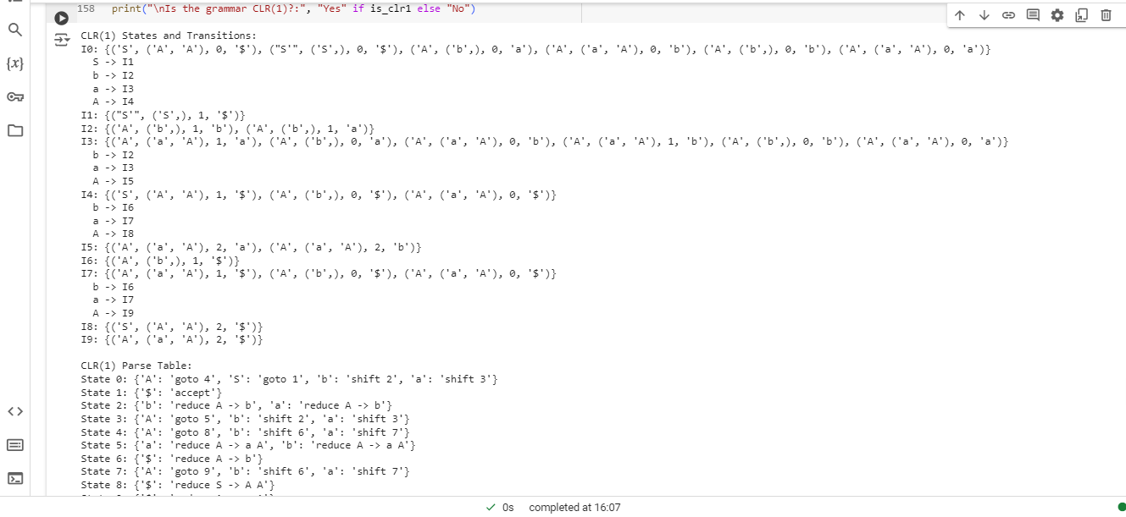
Q5:
Ans:
from collections import defaultdict, deque
import itertools

# Grammar definition
productions = {
'S': [['A', 'A']],
'A': [['a', 'A'], ['b']]
}

# Augment the grammar
start_symbol = 'S'
augmented_grammar = {'S\'': [['S']]}
augmented_grammar.update(productions)

# Function to compute FIRST sets iteratively
def compute_first(productions):
first = defaultdict(set)
changed = True

while changed:
changed = False
for lhs in productions:
for prod in productions[lhs]:
initial_len = len(first[lhs])
if prod[0] not in productions:
first[lhs].add(prod[0])
else:
for symbol in prod:
first[lhs].update(first[symbol] - {'ε'})
if 'ε' not in first[symbol]:
break
else:
first[lhs].add('ε')
if len(first[lhs]) > initial_len:
changed = True

return first

# Function to compute FOLLOW sets
def compute_follow(productions, first):
follow = defaultdict(set)
follow[start_symbol].add('$')
changed = True

while changed:
changed = False
for lhs in productions:
for prod in productions[lhs]:
trailer = follow[lhs].copy()
for symbol in reversed(prod):
if symbol in productions:
initial_len = len(follow[symbol])
follow[symbol].update(trailer)
if 'ε' in first[symbol]:
trailer.update(first[symbol] - {'ε'})
else:
trailer = first[symbol]
if len(follow[symbol]) > initial_len:
changed = True
else:
trailer = {symbol}

return follow

# Function to compute closure for LR(1) items
def closure_lr1(items):
closure_set = set(items)
added = True
while added:
added = False
items = list(closure_set)
for lhs, rhs, dot, lookahead in items:
if dot < len(rhs):
symbol = rhs[dot]
if symbol in augmented_grammar:
for prod in augmented_grammar[symbol]:
for la in (first[rhs[dot + 1]] if dot + 1 < len(rhs) else {lookahead}):
new_item = (symbol, tuple(prod), 0, la)
if new_item not in closure_set:
closure_set.add(new_item)
added = True
return closure_set

# Function to compute goto for LR(1) items
def goto_lr1(items, symbol):
goto_set = set()
for lhs, rhs, dot, lookahead in items:
if dot < len(rhs) and rhs[dot] == symbol:
goto_set.add((lhs, rhs, dot + 1, lookahead))
return closure_lr1(goto_set)

# Compute FIRST and FOLLOW sets
first = compute_first(productions)
follow = compute_follow(productions, first)

# Build DFA from LR(1) items
start_item = closure_lr1([('S\'', tuple(['S']), 0, '$')])
states = [start_item]
transitions = {}
state_map = {frozenset(start_item): 0}
queue = deque([start_item])

while queue:
current = queue.popleft()
state_id = state_map[frozenset(current)]
symbols = set()
for lhs, rhs, dot, lookahead in current:
if dot < len(rhs):
symbols.add(rhs[dot])
for symbol in symbols:
next_state = goto_lr1(current, symbol)
if next_state:
if frozenset(next_state) not in state_map:
new_id = len(states)
states.append(next_state)
state_map[frozenset(next_state)] = new_id
queue.append(next_state)
transitions[(state_id, symbol)] = state_map[frozenset(next_state)]

# Function to merge LR(1) states to create LALR(1) states
def merge_states(states):
merged_states = []
merged_map = {}
for i, j in itertools.combinations(range(len(states)), 2):
items_i = [(lhs, rhs, dot) for lhs, rhs, dot, lookahead in states[i]]
items_j = [(lhs, rhs, dot) for lhs, rhs, dot, lookahead in states[j]]
if items_i == items_j:
merged_items = states[i] | states[j]
merged_map[frozenset(states[i])] = len(merged_states)
merged_map[frozenset(states[j])] = len(merged_states)
merged_states.append(merged_items)
break
else:
merged_states = states
merged_map = {frozenset(state): i for i, state in enumerate(states)}
return merged_states, merged_map

merged_states, merged_map = merge_states(states)

# Generate LALR(1) parse table
parse_table = defaultdict(dict)

for state_id, items in enumerate(merged_states):
for lhs, rhs, dot, lookahead in items:
if dot == len(rhs):
if lhs == 'S\'':
parse_table[state_id]['$'] = 'accept'
else:
parse_table[state_id][lookahead] = f'reduce {lhs} -> {" ".join(rhs)}'
else:
symbol = rhs[dot]
if (state_id, symbol) in transitions:
next_state = transitions[(state_id, symbol)]
if symbol in productions:
parse_table[state_id][symbol] = f'goto {merged_map[frozenset(states[next_state])]}'
else:
parse_table[state_id][symbol] = f'shift {merged_map[frozenset(states[next_state])]}'

# Check if the grammar is LALR(1)
is_lalr1 = True
for state in parse_table:
actions = [action for action in parse_table[state].values() if action.startswith('shift') or action.startswith('reduce')]
if len(actions) > 1:
is_lalr1 = False
break

# Print results
print("LALR(1) States and Transitions:")
for state_id, items in enumerate(merged_states):
print(f"I{state_id}: {items}")
for (from_state, symbol), to_state in transitions.items():
if from_state == state_id:
print(f" {symbol} -> I{merged_map[frozenset(states[to_state])]}")

print("\nLALR(1) Parse Table:")
for state in parse_table:
print(f"State {state}: {parse_table[state]}")

print("\nIs the grammar LALR(1)?:", "Yes" if is_lalr1 else "No")
Output: 