Aim: Study and Implementation of Basic Git and GitHub Operations. This Experiment maps to LO2.
LO2: To understand and perform the basic version control operations using Git and GitHub, including repository creation, cloning, file tracking, committing, pushing, pulling, branching, merging, and remote repository management.

Theory:
Git is a distributed version control system that helps developers track changes in source code and files. It enables efficient project management through repositories, commits, branches, and remote repositories, making collaboration and version management easier. In this experiment, various Git commands are performed to understand the basic operations of version control.

Commands:
No. Command Description
- git init Initializes a new Git repository in the current directory.
- git clone <repository-url> Creates a local copy of a remote GitHub repository.
- git status Displays the current status of the working directory, staged files, and untracked files.
- git add <file> Adds a specific file to the staging area.
- git add . Adds all modified and new files to the staging area.

- git commit -m "message" Saves the staged changes to the local repository with a
commit message.
- git log Displays the commit history of the repository.
- git log --oneline Shows a compact, one-line summary of each commit.
- git diff Displays the differences between the working directory and the last commit.
- git branch Lists all local branches and highlights the current branch.
- git branch <branch-name> Creates a new branch.
- git checkout <branch-name> Switches to the specified branch.

No. Command Description

- git checkout -b <branch-name>
Creates a new branch and switches to it immediately.

- git switch <branch-name> Switches to an existing branch (newer alternative to
checkout).
- git merge <branch-name> Merges the specified branch into the current branch.

- git remote -v Displays the remote repositories associated with the project.

- git remote add origin
<repository-url>
- git push origin <branch-name>
Connects the local repository to a remote GitHub repository.
Uploads local commits to the specified branch on GitHub.

- git pull origin <branch-name> Downloads changes from GitHub and merges them into the current branch.
- git fetch Downloads the latest changes from the remote repository without merging them.
- git reset --hard HEAD Discards all uncommitted changes and resets the
working directory to the last commit.
- git stash Temporarily saves uncommitted changes without committing them.
- git stash pop Restores the most recently stashed changes and removes them from the stash.
- git rm <file> Removes a file from both the working directory and the Git repository.

- git config --global user.name "Your Name"
Sets the global Git username used for commits.

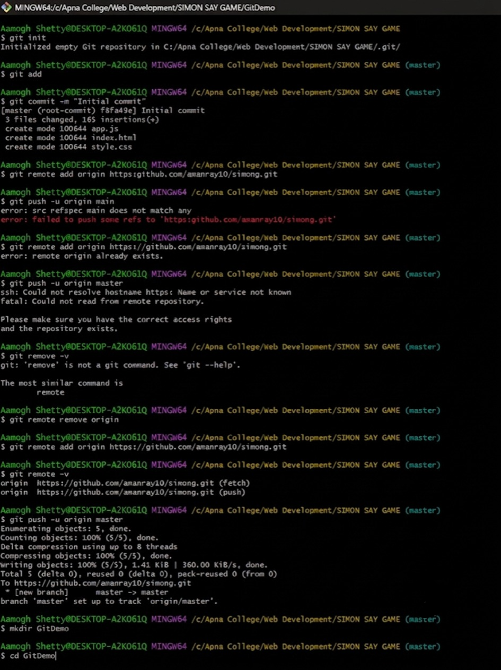

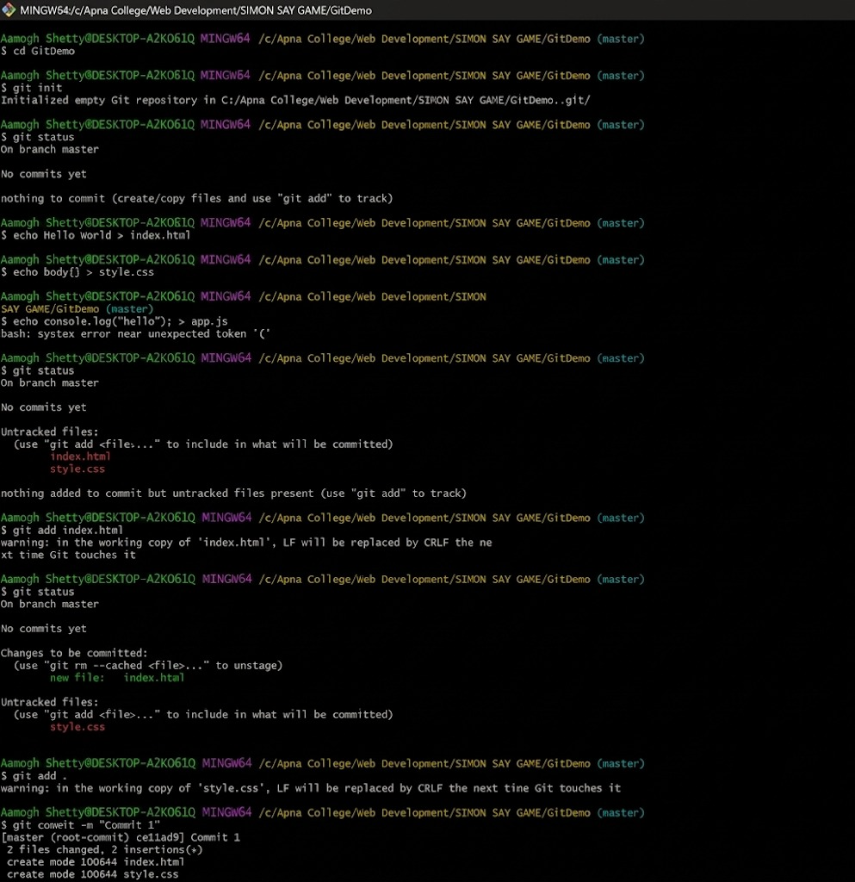

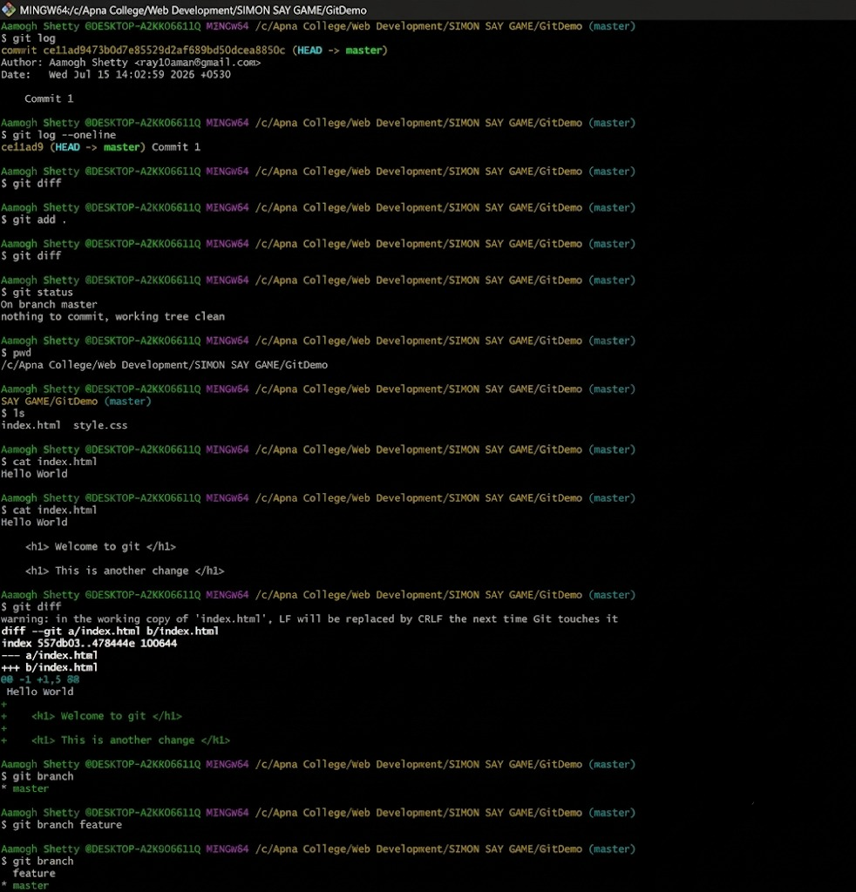

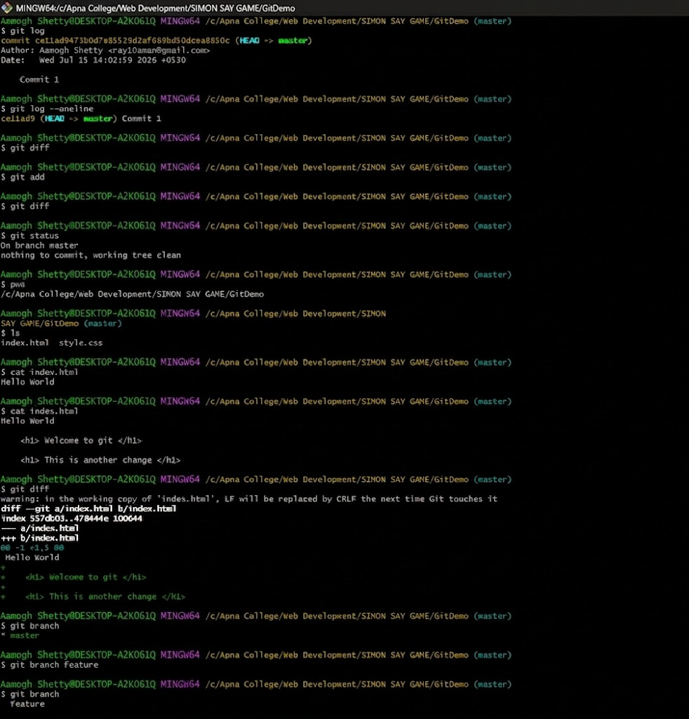

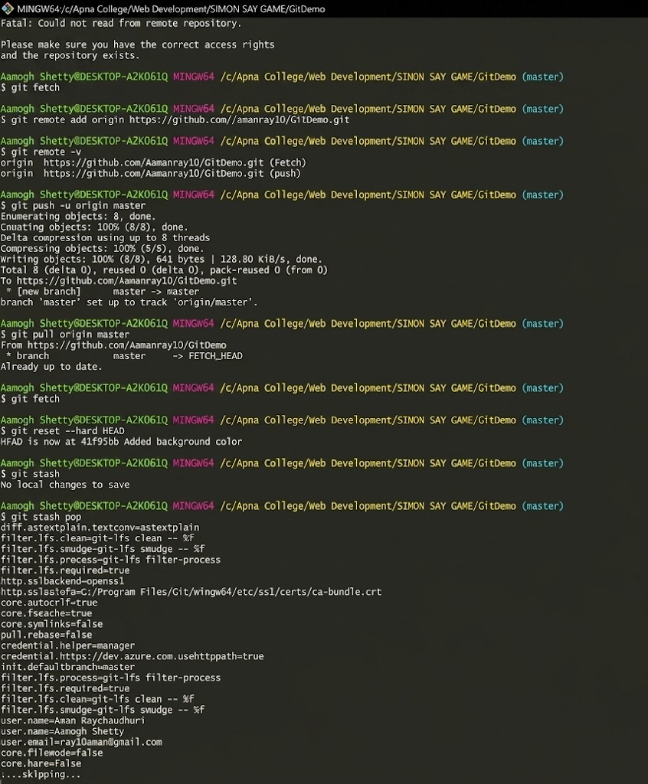

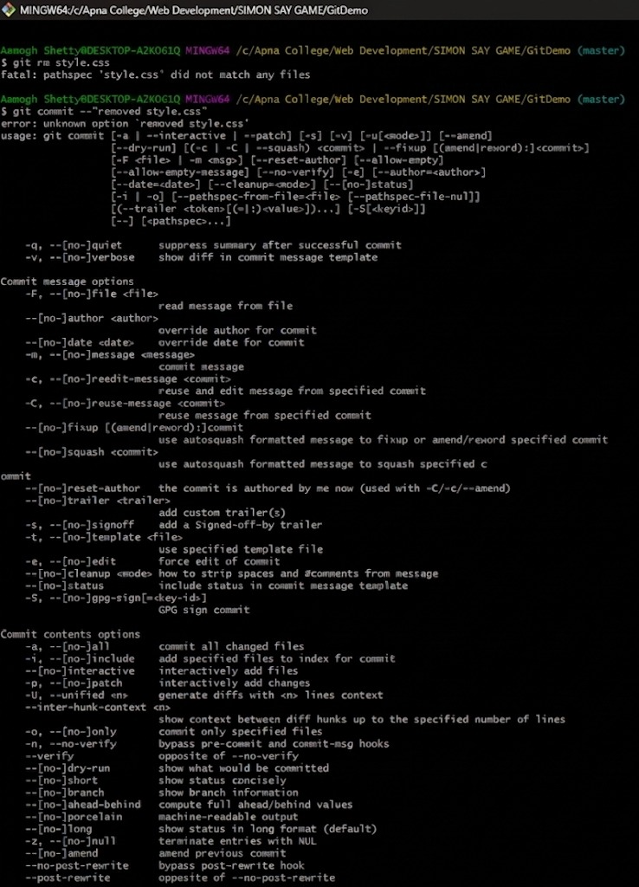

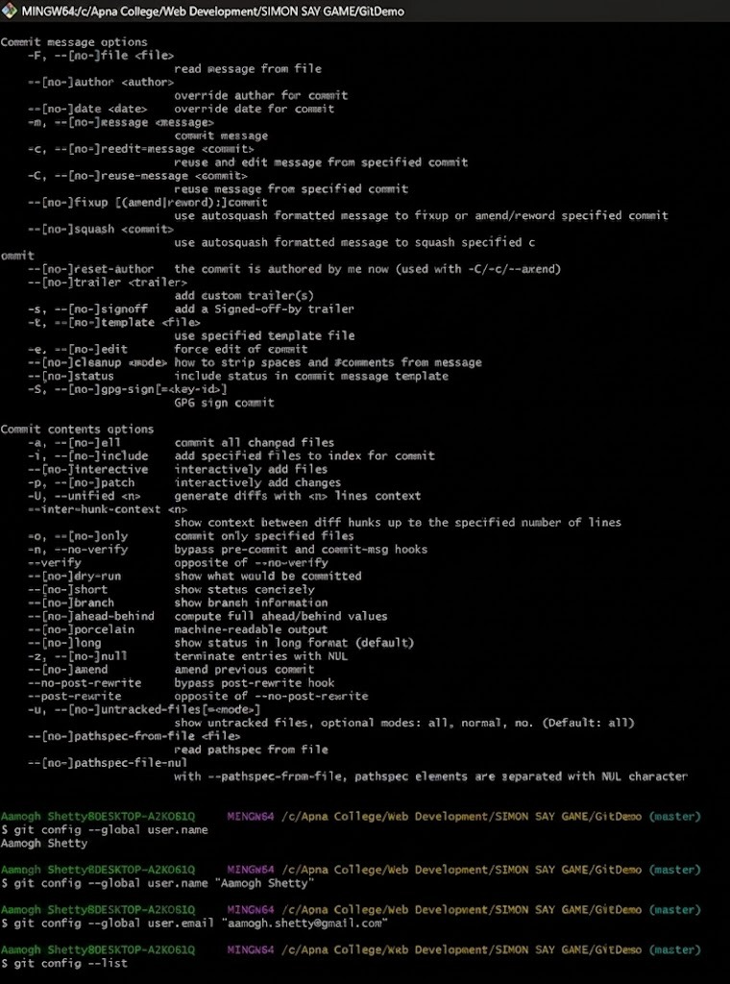

CONCLUSION
The experiment demonstrated the use of essential Git version control commands for
repository management, tracking changes, branch handling, and collaboration with GitHub. It provided practical knowledge of managing and maintaining software projects efficiently using Git.

