Agile Software Development and DevOps Lab
Experiment No. 08
Name | Aaditya Surve | Roll No. | 2401119
Batch | T22 | Experiment | 08

Aim: To build an automated CI/CD pipeline on AWS that takes code from a GitHub repository, builds it with AWS CodeBuild through AWS CodePipeline, and deploys it to an Amazon S3 bucket that serves a website.

Theory
CI/CD. Continuous Integration builds and checks every code change as soon as it is pushed, and Continuous Delivery or Deployment releases the verified result automatically. This removes manual deployment steps and shortens the time between a code change and a live update.
- GitHub: the source repository. A push to the tracked branch starts the pipeline.
- AWS CodePipeline: orchestrates the stages (Source, Build) and passes artifacts between them. It keeps its working files in an S3 artifact bucket.
- AWS CodeBuild: a managed build service that runs the commands listed in the buildspec.yml file of the repository.
- Amazon S3: object storage. The deployment bucket holds the website files, and a bucket policy can allow public read access to them.
- AWS IAM: controls what each service may do. The CodeBuild service role needs S3 permissions so that the build can write to the deployment bucket.
Pipeline flow: Developer pushes code to GitHub, CodePipeline detects the change (Source stage), CodeBuild runs buildspec.yml (Build stage), the files are copied to the S3 deployment bucket, and the website shows the update.

Resources Used
Resource | Name / Setting
AWS region | Asia Pacific (Sydney) ap-southeast-2
GitHub repository | Aaditya179/pwa-cicd-demo (files: index.html, buildspec.yml)
Artifact bucket | store-build-aaditya
Deployment bucket | deployment-aaditya-pwa
CodeBuild project | pwa-codebuild-xx (source: GitHub)
CodePipeline | pwa-codepipelinexx (type V2; stages: Source, Build)
IAM policy added | AmazonS3FullAccess on the CodeBuild service role

buildspec.yml
version: 0.2
phases:
build:
commands:
- aws s3 sync . s3://deployment-aaditya-pwa --delete --exclude ".git/*" --exclude "buildspec.yml"

Procedure
- Created an AWS account and opened the AWS Management Console (Figure 1).
- Created two S3 buckets in the same region: deployment-aaditya-pwa for the website and store-build-aaditya as the pipeline artifact store (Figure 2).
- Created the GitHub repository pwa-cicd-demo with index.html and buildspec.yml in the main branch (Figure 3).
- Created the CodeBuild project pwa-codebuild-xx with GitHub as the source, a new service role and the buildspec file (Figure 4).
- Created the CodePipeline pwa-codepipelinexx with the store-build-aaditya artifact location, a GitHub source stage and a CodeBuild build stage (Figures 5 and 6).
- Attached the AmazonS3FullAccess policy to the CodeBuild service role so that the build could write to the deployment bucket (Figure 7).
- Added a bucket policy to deployment-aaditya-pwa that allows public s3:GetObject, so that the website files can be read from a browser (Figure 8).
- Ran the pipeline again; the Source and Build stages both succeeded (Figure 9).
- Opened the deployed page in the browser (Figure 10).

Observation Table
Sr. No. | Activity | Action | Result
1 | S3 buckets | Created deployment-aaditya-pwa and store-build-aaditya | Both buckets listed in ap-southeast-2
2 | Source repository | Created pwa-cicd-demo with index.html and buildspec.yml | Repository created with 1 commit on main
3 | Build project | Created pwa-codebuild-xx with GitHub source | Project created, service role assigned
4 | Pipeline | Created pwa-codepipelinexx (Source and Build stages) | Pipeline created and first execution started
5 | Permissions | Attached AmazonS3FullAccess to the CodeBuild role | Policy attached successfully
6 | Public access | Edited the bucket policy of the deployment bucket | Policy edited successfully
7 | Pipeline run | Retried the pipeline | Source and Build stages succeeded
8 | Website | Opened the deployed page | Page displayed "Hello Aaditya"

Practical Evidence
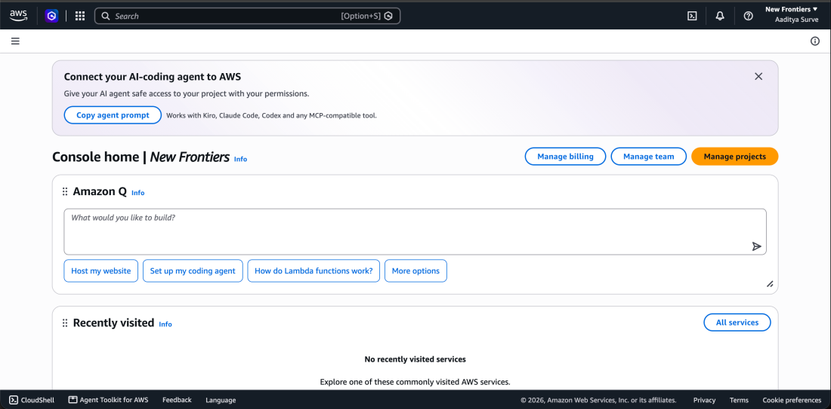
Figure 1: AWS Management Console home page after sign-up.
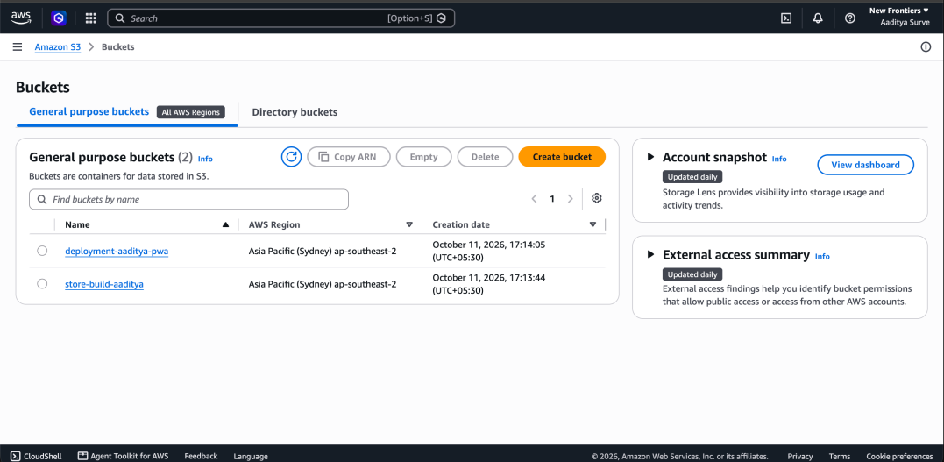
Figure 2: S3 buckets deployment-aaditya-pwa and store-build-aaditya created in ap-southeast-2.
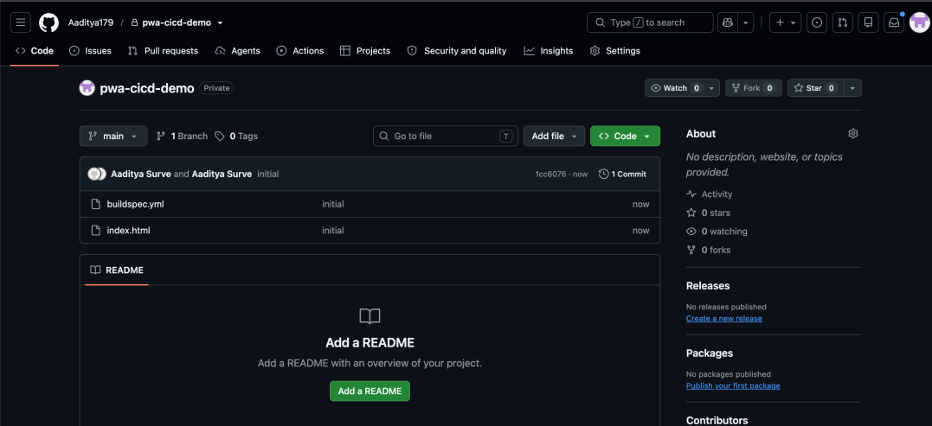
Figure 3: GitHub repository pwa-cicd-demo containing buildspec.yml and index.html.
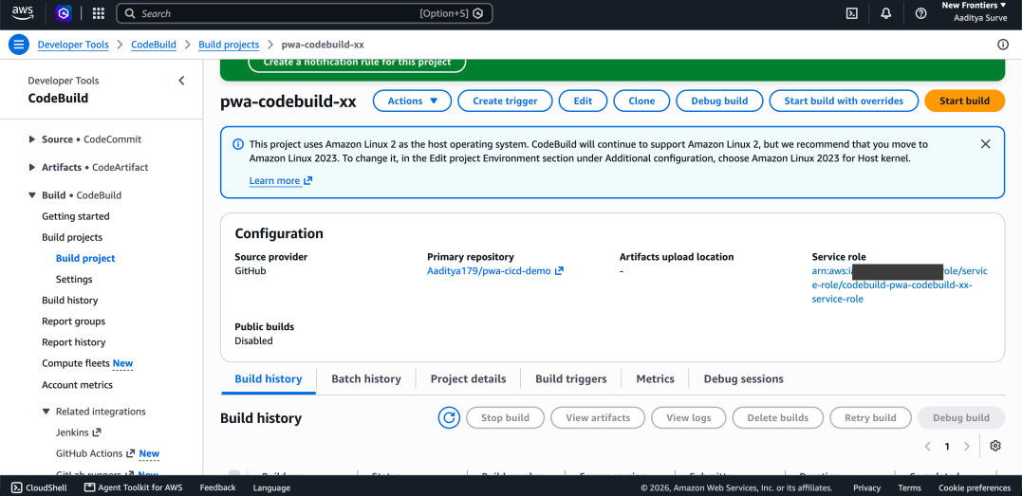
Figure 4: CodeBuild project pwa-codebuild-xx with GitHub as the source provider (account ID hidden).
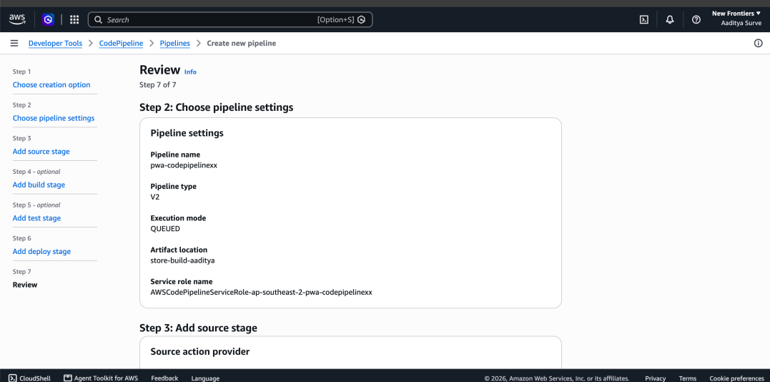
Figure 5: CodePipeline review page showing the pipeline settings and the artifact location.
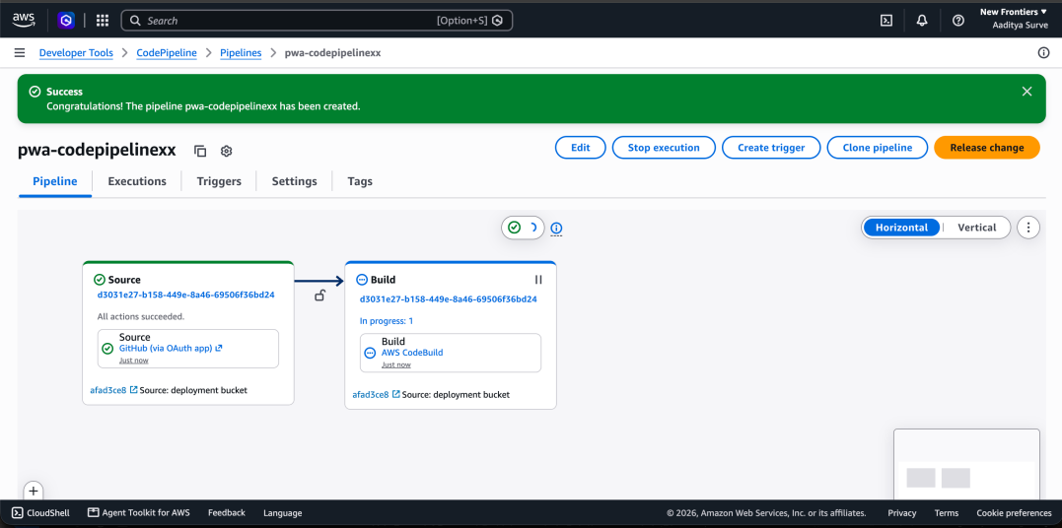
Figure 6: Pipeline pwa-codepipelinexx created; the Source stage succeeded and the Build stage is in progress.
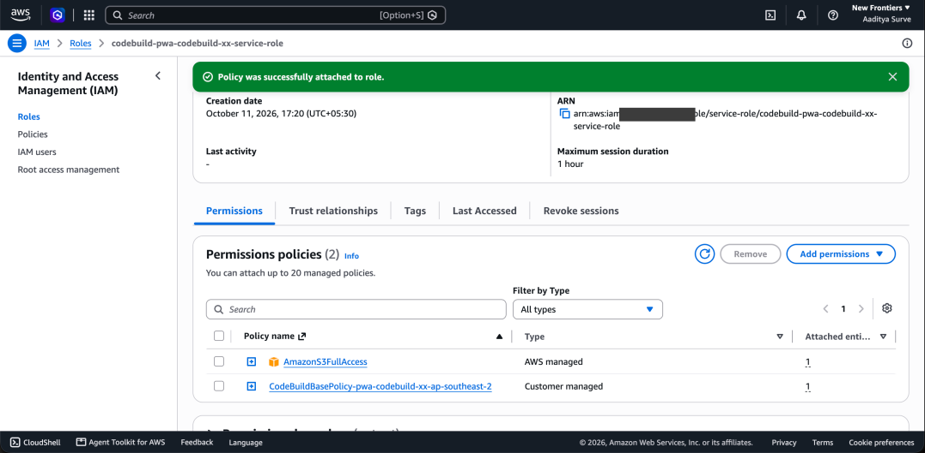
Figure 7: AmazonS3FullAccess policy attached to the CodeBuild service role (account ID hidden).
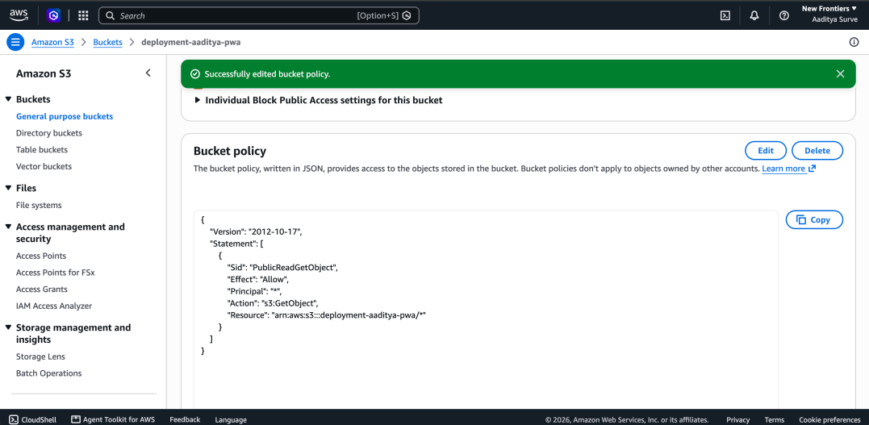
Figure 8: Bucket policy of deployment-aaditya-pwa edited to allow public read of objects.
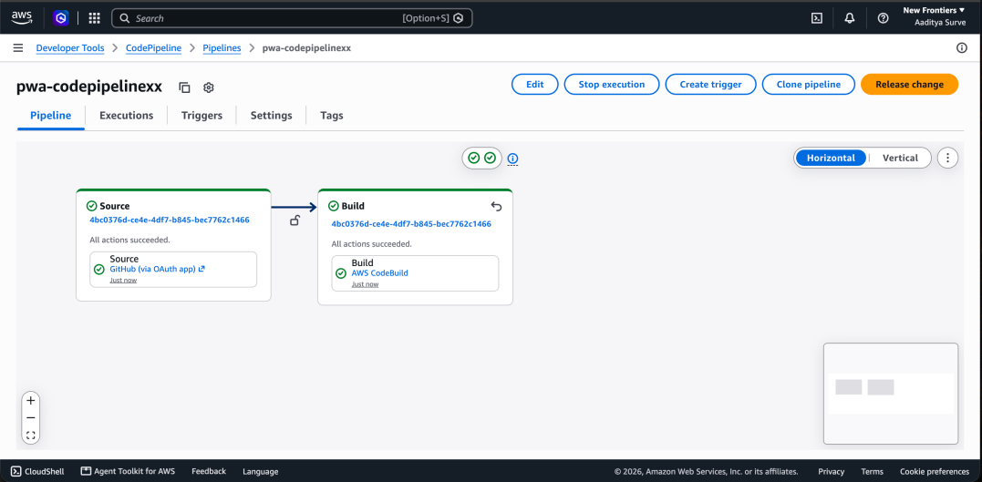
Figure 9: Pipeline run in which both the Source and Build stages succeeded.
Figure 10: Deployed page showing "Hello Aaditya".

Result
A CI/CD pipeline was created on AWS using GitHub, CodePipeline and CodeBuild. After the required S3 permissions were added, the pipeline ran successfully through its Source and Build stages and the website content was deployed to an S3 bucket and displayed in the browser.

Conclusion
Thus, we built an automated CI/CD pipeline on AWS. We learned how a GitHub repository, CodePipeline and CodeBuild work together, why the CodeBuild service role needs S3 permissions to deploy, and how a bucket policy makes the deployed files readable. This reduces manual deployment effort for a static website.

