REPORT

PROJECT TITLE- MOTOR DIRECTION CONTROL

1. **ABSTRACT**

Most DC motors are normally very easy to reverse. By simply changing the polarity of the DC input, the direction of the drive shaft reverses.

This property makes DC motors very popular among enthusiast people involved in robotics. In most cases, DC geared motors are used.

 when we use MCU in our circuit, we don’t need a relay. The necessary control signals will be generated by the MCU. This signal will be passed to a Motor Driver IC, which in turn drives the motors.

**2.REQUIREMENT: -**

**2.1 Microcontroller ATmega328**

* ATmega328 is an 8-bit, 28-Pin AVR Microcontroller, manufactured by Microchip, follows RISC Architecture and has a flash-type program memory of 32KB.
* Atmega328 is the microcontroller, used in basic Arduino boards i.e Arduino UNO, Arduino Pro Mini and Arduino Nano.
* It has an EEPROM memory of 1KB and its SRAM memory is 2KB.
* It has 8 Pins for ADC operations, which all combine to form PortA ( PA0 – PA7 ).
* It also has 3 built-in Timers, two of them are 8 Bit timers while the third one is 16-Bit Timer.
* Arduino UNO is based on atmega328 Microcontroller. It’s UNO’s heart.
* It operates ranging from 3.3V to 5.5V but normally we use 5V as a standard.

**2.2 Led**

A Light Emitting Diode (LED) is a semiconductor device, which can emit light when an

electric current passes through it. To do this, holes from p-type semiconductors recombine with electrons from n-type semiconductors to produce light. The wavelength of the light emitted depends on the bandgap of the semiconductor material. Harder materials with stronger molecular bonds generally have wider bandgaps. Aluminum Nitride semiconductors are known as ultra-wide bandgap semiconductors.

**2.3 Fixed Voltage**

A fixed output power supply has, well, a fixed output voltage. This means that when the power supply is plugged in and the output is on, the output voltage is a single voltage that is not expected to change – it is fixed at that voltage. These power supplies are typically used to provide simple bias for a circuit.

**2.4** **Relay**

A Relay is an electrically operated switch. Relays are the switches which aim at closing and opening the circuits electronically as well as electromechanically. It controls the opening and closing of the circuit contacts of an electronic circuit. When the relay contact is open (NO), the relay isn’t energize with the open contact. However, if it is closed (NC), the relay isn’t energize given the closed contact. However, when energy (electricity or charge) is supplied, the states are prone to change.

**2.5 DC Motor**

A **DC motor** is any of a class of rotary [electrical motors](https://en.wikipedia.org/wiki/Electrical_motor) that converts direct current (DC) electrical energy into mechanical energy. The most common types rely on the forces produced by magnetic fields. Nearly all types of DC motors have some internal mechanism, either electromechanical or electronic, to periodically change the direction of current in part of the motor.

DC motor applications depends on speed and direction.

**3.Design**

**3.1 Block Diagram**

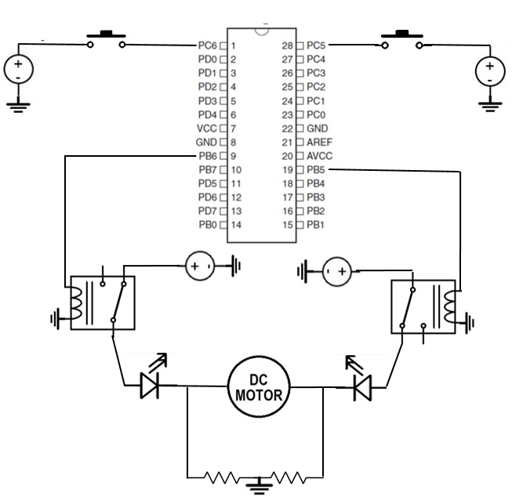

**3.2 Flow Chart**

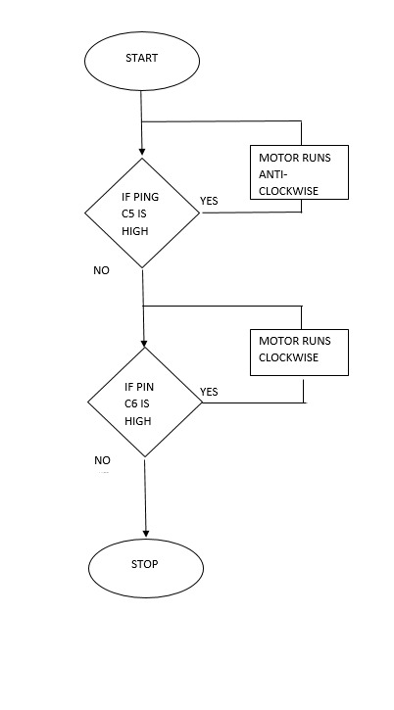

**3.3 Output**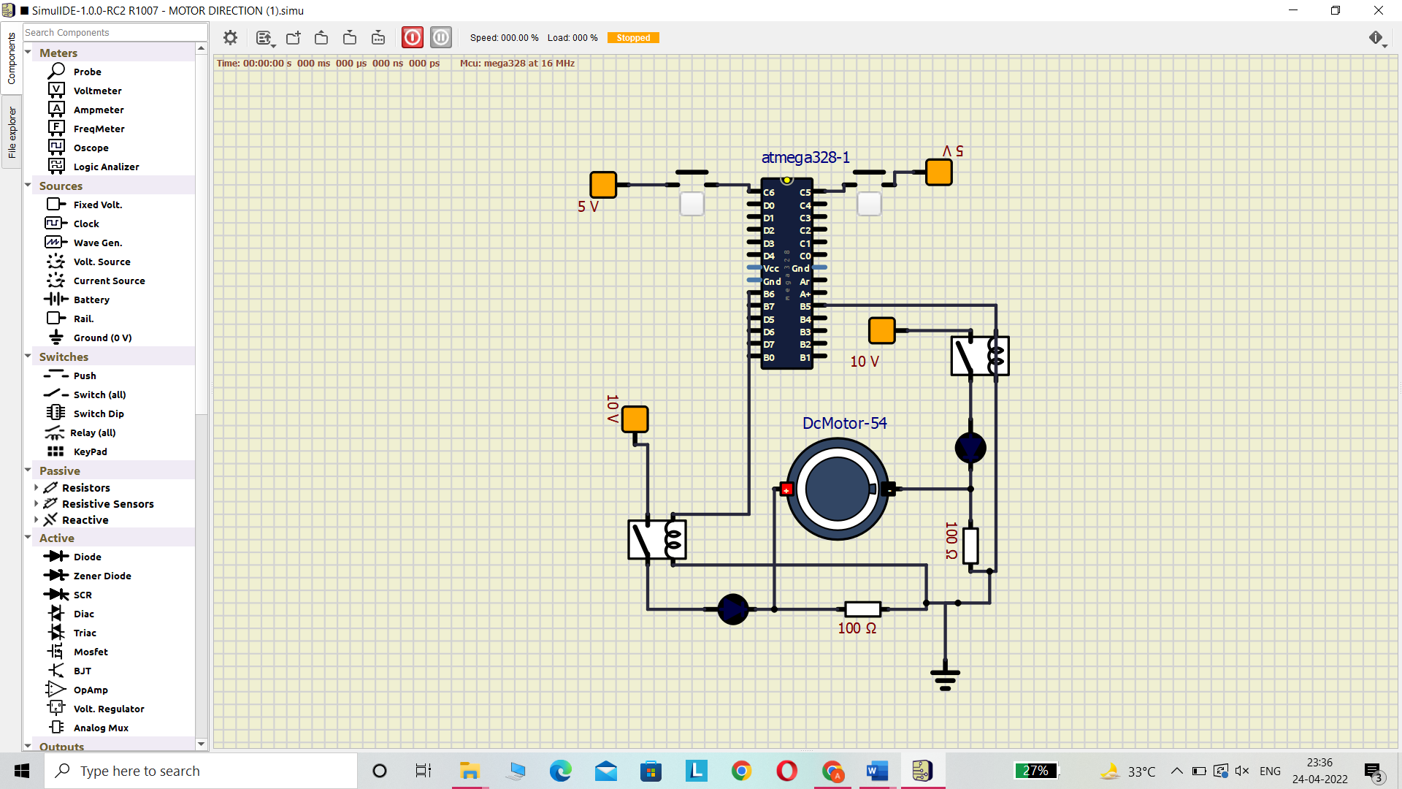

**Applications**

* There are several applications of DC motors.
* They can be used in different robots having wheels and robotic cars to move in different directions. Especially for line following robots (LFR) use of DC motors is very common
* Domestic sense like mixer, zero machine, hair dryer, elevator similarly in industry point of view like traction and in elevator. These applications demand accuracy high-speed control, and good dynamic responses.

**Conclusion**

Continuous demand in electronics, instrumentation and electrical, this research idea gives a concise idea about design the low-cost technology for the control of speed and direction control. Pulse width modulation can switch the motor supply on and off very quickly. User can easily control can changes in speed and direction by reprogramming in microcontroller.

There may be chance of electric shock for conventional switching system. Both speed and direction control can easily be used in industrial as an automation system. So, the future direction is for mobile based or touch screen-based control the whole scenario so that it is free from danger and safer control can possible.